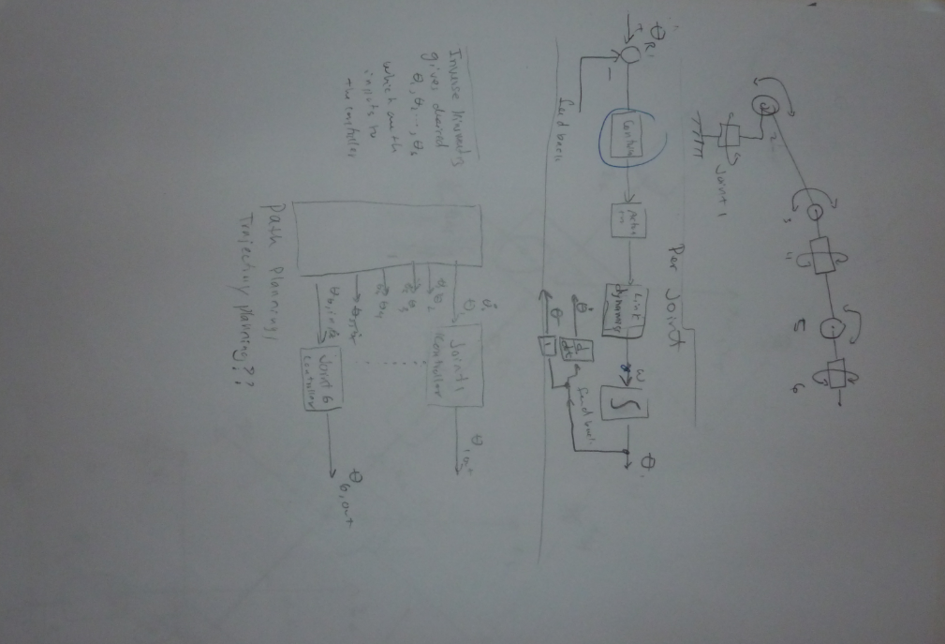

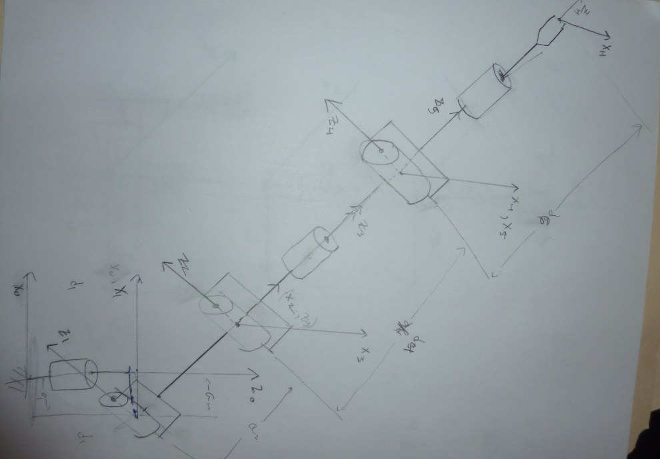

Assigning the frame references to each joint according to each motion.

The forward kinematics.

The figure shown below is the beginning to write the forward kinematics. The table is taken from the frames as developed in the model with axes. The inverse kinematics will be developed once all matrices are completed.

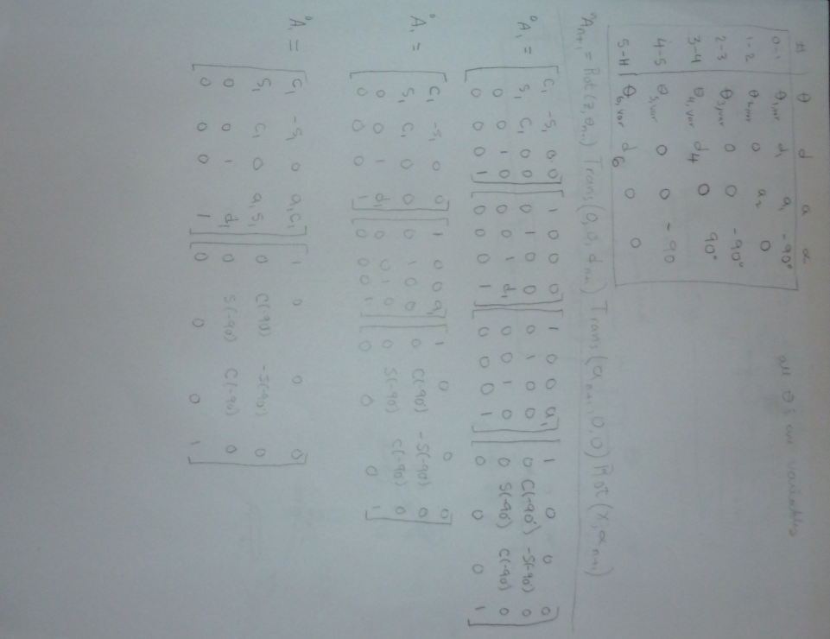

X4

X1

Z4

Z3

X0

Z0

Z1

z2

X2

X3

Controller.

Simplified motor/actuator controller. This would be one per joint.

Disturbance  
or Load

+

+

Output

Input

+

Controller

Plant/Arm link model

-

noise

Sensor/  
encoder

|  |  |
| --- | --- |
| Joint 1: base, 360° rotation |  |
| Joint 2: limited rotation, linear actuator |  |
| Joint 3: limited rotation, dc-motor actuator, requires 2 motors to run simultaneously so not to actuate joint 4 |  |
| Joint 4: limited rotation, differential gearing requiring differential rotation from the 2 dc motors such that it doesn’t actuate joint 3. |  |
| Joint 5: |  |
| Joint 6: |  |

