
SCHOOL OF COMMERCE
BACHERLOR OF MANAGENT INFORMATION SYSTEM
(BMIS)
LILONGWE CAMPUS
MODULE NAME | BUSINESS STATISTICS
MODULE CODE | BUS 215
SUBMITTED TO | Mr L. KASUNGA
SUBMITED BY | STANSLOUS MUSAYA
STUDENT CODE | MU3266
YEAR | 2
SEMISTER | 1

DUE DATE 12 DEC, 2025

Question 1
Constructing a grouped frequency distribution table with given data using the
K² >= n

10, 12, 15, 18, 20, 22, 25, 27, 28, 30, 31, 33, 35, 37, 38, 40, 41, 42,
45, 47,48, 50, 52, 53, 55, 56, 58, 60, 61, 62, 63, 64, 66, 67, 68, 70,
71, 73, 75, 76,78, 80, 81, 83, 84, 86, 88, 89, 90, 92, 94, 95, 96, 98,
99, 100, 101, 103, 104, 105,106, 107, 108, 109, 110, 112, 113, 114,
115, 116, 117, 118, 119, 120, 55, 60, 44, 31, 82, 77, 49, 36, 29, 27,
91, 65, 58, 40, 34, 18

Find the value of K in our formula:
Since the total values in the number set given is 90 so the K value must be greater or equal to 90
K² >= 90
K >= √90
K >= 9.5

Since a class name can’t be in decimal we are going to up front the value to 10

Now we know the number of classes, since K = 10 then the number of classes are 10 classes so the next step is to find the class width.
Class width =
Class width =
Class width =
Class width = 11

Since we have the number of classes and the class width we can go ahead and create the classes in a table as below
Class Interval | Frequency
10 - 20 | 6
21 - 31 | 9
32 - 42 | 14
43 - 53 | 10
54 - 64 | 14
65 - 75 | 13
76 - 86 | 11
87 - 97 | 9
98 - 108 | 10
109 - 120 | 4

Question 2
Constructing a histogram for the data set below.
Units Sold | Number of Ages
10 - 19 | 3
20 - 29 | 7
30 - 39 | 11
40 - 49 | 15
50 - 59 | 9
60 -69 | 5

With the table above we need to work on the class limits to convert them to class boundary for the bars to ouch each other since the class boundary have continuous data while the class limits have district data below is a table showing the class boundaries

Calculation for the class boundaries
Let us consider the first class 10 -19
The low boundary is = (10 - 0.5) = 9.5
The upper boundary = (19 + 0.5) = 19.5

So we will do this to all the other classes

Units Sold | Number of Ages | Class Boundaries
10 - 19 | 3 | 9.5 - 19.5
20 - 29 | 7 | 19.5 - 29.5
30 - 39 | 11 | 29.5 - 39.5
40 - 49 | 15 | 39.5 - 49.5
50 - 59 | 9 | 49.5 - 59.5
60 -69 | 5 | 59.5 - 69.5

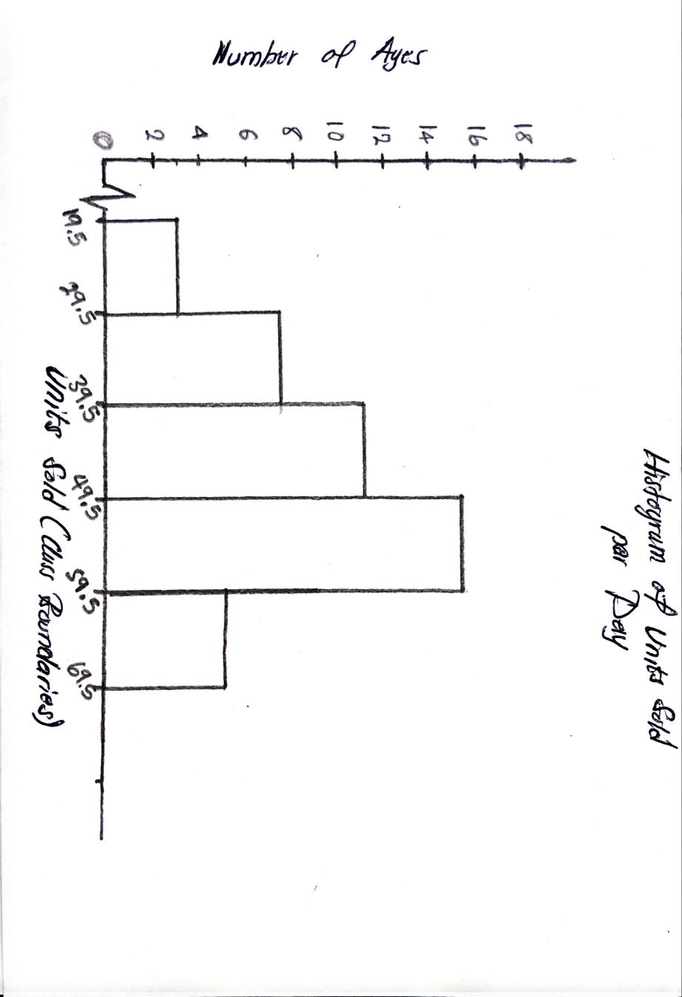
To comment on the diagram above the histogram shows that we have a peak at 40 - 49 units, indicating that most agents sell in this range

Question 3
Creating a frequency curve and the ogive for the table below and estimating the median delivery time using the ogive

Delivery Time (min) | Frequency
5 - 14 | 6
15 - 24 | 9
25 - 34 | 14
35 - 44 | 20
45 - 54 | 12
55 - 64 | 6
65 - 74 | 3

For us to find the relative frequency curve we need to fill the table above with the relative frequency colunm and midpoint column as well to find the relative frqucncey we go as follow:

Relative frequency =
for the n = 70

For the first class the frequency is 6 therefor
Relative frequency =
Relative frequency = 0.086

And for the midpoint calculations we go as follows
Midpoint =
Midpoint (first class) =
Midopoint = 9.5

Then we do the same for all other classes to find the relative frequency and midpoint

Delivery Time (min) | Frequency | Relative frequency | midpoint | Relative frequency in % | Cumulative Frequency
5 - 14 | 6 | 0.086 | 9.5 | 8.6% | 6
15 - 24 | 9 | 0.129 | 19.5 | 12.9% | 15
25 - 34 | 14 | 0.2 | 29.5 | 20% | 29
35 - 44 | 20 | 0.286 | 39.5 | 28.6% | 49
45 - 54 | 12 | 0.171 | 49.5 | 17.1% | 61
55 - 64 | 6 | 0.086 | 59.5 | 8.6% | 67
65 - 74 | 3 | 0.043 | 69.5 | 4.3% | 70

Since we have the table set up we can now create the relative frequency curve and the ogive graph
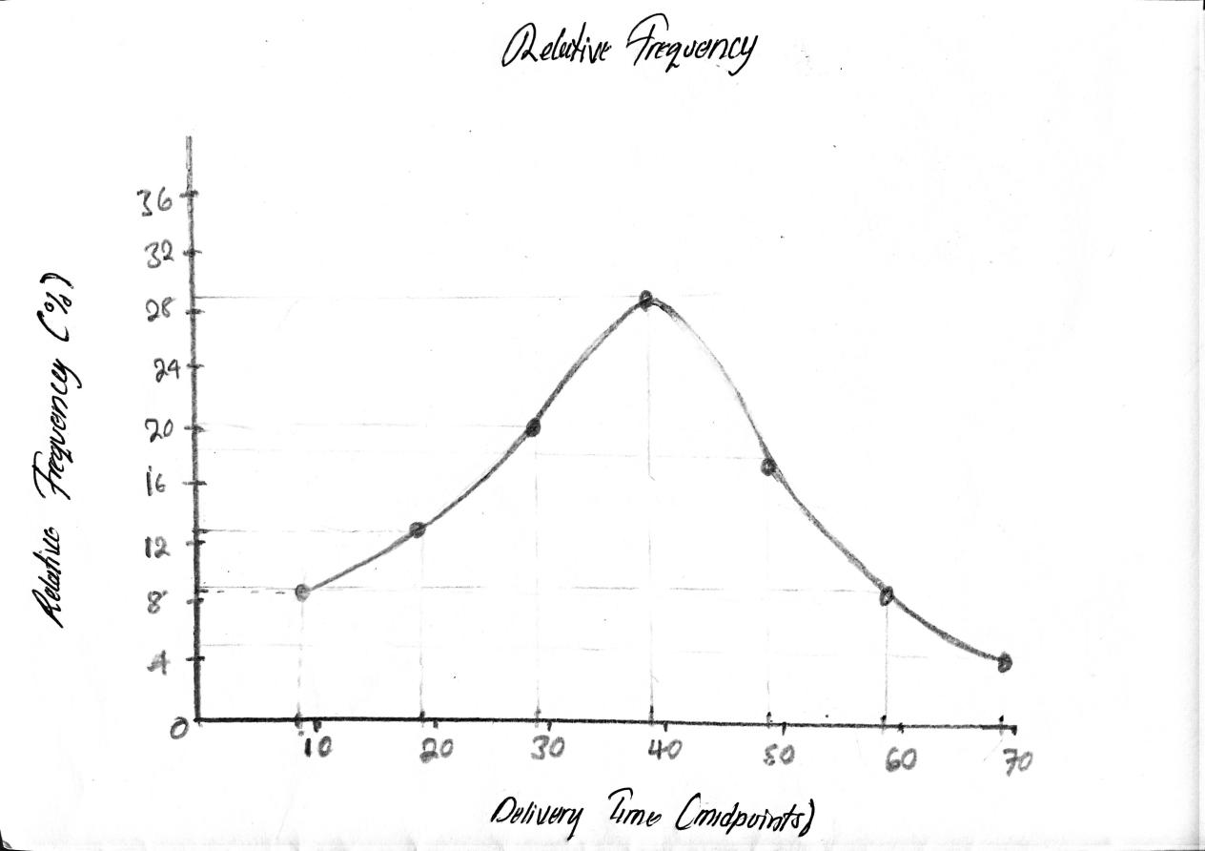

Below is the ogive

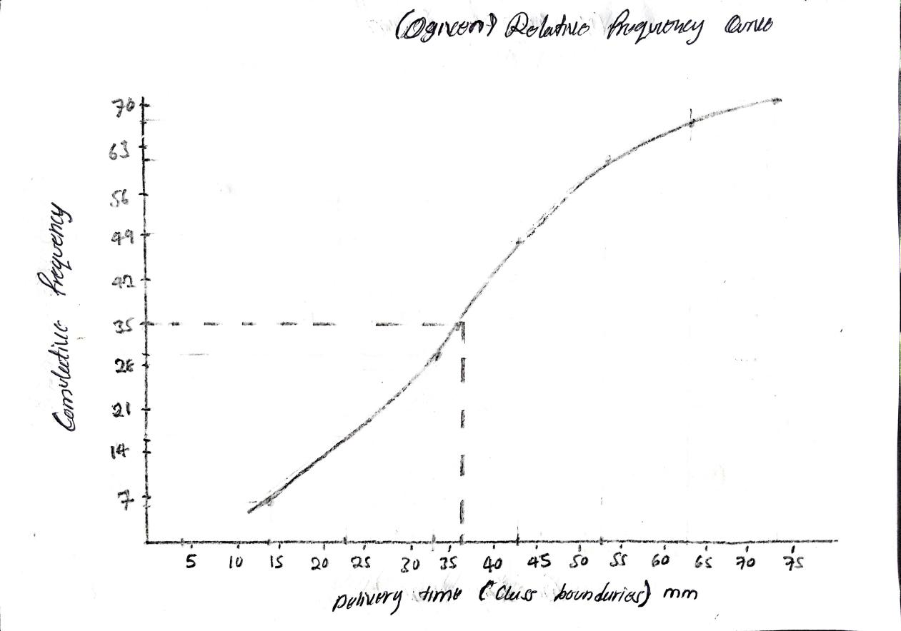
Finding the mean using the ogive as below:
Since helps use to know the median class where N is the total cumulative frequency
Median class =
Median class =
Median class = 35

Median =
Median = 37.5

Question 4
Constructing a stacked (Component) bar graph for the data
Quarter | Product A | Product B | Product C
Q1 | 403 | 255 | 154
Q2 | 455 | 307 | 180
Q3 | 550 | 350 | 223
Q4 | 553 | 408 | 209

Below is a sacked bar graph for the table above
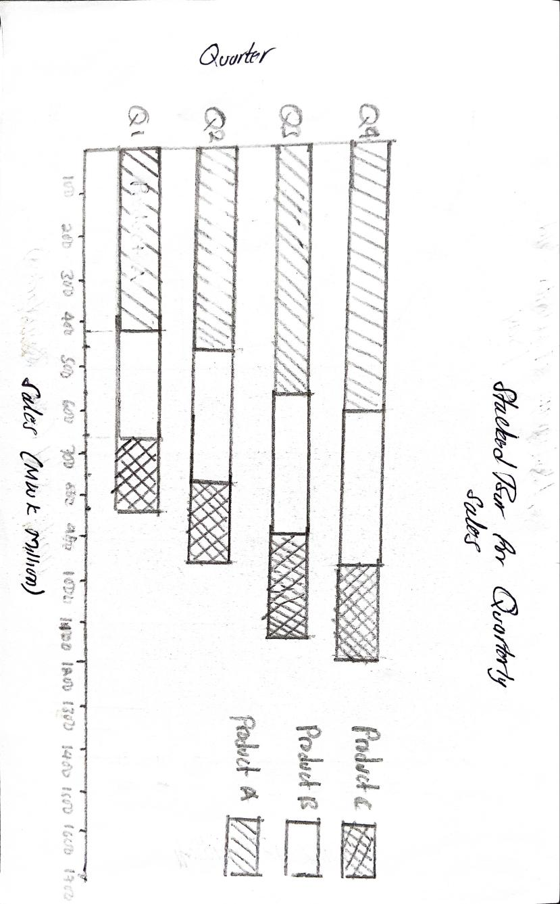

Question 5

a) Validity
Validity means how true and accurate a study is. When a research tool measures exactly what it is supposed to measure, the study is valid. If a study is valid, you can trust the results. If it is not valid, the findings may be misleading or wrong.
b) Types of Validity
There are a few common types of validity. Content validity checks if the questions or items fully cover the topic being studied. Construct validity checks if the tool truly measures the idea or concept it is meant to measure. Criterion validity looks at how well the tool matches or predicts another established measure. These types help show whether the study results are trustworthy.
c) Bias
Bias is any mistake in a study that causes the results to lean in one direction unfairly. It happens when something in the process influences the findings. Bias makes the results less truthful and less reliable.
d) Types of Bias
Bias can appear in different ways. Sampling bias happens when the sample does not represent the whole population. Measurement bias happens when the tool used to collect data gives wrong results. Researcher bias occurs when the researcher's own beliefs influence the study. Response bias happens when participants do not give truthful answers. All these forms of bias weaken the study.
e) Effects of Bias on a Research Study
Bias affects a study by making the results incorrect or misleading. It reduces the trustworthiness of the findings and can lead to wrong conclusions. When bias is present, the study might not show the true situation, and the results cannot be used confidently for decision-making or future research. In short, bias damages the quality and usefulness of the study.

References
Anderson, D.R., Sweeney, D.J., Williams, T.A., Camm, J.D. and Cochran, J.J., 2020. Statistics for business & economics. 14th edn. Boston: Cengage Learning.
Cooper, D.R. and Schindler, P.S., 2014. Business research methods. 12th edn. New York: McGraw-Hill Irwin.
Field, A., 2018. Discovering statistics using IBM SPSS statistics. 5th edn. London: Sage Publications.

