Fairness

a=0.3

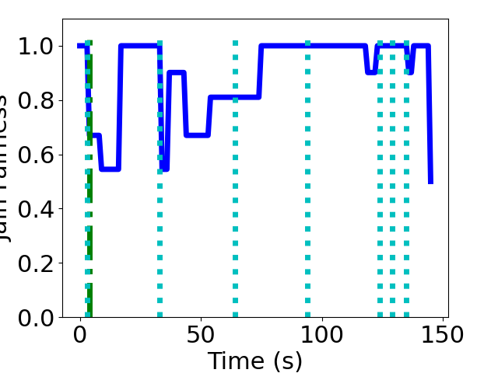

a=0.5

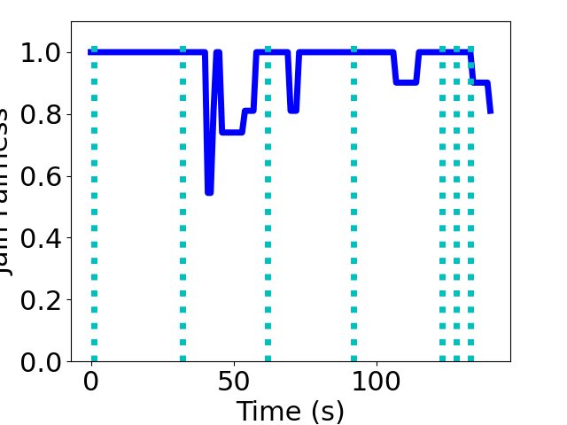

a=0.9

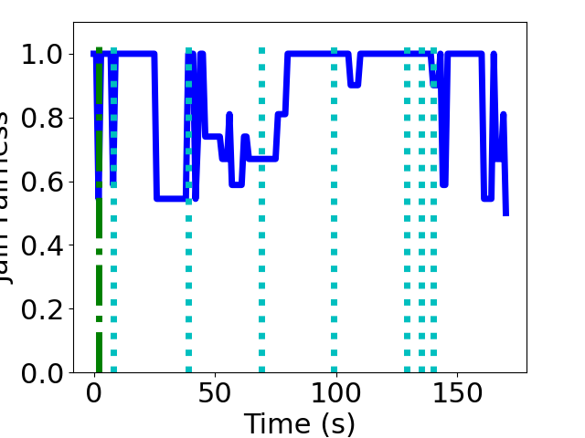

Smoothness

a=0.3

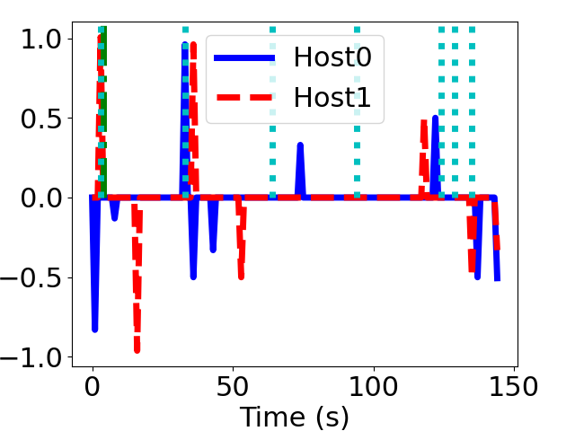

a=0.5

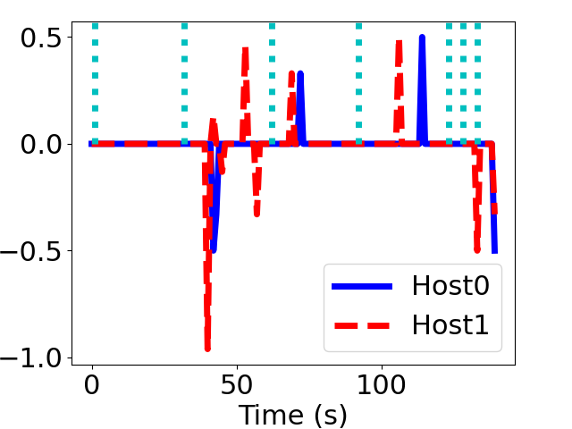

a=0.9

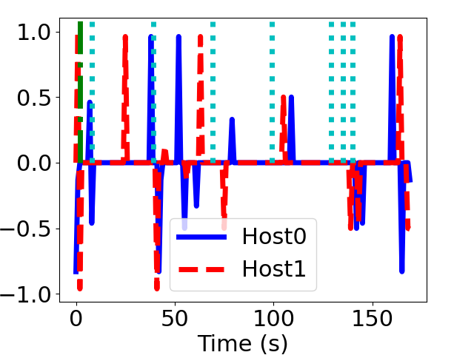

Utilization

a=0.3

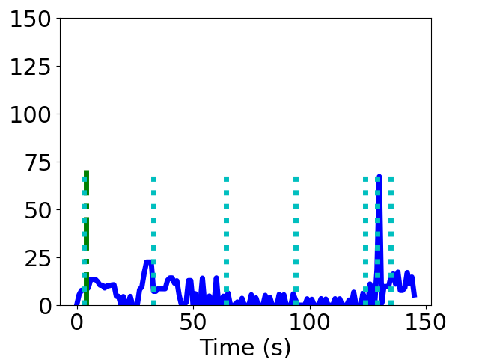

a=0.5

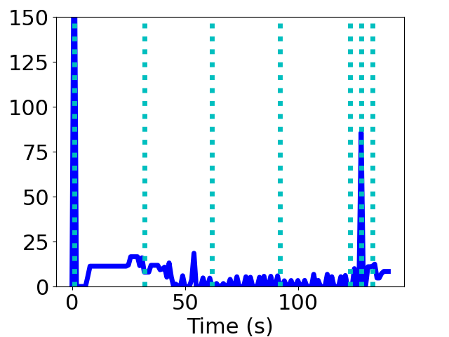

a=0.9

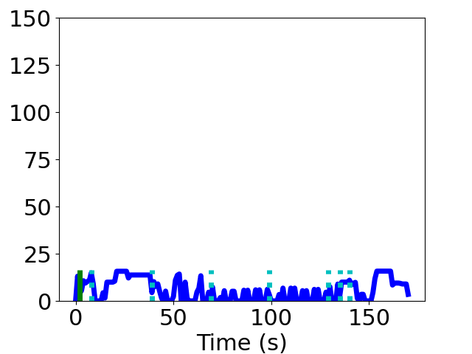

Comparing different alpha value, a=0.5 has the best fairness, smoothness, and utilization. This might because a=0.5 balance the weight of current measured throughput and past experience the best. Therefore, the measurement using a=0.5 is the most accurate.