Single-cell RNA-seq analysis of gonadal cells reveals genes important for germ cell development and sexual differentiation in sea lamprey (Petromyzon marinus)

Yu-Wen Chung-Davidson^{1*}, Stephanie L. Hickey^{2*}, Matthew P. Bernard³, Ciro Amato⁴, Martin Estermann⁴, Jacob Kimmel¹, Lily Gorman⁵, Tyler Buchinger¹, Braden A. Idalski⁶, Nicholas S. Johnson⁶, Humprey Yao⁴, Weiming Li¹

¹Department of Fisheries & Wildlife, ² MSU Bioinformatics Core Facility, ³Flow Cytometry Core Facility, ⁵Program of Environmental Biology & Plant Biology, Michigan State University, East Lansing, MI 48824
⁴Reproductive Developmental Biology Group, National Institute of Environmental Health Sciences, Research Triangle Park, NC 287709
⁶Hammond Bay Biological Station, Great Lakes Science Center, US Geological Survey, Millersburg, MI 49759
*Contribute equally as first authors

Abstract:

The sea lamprey (Petromyzon marinus) is a jawless vertebrate species that develops through larval, juvenile, and adult life stages. The mechanism of sex determination in this species is unknown and thought to be regulated by several environmental factors. During its lengthy larval stage that lasts between 3-20 years, the gonad usually contains both female and male germ cells before metamorphosis. To seek insights for sex determination and sexual differentiation in this agnathan species, we profiled gene expression patterns of gonadal cells from larvae (sex-labile) and recently metamorphosed juvenile transformers (sex-determined). We used flow cytometric cell sorting and single-cell RNA-seq to capture expressed genes in individual gonadal cells. Primordial germ cells expressed many specific cell markers, such as HOXA4, HOXA5A, HOXA10, KDM1A, LHX8, PAX7, POU2F2, SOX1, and SOX14. Male germ cells expressed specific cell marker ADGB, whereas gonadal macrophages expressed specific cell marker CD115/CSF1R. Interestingly, germ cells are enriched with ribosomal proteins, some can interact with heat-shock proteins or hormone receptors, and others are sensitive to sugar or lipid metabolisms. These ribosomal genes may provide a link between environmental factors such as temperature and nutrients to cellular functions, leading to changes in germ cell fate. Germ cells in the larvae expressed many transcription factors involving in DNA replication, transcription, translation, apoptosis, autophagy, cell cycles, cell differentiation, cell adhesion and migration, cell survival, chromatin remodeling and proliferation. In particular, TGFβ, and Wnt signaling pathways were involved in sexual differentiation in other species. We performed a branch point trajectory ananlysis . Further analysis is required to confirm the functions of these genes and pathways in sex determination and sexual differentiation in the sea lamprey.

Introduction

Current knowledge of sea lamprey sex determination and sexually differentiation
Gap of knowledge
Use single-cell RNA-seq to uncover gene expression pathway leading to specific sex

Sea lamprey is an invasive species in the Laurentian Great Lakes that cause grave economic loss and require strict population control. One way to improve current control methods is to understand the mechanisms of their sex determination and sexually differentiation to manipulate sex ratio in favor of the collapse of the invasive population. However, the sex of sea lamprey larvae remains plastic, and it is unclear how the sea lamprey commit to a specific sex during metamorphosis. To uncover the gene expression pathway leading to specific sex, we examine the single-cell RNA-seq of gonads from sex-undetermined larvae and sex-committed female and male transformers (metamorphosed juveniles)…..

Methods and Materials

Animals:

Gonadal cell dissociation:

Flow cytometry cell sorting:

PIP-seq:

Data analysis:

ICC and HCR validation:

Results

To investigate the molecular basis of sea lamprey sex determination and sexual differentiation, we used PIP-seq¹ and built a single-cell gene expression atlas of gonadal cells from larvae (sex-labile) and recently metamorphosed juvenile transformers (sex-determined). The full atlas contains 66,767 high-quality single-cell transcriptomes from four samples including 13,803 from female-determined gonads, 18,324 from male-determined gonads, and 17,186 and 17,454 from two replicates of sex-labile gonads (Supplemental Table S1). After sample integration, we used unsupervised clustering to identify 19 cell types including germ cells, somatic support cells, immune cells, vascular/blood cells, and kidney/mesonephric cells (Fig. 1a). Genes enriched in male-germ cell clusters 16-19 include SPAG16 and PIWIL1 while ZAR1L and WFDC3 are enriched in cluster 3, the combined primordial germ cell / female germ cell cluster (Fig. 1b, Fig S1, Supplemental Table S3).

To identify genes involved in sex determination and sexual differentiation, we first performed more resolved clustering of the germ cells identified in the full atlas. In addition to the expected clusters of male (PIWIL1 and FN3KRP enriched) and female (ZP4.3 and ZD1.15 enriched) germ cells, we identified two clusters of putative primordial germ cells (clusters 14 and 15) enriched for marker genes including WNT5A, PRDM12, UBA1, PUM1, CPEB1 and NANOS1 (Fig. 2a, Supplemental Table S4). We ordered cells along a developmental trajectory by constructing a minimum spanning tree (MST) to connect similar clusters and map the transitions between them (Fig. 2b)². PGC cluster 15 was identified as the trajectory starting point, given that its gene expression signature and sample composition—cells from undifferentiated gonads—indicated the earliest developmental stage (Fig. 2a-b). Each cell was projected to its nearest point on the trajectory, with pseudotime defined as the MST distance from cluster 15 to this projected position (Fig. 2c). The top 100 genes increasing with pseudotime along the female trajectory (cluster 15→2) are enriched for genes involved in fertilization processes, including binding of sperm to zona pellucida (GO:0007339), prevention of polyspermy (GO:0060468), egg coat formation (GO:0035803), and positive regulation of acrosome reaction (GO:2000344) (Supplemental Tables S5-S7). Along the male trajectory (cluster 15→7), the top 100 genes increasing with pseudotime are involved in protein synthesis, including translation (GO:0006412), cytoplasmic translation (GO:0002181), and ribosomal small subunit assembly (GO:0000028) (Supplemental Tables S3-S5). Genes decreasing with pseudotime on the female trajectory are enriched in these same translation-related categories.

Next, we identified genes that may be responsible for the branching event within PCG cluster 14 where the male and female germ cell paths diverge. While all cluster 14 cells are likely PGCs, proximity to a specific path suggests their gene expression profiles are shifting toward male- or female-biased germ cell identities. We classified cluster 14 cells as male, female, or unbranched based on their proximity to the PGC path (cluster 15→14), female path (cluster 14→1), or male path (cluster 14→13) (Fig. 3a). Following branch assignment, we re-calculated pseudotime on the male and female branches beginning at the branch point within cluster 14 (Fig. 3b-c) and identified genes uniquely associated with pseudotime along each path (Fig. 3d-e, Supplemental Tables S8-9). Fourteen genes are uniquely pseuodtime-associated on the female path, and all are increasing with pseudotime. Six of the fourteen genes are S100 protein family members suggesting a role for calcium signaling in the branching event (Supplemental Table S8). Greater than 97% of the unique male pseudotime-associated genes are decreasing with pseudotime including genes involved in RNA processing (HNRNPLL.1, HNRNPH1, SNRPB, EXOSC10, and EXOSC9) and protein homeostasis (HSPA5, HSBP1, and CTSD), suggesting that PCGs with male-biased identities are already reducing transcription and protein synthesis (Supplemental Table S9).

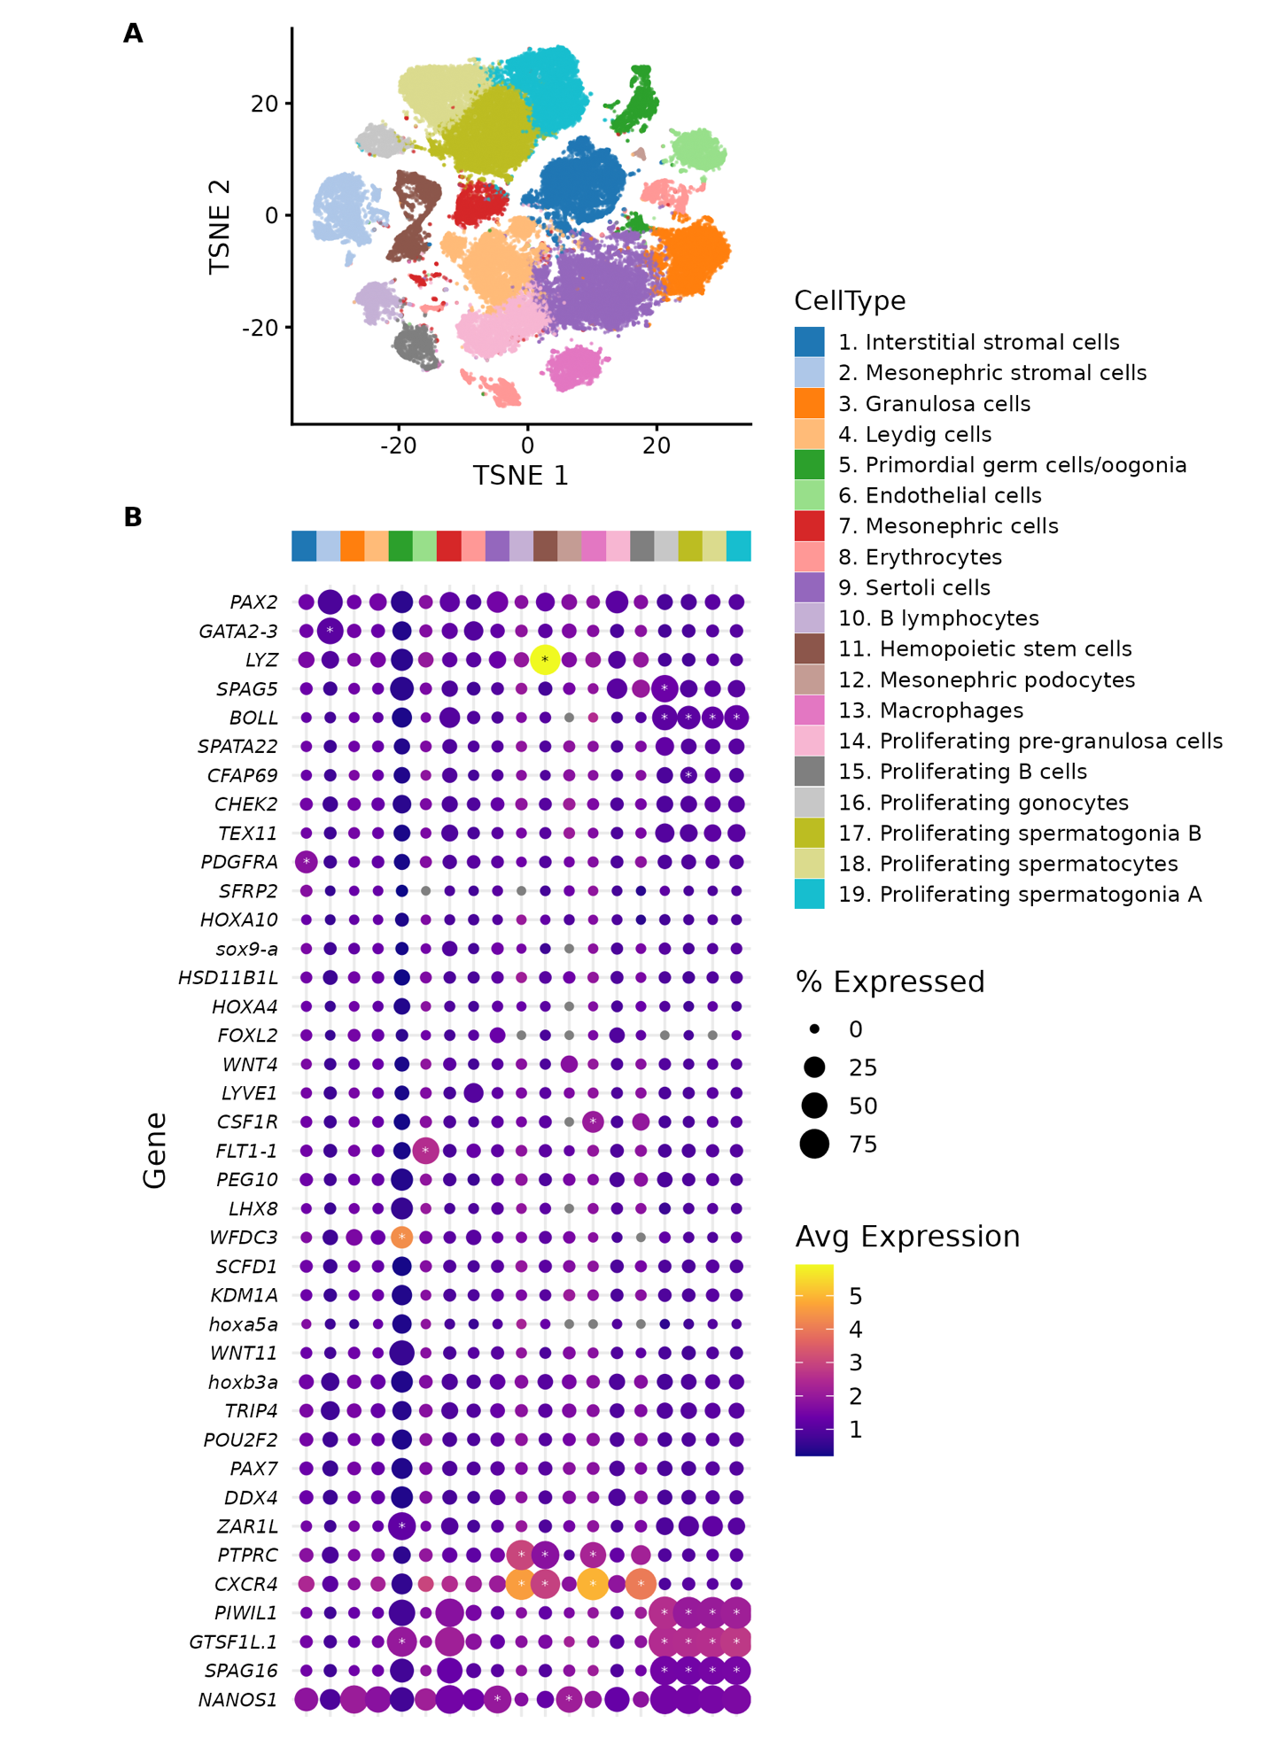

Specific markers for known cell types (ICC/HCR figures)

Gene expression patterns of important genes (violin plots; please include the new gene list)

Pseudotime trajectory of genes involved in female vs. male pathway (cell cluster grouping & two heat maps; please update the figures)

Discussion

Implication of gene expression patterns in specific cell types
Implication of pseudotime trajectory of gene expression leading to female vs. male pathway
Conclusion/Summary

References:

