Single-cell RNA-seq analysis of gonadal cells reveals genes important for germ cell development and sexual differentiation in sea lamprey (Petromyzon marinus)

Yu-Wen Chung-Davidson^{1*}, Stephanie L. Hickey^{2*}, Matthew P. Bernard³, Ciro Amato⁴, Martin Estermann⁴, Jacob Kimmel¹, Lily Gorman⁵, Tyler Buchinger¹, Braden A. Idalski⁶, Nicholas S. Johnson⁶, Humprey Yao⁴, Weiming Li¹

¹Department of Fisheries & Wildlife, ² MSU Bioinformatics Core Facility, ³Flow Cytometry Core Facility, ⁵Program of Environmental Biology & Plant Biology, Michigan State University, East Lansing, MI 48824
⁴Reproductive Developmental Biology Group, National Institute of Environmental Health Sciences, Research Triangle Park, NC 287709
⁶Hammond Bay Biological Station, Great Lakes Science Center, US Geological Survey, Millersburg, MI 49759
*Contribute equally as first authors

Abstract:

The sea lamprey (Petromyzon marinus) is a jawless vertebrate species that develops through larval, juvenile, and adult life stages. The mechanism of sex determination in this species is unknown and thought to be regulated by several environmental factors. During its lengthy larval stage that lasts between 3-20 years, the gonad usually contains both female and male germ cells before metamorphosis. To seek insights for sex determination and sexual differentiation in this agnathan species, we profiled gene expression patterns of gonadal cells from larvae (sex-labile) and recently metamorphosed juvenile transformers (sex-determined). We used flow cytometric cell sorting and single-cell RNA-seq to capture expressed genes in individual gonadal cells. Primordial germ cells expressed many specific cell markers, such as HOXA4, HOXA5A, HOXA10, KDM1A, LHX8, PAX7, POU2F2, SOX1, and SOX14. Male germ cells expressed specific cell marker ADGB, whereas gonadal macrophages expressed specific cell marker CD115/CSF1R. Interestingly, germ cells are enriched with ribosomal proteins, some can interact with heat-shock proteins or hormone receptors, and others are sensitive to sugar or lipid metabolisms. These ribosomal genes may provide a link between environmental factors such as temperature and nutrients to cellular functions, leading to changes in germ cell fate. Germ cells in the larvae expressed many transcription factors involving in DNA replication, transcription, translation, apoptosis, autophagy, cell cycles, cell differentiation, cell adhesion and migration, cell survival, chromatin remodeling and proliferation. In particular, TGFβ, and Wnt signaling pathways were involved in sexual differentiation in other species. We performed a branch point trajectory ananlysis . Further analysis is required to confirm the functions of these genes and pathways in sex determination and sexual differentiation in the sea lamprey.

Introduction

Current knowledge of sea lamprey sex determination and sexually differentiation
Gap of knowledge
Use single-cell RNA-seq to uncover gene expression pathway leading to specific sex

Sea lamprey is an invasive species in the Laurentian Great Lakes that cause grave economic loss and require strict population control. One way to improve current control methods is to understand the mechanisms of their sex determination and sexually differentiation to manipulate sex ratio in favor of the collapse of the invasive population. However, the sex of sea lamprey larvae remains plastic, and it is unclear how the sea lamprey commit to a specific sex during metamorphosis. To uncover the gene expression pathway leading to specific sex, we examine the single-cell RNA-seq of gonads from sex-undetermined larvae and sex-committed female and male transformers (metamorphosed juveniles)…..

Methods and Materials

Animals:

Gonadal cell dissociation:

Flow cytometry cell sorting:

PIP-seq:

Data analysis:

ICC and HCR validation:

Results

Specific markers for each cell cluster (figure, table)
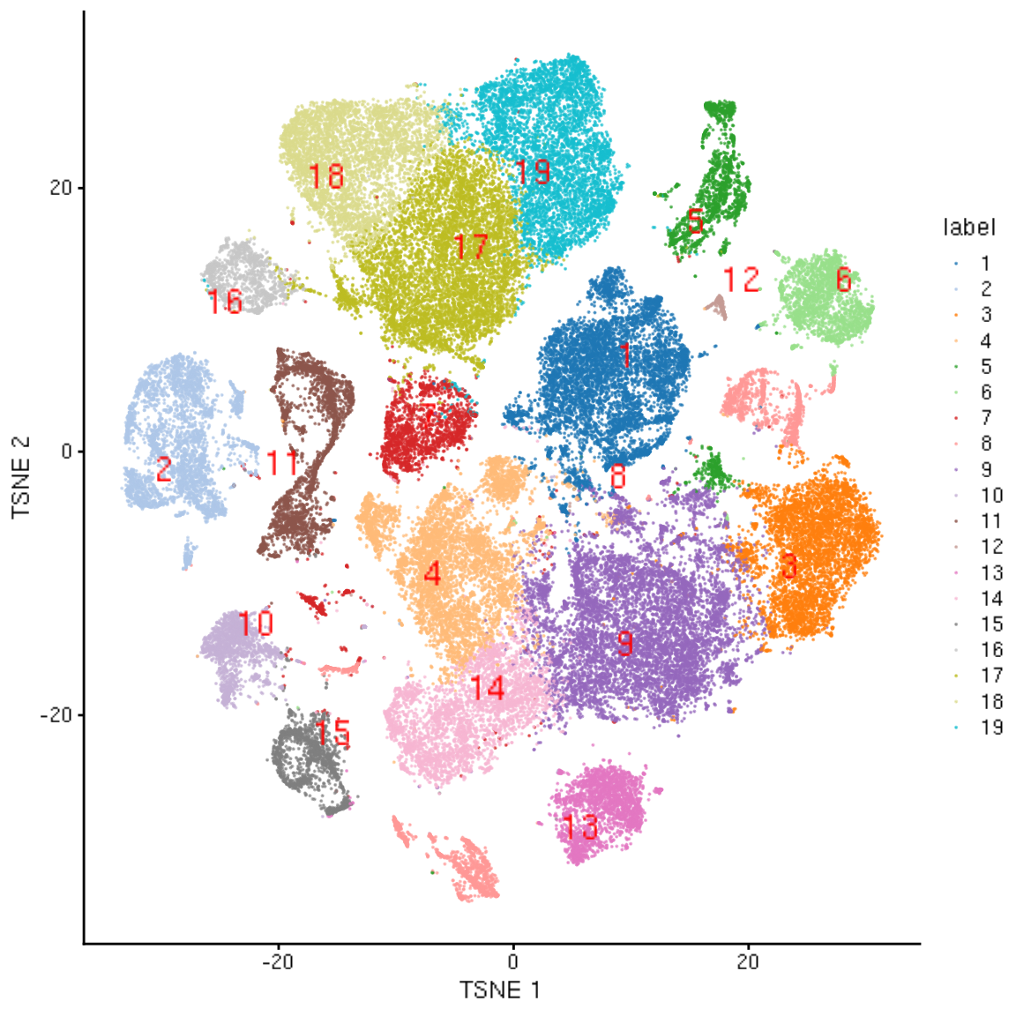

Specific markers for known cell types (ICC/HCR figures)

Gene expression patterns of important genes (violin plots; please include the new gene list)
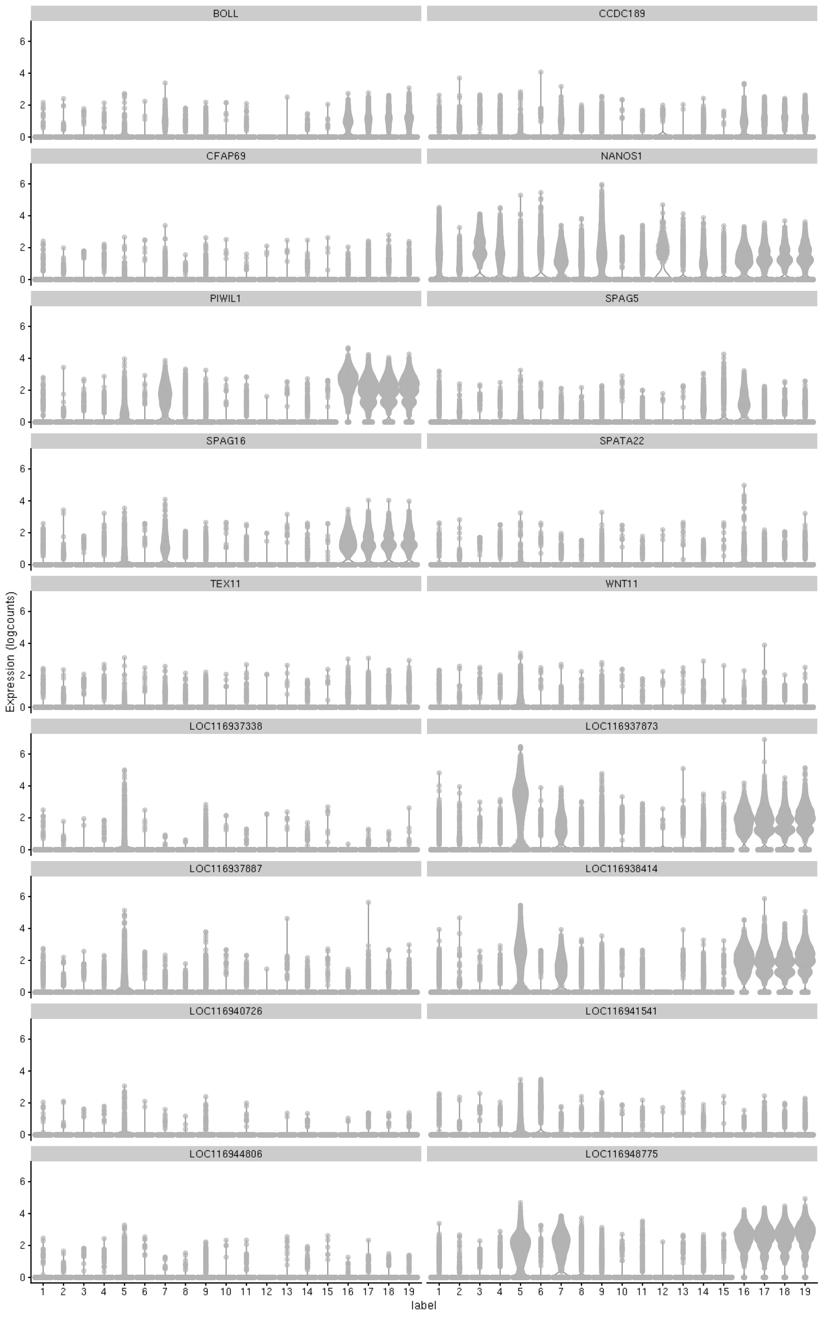

Pseudotime trajectory of genes involved in female vs. male pathway (cell cluster grouping & two heat maps; please update the figures)

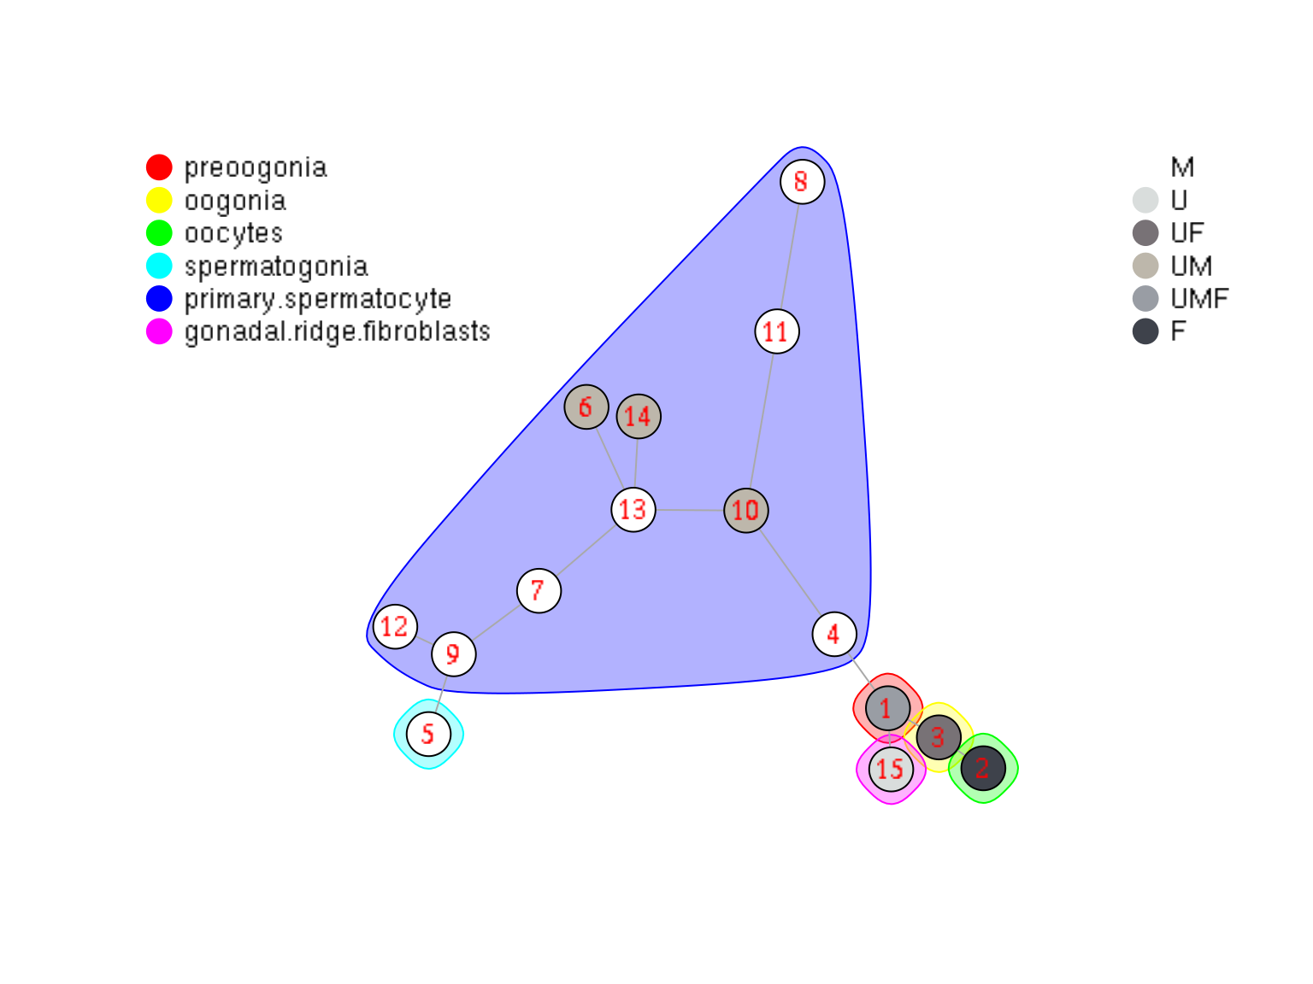

Top 50 heatmap
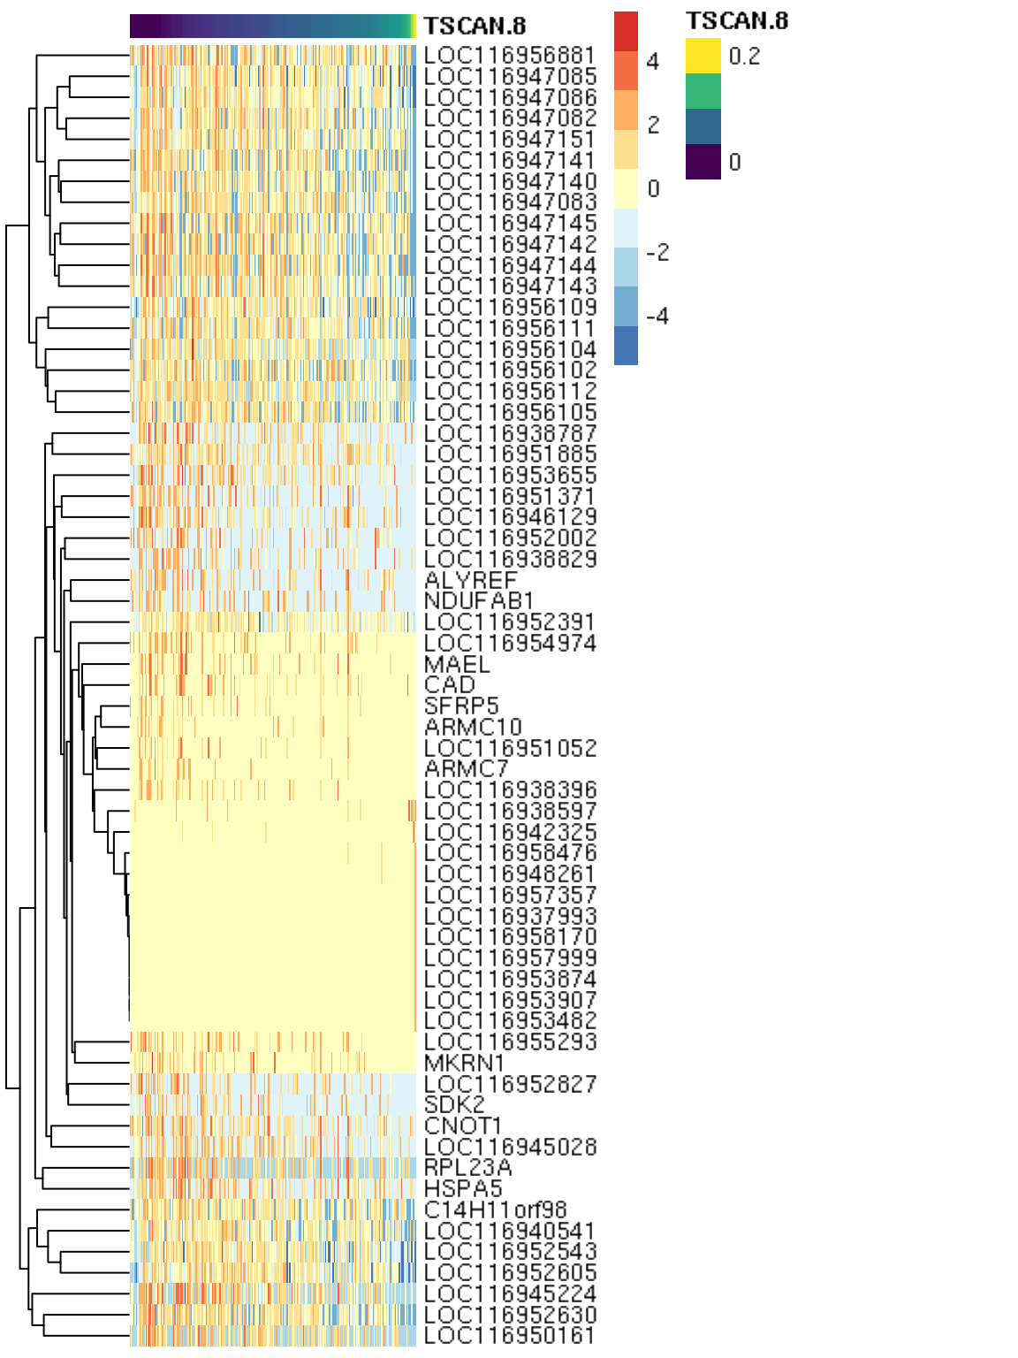
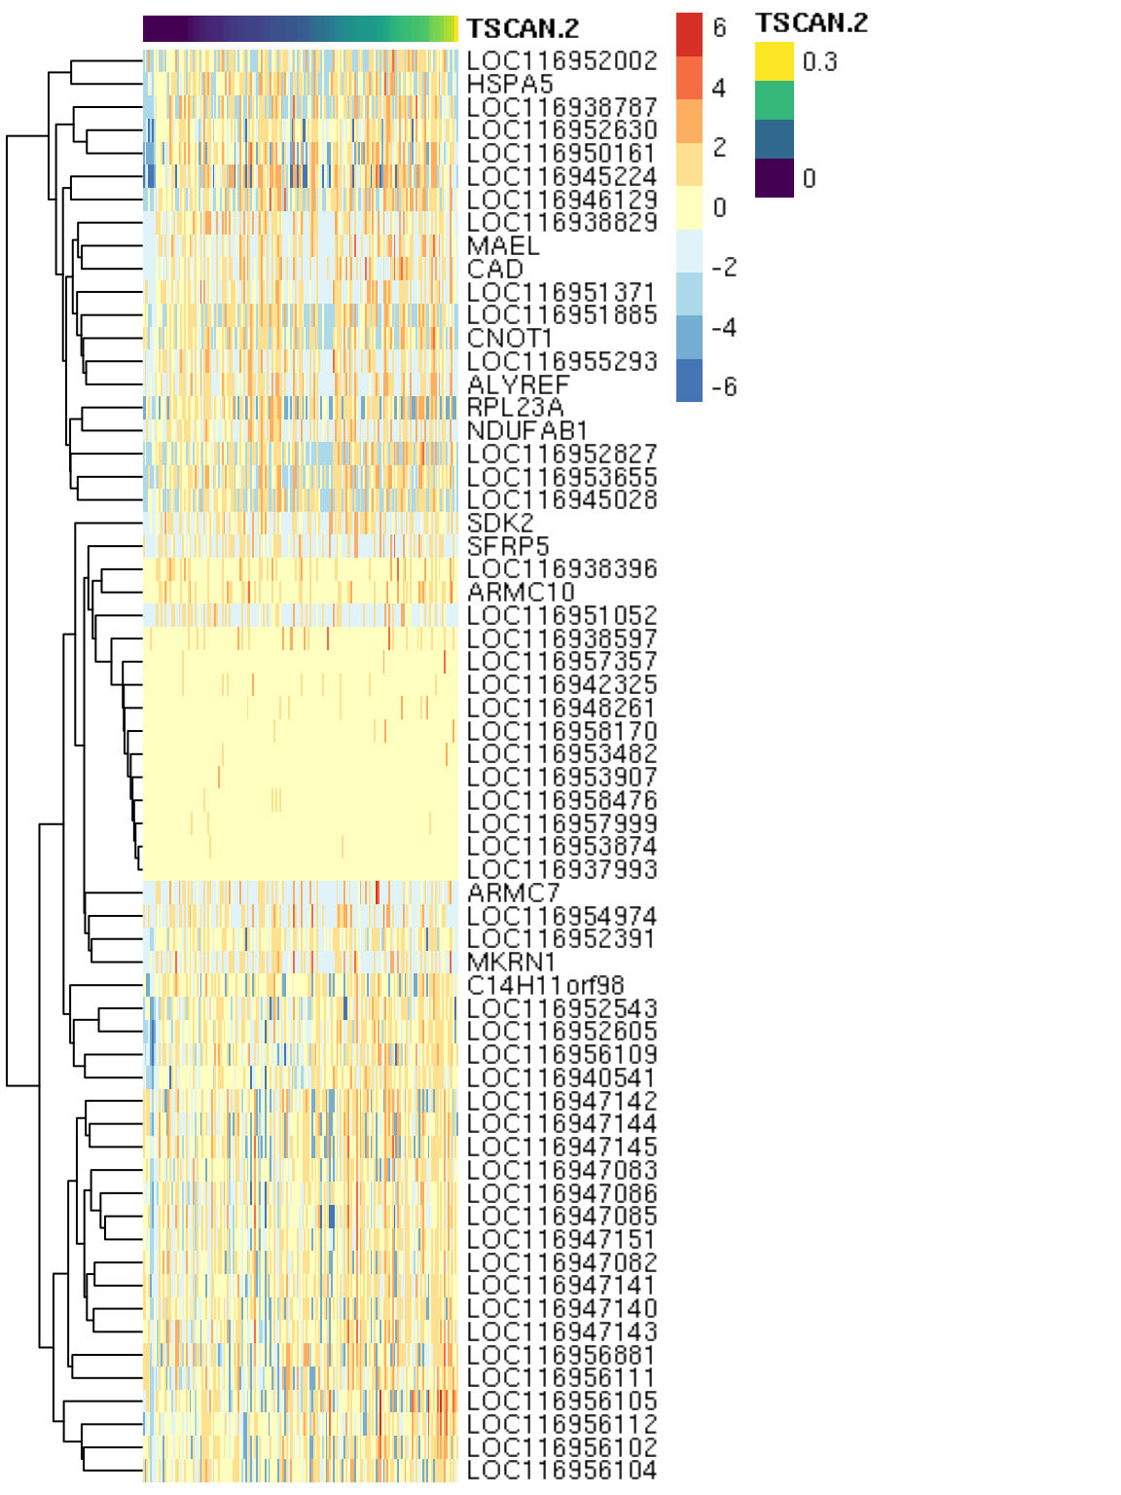

Discussion

Pros and Cons using Monocle vs. Scatter
Implication of gene expression patterns in specific cell types
Implication of pseudotime trajectory of gene expression leading to female vs. male pathway
Conclusion/Summary

References:

