The models we will be doing is modeling a cylindrical superconductor, and place it in a magnetic field. The magnetic field should bend around the superconductor and not penetrate it. We will then change the geometry from a cylinder to a prism and do the same thing to see if and how the geometry changed what the magnetic field does, inside the shape and outside the shape as the object becomes a superconductor. To do this we will need to construct the 3d shapes in python and find what the magnetic field inside the shapes is via:



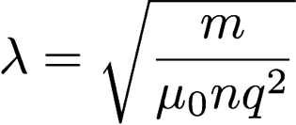

We will also be looking at, the expulsion of the magnetic field from the conductor as the temperature reaches the critical temperature to be a superconductor for both shapes. We will need to calculate the magnetic field and lookup how properties of materials change as temperature changes.

Orientation of spin-magnetic dipoles and Cooper pairing both play huge parts in the formation of the Meissner effect. Investigating these two phenomenon more fully and performing an analysis of both in the familiar case of a cylindrical superconductor and the case of a prism will be an important part of our research. The end result of the project will be multiple graphics and a finished analysis of the difference geometry plays in the Meissner effect. Images such as the one shown below can be used to this effect if an similar image of a prism is displayed along next to it.

[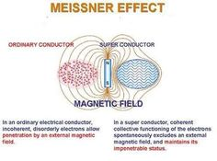](https://www.google.com/search?q=meissner+effect+cylinder&rlz=1C1CHWA_enUS549US549&espv=2&source=lnms&tbm=isch&sa=X&ved=0ahUKEwiKu4PvvPfSAhVs4oMKHdU_BtcQ_AUIBygC&biw=1600&bih=794#imgrc=RgbVJkg-gXhbZM:#)

[https://www.google.com/search?q=meissner+effect+cylinder&rlz=1C1CHWA_enUS549US549&espv=2&source=lnms&tbm=isch&sa=X&ved=0ahUKEwiKu4PvvPfSAhVs4oMKHdU_BtcQ_AUIBygC&biw=1600&bih=794#imgrc=RgbVJkg-gXhbZM:](https://www.google.com/search?q=meissner+effect+cylinder&rlz=1C1CHWA_enUS549US549&espv=2&source=lnms&tbm=isch&sa=X&ved=0ahUKEwiKu4PvvPfSAhVs4oMKHdU_BtcQ_AUIBygC&biw=1600&bih=794%23imgrc=RgbVJkg-gXhbZM:)