Atrial Fibrillation-Associated Hospitalizations Among Children and Adolescents in the United States
  - National Trends and In-Hospital Outcomes, 2017–2022 | NIS Analysis
Muhammad Saad

Preamble
- Study Objective:
- To describe national trends in atrial fibrillation (AF)-associated paediatric hospitalisations in the United States from 2017 to 2022, and to identify independent patient- and hospital-level predictors of the composite Major Adverse In-Hospital Event (MAIE) outcome, which comprises in-hospital mortality, invasive mechanical ventilation, cardiac arrest, and cardiogenic shock.
- Data Source:
- Retrospective cross-sectional analysis of the Nationwide Inpatient Sample (NIS), 2017–2022, developed by the Agency for Healthcare Research and Quality (AHRQ) through the Healthcare Cost and Utilization Project (HCUP). The NIS is the largest all-payer publicly available inpatient database in the United States, comprising an approximately 20% stratified random sample of discharges from non-federal acute-care community hospitals. Survey-weighted analyses generate nationally representative estimates for all US community hospital discharges.
- Cohort Definition:
- All NIS discharges 2017–2022 in which the patient was aged ≤17 years and had an ICD-10-CM diagnosis code for atrial fibrillation (I48.0, I48.11, I48.19, I48.20, I48.21, I48.91) recorded in any of the up to 40 diagnosis fields. Legacy codes I48.1 (persistent AF) and I48.2 (chronic AF), active through FY2019, are included to ensure consistent longitudinal coverage across the 2017–2019 period before subcoding was introduced. Atrial flutter codes (I48.3, I48.4) are excluded. Discharges with ICD-10-PCS codes for cardiac Replacement or Repair (Section 02R*, 02Q*) are excluded, as post-surgical AF represents a distinct and more benign clinical trajectory. Discharges with missing principal diagnosis or missing discharge weight are excluded.
- Exposures:
- Year of hospitalisation (2017–2022) entered as a continuous linear integer in regression models to estimate the annual temporal trend. In a sensitivity analysis, year is modelled as a 6-level categorical variable (reference: 2017).
- Primary Outcome:
- Composite Major Adverse In-Hospital Event (MAIE): any of in-hospital mortality, invasive mechanical ventilation (ICD-10-PCS: 5A1935Z, 5A1945Z, 5A1955Z), cardiac arrest (I46.0, I46.2, I46.8, I46.9), or cardiogenic shock (R57.0).
- Secondary Outcomes:
- In-hospital mortality; length of stay (days); inflation-adjusted hospitalisation cost (total charges × cost-to-charge ratio, adjusted to 2022 USD using the Medical Care Consumer Price Index); non-home discharge (discharge to skilled nursing facility, long-term acute care, rehabilitation, against medical advice, or in-hospital death).
- Trend Denominator:
- AF admissions per 100,000 total paediatric NIS hospitalisations per year. This rate-based metric accounts for year-to-year fluctuations in overall paediatric admission volume (including the COVID-19–related decline in 2020) and provides a valid basis for epidemiological trend inference. The denominator is computed from all paediatric discharges (age ≤17) prior to cohort restrictions.
- Covariates:
- Age (continuous, years), sex (reference: Male), race/ethnicity (reference: White), median household income quartile by ZIP code (reference: Q1 — lowest), primary expected payer (reference: Private), hospital region (reference: Northeast), hospital bed size (reference: Large), hospital location and teaching status (reference: Urban teaching), admission type (reference: Non-elective), transfer-in status (reference: No transfer), structural congenital heart disease (ICD-10-CM Q20–Q26; reference: No), Elixhauser Comorbidity Index (continuous).
- Statistical Methods:
- All analyses account for the complex survey design of the NIS using the survey package in R 4.5.1, with discharge-level weights, hospital-level clustering, and NIS strata. Baseline characteristics are summarised by year using weighted proportions (categorical variables) and weighted means with standard deviations (continuous variables); between-year differences are tested using the Rao–Scott chi-square test (categorical) and design-based t-test (continuous). The primary MAIE model uses survey-weighted quasibinomial logistic regression. Length of stay is modelled with Gaussian linear regression. Hospitalisation costs are modelled with Gamma regression with log link, the standard approach for right-skewed positive cost data. In-hospital mortality and non-home discharge are each modelled with survey-weighted quasibinomial logistic regression. Two pre-specified sensitivity analyses were conducted: (1) restricting the cohort to discharges where AF was the principal diagnosis, and (2) modelling year as a categorical variable.

Annual Trends: Hospitalisation Volume and Rate
Year | Weighted AF Hospitalizations | Total Pediatric Hospitalizations | AF Rate per 100,000 (95% CI)
2017 | 520 | 5,375,840 | 9.7 (7.3–12.0)
2018 | 670 | 5,266,260 | 12.7 (10.0–15.5)
2019 | 690 | 5,199,464 | 13.3 (10.3–16.3)
2020 | 545 | 4,687,162 | 11.6 (8.6–14.7)
2021 | 620 | 4,890,712 | 12.7 (9.6–15.7)
2022 | 605 | 5,027,451 | 12.0 (9.2–14.8)

Baseline Characteristics
Characteristic | Overall N = 3,650¹ | 2017 N = 520¹ | 2018 N = 670¹ | 2019 N = 690¹ | 2020 N = 545¹ | 2021 N = 620¹ | 2022 N = 605¹ | p-value²
Age, years | 12.0 (6.0) | 10.5 (6.7) | 11.9 (6.2) | 11.9 (6.0) | 11.9 (6.0) | 13.3 (5.2) | 12.3 (5.6) | 0.041
Sex |  |  |  |  |  |  |  | 0.6
Male | 2,385 (66%) | 345 (66%) | 455 (68%) | 425 (62%) | 330 (61%) | 400 (66%) | 430 (71%)
Female | 1,255 (34%) | 175 (34%) | 215 (32%) | 265 (38%) | 215 (39%) | 210 (34%) | 175 (29%)
Race/Ethnicity |  |  |  |  |  |  |  | 0.7
White | 1,845 (54%) | 275 (57%) | 375 (58%) | 345 (52%) | 290 (56%) | 280 (50%) | 280 (48%)
Asian or Pacific Islander | 105 (3.0%) | 20 (4.2%) | 10 (1.6%) | 30 (4.5%) | 20 (3.9%) | 10 (1.8%) | 15 (2.6%)
Black | 650 (19%) | 55 (11%) | 120 (19%) | 110 (17%) | 95 (18%) | 140 (25%) | 130 (22%)
Hispanic | 600 (17%) | 105 (22%) | 105 (16%) | 115 (17%) | 60 (12%) | 95 (17%) | 120 (21%)
Other | 245 (7.1%) | 25 (5.2%) | 35 (5.4%) | 60 (9.1%) | 50 (9.7%) | 40 (7.1%) | 35 (6.0%)
Median Household Income Quartile (ZIP code) |  |  |  |  |  |  |  | 0.8
Q1 | 1,085 (30%) | 160 (31%) | 220 (33%) | 225 (33%) | 130 (24%) | 185 (30%) | 165 (27%)
Q2 | 960 (26%) | 160 (31%) | 145 (22%) | 195 (29%) | 145 (27%) | 165 (27%) | 150 (25%)
Q3 | 840 (23%) | 90 (17%) | 160 (24%) | 160 (24%) | 130 (24%) | 140 (23%) | 160 (26%)
Q4 | 740 (20%) | 110 (21%) | 145 (22%) | 100 (15%) | 130 (24%) | 125 (20%) | 130 (21%)
Primary Expected Payer |  |  |  |  |  |  |  | 0.4
Private | 1,650 (45%) | 225 (43%) | 315 (47%) | 340 (49%) | 255 (47%) | 230 (37%) | 285 (47%)
Medicaid | 1,680 (46%) | 265 (51%) | 285 (43%) | 285 (41%) | 245 (45%) | 335 (54%) | 265 (44%)
Medicare | 60 (1.6%) | 0 (0%) | 30 (4.5%) | 5 (0.7%) | 5 (0.9%) | 15 (2.4%) | 5 (0.8%)
Other | 260 (7.1%) | 30 (5.8%) | 40 (6.0%) | 60 (8.7%) | 40 (7.3%) | 40 (6.5%) | 50 (8.3%)
Hospital Region |  |  |  |  |  |  |  | 0.8
Northeast | 595 (16%) | 90 (17%) | 80 (12%) | 120 (17%) | 110 (20%) | 105 (17%) | 90 (15%)
Midwest | 780 (21%) | 85 (16%) | 180 (27%) | 150 (22%) | 90 (17%) | 150 (24%) | 125 (21%)
South | 1,640 (45%) | 230 (44%) | 270 (40%) | 290 (42%) | 285 (52%) | 260 (42%) | 305 (50%)
West | 635 (17%) | 115 (22%) | 140 (21%) | 130 (19%) | 60 (11%) | 105 (17%) | 85 (14%)
Hospital Bed Size |  |  |  |  |  |  |  | 0.6
Large | 2,095 (57%) | 255 (49%) | 365 (54%) | 405 (59%) | 370 (68%) | 345 (56%) | 355 (59%)
Medium | 855 (23%) | 130 (25%) | 170 (25%) | 145 (21%) | 95 (17%) | 140 (23%) | 175 (29%)
Small | 700 (19%) | 135 (26%) | 135 (20%) | 140 (20%) | 80 (15%) | 135 (22%) | 75 (12%)
Hospital Location and Teaching Status |  |  |  |  |  |  |  | 0.002
Urban, teaching | 3,455 (95%) | 460 (88%) | 595 (89%) | 670 (97%) | 535 (98%) | 605 (98%) | 590 (98%)
Rural | 65 (1.8%) | 25 (4.8%) | 10 (1.5%) | 5 (0.7%) | 5 (0.9%) | 5 (0.8%) | 15 (2.5%)
Urban, non-teaching | 130 (3.6%) | 35 (6.7%) | 65 (9.7%) | 15 (2.2%) | 5 (0.9%) | 10 (1.6%) | 0 (0%)
Admission Type |  |  |  |  |  |  |  | 0.13
Non-elective | 2,995 (82%) | 385 (75%) | 540 (81%) | 570 (83%) | 435 (80%) | 540 (87%) | 525 (88%)
Elective | 640 (18%) | 130 (25%) | 125 (19%) | 120 (17%) | 110 (20%) | 80 (13%) | 75 (12%)
Transfer-in |  |  |  |  |  |  |  | 0.9
No transfer | 2,455 (68%) | 335 (64%) | 445 (66%) | 475 (69%) | 390 (72%) | 420 (68%) | 390 (65%)
Transferred in | 1,180 (32%) | 185 (36%) | 225 (34%) | 210 (31%) | 155 (28%) | 195 (32%) | 210 (35%)
Elixhauser Comorbidity Index | 2.60 (1.62) | 2.31 (1.52) | 2.58 (1.57) | 2.41 (1.39) | 2.60 (1.64) | 2.85 (1.81) | 2.81 (1.71) | 0.13
Structural Congenital Heart Disease | 635 (17%) | 100 (19%) | 120 (18%) | 130 (19%) | 80 (15%) | 90 (15%) | 115 (19%) | 0.8
¹Mean (SD); n (%)
²Design-based KruskalWallis test; Pearson's X^2: Rao & Scott adjustment

Outcomes by Year
Characteristic | Overall N = 3,650¹ | 2017 N = 520¹ | 2018 N = 670¹ | 2019 N = 690¹ | 2020 N = 545¹ | 2021 N = 620¹ | 2022 N = 605¹ | p-value²
Major Adverse In-Hospital Event (MAIE) | 570 (16%) | 65 (12%) | 110 (16%) | 60 (8.7%) | 105 (19%) | 125 (20%) | 105 (17%) | 0.11
In-Hospital Mortality | 160 (4.4%) | 5 (1.0%) | 40 (6.0%) | 10 (1.4%) | 10 (1.8%) | 55 (8.9%) | 40 (6.6%) | 0.009
Invasive Mechanical Ventilation | 475 (13%) | 55 (11%) | 80 (12%) | 45 (6.5%) | 90 (17%) | 115 (19%) | 90 (15%) | 0.068
Cardiac Arrest | 175 (4.8%) | 5 (1.0%) | 35 (5.2%) | 10 (1.4%) | 35 (6.4%) | 45 (7.3%) | 45 (7.4%) | 0.053
Cardiogenic Shock | 120 (3.3%) | 15 (2.9%) | 30 (4.5%) | 5 (0.7%) | 15 (2.8%) | 20 (3.2%) | 35 (5.8%) | 0.3
Length of Stay, days | 3 (1, 8) | 2 (1, 7) | 3 (1, 9) | 3 (1, 6) | 3 (1, 9) | 3 (1, 8) | 3 (1, 7) | >0.9
Inflation-Adjusted Hospitalization Cost (2022 USD) | 13,863 (5,985, 44,588) | 11,139 (5,017, 40,583) | 13,789 (5,158, 41,742) | 12,484 (4,945, 34,143) | 17,070 (6,792, 61,643) | 20,235 (8,009, 53,650) | 13,448 (6,195, 36,333) | 0.024
Non-Home Discharge | 540 (15%) | 60 (12%) | 115 (17%) | 70 (10%) | 70 (13%) | 110 (18%) | 115 (19%) | 0.3
¹n (%); Median (Q1, Q3)
²Pearson's X^2: Rao & Scott adjustment; Design-based KruskalWallis test

Top-10 Principal Diagnoses
 | Rank | ICD-10-CM Code | Weighted n
I4891 | 1 | I4891 | 635
I480 | 2 | I480 | 210
I471 | 3 | I471 | 180
I4892 | 4 | I4892 | 135
A419 | 5 | A419 | 65
Z3801 | 6 | Z3801 | 65
I456 | 7 | I456 | 55
Q234 | 8 | Q234 | 55
I4819 | 9 | I4819 | 50
I472 | 10 | I472 | 40

Primary Outcome: Predictors of Major Adverse In-Hospital Event (MAIE)
Characteristic | OR | 95% CI | p-value
Year (continuous, 2017–2022) | 1.02 | 0.88, 1.19 | 0.8
Age, years | 0.94 | 0.90, 0.98 | 0.005
Sex
Male | — | —
Female | 0.69 | 0.41, 1.16 | 0.2
Race/Ethnicity
White | — | —
Asian or Pacific Islander | 0.28 | 0.03, 2.58 | 0.3
Black | 0.86 | 0.46, 1.61 | 0.6
Hispanic | 0.84 | 0.42, 1.69 | 0.6
Other | 1.15 | 0.44, 3.02 | 0.8
Primary Expected Payer
Private | — | —
Medicaid | 1.36 | 0.79, 2.35 | 0.3
Medicare | 0.42 | 0.04, 4.72 | 0.5
Other | 1.42 | 0.46, 4.37 | 0.5
Median Household Income Quartile (ZIP code)
Q1 | — | —
Q2 | 0.99 | 0.50, 1.93 | >0.9
Q3 | 0.75 | 0.38, 1.50 | 0.4
Q4 | 1.55 | 0.80, 3.01 | 0.2
Hospital Region
Northeast | — | —
Midwest | 1.61 | 0.69, 3.74 | 0.3
South | 1.45 | 0.66, 3.21 | 0.4
West | 1.13 | 0.47, 2.76 | 0.8
Hospital Bed Size
Large | — | —
Medium | 1.15 | 0.66, 2.00 | 0.6
Small | 0.96 | 0.47, 1.96 | >0.9
Hospital Location and Teaching Status
Urban, teaching | — | —
Rural | 0.35 | 0.02, 7.49 | 0.5
Urban, non-teaching | 0.25 | 0.03, 1.74 | 0.2
Admission Type
Non-elective | — | —
Elective | 0.59 | 0.28, 1.22 | 0.2
Transfer-in
No transfer | — | —
Transferred in | 1.11 | 0.67, 1.84 | 0.7
Structural Congenital Heart Disease
No | — | —
Yes | 2.11 | 1.20, 3.69 | 0.009
Elixhauser Comorbidity Index | 1.71 | 1.43, 2.05 | <0.001
Abbreviations: CI = Confidence Interval, OR = Odds Ratio

Secondary Outcome: Length of Stay
Characteristic | Beta | 95% CI | p-value
Year (continuous, 2017–2022) | -0.02 | -0.64, 0.59 | >0.9
Age, years | -0.55 | -0.82, -0.28 | <0.001
Sex
Male | — | —
Female | 0.41 | -1.8, 2.6 | 0.7
Race/Ethnicity
White | — | —
Asian or Pacific Islander | 1.9 | -3.9, 7.7 | 0.5
Black | -0.53 | -3.4, 2.3 | 0.7
Hispanic | 0.77 | -1.9, 3.4 | 0.6
Other | 4.8 | -2.4, 12 | 0.2
Primary Expected Payer
Private | — | —
Medicaid | -0.29 | -2.6, 2.0 | 0.8
Medicare | -8.4 | -14, -3.0 | 0.003
Other | -3.2 | -6.0, -0.32 | 0.029
Median Household Income Quartile (ZIP code)
Q1 | — | —
Q2 | 1.7 | -1.2, 4.5 | 0.2
Q3 | 0.89 | -1.8, 3.5 | 0.5
Q4 | 0.46 | -2.5, 3.4 | 0.8
Hospital Region
Northeast | — | —
Midwest | -0.22 | -3.2, 2.7 | 0.9
South | -0.20 | -3.1, 2.7 | 0.9
West | 0.40 | -3.0, 3.8 | 0.8
Hospital Bed Size
Large | — | —
Medium | 0.81 | -1.3, 2.9 | 0.4
Small | 2.8 | -0.41, 6.1 | 0.087
Hospital Location and Teaching Status
Urban, teaching | — | —
Rural | -8.0 | -13, -2.8 | 0.003
Urban, non-teaching | -2.5 | -6.3, 1.3 | 0.2
Admission Type
Non-elective | — | —
Elective | -1.4 | -4.0, 1.2 | 0.3
Transfer-in
No transfer | — | —
Transferred in | 0.38 | -1.8, 2.6 | 0.7
Structural Congenital Heart Disease
No | — | —
Yes | 4.0 | 0.01, 8.0 | 0.050
Elixhauser Comorbidity Index | 2.1 | 1.1, 3.2 | <0.001
Abbreviation: CI = Confidence Interval

Secondary Outcome: Hospitalization Costs
Characteristic | exp(Beta) | 95% CI | p-value
Year (continuous, 2017–2022) | 1.0 | 0.93, 1.07 | 0.9
Age, years | 0.96 | 0.94, 0.98 | 0.001
Sex
Male | — | —
Female | 0.96 | 0.75, 1.23 | 0.7
Race/Ethnicity
White | — | —
Asian or Pacific Islander | 1.08 | 0.68, 1.72 | 0.7
Black | 1.05 | 0.72, 1.54 | 0.8
Hispanic | 1.05 | 0.77, 1.43 | 0.8
Other | 1.37 | 0.72, 2.59 | 0.3
Primary Expected Payer
Private | — | —
Medicaid | 1.23 | 0.95, 1.58 | 0.11
Medicare | 0.56 | 0.23, 1.38 | 0.2
Other | 1.18 | 0.72, 1.93 | 0.5
Median Household Income Quartile (ZIP code)
Q1 | — | —
Q2 | 1.39 | 0.98, 1.98 | 0.063
Q3 | 1.25 | 0.92, 1.71 | 0.15
Q4 | 1.23 | 0.89, 1.69 | 0.2
Hospital Region
Northeast | — | —
Midwest | 0.75 | 0.49, 1.16 | 0.2
South | 0.81 | 0.53, 1.23 | 0.3
West | 1.27 | 0.79, 2.04 | 0.3
Hospital Bed Size
Large | — | —
Medium | 1.25 | 0.98, 1.59 | 0.073
Small | 1.18 | 0.85, 1.64 | 0.3
Hospital Location and Teaching Status
Urban, teaching | — | —
Rural | 0.22 | 0.09, 0.56 | 0.002
Urban, non-teaching | 0.57 | 0.32, 1.03 | 0.061
Admission Type
Non-elective | — | —
Elective | 1.17 | 0.89, 1.54 | 0.3
Transfer-in
No transfer | — | —
Transferred in | 0.95 | 0.75, 1.22 | 0.7
Structural Congenital Heart Disease
No | — | —
Yes | 2.21 | 1.58, 3.10 | <0.001
Elixhauser Comorbidity Index | 1.47 | 1.35, 1.59 | <0.001
Abbreviation: CI = Confidence Interval

Secondary Outcome: In-Hospital Mortality
Characteristic | OR | 95% CI | p-value
Year (continuous, 2017–2022) | 1.14 | 0.88, 1.50 | 0.3
Age, years | 0.94 | 0.87, 1.01 | 0.11
Sex
Male | — | —
Female | 0.86 | 0.33, 2.26 | 0.8
Race/Ethnicity
White | — | —
Asian or Pacific Islander | 0.00 | 0.00, 0.00 | <0.001
Black | 1.49 | 0.49, 4.56 | 0.5
Hispanic | 0.67 | 0.18, 2.56 | 0.6
Other | 0.67 | 0.05, 9.03 | 0.8
Primary Expected Payer
Private | — | —
Medicaid | 0.85 | 0.30, 2.41 | 0.8
Medicare | 2.37 | 0.23, 24.5 | 0.5
Other | 2.46 | 0.67, 9.08 | 0.2
Median Household Income Quartile (ZIP code)
Q1 | — | —
Q2 | 0.48 | 0.12, 1.91 | 0.3
Q3 | 0.48 | 0.12, 1.82 | 0.3
Q4 | 0.54 | 0.14, 2.02 | 0.4
Hospital Region
Northeast | — | —
Midwest | 13.6 | 1.59, 117 | 0.017
South | 2.70 | 0.31, 23.8 | 0.4
West | 5.39 | 0.51, 56.9 | 0.2
Hospital Bed Size
Large | — | —
Medium | 1.78 | 0.59, 5.36 | 0.3
Small | 0.42 | 0.10, 1.74 | 0.2
Hospital Location and Teaching Status
Urban, teaching | — | —
Rural | 0.00 | 0.00, 0.00 | <0.001
Urban, non-teaching | 0.00 | 0.00, 0.00 | <0.001
Admission Type
Non-elective | — | —
Elective | 0.00 | 0.00, 0.00 | <0.001
Transfer-in
No transfer | — | —
Transferred in | 0.95 | 0.33, 2.71 | >0.9
Structural Congenital Heart Disease
No | — | —
Yes | 1.32 | 0.40, 4.33 | 0.6
Elixhauser Comorbidity Index | 1.88 | 1.47, 2.40 | <0.001
Abbreviations: CI = Confidence Interval, OR = Odds Ratio

Secondary Outcome: Non-Home Discharge
Characteristic | OR | 95% CI | p-value
Year (continuous, 2017–2022) | 1.04 | 0.89, 1.21 | 0.7
Age, years | 0.99 | 0.95, 1.04 | 0.7
Sex
Male | — | —
Female | 1.27 | 0.76, 2.15 | 0.4
Race/Ethnicity
White | — | —
Asian or Pacific Islander | 1.34 | 0.29, 6.26 | 0.7
Black | 1.16 | 0.59, 2.27 | 0.7
Hispanic | 0.72 | 0.36, 1.43 | 0.3
Other | 2.07 | 0.86, 4.97 | 0.10
Primary Expected Payer
Private | — | —
Medicaid | 0.98 | 0.60, 1.63 | >0.9
Medicare | 3.20 | 0.48, 21.1 | 0.2
Other | 1.22 | 0.44, 3.40 | 0.7
Median Household Income Quartile (ZIP code)
Q1 | — | —
Q2 | 0.98 | 0.52, 1.85 | >0.9
Q3 | 0.50 | 0.24, 1.05 | 0.065
Q4 | 0.74 | 0.36, 1.50 | 0.4
Hospital Region
Northeast | — | —
Midwest | 0.87 | 0.43, 1.74 | 0.7
South | 0.57 | 0.30, 1.10 | 0.10
West | 0.81 | 0.36, 1.81 | 0.6
Hospital Bed Size
Large | — | —
Medium | 0.81 | 0.46, 1.41 | 0.5
Small | 0.64 | 0.30, 1.35 | 0.2
Hospital Location and Teaching Status
Urban, teaching | — | —
Rural | 4.17 | 0.65, 26.9 | 0.13
Urban, non-teaching | 1.60 | 0.52, 4.98 | 0.4
Admission Type
Non-elective | — | —
Elective | 0.52 | 0.23, 1.17 | 0.11
Transfer-in
No transfer | — | —
Transferred in | 1.12 | 0.66, 1.88 | 0.7
Structural Congenital Heart Disease
No | — | —
Yes | 1.00 | 0.54, 1.85 | >0.9
Elixhauser Comorbidity Index | 1.52 | 1.30, 1.76 | <0.001
Abbreviations: CI = Confidence Interval, OR = Odds Ratio

Figures

Figure 1 — Annual Hospitalisation Volume and Population-Adjusted Rate
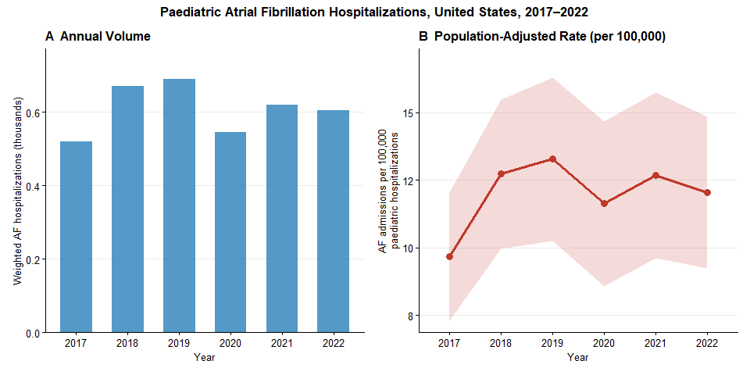
Paediatric atrial fibrillation hospitalizations by year (bars, left axis) and population-adjusted rate per 100,000 total paediatric hospitalizations with 95% confidence intervals (line and shaded ribbon, right axis), United States, 2017–2022. Bars reflect nationally representative weighted estimates. The rate metric accounts for year-to-year variation in overall paediatric admission volume, including the COVID-19–related decline in 2020.

Figure 2 — Predictors of Major Adverse In-Hospital Event (MAIE)
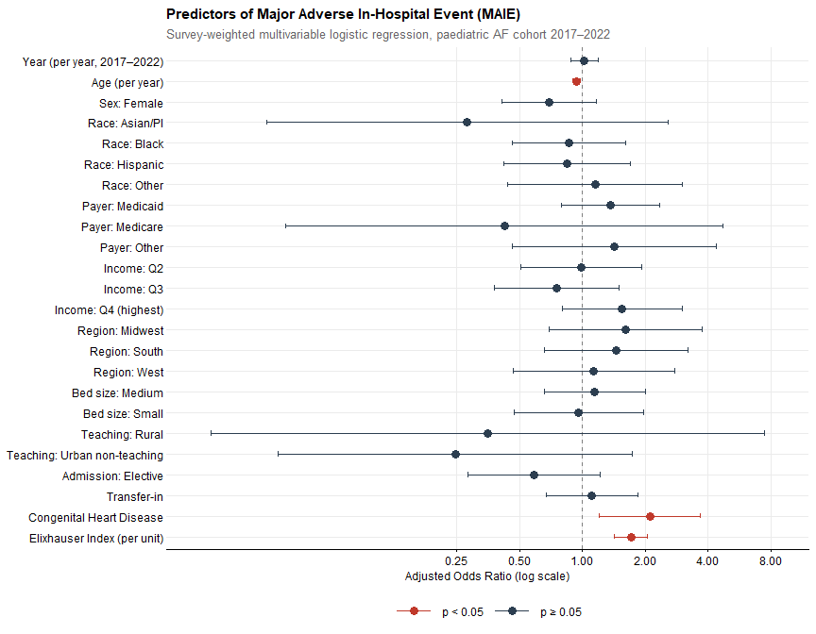
Adjusted odds ratios (aOR) with 95% confidence intervals for predictors of the composite Major Adverse In-Hospital Event (MAIE) outcome, from survey-weighted multivariable logistic regression. Red indicates p < 0.05; dark navy indicates p ≥ 0.05. Reference categories for categorical variables: Male sex; White race; Private insurance; Income Q1 (lowest); Northeast region; Large bed size; Urban teaching hospital; Non-elective admission; No transfer-in; No congenital heart disease.

Sensitivity Analysis 1: AF as Principal Diagnosis
Sensitivity Analysis 1 cohort: N = 190, MAIE events = 3
Fewer than 30 MAIE events in this subgroup — results reported descriptively only.

Sensitivity Analysis 2: Year as Categorical Variable
Characteristic | OR | 95% CI | p-value
Year (categorical, reference = 2017)
2017 | — | —
2018 | 1.18 | 0.46, 2.99 | 0.7
2019 | 0.51 | 0.18, 1.44 | 0.2
2020 | 1.35 | 0.49, 3.71 | 0.6
2021 | 1.42 | 0.55, 3.69 | 0.5
2022 | 0.88 | 0.33, 2.38 | 0.8
AGE | 0.94 | 0.90, 0.98 | 0.004
FEMALE
Male | — | —
Female | 0.67 | 0.40, 1.14 | 0.14
RACE
White | — | —
Asian or Pacific Islander | 0.29 | 0.03, 2.79 | 0.3
Black | 0.80 | 0.43, 1.50 | 0.5
Hispanic | 0.84 | 0.41, 1.70 | 0.6
Other | 1.22 | 0.48, 3.12 | 0.7
Insurance
Private | — | —
Medicaid | 1.31 | 0.76, 2.29 | 0.3
Medicare | 0.41 | 0.04, 3.78 | 0.4
Other | 1.43 | 0.46, 4.41 | 0.5
ZIPINC_QRTL
Q1 | — | —
Q2 | 0.94 | 0.48, 1.85 | 0.9
Q3 | 0.71 | 0.36, 1.41 | 0.3
Q4 | 1.43 | 0.74, 2.77 | 0.3
HOSP_REGION
Northeast | — | —
Midwest | 1.62 | 0.70, 3.78 | 0.3
South | 1.45 | 0.65, 3.22 | 0.4
West | 1.14 | 0.46, 2.82 | 0.8
HOSP_BEDSIZE
Large | — | —
Medium | 1.20 | 0.68, 2.12 | 0.5
Small | 0.97 | 0.47, 2.00 | >0.9
HOSP_LOCTEACH
Urban, teaching | — | —
Rural | 0.38 | 0.02, 7.55 | 0.5
Urban, non-teaching | 0.22 | 0.03, 1.72 | 0.15
ELECTIVE
Non-elective | — | —
Elective | 0.56 | 0.26, 1.17 | 0.12
TRAN_IN
No transfer | — | —
Transferred in | 1.11 | 0.66, 1.85 | 0.7
CongenitalHD
No | — | —
Yes | 2.21 | 1.26, 3.87 | 0.006
elixsum | 1.71 | 1.42, 2.05 | <0.001
Abbreviations: CI = Confidence Interval, OR = Odds Ratio

