Alcohol Withdrawal Syndrome in Adult Traumatic Brain Injury with Alcohol Use Disorder
  - National Inpatient Sample, 2017–2022
Muhammad Saad
Table of contents

Key Findings
 | - The cohort represented 249,570 hospitalizations nationally; 58,270 (23.3%) had coded alcohol withdrawal syndrome (AWS).  - AWS was documented in 23.3% of hospitalizations across 2017–2022.  - AWS was associated with lower adjusted odds of in-hospital death (adjusted odds ratio [aOR], 0.60 (0.53–0.67)).  - AWS was associated with higher adjusted odds of invasive ventilation (1.42 (1.34–1.50)), pneumonia or aspiration (2.32 (2.17–2.49)), institutional discharge among survivors (1.74 (1.65–1.84)), and discharge against medical advice among survivors (1.49 (1.34–1.66)).  - Hospitalizations with AWS had longer stays (11.43 days vs 6.74 days) and higher costs ($42,702 vs $29,159).

Methods

Data and cohort
We analyzed the Healthcare Cost and Utilization Project (HCUP) National Inpatient Sample (NIS) for 2017–2022. The cohort included adult hospitalizations for acute traumatic brain injury (TBI) with documented alcohol use disorder. Each record represents a hospitalization, not a unique person. Survey weights were used to estimate national patterns.

Exposure, outcomes, and covariates
The exposure was a diagnosis code for AWS during the hospitalization. Outcomes were in-hospital death, invasive mechanical ventilation, pneumonia or aspiration, discharge to an institution, discharge against medical advice, length of stay (LOS), and hospital cost. Adjusted models accounted for patient demographics, hospital characteristics, injury features, and chronic conditions.

Statistical analysis
We compared hospitalizations with and without coded AWS using survey-weighted regression. Adjusted odds ratios summarize the association after accounting for the listed covariates; values above 1 indicate higher odds and values below 1 indicate lower odds. Results describe associations and do not establish cause and effect. All counts and percentages are survey-weighted national estimates, reported as weighted n (weighted %). The analysis included 49,914 sampled hospitalizations, representing 249,570 hospitalizations nationally. Cells based on 10 or fewer sampled hospitalizations are suppressed (≤10) per the HCUP data use agreement.

Cohort Flow
The steps below show how the analytic cohort was selected from NIS hospitalizations.
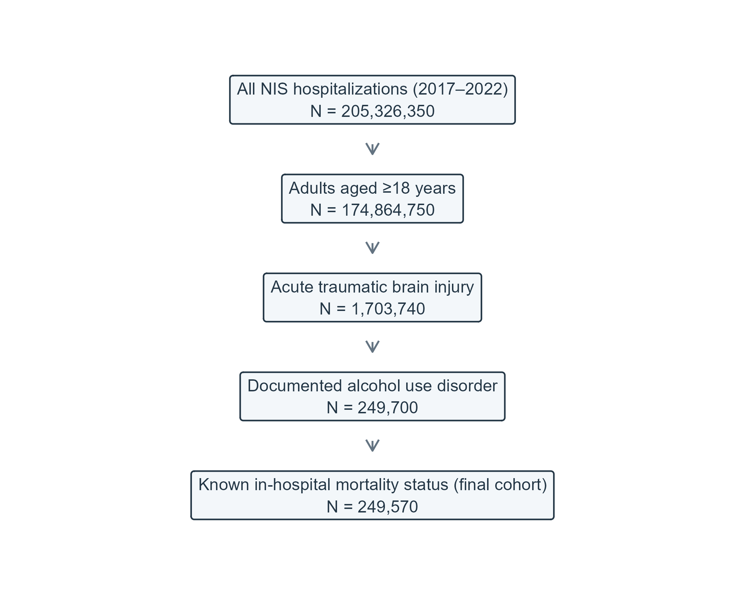
Figure 1: Cohort flow for adult TBI hospitalizations with alcohol use disorder, NIS 2017–2022.

Baseline Characteristics
Baseline characteristics are shown for the full cohort and by coded AWS status.
Table 1: Baseline characteristics of adult TBI hospitalizations by AWS status.
Characteristic | Overall, N = 249,570 | No AWS, N = 191,300 | AWS, N = 58,270 | p-value
Age, years | 53 (38, 63) | 52 (36, 63) | 56 (46, 64) | <0.001
Sex |  |  |  | <0.001
Male | 194,195 (77.8%) | 146,785 (76.7%) | 47,410 (81.4%)
Female | ≤10 | 44,425 (23.2%) | ≤10
Unknown | ≤10 | 90 (0.0%) | ≤10
Race/ethnicity |  |  |  | <0.001
White | 155,975 (62.5%) | 116,220 (60.8%) | 39,755 (68.2%)
Black | 31,640 (12.7%) | 26,040 (13.6%) | 5,600 (9.6%)
Hispanic | 34,230 (13.7%) | 27,185 (14.2%) | 7,045 (12.1%)
Asian or Pacific Islander | 3,400 (1.4%) | 2,765 (1.4%) | 635 (1.1%)
Native American | 5,510 (2.2%) | 4,105 (2.1%) | 1,405 (2.4%)
Other | 9,305 (3.7%) | 7,420 (3.9%) | 1,885 (3.2%)
Unknown | 9,510 (3.8%) | 7,565 (4.0%) | 1,945 (3.3%)
Primary expected payer |  |  |  | <0.001
Medicare | 62,235 (24.9%) | 46,655 (24.4%) | 15,580 (26.7%)
Medicaid | 72,170 (28.9%) | 52,335 (27.4%) | 19,835 (34.0%)
Private including HMO | 70,490 (28.2%) | 56,710 (29.6%) | 13,780 (23.6%)
Self-pay | 29,185 (11.7%) | 23,665 (12.4%) | 5,520 (9.5%)
No charge | 2,720 (1.1%) | 2,160 (1.1%) | 560 (1.0%)
Other | 12,000 (4.8%) | 9,150 (4.8%) | 2,850 (4.9%)
Unknown | 770 (0.3%) | 625 (0.3%) | 145 (0.2%)
Median household income quartile for patient ZIP code |  |  |  | <0.001
Q1 | 75,235 (30.1%) | 59,195 (30.9%) | 16,040 (27.5%)
Q2 | 59,755 (23.9%) | 46,300 (24.2%) | 13,455 (23.1%)
Q3 | 57,325 (23.0%) | 43,500 (22.7%) | 13,825 (23.7%)
Q4 | 47,240 (18.9%) | 35,295 (18.5%) | 11,945 (20.5%)
Unknown | 10,015 (4.0%) | 7,010 (3.7%) | 3,005 (5.2%)
Calendar era |  |  |  | <0.001
2017–2019 | 123,830 (49.6%) | 97,035 (50.7%) | 26,795 (46.0%)
2020 | 43,375 (17.4%) | 32,850 (17.2%) | 10,525 (18.1%)
2021–2022 | 82,365 (33.0%) | 61,415 (32.1%) | 20,950 (36.0%)
Hospital census region |  |  |  | <0.001
Northeast | 42,520 (17.0%) | 31,325 (16.4%) | 11,195 (19.2%)
Midwest | 57,745 (23.1%) | 45,160 (23.6%) | 12,585 (21.6%)
South | 81,475 (32.6%) | 63,950 (33.4%) | 17,525 (30.1%)
West | 67,830 (27.2%) | 50,865 (26.6%) | 16,965 (29.1%)
Hospital bed size |  |  |  | 0.001
Small | 25,450 (10.2%) | 18,955 (9.9%) | 6,495 (11.1%)
Medium | 65,185 (26.1%) | 49,750 (26.0%) | 15,435 (26.5%)
Large | 158,935 (63.7%) | 122,595 (64.1%) | 36,340 (62.4%)
Hospital location and teaching status |  |  |  | <0.001
Rural | 5,605 (2.2%) | 4,190 (2.2%) | 1,415 (2.4%)
Urban, non-teaching | 24,335 (9.8%) | 17,945 (9.4%) | 6,390 (11.0%)
Urban, teaching | 219,630 (88.0%) | 169,165 (88.4%) | 50,465 (86.6%)
TBI injury subtype |  |  |  | <0.001
Concussion, other or unspecified only | 59,690 (23.9%) | 48,555 (25.4%) | 11,135 (19.1%)
Diffuse injury or brain compression | 17,425 (7.0%) | 13,230 (6.9%) | 4,195 (7.2%)
Epidural hemorrhage | 10,290 (4.1%) | 8,075 (4.2%) | 2,215 (3.8%)
Subdural hemorrhage | 102,945 (41.2%) | 75,315 (39.4%) | 27,630 (47.4%)
Contusion/focal, SAH, or edema | 59,220 (23.7%) | 46,125 (24.1%) | 13,095 (22.5%)
Skull fracture | 50,520 (20.2%) | 41,215 (21.5%) | 9,305 (16.0%) | <0.001
Any injury code outside the head (initial encounter) | 113,500 (45.5%) | 91,155 (47.7%) | 22,345 (38.3%) | <0.001
TBI as principal diagnosis | 169,495 (67.9%) | 130,580 (68.3%) | 38,915 (66.8%) | 0.004
Chronic comorbidity count (Elixhauser refined) |  |  |  | <0.001
0 | 88,240 (35.4%) | 74,960 (39.2%) | 13,280 (22.8%)
1 | 72,700 (29.1%) | 54,345 (28.4%) | 18,355 (31.5%)
2 | 46,225 (18.5%) | 32,285 (16.9%) | 13,940 (23.9%)
>=3 | 42,405 (17.0%) | 29,710 (15.5%) | 12,695 (21.8%)
Hypertension | 110,430 (44.2%) | 78,965 (41.3%) | 31,465 (54.0%) | <0.001
Diabetes mellitus | 26,935 (10.8%) | 20,550 (10.7%) | 6,385 (11.0%) | 0.5
Chronic pulmonary disease | 30,550 (12.2%) | 22,120 (11.6%) | 8,430 (14.5%) | <0.001
Heart failure | 12,130 (4.9%) | 8,245 (4.3%) | 3,885 (6.7%) | <0.001
Chronic kidney disease | 7,815 (3.1%) | 6,055 (3.2%) | 1,760 (3.0%) | 0.4
Depression | 33,620 (13.5%) | 23,235 (12.1%) | 10,385 (17.8%) | <0.001
Obesity | 13,865 (5.6%) | 10,705 (5.6%) | 3,160 (5.4%) | 0.5
Any liver disease (K70–K77) | 35,040 (14.0%) | 19,715 (10.3%) | 15,325 (26.3%) | <0.001
Alcoholic liver disease (K70) | 21,585 (8.6%) | 11,295 (5.9%) | 10,290 (17.7%) | <0.001
Other substance use disorder | 41,135 (16.5%) | 32,465 (17.0%) | 8,670 (14.9%) | <0.001
Current or past tobacco/nicotine use | 112,100 (44.9%) | 84,825 (44.3%) | 27,275 (46.8%) | <0.001

Values are survey-weighted national estimates, n (%), unless stated otherwise.

In-Hospital Outcomes
The table presents crude comparisons and adjusted associations for the prespecified outcomes. Continuous outcomes are shown as weighted means. The adjusted estimate compares the odds or mean outcome for hospitalizations with AWS versus those without AWS, after covariate adjustment.
Table 2: Crude and adjusted in-hospital outcomes by AWS status.
Outcome | No AWS, N = 191,300 | AWS, N = 58,270 | Unadjusted OR/ratio (95% CI) | Adjusted OR/ratio (95% CI) | Adjusted difference (95% CI) | p-value
In-hospital mortality | 10,140 (5.3%) | 2,330 (4.0%) | 0.74 (0.67–0.83) | 0.60 (0.53–0.67) | -2.04% (-2.46% to -1.63%) | <0.001
Invasive mechanical ventilation | 42,330 (22.1%) | 15,150 (26.0%) | 1.24 (1.18–1.30) | 1.42 (1.34–1.50) | +5.97% (+4.94% to +7.00%) | <0.001
Pneumonia or aspiration pneumonitis | 15,000 (7.8%) | 10,480 (18.0%) | 2.58 (2.43–2.74) | 2.32 (2.17–2.49) | +8.49% (+7.70% to +9.29%) | <0.001
Institutional discharge (among survivors) | 46,550 (25.7%) | 22,310 (39.9%) | 1.92 (1.83–2.01) | 1.74 (1.65–1.84) | +10.38% (+9.35% to +11.40%) | <0.001
Discharge against medical advice (among survivors) | 7,530 (4.2%) | 3,150 (5.6%) | 1.38 (1.25–1.52) | 1.49 (1.34–1.66) | +1.75% (+1.23% to +2.27%) | <0.001
Length of stay | 6.7 days | 12.1 days | 1.80 (1.75–1.86) | 1.70 (1.64–1.75) | +4.69 days (+4.38 to +5.00) | <0.001
Hospital cost | $29,446 | $42,535 | 1.44 (1.41–1.48) | 1.46 (1.42–1.51) | +$13,543 (+$12,456 to +$14,630) | <0.001

Values are survey-weighted national estimates, n (%), unless stated otherwise.

Adjusted Odds Ratios for In-Hospital Outcomes
The estimates summarize adjusted associations between coded AWS and five binary outcomes. The vertical reference line at 1 marks equal odds between groups; confidence intervals crossing 1 are compatible with no difference at the 95% confidence level.
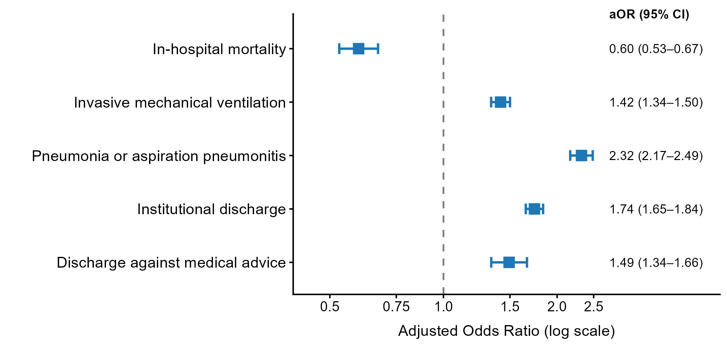
Figure 2: Adjusted odds ratios and 95% confidence intervals for in-hospital outcomes.

Annual Trend
The figure shows the annual percentage of eligible hospitalizations with coded AWS. Changes over time may reflect coding practices as well as changes in the hospitalized population.
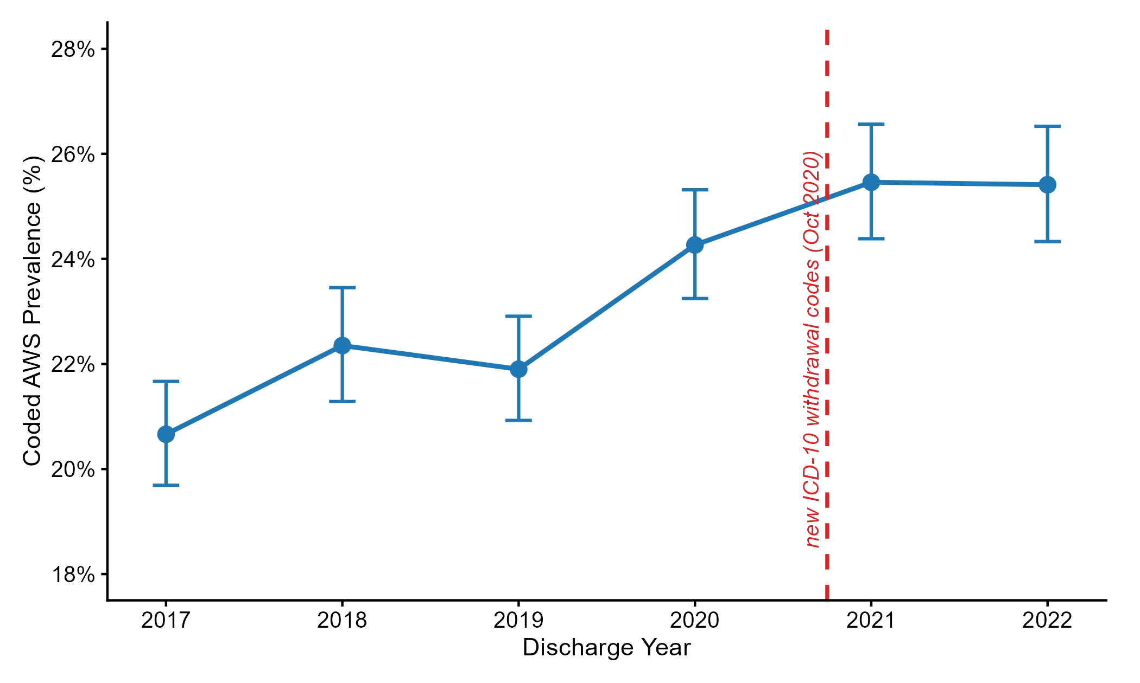
Figure 3: Annual prevalence of coded AWS among eligible hospitalizations.

Sensitivity Analyses
We repeated the mortality analysis after restricting the cohort to hospitalizations with LOS ≥2 days, requiring TBI to be the principal diagnosis, and excluding hospitalizations transferred in. The inverse association with mortality was smaller in the LOS-restricted analysis (0.70 (0.62–0.80)), a pattern consistent with early death or short stays leaving less opportunity for AWS recognition and coding. This does not identify the mechanism behind the association.
Table 3: Sensitivity analyses for in-hospital mortality.
Analysis | Hospitalizations, weighted n | Deaths, weighted n (weighted %) | Adjusted OR (95% CI) | p-value
Primary analysis (full cohort) | 229,740 | 11,080 (4.8%) | 0.60 (0.53–0.67) | <0.001
LOS ≥2 days | 187,470 | 8,280 (4.4%) | 0.70 (0.62–0.80) | <0.001
TBI as principal diagnosis | 156,170 | 8,990 (5.8%) | 0.58 (0.51–0.66) | <0.001
Exclude transferred-in | 192,550 | 8,660 (4.5%) | 0.59 (0.52–0.68) | <0.001

Values are survey-weighted national estimates, n (%), unless stated otherwise.

Limitations
This analysis uses administrative discharge records, so diagnoses may be missing or inconsistently coded. The NIS does not provide diagnosis timing or Present on Admission indicators; we cannot determine whether AWS or other outcomes began before or during the hospitalization. The lower mortality association may reflect survivor and coding bias: patients who die early or have short stays may have less opportunity for AWS to be recognized and coded. The LOS ≥2 days sensitivity analysis addresses part of this concern but cannot remove it. The database also lacks detailed clinical severity measures, linked records across hospitals, and inpatient medication data. Findings should therefore be interpreted as associations among hospitalizations, not treatment effects or patient-level risks.

References and Data Citation
Healthcare Cost and Utilization Project (HCUP). National Inpatient Sample (NIS), 2017–2022. Agency for Healthcare Research and Quality, Rockville, MD. HCUP data are made available through the HCUP Partners.

Appendix. ICD-10-CM Code List
Table A1. ICD-10-CM code groups used to identify the cohort and study conditions.
Condition | ICD-10 code(s) | Description
Acute traumatic brain injury (TBI) | S06.xxxA | Intracranial injury, initial encounter (7th character A, length 7)
Active alcohol use disorder (AUD) | F10.1, F10.2 | Alcohol abuse or dependence (excluding remission-only codes F10.11, F10.21)
Alcohol withdrawal syndrome (AWS) | F10.230–F10.239, F10.130–F10.139 | Alcohol withdrawal with or without delirium or perceptual disturbance (F10.13x valid from Oct 2020)
Invasive mechanical ventilation (IMV) | 5A1935Z, 5A1945Z, 5A1955Z | Invasive mechanical ventilation (<24h, 24–96h, >96h; ICD-10-PCS)
Pneumonia | J12–J18 | Viral, bacterial, or unspecified pneumonia
Aspiration pneumonitis | J69.0 | Pneumonitis due to inhalation of food and vomit
Other substance use disorder | F11–F16, F18, F19 | Other drug abuse or dependence (excluding remission-only codes)
Any liver disease | K70–K77 | Any acute or chronic liver disease
Alcoholic liver disease | K70 | Alcoholic liver disease
Skull fracture | S02.0, S02.1, S02.91 | Fracture of vault, base, or unspecified skull (7th character A or B)
Extracranial injury | S10–S99 | Trauma outside the head (initial encounter; 7th character A, B, or C)
Tobacco use | F17, Z72.0, Z87.891 | Current nicotine dependence or documented tobacco use history
Values are survey-weighted national estimates, n (%), unless stated otherwise.

