Thirty-day readmission after percutaneous left atrial appendage occlusion in dialysis-dependent kidney failure
  - Nationwide Readmissions Database, 2016–2022 — statistical report
Statistical analysis: Saad
2026-09-28
Table of contents

1. Provenance
Run provenance.
Item | Value
Study | NRD_Saad_LAAO_ESKD
Run at | 2026-09-28 00:20:13 PKT
R version | R version 4.6.1 (2026-06-24 ucrt)
survey package | 4.5
Platform | x86_64-w64-mingw32
Elapsed | 3.38 minutes
Stages completed | baseline, outcomes, regression, causes, subgroups, trends, diagnostics, sensitivity, figures, guards
Data | HCUP Nationwide Readmissions Database 2016-2022

2. Methods
The subsections below are written as manuscript prose and are intended to be moved into the Methods section of the paper with minimal editing. They are deliberately self-contained: nothing in them depends on having read the rest of this report.

2.1 Data source
We analysed the Healthcare Cost and Utilization Project (HCUP) Nationwide Readmissions Database (NRD) for discharge years 2016 to 2022. The NRD is a nationally representative all-payer administrative database constructed from HCUP State Inpatient Databases in participating states, containing verified patient linkage numbers that permit a patient to be tracked across hospitals within a single calendar year. It does not link patients across calendar years, does not contain geographic identifiers below the level of the nation, and does not contain a race or ethnicity variable; none of these limitations can be circumvented and each is addressed explicitly in the Limitations. Discharge weights supplied with the data, together with the sampling stratum and the hospital identifier, were used to produce nationally representative estimates. The Nationwide Readmissions Database contains de-identified, publicly available administrative data and this analysis was therefore determined to be non-human-subjects research and exempt from institutional review board review. The HCUP Data Use Agreement was executed before any data were accessed. Reporting follows STROBE, with the RECORD extension for routinely collected health data.

2.2 Cohort
We identified all adult hospitalizations with an any-listed ICD-10-PCS code for percutaneous left atrial appendage occlusion with an intraluminal device (02L73DK). Discharges coded with an extraluminal device (02L73CK) or with an unspecified device (02L73ZK) were excluded from the cohort definition: these denote different procedures with different complication profiles, and their number is reported in the cohort flow. We then excluded hospitalizations of patients younger than 18 years; hospitalizations ending in in-hospital death, because a decedent cannot be readmitted; hospitalizations ending in transfer to another short-term acute care hospital, because the discharge does not end the episode of care and a subsequent admission would be an artefact of the transfer; December discharges, because NRD linkage does not cross calendar years and a 30-day window would be incomplete by construction; records without the identifiers required for linkage; and hospitalizations with concomitant coronary artery bypass grafting, a surgical or transcatheter valve procedure, or an open or thoracoscopic left atrial appendage operation, because these change length of stay and the complication structure entirely. All code lists are published in full in the supplement. Analyses were performed at the level of the hospitalization; a small number of patients contributed more than one qualifying admission within a calendar year, and restricting to the first such admission per patient-year is a pre-specified sensitivity analysis.

2.3 Exposure
The exposure was dialysis-dependent kidney failure, defined as the conjunction of an any-listed ICD-10-CM diagnosis of end-stage renal disease (N18.6) and at least one marker of dialysis dependence: dependence on renal dialysis (Z99.2), an encounter for fitting, adjustment or adequacy testing of a dialysis catheter (Z49.01, Z49.02, Z49.31, Z49.32), performance of urinary filtration (5A1D60Z, 5A1D70Z, 5A1D80Z), or peritoneal dialysis (3E1M39Z). The code 5A1D90Z, which denotes continuous urinary filtration for more than 18 hours per day, was deliberately not treated as a marker of dialysis dependence: it identifies continuous renal replacement therapy in a critically ill patient with acute kidney injury rather than maintenance dialysis, and including it would contaminate the exposed arm and invert the clinical meaning of the exposure. Requiring both components is what makes the exposure dialysis dependence rather than coded kidney failure; the wider definition, an N18.6 diagnosis with or without a dialysis marker, is reported as a pre-specified sensitivity analysis.

2.4 Outcomes
The primary outcome was all-cause readmission to any hospital within 30 days of discharge from the index hospitalization. Secondary outcomes, forming a single pre-specified family, were: readmission with a bleeding principal diagnosis (AHRQ DXCCSR category DIG021, or an intracranial haemorrhage code I60-I62, or acute posthaemorrhagic anaemia D62); readmission with an ischaemic stroke principal diagnosis (DXCCSR CIR020); unplanned (non-elective) readmission; in-hospital death during the readmission; pericardial effusion or tamponade during the index hospitalization; pericardial drainage during the index hospitalization; and non-home discharge from the index hospitalization. Acute kidney injury during the index hospitalization is reported descriptively in the unexposed arm only: on a maintenance-dialysis background an N17 code does not carry its usual meaning and a between-arm comparison would be uninterpretable rather than merely imprecise. Index in-hospital mortality is reported on the full procedural cohort, before the discharge-survivor restriction, because that is the only denominator on which it is interpretable. Costs were obtained by multiplying total charges by the HCUP hospital-specific cost-to-charge ratio and were inflation-adjusted to 2022 US dollars using the CPI-U, All Items, U.S. city average, not seasonally adjusted, annual average (BLS series CUUR0000SA0).

2.5 Statistical analysis
All analyses accounted for the complex survey design using the discharge weight, the sampling stratum and the hospital as the primary sampling unit. Because stratum and hospital identifiers are re-issued in each data year and do not refer to the same unit across years, year-unique stratum and cluster identifiers were constructed before the design was specified; a single survey design object was built once on the complete cohort and every subsequent analysis was taken as a subset of it, so that stratum information required for variance estimation was never discarded. Strata containing a single primary sampling unit were centred at the grand mean rather than dropped.
Baseline characteristics are reported as design-weighted percentages with unweighted counts, and are compared using standardized mean differences rather than p-values, because in a cohort of this size every p-value would be small and none would describe the magnitude of an imbalance.
The primary model was a survey-weighted logistic regression of 30-day all-cause readmission on dialysis-dependent kidney failure. Age was modelled as a restricted cubic spline rather than as a linear or categorical term. The covariate block was deliberately compact and fixed a priori: sex, primary expected payer, ZIP-code median income quartile, NCHS urban-rural residence, admission type, hospital bed size, hospital location and teaching status, discharge year, hospital left atrial appendage occlusion volume tertile computed within year on the full procedural population before exclusions, the components of the CHA₂DS₂-VASc score, the bleeding-relevant components of HAS-BLED, and a residual Elixhauser comorbidity count. Renal failure was excluded from that count because it is collinear with the exposure by construction, and so was every comorbidity entered individually, so that no comorbidity contributes twice. No stepwise or data-driven variable selection was performed at any point.
Because 30-day readmission is common in this population, odds ratios materially overstate risk ratios, so adjusted absolute risks were obtained by marginal standardization (g-computation) over the observed covariate distribution of the whole analytic cohort, with variance by the delta method on the design-based covariance matrix and t critical values on the design degrees of freedom. A propensity-score overlap-weighted (ATO) estimate was treated as co-primary rather than as a sensitivity analysis: it reduces the outcome model to a single exposure term while balancing the full covariate set through the propensity score, which is the appropriate response to a study whose exposed arm is small. The outcome model was refitted on the overlap-weighted design, making that estimator doubly robust; the design-based variance treats the estimated weights as fixed, which is standard practice and mildly conservative for overlap weights.
An E-value was computed on the risk ratio scale to quantify the strength of unmeasured confounding that would be required to explain the finding. A pre-specified negative control outcome with no plausible causal link to the exposure was analysed using the identical model. Secondary outcomes were adjusted for multiplicity within their pre-specified family using the Benjamini-Hochberg procedure; the primary outcome was tested once, unadjusted, and is the only confirmatory test in the paper. Sensitivity analyses were not multiplicity-corrected and are judged on movement of the point estimate. Subgroup analyses were exploratory, were assessed by design-based interaction tests rather than by comparing subgroup confidence intervals, and are not reported in the Conclusions. Cells representing fewer than 11 unweighted discharges are suppressed throughout in accordance with the HCUP Data Use Agreement. Analyses were performed in R version 4.6.1 (2026-06-24 ucrt) using the survey package version 4.5.

3. Cohort construction
Cohort construction (unweighted discharge records).
Step | Cohort definition step | Unweighted discharges remaining | Excluded at this step
0 | All NRD discharges, 2016-2022 | 121,011,259
1 | Any-listed percutaneous LAA occlusion with an intraluminal device (02L73DK) | 112,890 | 120,898,369
2 | Age >= 18 years | 112,868 | 22
3 | Survived the index admission (DIED = 0) | 112,712 | 156
4 | Not transferred to another short-term hospital | 112,637 | 75
5 | Discharged in months 1-11 (complete 30-day follow-up window) | 102,141 | 10,496
6–7 | Linkable (NRD_VISITLINK, NRD_DAYSTOEVENT and LOS all recorded); No concomitant cardiac surgery, valve procedure or open LAA operation | 101,865 | 276
8 | Complete on every primary-model covariate | 101,813 | 52

A step that excluded between 1 and 10 discharges is merged with its neighbour so that no small exclusion can be recovered by subtraction.
Device-code and concomitant-procedure accounting.
Item | Unweighted N
Discharges with 02L73CK or 02L73ZK and no 02L73DK (excluded from the cohort definition) | 2,448
02L73DK discharges in which it is the PRINCIPAL procedure (I10_PR1) | 104,748
02L73DK discharges with a concomitant CABG | 39
02L73DK discharges with a concomitant valve procedure | 224
of which transcatheter aortic valve replacement | 127
02L73DK discharges with a concomitant open or thoracoscopic LAA operation | 51
Discharges carrying 5A1D90Z (CRRT) with no maintenance-dialysis marker (NOT counted as exposed) | <11 (suppressed)

Codes 02L73CK (extraluminal device) and 02L73ZK (unspecified device) lie outside the cohort definition and are counted here rather than in the attrition ladder. ICD-10-PCS cannot identify the device model, so no device-generation comparison is possible from these data.
Missingness on primary-model covariates (index cohort).
Variable | Missing n | Missing % | Handling
Admission type | 52 | 0.05% | Complete case
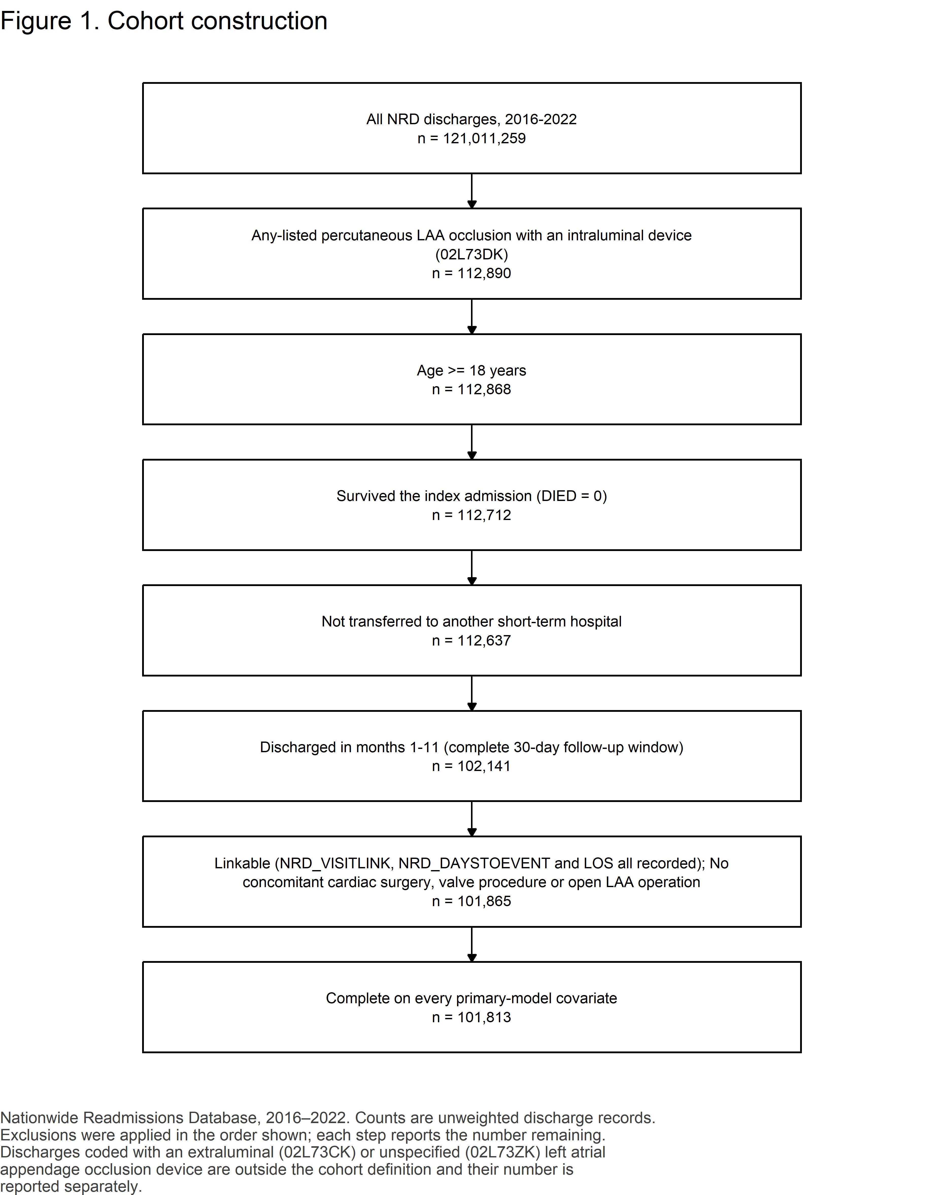
Figure 1. Cohort construction.

4. Results

4.1 Baseline characteristics
Table 1. Baseline characteristics of index hospitalizations, by dialysis-dependent kidney failure.
Characteristic | Overall (unweighted n = 101,813) | No dialysis-dependent kidney failure (unweighted n = 99,395) | Dialysis-dependent kidney failure (unweighted n = 2,418) | SMD
Age, years, mean (SD) | 76.2 (7.7) | 76.3 (7.7) | 71.3 (9.2) | 0.587
Age group, % (unweighted n) |  |  |  | 0.457
<75 years | 38.7% (38,857) | 38.2% (37,403) | 60.5% (1,454)
≥75 years | 61.3% (62,956) | 61.8% (61,992) | 39.5% (964)
Sex, % (unweighted n) |  |  |  | 0.144
Male | 58.5% (59,871) | 58.3% (58,285) | 65.3% (1,586)
Female | 41.5% (41,942) | 41.7% (41,110) | 34.7% (832)
Primary expected payer, % (unweighted n) |  |  |  | suppressed
Medicare | 90.0% (91,495) | 90.0% (89,296) | 91.2% (2,199)
Private | 7.1% (7,251) | 7.1% (7,123) | 5.2% (128)
Medicaid | <11 (suppressed) | 1.1% (1,091) | <11 (suppressed)
Other/self-pay | 1.8% (1,815) | 1.8% (1,767) | 2.0% (48)
Missing/other | <11 (suppressed) | 0.1% (118) | <11 (suppressed)
Median household income quartile (patient ZIP code), % (unweighted n) |  |  |  | 0.142
0-25th percentile | 21.8% (21,139) | 21.7% (20,504) | 27.8% (635)
26th to 50th percentile | 27.5% (26,797) | 27.5% (26,154) | 27.5% (643)
51st to 75th percentile | 27.4% (27,970) | 27.4% (27,372) | 24.5% (598)
76th to 100th percentile | 22.3% (24,722) | 22.4% (24,203) | 19.4% (519)
Missing/other | 1.0% (1,185) | 1.0% (1,162) | 0.9% (23)
Patient residence (NCHS urban-rural classification), % (unweighted n) |  |  |  | suppressed
Central metro ≥1 million | 18.3% (20,578) | 18.1% (19,904) | 26.4% (674)
Fringe metro ≥1 million | 26.3% (25,492) | 26.3% (24,872) | 26.6% (620)
Metro 250,000-999,999 | 27.4% (29,262) | 27.5% (28,660) | 23.4% (602)
Metro 50,000-249,999 | 11.1% (11,137) | 11.2% (10,910) | 9.6% (227)
Micropolitan | 9.0% (8,396) | 9.0% (8,241) | 7.0% (155)
Other | <11 (suppressed) | 7.8% (6,743) | <11 (suppressed)
Missing/other | <11 (suppressed) | 0.1% (65) | <11 (suppressed)
Admission day, % (unweighted n) |  |  |  | 0.080
Weekday (Mon-Fri) | 99.5% (101,255) | 99.5% (98,871) | 98.7% (2,384)
Weekend (Sat-Sun) | 0.5% (558) | 0.5% (524) | 1.3% (34)
Admission type, % (unweighted n) |  |  |  | 0.106
Elective | 93.9% (95,225) | 94.0% (93,022) | 91.3% (2,203)
Non-elective | 6.1% (6,588) | 6.0% (6,373) | 8.7% (215)
Discharge year, % (unweighted n) |  |  |  | 0.114
2016 | 2.5% (2,705) | 2.5% (2,653) | 1.9% (52)
2017 | 5.0% (5,334) | 5.0% (5,194) | 5.3% (140)
2018 | 8.3% (8,733) | 8.3% (8,490) | 9.8% (243)
2019 | 13.6% (14,111) | 13.5% (13,731) | 15.7% (380)
2020 | 14.1% (14,580) | 14.0% (14,163) | 16.9% (417)
2021 | 23.9% (23,943) | 23.9% (23,401) | 22.9% (542)
2022 | 32.6% (32,407) | 32.8% (31,763) | 27.5% (644)
Hospital bed size, % (unweighted n) |  |  |  | 0.041
Large | 69.8% (70,469) | 69.8% (68,731) | 71.7% (1,738)
Medium | 23.1% (24,753) | 23.1% (24,211) | 21.7% (542)
Small | 7.1% (6,591) | 7.1% (6,453) | 6.6% (138)
Hospital location and teaching status, % (unweighted n) |  |  |  | 0.059
Metropolitan, teaching | 86.7% (87,973) | 86.7% (85,844) | 88.3% (2,129)
Metropolitan, non-teaching | 11.4% (12,280) | 11.4% (12,028) | 9.6% (252)
Non-metropolitan | 1.9% (1,560) | 1.9% (1,523) | 2.1% (37)
Hospital ownership, % (unweighted n) |  |  |  | 0.027
Private, not-profit | 79.6% (80,610) | 79.6% (78,677) | 80.0% (1,933)
Government, nonfederal | 6.7% (7,451) | 6.7% (7,259) | 7.3% (192)
Private, invest-own | 13.6% (13,752) | 13.7% (13,459) | 12.7% (293)
Hospital LAAO volume tertile (within year), % (unweighted n) |  |  |  | 0.084
High | 32.4% (34,492) | 32.5% (33,750) | 29.0% (742)
Middle | 34.4% (33,826) | 34.4% (33,051) | 33.9% (775)
Low | 33.2% (33,495) | 33.1% (32,594) | 37.1% (901)
Atrial fibrillation or flutter, % (unweighted n) |  |  |  | suppressed
No | <11 (suppressed) | 0.1% (75) | <11 (suppressed)
Yes | <11 (suppressed) | 99.9% (99,320) | <11 (suppressed)
Congestive heart failure, % (unweighted n) |  |  |  | 0.468
No | 61.3% (62,789) | 61.8% (61,844) | 39.1% (945)
Yes | 38.7% (39,024) | 38.2% (37,551) | 60.9% (1,473)
Hypertension, % (unweighted n) |  |  |  | 0.331
No | 13.0% (13,509) | 13.2% (13,408) | 4.1% (101)
Yes | 87.0% (88,304) | 86.8% (85,987) | 95.9% (2,317)
Diabetes mellitus, % (unweighted n) |  |  |  | 0.636
No | 65.9% (67,524) | 66.6% (66,635) | 36.3% (889)
Yes | 34.1% (34,289) | 33.4% (32,760) | 63.7% (1,529)
Prior stroke, TIA or thromboembolism, % (unweighted n) |  |  |  | 0.063
No | 78.2% (79,466) | 78.1% (77,524) | 80.6% (1,942)
Yes | 21.8% (22,347) | 21.9% (21,871) | 19.4% (476)
Vascular disease (peripheral arterial, aortic or prior myocardial infarction), % (unweighted n) |  |  |  | 0.253
No | 51.9% (53,386) | 52.2% (52,426) | 39.7% (960)
Yes | 48.1% (48,427) | 47.8% (46,969) | 60.3% (1,458)
Prior major bleeding, % (unweighted n) |  |  |  | 0.109
No | 96.0% (97,718) | 96.0% (95,452) | 93.6% (2,266)
Yes | 4.0% (4,095) | 4.0% (3,943) | 6.4% (152)
Liver disease, % (unweighted n) |  |  |  | 0.121
No | 97.1% (98,781) | 97.1% (96,489) | 94.7% (2,292)
Yes | 2.9% (3,032) | 2.9% (2,906) | 5.3% (126)
Alcohol use disorder, % (unweighted n) |  |  |  | 0.007
No | 98.6% (100,370) | 98.6% (97,979) | 98.7% (2,391)
Yes | 1.4% (1,443) | 1.4% (1,416) | 1.3% (27)
Anaemia (deficiency or blood-loss), % (unweighted n) |  |  |  | 0.030
No | 94.3% (96,169) | 94.3% (93,869) | 94.9% (2,300)
Yes | 5.7% (5,644) | 5.7% (5,526) | 5.1% (118)
N18.6 recorded without a dialysis-dependence marker, % (unweighted n) |  |  |  | 0.072
No | 99.7% (101,546) | 99.7% (99,128) | 100.0% (2,418)
Yes | 0.3% (267) | 0.3% (267) | 0.0% (0)
Elixhauser comorbidity count (all 31 flags), mean (SD) | 4.2 (1.8) | 4.2 (1.8) | 6.0 (1.7) | 1.028
Residual Elixhauser comorbidity count, mean (SD) | 2.3 (1.2) | 2.3 (1.2) | 2.7 (1.4) | 0.321

Weighted percentages are design-based national estimates using the HCUP discharge weight; unweighted n is the actual NRD sample size. Continuous variables are reported as design-weighted mean (SD). Standardized mean differences are reported in place of p-values; for a categorical variable the SMD shown is the maximum across its levels. 14 of 23 characteristics show |SMD| >= 0.10: Age, years, mean (SD); Age group, % (unweighted n); Sex, % (unweighted n); Median household income quartile (patient ZIP code), % (unweighted n); Admission type, % (unweighted n); Discharge year, % (unweighted n); Congestive heart failure, % (unweighted n); Hypertension, % (unweighted n); Diabetes mellitus, % (unweighted n); Vascular disease (peripheral arterial, aortic or prior myocardial infarction), % (unweighted n); Prior major bleeding, % (unweighted n); Liver disease, % (unweighted n); Elixhauser comorbidity count (all 31 flags), mean (SD); Residual Elixhauser comorbidity count, mean (SD). Congestive heart failure, hypertension, diabetes, liver disease, alcohol use disorder and anaemia are taken from the AHRQ Elixhauser flags supplied with the data file; prior stroke, transient ischaemic attack or thromboembolism, vascular disease and prior major bleeding are coded from published ICD-10-CM lists. The residual Elixhauser count is the total Elixhauser count less renal failure and less every comorbidity entered individually in the model, so no comorbidity is counted twice. Cells representing fewer than 11 unweighted discharges are suppressed in accordance with the HCUP Data Use Agreement, together with every cell (and SMD) that would allow a suppressed cell to be recovered by subtraction; 12 cell(s) are suppressed in this table.

4.2 Unadjusted outcomes
Table 2. Unadjusted outcomes of the index hospitalization, by exposure.
Outcome | Overall | Unexposed | Exposed
30-day all-cause readmission, % (95% CI) (n) | 7.8% (7.6–8.0) (7,909) | 7.6% (7.3–7.8) (7,448) | 18.9% (17.0–20.7) (461)
Pericardial effusion or tamponade at index, % (95% CI) (n) | 2.5% (2.4–2.7) (2,544) | 2.5% (2.3–2.6) (2,447) | 4.2% (3.2–5.2) (97)
Pericardial drainage at index, % (95% CI) (n) | 0.6% (0.5–0.7) (608) | 0.6% (0.5–0.6) (589) | 0.9% (0.3–1.5) (19)
Vascular complication at index, % (95% CI) (n) | 0.5% (0.5–0.6) (534) | 0.5% (0.5–0.6) (515) | 0.7% (0.4–1.0) (19)
Non-home discharge, % (95% CI) (n) | 1.8% (1.7–2.0) (1,855) | 1.8% (1.7–1.9) (1,764) | 3.8% (2.9–4.8) (91)
Length of stay, days, median (IQR) | 1 (1–1) | 1 (1–1) | 1 (1–1)
Total cost, median (IQR), 2022 US dollars | $28,449 ($21,836–$36,478) | $28,415 ($21,807–$36,441) | $29,980 ($23,338–$37,905)
Total charges, median (IQR), 2022 US dollars | $117,475 ($87,035–$169,713) | $117,232 ($86,840–$169,504) | $126,352 ($95,536–$178,356)

Table 2b. Index in-hospital mortality, computed on the full procedural cohort (which retains in-hospital deaths).
Group | Unweighted n | Weighted N | In-hospital mortality, % (95% CI) | Deaths (unweighted)
Overall | 112,868 | 205,697 | <11 (suppressed) | <11 (suppressed)
No dialysis-dependent kidney failure | 110,181 | 200,868 | <11 (suppressed) | <11 (suppressed)
Dialysis-dependent kidney failure | 2,687 | 4,828 | <11 (suppressed) | <11 (suppressed)

Table 2c. Characteristics of the readmission hospitalization, among index admissions followed by a readmission.
Outcome | Overall | Unexposed | Exposed
Time from index discharge to readmission, days, median (IQR) | 13 (6–20) | 13 (6–20) | 11 (6–19)
Readmission length of stay, days, median (IQR) | 4 (2–6) | 4 (2–6) | 4 (2–6)
Unplanned (non-elective) readmission, % (95% CI) (n) | 96.3% (95.8–96.8) (7,638) | 96.3% (95.8–96.9) (7,191) | 95.9% (93.5–98.3) (447)
In-hospital death at readmission, % (95% CI) (n) | 2.6% (2.2–2.9) (198) | 2.5% (2.1–2.8) (177) | 4.5% (2.5–6.5) (21)
Readmission with a bleeding principal diagnosis, % (95% CI) (n) | 10.6% (9.8–11.3) (833) | 10.5% (9.7–11.3) (781) | 10.9% (7.7–14.2) (52)
Readmission with an ischaemic stroke principal diagnosis, % (95% CI) (n) | <11 (suppressed) | <11 (suppressed) | <11 (suppressed)
Readmission cost, median (IQR), 2022 US dollars | $9,669 ($6,064–$16,674) | $9,520 ($6,021–$16,398) | $12,944 ($7,453–$20,954)

Table 2d. Acute kidney injury during the index hospitalization, unexposed arm only.
Group | Unweighted n | Acute kidney injury at index, % (95% CI) | Events (unweighted)
No dialysis-dependent kidney failure | 99,395 | 1.8% (1.7–1.9) | 1,851

All percentages are design-based national estimates with 95% confidence intervals from the survey design; the figure in parentheses after the interval is the unweighted event count. Readmission, procedural complications, length of stay, cost and disposition are computed on the index cohort (discharge survivors with a complete 30-day window and no concomitant cardiac surgery); in-hospital mortality is computed on the full LAAO cohort, which retains in-hospital deaths, because that is the only denominator on which a mortality rate is interpretable. The two denominators are reported separately and are never mixed. Readmission characteristics are computed on index admissions that were followed by a readmission. A binary outcome with fewer than 11 unweighted events or non-events in either arm is suppressed in every arm and in every table, so that no suppressed count can be recovered by subtraction (suppressed here: Ischaemic stroke readmission; In-hospital death at index). ACUTE KIDNEY INJURY IS REPORTED IN THE UNEXPOSED ARM ONLY (Table 2d): on a maintenance-dialysis background an N17 code does not carry its usual meaning, and a between-arm comparison of it would be uninterpretable rather than merely imprecise. These are unadjusted comparisons; the adjusted estimates are in Table 3.
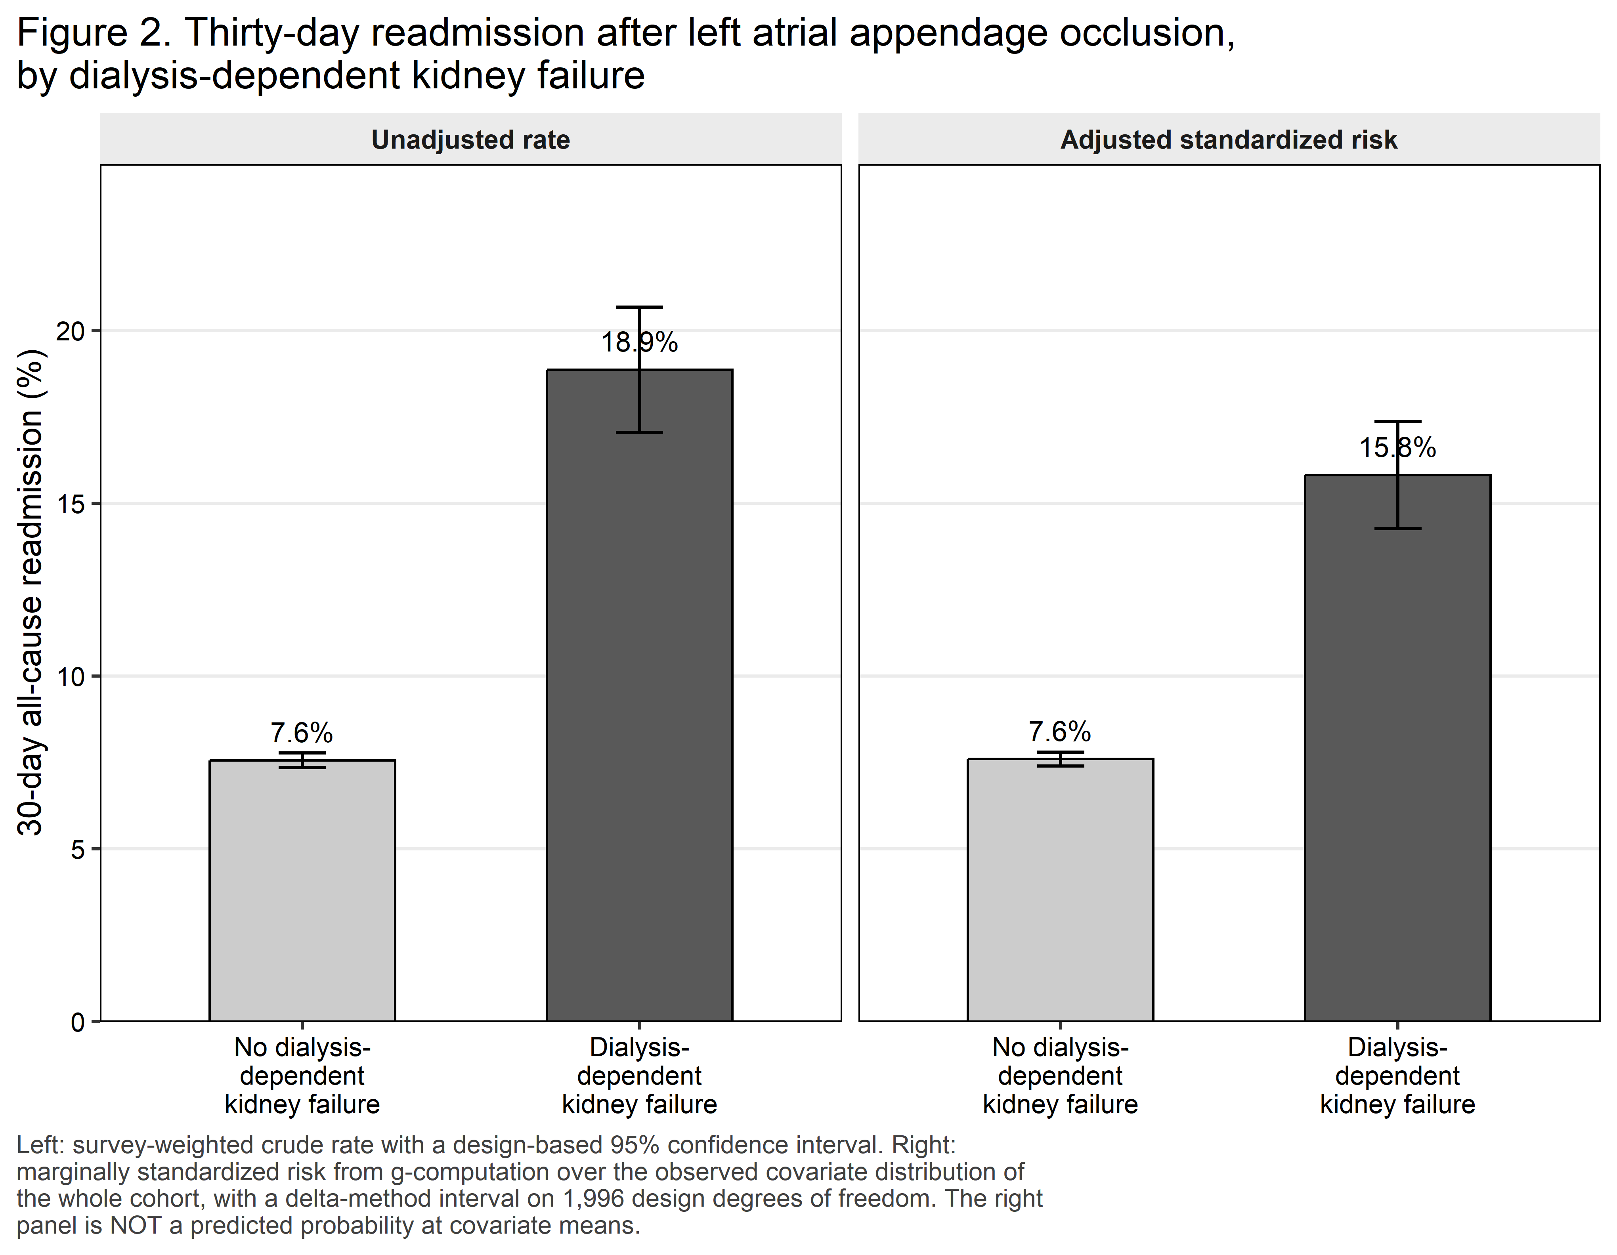
Figure 2. Thirty-day readmission, unadjusted and adjusted.

4.3 Primary analysis
Table 3. Primary model: adjusted odds ratio and adjusted absolute risk of 30-day all-cause readmission.
Quantity | Estimate (95% CI) | p value
Adjusted risk, No dialysis-dependent kidney failure | 7.6% (7.4–7.8)
Adjusted risk, Dialysis-dependent kidney failure | 15.8% (14.3–17.4)
Adjusted risk difference (percentage points) | 8.22 (6.66–9.77) | <0.001
Adjusted risk ratio | 2.08 (1.88–2.30)
Adjusted odds ratio | 2.34 (2.07–2.65) | <0.001
Number needed to be exposed for one additional readmission | 12

Table 3b. The two co-primary estimators.
Analysis | Adjusted OR (95% CI) | p value | Adjusted risk difference, pp (95% CI) | Adjusted risk ratio (95% CI)
Survey-weighted logistic regression – CO-PRIMARY | 2.34 (2.07–2.65) | <0.001 | 8.22 (6.66–9.77) | 2.08 (1.88–2.30)
Overlap-weighted (ATO), doubly robust – CO-PRIMARY | 2.29 (2.02–2.59) | <0.001 | 9.36 (7.64–11.08) | 1.99 (1.81–2.20)

Table 3c. Events-per-parameter accounting.
Quantity | Value
Index admissions analysed | 101,813
Exposed index admissions | 2,418
Readmission events, whole cohort | 7,909
Readmission events, exposed arm | 461
Model parameters (design-matrix columns, excluding intercept) | 42
Events per parameter, whole cohort | 188.3
Exposed events per parameter | 11.0

The primary model is a survey-weighted logistic regression of 30-day all-cause readmission on dialysis-dependent kidney failure, adjusted for the pre-specified compact covariate block: age modelled as a restricted cubic spline with four knots, sex, primary payer, ZIP-code income quartile, NCHS urban-rural residence, admission type, hospital bed size, location and teaching status, discharge year, hospital LAAO volume tertile, the CHA₂DS₂-VASc components (heart failure, hypertension, diabetes, prior stroke/TIA/thromboembolism, vascular disease), the HAS-BLED-adjacent components (prior major bleeding, liver disease, alcohol use disorder, anaemia), and a residual Elixhauser comorbidity count. The full 31-flag Elixhauser set is deliberately NOT used: with this exposed event count it would produce unstable estimates, and the clinically relevant comorbidities are entered individually instead. Renal failure is excluded from the comorbidity count by pre-specification because it is collinear with the exposure by construction. Adjusted absolute risks were obtained by marginal standardization over the whole analytic cohort with delta-method variance on the design-based covariance matrix and t critical values on 1996 design degrees of freedom. No pre-specified covariate required removal by the sparse-cell guard. The overlap-weighted estimate in Table 3b is a CO-PRIMARY estimator in this study rather than a sensitivity analysis, because it reduces the outcome model to a single exposure term while balancing the full covariate set through the propensity score. The effective sample size after overlap weighting was 7,864, and 0 of 20 covariates retained an absolute standardized mean difference of 0.10 or more. Sequential Models 1 to 4 are NOT monotone – check whether a covariate has been misclassified as a mediator. Model 5 is OVER-ADJUSTED: the Model 4 to Model 5 change is attenuation consistent with mediation and is not an adjusted estimate. All secondary outcomes are exploratory and form one Benjamini-Hochberg family (adjusted over the 6 outcome(s) with at least 11 events and non-events in each arm); the primary outcome is not a member of it.
E-value. An unmeasured confounder would need to be associated with both dialysis-dependent kidney failure and 30-day readmission by a risk ratio of at least 3.58 each, above and beyond the measured covariates, to explain away the observed adjusted risk ratio of 2.08; to move the confidence limit closest to the null to 1.00 the required association is 3.17. The most plausible such confounders here are frailty and dialysis vintage, neither of which the Nationwide Readmissions Database records in any form.
Table 3d. Independent cross-check of the marginal standardization.
Quantity | svy_std_risk() | marginaleffects::avg_comparisons() | Absolute difference | Agreement
Adjusted risk difference (percentage points) | 8.2153 | 8.2153 | 0.000000 | AGREE (to three decimal places on the probability scale)

Table 3e. Covariate balance before and after overlap weighting.
Variable | SMD before weighting | SMD after weighting | Balanced (|SMD| < 0.10)
Age, years | 0.587 | 0.000 | Yes
Sex | 0.144 | 0.000 | Yes
Primary expected payer | suppressed | suppressed | suppressed
Median household income quartile (patient ZIP code) | 0.142 | 0.000 | Yes
Patient residence (NCHS urban-rural classification) | suppressed | suppressed | suppressed
Admission type | 0.106 | 0.000 | Yes
Hospital location and teaching status | 0.059 | 0.000 | Yes
Hospital bed size | 0.041 | 0.000 | Yes
Discharge year | 0.114 | 0.000 | Yes
Hospital LAAO volume tertile (within year) | 0.084 | 0.000 | Yes
Congestive heart failure | 0.468 | 0.000 | Yes
Hypertension | 0.331 | 0.000 | Yes
Diabetes mellitus | 0.636 | 0.000 | Yes
Prior stroke, TIA or thromboembolism | 0.063 | 0.000 | Yes
Vascular disease (peripheral arterial, aortic or prior myocardial infarction) | 0.253 | 0.000 | Yes
Prior major bleeding | 0.109 | 0.000 | Yes
Liver disease | 0.121 | 0.000 | Yes
Alcohol use disorder | 0.007 | 0.000 | Yes
Anaemia (deficiency or blood-loss) | 0.030 | 0.000 | Yes
Residual Elixhauser comorbidity count | 0.321 | 0.000 | Yes
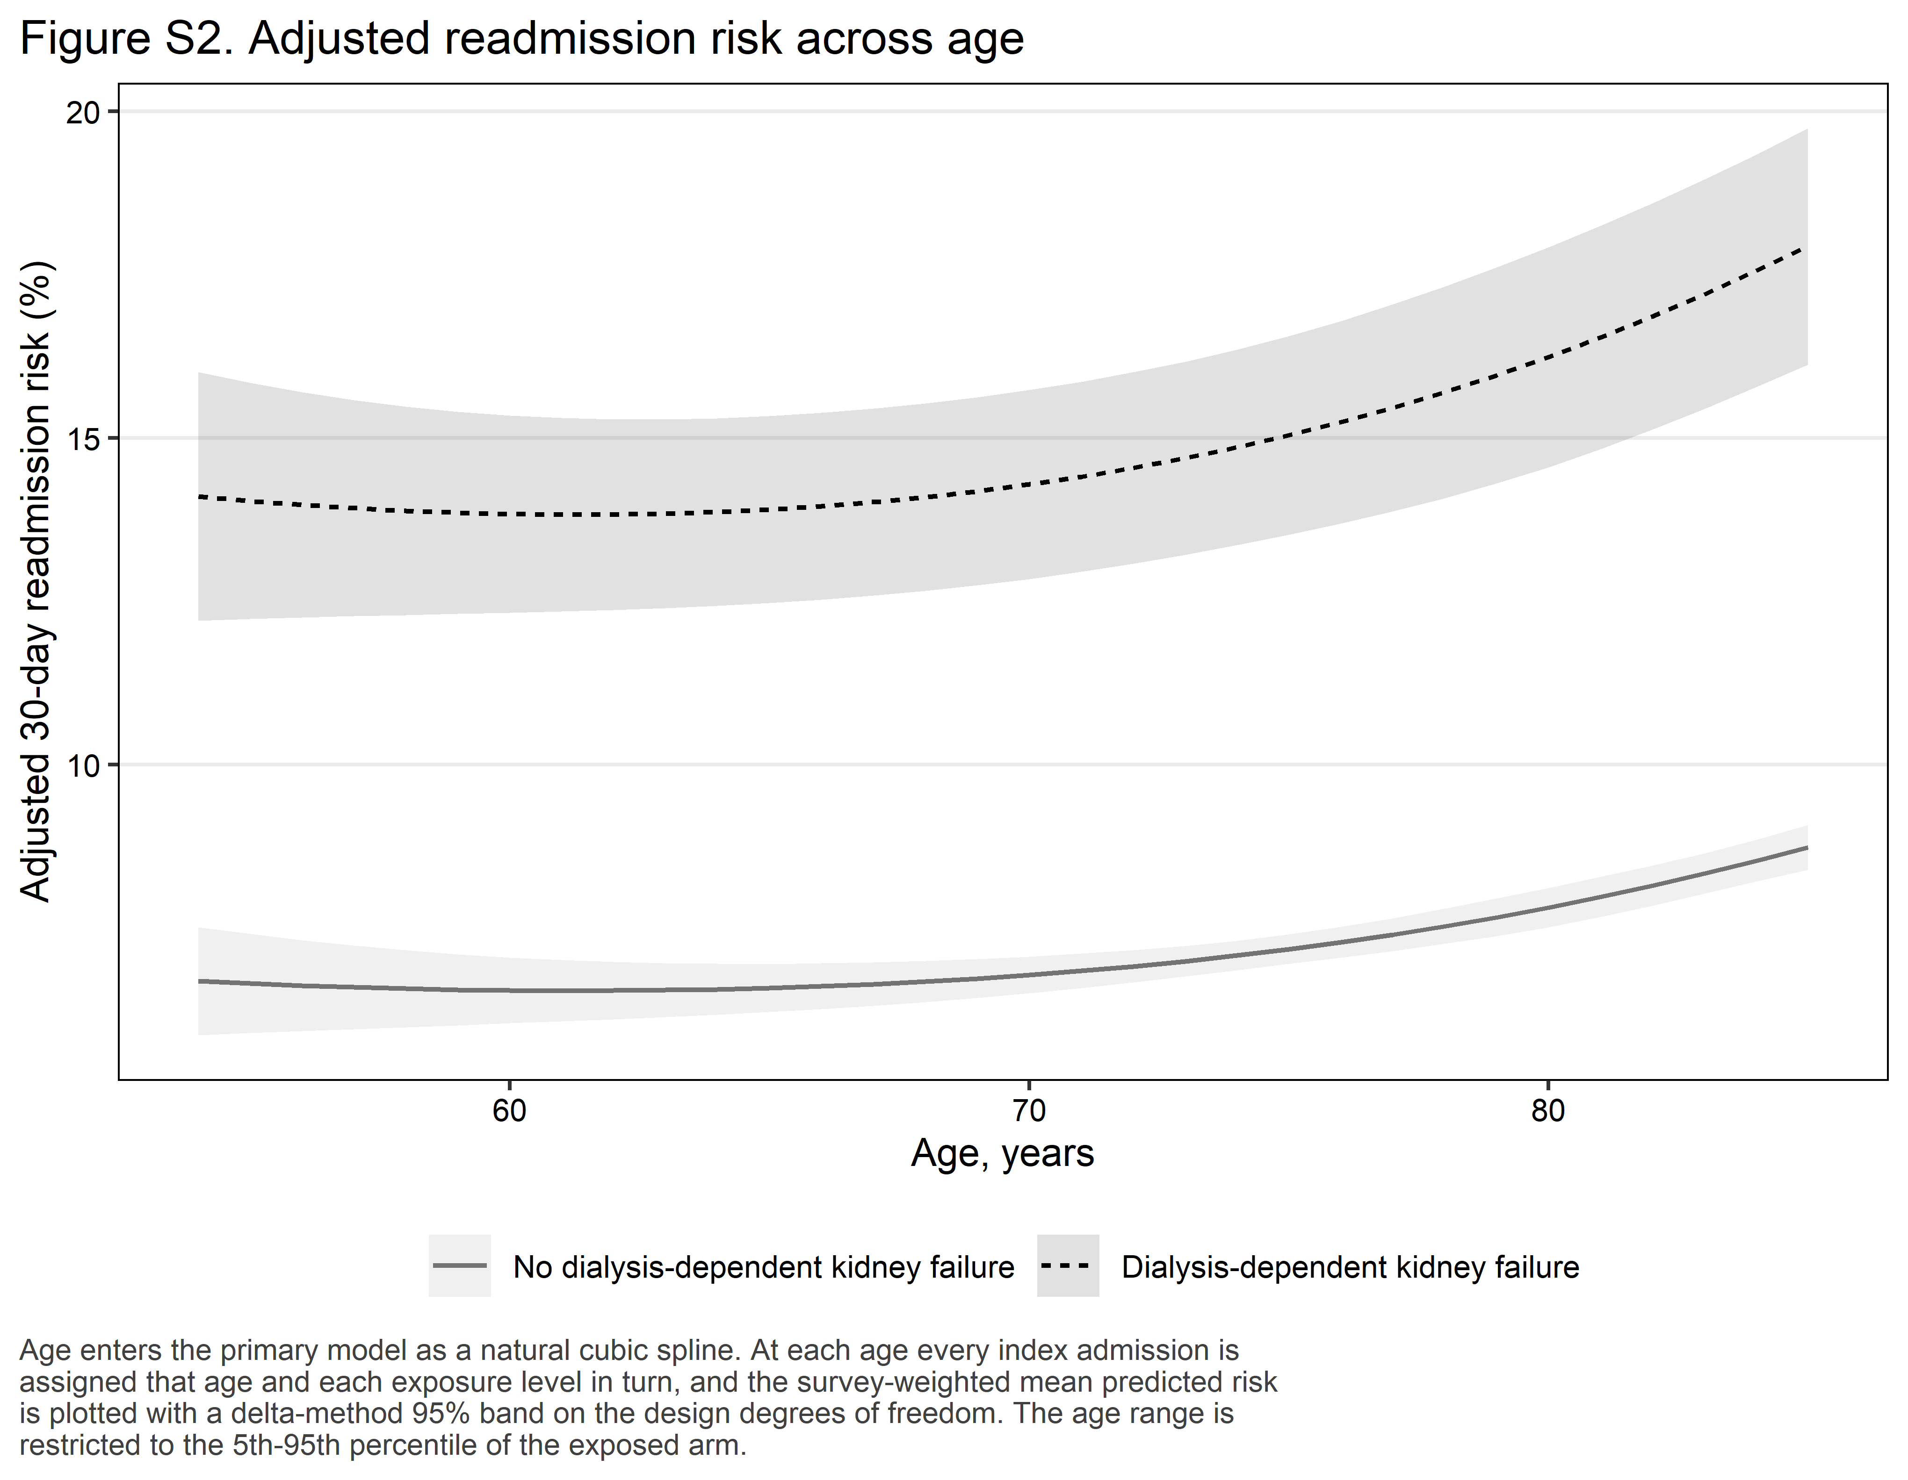
Figure S2. Adjusted 30-day readmission risk across age, by exposure.
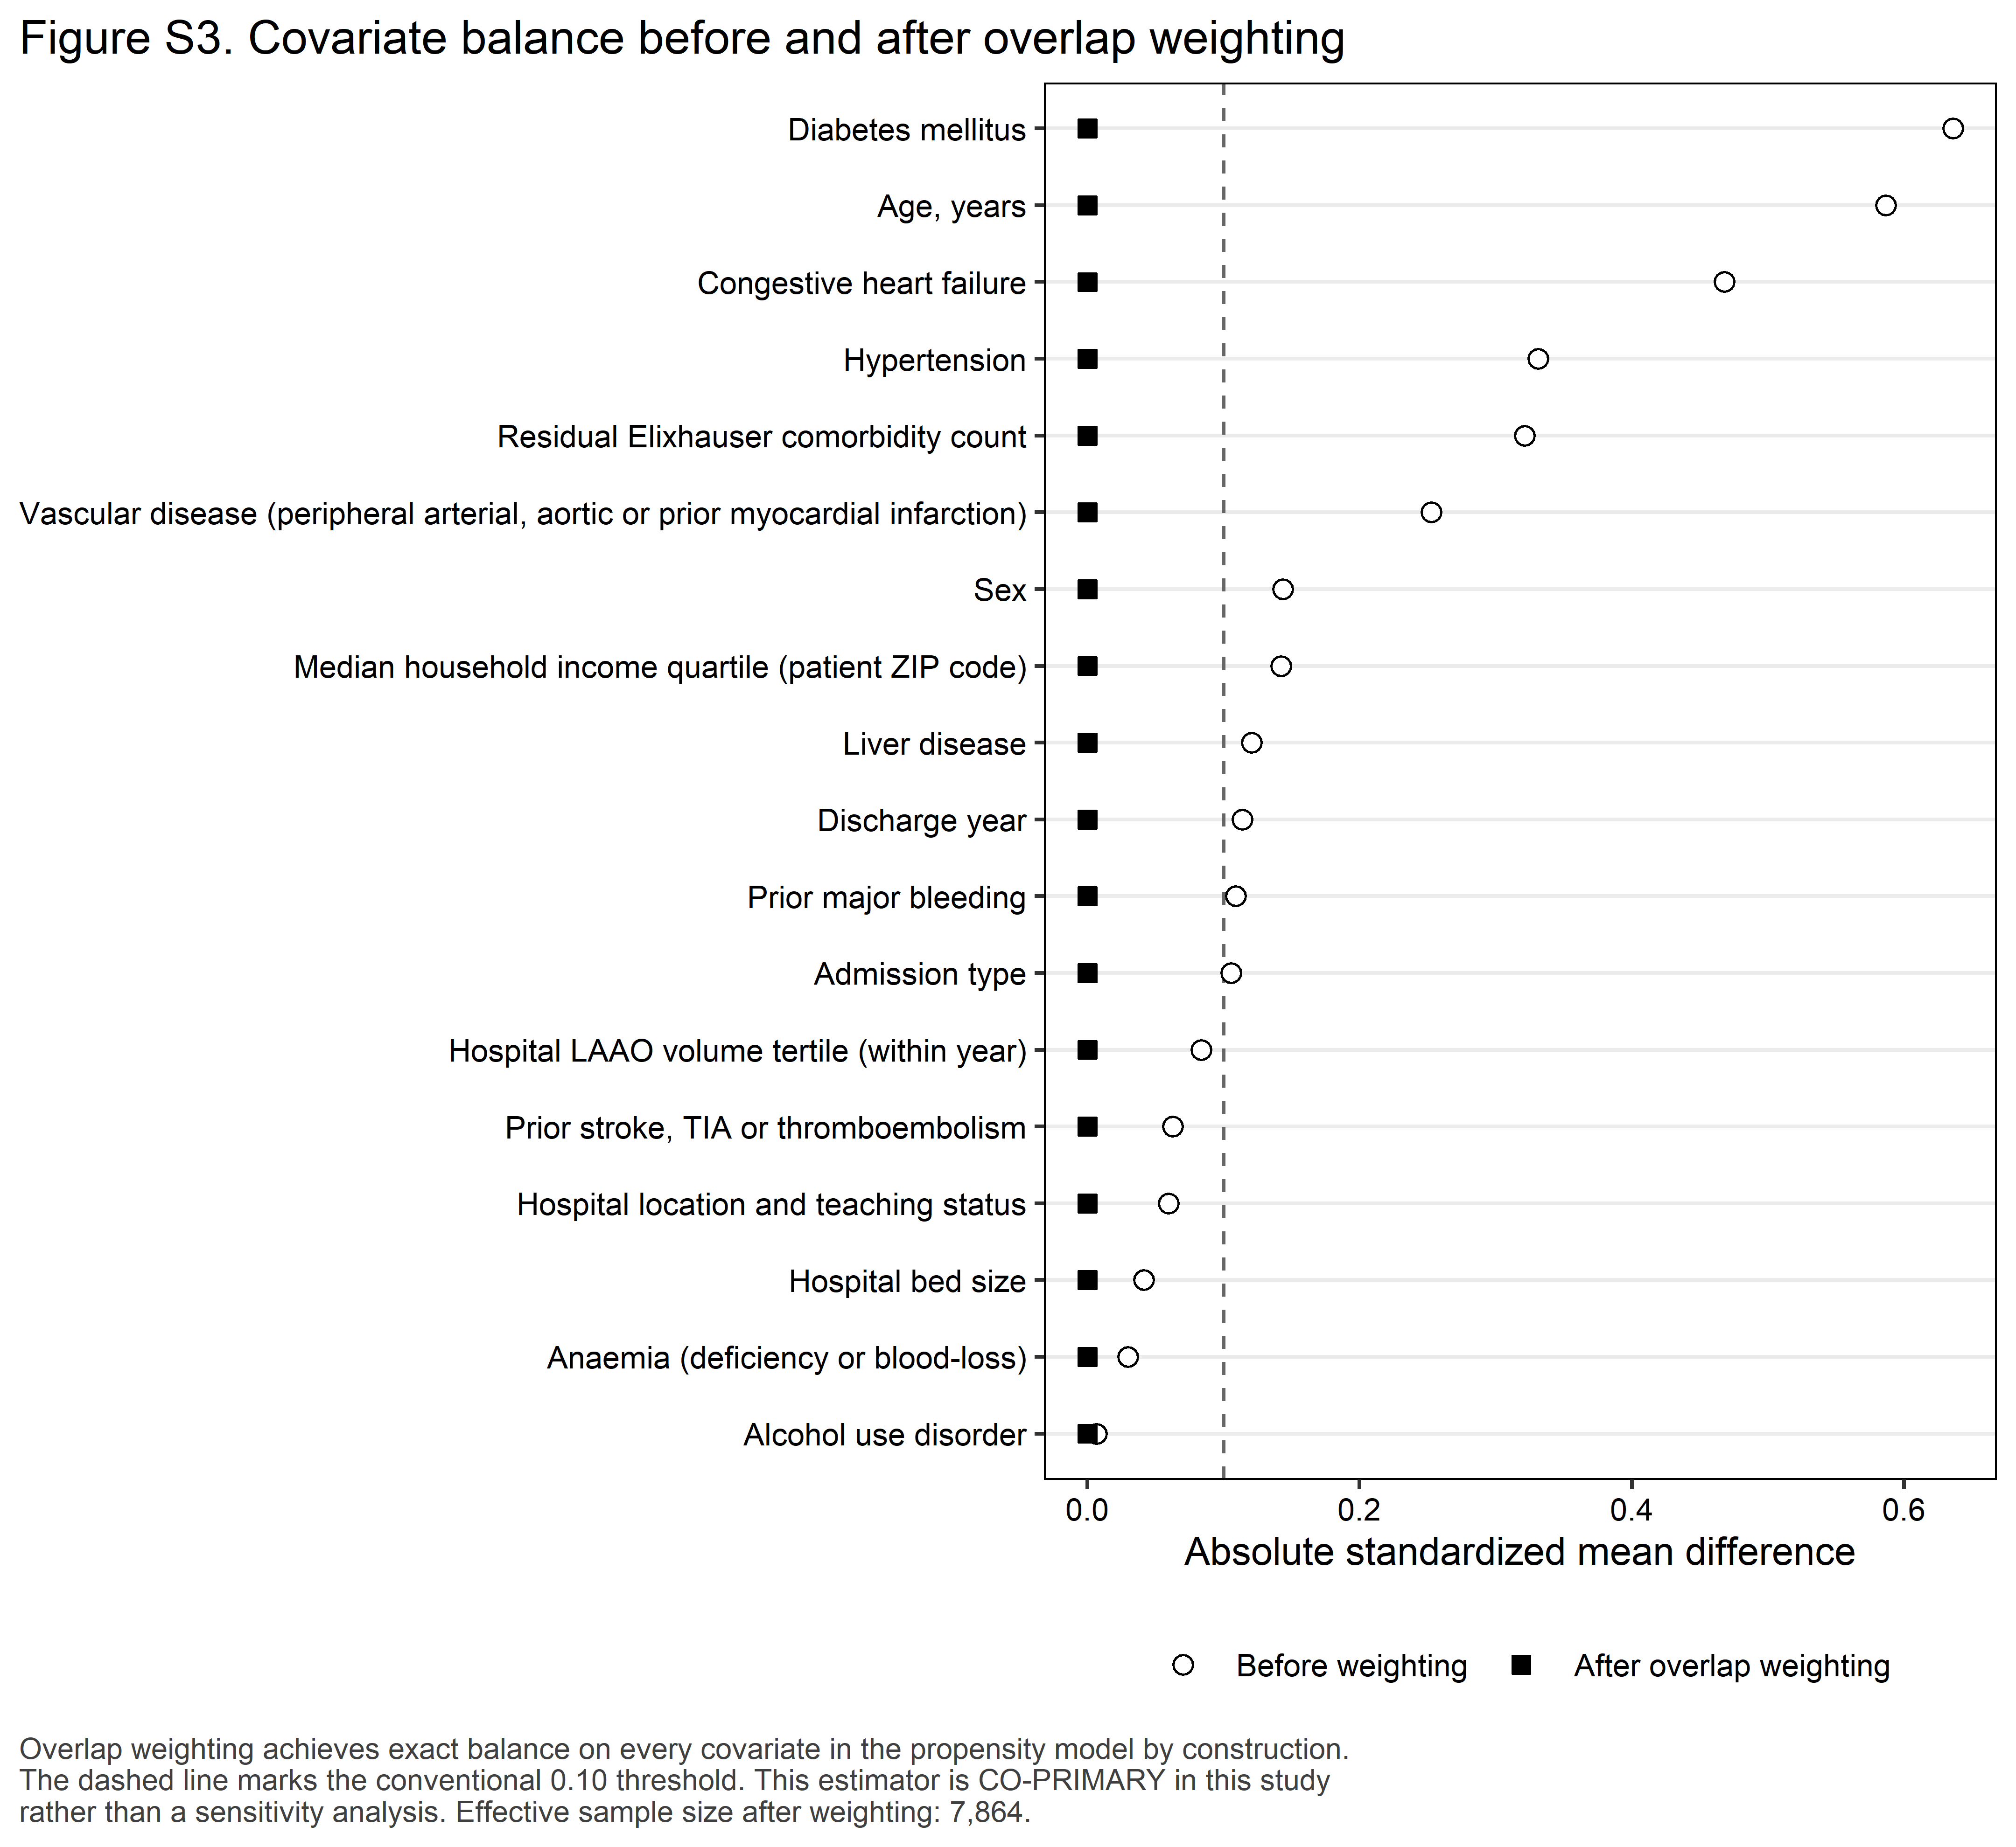
Figure S3. Covariate balance before and after overlap weighting.

4.4 Sequential adjustment
Table 4. Sequential covariate adjustment, exposure estimate only.
Analysis | Adjusted OR (95% CI) | p value | Adjusted risk difference, pp (95% CI) | Adjusted risk ratio (95% CI)
Model 1: unadjusted | 2.84 (2.53–3.20) | <0.001 | 11.31 (9.54–13.07) | 2.50 (2.27–2.75)
Model 2: + demographic and administrative covariates | 2.89 (2.57–3.26) | <0.001 | 11.43 (9.64–13.21) | 2.51 (2.28–2.77)
Model 3: + hospital covariates including LAAO volume | 2.84 (2.52–3.21) | <0.001 | 11.13 (9.36–12.89) | 2.47 (2.24–2.73)
Model 4: + clinical-score covariate block (PRIMARY MODEL) | 2.34 (2.07–2.65) | <0.001 | 8.22 (6.66–9.77) | 2.08 (1.88–2.30)
Model 5: + mediators (length of stay, discharge disposition) – OVER-ADJUSTED, not the adjusted estimate | 2.30 (2.03–2.61) | <0.001 | 7.98 (6.42–9.53) | 2.05 (1.85–2.27)

Model 4 is the primary specification. Model 5 additionally conditions on length of stay and discharge disposition, which are mediators; the change from Model 4 to Model 5 is attenuation consistent with mediation and is NOT an adjusted estimate.
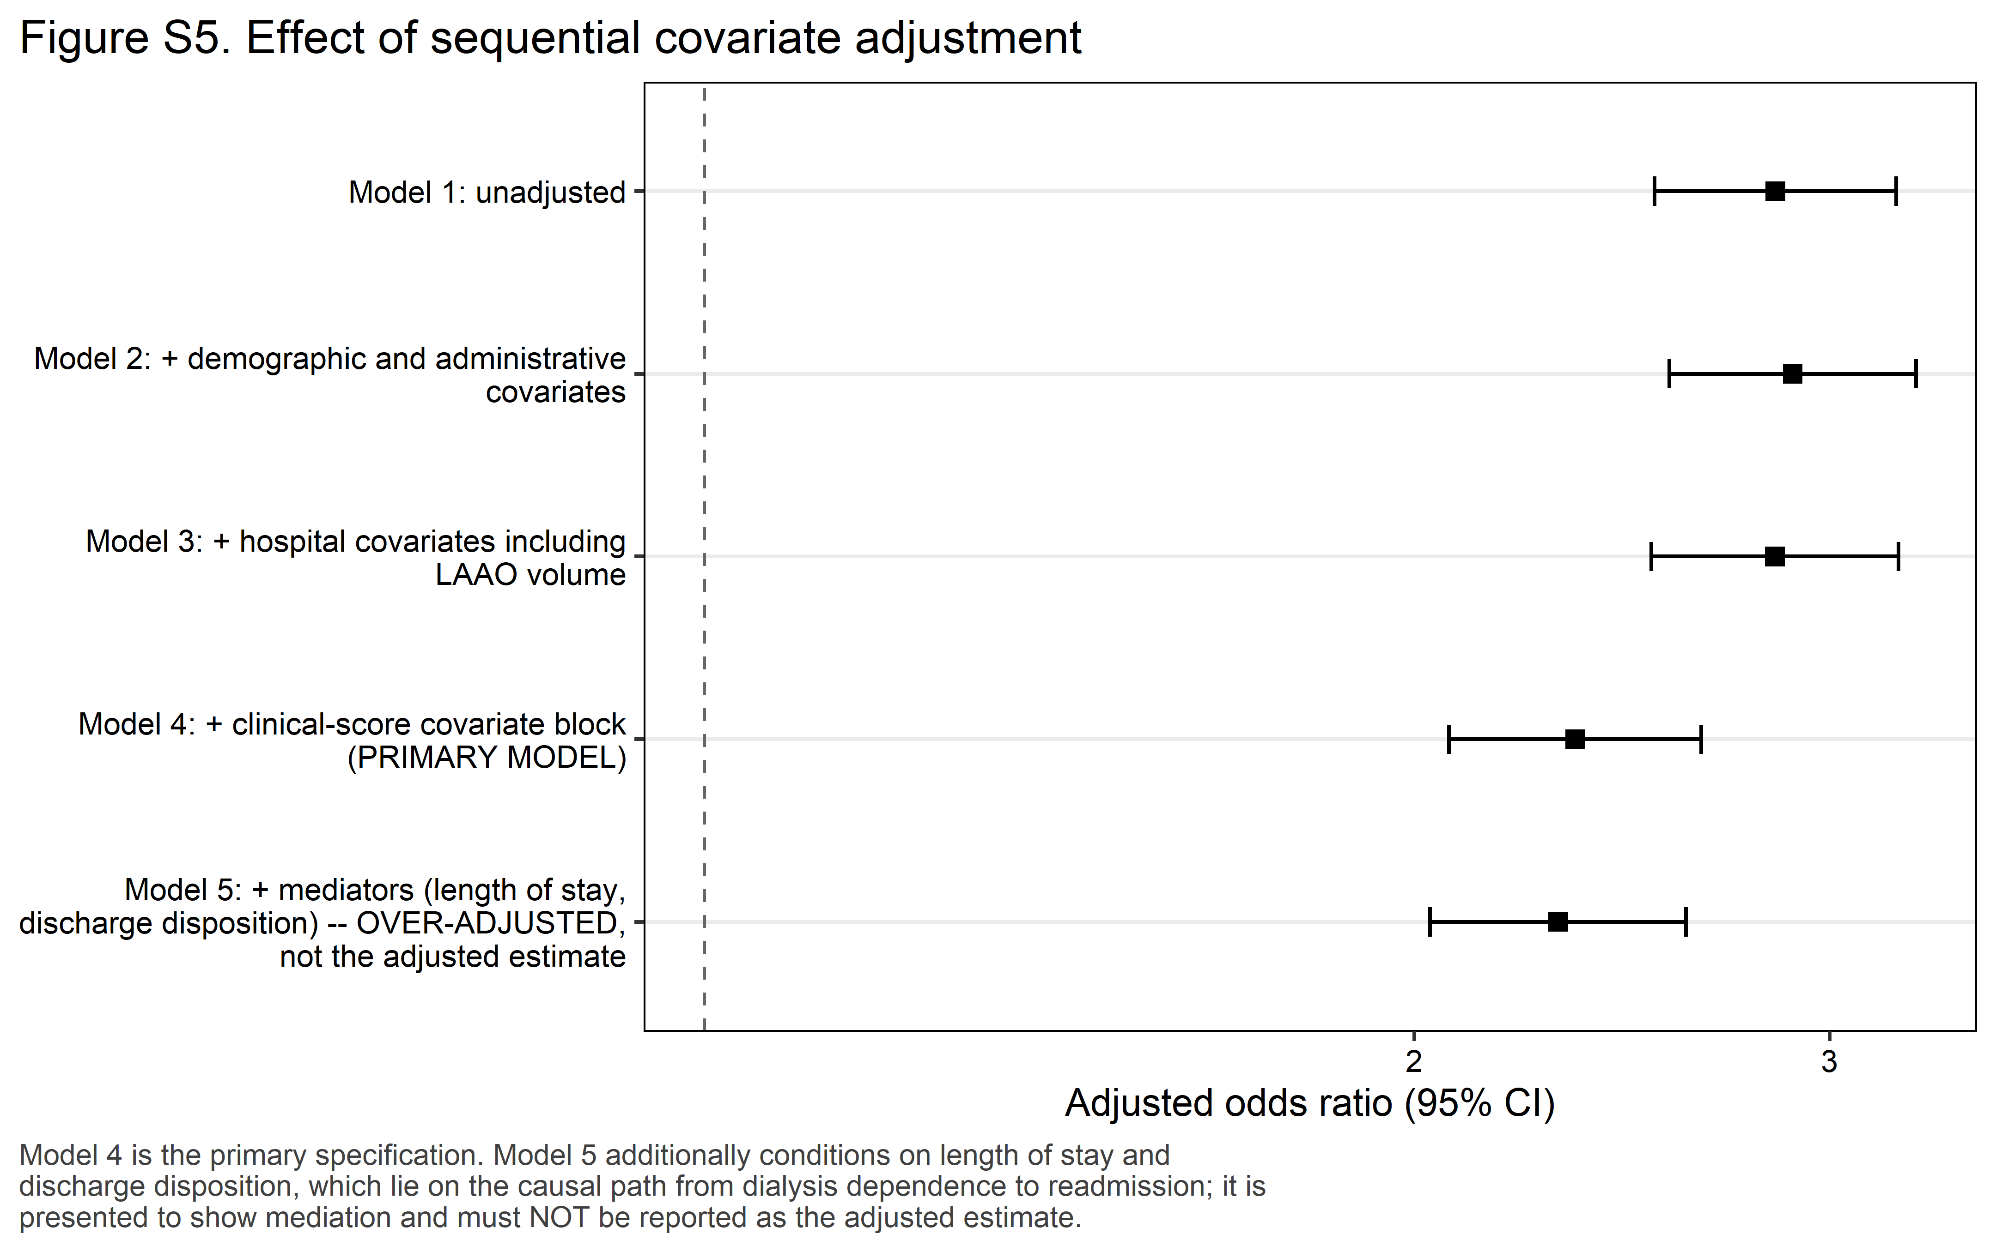
Figure S5. Effect of sequential covariate adjustment.

4.5 Secondary outcomes
Table 4b. Secondary outcomes, with Benjamini-Hochberg adjustment within the pre-specified family.
Secondary outcome | Denominator | Events (unweighted) | Adjusted OR (95% CI) | p value | BH q value
Bleeding readmission (GI haemorrhage, intracranial haemorrhage or acute posthaemorrhagic anaemia) | Readmitted index admissions | 833 | 1.10 (0.79–1.54) | 0.564 | 0.564
Ischaemic stroke readmission (CCSR CIR020) | Readmitted index admissions | <11 (suppressed) | Suppressed (<11 events in an arm) | — | —
Unplanned (non-elective) readmission | Readmitted index admissions | 7,638 | 0.71 (0.39–1.28) | 0.249 | 0.298
In-hospital death at readmission | Readmitted index admissions | 198 | 1.83 (1.11–3.03) | 0.018 | 0.037
Pericardial effusion or tamponade at index | Index admissions | 2,544 | 1.63 (1.29–2.05) | <0.001 | <0.001
Pericardial drainage at index | Index admissions | 608 | 1.44 (0.83–2.52) | 0.195 | 0.293
Non-home discharge at index | Index admissions | 1,855 | 1.71 (1.34–2.19) | <0.001 | <0.001

All secondary outcomes are exploratory. Outcomes measured on the readmission record are conditional on being readmitted and have a readmitted denominator. The primary outcome is not a member of this family.
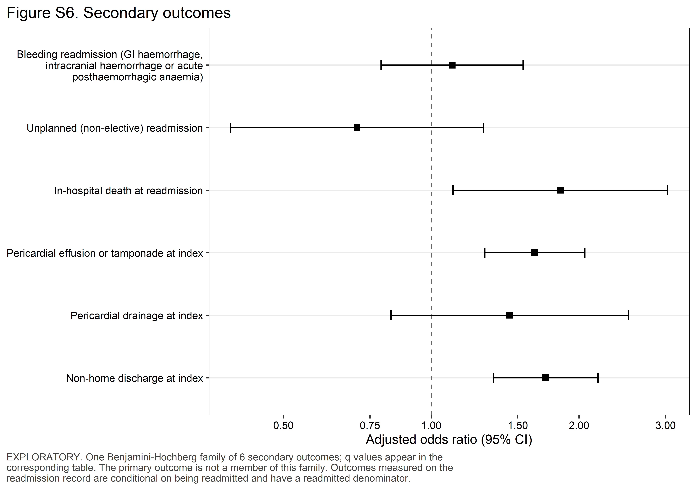
Figure S6. Secondary outcomes.

4.6 Cause of readmission
Table 5. Principal cause of the first 30-day readmission, by exposure (exploratory).
Cause of readmission (DXCCSR category) | Overall, % | No dialysis-dependent kidney failure, % (n) | Dialysis-dependent kidney failure, % (n) | p value | BH q value
Cardiac dysrhythmias | 8.8% | 9.1% (669) | 4.2% (21) | <0.001 | 0.002
Gastrointestinal hemorrhage | 8.1% | 8.0% (595) | 9.5% (45) | 0.291 | 0.436
Septicemia | 6.1% | 6.1% (447) | 6.1% (31) | 0.976 | 0.976
Other | 77.1% | 76.9% (5,737) | 80.2% (364) | — | —

EXPLORATORY. Based on 7,909 unweighted 30-day readmissions with a recorded principal diagnosis, mapped to the AHRQ DXCCSR v2025.1 default inpatient category. 3 readmission principal diagnosis code(s) had no default CCSR assignment and are grouped under ‘Other’. The top 4 categories by overall weighted share are reported – four rather than ten or fifteen because this cohort has a thin exposed arm; the number was fixed in the analysis plan before any result was seen. All remaining categories are folded into ‘Other’, as are 1 category that fell below the 11 unweighted discharge threshold in at least one exposure arm (Heart failure). Percentages are within-arm shares of all readmissions in that arm and sum to 100% down each column. P values are design-based Wald tests from survey-weighted logistic regression of the category indicator on exposure; q values are Benjamini-Hochberg adjusted across the reported categories, a family separate from the secondary-outcome family.
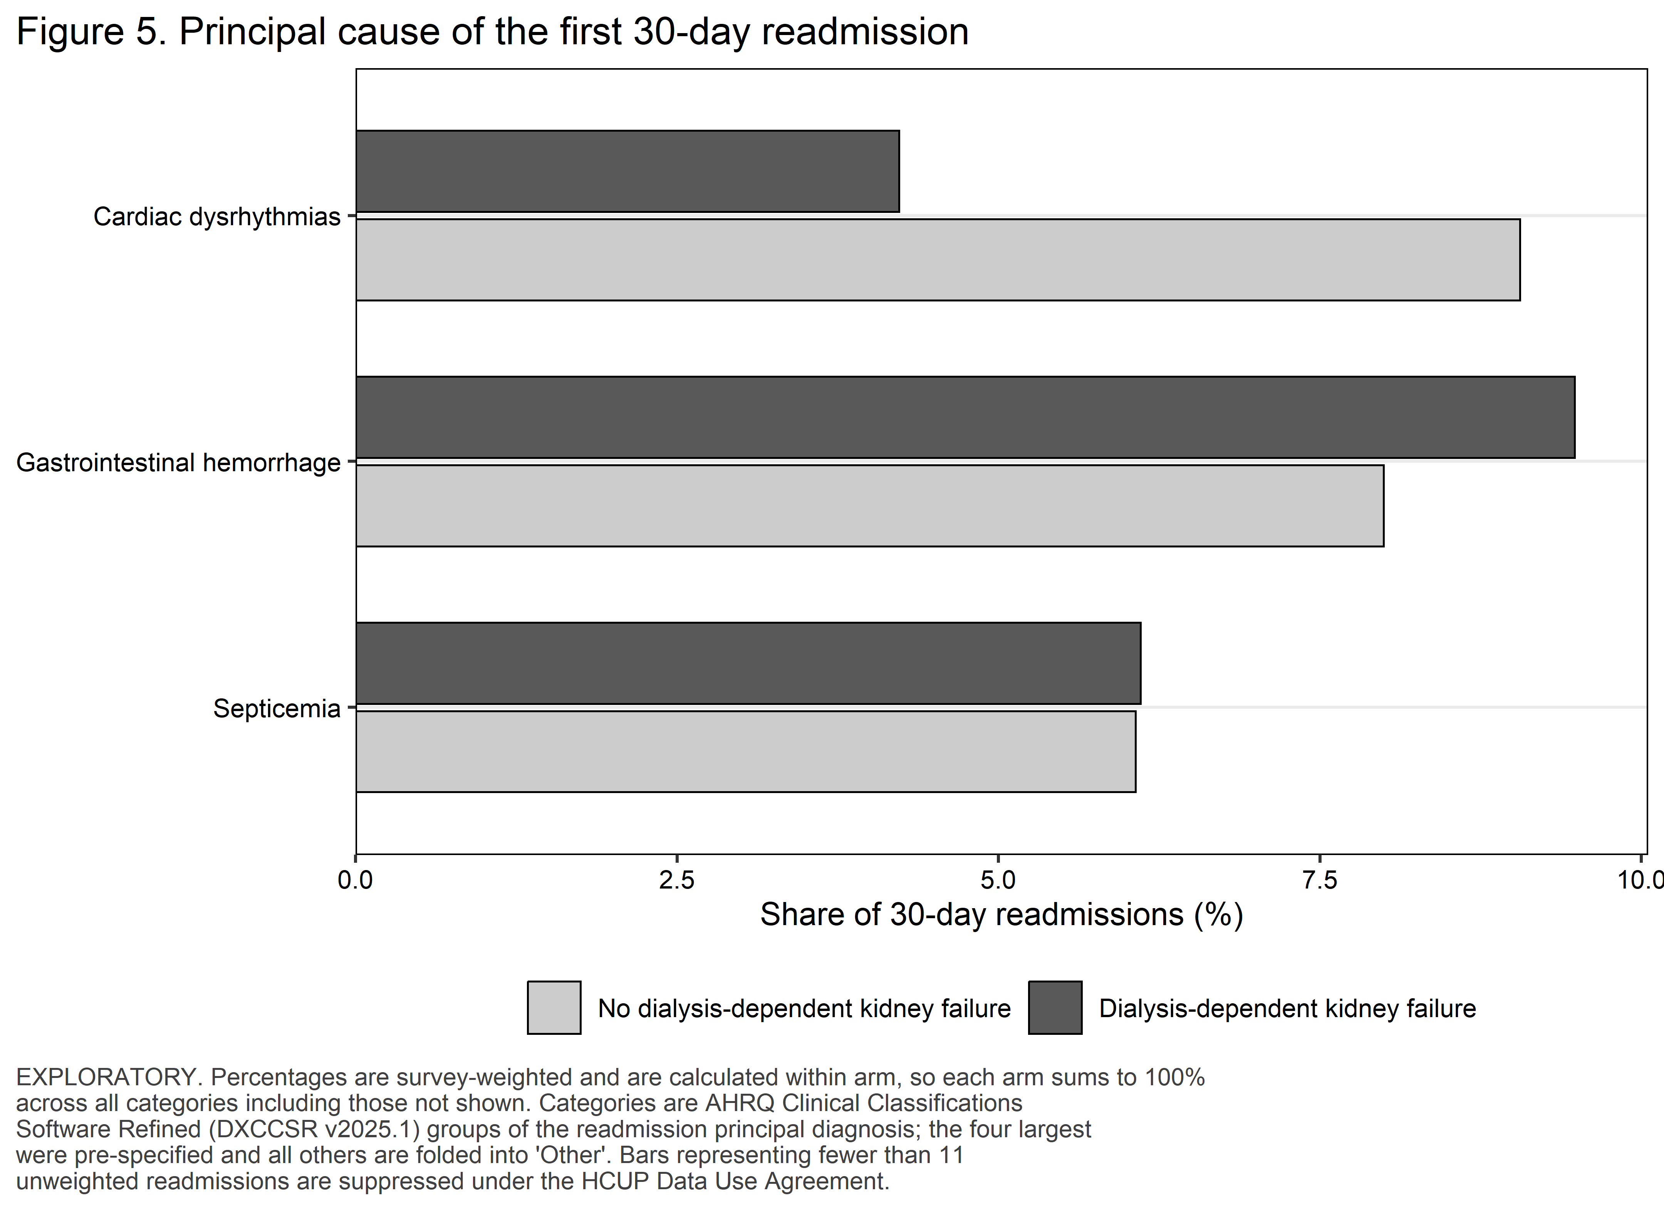
Figure 5. Principal cause of the first 30-day readmission.

4.7 Timing of readmission
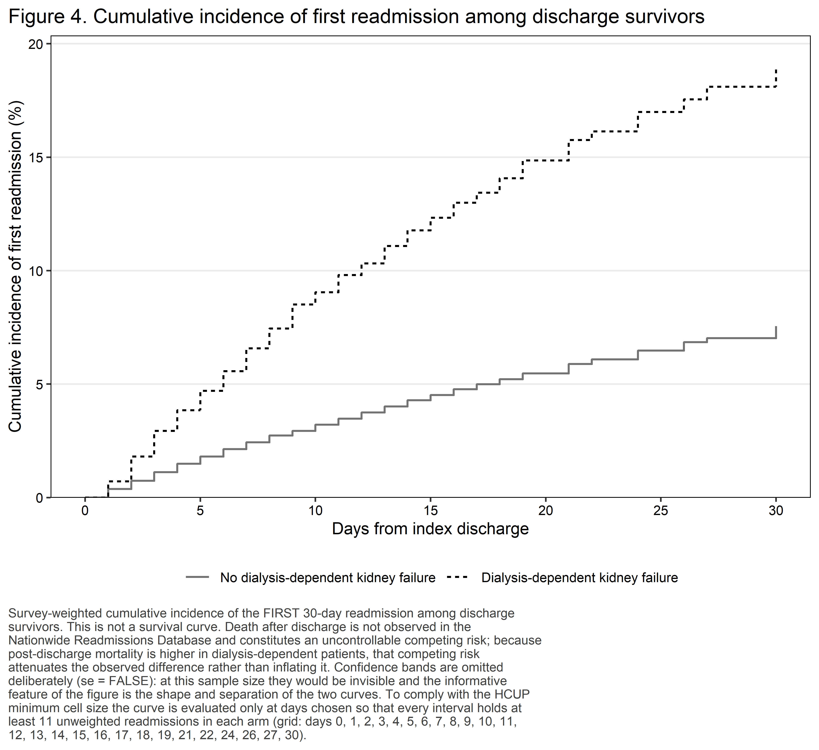
Figure 4. Cumulative incidence of first readmission among discharge survivors.
Figure 4 at-risk table: index admissions not yet readmitted (unweighted).
Arm | Day 0 | Day 10 | Day 19 | Day 30
No dialysis-dependent kidney failure | 99,395 | 96,217 | 94,001 | 91,947
Dialysis-dependent kidney failure | 2,418 | 2,201 | 2,061 | 1,957
This is a cumulative incidence curve for the first readmission among discharge survivors, not a survival curve. Death after discharge is not observed in the Nationwide Readmissions Database and is an uncontrollable competing risk; because post-discharge mortality is substantially higher in dialysis-dependent patients, that competing risk attenuates the observed difference between arms rather than inflating it.

4.8 Exploratory subgroups
Table 5b. Exploratory subgroup analyses.
Subgroup | Level | Unweighted n | Exposed (unweighted) | Readmissions (unweighted) | Adjusted OR (95% CI) | Adjusted RD, pp (95% CI) | Interaction p
Overall (primary model) |  | 101,813 | 2,418 | 7,909 | 2.34 (2.07–2.65) | 8.22 (6.66–9.77)
Prior major bleeding vs none | No prior major bleeding | 97,718 | 2,266 | 7,289 | 2.39 (2.10–2.71) | 8.25 (6.65–9.86) | 0.265
 | Prior major bleeding | 4,095 | 152 | 620 | 1.88 (1.26–2.82) | 9.17 (2.36–15.99)
Age ≥75 vs <75 years | <75 years | 38,857 | 1,454 | 2,715 | 2.12 (1.79–2.52) | 6.30 (4.47–8.12) | 0.126
 | ≥75 years | 62,956 | 964 | 5,194 | 2.63 (2.20–3.13) | 10.36 (7.83–12.89)
Hospital LAAO volume tertile | High | 34,492 | 742 | 2,432 | 2.46 (1.92–3.14) | 8.11 (5.16–11.06) | 0.535
 | Middle | 33,826 | 775 | 2,600 | 2.17 (1.74–2.70) | 7.28 (4.63–9.92)
 | Low | 33,495 | 901 | 2,877 | 2.40 (1.95–2.95) | 9.19 (6.38–11.99)

ALL SUBGROUP RESULTS ARE EXPLORATORY and are not adjusted for multiplicity. Each estimate is the adjusted association between dialysis-dependent kidney failure and 30-day readmission, refitted within that subgroup using the primary covariate block. A stratum is reported only when each of its four exposure-by-outcome cells holds at least 11 unweighted discharges; the interaction p value is derived from every stratum and is suppressed whenever any stratum is. Effect modification is assessed by a design-based Wald test on the whole interaction block, fitted on the rows with a non-missing modifier; the modifier’s deterministic parent covariate is removed from that model so that no coefficient is aliased (prior major bleeding for the bleeding subgroup, the volume tertile for the volume subgroup). Non-overlapping subgroup confidence intervals are NOT evidence of interaction and are not interpreted as such. The prior-major-bleeding subgroup is the pre-specified restricted comparison that addresses indication bias directly. No subgroup finding appears in the Conclusions.
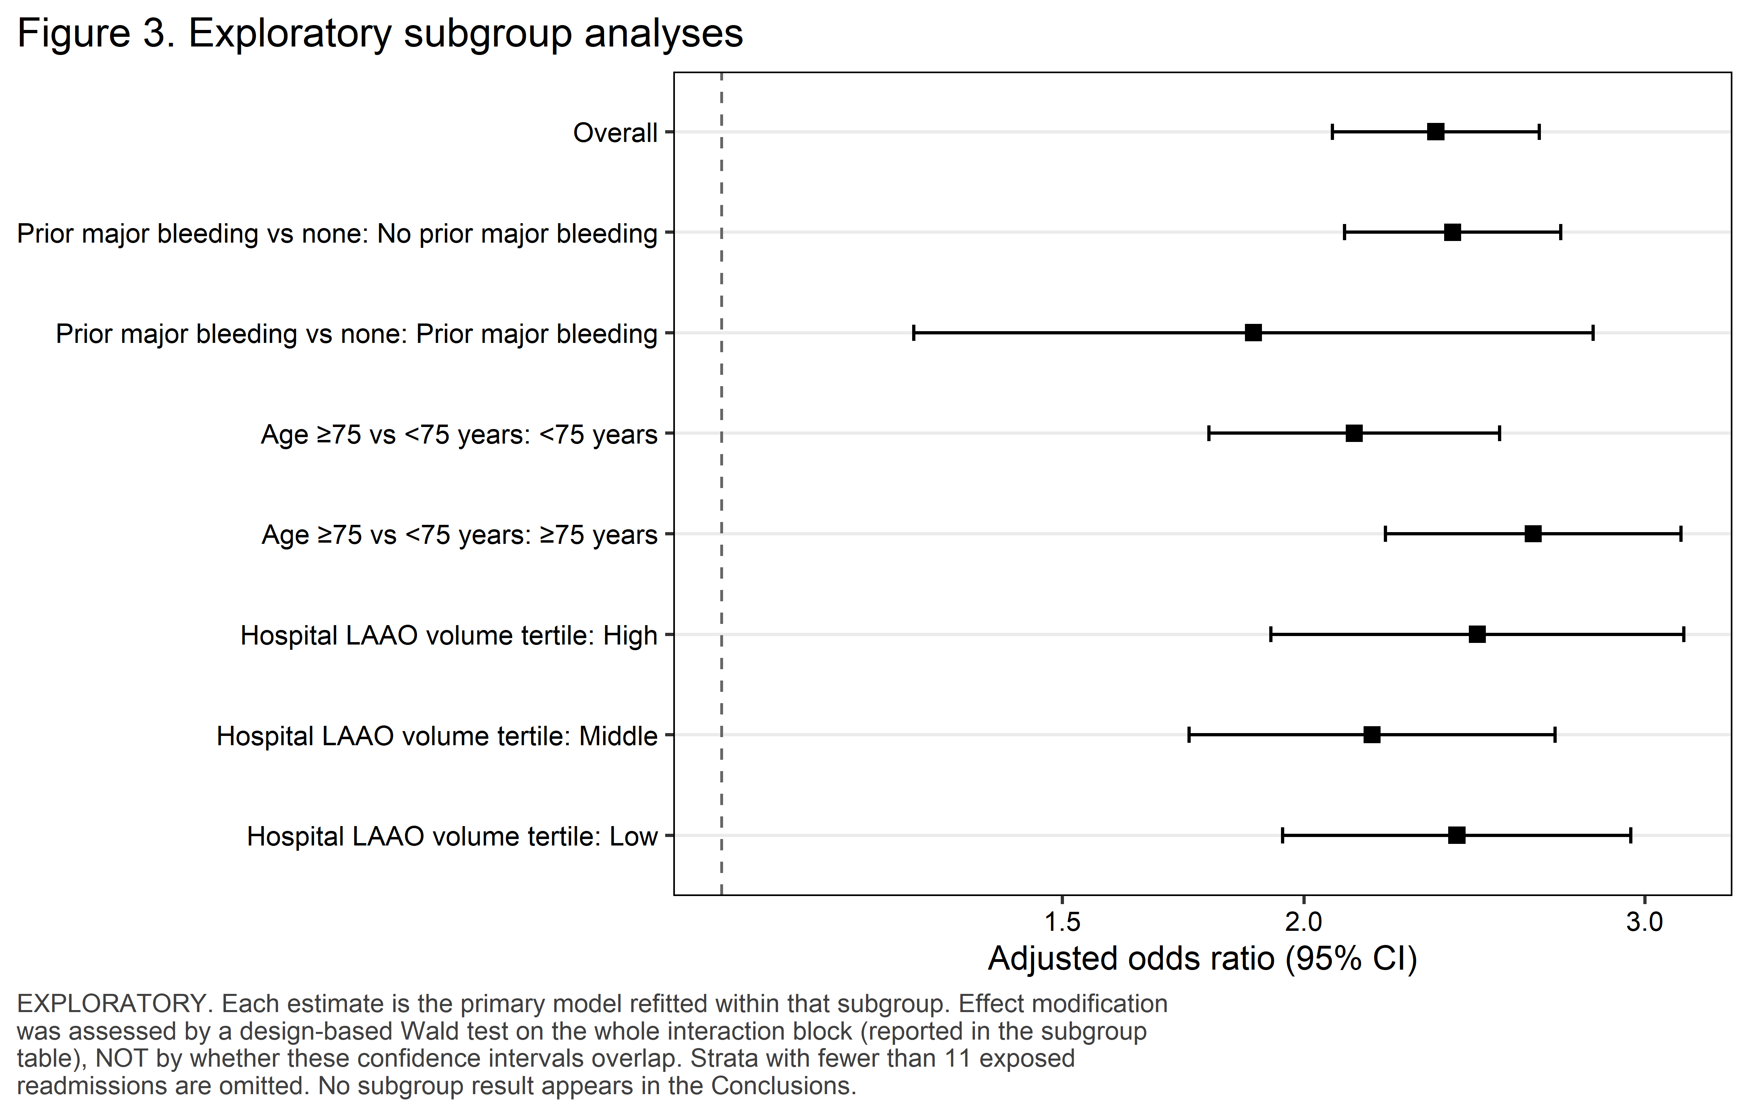
Figure 3. Exploratory subgroup analyses.

4.9 Temporal trends
Table S3. Temporal trends, 2016-2022.
Year | Weighted national index admissions | Dialysis-dependent kidney failure, % (95% CI) | Readmission, unexposed | Readmission, exposed
2016 | 4,638 | 1.8% (1.2–2.3) | 8.3% (7.1–9.5) | 21.1% (8.1–34.1)
2017 | 9,270 | 2.5% (2.0–3.0) | 9.5% (8.7–10.4) | 23.3% (16.2–30.4)
2018 | 15,372 | 2.8% (2.3–3.2) | 9.0% (8.3–9.6) | 23.0% (15.8–30.2)
2019 | 25,213 | 2.7% (2.4–3.0) | 8.6% (8.1–9.2) | 19.4% (14.7–24.0)
2020 | 26,130 | 2.8% (2.5–3.1) | 8.0% (7.4–8.5) | 16.1% (12.6–19.7)
2021 | 44,317 | 2.3% (2.0–2.5) | 7.2% (6.7–7.7) | 17.4% (13.9–21.0)
2022 | 60,538 | 2.0% (1.8–2.2) | 6.5% (6.1–6.8) | 19.0% (15.4–22.5)

Four qualifications apply to every trend result reported here and must appear alongside them in the manuscript. First, these are seven independent annual cross-sections drawn from a partly changing hospital sample, not a longitudinal cohort; NRD patient linkage does not cross calendar years and hospital identifiers are reset each year. Second, coding intensity increased across this window, so an apparent rise in the prevalence of an any-listed diagnosis reflects ascertainment as much as incidence, and no biological trend is claimed. Third, 2020 is anomalous because of pandemic admission avoidance, COVID-19 coding and capacity effects, and is examined in the leave-2020-out sensitivity analysis S2. Fourth, and specific to this procedure, left atrial appendage occlusion diffused rapidly across this window, so the annual volume series describes the adoption of a technology rather than the incidence of a disease, and because ICD-10-PCS does not identify the device model the later years are a mixture of device generations in unknown proportion. The trend test enters discharge year as a continuous term replacing the year factor, which is a design-based test; Joinpoint and segmented regression on the annual point estimates are not appropriate because they ignore the survey design. An exposure-by-year interaction was NOT tested in this study: the analysis plan restricts that test to the two larger studies in the programme, and with this exposed event count spread over seven years it would be an underpowered test whose null result would carry no information.
Adjusted trend in the outcome. 0.94 (0.92–0.95) per calendar year (p <0.001)
Trend in exposure prevalence among LAAO admissions. 0.95 (0.92–0.98) per calendar year (p <0.001)
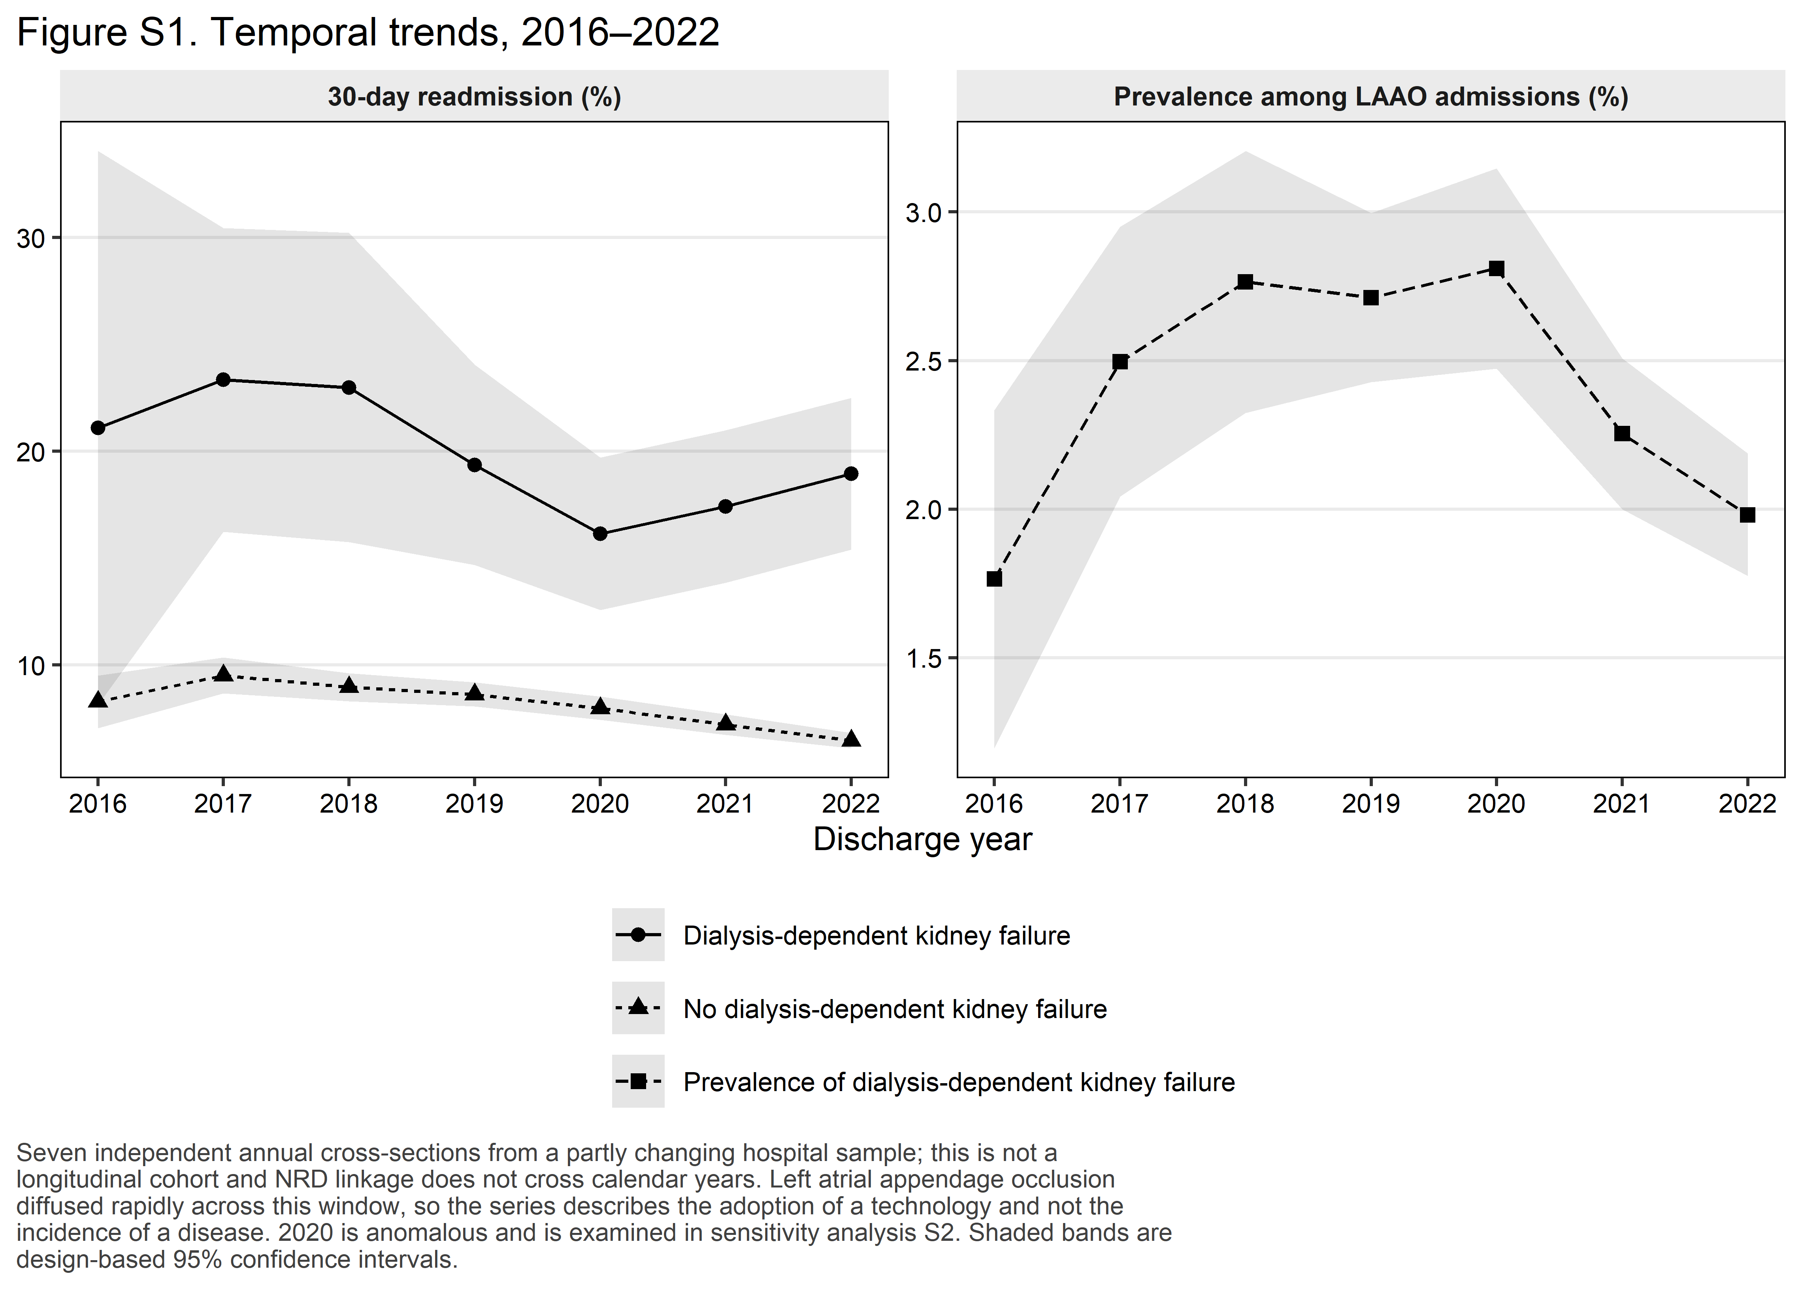
Figure S1. Temporal trends, 2016-2022.

4.10 Sensitivity analyses
Table 6. Sensitivity analyses, exposure estimate only.
Analysis | Adjusted OR (95% CI) | p value | Adjusted risk difference, pp (95% CI) | Adjusted risk ratio (95% CI)
Primary model (reference) | 2.34 (2.07–2.65) | <0.001 | 8.22 (6.66–9.77) | 2.08 (1.88–2.30)
S1. First qualifying index admission per patient-year only | 2.34 (2.07–2.64) | <0.001 | 8.21 (6.66–9.77) | 2.08 (1.88–2.30)
S2. Leave-2020-out | 2.45 (2.14–2.81) | <0.001 | 8.77 (7.01–10.52) | 2.17 (1.94–2.42)
S3. Propensity-score overlap-weighted (ATO) estimate – also reported as co-primary | 2.29 (2.02–2.59) | <0.001 | 9.36 (7.64–11.08) | 1.99 (1.81–2.20)
S4. Cox model, administrative censoring at day 30, full cohort | HR 2.19 (1.96–2.45) | <0.001 | Not applicable (hazard scale) | Not applicable (hazard scale)
S5. Device-era restriction: 2020-2022 discharges only | 2.30 (1.97–2.68) | <0.001 | 7.53 (5.72–9.34) | 2.07 (1.82–2.35)
S6. Alternative exposure: N18.6 with or without a dialysis-dependence marker | 2.38 (2.12–2.66) | <0.001 | 8.39 (6.94–9.84) | 2.11 (1.92–2.31)
S7. Excluding non-elective index admissions | 2.39 (2.09–2.72) | <0.001 | 8.25 (6.63–9.87) | 2.13 (1.91–2.37)
S8. Exposure ascertained from I10_DX1-I10_DX30 and I10_PR1-I10_PR15 only (uniform field depth) | 2.34 (2.07–2.65) | <0.001 | 8.21 (6.65–9.76) | 2.08 (1.88–2.30)
Present-on-admission-restricted definitions (SAP C1 item 4) | Not estimable: no present-on-admission indicator exists in NRD 2016-2022 | — | Not estimable | Not estimable

Sensitivity analyses are consistency checks and are NOT corrected for multiplicity; they are judged on whether the point estimate moves, not on whether a p-value crosses 0.05. Every subset was taken with subset() on the survey design constructed once on the full cohort, so the stratum information needed for correct variance estimation is preserved; the design was never rebuilt on filtered data. S3 is the co-primary overlap-weighted estimate carried across from Table 3b, not a second computation of it. S5 is a CALENDAR restriction, not a device restriction: ICD-10-PCS code 02L73DK covers every intraluminal left atrial appendage occlusion device and the device model cannot be identified from administrative data. S6 widens the exposure to any N18.6 diagnosis regardless of dialysis dependence, which is closer to the definition used by the published propensity-matched network analysis. S8 re-ascertains the exposure within the diagnosis and procedure fields present in every data year; records exposed only through a higher-numbered field are re-classified as unexposed. Present-on-admission-restricted definitions are NOT ESTIMABLE in NRD 2016-2022, which carries no present-on-admission indicator. Rows that could not be estimated or were suppressed (reason in the table): Present-on-admission-restricted definitions (SAP C1 item 4). The overlap-weighted design had an effective sample size of 7,864. The Cox model in S4 is a sensitivity analysis only and is not an alternative primary specification: every patient has complete 30-day follow-up by design, so a hazard ratio adds no information beyond the binary outcome.
Table 6b. Pre-specified negative control outcome.
Analysis | Events (unweighted) | Adjusted OR (95% CI) | p value | Interpretation
Negative control: 30-day readmission with a skin or subcutaneous principal diagnosis | <11 (suppressed) | Suppressed (<11 events in an exposure arm) | — | Not estimable at the HCUP minimum cell size: the pre-specified negative control is uninformative in this cohort. It is reported so that the pre-specified test is accounted for.

5. Supplement

5.1 Survey design and model diagnostics
Table S1. Survey design properties.
Property | Value
Unweighted index admissions | 101,813
Weighted national index admissions | 185,478
Strata (year x NRD stratum, integer-coded) | 316
Primary sampling units (year x hospital, integer-coded) | 2,312
Strata containing a single PSU | 59
Design degrees of freedom | 1,996
Critical value used for manually constructed intervals | t(1,996) = 1.961

Table S4. Model diagnostics.
Diagnostic | Value | Interpretation
Maximum variance inflation factor (per design-matrix column) | 22.68 | Above 5 only for the age natural-spline basis columns and the discharge-year indicators (Age, natural-spline basis 1; Age, natural-spline basis 2; Age, natural-spline basis 3; Discharge year: 2022; Discharge year: 2021; Discharge year: 2020; Discharge year: 2019). Basis columns of one spline are collinear with each other by construction and year indicators are inflated by a small reference year; neither is collinearity between covariates, and the exposure column is not affected (see Table S4b).
Survey-weighted c-statistic (tie-corrected) | 0.648 | Reported without a threshold; discrimination is not the objective of an aetiological model
Design-based decile calibration test (survey analogue of Hosmer-Lemeshow) | <0.001 | A calibration test in a cohort of this size is expected to reject. Figure S4 is the substantive evidence; this p-value is reported for completeness only and is not interpreted alone.
Propensity-score range by exposure arm | exposed 0.001-0.712, unexposed 0.000-0.627 | Wide, overlapping ranges mean the overlap-weighted estimand is defined across the covariate space rather than in a narrow sliver of it
Effective sample size after overlap weighting | 7,864 | The population the ATO estimand actually describes
Covariates removed by the sparse-cell guard | None | Every removal is named here and in the Methods section
Minimum unweighted cell enforced on every reported table | 11 | HCUP Data Use Agreement

Variance inflation factors are computed per design-matrix column rather than aggregated to a generalized VIF, which is the conservative reading: if no individual dummy column is inflated then no multi-level factor is either. The c-statistic is survey-weighted and tie-corrected. The calibration test is the survey analogue of the Hosmer-Lemeshow test and is NOT the Archer-Lemeshow F-adjusted mean residual test; it should not be described as such. Singleton strata were centred at the grand mean (survey.lonely.psu = ‘adjust’) rather than removed; 59 stratum/strata contained a single primary sampling unit, which is expected for a concentrated procedure whose year-specific hospital identifiers cannot be pooled. All manually constructed intervals use t critical values on 1,996 design degrees of freedom rather than 1.96.
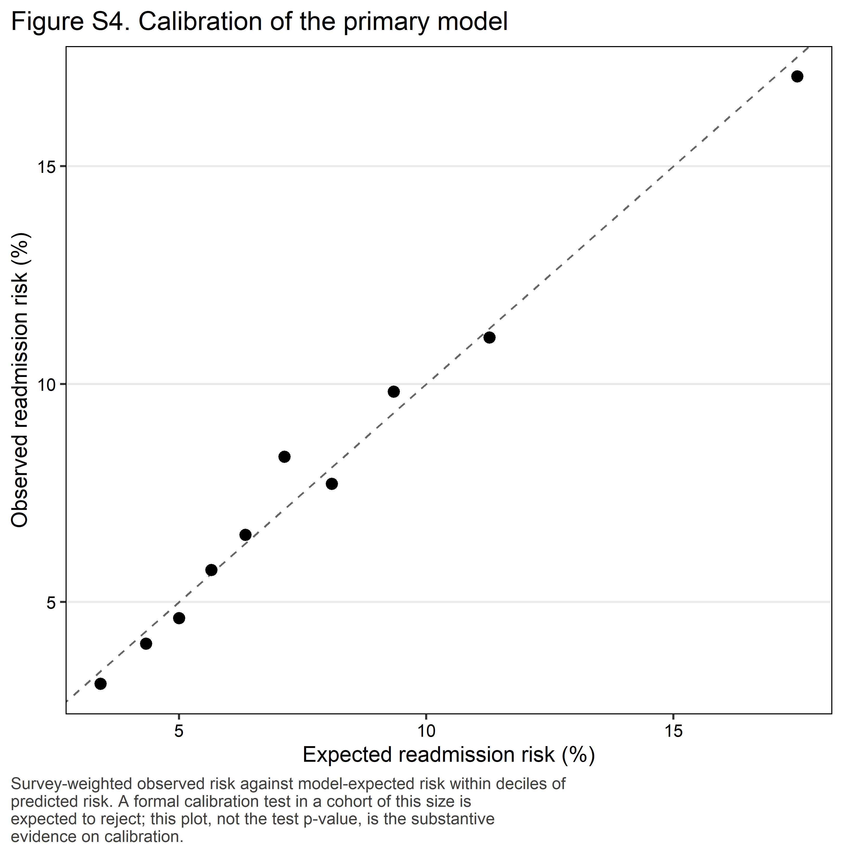
Figure S4. Calibration of the primary model.
Table S4b. Variance inflation factors, per design-matrix column.
Term | VIF
Age, natural-spline basis 1 | 22.68
Age, natural-spline basis 2 | 21.1
Age, natural-spline basis 3 | 14.36
Discharge year: 2022 | 8.93
Discharge year: 2021 | 7.59
Discharge year: 2020 | 5.52
Discharge year: 2019 | 5.39
Discharge year: 2018 | 3.89
Discharge year: 2017 | 2.82
Median household income quartile (patient ZIP code): 76th to 100th percentile | 2.1
Median household income quartile (patient ZIP code): 51st to 75th percentile | 1.96
Patient residence (NCHS urban-rural classification): Metro 250,000-999,999 | 1.81
Median household income quartile (patient ZIP code): 26th to 50th percentile | 1.75
Patient residence (NCHS urban-rural classification): Fringe metro ≥1 million | 1.71
Patient residence (NCHS urban-rural classification): Metro 50,000-249,999 | 1.5
Patient residence (NCHS urban-rural classification): Micropolitan | 1.48
Patient residence (NCHS urban-rural classification): Other | 1.42
Hospital LAAO volume tertile (within year): Low | 1.39
Hospital LAAO volume tertile (within year): Middle | 1.37
Primary expected payer: Private | 1.16
Residual Elixhauser comorbidity count | 1.12
Congestive heart failure: Yes | 1.11
Vascular disease (peripheral arterial, aortic or prior myocardial infarction): Yes | 1.11
Hospital location and teaching status: Non-metropolitan | 1.1
Primary expected payer: Medicaid | 1.09
Hospital bed size: Medium | 1.09
Sex: Female | 1.08
Median household income quartile (patient ZIP code): Missing/other | 1.07
Diabetes mellitus: Yes | 1.07
Hospital location and teaching status: Metropolitan, non-teaching | 1.06
Liver disease: Yes | 1.06
Alcohol use disorder: Yes | 1.06
Hospital bed size: Small | 1.05
Hypertension: Yes | 1.05
Dialysis-dependent kidney failure (vs No dialysis-dependent kidney failure) | 1.03
Patient residence (NCHS urban-rural classification): Missing/other | 1.03
Primary expected payer: Other/self-pay | 1.02
Admission type: Non-elective | 1.02
Prior major bleeding: Yes | 1.02
Anaemia (deficiency or blood-loss): Yes | 1.02
Prior stroke, TIA or thromboembolism: Yes | 1.01
Primary expected payer: Missing/other | 1

5.2 Full model coefficients
Table S2. Full covariate coefficients from the primary model.
Term | Adjusted OR (95% CI) | p value
Dialysis-dependent kidney failure (vs No dialysis-dependent kidney failure) | 2.34 (2.07–2.65) | <0.001
Age, natural-spline basis 1 | 0.92 (0.57–1.48) | 0.729
Age, natural-spline basis 2 | 0.45 (0.10–2.11) | 0.309
Age, natural-spline basis 3 | 1.41 (1.03–1.91) | 0.029
Sex: Female | 1.26 (1.19–1.33) | <0.001
Primary expected payer: Private | 0.79 (0.69–0.91) | <0.001
Primary expected payer: Medicaid | 1.23 (1.00–1.50) | 0.047
Primary expected payer: Other/self-pay | 1.00 (0.84–1.21) | 0.967
Primary expected payer: Missing/other | 1.83 (1.16–2.88) | 0.009
Median household income quartile (patient ZIP code): 26th to 50th percentile | 0.92 (0.86–0.99) | 0.019
Median household income quartile (patient ZIP code): 51st to 75th percentile | 0.85 (0.78–0.91) | <0.001
Median household income quartile (patient ZIP code): 76th to 100th percentile | 0.81 (0.75–0.89) | <0.001
Median household income quartile (patient ZIP code): Missing/other | 0.96 (0.75–1.23) | 0.750
Patient residence (NCHS urban-rural classification): Fringe metro ≥1 million | 1.08 (1.00–1.17) | 0.061
Patient residence (NCHS urban-rural classification): Metro 250,000-999,999 | 0.91 (0.84–0.99) | 0.026
Patient residence (NCHS urban-rural classification): Metro 50,000-249,999 | 0.85 (0.77–0.95) | 0.004
Patient residence (NCHS urban-rural classification): Micropolitan | 0.76 (0.68–0.86) | <0.001
Patient residence (NCHS urban-rural classification): Other | 0.70 (0.62–0.80) | <0.001
Patient residence (NCHS urban-rural classification): Missing/other | 0.81 (0.26–2.52) | 0.716
Admission type: Non-elective | 1.47 (1.34–1.61) | <0.001
Hospital location and teaching status: Metropolitan, non-teaching | 0.98 (0.90–1.06) | 0.600
Hospital location and teaching status: Non-metropolitan | 1.28 (1.03–1.58) | 0.025
Hospital bed size: Medium | 0.95 (0.88–1.02) | 0.131
Hospital bed size: Small | 0.98 (0.88–1.08) | 0.628
Discharge year: 2017 | 1.13 (0.95–1.35) | 0.178
Discharge year: 2018 | 1.03 (0.87–1.23) | 0.717
Discharge year: 2019 | 1.00 (0.85–1.19) | 0.954
Discharge year: 2020 | 0.91 (0.77–1.08) | 0.276
Discharge year: 2021 | 0.84 (0.71–1.00) | 0.044
Discharge year: 2022 | 0.78 (0.66–0.92) | 0.003
Hospital LAAO volume tertile (within year): Middle | 1.06 (0.99–1.15) | 0.106
Hospital LAAO volume tertile (within year): Low | 1.18 (1.10–1.27) | <0.001
Congestive heart failure: Yes | 1.43 (1.36–1.51) | <0.001
Hypertension: Yes | 0.97 (0.90–1.05) | 0.428
Diabetes mellitus: Yes | 1.27 (1.20–1.34) | <0.001
Prior stroke, TIA or thromboembolism: Yes | 1.09 (1.03–1.16) | 0.003
Vascular disease (peripheral arterial, aortic or prior myocardial infarction): Yes | 1.15 (1.09–1.21) | <0.001
Prior major bleeding: Yes | 1.67 (1.51–1.84) | <0.001
Liver disease: Yes | 1.35 (1.18–1.55) | <0.001
Alcohol use disorder: Yes | 1.17 (0.95–1.44) | 0.148
Anaemia (deficiency or blood-loss): Yes | 1.50 (1.36–1.65) | <0.001
Residual Elixhauser comorbidity count | 1.14 (1.12–1.17) | <0.001

5.3 Code lists
Table S5. Complete code lists used to construct the cohort, the exposure, the exclusions and the covariates.
Group | System | Code
Left atrial appendage occlusion (cohort, any-listed procedure) | ICD-10-PCS | 02L73DK
LAA occlusion device codes EXCLUDED from the cohort definition | ICD-10-PCS | 02L73CK
LAA occlusion device codes EXCLUDED from the cohort definition | ICD-10-PCS | 02L73ZK
End-stage kidney disease (exposure, part 1 of 2) | ICD-10-CM | N186
Dialysis dependence (exposure, part 2 of 2) | ICD-10-CM | Z992
Dialysis dependence (exposure, part 2 of 2) | ICD-10-CM | Z4901
Dialysis dependence (exposure, part 2 of 2) | ICD-10-CM | Z4902
Dialysis dependence (exposure, part 2 of 2) | ICD-10-CM | Z4931
Dialysis dependence (exposure, part 2 of 2) | ICD-10-CM | Z4932
Dialysis dependence (exposure, part 2 of 2) | ICD-10-PCS | 5A1D60Z
Dialysis dependence (exposure, part 2 of 2) | ICD-10-PCS | 5A1D70Z
Dialysis dependence (exposure, part 2 of 2) | ICD-10-PCS | 5A1D80Z
Dialysis dependence (exposure, part 2 of 2) | ICD-10-PCS | 3E1M39Z
Continuous renal replacement therapy – EXCLUDED from the exposure | ICD-10-PCS | 5A1D90Z
Concomitant coronary artery bypass grafting (exclusion) | ICD-10-PCS | 0210083
Concomitant coronary artery bypass grafting (exclusion) | ICD-10-PCS | 0210088
Concomitant coronary artery bypass grafting (exclusion) | ICD-10-PCS | 0210089
Concomitant coronary artery bypass grafting (exclusion) | ICD-10-PCS | 021008C
Concomitant coronary artery bypass grafting (exclusion) | ICD-10-PCS | 021008F
Concomitant coronary artery bypass grafting (exclusion) | ICD-10-PCS | 021008W
Concomitant coronary artery bypass grafting (exclusion) | ICD-10-PCS | 0210093
Concomitant coronary artery bypass grafting (exclusion) | ICD-10-PCS | 0210098
Concomitant coronary artery bypass grafting (exclusion) | ICD-10-PCS | 0210099
Concomitant coronary artery bypass grafting (exclusion) | ICD-10-PCS | 021009C
Concomitant coronary artery bypass grafting (exclusion) | ICD-10-PCS | 021009F
Concomitant coronary artery bypass grafting (exclusion) | ICD-10-PCS | 021009W
Concomitant coronary artery bypass grafting (exclusion) | ICD-10-PCS | 02100A3
Concomitant coronary artery bypass grafting (exclusion) | ICD-10-PCS | 02100A8
Concomitant coronary artery bypass grafting (exclusion) | ICD-10-PCS | 02100A9
Concomitant coronary artery bypass grafting (exclusion) | ICD-10-PCS | 02100AC
Concomitant coronary artery bypass grafting (exclusion) | ICD-10-PCS | 02100AF
Concomitant coronary artery bypass grafting (exclusion) | ICD-10-PCS | 02100AW
Concomitant coronary artery bypass grafting (exclusion) | ICD-10-PCS | 02100J3
Concomitant coronary artery bypass grafting (exclusion) | ICD-10-PCS | 02100J8
Concomitant coronary artery bypass grafting (exclusion) | ICD-10-PCS | 02100J9
Concomitant coronary artery bypass grafting (exclusion) | ICD-10-PCS | 02100JC
Concomitant coronary artery bypass grafting (exclusion) | ICD-10-PCS | 02100JF
Concomitant coronary artery bypass grafting (exclusion) | ICD-10-PCS | 02100JW
Concomitant coronary artery bypass grafting (exclusion) | ICD-10-PCS | 02100K3
Concomitant coronary artery bypass grafting (exclusion) | ICD-10-PCS | 02100K8
Concomitant coronary artery bypass grafting (exclusion) | ICD-10-PCS | 02100K9
Concomitant coronary artery bypass grafting (exclusion) | ICD-10-PCS | 02100KC
Concomitant coronary artery bypass grafting (exclusion) | ICD-10-PCS | 02100KF
Concomitant coronary artery bypass grafting (exclusion) | ICD-10-PCS | 02100KW
Concomitant coronary artery bypass grafting (exclusion) | ICD-10-PCS | 02100Z3
Concomitant coronary artery bypass grafting (exclusion) | ICD-10-PCS | 02100Z8
Concomitant coronary artery bypass grafting (exclusion) | ICD-10-PCS | 02100Z9
Concomitant coronary artery bypass grafting (exclusion) | ICD-10-PCS | 02100ZC
Concomitant coronary artery bypass grafting (exclusion) | ICD-10-PCS | 02100ZF
Concomitant coronary artery bypass grafting (exclusion) | ICD-10-PCS | 0210444
Concomitant coronary artery bypass grafting (exclusion) | ICD-10-PCS | 0210483
Concomitant coronary artery bypass grafting (exclusion) | ICD-10-PCS | 0210488
Concomitant coronary artery bypass grafting (exclusion) | ICD-10-PCS | 0210489
Concomitant coronary artery bypass grafting (exclusion) | ICD-10-PCS | 021048C
Concomitant coronary artery bypass grafting (exclusion) | ICD-10-PCS | 021048F
Concomitant coronary artery bypass grafting (exclusion) | ICD-10-PCS | 021048W
Concomitant coronary artery bypass grafting (exclusion) | ICD-10-PCS | 0210493
Concomitant coronary artery bypass grafting (exclusion) | ICD-10-PCS | 0210498
Concomitant coronary artery bypass grafting (exclusion) | ICD-10-PCS | 0210499
Concomitant coronary artery bypass grafting (exclusion) | ICD-10-PCS | 021049C
Concomitant coronary artery bypass grafting (exclusion) | ICD-10-PCS | 021049F
Concomitant coronary artery bypass grafting (exclusion) | ICD-10-PCS | 021049W
Concomitant coronary artery bypass grafting (exclusion) | ICD-10-PCS | 02104A3
Concomitant coronary artery bypass grafting (exclusion) | ICD-10-PCS | 02104A8
Concomitant coronary artery bypass grafting (exclusion) | ICD-10-PCS | 02104A9
Concomitant coronary artery bypass grafting (exclusion) | ICD-10-PCS | 02104AC
Concomitant coronary artery bypass grafting (exclusion) | ICD-10-PCS | 02104AF
Concomitant coronary artery bypass grafting (exclusion) | ICD-10-PCS | 02104AW
Concomitant coronary artery bypass grafting (exclusion) | ICD-10-PCS | 02104D4
Concomitant coronary artery bypass grafting (exclusion) | ICD-10-PCS | 02104J3
Concomitant coronary artery bypass grafting (exclusion) | ICD-10-PCS | 02104J8
Concomitant coronary artery bypass grafting (exclusion) | ICD-10-PCS | 02104J9
Concomitant coronary artery bypass grafting (exclusion) | ICD-10-PCS | 02104JC
Concomitant coronary artery bypass grafting (exclusion) | ICD-10-PCS | 02104JF
Concomitant coronary artery bypass grafting (exclusion) | ICD-10-PCS | 02104JW
Concomitant coronary artery bypass grafting (exclusion) | ICD-10-PCS | 02104K3
Concomitant coronary artery bypass grafting (exclusion) | ICD-10-PCS | 02104K8
Concomitant coronary artery bypass grafting (exclusion) | ICD-10-PCS | 02104K9
Concomitant coronary artery bypass grafting (exclusion) | ICD-10-PCS | 02104KC
Concomitant coronary artery bypass grafting (exclusion) | ICD-10-PCS | 02104KF
Concomitant coronary artery bypass grafting (exclusion) | ICD-10-PCS | 02104KW
Concomitant coronary artery bypass grafting (exclusion) | ICD-10-PCS | 02104Z3
Concomitant coronary artery bypass grafting (exclusion) | ICD-10-PCS | 02104Z8
Concomitant coronary artery bypass grafting (exclusion) | ICD-10-PCS | 02104Z9
Concomitant coronary artery bypass grafting (exclusion) | ICD-10-PCS | 02104ZC
Concomitant coronary artery bypass grafting (exclusion) | ICD-10-PCS | 02104ZF
Concomitant coronary artery bypass grafting (exclusion) | ICD-10-PCS | 0211083
Concomitant coronary artery bypass grafting (exclusion) | ICD-10-PCS | 0211088
Concomitant coronary artery bypass grafting (exclusion) | ICD-10-PCS | 0211089
Concomitant coronary artery bypass grafting (exclusion) | ICD-10-PCS | 021108C
Concomitant coronary artery bypass grafting (exclusion) | ICD-10-PCS | 021108F
Concomitant coronary artery bypass grafting (exclusion) | ICD-10-PCS | 021108W
Concomitant coronary artery bypass grafting (exclusion) | ICD-10-PCS | 0211093
Concomitant coronary artery bypass grafting (exclusion) | ICD-10-PCS | 0211098
Concomitant coronary artery bypass grafting (exclusion) | ICD-10-PCS | 0211099
Concomitant coronary artery bypass grafting (exclusion) | ICD-10-PCS | 021109C
Concomitant coronary artery bypass grafting (exclusion) | ICD-10-PCS | 021109F
Concomitant coronary artery bypass grafting (exclusion) | ICD-10-PCS | 021109W
Concomitant coronary artery bypass grafting (exclusion) | ICD-10-PCS | 02110A3
Concomitant coronary artery bypass grafting (exclusion) | ICD-10-PCS | 02110A8
Concomitant coronary artery bypass grafting (exclusion) | ICD-10-PCS | 02110A9
Concomitant coronary artery bypass grafting (exclusion) | ICD-10-PCS | 02110AC
Concomitant coronary artery bypass grafting (exclusion) | ICD-10-PCS | 02110AF
Concomitant coronary artery bypass grafting (exclusion) | ICD-10-PCS | 02110AW
Concomitant coronary artery bypass grafting (exclusion) | ICD-10-PCS | 02110J3
Concomitant coronary artery bypass grafting (exclusion) | ICD-10-PCS | 02110J8
Concomitant coronary artery bypass grafting (exclusion) | ICD-10-PCS | 02110J9
Concomitant coronary artery bypass grafting (exclusion) | ICD-10-PCS | 02110JC
Concomitant coronary artery bypass grafting (exclusion) | ICD-10-PCS | 02110JF
Concomitant coronary artery bypass grafting (exclusion) | ICD-10-PCS | 02110JW
Concomitant coronary artery bypass grafting (exclusion) | ICD-10-PCS | 02110K3
Concomitant coronary artery bypass grafting (exclusion) | ICD-10-PCS | 02110K8
Concomitant coronary artery bypass grafting (exclusion) | ICD-10-PCS | 02110K9
Concomitant coronary artery bypass grafting (exclusion) | ICD-10-PCS | 02110KC
Concomitant coronary artery bypass grafting (exclusion) | ICD-10-PCS | 02110KF
Concomitant coronary artery bypass grafting (exclusion) | ICD-10-PCS | 02110KW
Concomitant coronary artery bypass grafting (exclusion) | ICD-10-PCS | 02110Z3
Concomitant coronary artery bypass grafting (exclusion) | ICD-10-PCS | 02110Z8
Concomitant coronary artery bypass grafting (exclusion) | ICD-10-PCS | 02110Z9
Concomitant coronary artery bypass grafting (exclusion) | ICD-10-PCS | 02110ZC
Concomitant coronary artery bypass grafting (exclusion) | ICD-10-PCS | 02110ZF
Concomitant coronary artery bypass grafting (exclusion) | ICD-10-PCS | 0211444
Concomitant coronary artery bypass grafting (exclusion) | ICD-10-PCS | 0211483
Concomitant coronary artery bypass grafting (exclusion) | ICD-10-PCS | 0211488
Concomitant coronary artery bypass grafting (exclusion) | ICD-10-PCS | 0211489
Concomitant coronary artery bypass grafting (exclusion) | ICD-10-PCS | 021148C
Concomitant coronary artery bypass grafting (exclusion) | ICD-10-PCS | 021148F
Concomitant coronary artery bypass grafting (exclusion) | ICD-10-PCS | 021148W
Concomitant coronary artery bypass grafting (exclusion) | ICD-10-PCS | 0211493
Concomitant coronary artery bypass grafting (exclusion) | ICD-10-PCS | 0211498
Concomitant coronary artery bypass grafting (exclusion) | ICD-10-PCS | 0211499
Concomitant coronary artery bypass grafting (exclusion) | ICD-10-PCS | 021149C
Concomitant coronary artery bypass grafting (exclusion) | ICD-10-PCS | 021149F
Concomitant coronary artery bypass grafting (exclusion) | ICD-10-PCS | 021149W
Concomitant coronary artery bypass grafting (exclusion) | ICD-10-PCS | 02114A3
Concomitant coronary artery bypass grafting (exclusion) | ICD-10-PCS | 02114A8
Concomitant coronary artery bypass grafting (exclusion) | ICD-10-PCS | 02114A9
Concomitant coronary artery bypass grafting (exclusion) | ICD-10-PCS | 02114AC
Concomitant coronary artery bypass grafting (exclusion) | ICD-10-PCS | 02114AF
Concomitant coronary artery bypass grafting (exclusion) | ICD-10-PCS | 02114AW
Concomitant coronary artery bypass grafting (exclusion) | ICD-10-PCS | 02114D4
Concomitant coronary artery bypass grafting (exclusion) | ICD-10-PCS | 02114J3
Concomitant coronary artery bypass grafting (exclusion) | ICD-10-PCS | 02114J8
Concomitant coronary artery bypass grafting (exclusion) | ICD-10-PCS | 02114J9
Concomitant coronary artery bypass grafting (exclusion) | ICD-10-PCS | 02114JC
Concomitant coronary artery bypass grafting (exclusion) | ICD-10-PCS | 02114JF
Concomitant coronary artery bypass grafting (exclusion) | ICD-10-PCS | 02114JW
Concomitant coronary artery bypass grafting (exclusion) | ICD-10-PCS | 02114K3
Concomitant coronary artery bypass grafting (exclusion) | ICD-10-PCS | 02114K8
Concomitant coronary artery bypass grafting (exclusion) | ICD-10-PCS | 02114K9
Concomitant coronary artery bypass grafting (exclusion) | ICD-10-PCS | 02114KC
Concomitant coronary artery bypass grafting (exclusion) | ICD-10-PCS | 02114KF
Concomitant coronary artery bypass grafting (exclusion) | ICD-10-PCS | 02114KW
Concomitant coronary artery bypass grafting (exclusion) | ICD-10-PCS | 02114Z3
Concomitant coronary artery bypass grafting (exclusion) | ICD-10-PCS | 02114Z8
Concomitant coronary artery bypass grafting (exclusion) | ICD-10-PCS | 02114Z9
Concomitant coronary artery bypass grafting (exclusion) | ICD-10-PCS | 02114ZC
Concomitant coronary artery bypass grafting (exclusion) | ICD-10-PCS | 02114ZF
Concomitant coronary artery bypass grafting (exclusion) | ICD-10-PCS | 0212083
Concomitant coronary artery bypass grafting (exclusion) | ICD-10-PCS | 0212088
Concomitant coronary artery bypass grafting (exclusion) | ICD-10-PCS | 0212089
Concomitant coronary artery bypass grafting (exclusion) | ICD-10-PCS | 021208C
Concomitant coronary artery bypass grafting (exclusion) | ICD-10-PCS | 021208F
Concomitant coronary artery bypass grafting (exclusion) | ICD-10-PCS | 021208W
Concomitant coronary artery bypass grafting (exclusion) | ICD-10-PCS | 0212093
Concomitant coronary artery bypass grafting (exclusion) | ICD-10-PCS | 0212098
Concomitant coronary artery bypass grafting (exclusion) | ICD-10-PCS | 0212099
Concomitant coronary artery bypass grafting (exclusion) | ICD-10-PCS | 021209C
Concomitant coronary artery bypass grafting (exclusion) | ICD-10-PCS | 021209F
Concomitant coronary artery bypass grafting (exclusion) | ICD-10-PCS | 021209W
Concomitant coronary artery bypass grafting (exclusion) | ICD-10-PCS | 02120A3
Concomitant coronary artery bypass grafting (exclusion) | ICD-10-PCS | 02120A8
Concomitant coronary artery bypass grafting (exclusion) | ICD-10-PCS | 02120A9
Concomitant coronary artery bypass grafting (exclusion) | ICD-10-PCS | 02120AC
Concomitant coronary artery bypass grafting (exclusion) | ICD-10-PCS | 02120AF
Concomitant coronary artery bypass grafting (exclusion) | ICD-10-PCS | 02120AW
Concomitant coronary artery bypass grafting (exclusion) | ICD-10-PCS | 02120J3
Concomitant coronary artery bypass grafting (exclusion) | ICD-10-PCS | 02120J8
Concomitant coronary artery bypass grafting (exclusion) | ICD-10-PCS | 02120J9
Concomitant coronary artery bypass grafting (exclusion) | ICD-10-PCS | 02120JC
Concomitant coronary artery bypass grafting (exclusion) | ICD-10-PCS | 02120JF
Concomitant coronary artery bypass grafting (exclusion) | ICD-10-PCS | 02120JW
Concomitant coronary artery bypass grafting (exclusion) | ICD-10-PCS | 02120K3
Concomitant coronary artery bypass grafting (exclusion) | ICD-10-PCS | 02120K8
Concomitant coronary artery bypass grafting (exclusion) | ICD-10-PCS | 02120K9
Concomitant coronary artery bypass grafting (exclusion) | ICD-10-PCS | 02120KC
Concomitant coronary artery bypass grafting (exclusion) | ICD-10-PCS | 02120KF
Concomitant coronary artery bypass grafting (exclusion) | ICD-10-PCS | 02120KW
Concomitant coronary artery bypass grafting (exclusion) | ICD-10-PCS | 02120Z3
Concomitant coronary artery bypass grafting (exclusion) | ICD-10-PCS | 02120Z8
Concomitant coronary artery bypass grafting (exclusion) | ICD-10-PCS | 02120Z9
Concomitant coronary artery bypass grafting (exclusion) | ICD-10-PCS | 02120ZC
Concomitant coronary artery bypass grafting (exclusion) | ICD-10-PCS | 02120ZF
Concomitant coronary artery bypass grafting (exclusion) | ICD-10-PCS | 0212444
Concomitant coronary artery bypass grafting (exclusion) | ICD-10-PCS | 0212483
Concomitant coronary artery bypass grafting (exclusion) | ICD-10-PCS | 0212488
Concomitant coronary artery bypass grafting (exclusion) | ICD-10-PCS | 0212489
Concomitant coronary artery bypass grafting (exclusion) | ICD-10-PCS | 021248C
Concomitant coronary artery bypass grafting (exclusion) | ICD-10-PCS | 021248F
Concomitant coronary artery bypass grafting (exclusion) | ICD-10-PCS | 021248W
Concomitant coronary artery bypass grafting (exclusion) | ICD-10-PCS | 0212493
Concomitant coronary artery bypass grafting (exclusion) | ICD-10-PCS | 0212498
Concomitant coronary artery bypass grafting (exclusion) | ICD-10-PCS | 0212499
Concomitant coronary artery bypass grafting (exclusion) | ICD-10-PCS | 021249C
Concomitant coronary artery bypass grafting (exclusion) | ICD-10-PCS | 021249F
Concomitant coronary artery bypass grafting (exclusion) | ICD-10-PCS | 021249W
Concomitant coronary artery bypass grafting (exclusion) | ICD-10-PCS | 02124A3
Concomitant coronary artery bypass grafting (exclusion) | ICD-10-PCS | 02124A8
Concomitant coronary artery bypass grafting (exclusion) | ICD-10-PCS | 02124A9
Concomitant coronary artery bypass grafting (exclusion) | ICD-10-PCS | 02124AC
Concomitant coronary artery bypass grafting (exclusion) | ICD-10-PCS | 02124AF
Concomitant coronary artery bypass grafting (exclusion) | ICD-10-PCS | 02124AW
Concomitant coronary artery bypass grafting (exclusion) | ICD-10-PCS | 02124D4
Concomitant coronary artery bypass grafting (exclusion) | ICD-10-PCS | 02124J3
Concomitant coronary artery bypass grafting (exclusion) | ICD-10-PCS | 02124J8
Concomitant coronary artery bypass grafting (exclusion) | ICD-10-PCS | 02124J9
Concomitant coronary artery bypass grafting (exclusion) | ICD-10-PCS | 02124JC
Concomitant coronary artery bypass grafting (exclusion) | ICD-10-PCS | 02124JF
Concomitant coronary artery bypass grafting (exclusion) | ICD-10-PCS | 02124JW
Concomitant coronary artery bypass grafting (exclusion) | ICD-10-PCS | 02124K3
Concomitant coronary artery bypass grafting (exclusion) | ICD-10-PCS | 02124K8
Concomitant coronary artery bypass grafting (exclusion) | ICD-10-PCS | 02124K9
Concomitant coronary artery bypass grafting (exclusion) | ICD-10-PCS | 02124KC
Concomitant coronary artery bypass grafting (exclusion) | ICD-10-PCS | 02124KF
Concomitant coronary artery bypass grafting (exclusion) | ICD-10-PCS | 02124KW
Concomitant coronary artery bypass grafting (exclusion) | ICD-10-PCS | 02124Z3
Concomitant coronary artery bypass grafting (exclusion) | ICD-10-PCS | 02124Z8
Concomitant coronary artery bypass grafting (exclusion) | ICD-10-PCS | 02124Z9
Concomitant coronary artery bypass grafting (exclusion) | ICD-10-PCS | 02124ZC
Concomitant coronary artery bypass grafting (exclusion) | ICD-10-PCS | 02124ZF
Concomitant coronary artery bypass grafting (exclusion) | ICD-10-PCS | 0213083
Concomitant coronary artery bypass grafting (exclusion) | ICD-10-PCS | 0213088
Concomitant coronary artery bypass grafting (exclusion) | ICD-10-PCS | 0213089
Concomitant coronary artery bypass grafting (exclusion) | ICD-10-PCS | 021308C
Concomitant coronary artery bypass grafting (exclusion) | ICD-10-PCS | 021308F
Concomitant coronary artery bypass grafting (exclusion) | ICD-10-PCS | 021308W
Concomitant coronary artery bypass grafting (exclusion) | ICD-10-PCS | 0213093
Concomitant coronary artery bypass grafting (exclusion) | ICD-10-PCS | 0213098
Concomitant coronary artery bypass grafting (exclusion) | ICD-10-PCS | 0213099
Concomitant coronary artery bypass grafting (exclusion) | ICD-10-PCS | 021309C
Concomitant coronary artery bypass grafting (exclusion) | ICD-10-PCS | 021309F
Concomitant coronary artery bypass grafting (exclusion) | ICD-10-PCS | 021309W
Concomitant coronary artery bypass grafting (exclusion) | ICD-10-PCS | 02130A3
Concomitant coronary artery bypass grafting (exclusion) | ICD-10-PCS | 02130A8
Concomitant coronary artery bypass grafting (exclusion) | ICD-10-PCS | 02130A9
Concomitant coronary artery bypass grafting (exclusion) | ICD-10-PCS | 02130AC
Concomitant coronary artery bypass grafting (exclusion) | ICD-10-PCS | 02130AF
Concomitant coronary artery bypass grafting (exclusion) | ICD-10-PCS | 02130AW
Concomitant coronary artery bypass grafting (exclusion) | ICD-10-PCS | 02130J3
Concomitant coronary artery bypass grafting (exclusion) | ICD-10-PCS | 02130J8
Concomitant coronary artery bypass grafting (exclusion) | ICD-10-PCS | 02130J9
Concomitant coronary artery bypass grafting (exclusion) | ICD-10-PCS | 02130JC
Concomitant coronary artery bypass grafting (exclusion) | ICD-10-PCS | 02130JF
Concomitant coronary artery bypass grafting (exclusion) | ICD-10-PCS | 02130JW
Concomitant coronary artery bypass grafting (exclusion) | ICD-10-PCS | 02130K3
Concomitant coronary artery bypass grafting (exclusion) | ICD-10-PCS | 02130K8
Concomitant coronary artery bypass grafting (exclusion) | ICD-10-PCS | 02130K9
Concomitant coronary artery bypass grafting (exclusion) | ICD-10-PCS | 02130KC
Concomitant coronary artery bypass grafting (exclusion) | ICD-10-PCS | 02130KF
Concomitant coronary artery bypass grafting (exclusion) | ICD-10-PCS | 02130KW
Concomitant coronary artery bypass grafting (exclusion) | ICD-10-PCS | 02130Z3
Concomitant coronary artery bypass grafting (exclusion) | ICD-10-PCS | 02130Z8
Concomitant coronary artery bypass grafting (exclusion) | ICD-10-PCS | 02130Z9
Concomitant coronary artery bypass grafting (exclusion) | ICD-10-PCS | 02130ZC
Concomitant coronary artery bypass grafting (exclusion) | ICD-10-PCS | 02130ZF
Concomitant coronary artery bypass grafting (exclusion) | ICD-10-PCS | 0213444
Concomitant coronary artery bypass grafting (exclusion) | ICD-10-PCS | 0213483
Concomitant coronary artery bypass grafting (exclusion) | ICD-10-PCS | 0213488
Concomitant coronary artery bypass grafting (exclusion) | ICD-10-PCS | 0213489
Concomitant coronary artery bypass grafting (exclusion) | ICD-10-PCS | 021348C
Concomitant coronary artery bypass grafting (exclusion) | ICD-10-PCS | 021348F
Concomitant coronary artery bypass grafting (exclusion) | ICD-10-PCS | 021348W
Concomitant coronary artery bypass grafting (exclusion) | ICD-10-PCS | 0213493
Concomitant coronary artery bypass grafting (exclusion) | ICD-10-PCS | 0213498
Concomitant coronary artery bypass grafting (exclusion) | ICD-10-PCS | 0213499
Concomitant coronary artery bypass grafting (exclusion) | ICD-10-PCS | 021349C
Concomitant coronary artery bypass grafting (exclusion) | ICD-10-PCS | 021349F
Concomitant coronary artery bypass grafting (exclusion) | ICD-10-PCS | 021349W
Concomitant coronary artery bypass grafting (exclusion) | ICD-10-PCS | 02134A3
Concomitant coronary artery bypass grafting (exclusion) | ICD-10-PCS | 02134A8
Concomitant coronary artery bypass grafting (exclusion) | ICD-10-PCS | 02134A9
Concomitant coronary artery bypass grafting (exclusion) | ICD-10-PCS | 02134AC
Concomitant coronary artery bypass grafting (exclusion) | ICD-10-PCS | 02134AF
Concomitant coronary artery bypass grafting (exclusion) | ICD-10-PCS | 02134AW
Concomitant coronary artery bypass grafting (exclusion) | ICD-10-PCS | 02134D4
Concomitant coronary artery bypass grafting (exclusion) | ICD-10-PCS | 02134J3
Concomitant coronary artery bypass grafting (exclusion) | ICD-10-PCS | 02134J8
Concomitant coronary artery bypass grafting (exclusion) | ICD-10-PCS | 02134J9
Concomitant coronary artery bypass grafting (exclusion) | ICD-10-PCS | 02134JC
Concomitant coronary artery bypass grafting (exclusion) | ICD-10-PCS | 02134JF
Concomitant coronary artery bypass grafting (exclusion) | ICD-10-PCS | 02134JW
Concomitant coronary artery bypass grafting (exclusion) | ICD-10-PCS | 02134K3
Concomitant coronary artery bypass grafting (exclusion) | ICD-10-PCS | 02134K8
Concomitant coronary artery bypass grafting (exclusion) | ICD-10-PCS | 02134K9
Concomitant coronary artery bypass grafting (exclusion) | ICD-10-PCS | 02134KC
Concomitant coronary artery bypass grafting (exclusion) | ICD-10-PCS | 02134KF
Concomitant coronary artery bypass grafting (exclusion) | ICD-10-PCS | 02134KW
Concomitant coronary artery bypass grafting (exclusion) | ICD-10-PCS | 02134Z3
Concomitant coronary artery bypass grafting (exclusion) | ICD-10-PCS | 02134Z8
Concomitant coronary artery bypass grafting (exclusion) | ICD-10-PCS | 02134Z9
Concomitant coronary artery bypass grafting (exclusion) | ICD-10-PCS | 02134ZC
Concomitant coronary artery bypass grafting (exclusion) | ICD-10-PCS | 02134ZF
Concomitant valve procedure (exclusion; 5-character stems, all children) | ICD-10-PCS | 02RF0 (stem)
Concomitant valve procedure (exclusion; 5-character stems, all children) | ICD-10-PCS | 02RF3 (stem)
Concomitant valve procedure (exclusion; 5-character stems, all children) | ICD-10-PCS | 02RF4 (stem)
Concomitant valve procedure (exclusion; 5-character stems, all children) | ICD-10-PCS | 02RG0 (stem)
Concomitant valve procedure (exclusion; 5-character stems, all children) | ICD-10-PCS | 02RG3 (stem)
Concomitant valve procedure (exclusion; 5-character stems, all children) | ICD-10-PCS | 02RG4 (stem)
Concomitant valve procedure (exclusion; 5-character stems, all children) | ICD-10-PCS | 02RH0 (stem)
Concomitant valve procedure (exclusion; 5-character stems, all children) | ICD-10-PCS | 02RH3 (stem)
Concomitant valve procedure (exclusion; 5-character stems, all children) | ICD-10-PCS | 02RH4 (stem)
Concomitant valve procedure (exclusion; 5-character stems, all children) | ICD-10-PCS | 02RJ0 (stem)
Concomitant valve procedure (exclusion; 5-character stems, all children) | ICD-10-PCS | 02RJ3 (stem)
Concomitant valve procedure (exclusion; 5-character stems, all children) | ICD-10-PCS | 02RJ4 (stem)
Concomitant valve procedure (exclusion; 5-character stems, all children) | ICD-10-PCS | 02UF0 (stem)
Concomitant valve procedure (exclusion; 5-character stems, all children) | ICD-10-PCS | 02UF3 (stem)
Concomitant valve procedure (exclusion; 5-character stems, all children) | ICD-10-PCS | 02UF4 (stem)
Concomitant valve procedure (exclusion; 5-character stems, all children) | ICD-10-PCS | 02UG0 (stem)
Concomitant valve procedure (exclusion; 5-character stems, all children) | ICD-10-PCS | 02UG3 (stem)
Concomitant valve procedure (exclusion; 5-character stems, all children) | ICD-10-PCS | 02UG4 (stem)
Concomitant valve procedure (exclusion; 5-character stems, all children) | ICD-10-PCS | 02UH0 (stem)
Concomitant valve procedure (exclusion; 5-character stems, all children) | ICD-10-PCS | 02UH3 (stem)
Concomitant valve procedure (exclusion; 5-character stems, all children) | ICD-10-PCS | 02UH4 (stem)
Concomitant valve procedure (exclusion; 5-character stems, all children) | ICD-10-PCS | 02UJ0 (stem)
Concomitant valve procedure (exclusion; 5-character stems, all children) | ICD-10-PCS | 02UJ3 (stem)
Concomitant valve procedure (exclusion; 5-character stems, all children) | ICD-10-PCS | 02UJ4 (stem)
Concomitant valve procedure (exclusion; 5-character stems, all children) | ICD-10-PCS | 02QF0 (stem)
Concomitant valve procedure (exclusion; 5-character stems, all children) | ICD-10-PCS | 02QF3 (stem)
Concomitant valve procedure (exclusion; 5-character stems, all children) | ICD-10-PCS | 02QF4 (stem)
Concomitant valve procedure (exclusion; 5-character stems, all children) | ICD-10-PCS | 02QG0 (stem)
Concomitant valve procedure (exclusion; 5-character stems, all children) | ICD-10-PCS | 02QG3 (stem)
Concomitant valve procedure (exclusion; 5-character stems, all children) | ICD-10-PCS | 02QG4 (stem)
Concomitant valve procedure (exclusion; 5-character stems, all children) | ICD-10-PCS | 02QH0 (stem)
Concomitant valve procedure (exclusion; 5-character stems, all children) | ICD-10-PCS | 02QH3 (stem)
Concomitant valve procedure (exclusion; 5-character stems, all children) | ICD-10-PCS | 02QH4 (stem)
Concomitant valve procedure (exclusion; 5-character stems, all children) | ICD-10-PCS | 02QJ0 (stem)
Concomitant valve procedure (exclusion; 5-character stems, all children) | ICD-10-PCS | 02QJ3 (stem)
Concomitant valve procedure (exclusion; 5-character stems, all children) | ICD-10-PCS | 02QJ4 (stem)
Concomitant valve procedure (exclusion; 5-character stems, all children) | ICD-10-PCS | 02NF0 (stem)
Concomitant valve procedure (exclusion; 5-character stems, all children) | ICD-10-PCS | 02NF3 (stem)
Concomitant valve procedure (exclusion; 5-character stems, all children) | ICD-10-PCS | 02NF4 (stem)
Concomitant valve procedure (exclusion; 5-character stems, all children) | ICD-10-PCS | 02NG0 (stem)
Concomitant valve procedure (exclusion; 5-character stems, all children) | ICD-10-PCS | 02NG3 (stem)
Concomitant valve procedure (exclusion; 5-character stems, all children) | ICD-10-PCS | 02NG4 (stem)
Concomitant valve procedure (exclusion; 5-character stems, all children) | ICD-10-PCS | 02NH0 (stem)
Concomitant valve procedure (exclusion; 5-character stems, all children) | ICD-10-PCS | 02NH3 (stem)
Concomitant valve procedure (exclusion; 5-character stems, all children) | ICD-10-PCS | 02NH4 (stem)
Concomitant valve procedure (exclusion; 5-character stems, all children) | ICD-10-PCS | 02NJ0 (stem)
Concomitant valve procedure (exclusion; 5-character stems, all children) | ICD-10-PCS | 02NJ3 (stem)
Concomitant valve procedure (exclusion; 5-character stems, all children) | ICD-10-PCS | 02NJ4 (stem)
Concomitant open or thoracoscopic LAA operation (exclusion) | ICD-10-PCS | 02L70 (stem)
Concomitant open or thoracoscopic LAA operation (exclusion) | ICD-10-PCS | 02L74 (stem)
Pericardial effusion or tamponade at index | ICD-10-CM | I313
Pericardial effusion or tamponade at index | ICD-10-CM | I3131
Pericardial effusion or tamponade at index | ICD-10-CM | I3139
Pericardial effusion or tamponade at index | ICD-10-CM | I314
Pericardial drainage at index | ICD-10-PCS | 0W9D30Z
Pericardial drainage at index | ICD-10-PCS | 0W9D3ZZ
Pericardial drainage at index | ICD-10-PCS | 0W9D3ZX
Pericardial drainage at index | ICD-10-PCS | 0W9D00Z
Pericardial drainage at index | ICD-10-PCS | 0W9D0ZZ
Pericardial drainage at index | ICD-10-PCS | 0W9D0ZX
Vascular complication at index | ICD-10-CM | I976 1/2/3/4 (stems)
Vascular complication at index | ICD-10-CM | T817 1/2 (stems)
Acute kidney injury at index | ICD-10-CM | N170
Acute kidney injury at index | ICD-10-CM | N171
Acute kidney injury at index | ICD-10-CM | N172
Acute kidney injury at index | ICD-10-CM | N178
Acute kidney injury at index | ICD-10-CM | N179
Prior stroke, TIA or thromboembolism (CHA2DS2-VASc) | ICD-10-CM | I63 (family)
Prior stroke, TIA or thromboembolism (CHA2DS2-VASc) | ICD-10-CM | G459
Prior stroke, TIA or thromboembolism (CHA2DS2-VASc) | ICD-10-CM | Z8673
Prior stroke, TIA or thromboembolism (CHA2DS2-VASc) | ICD-10-CM | I74 (family)
Vascular disease (CHA2DS2-VASc) | ICD-10-CM | I70 (family)
Vascular disease (CHA2DS2-VASc) | ICD-10-CM | I71 (family)
Vascular disease (CHA2DS2-VASc) | ICD-10-CM | I252
Vascular disease (CHA2DS2-VASc) | ICD-10-CM | I2510
Prior major bleeding (HAS-BLED) | ICD-10-CM | K250
Prior major bleeding (HAS-BLED) | ICD-10-CM | K252
Prior major bleeding (HAS-BLED) | ICD-10-CM | K254
Prior major bleeding (HAS-BLED) | ICD-10-CM | K256
Prior major bleeding (HAS-BLED) | ICD-10-CM | K260
Prior major bleeding (HAS-BLED) | ICD-10-CM | K262
Prior major bleeding (HAS-BLED) | ICD-10-CM | K264
Prior major bleeding (HAS-BLED) | ICD-10-CM | K266
Prior major bleeding (HAS-BLED) | ICD-10-CM | K920
Prior major bleeding (HAS-BLED) | ICD-10-CM | K921
Prior major bleeding (HAS-BLED) | ICD-10-CM | K922
Prior major bleeding (HAS-BLED) | ICD-10-CM | K625
Prior major bleeding (HAS-BLED) | ICD-10-CM | K5521
Prior major bleeding (HAS-BLED) | ICD-10-CM | I8501
Prior major bleeding (HAS-BLED) | ICD-10-CM | D62
Prior major bleeding (HAS-BLED) | ICD-10-CM | I60 (family)
Prior major bleeding (HAS-BLED) | ICD-10-CM | I61 (family)
Prior major bleeding (HAS-BLED) | ICD-10-CM | I62 (family)
Atrial fibrillation (Table 1 only) | ICD-10-CM | I48 (family)

6. Limitations
The unit of analysis is the hospitalization, not the patient. The NRD contains verified within-year patient linkage, and a minority of patients contributed more than one qualifying admission in a calendar year. The pre-specified first-admission-per-patient-year sensitivity analysis addresses this and is reported in Table 6.
Follow-up cannot cross a calendar year. NRD linkage is within-year only, so December discharges were excluded by design. The consequence is that the cohort under-represents late-December activity, and no 30-day window that would straddle 31 December is observable in this data source at all.
Post-discharge death is not observed. The database records in-hospital death but nothing that happens outside a hospital, so death after discharge is an uncontrollable competing risk for readmission. This matters more here than in most readmission studies: post-discharge mortality is substantially higher in dialysis-dependent patients, so a dialysis-dependent patient has a greater chance of dying before being readmitted. The direction of that bias is towards the null, so the reported association is, if anything, an underestimate.
Administrative coding defines every variable. Comorbidities, complications and the exposure itself are ICD-10 codes, not clinical observations. There is no present-on-admission indicator in any NRD data year in this window, so an index complication cannot be distinguished with certainty from a condition present at arrival, and every present-on-admission restricted analysis is not estimable in this data source (it is listed as such in Table 6). For the same reason prior major bleeding and prior stroke coded on the index record cannot be separated from a periprocedural event during the index stay. Coding intensity also increased across the study window, so an apparent increase in the prevalence of an any-listed condition reflects ascertainment as much as incidence.
The number of populated diagnosis and procedure fields differs across data years. Because the exposure requires an any-listed diagnosis together with an any-listed dialysis marker, it is ascertained less completely in years with fewer populated fields. The pre-specified sensitivity analysis that re-ascertains the exposure within the uniform field depth present in every year is reported in Table 6.
The device model cannot be identified. ICD-10-PCS code 02L73DK covers every intraluminal left atrial appendage occlusion device. The restriction to 2020-2022 discharges is therefore a calendar restriction, not a device restriction, and no comparison between device generations is possible from these data.
Dialysis vintage, modality and adequacy are unrecorded. The exposure is binary. Time on dialysis, haemodialysis versus peritoneal dialysis in a form reliable enough to stratify on, residual renal function and dialysis adequacy are all absent, and each is plausibly associated with both the decision to implant and the risk of readmission. Frailty is likewise unmeasured. The E-value quantifies how strong such a confounder would have to be.
Indication for the procedure is not recorded. Left atrial appendage occlusion is performed in patients judged unsuitable for long-term anticoagulation, and the reason for that judgement is not in the data. Dialysis-dependent patients may reach the procedure through a different clinical pathway from other patients. The pre-specified subgroup restricted to patients with prior major bleeding is the closest available approach to a like-for-like comparison, because both arms of that stratum carry a documented bleed.
Anticoagulant and antiplatelet therapy after discharge is not recorded. Post-implantation antithrombotic strategy differs between dialysis-dependent and other patients and is a plausible mediator of bleeding readmission that cannot be measured here.
No race, ethnicity or geographic identifiers. The NRD contains no race or ethnicity variable and no geographic identifier below the national level, so disparities in access to or outcomes after this procedure cannot be examined and regional variation cannot be described.
Residual confounding. This is an observational analysis of administrative data. Overlap weighting balances measured covariates only; it does nothing about unmeasured ones. The negative control outcome and the E-value are reported so that the reader can judge the plausibility of residual confounding rather than take an assurance on trust.
Subgroup and cause-of-readmission analyses are exploratory. The exposed arm contributes roughly 461 readmission events in total. That number, not the size of the full cohort, governs the precision of every stratified estimate, and it is why the cause-of-readmission table reports four categories rather than fifteen and why no subgroup finding appears in the Conclusions.

7. Anticipated statistical review
Prepared responses to the criticisms this analysis is most likely to attract. Each is answered from what was actually done, with the location of the supporting evidence.
“You have used an odds ratio for a common outcome, which exaggerates the effect.” Agreed, which is why the odds ratio is not the headline estimate. Table 3 reports the marginally standardized adjusted absolute risk in each arm, the adjusted risk difference in percentage points and the adjusted risk ratio, all obtained by g-computation over the observed covariate distribution with delta-method variance on the design-based covariance matrix. The abstract leads with the absolute risk difference.
“Your standard errors are wrong because you pooled seven years of NRD data.” Stratum and hospital identifiers are re-issued each data year and do not identify the same unit across years. Year-unique stratum and cluster identifiers were constructed before the design was specified, which prevents unrelated hospitals from collapsing into one cluster. Table S1 reports the resulting number of strata, primary sampling units and design degrees of freedom.
“You rebuilt the survey design for each subgroup, which discards strata.” We did not. A single design object was built once on the complete cohort and every analysis in this report, including every subgroup and every sensitivity analysis, is a subset() of that object. This is stated in the Methods and is visible in the analysis scripts.
“With this few exposed events you cannot support that many covariates.” Table 3c separates the two quantities this objection conflates. The stability of a logistic model’s coefficients is governed by the smaller of the event and non-event counts across the whole cohort, which here is in the thousands; the exposed-arm event count governs the precision of the exposure contrast and the granularity at which subgroups can be reported. The covariate block was kept compact for that reason, the full 31-flag Elixhauser set was deliberately not used, the overlap-weighted estimator reduces the outcome model to a single exposure term, and every subgroup and cause-of-readmission analysis is labelled exploratory.
“Renal failure is in your comorbidity index and also in your exposure.” It is not. The Elixhauser renal failure flag was removed from the comorbidity count by pre-specification, as was every comorbidity entered individually in the model, so the residual count double-counts nothing.
“This is confounding by indication: these patients were selected for the procedure differently.” Probably true in part, and it is stated as a limitation rather than argued away. Three things address it directly: the overlap-weighted co-primary estimate, which balances the measured covariate set exactly; the pre-specified subgroup restricted to patients with prior major bleeding, in which both arms carry a documented bleed; and the E-value, which states how strong an unmeasured confounder would need to be.
“A Cox model would be more appropriate.” Every patient in the analytic cohort has complete 30-day follow-up by construction and the only censoring is administrative at day 30, so a hazard ratio adds nothing to a binary outcome. Cox is reported as a sensitivity analysis fitted on the full cohort with administrative censoring at day 30, never on readmitted records only.
“Your Kaplan-Meier curve ignores the competing risk of death.” The figure is labelled as cumulative incidence of first readmission among discharge survivors, not as survival. Post-discharge death is not observed in the NRD at all, so no competing-risk estimator can be fitted; the direction of the resulting bias is towards the null and is stated in both the figure legend and the Limitations.
“Length of stay should be in the model.” Length of stay and discharge disposition lie on the causal path between dialysis dependence and readmission. They appear only in Model 5 of Table 4, which is labelled as over-adjusted and is presented to demonstrate mediation. Model 4 is the primary specification.
“You have not adjusted for multiplicity.” The primary outcome is tested once and is the only confirmatory test. Secondary outcomes form one pre-specified Benjamini-Hochberg family whose membership was fixed before any result was seen; the cause-of-readmission categories form a second, separate family and the two are never pooled. Sensitivity analyses are consistency checks and are deliberately not corrected, which is stated where they are reported. Subgroups are exploratory and are not corrected, which is also stated.
“How do we know this is not just residual confounding?” A negative control outcome with no plausible causal link to the exposure was pre-specified and analysed with the identical model (Table 6b), and an E-value is reported on the risk ratio scale. Neither proves the absence of confounding and neither is presented as doing so.
“This has already been published.” Amin AM et al. Left atrial appendage occlusion in patients with chronic kidney disease and end-stage renal disease: a propensity-matched TriNetX analysis of 10,689 patients. European Heart Journal Open 2026. doi:10.1093/ehjopen/oeag082 reports a propensity-matched network analysis pooling chronic kidney disease and end-stage renal disease. This study differs in three ways that are stated in the Introduction rather than left for a reviewer to find: the exposure requires demonstrated dialysis dependence rather than a coded kidney-failure diagnosis, and the sensitivity analysis using the wider definition quantifies how much that requirement changes the estimate; the outcome is all-cause readmission to any hospital in a nationally representative all-payer sample rather than a convenience network; and the cause-of-readmission and hospital-volume analyses are not available in the comparator data source.
“Your cost figures are not comparable across years.” Charges were converted to costs using the HCUP hospital-specific cost-to-charge ratio and deflated to 2022 US dollars using CUUR0000SA0. The series identifier and its annual values are printed in this report so that the adjustment can be reproduced exactly.

8. Verification

8.1 Feasibility of planned analyses
Every planned analysis, its binding unweighted cell and whether it was estimated, suppressed or not estimable.
Analysis | Binding unweighted cell | Events per parameter (whole cohort) | Status
Primary: survey-weighted logistic regression + g-computation | 461 | 188.3 | Estimated
Co-primary: overlap weighting (ATO) | 461 | — | Estimated
Secondary: Bleeding readmission (GI haemorrhage, intracranial haemorrhage or acute posthaemorrhagic anaemia) | 52 | — | Estimated
Secondary: Ischaemic stroke readmission (CCSR CIR020) | <11 | — | Suppressed (HCUP <11 cell)
Secondary: Unplanned (non-elective) readmission | 14 | — | Estimated
Secondary: In-hospital death at readmission | 21 | — | Estimated
Secondary: Pericardial effusion or tamponade at index | 97 | — | Estimated
Secondary: Pericardial drainage at index | 19 | — | Estimated
Secondary: Non-home discharge at index | 91 | — | Estimated
Subgroup (exploratory): Prior major bleeding vs none = No prior major bleeding | >= 11 | — | Estimated
Subgroup (exploratory): Prior major bleeding vs none = Prior major bleeding | >= 11 | — | Estimated
Subgroup (exploratory): Age ≥75 vs <75 years = <75 years | >= 11 | — | Estimated
Subgroup (exploratory): Age ≥75 vs <75 years = ≥75 years | >= 11 | — | Estimated
Subgroup (exploratory): Hospital LAAO volume tertile = High | >= 11 | — | Estimated
Subgroup (exploratory): Hospital LAAO volume tertile = Middle | >= 11 | — | Estimated
Subgroup (exploratory): Hospital LAAO volume tertile = Low | >= 11 | — | Estimated
Sensitivity: S1. First qualifying index admission per patient-year only | 461 | — | Estimated
Sensitivity: S2. Leave-2020-out | 390 | — | Estimated
Sensitivity: S3. Propensity-score overlap-weighted (ATO) estimate – also reported as co-primary | 461 | — | Estimated
Sensitivity: S4. Cox model, administrative censoring at day 30, full cohort | 461 | — | Estimated
Sensitivity: S5. Device-era restriction: 2020-2022 discharges only | 293 | — | Estimated
Sensitivity: S6. Alternative exposure: N18.6 with or without a dialysis-dependence marker | 511 | — | Estimated
Sensitivity: S7. Excluding non-elective index admissions | 407 | — | Estimated
Sensitivity: S8. Exposure ascertained from I10_DX1-I10_DX30 and I10_PR1-I10_PR15 only (uniform field depth) | 460 | — | Estimated
Sensitivity: Present-on-admission-restricted definitions (SAP C1 item 4) | — | — | Not estimable: no present-on-admission indicator exists in NRD 2016-2022
Negative control outcome (SKN readmission) | <11 | — | Suppressed (HCUP <11 cell)
Temporal trend: arm-by-year readmission rates | per year | — | 0 of 14 arm-years suppressed

The exposed arm is thin, so several pre-specified analyses rest on cells below the HCUP minimum of 11 unweighted discharges. They are reported as suppressed or not estimable rather than forced.

8.2 Small-cell scan
Automated scan of every rendered table for unsuppressed cells below the HCUP minimum of 11 unweighted discharges (cell text, count columns, headers and the smallest cell underlying each estimate).
table | cells_scanned | n_violations | min_cell
Cohort construction (attrition) | 15 | 0 | —
Device-code and concomitant-procedure accounting | 6 | 0 | —
Missingness | 1 | 0 | —
Table 1 (baseline) | 189 | 0 | —
Table 2 (index outcomes) | 15 | 0 | —
Table 2b (index mortality) | 3 | 0 | —
Table 2c (readmission outcomes) | 9 | 0 | —
Table 2d (AKI, unexposed) | 2 | 0 | —
Table 3 (primary model) | 6 | 0 | —
Table 3b (co-primary estimators) | 2 | 0 | —
Table 3c (events per parameter) | 4 | 0 | —
Table 4 (sequential models) | 5 | 0 | —
Table S2 (coefficients) | 42 | 0 | —
Table 3e (balance) | 0 | 0 | —
Table 4b (secondary outcomes) | 13 | 0 | —
Table 5 (cause of readmission) | 12 | 0 | —
Table 5b (subgroups) | 32 | 0 | —
Table S3 (temporal trends) | 7 | 0 | —
Table 6 (sensitivity) | 10 | 0 | —
Table 6b (negative control) | 1 | 0 | —
Figure 4 at-risk table | 8 | 0 | —
Table S1 (design) | 2 | 0 | —
Table S4 (diagnostics) | 0 | 0 | —
Table S4b (VIF) | 0 | 0 | —
Table 3d (g-computation cross-check) | 0 | 0 | —
Feasibility of planned analyses | 16 | 0 | —

Self-test of the scanner in both directions.
Test | Direction | Violations | pass
Injected a parenthesised count of seven into a Table 1 cell is caught | Must FAIL (catch) | 1 | TRUE
Injected a bare count of eight in a subgroup n column is caught | Must FAIL (catch) | 1 | TRUE
Injected a smallest-cell value of five on a Table 3b model row is caught | Must FAIL (catch) | 1 | TRUE
Injected a header count of nine in Table 5 is caught | Must FAIL (catch) | 1 | TRUE
A clean table (all counts >= 11 or marked suppressed) passes | Must PASS | 0 | TRUE
Complementary suppression leaves no row or column with a single hidden cell | Must hold | — | TRUE
PASS. 400 cells scanned across 26 rendered tables; zero unsuppressed cells below 11 unweighted discharges, and the scanner catches every injected small cell.

8.3 Denominator guards
Denominator guards (the report does not render if any fails).
check | observed | expected | pass
Analytic design rows = attrition final step (complete cases) | 101813 | 101813 | TRUE
Index design rows before complete-case step = attrition step 7 | 101865 | 101865 | TRUE
Attrition: every ‘excluded’ = difference of ‘remaining’ | checked | all equal | TRUE
Attrition is non-increasing | checked | monotone | TRUE
No in-hospital deaths in the index cohort | 0 | 0 | TRUE
No December discharges / transfers out / concomitant surgery in the index cohort | 0 | 0 | TRUE
Levels of ‘Dialysis-dependent kidney failure’ sum to the analytic cohort | 101813 | 101813 | TRUE
Levels of ‘Discharge year’ sum to the analytic cohort | 101813 | 101813 | TRUE
Levels of ‘Prior major bleeding’ sum to the analytic cohort | 101813 | 101813 | TRUE
Levels of ‘Age group’ sum to the analytic cohort | 101813 | 101813 | TRUE
Levels of ‘Hospital LAAO volume tertile (within year)’ sum to the analytic cohort | 101813 | 101813 | TRUE
Levels of ‘Sex’ sum to the analytic cohort | 101813 | 101813 | TRUE
Levels of ‘Primary expected payer’ sum to the analytic cohort | 101813 | 101813 | TRUE
Levels of ‘Median household income quartile (patient ZIP code)’ sum to the analytic cohort | 101813 | 101813 | TRUE
Levels of ‘Patient residence (NCHS urban-rural classification)’ sum to the analytic cohort | 101813 | 101813 | TRUE
Levels of ‘Admission day’ sum to the analytic cohort | 101813 | 101813 | TRUE
Levels of ‘Admission type’ sum to the analytic cohort | 101813 | 101813 | TRUE
Levels of ‘Hospital bed size’ sum to the analytic cohort | 101813 | 101813 | TRUE
Levels of ‘Hospital location and teaching status’ sum to the analytic cohort | 101813 | 101813 | TRUE
Levels of ‘Hospital ownership’ sum to the analytic cohort | 101813 | 101813 | TRUE
Levels of ‘Atrial fibrillation or flutter’ sum to the analytic cohort | 101813 | 101813 | TRUE
Levels of ‘Congestive heart failure’ sum to the analytic cohort | 101813 | 101813 | TRUE
Levels of ‘Hypertension’ sum to the analytic cohort | 101813 | 101813 | TRUE
Levels of ‘Diabetes mellitus’ sum to the analytic cohort | 101813 | 101813 | TRUE
Levels of ‘Prior stroke, TIA or thromboembolism’ sum to the analytic cohort | 101813 | 101813 | TRUE
Levels of ‘Vascular disease (peripheral arterial, aortic or prior myocardial infarction)’ sum to the analytic cohort | 101813 | 101813 | TRUE
Levels of ‘Prior major bleeding’ sum to the analytic cohort | 101813 | 101813 | TRUE
Levels of ‘Liver disease’ sum to the analytic cohort | 101813 | 101813 | TRUE
Levels of ‘Alcohol use disorder’ sum to the analytic cohort | 101813 | 101813 | TRUE
Levels of ‘Anaemia (deficiency or blood-loss)’ sum to the analytic cohort | 101813 | 101813 | TRUE
Levels of ‘N18.6 recorded without a dialysis-dependence marker’ sum to the analytic cohort | 101813 | 101813 | TRUE
Readmission count identical in design, primary model and Table 3c | 7909 7909 7909 | all equal | TRUE
Design/SRS standard-error ratio plausible (overall) | 1.32 | 0.5 to 10 | TRUE
Design/SRS standard-error ratio plausible (No dialysis-dependent kidney failure) | 1.30 | 0.5 to 10 | TRUE
Design/SRS standard-error ratio plausible (Dialysis-dependent kidney failure) | 1.16 | 0.5 to 10 | TRUE
Overall rate lies within the range of ‘Dialysis-dependent kidney failure’ levels | 7.82% in [7.55%, 18.86%] | inside | TRUE
Overall rate lies within the range of ‘Discharge year’ levels | 7.82% in [6.71%, 9.86%] | inside | TRUE
Overall rate lies within the range of ‘Prior major bleeding’ levels | 7.82% in [7.52%, 15.03%] | inside | TRUE
Overall rate lies within the range of ‘Age group’ levels | 7.82% in [7.04%, 8.31%] | inside | TRUE
Overall rate lies within the range of ‘Hospital LAAO volume tertile (within year)’ levels | 7.82% in [7.06%, 8.60%] | inside | TRUE
Every reported standard error finite (no non-finite or missing value in any table cell) | 0 | 0 | TRUE
Design degrees of freedom > 100 (SAP D2) | 1996 | > 100 | TRUE
Small-cell scan: zero violations across every rendered table | 0 | 0 | TRUE
Suppression scanner self-test passes in both directions | 6 | 6 | TRUE

Unweighted all-listed 02L73DK discharges per year: this build vs the HCUP frequency workbook.
Year | HCUP frequency workbook, all-listed 02L73DK (unweighted) | This build, all-listed 02L73DK (unweighted) | Difference, %
2016 | 3083 | 3083 | 0
2017 | 6014 | 6014 | 0
2018 | 9605 | 9605 | 0
2019 | 1.561e+04 | 1.561e+04 | 0
2020 | 1.63e+04 | 1.63e+04 | 0
2021 | 2.65e+04 | 2.65e+04 | 0
2022 | 3.577e+04 | 3.577e+04 | 0

8.4 Structural checks
Structural verification (SAP section D2/D3).
Check | Result | Evidence
Survey design built once and subset thereafter | Yes | scripts/NRD_Saad_LAAO_ESKD_setup.R; every stage calls subset()
Year-unique, integer-coded stratum and cluster identifiers (1:1 asserted) | Yes | add_year_unique_ids() in nrd_survey_core.R; Table S1
In-hospital deaths excluded from the index cohort | Yes | stopifnot() in prepare_cohort; denominator guards
December discharges excluded from the index cohort | Yes | stopifnot() in prepare_cohort; denominator guards
Transfers to another acute hospital excluded | Yes | stopifnot() in prepare_cohort; denominator guards
Concomitant cardiac surgery excluded | Yes | stopifnot() in prepare_cohort; denominator guards
Exposure has exactly two levels, no missing values | Yes | stopifnot() in prepare_cohort
Odds ratio and risk difference agree in direction | Yes | Hard stop in the regression stage
Marginal standardization cross-checked independently | AGREE (to three decimal places on the probability scale) | Table 3d
Uniform field-depth sensitivity analysis required by the year audit | Yes – S8 run | Table 6
Present-on-admission indicator available | No – POA-restricted analyses not estimable | Pre-analysis year audit (Project 1)

8.5 Figures written
Figure files produced by this run.
File | Size
Figure1_cohort_flow.pdf | 5 KB
Figure1_cohort_flow.png | 152 KB
Figure2_readmission_rates.pdf | 5 KB
Figure2_readmission_rates.png | 169 KB
Figure3_subgroups.pdf | 5 KB
Figure3_subgroups.png | 116 KB
Figure4_cumulative_incidence.pdf | 6 KB
Figure4_cumulative_incidence.png | 154 KB
Figure5_readmission_causes.pdf | 5 KB
Figure5_readmission_causes.png | 113 KB
FigureS1_temporal_trends.pdf | 7 KB
FigureS1_temporal_trends.png | 153 KB
FigureS2_age_spline.pdf | 6 KB
FigureS2_age_spline.png | 105 KB
FigureS3_covariate_balance.pdf | 7 KB
FigureS3_covariate_balance.png | 170 KB
FigureS4_calibration.pdf | 5 KB
FigureS4_calibration.png | 82 KB
FigureS5_sequential_adjustment.pdf | 5 KB
FigureS5_sequential_adjustment.png | 114 KB
FigureS6_secondary_outcomes.pdf | 5 KB
FigureS6_secondary_outcomes.png | 115 KB

All figures were produced in R with ggplot2 and are supplied as vector PDFs together with 600-dpi PNG copies in the figures/ directory. Vector artwork has no intrinsic resolution; the raster copies exist only for pasting into a word-processor draft and should not be submitted in place of the PDFs. Figures use shape and greyscale contrast rather than colour so that they remain readable in black-and-white print and to readers with colour vision deficiency. Cells suppressed under the HCUP minimum-cell rule are absent from the figures as well as from the tables, so no suppressed count can be recovered from a plotted value.

9. Session information
R version 4.6.1 (2026-06-24 ucrt)
Platform: x86_64-w64-mingw32
survey: 4.5
Run at: 2026-09-28 00:20:13 PKT

