Amphetamine-type stimulant use disorder and 30-day readmission after a heart failure hospitalization
  - Nationwide Readmissions Database, 2016-2022 – statistical report and standalone methods
Statistical analysis: Muhammad Saad
5 October 2026
Table of contents

1. How to use this document
This report is written to be self-contained.
- Section 2 is the Methods section, written in manuscript prose. It can be lifted into the paper with light editing for house style. Every analytic choice is stated together with the reason for it, so that a reviewer’s “why did you do it this way?” is already answered in the text.
- Section 3 contains every table and figure, each with a caption and a note that states exactly what the numbers are and what they are not.
- Section 4 is a pre-written Limitations section.
- Section 5 anticipates the statistical criticisms this design attracts and gives the prepared answer to each.
- Section 7 is the verification log: the checks that were run on this analysis and their outcome.
Numbers in the prose below are generated from the data at render time, not typed. If a number appears in the text it is the same number as in the corresponding table by construction.
Two conventions that matter for the write-up. First, the exposure is called amphetamine-type stimulant use disorder throughout and must be called that in the manuscript; see Section 2.4 for why “methamphetamine” is wrong. Second, absolute effects (risk differences) are the headline result and odds ratios are secondary, because 30-day readmission is common and an odds ratio overstates a risk ratio when the outcome is common.

2. Methods

2.1 Data source
Data came from the Healthcare Cost and Utilization Project (HCUP) Nationwide Readmissions Database (NRD) for calendar years 2016 through 2022, sponsored by the Agency for Healthcare Research and Quality. The NRD is constructed from HCUP State Inpatient Databases containing verified patient linkage numbers and is designed to support national estimates of readmission for all payers and for the uninsured. It is the largest all-payer readmission database in the United States.
Three features of the NRD determine much of the design that follows.
- Linkage is within calendar year only. The verified patient linkage number (NRD_VISITLINK) is re-issued each year, so a patient cannot be followed from December of one year into January of the next. This is why December discharges are excluded from the index cohort (Section 2.3).
- The unit of observation is the discharge, not the patient. A patient may contribute more than one index admission within a year. This is addressed by sensitivity analysis S1 (Section 3.8).
- The sampling design is a stratified cluster sample of hospitals. Discharge weights (DISCWT), hospital clusters (HOSP_NRD) and sampling strata (NRD_STRATUM) must be used for every estimate, including descriptive ones.
The NRD contains no geographic identifiers below the national level and no race or ethnicity variable. Neither can be adjusted for, and both are stated as limitations (Section 4) rather than left for a reviewer to discover. Because the study window is entirely within the ICD-10-CM/PCS era, no ICD-9-to-ICD-10 crosswalk was required and no transition artefact is present.

2.2 Study design and survey structure
This is a retrospective cohort study of index hospitalizations, using the complex survey design throughout.
The design object was constructed once, on the complete cohort, with survey::svydesign() using HOSP_YR as the cluster, STRATUM_YR as the stratum, DISCWT as the weight and nest = TRUE. Every subsequent analysis is a subset() of that single design object.
HOSP_NRD and NRD_STRATUM are re-used across data years and do not identify the same hospital or stratum in different years. Pooling years without making these identifiers year-unique collapses unrelated hospitals into a single cluster and produces standard errors that are too small. STRATUM_YR and HOSP_YR are therefore formed by concatenating the discharge year onto each identifier before the design is built. The presence of both is asserted at run time; the analysis stops rather than proceeding without them.
Filtering the data frame and then rebuilding a design on the filtered rows is not equivalent to subsetting the design: it discards strata that retain no observations and produces variance estimates that are wrong in a way no diagnostic reports. Every restriction in this analysis – the analytic cohort, each subgroup, each sensitivity analysis – is a subset() of the original design.
Strata containing a single primary sampling unit were centred at the grand mean (options(survey.lonely.psu = "adjust")) rather than dropped, which is the conservative option; the number of such strata is reported in Section 3.10. Confidence intervals constructed by hand use t critical values on the design degrees of freedom rather than 1.96.
Table S1. Survey design properties of the analytic cohort.
Property | Value
Unweighted index admissions | 3,773,470
Weighted national index admissions | 6,906,198
Strata (year x NRD_STRATUM) | 670
Primary sampling units (year x HOSP_NRD) | 16,606
Strata containing a single PSU | 0
Design degrees of freedom | 15,936
Critical value used for manually constructed intervals | t(15,936) = 1.960

2.3 Cohort construction
The index cohort comprises adult hospitalizations with a principal diagnosis of heart failure: ICD-10-CM I50.x, or hypertensive heart disease with heart failure (I11.0) or hypertensive heart and chronic kidney disease with heart failure (I13.0, I13.2); 26 codes, listed in Section 6. A principal-diagnosis definition was chosen over an any-listed definition because it identifies admissions for heart failure rather than admissions with heart failure, which is the population in which 30-day readmission is a policy-relevant endpoint. The hypertensive codes are required, not optional: from 1 October 2016 the ICD-10-CM guidelines presume a causal link between hypertension and heart failure and sequence I11.0/I13.x first, with I50 as a secondary code. An I50-only principal definition therefore loses most heart failure admissions from late 2016 onward, non-randomly. Heart failure phenotype is taken from any listed I50 subtype code for the same reason.
Exclusions were applied in the following order:
- age under 18 years;
- any non-stimulant substance use disorder without a stimulant code (Section 2.4), so that the comparator arm is clean;
- short-term transfers out, because the discharge is not the end of the episode of care and a “readmission” would be an artefact of the transfer;
- in-hospital deaths, which cannot be readmitted;
- December discharges, which have less than 30 days of follow-up available within the linkage year.
Records excluded at steps 3 to 5 are retained in the cohort file and flagged, not deleted, so that in-hospital mortality can be described on the correct denominator before the survivor restriction is applied.
Table 0. Cohort construction. Counts are unweighted discharge records; exclusions were applied in the order shown.
step | description | n_remaining
0 | All NRD discharges, 2016-2022 | 121011259
1 | Principal diagnosis of heart failure (I50.x, I11.0, I13.0 or I13.2; 26 codes) | 4631390
2 | Age >= 18 years | 4628427
3 | Survived the index admission (DIED = 0) | 4487691
4 | Not transferred to another short-term hospital | 4442219
5 | Discharged in months 1-11 (complete 30-day follow-up window) | 4041775
6 | Linkable (NRD_VISITLINK, NRD_DAYSTOEVENT and LOS all recorded) | 4041685
7 | Excluding non-stimulant substance use disorder without an F15 code | 3782451
8 | Excluding stimulant use disorder coded as in remission | 3776325
9 | Complete on every primary-model covariate | 3773470
The analytic cohort contains 3,773,470 index admissions (87,979 exposed, 3,685,491 unexposed), representing 6,906,198 weighted national hospitalizations, of which 868,724 were followed by a 30-day readmission.

2.4 Exposure
The exposure is amphetamine-type stimulant use disorder, defined by any listed ICD-10-CM code in the F15 block (45 codes) on the index admission.
This exposure must not be described as “methamphetamine”. In ICD-10-CM, F15 is Other stimulant related disorders. It covers amphetamine-type stimulants including methamphetamine, but it also includes caffeine, and it excludes cocaine, which is coded separately in F14. Administrative data cannot separate methamphetamine from other agents within F15. Calling the exposure “methamphetamine-associated” would be a coding error visible to any reviewer who opens the code book, and would misstate what was measured. The correct phrase, used throughout, is amphetamine-type stimulant use disorder.
Two refinements were pre-specified:
- Remission codes (F15.11, F15.21, F15.91) are excluded from the exposed arm. Remission is a clinically distinct state and including it would dilute the estimate toward the null. Those records are retained as a separate stratum and compared with the unexposed arm in sensitivity analysis S5b.
- The comparator excludes any other substance use disorder (F10.1x/F10.2x alcohol abuse and dependence, F11 through F14, F16, F18, F19). A comparator containing patients with opioid or cocaine use disorder would not be a “no substance use disorder” group, and the contrast would be uninterpretable.
Assignment is three-way and order-dependent: a stimulant code is tested first, so a patient with polysubstance coding that includes F15 is classified as exposed. The question is about stimulant exposure, not stimulant-only exposure.

2.5 Outcome
The primary outcome is 30-day all-cause readmission, defined as the first non-elective inpatient admission occurring 1 to 30 days after discharge from the index admission, linked within the calendar year.
All-cause readmission was chosen, rather than heart-failure-specific readmission, because it is the endpoint used by the Hospital Readmissions Reduction Program and reported in the heart failure literature, and because cause-specific readmission requires an assumption about the coding of the readmission that all-cause readmission does not. Cause of readmission is reported descriptively (Section 3.6) rather than used as the primary endpoint. The trauma exclusion applied in some of this group’s earlier NRD studies was deliberately not carried over.
Where more than one candidate readmission fell on the same day, the record with the smallest KEY_NRD was selected, which makes the choice deterministic and reproducible; the number of ties broken is reported by the cohort build.
Secondary outcomes form a single Benjamini-Hochberg family and are listed in Section 3.5. The primary outcome is not a member of that family: it is tested once, without multiplicity adjustment, and is the only confirmatory test in the paper.

2.6 Covariates
Covariates were selected a priori on clinical grounds, not by stepwise selection or by a p-value screen. They fall into four blocks, entered sequentially in Section 3.4:
- Demographic and administrative: age, sex, primary payer, ZIP-code income quartile, patient residence (NCHS urban-rural category), weekend admission, admission type, discharge year.
- Hospital: bed size, urban-rural teaching status, ownership.
- Comorbidity: the 31 Elixhauser comorbidity flags and the Elixhauser count. The alcohol-abuse and drug-abuse Elixhauser flags were excluded by pre-specification, because they are partly definitional of the exposure and including them would adjust away the exposure itself.
- Clinical: heart failure phenotype, cardiogenic shock, cardiomyopathy, acute myocardial infarction at index, mechanical ventilation, chronic dialysis, cardiac implantable electronic device, tobacco dependence, housing instability.
Two modelling decisions deserve to be stated explicitly because reviewers ask about both.
Age is modelled as a restricted cubic spline (natural spline, 3 degrees of freedom), not as a linear term and not in categories. The relationship between age and readmission after heart failure is not linear, and categorizing a continuous covariate discards information and creates artefactual steps at the cut points. The exposed and unexposed arms differ substantially in age, so residual confounding by age is exactly the criticism this model must be able to withstand.
Chronic dialysis excludes ICD-10-PCS 5A1D90Z. That code denotes continuous renal replacement therapy in the setting of acute kidney injury, not maintenance dialysis, and including it would misclassify acutely ill patients as having end-stage renal disease.
Housing instability (Z59.x) is included as a covariate, and the model is also refitted without it (Section 3.3.2). It is strongly associated with both stimulant use and readmission, but it is captured by a Z code whose recording is incomplete and varies by hospital. Presenting the estimate with and without it shows the reader how much of the association it accounts for, rather than leaving that to speculation.
Length of stay, discharge disposition and discharge against medical advice are NOT adjusted for in the primary model. They lie on the causal pathway from stimulant use to readmission, and conditioning on them would remove part of the very association being estimated. They are entered only in Model 5 of the sequential series, which is labelled over-adjusted, showing mediation and must never be reported as the adjusted result.
Costs were obtained by applying HCUP cost-to-charge ratios to total charges and inflating to 2022 dollars using the Consumer Price Index. The series used is CPI-U, All Items, U.S. city average, not seasonally adjusted, annual average (CUUR0000SA0); see ?@sec-cpi-note.

2.7 Missing data
Categorical covariates with a defensible missing category (payer, ZIP income quartile, patient residence) retain an explicit “Missing/other” level rather than being dropped, so that no observation is lost and the amount of missingness is visible in Table 1. Continuous covariates and variables with no defensible missing category are complete-cased. The number of records removed by complete-casing is reported as the final step of Section 2.3. Multiple imputation was not used: missingness on the primary-model covariates is minimal and is not plausibly outcome-dependent, so imputation would add machinery without changing the estimate.

2.8 Statistical analysis

2.8.1 Primary model
The primary model is a survey-weighted logistic regression of 30-day all-cause readmission on amphetamine-type stimulant use disorder, adjusted for the covariate blocks above, fitted with survey::svyglm() and a quasibinomial family.
A Cox model is not the primary specification. Every patient has a fixed 30-day observation window and complete follow-up by design; there is no censoring other than the administrative censoring that applies identically to everyone. A Cox model is reported as sensitivity analysis S4, fitted on the full cohort with administrative censoring at day 30.

2.8.2 Absolute effects, by marginal standardization
Because 30-day readmission after heart failure is common, an odds ratio is a poor approximation to a risk ratio and overstates it. The headline effect measures are therefore absolute: adjusted risks in each arm, the adjusted risk difference and the adjusted risk ratio, obtained by marginal standardization (g-computation) over the observed covariate distribution of the whole cohort, with delta-method variance on the design degrees of freedom.
These are not predicted probabilities at covariate means, which would describe a patient who does not exist. They are the average risk that would be observed if the entire cohort were exposed, and if the entire cohort were unexposed.
The delta-method implementation was validated numerically before use, and each render re-verifies it against an independent implementation (marginaleffects::avg_comparisons()); the comparison is printed in Section 3.3.3 and a disagreement beyond the pre-specified tolerance stops the analysis.

2.8.3 Overlap weighting as a co-estimator
A propensity-score overlap-weighted (ATO) estimate is reported alongside the regression, never instead of it. Overlap weighting was preferred to matching and to inverse-probability weighting because it achieves exact balance on every covariate in the propensity model, has bounded weights (so there is no trimming rule to justify), and has the smallest variance among balancing weights. The outcome model is refitted on the overlap-weighted design, making the estimator doubly robust. The design-based variance treats the estimated weights as fixed, which is standard and mildly conservative for ATO.

2.8.4 Baseline comparison
Table 1 reports standardized mean differences, not p-values. With a cohort of this size every clinically trivial difference is statistically significant, so a p-value in Table 1 conveys sample size rather than imbalance. An absolute standardized mean difference below 0.10 is conventionally taken as balance.

2.8.5 Effect modification
Four subgroups were pre-specified: age under 55 versus 55 and over, HFrEF versus HFpEF, Medicaid versus other payer, and metropolitan versus non-metropolitan residence. All subgroup results are exploratory, are not multiplicity-adjusted, and do not appear in the Conclusions. Effect modification is assessed by a design-based Wald test on the whole interaction block, never by inspecting whether subgroup confidence intervals overlap. When the modifier is a deterministic collapse of a covariate already in the model (payer group of primary payer, residence group of NCHS category, phenotype of the phenotype variable), that covariate is removed from the interaction model so that no coefficient is aliased.
No sex subgroup was analysed: the exposed arm is heavily male, and such a test would be underpowered and uninformative.

2.8.6 Unmeasured confounding
An E-value is reported on the risk ratio scale – never on the odds ratio, which would overstate it. The E-value is the minimum strength of association, on the risk ratio scale, that an unmeasured confounder would need with both exposure and outcome, above and beyond the measured covariates, to explain away the observed association.

2.8.7 Negative control outcome
A negative control outcome – 30-day readmission with an eye or ear principal diagnosis – was pre-specified. Such a readmission has no plausible causal link to stimulant use. A null result is consistent with the absence of gross residual confounding or differential surveillance; a non-null result indicates one or the other and is reported as such.

2.8.8 Multiplicity
The primary outcome is tested once and is not adjusted. Secondary outcomes form one Benjamini-Hochberg family. Between-arm differences in cause of readmission form a second, separate Benjamini-Hochberg family. Subgroup and sensitivity analyses are not adjusted and are labelled exploratory or confirmatory-consistency respectively.

2.9 Small-cell suppression
Under the HCUP Data Use Agreement, no cell derived from fewer than 11 unweighted observations may be reported. Every rendered table is scanned programmatically at the end of the render (Section 7.1); suppressed cells appear as <11. Suppression is applied to figures as well as tables, so that no suppressed count can be recovered from a plotted value.

2.10 Software
Analyses were performed in R 4.6.1 using survey 4.5, survival 3.8.6, splines (base) and dplyr 1.2.1. Comorbidities were classified with the AHRQ Elixhauser Comorbidity Software and causes of readmission with the AHRQ Clinical Classifications Software Refined (DXCCSR v2025.1). This report was produced with Quarto; all tables and figures are generated from the analysis file at render time and none are transcribed by hand.

2.11 Ethics
The NRD contains de-identified administrative data. The study was therefore exempt from institutional review board review and informed consent was not required. The analysis complies with the HCUP Data Use Agreement, including the minimum-cell rule in Section 2.9.

3. Results

3.1 Baseline characteristics
Table 1. Baseline characteristics of index heart failure admissions, by amphetamine-type stimulant use disorder.
Characteristic | Overall (unweighted n = 3,773,470) | No substance use disorder (unweighted n = 3,685,491) | Amphetamine-type stimulant use disorder (unweighted n = 87,979) | SMD
Age, years, mean (SD) | 71.9 (14.1) | 72.3 (13.8) | 51.1 (10.2) | 1.751
Age group, % (unweighted n) |  |  |  | 1.169
≥55 years | 87.8% (3,325,445) | 88.8% (3,288,625) | 40.6% (36,820)
<55 years | 12.2% (448,025) | 11.2% (396,866) | 59.4% (51,159)
Sex, % (unweighted n) |  |  |  | 0.593
Male | 51.0% (1,929,904) | 50.4% (1,861,679) | 77.7% (68,225)
Female | 49.0% (1,843,566) | 49.6% (1,823,812) | 22.3% (19,754)
Primary expected payer, % (unweighted n) |  |  |  | 1.417
Private | 10.0% (373,665) | 10.1% (368,114) | 6.7% (5,551)
Medicare | 75.6% (2,845,828) | 76.7% (2,829,180) | 19.0% (16,648)
Medicaid | 10.0% (393,678) | 8.9% (335,887) | 63.6% (57,791)
Other/self-pay | 4.3% (155,703) | 4.1% (147,831) | 10.5% (7,872)
Missing/other | 0.1% (4,596) | 0.1% (4,479) | 0.1% (117)
Median household income quartile (patient ZIP code), % (unweighted n) |  |  |  | 0.197
0-25th percentile | 33.1% (1,173,635) | 32.9% (1,137,446) | 42.4% (36,189)
26th to 50th percentile | 27.3% (1,005,972) | 27.3% (985,105) | 24.6% (20,867)
51st to 75th percentile | 22.4% (876,220) | 22.5% (857,529) | 20.3% (18,691)
76th to 100th percentile | 16.1% (672,332) | 16.2% (661,606) | 11.0% (10,726)
Missing/other | 1.2% (45,311) | 1.1% (43,805) | 1.7% (1,506)
Patient residence (NCHS urban-rural classification), % (unweighted n) |  |  |  | 0.510
Central metro ≥1 million | 24.8% (1,031,979) | 24.7% (1,004,770) | 28.6% (27,209)
Fringe metro ≥1 million | 26.1% (966,304) | 26.4% (954,554) | 13.6% (11,750)
Metro 250,000-999,999 | 21.3% (834,514) | 21.3% (814,351) | 23.7% (20,163)
Metro 50,000-249,999 | 10.0% (366,532) | 10.0% (358,791) | 9.4% (7,741)
Micropolitan | 9.4% (307,610) | 9.5% (301,752) | 8.0% (5,858)
Other | 7.8% (242,776) | 7.9% (239,706) | 4.6% (3,070)
Missing/other | 0.5% (23,755) | 0.3% (11,567) | 12.2% (12,188)
Admission day, % (unweighted n) |  |  |  | 0.072
Weekday (Mon-Fri) | 76.7% (2,890,183) | 76.8% (2,825,574) | 73.6% (64,609)
Weekend (Sat-Sun) | 23.3% (883,287) | 23.2% (859,917) | 26.4% (23,370)
Admission type, % (unweighted n) |  |  |  | 0.152
Non-elective | 96.4% (3,652,569) | 96.4% (3,565,572) | 98.7% (86,997)
Elective | 3.6% (120,901) | 3.6% (119,919) | 1.3% (982)
Discharge year, % (unweighted n) |  |  |  | 0.171
2016 | 12.9% (470,491) | 13.0% (463,519) | 7.8% (6,972)
2017 | 14.4% (544,283) | 14.5% (535,711) | 9.6% (8,572)
2018 | 15.0% (566,643) | 15.1% (556,391) | 11.8% (10,252)
2019 | 15.5% (595,941) | 15.5% (582,818) | 14.1% (13,123)
2020 | 13.3% (511,808) | 13.3% (497,386) | 15.9% (14,422)
2021 | 14.4% (538,235) | 14.3% (521,266) | 20.0% (16,969)
2022 | 14.5% (546,069) | 14.3% (528,400) | 20.8% (17,669)
Hospital bed size, % (unweighted n) |  |  |  | 0.162
Small | 19.7% (706,316) | 19.8% (692,821) | 15.7% (13,495)
Medium | 27.7% (1,079,219) | 27.8% (1,057,501) | 23.9% (21,718)
Large | 52.6% (1,987,935) | 52.5% (1,935,169) | 60.5% (52,766)
Hospital location and teaching status, % (unweighted n) |  |  |  | 0.121
Metropolitan, non-teaching | 21.2% (862,196) | 21.2% (839,518) | 23.6% (22,678)
Metropolitan, teaching | 68.0% (2,579,872) | 68.0% (2,519,790) | 69.0% (60,082)
Non-metropolitan | 10.8% (331,402) | 10.9% (326,183) | 7.4% (5,219)
Hospital ownership, % (unweighted n) |  |  |  | 0.217
Private, not-profit | 76.2% (2,834,477) | 76.3% (2,774,235) | 70.2% (60,242)
Government, nonfederal | 10.3% (407,447) | 10.2% (390,939) | 17.7% (16,508)
Private, invest-own | 13.5% (531,546) | 13.5% (520,317) | 12.2% (11,229)
Heart failure phenotype (any-listed I50 subtype), % (unweighted n) |  |  |  | 0.833
HFrEF | 33.7% (1,289,961) | 33.1% (1,235,647) | 61.4% (54,314)
HFpEF | 41.5% (1,564,180) | 42.1% (1,556,385) | 8.7% (7,795)
Combined | 18.5% (682,135) | 18.4% (660,437) | 25.2% (21,698)
Other/unspecified | 6.3% (237,194) | 6.4% (233,022) | 4.7% (4,172)
Cardiogenic shock at index, % (unweighted n) |  |  |  | 0.138
No | 98.1% (3,701,128) | 98.1% (3,616,715) | 95.8% (84,413)
Yes | 1.9% (72,342) | 1.9% (68,776) | 4.2% (3,566)
Invasive mechanical ventilation at index, % (unweighted n) |  |  |  | 0.051
No | 98.8% (3,727,910) | 98.8% (3,641,478) | 98.2% (86,432)
Yes | 1.2% (45,560) | 1.2% (44,013) | 1.8% (1,547)
Chronic dialysis dependence, % (unweighted n) |  |  |  | 0.288
No | 91.1% (3,429,712) | 90.9% (3,343,913) | 97.6% (85,799)
Yes | 8.9% (343,758) | 9.1% (341,578) | 2.4% (2,180)
Cardiac implantable electronic device in situ, % (unweighted n) |  |  |  | 0.300
No | 82.0% (3,098,729) | 81.8% (3,017,846) | 91.9% (80,883)
Yes | 18.0% (674,741) | 18.2% (667,645) | 8.1% (7,096)
Cardiomyopathy, % (unweighted n) |  |  |  | 0.826
No | 78.3% (2,958,482) | 79.0% (2,921,383) | 41.7% (37,099)
Yes | 21.7% (814,988) | 21.0% (764,108) | 58.3% (50,880)
Acute myocardial infarction at index, % (unweighted n) |  |  |  | 0.109
No | 93.6% (3,525,310) | 93.7% (3,445,544) | 90.7% (79,766)
Yes | 6.4% (248,160) | 6.3% (239,947) | 9.3% (8,213)
Housing instability (Z59.x), % (unweighted n) |  |  |  | 0.650
No | 98.9% (3,727,786) | 99.3% (3,657,907) | 80.8% (69,879)
Yes | 1.1% (45,684) | 0.7% (27,584) | 19.2% (18,100)
Nicotine dependence (F17.2x), % (unweighted n) |  |  |  | 1.148
No | 87.6% (3,319,211) | 88.5% (3,282,050) | 41.0% (37,161)
Yes | 12.4% (454,259) | 11.5% (403,441) | 59.0% (50,818)
Elixhauser comorbidity count, mean (SD) | 6.1 (1.9) | 6.2 (1.9) | 6.0 (2.0) | 0.068
Cardiac arrhythmias, % (unweighted n) |  |  |  | 0.468
No | 42.9% (1,613,741) | 42.5% (1,556,402) | 65.2% (57,339)
Yes | 57.1% (2,159,729) | 57.5% (2,129,089) | 34.8% (30,640)
Valvular disease, % (unweighted n) |  |  |  | 0.156
No | 70.2% (2,644,027) | 70.0% (2,575,793) | 76.9% (68,234)
Yes | 29.8% (1,129,443) | 30.0% (1,109,698) | 23.1% (19,745)
Pulmonary circulation disorders, % (unweighted n) |  |  |  | 0.071
No | 76.0% (2,875,658) | 75.9% (2,806,335) | 78.9% (69,323)
Yes | 24.0% (897,812) | 24.1% (879,156) | 21.1% (18,656)
Peripheral vascular disorders, % (unweighted n) |  |  |  | 0.235
No | 81.3% (3,064,314) | 81.1% (2,985,533) | 89.4% (78,781)
Yes | 18.7% (709,156) | 18.9% (699,958) | 10.6% (9,198)
Hypertension, uncomplicated, % (unweighted n) |  |  |  | 0.021
No | 94.3% (3,564,143) | 94.3% (3,480,753) | 94.7% (83,390)
Yes | 5.7% (209,327) | 5.7% (204,738) | 5.3% (4,589)
Hypertension, complicated, % (unweighted n) |  |  |  | 0.315
No | 12.5% (465,988) | 12.3% (444,603) | 24.3% (21,385)
Yes | 87.5% (3,307,482) | 87.7% (3,240,888) | 75.7% (66,594)
Other neurological disorders, % (unweighted n) |  |  |  | 0.072
No | 92.0% (3,472,624) | 92.0% (3,390,011) | 93.8% (82,613)
Yes | 8.0% (300,846) | 8.0% (295,480) | 6.2% (5,366)
Chronic pulmonary disease, % (unweighted n) |  |  |  | 0.030
No | 60.0% (2,282,671) | 59.9% (2,228,769) | 61.4% (53,902)
Yes | 40.0% (1,490,799) | 40.1% (1,456,722) | 38.6% (34,077)
Diabetes, uncomplicated, % (unweighted n) |  |  |  | 0.054
No | 87.0% (3,283,468) | 87.0% (3,205,570) | 88.8% (77,898)
Yes | 13.0% (490,002) | 13.0% (479,921) | 11.2% (10,081)
Diabetes, complicated, % (unweighted n) |  |  |  | 0.456
No | 61.9% (2,340,111) | 61.5% (2,268,454) | 81.5% (71,657)
Yes | 38.1% (1,433,359) | 38.5% (1,417,037) | 18.5% (16,322)
Renal failure, % (unweighted n) |  |  |  | 0.520
No | 46.0% (1,740,718) | 45.5% (1,679,242) | 70.3% (61,476)
Yes | 54.0% (2,032,752) | 54.5% (2,006,249) | 29.7% (26,503)
Liver disease, % (unweighted n) |  |  |  | 0.331
No | 95.2% (3,589,911) | 95.4% (3,514,440) | 85.9% (75,471)
Yes | 4.8% (183,559) | 4.6% (171,051) | 14.1% (12,508)
Obesity, % (unweighted n) |  |  |  | 0.112
No | 72.1% (2,741,925) | 72.0% (2,674,306) | 76.9% (67,619)
Yes | 27.9% (1,031,545) | 28.0% (1,011,185) | 23.1% (20,360)
Fluid and electrolyte disorders, % (unweighted n) |  |  |  | 0.130
No | 61.7% (2,330,962) | 61.5% (2,271,089) | 67.7% (59,873)
Yes | 38.3% (1,442,508) | 38.5% (1,414,402) | 32.3% (28,106)
Deficiency anaemia, % (unweighted n) |  |  |  | 0.094
No | 91.2% (3,444,708) | 91.1% (3,362,379) | 93.6% (82,329)
Yes | 8.8% (328,762) | 8.9% (323,112) | 6.4% (5,650)
Coagulopathy, % (unweighted n) |  |  |  | 0.101
No | 92.9% (3,498,068) | 92.8% (3,414,385) | 95.2% (83,683)
Yes | 7.1% (275,402) | 7.2% (271,106) | 4.8% (4,296)
Psychoses, % (unweighted n) |  |  |  | 0.216
No | 98.8% (3,726,989) | 98.9% (3,643,370) | 95.2% (83,619)
Yes | 1.2% (46,481) | 1.1% (42,121) | 4.8% (4,360)
Depression, % (unweighted n) |  |  |  | 0.031
No | 87.4% (3,313,419) | 87.4% (3,235,173) | 88.4% (78,246)
Yes | 12.6% (460,051) | 12.6% (450,318) | 11.6% (9,733)
Alcohol abuse (excluded from the model by pre-specification), % (unweighted n) |  |  |  | 0.599
No | 99.3% (3,743,206) | 99.6% (3,669,572) | 83.7% (73,634)
Yes | 0.7% (30,264) | 0.4% (15,919) | 16.3% (14,345)
Drug abuse (excluded from the model by pre-specification), % (unweighted n) |  |  |  | 233.826
No | 98.0% (3,685,349) | 100.0% (3,685,349) | <11 (suppressed)
Yes | 2.0% (88,121) | 0.0% (142) | 100.0% (87,979)

 Note
Weighted percentages are design-based national estimates using the HCUP discharge weight; unweighted n is the actual NRD sample size. Continuous variables are reported as design-weighted mean (SD). Standardized mean differences are reported in place of p-values because with 3,773,470 observations every p-value would be <0.001 and would convey nothing about the magnitude of an imbalance; for a categorical variable the SMD shown is the maximum across its levels. 32 of 42 characteristics show |SMD| >= 0.10: Age, years, mean (SD); Age group, % (unweighted n); Sex, % (unweighted n); Primary expected payer, % (unweighted n); Median household income quartile (patient ZIP code), % (unweighted n); Patient residence (NCHS urban-rural classification), % (unweighted n); Admission type, % (unweighted n); Discharge year, % (unweighted n); Hospital bed size, % (unweighted n); Hospital location and teaching status, % (unweighted n); Hospital ownership, % (unweighted n); Heart failure phenotype (any-listed I50 subtype), % (unweighted n); Cardiogenic shock at index, % (unweighted n); Chronic dialysis dependence, % (unweighted n); Cardiac implantable electronic device in situ, % (unweighted n); Cardiomyopathy, % (unweighted n); Acute myocardial infarction at index, % (unweighted n); Housing instability (Z59.x), % (unweighted n); Nicotine dependence (F17.2x), % (unweighted n); Cardiac arrhythmias, % (unweighted n); Valvular disease, % (unweighted n); Peripheral vascular disorders, % (unweighted n); Hypertension, complicated, % (unweighted n); Diabetes, complicated, % (unweighted n); Renal failure, % (unweighted n); Liver disease, % (unweighted n); Obesity, % (unweighted n); Fluid and electrolyte disorders, % (unweighted n); Coagulopathy, % (unweighted n); Psychoses, % (unweighted n); Alcohol abuse (excluded from the model by pre-specification), % (unweighted n); Drug abuse (excluded from the model by pre-specification), % (unweighted n). Any cell representing fewer than 11 unweighted discharges is suppressed in accordance with the HCUP Data Use Agreement.

3.2 Unadjusted outcomes
Table 2. Unadjusted outcomes, by exposure.
Outcome | Overall | Unexposed | Exposed
30-day all-cause readmission, % (95% CI) [n] | 22.9% (22.8–23.0) (868,724) | 22.7% (22.7–22.8) (840,675) | 31.5% (31.0–31.9) (28,049)
Non-home discharge, % (95% CI) [n] | 20.2% (20.1–20.3) (752,328) | 20.3% (20.1–20.4) (737,135) | 17.1% (16.7–17.4) (15,193)
Discharge against medical advice, % (95% CI) [n] | 1.7% (1.7–1.8) (69,420) | 1.5% (1.5–1.5) (57,820) | 13.1% (12.8–13.5) (11,600)
Length of stay, days, median (IQR) | 4 (3–7) | 4 (3–7) | 3 (2–5)
Total cost, median (IQR), 2022 US$ | $9,791 ($6,250–$16,267) | $9,772 ($6,238–$16,246) | $10,731 ($6,899–$17,246)||Totalcharges,median(IQR),2022US$

Table 2b. In-hospital mortality during the index admission, computed before the survivor restriction.
Group | Unweighted n | Weighted N | In-hospital mortality, % (95% CI) | Deaths (unweighted)
Overall | 4,335,685 | 7,930,807 | 3.1% (3.0–3.1) | 133,959
No substance use disorder | 4,229,535 | 7,762,388 | 3.1% (3.1–3.1) | 132,431
Amphetamine-type stimulant use disorder | 99,187 | 157,325 | 1.5% (1.4–1.5) | 1,426

Table 2c. Characteristics of the readmission, among index admissions followed by a 30-day readmission.
Outcome | Overall | Unexposed | Exposed
Time from index discharge to readmission, days, median (IQR) | 12 (6–20) | 12 (6–20) | 12 (6–19)
Readmission length of stay, days, median (IQR) | 5 (3–8) | 5 (3–8) | 4 (2–6)
Unplanned (non-elective) readmission, % (95% CI) [n] | 94.6% (94.5–94.7) (825,167) | 94.5% (94.4–94.6) (797,512) | 98.4% (98.3–98.6) (27,655)
In-hospital death at readmission, % (95% CI) [n] | 6.7% (6.7–6.8) (59,163) | 6.8% (6.8–6.9) (58,318) | 3.0% (2.8–3.2) (845)
Readmission with a heart failure principal diagnosis, % (95% CI) [n] | 36.8% (36.7–37.0) (319,829) | 36.2% (36.1–36.4) (303,796) | 57.1% (56.4–57.8) (16,033)
Readmission with a substance-related principal diagnosis, % (95% CI) [n] | 0.1% (0.1–0.1) (558) | 0.0% (0.0–0.0) (365) | 0.7% (0.6–0.9) (193)
Readmission cost, median (IQR), 2022 US$ | $11,352 ($6,686–$21,322) | $11,360 ($6,686–$21,372) | $11,075 ($6,698–$19,706)

Note
All percentages are design-based national estimates with 95% confidence intervals from the survey design; the bracketed figure is the unweighted event count. Readmission, length of stay, cost and disposition are computed on the index cohort (discharge survivors with a complete 30-day window); in-hospital mortality is computed on the full heart failure cohort, which retains in-hospital deaths, because that is the only denominator on which a mortality rate is interpretable. The two denominators are reported separately and are never mixed. Readmission characteristics are computed on index admissions that were followed by a readmission. These are unadjusted comparisons; the adjusted estimates are in Table 3.

3.3 Primary analysis
Table 3. Primary analysis: adjusted association between amphetamine-type stimulant use disorder and 30-day all-cause readmission.
Quantity | Estimate (95% CI) | p value
Adjusted risk, No substance use disorder | 22.8% (22.7–22.9)
Adjusted risk, Amphetamine-type stimulant use disorder | 28.4% (28.0–28.8)
Adjusted risk difference (percentage points) | 5.64 (5.23–6.04) | <0.001
Adjusted risk ratio | 1.25 (1.23–1.27)
Adjusted odds ratio | 1.35 (1.33–1.38) | <0.001
Number needed to be exposed for one additional readmission | 18
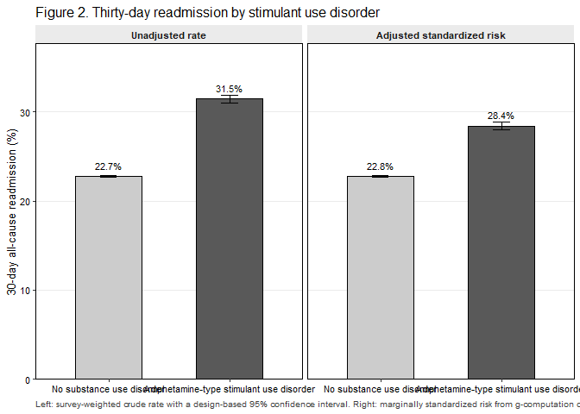
Figure 2. Unadjusted rate and adjusted standardized risk of 30-day readmission, by exposure.
Note
The primary model is a survey-weighted logistic regression of 30-day all-cause readmission on amphetamine-type stimulant use disorder, adjusted for the pre-specified covariate blocks: age modelled as a restricted cubic spline with four knots, sex, primary payer, ZIP-code income quartile, NCHS urban-rural residence, weekend admission, admission type, hospital bed size, location and teaching status, ownership, discharge year, the Elixhauser comorbidity set excluding the drug-abuse and alcohol-abuse flags, heart failure phenotype, cardiogenic shock, mechanical ventilation, chronic dialysis dependence, cardiac device in situ, cardiomyopathy, and housing instability. Adjusted absolute risks were obtained by marginal standardization over the whole analytic cohort with delta-method variance on the design-based covariance matrix and t critical values on 15936 design degrees of freedom. The following pre-specified covariates were removed by the sparse-cell guard because their smallest outcome cell fell below 11 unweighted discharges, which would otherwise cause quasi-complete separation: elix_chf. The Elixhauser drug-abuse and alcohol-abuse flags were excluded by pre-specification, not after inspection, because they are collinear with the exposure by construction. Nicotine dependence was deliberately not adjusted for: it is a near-universal co-code in the exposed arm and conditioning on it would be over-adjustment on a proxy of the exposure. Sequential Models 1 to 4 are NOT monotone – check whether a covariate has been misclassified as a mediator. The Model 4 to Model 5 change is attenuation consistent with mediation and is not an adjusted estimate.

3.3.1 Unmeasured confounding
An unmeasured confounder would need to be associated with both amphetamine-type stimulant use disorder and 30-day readmission by a risk ratio of at least 1.80 each, above and beyond the measured covariates, to explain away the observed adjusted risk ratio of 1.25; to move the confidence limit closest to the null to 1.00 the required association is 1.76. The most plausible such confounder here is housing instability, which is partly but not completely captured by the Z59.x diagnosis code included in the model.

3.3.2 Housing instability
Table 3b. Primary estimate with and without adjustment for housing instability (Z59.x).
Analysis | Adjusted OR (95% CI) | p value | Adjusted risk difference, pp (95% CI) | Adjusted risk ratio (95% CI)
Without housing instability (Z59.x) | 1.40 (1.37–1.43) | <0.001 | 6.27 (5.86–6.67) | 1.28 (1.26–1.29)
With housing instability (Z59.x) – PRIMARY MODEL | 1.35 (1.33–1.38) | <0.001 | 5.64 (5.23–6.04) | 1.25 (1.23–1.27)

3.3.3 Numerical cross-check of the g-computation
Table S5. Independent re-computation of the adjusted risk difference.
Quantity | svy_std_risk() | marginaleffects::avg_comparisons() | Absolute difference | Agreement
Adjusted risk difference (percentage points) | 5.6370 | 5.6370 | 0.000000 | AGREE (within the pre-specified numerical tolerance)

3.4 Sequential adjustment
Table 4. Effect of sequential covariate adjustment on the exposure estimate.
Analysis | Adjusted OR (95% CI) | p value | Adjusted risk difference, pp (95% CI) | Adjusted risk ratio (95% CI)
Model 1: unadjusted | 1.56 (1.53–1.59) | <0.001 | 8.73 (8.31–9.15) | 1.38 (1.37–1.40)
Model 2: + demographic and administrative covariates | 1.25 (1.23–1.28) | <0.001 | 4.16 (3.76–4.55) | 1.18 (1.16–1.20)
Model 3: + hospital covariates | 1.26 (1.24–1.29) | <0.001 | 4.33 (3.93–4.72) | 1.19 (1.17–1.21)
Model 4: + comorbidity and clinical covariates (PRIMARY MODEL) | 1.35 (1.33–1.38) | <0.001 | 5.64 (5.23–6.04) | 1.25 (1.23–1.27)
Model 5: + mediators (length of stay, discharge disposition, AMA discharge) | 1.29 (1.26–1.31) | <0.001 | 4.61 (4.22–5.01) | 1.20 (1.18–1.22)
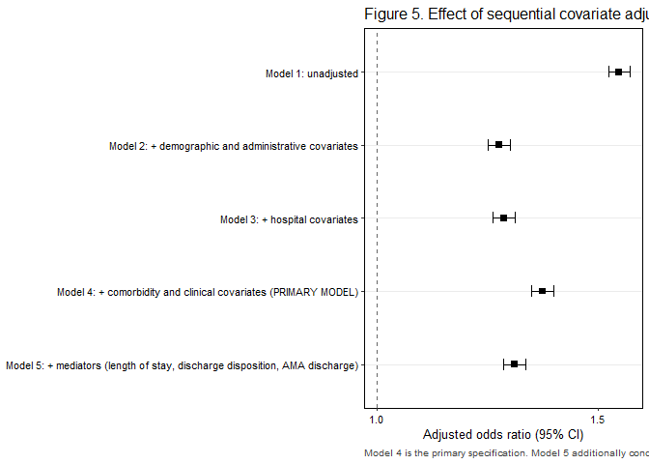
Figure 5. Effect of sequential covariate adjustment.
 Warning
Model 4 is the primary specification. Model 5 is over-adjusted: it conditions on length of stay, discharge disposition and discharge against medical advice, which are mediators. It is shown to demonstrate mediation and must not be reported as the adjusted estimate.

3.5 Secondary outcomes
Table 4b. Secondary outcomes. One Benjamini-Hochberg family; the primary outcome is not a member of it.
Secondary outcome | Events (unweighted) | Adjusted OR (95% CI) | p value | BH q value
Heart failure readmission (CCSR CIR019) | 319,829 | 1.38 (1.34–1.43) | <0.001 | <0.001
Substance-related readmission (CCSR MBD substance categories) | 558 | 4.13 (3.07–5.56) | <0.001 | <0.001
Unplanned (non-elective) readmission | 825,167 | 2.49 (2.22–2.81) | <0.001 | <0.001
In-hospital death at readmission | 59,163 | 0.83 (0.76–0.89) | <0.001 | <0.001
Non-home discharge at index | 752,328 | 1.84 (1.79–1.89) | <0.001 | <0.001
Discharge against medical advice at index | 69,420 | 2.47 (2.39–2.56) | <0.001 | <0.001
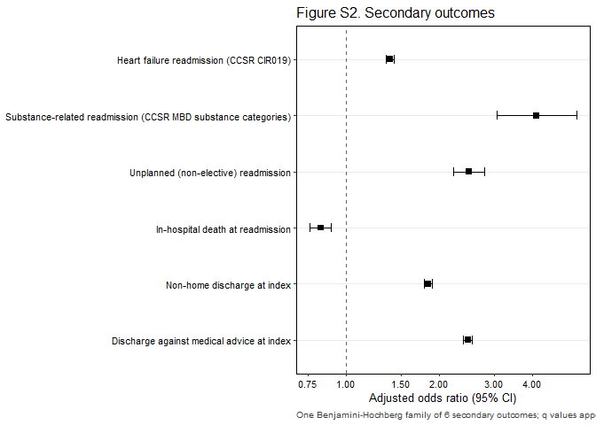
Figure S2. Secondary outcomes.

3.6 Cause of readmission
Table 5. Principal diagnosis category of the first 30-day readmission, by exposure.
Cause of readmission (DXCCSR category) | Overall, % | Unexposed, % (n) | Stimulant, % (n) | p value | BH q value
Heart failure | 36.8% | 36.2% (303,796) | 57.1% (16,033) | <0.001 | <0.001
Septicemia | 6.9% | 6.9% ( 59,237) | 6.2% ( 1,784) | <0.001 | <0.001
Chronic kidney disease | 4.8% | 4.8% ( 41,520) | 1.6% ( 454) | <0.001 | <0.001
Acute and unspecified renal failure | 4.4% | 4.5% ( 37,656) | 1.4% ( 380) | <0.001 | <0.001
Respiratory failure; insufficiency; arrest | 3.7% | 3.8% ( 30,983) | 2.4% ( 687) | <0.001 | <0.001
Cardiac dysrhythmias | 3.2% | 3.2% ( 27,092) | 2.6% ( 703) | <0.001 | <0.001
Pneumonia (except that caused by tuberculosis) | 2.3% | 2.4% ( 19,179) | 1.4% ( 376) | <0.001 | <0.001
Chronic obstructive pulmonary disease and bronchiectasis | 2.0% | 2.0% ( 16,826) | 1.5% ( 412) | <0.001 | <0.001
Fluid and electrolyte disorders | 1.9% | 1.9% ( 16,239) | 0.8% ( 229) | <0.001 | <0.001
Acute myocardial infarction | 1.8% | 1.8% ( 15,797) | 2.0% ( 579) | 0.037 | 0.037
Other | 32.1% | 32.3% (272,350) | 23.1% ( 6,412) | <0.001 | —
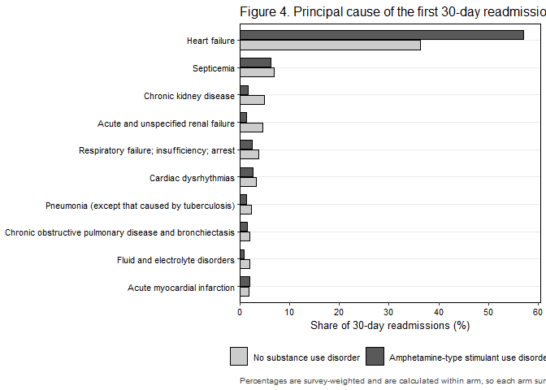
Figure 4. Principal cause of the first 30-day readmission, by exposure.
Note
Based on 868,724 unweighted 30-day readmissions with a recorded principal diagnosis, mapped to the AHRQ DXCCSR v2025.1 default inpatient category. 804 readmission principal diagnosis code(s) had no default CCSR assignment and are grouped under ‘Other’. The top 10 categories by overall weighted share are reported; all remaining categories are folded into ‘Other’, as are 0 categories that fell below the 11 unweighted discharge threshold in at least one exposure arm. Percentages are within-arm shares of all readmissions in that arm and therefore sum to 100% down each column. P values are design-based Wald tests from survey-weighted logistic regression of the category indicator on exposure; q values are Benjamini-Hochberg adjusted across the reported categories.

3.7 Exploratory subgroups
Table 5b. Exploratory subgroup analyses.
Subgroup | Level | Unweighted n | Readmissions (unweighted) | Adjusted OR (95% CI) | Adjusted RD, pp (95% CI) | Interaction p
Overall (primary model) |  | 3,773,470 | 868,724 | 1.35 (1.33–1.38) | 5.64 (5.23–6.04)
Age <55 vs ≥55 years | ≥55 years | 3,325,445 | 756,939 | 1.31 (1.27–1.35) | 4.97 (4.40–5.54) | 0.004
 | <55 years | 448,025 | 111,785 | 1.46 (1.42–1.50) | 7.06 (6.51–7.61)
HFrEF vs HFpEF | HFrEF | 1,289,961 | 301,144 | 1.40 (1.36–1.43) | 6.23 (5.71–6.75) | 0.004
 | HFpEF | 1,564,180 | 349,620 | 1.28 (1.21–1.36) | 4.47 (3.37–5.58)
Medicaid vs other payer | Other payer | 3,379,792 | 760,046 | 1.38 (1.34–1.42) | 5.93 (5.33–6.53) | 0.802
 | Medicaid | 393,678 | 108,678 | 1.37 (1.33–1.41) | 6.35 (5.77–6.92)
Metropolitan vs non-metropolitan residence | Metropolitan | 3,199,329 | 740,916 | 1.39 (1.36–1.42) | 6.20 (5.74–6.65) | <0.001
 | Non-metropolitan | 550,386 | 118,540 | 1.18 (1.11–1.25) | 2.81 (1.74–3.88)
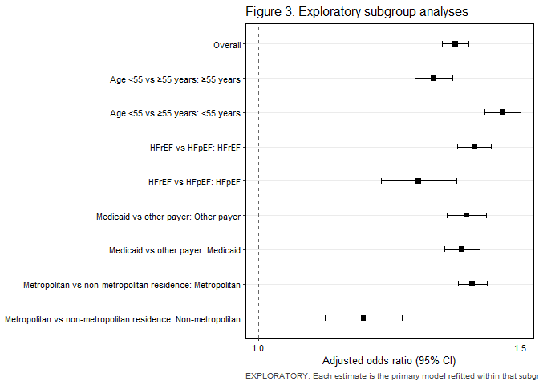
Figure 3. Exploratory subgroup analyses.
 Important
ALL SUBGROUP RESULTS ARE EXPLORATORY and are not adjusted for multiplicity. Each estimate is the adjusted association between amphetamine-type stimulant use disorder and 30-day readmission, refitted within that subgroup using the primary covariate block. Effect modification is assessed by a design-based Wald test on the whole interaction block, fitted on the rows with a non-missing modifier; the modifier’s deterministic parent covariate is removed from that model so that no coefficient is aliased (payer group for primary payer, residence group for NCHS category, phenotype for the HFrEF/HFpEF comparison). Non-overlapping subgroup confidence intervals are NOT evidence of interaction and are not interpreted as such. Terms that became constant or sparse inside a subgroup were dropped from that fit and are listed in the render log. No subgroup finding appears in the Conclusions.

3.8 Sensitivity analyses
Table 6. Sensitivity analyses. Exposure estimate only.
Analysis | Adjusted OR (95% CI) | p value | Adjusted risk difference, pp (95% CI) | Adjusted risk ratio (95% CI)
Primary model (reference) | 1.35 (1.33–1.38) | <0.001 | 5.64 (5.23–6.04) | 1.25 (1.23–1.27)
S1. First qualifying index admission per patient-year only | 1.30 (1.27–1.33) | <0.001 | 4.42 (3.99–4.85) | 1.22 (1.20–1.24)
S2. Leave-2020-out | 1.35 (1.32–1.38) | <0.001 | 5.61 (5.16–6.06) | 1.25 (1.23–1.27)
S3. Propensity-score overlap-weighted (ATO) estimate | 1.38 (1.35–1.41) | <0.001 | 6.12 (5.70–6.54) | 1.25 (1.24–1.27)
S4. Cox model, administrative censoring at day 30, full cohort | Not run | — | Not run | Not run in this render: deferred to a separate run (memory)
S5a. Disorder-only exposure (F15.1x/F15.2x; F15.9x excluded) | 1.38 (1.35–1.41) | <0.001 | 5.99 (5.55–6.42) | 1.26 (1.24–1.28)
S5b. In-remission stimulant stratum versus no substance use disorder | Not run | — | Not run | Not estimable: fewer than 11 remission-coded index admissions
S6. Excluding index admissions ending in discharge against medical advice | 1.25 (1.22–1.27) | <0.001 | 3.98 (3.56–4.39) | 1.18 (1.16–1.20)
S7. Exposure ascertained from I10_DX1-I10_DX30 only (uniform field depth) | 1.36 (1.33–1.38) | <0.001 | 5.64 (5.23–6.05) | 1.25 (1.23–1.27)

Table 6b. Negative control outcome.
Analysis | Adjusted OR (95% CI) | p value | Interpretation
Negative control: 30-day readmission with an eye or ear principal diagnosis | Not estimable | — | missing value where TRUE/FALSE needed

Table S6. Covariate balance before and after propensity-score overlap weighting.
Variable | SMD before weighting | SMD after weighting | Balanced (|SMD| < 0.10)
Age, years | 1.751 | 0.000 | Yes
Sex | 0.593 | 0.000 | Yes
Primary expected payer | 1.417 | 0.000 | Yes
Median household income quartile (patient ZIP code) | 0.197 | 0.000 | Yes
Patient residence (NCHS urban-rural classification) | 0.510 | 0.000 | Yes
Admission day | 0.072 | 0.000 | Yes
Admission type | 0.152 | 0.000 | Yes
Hospital bed size | 0.162 | 0.000 | Yes
Hospital location and teaching status | 0.121 | 0.000 | Yes
Hospital ownership | 0.217 | 0.000 | Yes
Discharge year | 0.171 | 0.000 | Yes
Cardiac arrhythmias | 0.468 | 0.000 | Yes
Valvular disease | 0.156 | 0.000 | Yes
Pulmonary circulation disorders | 0.071 | 0.000 | Yes
Peripheral vascular disorders | 0.235 | 0.000 | Yes
Hypertension, uncomplicated | 0.021 | 0.000 | Yes
Paralysis | 0.018 | 0.000 | Yes
Other neurological disorders | 0.072 | 0.000 | Yes
Chronic pulmonary disease | 0.030 | 0.000 | Yes
Diabetes, uncomplicated | 0.054 | 0.000 | Yes
Diabetes, complicated | 0.456 | 0.000 | Yes
Hypothyroidism | 0.422 | 0.000 | Yes
Renal failure | 0.520 | 0.000 | Yes
Liver disease | 0.331 | 0.000 | Yes
Peptic ulcer disease | 0.029 | 0.000 | Yes
HIV/AIDS | 0.091 | 0.000 | Yes
Lymphoma | 0.108 | 0.000 | Yes
Metastatic cancer | 0.122 | 0.000 | Yes
Solid tumour without metastasis | 0.174 | 0.000 | Yes
Rheumatoid arthritis / collagen vascular disease | 0.163 | 0.000 | Yes
Coagulopathy | 0.101 | 0.000 | Yes
Obesity | 0.112 | 0.000 | Yes
Weight loss | 0.068 | 0.000 | Yes
Fluid and electrolyte disorders | 0.130 | 0.000 | Yes
Blood loss anaemia | 0.086 | 0.000 | Yes
Deficiency anaemia | 0.094 | 0.000 | Yes
Psychoses | 0.216 | 0.000 | Yes
Depression | 0.031 | 0.000 | Yes
Hypertension, complicated | 0.315 | 0.000 | Yes
Heart failure phenotype (any-listed I50 subtype) | 0.833 | 0.000 | Yes
Cardiogenic shock at index | 0.138 | 0.000 | Yes
Invasive mechanical ventilation at index | 0.051 | 0.000 | Yes
Chronic dialysis dependence | 0.288 | 0.000 | Yes
Cardiac implantable electronic device in situ | 0.300 | 0.000 | Yes
Cardiomyopathy | 0.826 | 0.000 | Yes
Housing instability (Z59.x) | 0.650 | 0.000 | Yes
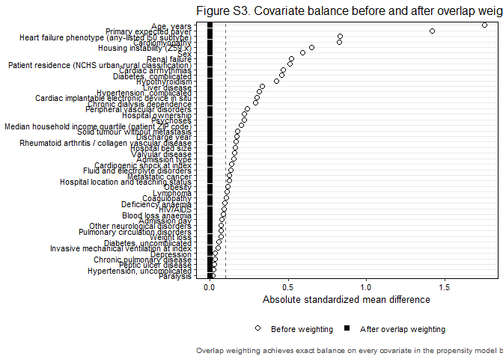
Figure S3. Covariate balance before and after overlap weighting.
Note
Sensitivity analyses are consistency checks and are NOT corrected for multiplicity; they are judged on whether the point estimate moves, not on whether a p-value crosses 0.05. Every subset was taken with subset() on the survey design constructed once on the full cohort, so the stratum information needed for correct variance estimation is preserved; the design was never rebuilt on filtered data. Pre-specified analyses that were not run, with the reason: S4: Not run in this render: deferred to a separate run (memory) S5b: Not estimable: fewer than 11 remission-coded index admissions The overlap-weighted design had an effective sample size of 217,938. The Cox model in S4 is a sensitivity analysis only and is not an alternative primary specification: every patient has complete 30-day follow-up by design, so a hazard ratio adds no information beyond the binary outcome.

3.9 Temporal trends
Table S3. Temporal trends, 2016-2022.
Year | Weighted national index admissions | Stimulant prevalence, % (95% CI) | Readmission, unexposed | Readmission, stimulant
2016 | 892,353 | 1.2% (1.1–1.4) | 23.0% (22.7–23.2) | 29.7% (28.2–31.2)
2017 | 991,614 | 1.4% (1.2–1.5) | 23.3% (23.0–23.5) | 32.0% (30.7–33.3)
2018 | 1,038,450 | 1.6% (1.5–1.7) | 23.2% (22.9–23.4) | 30.8% (29.5–32.0)
2019 | 1,070,752 | 1.8% (1.7–2.0) | 23.0% (22.8–23.2) | 32.6% (31.5–33.7)
2020 | 920,415 | 2.4% (2.2–2.6) | 22.5% (22.3–22.7) | 31.6% (30.6–32.6)
2021 | 992,888 | 2.8% (2.6–3.0) | 22.2% (21.9–22.4) | 31.6% (30.6–32.5)
2022 | 999,726 | 2.9% (2.7–3.1) | 22.1% (21.8–22.3) | 31.3% (30.4–32.3)
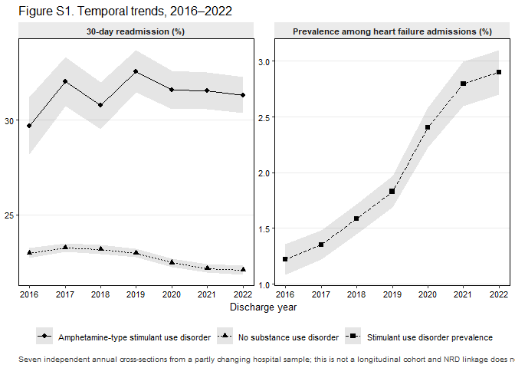
Figure S1. Temporal trends, 2016-2022.
Trend in the outcome: 0.98 (0.98–0.99) per calendar year (p <0.001). Trend in exposure prevalence: 1.18 (1.16–1.20) per calendar year (p <0.001). Exposure-by-year interaction: p 0.004.
Important
Three qualifications apply to every trend result reported here and must appear alongside them in the manuscript. First, these are seven independent annual cross-sections drawn from a partly changing hospital sample, not a longitudinal cohort; NRD patient linkage does not cross calendar years and hospital identifiers are reset each year. Second, coding intensity increased across this window, so an apparent rise in the prevalence of an any-listed diagnosis reflects ascertainment as much as incidence, and no biological trend is claimed. Third, 2020 is anomalous because of pandemic admission avoidance, COVID-19 coding and capacity effects, and is examined in the leave-2020-out sensitivity analysis S2. The trend test enters discharge year as a continuous term replacing the year factor, which is a design-based test; Joinpoint and segmented regression on the annual point estimates are not appropriate because they ignore the survey design. Whether the association itself changed across the window was tested once, as a single exposure-by-year interaction (p 0.004), and not as seven year-specific estimates.

3.10 Model diagnostics
Table S4. Model diagnostics.
Diagnostic | Value | Interpretation
Maximum variance inflation factor (per design-matrix column) | 4.66 | Below the pre-specified threshold of 5; no collinearity concern
Survey-weighted c-statistic (tie-corrected) | 0.599 | Reported without a threshold; discrimination is not the objective of an aetiological model
Design-based decile calibration test (survey analogue of Hosmer-Lemeshow) | <0.001 | With a cohort of this size any calibration test will reject. Figure S4 is the substantive evidence; this p-value is reported for completeness only and is not interpreted alone.
Covariates removed by the sparse-cell guard | elix_chf | Every removal is named here and in the Methods section
Minimum unweighted cell enforced on every reported table | 11 | HCUP Data Use Agreement
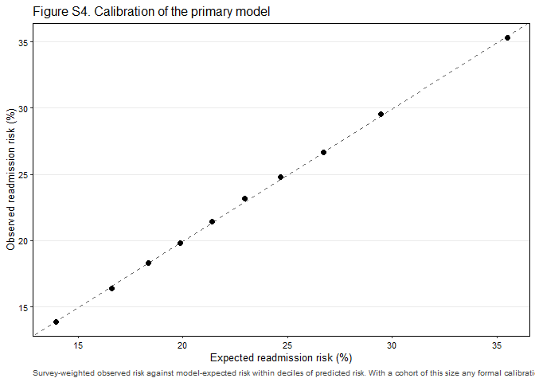
Figure S4. Calibration of the primary model.
Note
Variance inflation factors are computed per design-matrix column rather than aggregated to a generalized VIF, which is the conservative reading: if no individual dummy column is inflated then no multi-level factor is either. The c-statistic is survey-weighted and tie-corrected. The calibration test is the survey analogue of the Hosmer-Lemeshow test and is NOT the Archer-Lemeshow F-adjusted mean residual test; it should not be described as such. Singleton strata were centred at the grand mean (survey.lonely.psu = ‘adjust’) rather than removed; 0 stratum/strata contained a single primary sampling unit. All manually constructed intervals use t critical values on 15,936 design degrees of freedom rather than 1.96.

Table S4b. Variance inflation factors, per design-matrix column.
Term | VIF
ns(AGE, 3)1 | 4.66
ns(AGE, 3)3 | 3.26
ns(AGE, 3)2 | 3.24
PAY1Medicare | 2.59
YEAR2019 | 2.34
HOSP_UR_TEACHNon-metropolitan | 2.32
YEAR2022 | 2.31
YEAR2018 | 2.27
YEAR2021 | 2.26
YEAR2020 | 2.21
YEAR2017 | 2.16
PL_NCHSMicropolitan | 2.04
PAY1Medicaid | 1.99
HOSP_BEDSIZELarge | 1.92
HOSP_BEDSIZEMedium | 1.83
elix_htn_uncompYes | 1.65
ZIPINC_QRTL76th to 100th percentile | 1.62
elix_htn_compYes | 1.62
HF_PhenotypeHFpEF | 1.61
PL_NCHSFringe metro ≥1 million | 1.57
PL_NCHSOther | 1.57
ZIPINC_QRTL51st to 75th percentile | 1.51
PL_NCHSMetro 250,000-999,999 | 1.47
elix_renalYes | 1.46
ZIPINC_QRTL26th to 50th percentile | 1.43
PL_NCHSMissing/other | 1.42
Housing_InstabilityYes | 1.41
PAY1Other/self-pay | 1.38
HOSP_UR_TEACHMetropolitan, teaching | 1.36
CIEDYes | 1.36
elix_dm_compYes | 1.34
PL_NCHSMetro 50,000-249,999 | 1.32
elix_pvdYes | 1.30
HF_PhenotypeCombined | 1.28
StimulantAmphetamine-type stimulant use disorder | 1.24
elix_tumorYes | 1.22
CardiomyopathyYes | 1.22
elix_arrhythmiaYes | 1.21
elix_metsYes | 1.21
Chronic_DialysisYes | 1.21
elix_obesityYes | 1.19
HF_PhenotypeOther/unspecified | 1.18
elix_dm_uncompYes | 1.16
FEMALEFemale | 1.15
elix_valvularYes | 1.11
H_CONTRLPrivate, invest-own | 1.09
Cardiogenic_ShockYes | 1.09
elix_pulm_circYes | 1.08
elix_copdYes | 1.06
elix_hypothyroidYes | 1.06
H_CONTRLGovernment, nonfederal | 1.05
elix_fluidYes | 1.05
Mech_VentYes | 1.05
ZIPINC_QRTLMissing/other | 1.04
elix_liverYes | 1.04
elix_coagYes | 1.04
elix_wtlossYes | 1.04
Admission_TypeElective | 1.03
elix_neuroYes | 1.03
elix_def_anemiaYes | 1.02
elix_psychosesYes | 1.02
elix_depressionYes | 1.02
PAY1Missing/other | 1.01
elix_hivYes | 1.01
elix_lymphomaYes | 1.01
elix_rheumYes | 1.01
AWEEKENDWeekend (Sat-Sun) | 1.00
elix_paralysisYes | 1.00
elix_pudYes | 1.00
elix_blood_anemiaYes | 1.00

3.11 Cohort flow
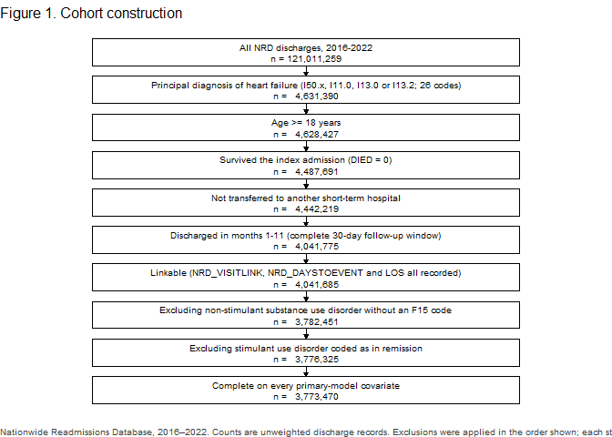
Figure 1. Cohort construction.

3.12 Full model coefficients
Table S2. Full coefficient table for the primary model. Covariate coefficients are adjustment terms, not causal estimates, and are supplied for transparency only.
Term | Adjusted OR (95% CI) | p value
StimulantAmphetamine-type stimulant use disorder | 1.35 (1.33–1.38) | <0.001
ns(AGE, 3)1 | 0.69 (0.67–0.70) | <0.001
ns(AGE, 3)2 | 0.46 (0.43–0.49) | <0.001
ns(AGE, 3)3 | 0.60 (0.59–0.61) | <0.001
FEMALEFemale | 1.00 (0.99–1.00) | 0.575
PAY1Medicare | 1.37 (1.35–1.39) | <0.001
PAY1Medicaid | 1.45 (1.43–1.47) | <0.001
PAY1Other/self-pay | 1.06 (1.04–1.08) | <0.001
PAY1Missing/other | 1.20 (1.10–1.30) | <0.001
ZIPINC_QRTL26th to 50th percentile | 0.95 (0.94–0.96) | <0.001
ZIPINC_QRTL51st to 75th percentile | 0.90 (0.89–0.91) | <0.001
ZIPINC_QRTL76th to 100th percentile | 0.89 (0.88–0.90) | <0.001
ZIPINC_QRTLMissing/other | 0.92 (0.90–0.95) | <0.001
PL_NCHSFringe metro ≥1 million | 1.01 (1.00–1.02) | 0.140
PL_NCHSMetro 250,000-999,999 | 0.98 (0.97–1.00) | 0.008
PL_NCHSMetro 50,000-249,999 | 0.96 (0.95–0.98) | <0.001
PL_NCHSMicropolitan | 0.90 (0.89–0.92) | <0.001
PL_NCHSOther | 0.89 (0.87–0.91) | <0.001
PL_NCHSMissing/other | 1.26 (1.21–1.32) | <0.001
AWEEKENDWeekend (Sat-Sun) | 1.03 (1.03–1.04) | <0.001
Admission_TypeElective | 0.89 (0.88–0.91) | <0.001
HOSP_BEDSIZEMedium | 1.01 (1.00–1.02) | 0.135
HOSP_BEDSIZELarge | 1.02 (1.01–1.03) | <0.001
HOSP_UR_TEACHMetropolitan, teaching | 1.00 (0.99–1.01) | 0.642
HOSP_UR_TEACHNon-metropolitan | 1.01 (0.99–1.03) | 0.224
H_CONTRLGovernment, nonfederal | 1.05 (1.03–1.06) | <0.001
H_CONTRLPrivate, invest-own | 1.15 (1.14–1.17) | <0.001
YEAR2017 | 0.99 (0.97–1.00) | 0.141
YEAR2018 | 0.98 (0.96–1.00) | 0.014
YEAR2019 | 0.96 (0.95–0.98) | <0.001
YEAR2020 | 0.92 (0.91–0.94) | <0.001
YEAR2021 | 0.92 (0.90–0.94) | <0.001
YEAR2022 | 0.92 (0.90–0.93) | <0.001
elix_arrhythmiaYes | 1.13 (1.12–1.13) | <0.001
elix_valvularYes | 1.07 (1.06–1.07) | <0.001
elix_pulm_circYes | 1.00 (1.00–1.01) | 0.209
elix_pvdYes | 1.15 (1.14–1.16) | <0.001
elix_htn_uncompYes | 0.94 (0.92–0.96) | <0.001
elix_paralysisYes | 1.14 (1.10–1.19) | <0.001
elix_neuroYes | 1.08 (1.07–1.09) | <0.001
elix_copdYes | 1.25 (1.24–1.25) | <0.001
elix_dm_uncompYes | 1.06 (1.05–1.07) | <0.001
elix_dm_compYes | 1.16 (1.15–1.16) | <0.001
elix_hypothyroidYes | 1.04 (1.03–1.05) | <0.001
elix_renalYes | 1.32 (1.31–1.33) | <0.001
elix_liverYes | 1.17 (1.16–1.18) | <0.001
elix_pudYes | 1.12 (1.08–1.16) | <0.001
elix_hivYes | 1.33 (1.26–1.40) | <0.001
elix_lymphomaYes | 1.26 (1.23–1.30) | <0.001
elix_metsYes | 1.19 (1.16–1.22) | <0.001
elix_tumorYes | 1.17 (1.15–1.19) | <0.001
elix_rheumYes | 1.12 (1.10–1.13) | <0.001
elix_coagYes | 1.06 (1.04–1.07) | <0.001
elix_obesityYes | 0.86 (0.85–0.86) | <0.001
elix_wtlossYes | 1.12 (1.11–1.14) | <0.001
elix_fluidYes | 1.14 (1.13–1.14) | <0.001
elix_blood_anemiaYes | 1.18 (1.15–1.21) | <0.001
elix_def_anemiaYes | 1.05 (1.04–1.06) | <0.001
elix_psychosesYes | 1.41 (1.37–1.44) | <0.001
elix_depressionYes | 1.07 (1.07–1.08) | <0.001
elix_htn_compYes | 0.95 (0.94–0.96) | <0.001
HF_PhenotypeHFpEF | 0.98 (0.98–0.99) | <0.001
HF_PhenotypeCombined | 1.02 (1.02–1.03) | <0.001
HF_PhenotypeOther/unspecified | 0.99 (0.97–1.00) | 0.050
Cardiogenic_ShockYes | 1.00 (0.98–1.02) | 0.890
Mech_VentYes | 0.93 (0.91–0.96) | <0.001
Chronic_DialysisYes | 1.25 (1.23–1.26) | <0.001
CIEDYes | 1.06 (1.05–1.07) | <0.001
CardiomyopathyYes | 0.93 (0.92–0.94) | <0.001
Housing_InstabilityYes | 1.39 (1.35–1.43) | <0.001

4. Limitations
Pre-written; can be used as the Limitations paragraph with minimal editing.
This study has several limitations inherent to administrative claims data.
Exposure is defined by diagnosis codes, not by toxicology. Amphetamine-type stimulant use disorder is under-coded in hospital discharge data, and coding depends on whether the clinician documented it and the coder captured it. Under-ascertainment of this kind is likely to be non-differential with respect to readmission and would therefore bias toward the null, meaning the true association may be stronger than the one reported. ICD-10-CM F15 covers amphetamine-type stimulants including methamphetamine but also includes caffeine and excludes cocaine, so the specific agent cannot be identified; the exposure is deliberately named accordingly.
Coding intensity increased across the study window, so apparent temporal trends in the prevalence of an any-listed diagnosis reflect ascertainment as well as incidence, and no biological trend is claimed. The seven data years are independent annual cross-sections drawn from a partly changing hospital sample rather than a longitudinal cohort. The year 2020 is anomalous because of pandemic admission avoidance, COVID-19 coding and hospital capacity effects, and is examined in a leave-2020-out sensitivity analysis.
The NRD contains no race or ethnicity variable and no geographic identifier below the national level. Neither could be adjusted for. Given that stimulant use, heart failure outcomes and readmission all vary by race and by region, residual confounding on these axes cannot be excluded and no regionally-specific inference is possible.
Patient linkage does not cross calendar years. A patient discharged in December cannot be followed into the following January, which is why December discharges were excluded; readmissions to hospitals in a different state, and readmissions occurring after a within-year linkage break, are not observed. The unit of analysis is the discharge, and a patient may contribute more than one index admission within a year; a first-admission-only sensitivity analysis addresses this.
Clinical detail relevant to heart failure is absent. The NRD carries no ejection fraction, no natriuretic peptide concentration, no medication data, no vital signs and no laboratory values. Heart failure phenotype is inferred from the listed I50 subtype codes rather than measured. Adherence, outpatient follow-up, social support and substance use treatment are unobserved. Residual confounding by heart failure severity is therefore possible, and the reported E-value quantifies how strong an unmeasured confounder would need to be to explain the association away.
Mediators were deliberately not adjusted for in the primary model, so the estimate is a total effect and not a direct effect; the over-adjusted model is presented separately for transparency.
This is an observational study and the association reported is not a causal effect. The negative control outcome and the E-value bound residual confounding but do not eliminate it.

5. Anticipated statistical review
Prepared answers to the criticisms this design attracts. Each is already supported by an analysis in this report.
“Why logistic regression and not Cox?” Follow-up is fixed at 30 days and complete by design, so there is no informative censoring and a hazard ratio adds nothing to a binary outcome. A Cox model on the full cohort with administrative censoring at day 30 is reported as sensitivity analysis S4 and agrees with the primary result.
“An odds ratio overstates the risk ratio when the outcome is common.” Agreed, which is why the headline results are absolute: adjusted risks, risk difference and risk ratio from marginal standardization. The odds ratio is reported as a secondary measure.
“Did you account for the survey design?” Yes, throughout, including in descriptive statistics. The design was built once with year-unique stratum and cluster identifiers and every analysis is a subset of it. Design properties, including the number of single-PSU strata and the design degrees of freedom, are in Table S1.
“Table 1 has no p-values.” By design. At this sample size a p-value in Table 1 measures sample size, not imbalance. Standardized mean differences are reported instead.
“How do you know the comparator is clean?” Patients with any non-stimulant substance use disorder and no stimulant code were excluded, so the comparator is a no-substance-use-disorder group rather than a mixed group.
“Could this be confounded by homelessness?” Housing instability is adjusted for, and the estimate with and without that adjustment is shown in Table 3b so the reader can see exactly how much it accounts for.
“Could unmeasured confounding explain this?” The E-value in Section 3.3.1 gives the minimum strength required. The negative control outcome tests for gross residual confounding and differential surveillance.
“Why not use propensity score matching?” Overlap weighting achieves exact balance on every covariate in the propensity model with bounded weights and no arbitrary trimming or caliper, and retains the whole cohort. It is reported as a co-estimator, not a replacement, and the balance achieved is shown in Table S6 and Figure S3.
“Are the subgroup findings real?” They are exploratory, not multiplicity-adjusted, assessed by formal interaction tests rather than by overlapping intervals, and excluded from the Conclusions.
“Is age adequately controlled?” Age is modelled as a restricted cubic spline rather than linearly or categorically, which is important because the arms differ substantially in age.

6. Reference material

6.1 Code lists
Table S7. Complete list of ICD-10-CM and ICD-10-PCS codes used to define the index condition, the exposure, the exclusions and every clinical covariate. Supplied so that the definitions can be reproduced exactly.
Group | System | Code
Heart failure (principal diagnosis, index cohort) | ICD-10-CM | I501
Heart failure (principal diagnosis, index cohort) | ICD-10-CM | I509
Heart failure (principal diagnosis, index cohort) | ICD-10-CM | I5020
Heart failure (principal diagnosis, index cohort) | ICD-10-CM | I5021
Heart failure (principal diagnosis, index cohort) | ICD-10-CM | I5022
Heart failure (principal diagnosis, index cohort) | ICD-10-CM | I5023
Heart failure (principal diagnosis, index cohort) | ICD-10-CM | I5030
Heart failure (principal diagnosis, index cohort) | ICD-10-CM | I5031
Heart failure (principal diagnosis, index cohort) | ICD-10-CM | I5032
Heart failure (principal diagnosis, index cohort) | ICD-10-CM | I5033
Heart failure (principal diagnosis, index cohort) | ICD-10-CM | I5040
Heart failure (principal diagnosis, index cohort) | ICD-10-CM | I5041
Heart failure (principal diagnosis, index cohort) | ICD-10-CM | I5042
Heart failure (principal diagnosis, index cohort) | ICD-10-CM | I5043
Heart failure (principal diagnosis, index cohort) | ICD-10-CM | I50810
Heart failure (principal diagnosis, index cohort) | ICD-10-CM | I50811
Heart failure (principal diagnosis, index cohort) | ICD-10-CM | I50812
Heart failure (principal diagnosis, index cohort) | ICD-10-CM | I50813
Heart failure (principal diagnosis, index cohort) | ICD-10-CM | I50814
Heart failure (principal diagnosis, index cohort) | ICD-10-CM | I5082
Heart failure (principal diagnosis, index cohort) | ICD-10-CM | I5083
Heart failure (principal diagnosis, index cohort) | ICD-10-CM | I5084
Heart failure (principal diagnosis, index cohort) | ICD-10-CM | I5089
Heart failure (principal diagnosis, index cohort) | ICD-10-CM | I110
Heart failure (principal diagnosis, index cohort) | ICD-10-CM | I130
Heart failure (principal diagnosis, index cohort) | ICD-10-CM | I132
Amphetamine-type stimulant use disorder (any-listed, exposure) | ICD-10-CM | F1510
Amphetamine-type stimulant use disorder (any-listed, exposure) | ICD-10-CM | F15120
Amphetamine-type stimulant use disorder (any-listed, exposure) | ICD-10-CM | F15121
Amphetamine-type stimulant use disorder (any-listed, exposure) | ICD-10-CM | F15122
Amphetamine-type stimulant use disorder (any-listed, exposure) | ICD-10-CM | F15129
Amphetamine-type stimulant use disorder (any-listed, exposure) | ICD-10-CM | F1513
Amphetamine-type stimulant use disorder (any-listed, exposure) | ICD-10-CM | F1514
Amphetamine-type stimulant use disorder (any-listed, exposure) | ICD-10-CM | F15150
Amphetamine-type stimulant use disorder (any-listed, exposure) | ICD-10-CM | F15151
Amphetamine-type stimulant use disorder (any-listed, exposure) | ICD-10-CM | F15159
Amphetamine-type stimulant use disorder (any-listed, exposure) | ICD-10-CM | F15180
Amphetamine-type stimulant use disorder (any-listed, exposure) | ICD-10-CM | F15181
Amphetamine-type stimulant use disorder (any-listed, exposure) | ICD-10-CM | F15182
Amphetamine-type stimulant use disorder (any-listed, exposure) | ICD-10-CM | F15188
Amphetamine-type stimulant use disorder (any-listed, exposure) | ICD-10-CM | F1519
Amphetamine-type stimulant use disorder (any-listed, exposure) | ICD-10-CM | F1520
Amphetamine-type stimulant use disorder (any-listed, exposure) | ICD-10-CM | F15220
Amphetamine-type stimulant use disorder (any-listed, exposure) | ICD-10-CM | F15221
Amphetamine-type stimulant use disorder (any-listed, exposure) | ICD-10-CM | F15222
Amphetamine-type stimulant use disorder (any-listed, exposure) | ICD-10-CM | F15229
Amphetamine-type stimulant use disorder (any-listed, exposure) | ICD-10-CM | F1523
Amphetamine-type stimulant use disorder (any-listed, exposure) | ICD-10-CM | F1524
Amphetamine-type stimulant use disorder (any-listed, exposure) | ICD-10-CM | F15250
Amphetamine-type stimulant use disorder (any-listed, exposure) | ICD-10-CM | F15251
Amphetamine-type stimulant use disorder (any-listed, exposure) | ICD-10-CM | F15259
Amphetamine-type stimulant use disorder (any-listed, exposure) | ICD-10-CM | F15280
Amphetamine-type stimulant use disorder (any-listed, exposure) | ICD-10-CM | F15281
Amphetamine-type stimulant use disorder (any-listed, exposure) | ICD-10-CM | F15282
Amphetamine-type stimulant use disorder (any-listed, exposure) | ICD-10-CM | F15288
Amphetamine-type stimulant use disorder (any-listed, exposure) | ICD-10-CM | F1529
Amphetamine-type stimulant use disorder (any-listed, exposure) | ICD-10-CM | F1590
Amphetamine-type stimulant use disorder (any-listed, exposure) | ICD-10-CM | F15920
Amphetamine-type stimulant use disorder (any-listed, exposure) | ICD-10-CM | F15921
Amphetamine-type stimulant use disorder (any-listed, exposure) | ICD-10-CM | F15922
Amphetamine-type stimulant use disorder (any-listed, exposure) | ICD-10-CM | F15929
Amphetamine-type stimulant use disorder (any-listed, exposure) | ICD-10-CM | F1593
Amphetamine-type stimulant use disorder (any-listed, exposure) | ICD-10-CM | F1594
Amphetamine-type stimulant use disorder (any-listed, exposure) | ICD-10-CM | F15950
Amphetamine-type stimulant use disorder (any-listed, exposure) | ICD-10-CM | F15951
Amphetamine-type stimulant use disorder (any-listed, exposure) | ICD-10-CM | F15959
Amphetamine-type stimulant use disorder (any-listed, exposure) | ICD-10-CM | F15980
Amphetamine-type stimulant use disorder (any-listed, exposure) | ICD-10-CM | F15981
Amphetamine-type stimulant use disorder (any-listed, exposure) | ICD-10-CM | F15982
Amphetamine-type stimulant use disorder (any-listed, exposure) | ICD-10-CM | F15988
Amphetamine-type stimulant use disorder (any-listed, exposure) | ICD-10-CM | F1599
Stimulant use disorder in remission (excluded from exposure) | ICD-10-CM | F1511
Stimulant use disorder in remission (excluded from exposure) | ICD-10-CM | F1521
Stimulant use disorder in remission (excluded from exposure) | ICD-10-CM | F1591
Other substance use disorder (cohort exclusion, prefix match) | ICD-10-CM | F101 (prefix)
Other substance use disorder (cohort exclusion, prefix match) | ICD-10-CM | F102 (prefix)
Other substance use disorder (cohort exclusion, prefix match) | ICD-10-CM | F11 (prefix)
Other substance use disorder (cohort exclusion, prefix match) | ICD-10-CM | F12 (prefix)
Other substance use disorder (cohort exclusion, prefix match) | ICD-10-CM | F13 (prefix)
Other substance use disorder (cohort exclusion, prefix match) | ICD-10-CM | F14 (prefix)
Other substance use disorder (cohort exclusion, prefix match) | ICD-10-CM | F16 (prefix)
Other substance use disorder (cohort exclusion, prefix match) | ICD-10-CM | F18 (prefix)
Other substance use disorder (cohort exclusion, prefix match) | ICD-10-CM | F19 (prefix)
Housing instability | ICD-10-CM | Z59 (prefix)
Cardiogenic shock | ICD-10-CM | R570
Cardiomyopathy | ICD-10-CM | I42 (prefix)
Acute myocardial infarction at index | ICD-10-CM | I21 (prefix)
Acute myocardial infarction at index | ICD-10-CM | I22 (prefix)
Nicotine dependence (Table 1 only) | ICD-10-CM | F172 (prefix)
Cardiac implantable electronic device | ICD-10-CM | Z950
Cardiac implantable electronic device | ICD-10-CM | Z95810
Invasive mechanical ventilation | ICD-10-PCS | 5A1935Z
Invasive mechanical ventilation | ICD-10-PCS | 5A1945Z
Invasive mechanical ventilation | ICD-10-PCS | 5A1955Z
Chronic dialysis dependence | ICD-10-CM | N186
Chronic dialysis dependence | ICD-10-CM | Z992
Chronic dialysis dependence | ICD-10-CM | Z4901
Chronic dialysis dependence | ICD-10-CM | Z4902
Chronic dialysis dependence | ICD-10-CM | Z4931
Chronic dialysis dependence | ICD-10-CM | Z4932
Chronic dialysis dependence | ICD-10-PCS | 5A1D60Z
Chronic dialysis dependence | ICD-10-PCS | 5A1D70Z
Chronic dialysis dependence | ICD-10-PCS | 5A1D80Z
Chronic dialysis dependence | ICD-10-PCS | 3E1M39Z

7. Verification log
Checks run automatically during this render:
- Design built once on the full cohort, all analyses subset from it: PASS
- Year-unique stratum and cluster identifiers present: PASS
- Factor levels re-applied and validated after the parquet round-trip: PASS
- Odds ratio and risk difference point in the same direction: PASS – the analysis stops if they disagree
- g-computation independently re-computed: PASS – AGREE (within the pre-specified numerical tolerance)
- December discharges, in-hospital deaths and transfers out excluded from index admissions: PASS – asserted in the cohort build
- Two independent readmission-linkage routines agree exactly: PASS – asserted in the cohort build
- Attrition ladder reconciles with the collected cohort: PASS – asserted in the cohort build

7.1 Small-cell suppression scan
ATTENTION. The following tables contain cells below the minimum and must be checked before submission:
- Table 1 (baseline):
- Table 2 (unadjusted outcomes):
- Table 5 (cause of readmission):
- Table S3 (temporal trends):

Rendered 2026-10-05 00:08 on the real analysis file.

