Precipitant-stratified 30-day readmission after type 2 myocardial infarction
  - Nationwide Readmissions Database, 2018–2022 — statistical report
Statistical analysis: Saad
2026-09-28
Table of contents

1. Provenance
Run provenance.
Item | Value
Study | NRD_Saad_T2MI_Precip
Run at | 2026-09-28 02:35
R version | R version 4.6.1 (2026-06-24 ucrt)
survey package | 4.5
marginaleffects package | 1.0.0
Platform | x86_64-w64-mingw32
Data | HCUP Nationwide Readmissions Database 2018-2022

2. Methods summary

2.1 Cohort
Index admissions are any-listed type 2 myocardial infarction (ICD-10-CM I21.A1) among adults, discharged 2018–2022. I21.A1 is overwhelmingly a secondary diagnosis, which is the clinically correct picture for a supply–demand infarction, so the any-listed definition is mandatory; a principal-diagnosis-only cohort is sensitivity S5. The window starts in 2018 because I21.A1 became effective on 1 October 2017; 2016 has no I21.A1 records and 2017 has one quarter, which would manufacture a spurious trend. Project 1 reads only the 2018–2022 files and asserts that no other year is present.
Excluded: records also carrying I21.A9 (other MI type) and records carrying both a type 1 and a type 2 code (uninterpretable as to which event drove the admission; 28,316 such records, reported as a finding in its own right).
Type 1 versus type 2 comparison (secondary aim 2) — descriptive and explicitly NON-CAUSAL. The type 1 comparator (any-listed I21.0–I21.4, I21.9 or I22.x without I21.A1, same years and exclusions, linked for 30-day readmission in the same pass) is used only to describe how the two coded populations differ. The two are not competing treatments, and no causal contrast is estimated or implied.

2.2 Exposure: the precipitant hierarchy
Eight mutually exclusive and exhaustive classes, assigned by a hierarchy frozen before any result was seen (SAP B3.2): (1) sepsis or severe infection; (2) acute GI bleed or blood-loss anaemia; (3) hypertensive emergency; (4) tachyarrhythmia; (5) acute respiratory failure; (6) hypovolaemia or non-cardiogenic shock; (7) perioperative; (8) none of the above. Ranks 1–6 are tested on the principal diagnosis first, then on any secondary diagnosis; rank 7 is procedure-based; rank 8 is the residual. The SAP asked for present-on-admission-positive secondary diagnoses; no NRD file carries a POA indicator, so all secondary diagnoses are used and a complication that arose after admission cannot be distinguished from a precipitant (a stated limitation). Reference class: Sepsis or severe infection.
 Definitional decisions a cardiologist reviewer will check
Cardiogenic shock (R57.0) is not a precipitant. It is a consequence of the infarction and is entered as a covariate.
Hypertensive emergency is I16.1 and I16.9 only. I16.0 is hypertensive urgency and is never a precipitant in any rank (including rank 7, which is procedure-based); 39,889 index admissions carry I16.0 and are reported only as a count.
Perioperative = an ICD-10-PCS Section 0 (Medical and Surgical) procedure with approach 0 (open) or 4 (percutaneous endoscopic). Neither the NRD nor the AHRQ PRCCSR file carries an operating-room flag. The received rule also admitted natural-opening approaches (7/8/F), which capture bedside urinary catheters, feeding tubes, intubation and diagnostic endoscopy; under that rule 22,674 admissions would be perioperative versus 11,533 under the rule used (Table S0b).

The raw co-occurrence of the classes before the hierarchy is Table S1b.

2.3 Outcome, design and estimation
Thirty-day all-cause readmission, linked within calendar year; December discharges, in-hospital deaths and transfers out are excluded from the index cohort. Design-based throughout: DISCWT weights, year-unique strata and clusters integer-coded, the design built once on the full cohort and every analysis a subset() of it; singleton strata centred. Primary model: survey-weighted logistic regression with age as a restricted cubic spline; the precipitant block is tested jointly first, then seven pairwise contrasts versus sepsis. Adjusted absolute risks by g-computation with delta-method intervals; overlap weighting (ATO), applied pairwise, is the co-estimator. Costs in 2022 US dollars using CPI-U, All Items, U.S. city average, not seasonally adjusted, annual average (CUUR0000SA0). Nothing representing 1–10 unweighted discharges is reported, and complementary suppression prevents recovery by subtraction (Section 16).
The following declared factor levels had no observations in the analytic cohort and were dropped before modelling, so that they could not appear as silent NA coefficients: Hospital bed size: Missing/other; Hospital location and teaching status: Missing/other; Hospital ownership: Missing/other. No reference category was affected.
The Nationwide Readmissions Database contains de-identified, publicly available administrative data and this analysis was therefore determined to be non-human-subjects research and exempt from institutional review board review. The HCUP Data Use Agreement was executed before any data were accessed.

3. Cohort construction
Table S0. Attrition from all NRD discharges to the analytic cohort (any step excluding 1-10 records is merged with its neighbour).
Step | Cohort definition step | Unweighted discharges remaining | Excluded at this step
0 | All NRD discharges, 2018-2022 | 85,834,822
1 | Any-listed type 2 myocardial infarction (I21.A1) | 1,126,920 | 84,707,902
2 | Excluding records also carrying I21.A9 (other MI type) | 1,126,802 | 118
3 | Excluding records also carrying a type 1 MI code (I21.0-I21.4, I21.9, I22.x) | 1,098,486 | 28,316
4 | Age >= 18 years | 1,098,404 | 82
5 | Survived the index admission (DIED = 0) | 980,701 | 117,703
6 | Not transferred to another short-term hospital | 967,395 | 13,306
7 | Discharged in months 1-11 (complete 30-day follow-up window) | 871,157 | 96,238
8 | Linkable (NRD_VISITLINK, NRD_DAYSTOEVENT and LOS all recorded) | 871,136 | 21
9 | Complete on every primary-model covariate | 870,486 | 650

Table S0b. Counts quoted in the Results that are not attrition steps.
Item | Unweighted N
Type 1 / type 2 overlap records (excluded at step 3) | 28,316
I21.A9 co-coded type 2 records (excluded at step 2) | 118
Index admissions carrying I16.0 hypertensive URGENCY (not a precipitant) | 39,889
Index admissions with an operating-room procedure, primary rule (Section 0, approach 0/4) | 75,907
Index admissions with a procedure under the received broad rule (approach 0/4/7/8/F) | 196,556
Index admissions classed Perioperative, primary rule | 11,533
Index admissions that would be classed Perioperative under the broad rule | 22,674
Index admissions classed None of the above, primary rule | 187,923
Index admissions that would be classed None of the above under the broad rule | 176,782
Patients contributing more than one index admission in a year | 44,791
- Type 2 MI index admissions (analytic cohort): 870,486 unweighted, representing 1,527,575 weighted national admissions over the five years.
- Followed by a 30-day readmission: 175,312.
- Type 1 MI comparator index admissions (descriptive, non-causal secondary aim): 1,837,814.
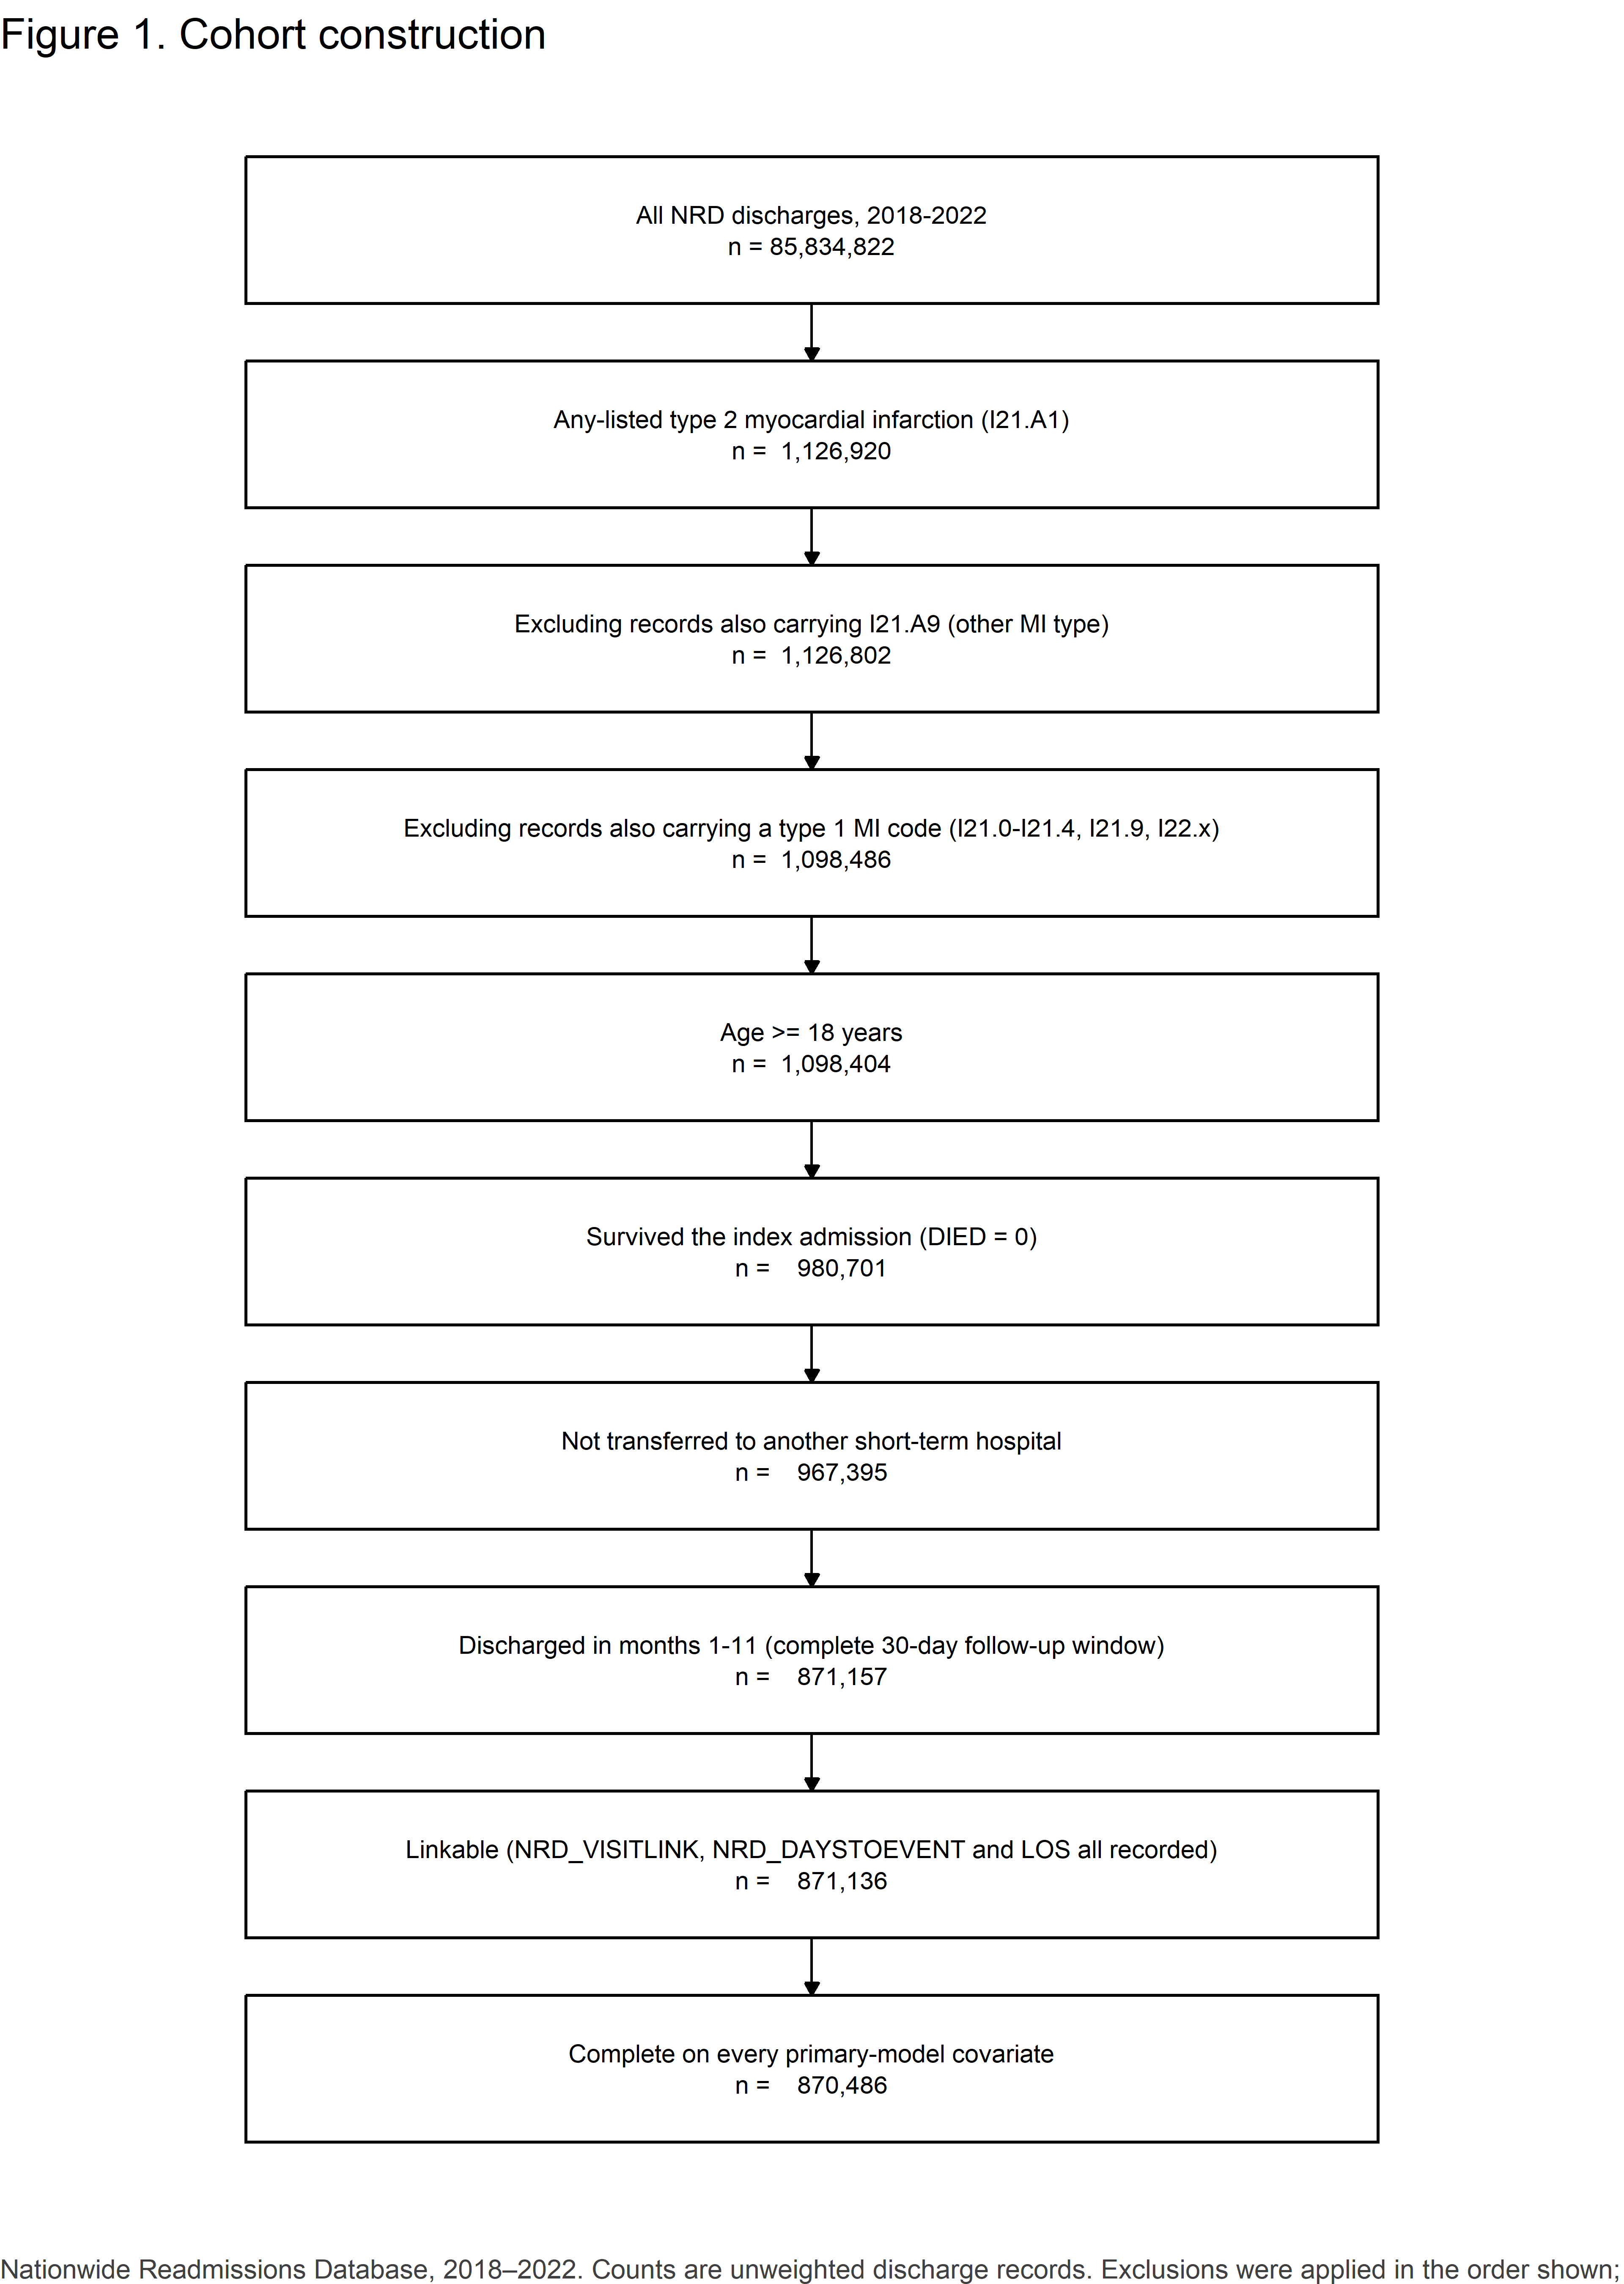
Figure 1. Cohort construction.
Table S1. Survey design properties.
Property | Value
Unweighted index admissions | 870,486
Weighted national index admissions | 1,527,575
Strata (year x NRD_STRATUM) | 476
Primary sampling units (year x HOSP_NRD) | 9,404
Strata containing a single PSU | 5
Design degrees of freedom | 8,928
Critical value used for manually constructed intervals | t(8,928) = 1.960

Table S1a. All-listed I21.A1 per year: this build versus the HCUP frequency workbook.
Year | HCUP frequency workbook, all-listed I21.A1 (unweighted) | This build, all-listed I21.A1 (unweighted) | Difference, %
2018 | 1.455e+05 | 1.455e+05 | 0
2019 | 1.796e+05 | 1.796e+05 | 0
2020 | 2.282e+05 | 2.282e+05 | 0
2021 | 2.693e+05 | 2.693e+05 | 0
2022 | 3.043e+05 | 3.043e+05 | 0

4. Table 1. Baseline characteristics
Table 1. Baseline characteristics of index type 2 myocardial infarction hospitalizations, by precipitating illness class.
Characteristic | Overall (n = 870,486) | Sepsis or severe infection (n = 212,755) | Acute GI bleed or blood-loss anaemia (n = 67,482) | Hypertensive emergency (n = 47,196) | Tachyarrhythmia (n = 228,176) | Acute respiratory failure (n = 77,718) | Hypovolaemia or non-cardiogenic shock (n = 37,854) | Perioperative (n = 11,520) | None of the above (n = 187,785) | Maximum absolute SMD vs sepsis
Age, years, mean (SD) | 70.4 (14.6) | 71.1 (14.3) | 72.7 (13.1) | 61.8 (16.0) | 74.3 (12.7) | 67.9 (14.9) | 70.2 (15.2) | 69.1 (14.2) | 67.4 (15.2) | 0.611
Age group, % (unweighted n) |  |  |  |  |  |  |  |  |  | 0.571
≥65 years | 68.6% (604,348) | 71.5% (153,807) | 76.2% (51,816) | 44.4% (21,581) | 78.8% (181,114) | 61.9% (48,803) | 67.4% (25,876) | 65.5% (7,641) | 59.8% (113,710)
<65 years | 31.4% (266,138) | 28.5% (58,948) | 23.8% (15,666) | 55.6% (25,615) | 21.2% (47,062) | 38.1% (28,915) | 32.6% (11,978) | 34.5% (3,879) | 40.2% (74,075)
Sex, % (unweighted n) |  |  |  |  |  |  |  |  |  | 0.123
Male | 52.9% (460,734) | 53.5% (113,970) | 54.9% (37,068) | 53.4% (25,066) | 55.4% (126,346) | 50.4% (39,067) | 47.4% (17,910) | 53.3% (6,147) | 50.6% (95,160)
Female | 47.1% (409,752) | 46.5% (98,785) | 45.1% (30,414) | 46.6% (22,130) | 44.6% (101,830) | 49.6% (38,651) | 52.6% (19,944) | 46.7% (5,373) | 49.4% (92,625)
Primary expected payer, % (unweighted n) |  |  |  |  |  |  |  |  |  | Suppressed
Medicare | 71.1% (620,855) | 74.2% (158,340) | 76.2% (51,614) | 51.8% (24,731) | 78.2% (178,592) | 65.9% (51,470) | 70.5% (26,789) | 69.2% (7,984) | 64.5% (121,335)
Private | 12.4% (105,510) | 11.3% (23,503) | 11.5% (7,595) | 16.7% (7,705) | 10.5% (23,442) | 14.5% (10,980) | 12.0% (4,478) | 14.3% (1,616) | 14.3% (26,191)
Medicaid | 11.2% (100,339) | 10.0% (21,774) | 7.9% (5,406) | 21.3% (10,211) | 7.3% (17,025) | 13.5% (10,692) | 12.1% (4,661) | 11.4% (1,363) | 15.0% (29,207)
Other/self-pay | <11 (suppressed) | 4.3% (8,866) | 4.3% (2,778) | 10.1% (4,456) | 4.0% (8,853) | 5.9% (4,408) | 5.3% (1,877) | <11 (suppressed) | 6.1% (10,735)
Missing/other | <11 (suppressed) | 0.1% (272) | 0.1% (89) | 0.2% (93) | 0.1% (264) | 0.2% (168) | 0.1% (49) | <11 (suppressed) | 0.2% (317)
Median household income quartile (patient ZIP code), % (unweighted n) |  |  |  |  |  |  |  |  |  | 0.245
0-25th percentile | 31.7% (260,173) | 29.7% (59,045) | 29.3% (18,718) | 41.3% (18,261) | 29.1% (62,476) | 32.8% (24,178) | 32.1% (11,379) | 30.7% (3,341) | 35.2% (62,775)
26th to 50th percentile | 27.8% (235,425) | 28.1% (58,122) | 28.8% (18,763) | 25.3% (11,895) | 28.1% (62,116) | 28.6% (21,619) | 26.4% (9,798) | 28.7% (3,205) | 27.2% (49,907)
51st to 75th percentile | 22.6% (202,538) | 23.2% (50,842) | 23.3% (16,112) | 19.9% (9,889) | 23.4% (54,706) | 22.7% (18,262) | 22.4% (8,709) | 22.4% (2,652) | 21.4% (41,366)
76th to 100th percentile | 16.8% (162,350) | 17.9% (42,245) | 17.5% (13,120) | 12.4% (6,625) | 18.4% (46,339) | 14.8% (12,715) | 18.1% (7,586) | 17.1% (2,185) | 15.1% (31,535)
Missing/other | 1.1% (10,000) | 1.1% (2,501) | 1.1% (769) | 1.1% (526) | 1.1% (2,539) | 1.2% (944) | 1.0% (382) | 1.2% (137) | 1.1% (2,202)
Patient residence (NCHS urban-rural classification), % (unweighted n) |  |  |  |  |  |  |  |  |  | 0.216
Central metro ≥1 million | 27.0% (257,916) | 27.1% (64,321) | 24.4% (18,049) | 37.1% (18,127) | 24.7% (62,440) | 25.1% (21,437) | 30.1% (12,450) | 26.0% (3,300) | 28.1% (57,792)
Fringe metro ≥1 million | 22.8% (197,984) | 23.6% (49,742) | 23.3% (15,740) | 20.5% (9,771) | 23.8% (54,368) | 21.5% (16,613) | 23.5% (8,849) | 22.8% (2,614) | 21.6% (40,287)
Metro 250,000-999,999 | 21.1% (182,713) | 20.9% (44,366) | 21.4% (14,532) | 20.7% (9,759) | 20.9% (47,478) | 22.3% (17,485) | 19.9% (7,469) | 21.0% (2,420) | 21.1% (39,204)
Metro 50,000-249,999 | 11.4% (96,214) | 11.0% (22,605) | 11.8% (7,779) | 9.1% (4,228) | 12.2% (27,239) | 11.9% (9,014) | 10.8% (3,903) | 11.5% (1,281) | 11.1% (20,165)
Micropolitan | 9.6% (73,357) | 9.6% (17,664) | 10.5% (6,409) | 6.5% (2,714) | 9.9% (19,832) | 10.3% (7,102) | 8.5% (2,835) | 9.6% (999) | 9.5% (15,802)
Other | 7.6% (56,143) | 7.3% (12,827) | 8.3% (4,745) | 5.1% (2,108) | 8.1% (15,619) | 8.2% (5,451) | 6.5% (2,031) | 8.5% (838) | 7.8% (12,524)
Missing/other | 0.6% (6,159) | 0.5% (1,230) | 0.3% (228) | 0.9% (489) | 0.4% (1,200) | 0.7% (616) | 0.7% (317) | 0.5% (68) | 0.9% (2,011)
Admission day, % (unweighted n) |  |  |  |  |  |  |  |  |  | 0.108
Weekday (Mon-Fri) | 73.9% (643,193) | 72.6% (154,458) | 75.4% (50,908) | 74.0% (34,988) | 74.5% (169,964) | 72.7% (56,508) | 74.2% (28,078) | 77.3% (8,891) | 74.2% (139,398)
Weekend (Sat-Sun) | 26.1% (227,293) | 27.4% (58,297) | 24.6% (16,574) | 26.0% (12,208) | 25.5% (58,212) | 27.3% (21,210) | 25.8% (9,776) | 22.7% (2,629) | 25.8% (48,387)
Admission type, % (unweighted n) |  |  |  |  |  |  |  |  |  | 0.418
Non-elective | 97.8% (852,164) | 98.3% (209,436) | 94.8% (64,037) | 98.8% (46,655) | 97.9% (223,617) | 97.8% (76,147) | 98.5% (37,311) | 88.0% (10,162) | 98.3% (184,799)
Elective | 2.2% (18,322) | 1.7% (3,319) | 5.2% (3,445) | 1.2% (541) | 2.1% (4,559) | 2.2% (1,571) | 1.5% (543) | 12.0% (1,358) | 1.7% (2,986)
Discharge year, % (unweighted n) |  |  |  |  |  |  |  |  |  | 0.078
2018 | 13.4% (113,899) | 13.5% (28,110) | 14.7% (9,767) | 11.7% (5,304) | 13.4% (29,836) | 11.9% (8,891) | 14.2% (5,232) | 14.2% (1,602) | 13.8% (25,157)
2019 | 16.1% (140,913) | 16.1% (34,569) | 16.9% (11,533) | 15.0% (7,103) | 16.3% (37,541) | 14.7% (11,444) | 15.6% (5,947) | 16.8% (1,923) | 16.3% (30,853)
2020 | 19.5% (173,245) | 20.5% (44,540) | 20.3% (13,944) | 18.8% (9,162) | 18.9% (44,006) | 19.1% (15,195) | 19.7% (7,666) | 20.0% (2,352) | 19.0% (36,380)
2021 | 23.7% (205,508) | 23.3% (49,306) | 23.7% (15,969) | 24.4% (11,561) | 23.8% (54,073) | 25.8% (19,941) | 22.7% (8,544) | 23.6% (2,758) | 23.1% (43,356)
2022 | 27.3% (236,921) | 26.5% (56,230) | 24.3% (16,269) | 30.0% (14,066) | 27.6% (62,720) | 28.5% (22,247) | 27.7% (10,465) | 25.4% (2,885) | 27.8% (52,039)
Hospital bed size, % (unweighted n) |  |  |  |  |  |  |  |  |  | 0.141
Small | 18.0% (151,509) | 18.3% (37,963) | 15.5% (10,220) | 16.1% (7,366) | 18.4% (40,400) | 18.7% (14,124) | 18.7% (6,890) | 13.5% (1,508) | 18.3% (33,038)
Medium | 26.7% (235,166) | 26.9% (57,734) | 25.7% (17,595) | 27.4% (12,779) | 26.8% (62,051) | 26.8% (21,005) | 27.2% (10,321) | 24.8% (2,908) | 26.7% (50,773)
Large | 55.3% (483,811) | 54.8% (117,058) | 58.7% (39,667) | 56.6% (27,051) | 54.8% (125,725) | 54.5% (42,589) | 54.1% (20,643) | 61.8% (7,104) | 55.1% (103,974)
Hospital location and teaching status, % (unweighted n) |  |  |  |  |  |  |  |  |  | 0.187
Metropolitan, non-teaching | 17.3% (157,338) | 18.0% (40,077) | 15.1% (10,694) | 13.0% (6,515) | 18.1% (42,847) | 18.1% (14,817) | 17.7% (6,958) | 14.5% (1,778) | 17.3% (33,652)
Metropolitan, teaching | 74.7% (655,990) | 74.0% (158,827) | 77.9% (52,801) | 81.7% (38,669) | 73.5% (169,496) | 73.0% (57,177) | 74.2% (28,394) | 79.4% (9,185) | 74.5% (141,441)
Non-metropolitan | 8.0% (57,158) | 8.0% (13,851) | 7.0% (3,987) | 5.3% (2,012) | 8.4% (15,833) | 8.8% (5,724) | 8.1% (2,502) | 6.0% (557) | 8.1% (12,692)
Hospital ownership, % (unweighted n) |  |  |  |  |  |  |  |  |  | 0.103
Private, not-profit | 75.1% (648,234) | 75.3% (159,013) | 77.7% (52,034) | 71.5% (33,533) | 76.5% (173,294) | 73.6% (56,672) | 73.4% (27,537) | 76.5% (8,737) | 73.9% (137,414)
Government, nonfederal | 10.5% (96,381) | 9.8% (21,871) | 10.2% (7,147) | 13.1% (6,287) | 9.4% (22,839) | 11.7% (9,342) | 11.4% (4,616) | 10.2% (1,262) | 11.5% (23,017)
Private, invest-own | 14.4% (125,871) | 14.8% (31,871) | 12.1% (8,301) | 15.4% (7,376) | 14.1% (32,043) | 14.7% (11,704) | 15.1% (5,701) | 13.3% (1,521) | 14.6% (27,354)
Type 2 MI coded as the principal diagnosis, % (unweighted n) |  |  |  |  |  |  |  |  |  | 0.447
No | 94.8% (825,220) | 99.6% (211,941) | 96.5% (65,148) | 93.2% (43,984) | 93.7% (213,640) | 96.6% (75,082) | 93.5% (35,396) | 97.4% (11,221) | 89.9% (168,808)
Yes | 5.2% (45,266) | 0.4% (814) | 3.5% (2,334) | 6.8% (3,212) | 6.3% (14,536) | 3.4% (2,636) | 6.5% (2,458) | 2.6% (299) | 10.1% (18,977)
Cardiogenic shock at index, % (unweighted n) |  |  |  |  |  |  |  |  |  | 0.233
No | 97.6% (849,966) | 96.1% (204,582) | 97.1% (65,564) | 99.5% (46,957) | 97.2% (221,856) | 97.3% (75,621) | 99.2% (37,532) | 98.3% (11,327) | 99.3% (186,527)
Yes | 2.4% (20,520) | 3.9% (8,173) | 2.9% (1,918) | 0.5% (239) | 2.8% (6,320) | 2.7% (2,097) | 0.8% (322) | 1.7% (193) | 0.7% (1,258)
Invasive mechanical ventilation at index, % (unweighted n) |  |  |  |  |  |  |  |  |  | 0.585
No | 91.3% (795,943) | 80.9% (172,666) | 91.9% (62,140) | 95.4% (45,028) | 96.3% (219,881) | 81.7% (63,779) | 97.7% (37,000) | 96.6% (11,131) | 98.1% (184,318)
Yes | 8.7% (74,543) | 19.1% (40,089) | 8.1% (5,342) | 4.6% (2,168) | 3.7% (8,295) | 18.3% (13,939) | 2.3% (854) | 3.4% (389) | 1.9% (3,467)
Chronic kidney disease stage, % (unweighted n) |  |  |  |  |  |  |  |  |  | 0.332
No coded CKD | 58.9% (512,297) | 61.1% (130,299) | 54.6% (36,830) | 44.8% (21,089) | 56.4% (128,717) | 61.2% (47,377) | 63.0% (23,905) | 60.9% (7,003) | 62.6% (117,077)
Stage 1-2 | 1.8% (15,287) | 1.6% (3,365) | 1.6% (1,084) | 2.2% (973) | 2.0% (4,614) | 1.5% (1,181) | 2.0% (753) | 1.6% (168) | 1.7% (3,149)
Stage 3 | 17.3% (148,049) | 15.4% (32,125) | 18.6% (12,343) | 18.0% (8,346) | 21.2% (47,617) | 15.1% (11,543) | 17.1% (6,365) | 14.0% (1,597) | 15.2% (28,113)
Stage 4-5, not on dialysis | 6.1% (53,059) | 4.8% (10,185) | 7.7% (5,242) | 9.4% (4,454) | 6.5% (14,847) | 5.8% (4,561) | 5.5% (2,076) | 4.6% (540) | 5.9% (11,154)
Unspecified stage | 6.3% (56,494) | 6.4% (13,885) | 5.8% (4,051) | 7.8% (3,720) | 6.8% (15,898) | 5.4% (4,347) | 7.7% (3,020) | 4.8% (550) | 5.7% (11,023)
Dialysis-dependent / ESKD | 9.7% (85,300) | 10.7% (22,896) | 11.6% (7,932) | 17.8% (8,614) | 7.1% (16,483) | 10.9% (8,709) | 4.6% (1,735) | 14.1% (1,662) | 9.0% (17,269)
Dialysis dependence at index, % (unweighted n) |  |  |  |  |  |  |  |  |  | 0.230
No | 90.3% (785,186) | 89.3% (189,859) | 88.4% (59,550) | 82.2% (38,582) | 92.9% (211,693) | 89.1% (69,009) | 95.4% (36,119) | 85.9% (9,858) | 91.0% (170,516)
Yes | 9.7% (85,300) | 10.7% (22,896) | 11.6% (7,932) | 17.8% (8,614) | 7.1% (16,483) | 10.9% (8,709) | 4.6% (1,735) | 14.1% (1,662) | 9.0% (17,269)
Known coronary artery disease (I25.1x/I25.7x), % (unweighted n) |  |  |  |  |  |  |  |  |  | 0.356
No | 57.7% (506,872) | 66.4% (142,663) | 49.7% (33,951) | 60.7% (28,747) | 49.1% (113,457) | 62.3% (48,629) | 64.6% (24,712) | 54.9% (6,388) | 57.2% (108,325)
Yes | 42.3% (363,614) | 33.6% (70,092) | 50.3% (33,531) | 39.3% (18,449) | 50.9% (114,719) | 37.7% (29,089) | 35.4% (13,142) | 45.1% (5,132) | 42.8% (79,460)
Prior revascularization (Z95.1/Z95.5), % (unweighted n) |  |  |  |  |  |  |  |  |  | 0.273
No | 84.0% (734,208) | 89.0% (190,094) | 79.1% (53,651) | 86.9% (41,047) | 79.8% (183,125) | 86.0% (67,039) | 87.3% (33,164) | 82.4% (9,538) | 83.1% (156,550)
Yes | 16.0% (136,278) | 11.0% (22,661) | 20.9% (13,831) | 13.1% (6,149) | 20.2% (45,051) | 14.0% (10,679) | 12.7% (4,690) | 17.6% (1,982) | 16.9% (31,235)
Atrial fibrillation or flutter (I48), % (unweighted n) |  |  |  |  |  |  |  |  |  | 1.273
No | 64.7% (562,746) | 65.9% (140,308) | 62.3% (42,144) | 84.4% (39,735) | 13.3% (30,127) | 95.4% (74,179) | 97.6% (36,948) | 100.0% (11,520) | 100.0% (187,785)
Yes | 35.3% (307,740) | 34.1% (72,447) | 37.7% (25,338) | 15.6% (7,461) | 86.7% (198,049) | 4.6% (3,539) | 2.4% (906) | 0.0% (0) | 0.0% (0)
COVID-19 at index (U07.1), % (unweighted n) |  |  |  |  |  |  |  |  |  | 0.304
No | 93.5% (814,176) | 91.2% (193,823) | 96.5% (65,101) | 97.0% (45,812) | 94.6% (215,955) | 86.8% (67,435) | 94.1% (35,622) | 98.0% (11,280) | 95.4% (179,148)
Yes | 6.5% (56,310) | 8.8% (18,932) | 3.5% (2,381) | 3.0% (1,384) | 5.4% (12,221) | 13.2% (10,283) | 5.9% (2,232) | 2.0% (240) | 4.6% (8,637)
Elixhauser comorbidity count, mean (SD) | 5.6 (2.2) | 5.8 (2.2) | 5.9 (2.2) | 5.2 (2.0) | 6.2 (2.1) | 5.4 (2.1) | 5.4 (2.0) | 4.9 (2.1) | 4.8 (2.1) | 0.471
Congestive heart failure, % (unweighted n) |  |  |  |  |  |  |  |  |  | 0.380
No | 41.9% (366,081) | 47.6% (101,980) | 44.0% (29,770) | 37.9% (17,977) | 29.6% (67,554) | 38.4% (29,706) | 66.1% (25,197) | 54.2% (6,270) | 46.5% (87,627)
Yes | 58.1% (504,405) | 52.4% (110,775) | 56.0% (37,712) | 62.1% (29,219) | 70.4% (160,622) | 61.6% (48,012) | 33.9% (12,657) | 45.8% (5,250) | 53.5% (100,158)
Valvular disease, % (unweighted n) |  |  |  |  |  |  |  |  |  | 0.316
No | 80.2% (698,045) | 84.9% (180,791) | 75.3% (50,847) | 85.1% (40,107) | 72.0% (164,284) | 82.4% (64,055) | 86.8% (32,883) | 81.3% (9,370) | 82.9% (155,708)
Yes | 19.8% (172,441) | 15.1% (31,964) | 24.7% (16,635) | 14.9% (7,089) | 28.0% (63,892) | 17.6% (13,663) | 13.2% (4,971) | 18.7% (2,150) | 17.1% (32,077)
Pulmonary circulation disorders, % (unweighted n) |  |  |  |  |  |  |  |  |  | 0.229
No | 83.7% (729,650) | 86.6% (184,573) | 83.7% (56,559) | 88.9% (41,944) | 80.7% (184,175) | 77.9% (60,604) | 90.4% (34,305) | 87.6% (10,095) | 83.6% (157,395)
Yes | 16.3% (140,836) | 13.4% (28,182) | 16.3% (10,923) | 11.1% (5,252) | 19.3% (44,001) | 22.1% (17,114) | 9.6% (3,549) | 12.4% (1,425) | 16.4% (30,390)
Peripheral vascular disorders, % (unweighted n) |  |  |  |  |  |  |  |  |  | 0.177
No | 86.9% (756,284) | 88.8% (188,742) | 82.6% (55,780) | 89.2% (42,090) | 83.2% (189,654) | 89.2% (69,298) | 90.4% (34,198) | 84.6% (9,740) | 88.8% (166,782)
Yes | 13.1% (114,202) | 11.2% (24,013) | 17.4% (11,702) | 10.8% (5,106) | 16.8% (38,522) | 10.8% (8,420) | 9.6% (3,656) | 15.4% (1,780) | 11.2% (21,003)
Hypertension, uncomplicated, % (unweighted n) |  |  |  |  |  |  |  |  |  | 0.253
No | 78.4% (682,658) | 78.2% (166,451) | 77.6% (52,469) | 82.1% (38,741) | 82.2% (187,857) | 80.5% (62,759) | 67.0% (25,388) | 69.8% (8,011) | 74.9% (140,982)
Yes | 21.6% (187,828) | 21.8% (46,304) | 22.4% (15,013) | 17.9% (8,455) | 17.8% (40,319) | 19.5% (14,959) | 33.0% (12,466) | 30.2% (3,509) | 25.1% (46,803)
Hypertension, complicated, % (unweighted n) |  |  |  |  |  |  |  |  |  | 0.474
No | 37.5% (327,758) | 44.1% (94,337) | 37.1% (25,064) | 22.3% (10,579) | 29.1% (66,543) | 37.4% (28,942) | 51.9% (19,774) | 44.9% (5,197) | 41.2% (77,322)
Yes | 62.5% (542,728) | 55.9% (118,418) | 62.9% (42,418) | 77.7% (36,617) | 70.9% (161,633) | 62.6% (48,776) | 48.1% (18,080) | 55.1% (6,323) | 58.8% (110,463)
Other neurological disorders, % (unweighted n) |  |  |  |  |  |  |  |  |  | 0.523
No | 78.5% (683,432) | 64.0% (136,261) | 83.0% (56,137) | 85.5% (40,313) | 84.4% (192,672) | 79.3% (61,662) | 73.9% (27,993) | 85.9% (9,907) | 84.4% (158,487)
Yes | 21.5% (187,054) | 36.0% (76,494) | 17.0% (11,345) | 14.5% (6,883) | 15.6% (35,504) | 20.7% (16,056) | 26.1% (9,861) | 14.1% (1,613) | 15.6% (29,298)
Chronic pulmonary disease, % (unweighted n) |  |  |  |  |  |  |  |  |  | 0.203
No | 67.9% (595,973) | 69.0% (148,166) | 72.0% (48,908) | 76.0% (36,006) | 66.6% (153,176) | 59.3% (46,369) | 75.4% (28,746) | 76.4% (8,873) | 66.3% (125,729)
Yes | 32.1% (274,513) | 31.0% (64,589) | 28.0% (18,574) | 24.0% (11,190) | 33.4% (75,000) | 40.7% (31,349) | 24.6% (9,108) | 23.6% (2,647) | 33.7% (62,056)
Diabetes, uncomplicated, % (unweighted n) |  |  |  |  |  |  |  |  |  | 0.122
No | 88.9% (773,444) | 88.4% (188,047) | 90.5% (61,085) | 90.8% (42,824) | 89.6% (204,381) | 89.3% (69,419) | 84.2% (31,898) | 89.6% (10,322) | 88.1% (165,468)
Yes | 11.1% (97,042) | 11.6% (24,708) | 9.5% (6,397) | 9.2% (4,372) | 10.4% (23,795) | 10.7% (8,299) | 15.8% (5,956) | 10.4% (1,198) | 11.9% (22,317)
Diabetes, complicated, % (unweighted n) |  |  |  |  |  |  |  |  |  | 0.071
No | 67.2% (585,691) | 66.1% (141,029) | 65.3% (44,046) | 63.3% (29,737) | 69.3% (158,338) | 66.4% (51,542) | 67.5% (25,644) | 62.7% (7,220) | 68.2% (128,135)
Yes | 32.8% (284,795) | 33.9% (71,726) | 34.7% (23,436) | 36.7% (17,459) | 30.7% (69,838) | 33.6% (26,176) | 32.5% (12,210) | 37.3% (4,300) | 31.8% (59,650)
Liver disease, % (unweighted n) |  |  |  |  |  |  |  |  |  | 0.257
No | 91.9% (799,360) | 88.4% (188,219) | 87.9% (59,259) | 95.4% (44,984) | 93.9% (214,154) | 92.7% (71,991) | 91.1% (34,470) | 94.0% (10,834) | 93.5% (175,449)
Yes | 8.1% (71,126) | 11.6% (24,536) | 12.1% (8,223) | 4.6% (2,212) | 6.1% (14,022) | 7.3% (5,727) | 8.9% (3,384) | 6.0% (686) | 6.5% (12,336)
Obesity, % (unweighted n) |  |  |  |  |  |  |  |  |  | 0.171
No | 79.9% (699,723) | 81.1% (173,658) | 83.4% (56,627) | 74.0% (35,246) | 79.8% (182,969) | 76.3% (59,689) | 85.8% (32,645) | 79.1% (9,158) | 79.2% (149,731)
Yes | 20.1% (170,763) | 18.9% (39,097) | 16.6% (10,855) | 26.0% (11,950) | 20.2% (45,207) | 23.7% (18,029) | 14.2% (5,209) | 20.9% (2,362) | 20.8% (38,054)
Weight loss, % (unweighted n) |  |  |  |  |  |  |  |  |  | 0.425
No | 87.8% (762,371) | 80.7% (171,217) | 85.4% (57,485) | 94.4% (44,514) | 90.6% (206,411) | 89.8% (69,680) | 81.7% (30,823) | 89.7% (10,312) | 91.7% (171,929)
Yes | 12.2% (108,115) | 19.3% (41,538) | 14.6% (9,997) | 5.6% (2,682) | 9.4% (21,765) | 10.2% (8,038) | 18.3% (7,031) | 10.3% (1,208) | 8.3% (15,856)
Coagulopathy, % (unweighted n) |  |  |  |  |  |  |  |  |  | 0.398
No | 87.4% (759,242) | 80.9% (171,545) | 78.8% (53,048) | 93.8% (44,226) | 89.7% (203,986) | 89.7% (69,605) | 89.2% (33,693) | 90.7% (10,425) | 92.1% (172,714)
Yes | 12.6% (111,244) | 19.1% (41,210) | 21.2% (14,434) | 6.2% (2,970) | 10.3% (24,190) | 10.3% (8,113) | 10.8% (4,161) | 9.3% (1,095) | 7.9% (15,071)
Metastatic cancer, % (unweighted n) |  |  |  |  |  |  |  |  |  | 0.196
No | 97.0% (843,612) | 96.3% (204,645) | 96.2% (64,846) | 99.2% (46,802) | 97.6% (222,675) | 96.8% (75,190) | 95.5% (36,153) | 96.2% (11,064) | 97.1% (182,237)
Yes | 3.0% (26,874) | 3.7% (8,110) | 3.8% (2,636) | 0.8% (394) | 2.4% (5,501) | 3.2% (2,528) | 4.5% (1,701) | 3.8% (456) | 2.9% (5,548)
Solid tumour without metastasis, % (unweighted n) |  |  |  |  |  |  |  |  |  | 0.237
No | 94.2% (819,776) | 93.2% (198,041) | 91.6% (61,732) | 98.0% (46,243) | 95.0% (216,749) | 94.4% (73,327) | 92.5% (35,032) | 92.4% (10,641) | 94.8% (178,011)
Yes | 5.8% (50,710) | 6.8% (14,714) | 8.4% (5,750) | 2.0% (953) | 5.0% (11,427) | 5.6% (4,391) | 7.5% (2,822) | 7.6% (879) | 5.2% (9,774)
Psychoses, % (unweighted n) |  |  |  |  |  |  |  |  |  | 0.086
No | 98.2% (854,297) | 97.9% (208,257) | 99.0% (66,781) | 97.9% (46,212) | 98.8% (225,461) | 97.8% (76,010) | 97.3% (36,789) | 98.7% (11,365) | 97.7% (183,422)
Yes | 1.8% (16,189) | 2.1% (4,498) | 1.0% (701) | 2.1% (984) | 1.2% (2,715) | 2.2% (1,708) | 2.7% (1,065) | 1.3% (155) | 2.3% (4,363)
Depression, % (unweighted n) |  |  |  |  |  |  |  |  |  | 0.100
No | 86.4% (755,363) | 86.7% (185,293) | 87.2% (59,123) | 88.4% (41,855) | 87.4% (200,018) | 85.5% (66,715) | 83.1% (31,587) | 86.0% (9,949) | 85.3% (160,823)
Yes | 13.6% (115,123) | 13.3% (27,462) | 12.8% (8,359) | 11.6% (5,341) | 12.6% (28,158) | 14.5% (11,003) | 16.9% (6,267) | 14.0% (1,571) | 14.7% (26,962)
Alcohol abuse, % (unweighted n) |  |  |  |  |  |  |  |  |  | 0.146
No | 94.1% (819,125) | 94.7% (201,666) | 92.4% (62,391) | 94.1% (44,454) | 95.0% (216,766) | 93.8% (72,943) | 90.9% (34,452) | 95.5% (11,007) | 93.5% (175,446)
Yes | 5.9% (51,361) | 5.3% (11,089) | 7.6% (5,091) | 5.9% (2,742) | 5.0% (11,410) | 6.2% (4,775) | 9.1% (3,402) | 4.5% (513) | 6.5% (12,339)
Drug abuse, % (unweighted n) |  |  |  |  |  |  |  |  |  | 0.238
No | 92.5% (804,073) | 93.6% (198,944) | 95.8% (64,607) | 86.5% (40,802) | 95.1% (216,384) | 90.2% (69,971) | 90.7% (34,329) | 94.3% (10,849) | 89.9% (168,187)
Yes | 7.5% (66,413) | 6.4% (13,811) | 4.2% (2,875) | 13.5% (6,394) | 4.9% (11,792) | 9.8% (7,747) | 9.3% (3,525) | 5.7% (671) | 10.1% (19,598)
Cardiac arrhythmias (excluded from the model by pre-specification), % (unweighted n) |  |  |  |  |  |  |  |  |  | 1.560
No | 52.2% (455,275) | 54.9% (117,199) | 50.7% (34,395) | 72.4% (34,162) | 0.0% (0) | 82.9% (64,612) | 83.5% (31,661) | 71.1% (8,215) | 87.8% (165,031)
Yes | 47.8% (415,211) | 45.1% (95,556) | 49.3% (33,087) | 27.6% (13,034) | 100.0% (228,176) | 17.1% (13,106) | 16.5% (6,193) | 28.9% (3,305) | 12.2% (22,754)
Fluid and electrolyte disorders (excluded from the model by pre-specification), % (unweighted n) |  |  |  |  |  |  |  |  |  | 0.766
No | 44.6% (388,030) | 26.4% (56,328) | 42.6% (28,795) | 51.4% (24,111) | 53.1% (121,101) | 43.7% (34,029) | 1.6% (611) | 57.4% (6,595) | 61.9% (116,460)
Yes | 55.4% (482,456) | 73.6% (156,427) | 57.4% (38,687) | 48.6% (23,085) | 46.9% (107,075) | 56.3% (43,689) | 98.4% (37,243) | 42.6% (4,925) | 38.1% (71,325)
Renal failure (excluded from the model by pre-specification), % (unweighted n) |  |  |  |  |  |  |  |  |  | 0.352
No | 59.2% (514,972) | 62.1% (132,396) | 55.0% (37,043) | 44.8% (21,110) | 56.4% (128,705) | 61.6% (47,618) | 63.2% (23,956) | 61.1% (7,027) | 62.6% (117,117)
Yes | 40.8% (355,514) | 37.9% (80,359) | 45.0% (30,439) | 55.2% (26,086) | 43.6% (99,471) | 38.4% (30,100) | 36.8% (13,898) | 38.9% (4,493) | 37.4% (70,668)
Blood loss anaemia (excluded from the model by pre-specification), % (unweighted n) |  |  |  |  |  |  |  |  |  | 0.183
No | 98.8% (859,957) | 99.1% (210,776) | 96.3% (65,025) | 99.6% (46,990) | 98.9% (225,680) | 99.2% (77,110) | 98.9% (37,436) | 98.3% (11,334) | 98.9% (185,606)
Yes | 1.2% (10,529) | 0.9% (1,979) | 3.7% (2,457) | 0.4% (206) | 1.1% (2,496) | 0.8% (608) | 1.1% (418) | 1.7% (186) | 1.1% (2,179)
Deficiency anaemia (excluded from the model by pre-specification), % (unweighted n) |  |  |  |  |  |  |  |  |  | 0.096
No | 91.8% (799,669) | 91.8% (195,653) | 89.0% (60,196) | 92.2% (43,553) | 92.0% (209,921) | 92.1% (71,574) | 91.7% (34,715) | 92.7% (10,666) | 92.3% (173,391)
Yes | 8.2% (70,817) | 8.2% (17,102) | 11.0% (7,286) | 7.8% (3,643) | 8.0% (18,255) | 7.9% (6,144) | 8.3% (3,139) | 7.3% (854) | 7.7% (14,394)

Weighted percentages are design-based national estimates using the HCUP discharge weight; unweighted n is the actual NRD sample size. Continuous variables are reported as design-weighted mean (SD). Standardized mean differences are reported in place of p-values because with 870,486 observations every p-value would be <0.001 and would convey nothing about the magnitude of an imbalance. Because the exposure has eight levels there is no single standardized mean difference; the figure shown is the MAXIMUM absolute standardized mean difference across the seven pairwise comparisons against the reference class (sepsis or severe infection), and for a categorical variable it is the maximum across that variable’s levels as well. 42 of 46 characteristics show |SMD| >= 0.10: Age, years, mean (SD); Age group, % (unweighted n); Sex, % (unweighted n); Median household income quartile (patient ZIP code), % (unweighted n); Patient residence (NCHS urban-rural classification), % (unweighted n); Admission day, % (unweighted n); Admission type, % (unweighted n); Hospital bed size, % (unweighted n); Hospital location and teaching status, % (unweighted n); Hospital ownership, % (unweighted n); Type 2 MI coded as the principal diagnosis, % (unweighted n); Cardiogenic shock at index, % (unweighted n); Invasive mechanical ventilation at index, % (unweighted n); Chronic kidney disease stage, % (unweighted n); Dialysis dependence at index, % (unweighted n); Known coronary artery disease (I25.1x/I25.7x), % (unweighted n); Prior revascularization (Z95.1/Z95.5), % (unweighted n); Atrial fibrillation or flutter (I48), % (unweighted n); COVID-19 at index (U07.1), % (unweighted n); Elixhauser comorbidity count, mean (SD); Congestive heart failure, % (unweighted n); Valvular disease, % (unweighted n); Pulmonary circulation disorders, % (unweighted n); Peripheral vascular disorders, % (unweighted n); Hypertension, uncomplicated, % (unweighted n); Hypertension, complicated, % (unweighted n); Other neurological disorders, % (unweighted n); Chronic pulmonary disease, % (unweighted n); Diabetes, uncomplicated, % (unweighted n); Liver disease, % (unweighted n); Obesity, % (unweighted n); Weight loss, % (unweighted n); Coagulopathy, % (unweighted n); Metastatic cancer, % (unweighted n); Solid tumour without metastasis, % (unweighted n); Depression, % (unweighted n); Alcohol abuse, % (unweighted n); Drug abuse, % (unweighted n); Cardiac arrhythmias (excluded from the model by pre-specification), % (unweighted n); Fluid and electrolyte disorders (excluded from the model by pre-specification), % (unweighted n); Renal failure (excluded from the model by pre-specification), % (unweighted n); Blood loss anaemia (excluded from the model by pre-specification), % (unweighted n). The eight precipitant classes are mutually exclusive and exhaustive by construction and sum to the analytic cohort. The Elixhauser cardiac-arrhythmia, fluid-and-electrolyte, renal-failure and anaemia flags are shown here but were removed from every model by pre-specification, because each overlaps a precipitant class by construction; showing them lets the reader verify that argument rather than take it on trust. Any cell representing fewer than 11 unweighted discharges is suppressed in accordance with the HCUP Data Use Agreement.

4.1 Raw co-occurrence of the precipitant classes
Table S1b. Any-listed co-occurrence of the seven precipitant classes, BEFORE the hierarchy was applied.
Class (any-listed) | n | % of cohort | Sepsis or severe infection | Acute GI bleed or blood-loss anaemia | Hypertensive emergency | Tachyarrhythmia | Acute respiratory failure | Hypovolaemia or non-cardiogenic shock | Perioperative
Sepsis or severe infection | 215,055 | 24.7% | — | 25,147 (11.7%) | 4,818 (2.2%) | 85,543 (39.8%) | 91,466 (42.5%) | 49,158 (22.9%) | 25,220 (11.7%)
Acute GI bleed or blood-loss anaemia | 94,872 | 10.9% | 25,147 (26.5%) | — | 2,374 (2.5%) | 41,055 (43.3%) | 26,993 (28.5%) | 23,784 (25.1%) | 22,190 (23.4%)
Hypertensive emergency | 55,312 | 6.4% | 4,818 (8.7%) | 2,374 (4.3%) | — | 12,008 (21.7%) | 16,252 (29.4%) | 3,911 (7.1%) | 2,932 (5.3%)
Tachyarrhythmia | 355,329 | 40.8% | 85,543 (24.1%) | 41,055 (11.6%) | 12,008 (3.4%) | — | 93,013 (26.2%) | 56,409 (15.9%) | 34,836 (9.8%)
Acute respiratory failure | 237,161 | 27.2% | 91,466 (38.6%) | 26,993 (11.4%) | 16,252 (6.9%) | 93,013 (39.2%) | — | 37,091 (15.6%) | 23,969 (10.1%)
Hypovolaemia or non-cardiogenic shock | 142,169 | 16.3% | 49,158 (34.6%) | 23,784 (16.7%) | 3,911 (2.8%) | 56,409 (39.7%) | 37,091 (26.1%) | — | 13,794 (9.7%)
Perioperative | 75,825 | 8.7% | 25,220 (33.3%) | 22,190 (29.3%) | 2,932 (3.9%) | 34,836 (45.9%) | 23,969 (31.6%) | 13,794 (18.2%) | —

Raw any-listed frequencies of the seven precipitant classes among index type 2 myocardial infarction admissions, computed BEFORE the pre-specified hierarchy was applied, so the rows are NOT mutually exclusive and the percentages do not sum to 100. Each off-diagonal cell is the number of admissions carrying both the row class and the column class, with the percentage taken over the row class. This table is published because it is the direct evidence for why a hierarchy is necessary at all: these conditions co-occur constantly, and any assignment rule must resolve that overlap. The hierarchy used is stated in full in the Methods and was frozen before any result was seen. Cells below 11 unweighted discharges are suppressed.

5. Table 2. Unadjusted outcomes
Table 2. Unadjusted outcomes of the index hospitalization, by precipitating illness class.
Outcome | Overall | Sepsis or severe infection | Acute GI bleed or blood-loss anaemia | Hypertensive emergency | Tachyarrhythmia | Acute respiratory failure | Hypovolaemia or non-cardiogenic shock | Perioperative | None of the above
30-day all-cause readmission, % (95% CI) [n] | 20.0% (19.9–20.2) [175,312] | 20.4% (20.2–20.6) [43,508] | 22.8% (22.4–23.1) [15,486] | 18.1% (17.7–18.5) [8,616] | 21.0% (20.7–21.2) [48,103] | 18.7% (18.4–19.0) [14,686] | 17.8% (17.4–18.2) [6,750] | 18.9% (18.1–19.7) [2,156] | 19.1% (18.8–19.3) [36,007]
Non-home discharge, % (95% CI) [n] | 29.5% (29.2–29.8) [256,101] | 43.7% (43.3–44.1) [92,554] | 33.3% (32.8–33.7) [22,358] | 16.6% (16.2–17.0) [7,881] | 26.3% (26.0–26.7) [59,500] | 25.8% (25.5–26.2) [20,010] | 30.8% (30.2–31.4) [11,640] | 31.8% (30.9–32.8) [3,675] | 20.5% (20.2–20.8) [38,483]
Discharge against medical advice, % (95% CI) [n] | 2.1% (2.0–2.2) [18,652] | 1.6% (1.6–1.7) [3,541] | 1.4% (1.3–1.5) [956] | 4.5% (4.3–4.8) [2,148] | 1.5% (1.4–1.5) [3,456] | 2.6% (2.5–2.8) [2,052] | 2.2% (2.0–2.4) [855] | 0.9% (0.7–1.1) [106] | 2.9% (2.7–3.0) [5,538]
Length of stay, days, median (IQR) | 5 (3–9) | 8 (5–14) | 7 (4–12) | 4 (2–6) | 5 (3–8) | 5 (3–9) | 4 (3–7) | 7 (4–12) | 4 (2–6)
Total cost, median (IQR), 2022 USD | $15,304 ($9,135–$27,961) | $23,111 ($13,720–$42,815) | $21,713 ($12,620–$42,112) | $12,447 ($7,856–$20,935) | $13,227 ($8,026–$23,575) | $16,482 ($9,997–$28,663) | $12,420 ($7,946–$20,458) | $30,238 ($20,433–$48,505) | $11,099 ($7,213–$17,626)
Total charges, median (IQR), 2022 USD | $61,294 ($33,700–$119,135) | $94,143 ($51,097–$184,890) | $87,512 ($46,840–$177,649) | $51,400 ($29,618–$93,206) | $52,145 ($29,112–$99,678) | $65,097 ($36,382–$121,002) | $49,764 ($28,659–$87,391) | $123,281 ($74,774–$211,795) | $44,353 ($26,415–$76,037)

Table 2b. In-hospital mortality at the index admission, on the denominator that RETAINS in-hospital deaths (descriptive).
Precipitant class | Unweighted n | Weighted N | In-hospital mortality, % (95% CI) | Deaths (unweighted)
Overall | 976,130 | 1,710,446 | 10.6% (10.4–10.7) | 104,609
Sepsis or severe infection | 277,040 | 480,966 | 22.8% (22.5–23.1) | 64,013
Acute GI bleed or blood-loss anaemia | 73,710 | 130,138 | 8.3% (8.1–8.6) | 6,152
Hypertensive emergency | 48,196 | 86,726 | 1.9% (1.8–2.1) | 955
Tachyarrhythmia | 244,585 | 428,632 | 6.6% (6.4–6.7) | 16,152
Acute respiratory failure | 89,016 | 158,224 | 12.5% (12.2–12.8) | 11,180
Hypovolaemia or non-cardiogenic shock | 39,424 | 68,339 | 3.8% (3.6–4.0) | 1,519
Perioperative | 11,804 | 20,488 | 2.3% (2.0–2.6) | 271
None of the above | 192,355 | 336,933 | 2.3% (2.2–2.4) | 4,367

Table 2c. Process measures at the index admission (descriptive; not outcomes).
Process measure at index | Overall | Sepsis or severe infection | Acute GI bleed or blood-loss anaemia | Hypertensive emergency | Tachyarrhythmia | Acute respiratory failure | Hypovolaemia or non-cardiogenic shock | Perioperative | None of the above
Coronary angiography or cardiac catheterization at index | 12.2% (103,424) | 6.1% (12,620) | 9.6% (6,316) | 16.4% (7,602) | 15.2% (33,923) | 11.9% (8,995) | 7.6% (2,800) | 17.3% (1,937) | 16.1% (29,231)
Percutaneous coronary intervention at index | 1.6% (13,784) | 1.0% (1,978) | 1.6% (1,069) | 2.3% (1,088) | 1.9% (4,280) | 1.6% (1,254) | 0.8% (307) | 1.9% (209) | 2.0% (3,599)
Coronary artery bypass grafting at index | <11 (suppressed) | 0.2% (382) | 2.0% (1,355) | 0.3% (126) | 0.3% (567) | 0.2% (120) | 0.1% (29) | 2.7% (303) | <11 (suppressed)

Table 2d. Characteristics of the readmission hospitalization, among those readmitted.
Outcome | Overall | Sepsis or severe infection | Acute GI bleed or blood-loss anaemia | Hypertensive emergency | Tachyarrhythmia | Acute respiratory failure | Hypovolaemia or non-cardiogenic shock | Perioperative | None of the above
Time from index discharge to readmission, days, median (IQR) | 11 (5–19) | 11 (5–19) | 11 (5–19) | 12 (5–20) | 11 (5–19) | 11 (5–19) | 11 (5–19) | 11 (5–18) | 11 (5–20)
Readmission length of stay, days, median (IQR) | 5 (3–8) | 5 (3–10) | 5 (3–9) | 4 (2–7) | 5 (3–8) | 4 (3–8) | 5 (3–8) | 5 (3–9) | 4 (2–8)
Unplanned (non-elective) readmission, % (95% CI) [n] | 95.4% (95.2–95.5) [167,646] | 96.1% (95.9–96.3) [41,929] | 94.5% (94.1–94.9) [14,690] | 96.3% (95.9–96.8) [8,321] | 95.1% (94.9–95.4) [45,868] | 95.0% (94.6–95.4) [13,992] | 96.0% (95.5–96.5) [6,494] | 93.4% (92.4–94.5) [2,019] | 95.1% (94.8–95.3) [34,333]
In-hospital death at readmission, % (95% CI) [n] | 8.6% (8.4–8.7) [15,303] | 10.2% (9.9–10.5) [4,574] | 8.6% (8.2–9.1) [1,363] | 3.6% (3.2–4.0) [315] | 9.2% (8.9–9.5) [4,469] | 8.6% (8.2–9.1) [1,301] | 8.0% (7.3–8.7) [549] | 7.6% (6.4–8.7) [171] | 7.0% (6.7–7.3) [2,561]
Readmission with a cardiac principal diagnosis, % (95% CI) [n] | 23.5% (23.2–23.8) [41,035] | 12.7% (12.4–13.1) [5,483] | 18.7% (18.0–19.3) [2,876] | 23.8% (22.8–24.8) [2,036] | 35.1% (34.6–35.5) [16,814] | 24.1% (23.4–24.9) [3,533] | 13.4% (12.5–14.3) [885] | 15.7% (14.1–17.4) [335] | 25.1% (24.6–25.6) [9,073]
Readmission cost, median (IQR), 2022 USD | $12,994 ($7,486–$24,611) | $14,662 ($8,451–$27,348) | $13,832 ($8,069–$25,982) | $11,360 ($6,673–$21,209) | $12,492 ($7,199–$23,687) | $12,833 ($7,383–$24,253) | $12,233 ($7,217–$22,393) | $14,123 ($7,948–$26,704) | $12,083 ($6,971–$22,817)

All percentages are design-based national estimates with 95% confidence intervals from the survey design; the bracketed figure is the unweighted event count. Readmission, length of stay, cost and disposition are computed on the analytic cohort (discharge survivors with a complete 30-day window and a complete covariate vector). In-hospital mortality is computed on the larger denominator that RETAINS in-hospital deaths, because that is the only population on which a mortality rate is interpretable; the two denominators are reported separately and are never mixed. Readmission characteristics are computed on index admissions that were followed by a readmission and are therefore conditional on being readmitted. Coronary angiography, percutaneous coronary intervention and bypass grafting are reported as PROCESS MEASURES describing how coded type 2 myocardial infarction was managed; they are not outcomes and are not modelled as such. These are unadjusted comparisons; the adjusted estimates are in Table 3.

6. Table 3. Primary analysis
The omnibus test comes first
Design-based joint Wald test across the whole eight-level precipitant block: F(7, 8855) = 92.44, p <0.001.

Table 3. Adjusted association between precipitating illness class and 30-day all-cause readmission, versus sepsis or severe infection.
Precipitant class | Adjusted OR (95% CI) | p value | Adjusted risk difference, pp (95% CI) | Adjusted risk ratio (95% CI)
Acute GI bleed or blood-loss anaemia | 1.12 (1.09–1.14) | <0.001 | 1.78 (1.39–2.16) | 1.09 (1.07–1.11)
Hypertensive emergency | 0.79 (0.77–0.82) | <0.001 | -3.39 (-3.80–-2.99) | 0.83 (0.81–0.85)
Tachyarrhythmia | 1.03 (1.02–1.05) | <0.001 | 0.51 (0.24–0.78) | 1.03 (1.01–1.04)
Acute respiratory failure | 0.88 (0.86–0.90) | <0.001 | -1.93 (-2.27–-1.59) | 0.91 (0.89–0.92)
Hypovolaemia or non-cardiogenic shock | 0.92 (0.89–0.95) | <0.001 | -1.31 (-1.78–-0.85) | 0.94 (0.91–0.96)
Perioperative | 0.94 (0.89–0.99) | 0.021 | -0.95 (-1.74–-0.15) | 0.95 (0.92–0.99)
None of the above | 0.93 (0.91–0.95) | <0.001 | -1.09 (-1.38–-0.79) | 0.95 (0.93–0.96)

Table 3b. Adjusted absolute 30-day readmission risk for each precipitant class (marginal standardization).
Precipitant class | Unweighted n | Adjusted 30-day readmission risk, % (95% CI)
Sepsis or severe infection | 212,755 | 20.4% (20.2–20.6)
Acute GI bleed or blood-loss anaemia | 67,482 | 22.2% (21.9–22.5)
Hypertensive emergency | 47,196 | 17.0% (16.7–17.4)
Tachyarrhythmia | 228,176 | 20.9% (20.7–21.1)
Acute respiratory failure | 77,718 | 18.5% (18.2–18.8)
Hypovolaemia or non-cardiogenic shock | 37,854 | 19.1% (18.7–19.5)
Perioperative | 11,520 | 19.5% (18.7–20.3)
None of the above | 187,785 | 19.3% (19.1–19.6)

The primary model is a survey-weighted logistic regression of 30-day all-cause readmission on the eight-level precipitating illness class, with sepsis or severe infection as the reference, adjusted for the pre-specified covariate blocks: age modelled as a restricted cubic spline with four knots, sex, primary payer, ZIP-code income quartile, NCHS urban-rural residence, weekend admission, admission type, hospital bed size, location and teaching status, ownership, discharge year, the Elixhauser comorbidity set with the pre-specified exclusions below, cardiogenic shock, mechanical ventilation, chronic kidney disease stage, known coronary artery disease, prior revascularization and whether the index admission included coronary angiography. Design-based joint Wald test across the whole eight-level precipitant block: F(7, 8855) = 92.44, p <0.001. Adjusted absolute risks were obtained by marginal standardization over the whole analytic cohort with delta-method variance on the design-based covariance matrix and t critical values on 8928 design degrees of freedom. FIVE ELIXHAUSER FLAGS WERE REMOVED FROM EVERY MODEL BY PRE-SPECIFICATION, not after inspection, because each overlaps a precipitant class by construction and adjusting for it would attenuate the very contrast being estimated: Blood loss anaemia (excluded from the model by pre-specification) (D62 is the rank-2 precipitant itself); Deficiency anaemia (excluded from the model by pre-specification) (same clinical entity as the rank-2 precipitant); Cardiac arrhythmias (excluded from the model by pre-specification) (I47/I48/I49 is the rank-4 precipitant itself); Fluid and electrolyte disorders (excluded from the model by pre-specification) (E86/E87 is the rank-6 precipitant itself); Renal failure (excluded from the model by pre-specification) (superseded in finer detail by the CKD_Stage covariate). Chronic pulmonary disease was deliberately RETAINED, because chronic disease is a confounder while acute respiratory failure is the exposure, and ICD-10-CM distinguishes them. Atrial fibrillation and the Elixhauser comorbidity count are reported in Table 1 but are not covariates: the former is definitionally the tachyarrhythmia class, the latter is a linear combination of flags already entered individually. No pre-specified covariate required removal by the sparse-cell guard. The Model 4 to Model 5 change is attenuation consistent with mediation and is not an adjusted estimate.
Table 3c. Co-estimator: pairwise propensity-score overlap-weighted (ATO) odds ratio and risk difference versus sepsis.
Precipitant class (vs sepsis) | Overlap-weighted OR (95% CI) | p value | Overlap-weighted RD, pp (95% CI)
Acute GI bleed or blood-loss anaemia | 1.12 (1.09–1.15) | <0.001 | 1.87 (1.47–2.27)
Hypertensive emergency | 0.78 (0.76–0.81) | <0.001 | -3.69 (-4.17–-3.21)
Tachyarrhythmia | 1.03 (1.01–1.05) | 0.002 | 0.44 (0.16–0.72)
Acute respiratory failure | 0.88 (0.86–0.90) | <0.001 | -2.01 (-2.37–-1.66)
Hypovolaemia or non-cardiogenic shock | 0.91 (0.88–0.93) | <0.001 | -1.48 (-1.94–-1.02)
Perioperative | 0.91 (0.86–0.96) | <0.001 | -1.41 (-2.22–-0.61)
None of the above | 0.94 (0.92–0.95) | <0.001 | -1.03 (-1.33–-0.72)

Table 3d. Effective sample size and worst post-weighting covariate balance, by pair.
Precipitant class (vs sepsis) | Unweighted n in the pair | Effective sample size after overlap weighting | Maximum absolute SMD after weighting
Acute GI bleed or blood-loss anaemia | 280,237 | 161,242 | 0.000
Hypertensive emergency | 259,951 | 101,302 | 0.000
Tachyarrhythmia | 440,931 | 317,433 | 0.000
Acute respiratory failure | 290,473 | 184,076 | 0.000
Hypovolaemia or non-cardiogenic shock | 250,609 | 105,168 | 0.000
Perioperative | 224,275 | 35,826 | 0.000
None of the above | 400,540 | 286,096 | 0.000
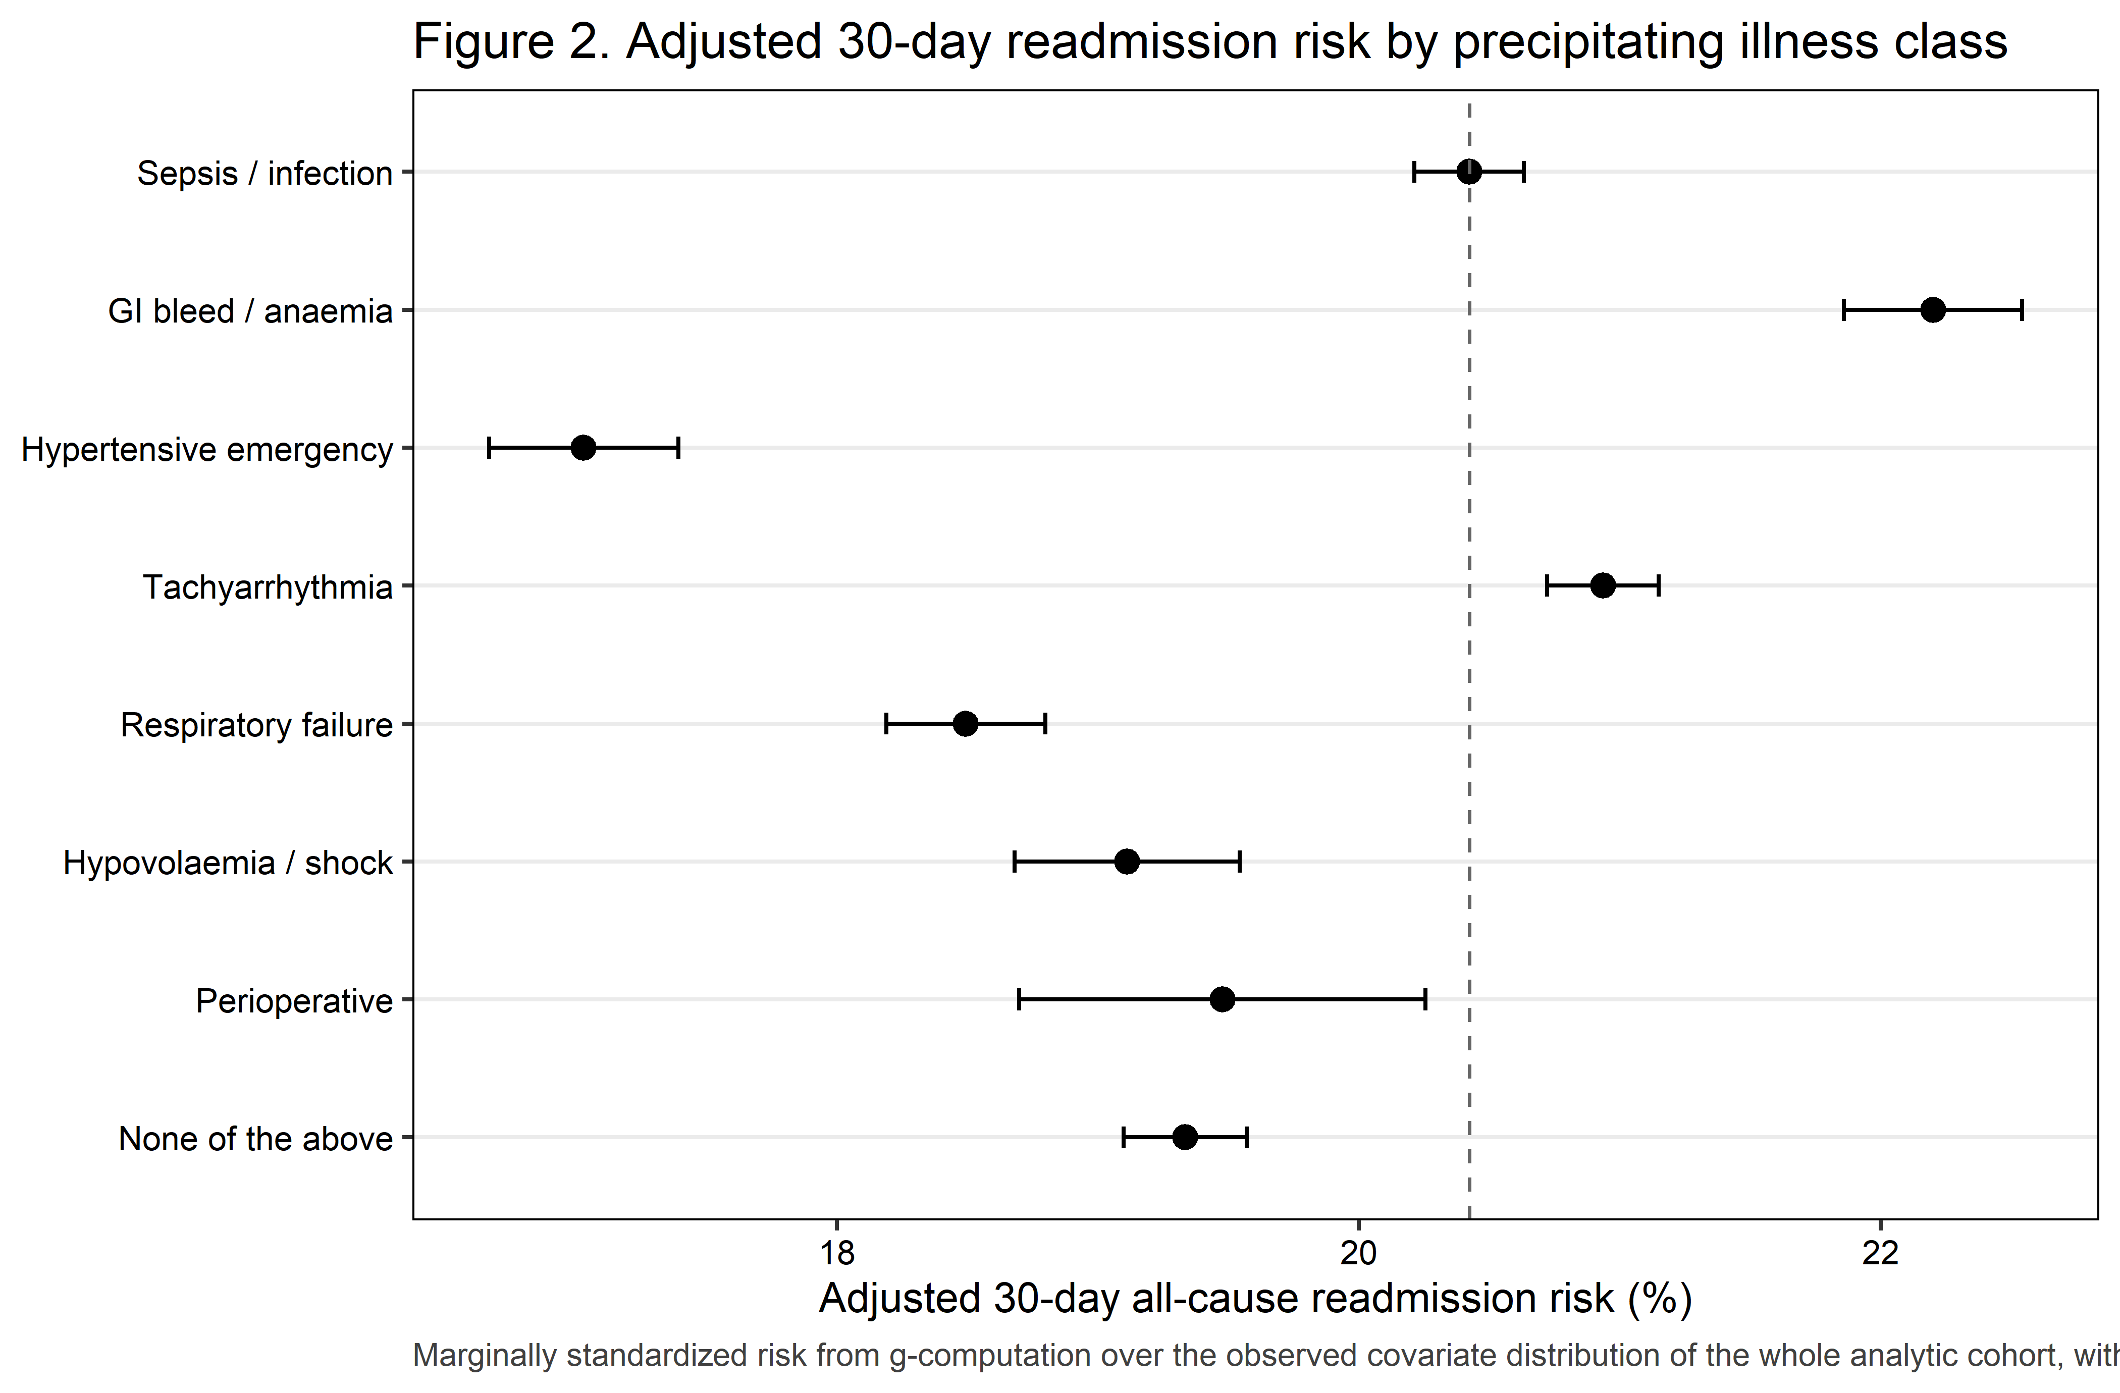
Figure 2. Adjusted 30-day readmission risk by precipitating illness class.

6.1 Sequential adjustment
Table 4. Sequential covariate adjustment, headline contrast and joint test. Model 4 is the adjusted estimate; Model 5 is OVER-ADJUSTED.
Analysis | Joint Wald p (whole precipitant block) | Adjusted OR (95% CI) | p value | Adjusted risk difference, pp (95% CI)
Model 1: unadjusted | <0.001 | 1.04 (1.02–1.05) | <0.001 | 0.58 (0.31–0.85)
Model 2: + demographic and administrative covariates | <0.001 | 1.06 (1.04–1.07) | <0.001 | 0.89 (0.62–1.16)
Model 3: + hospital covariates | <0.001 | 1.06 (1.04–1.07) | <0.001 | 0.90 (0.63–1.17)
Model 4: + comorbidity and clinical covariates (PRIMARY MODEL) | <0.001 | 1.03 (1.02–1.05) | <0.001 | 0.51 (0.24–0.78)
Model 5: OVER-ADJUSTED, not the adjusted estimate (+ length of stay, discharge disposition, AMA discharge) | <0.001 | 1.07 (1.05–1.08) | <0.001 | 1.00 (0.72–1.27)

 Warning
The change from Model 4 to Model 5 is attenuation consistent with mediation, not adjustment: length of stay, discharge disposition and discharge against medical advice lie on the causal path. Model 5 is over-adjusted and must never be reported as the adjusted estimate.

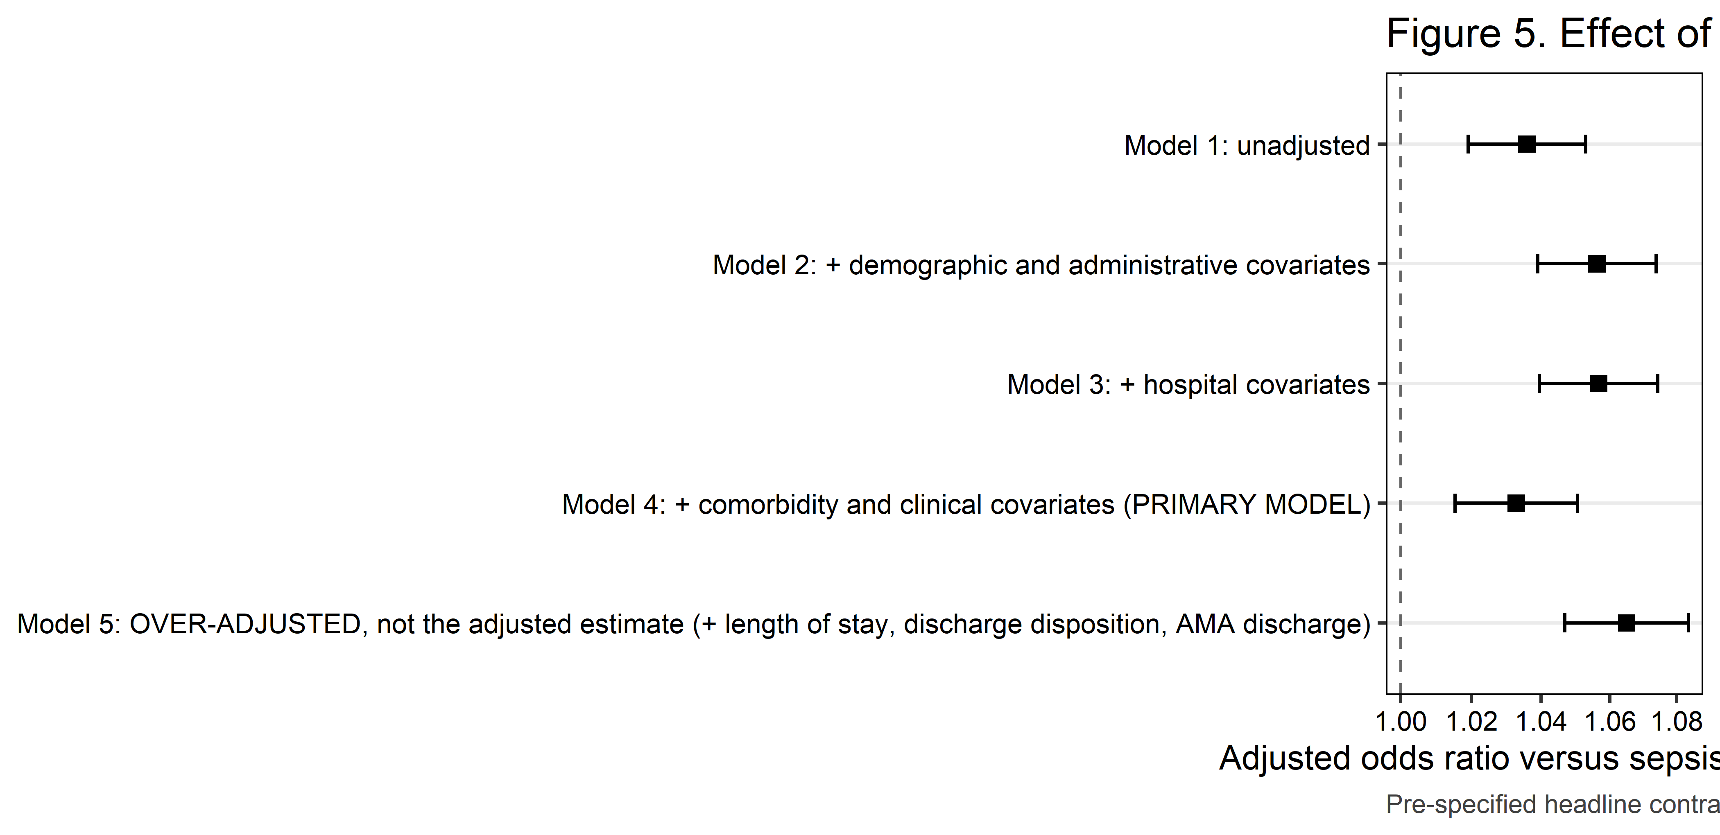
Figure 5. Sequential covariate adjustment.

6.2 Secondary outcomes
Table 4b. Secondary outcomes (one Benjamini-Hochberg family; q values over the estimable members).
Secondary outcome | Events (unweighted) | Joint Wald p (precipitant block) | BH q value | Adjusted OR, Tachyarrhythmia vs Sepsis or severe infection (95% CI)
Concordant readmission (same clinical domain as the index precipitant) | 24,394 | <0.001 | <0.001 | 0.19 (0.19–0.20)
Cardiac readmission (CCSR CIR009/CIR010/CIR011/CIR017/CIR019) | 41,035 | <0.001 | <0.001 | 2.47 (2.37–2.57)
Unplanned (non-elective) readmission | 167,646 | <0.001 | <0.001 | 0.97 (0.90–1.05)
In-hospital death at readmission | 15,303 | <0.001 | <0.001 | 0.94 (0.89–0.99)
Non-home discharge at index | 256,101 | <0.001 | <0.001 | 0.59 (0.58–0.60)
Discharge against medical advice at index | 18,652 | <0.001 | <0.001 | 1.06 (1.00–1.12)
The primary outcome is not a member of this family: it is tested once, unadjusted.

6.3 Unmeasured confounding and cross-check
Table S5. E-values for each precipitant class, on the risk ratio scale.
Precipitant class (vs sepsis) | Adjusted risk ratio (95% CI) | E-value, point estimate | E-value, CI limit nearest the null
Acute GI bleed or blood-loss anaemia | 1.09 (1.07–1.11) | 1.39 | 1.34
Hypertensive emergency | 0.83 (0.81–0.85) | 1.69 | 1.62
Tachyarrhythmia | 1.03 (1.01–1.04) | 1.19 | 1.12
Acute respiratory failure | 0.91 (0.89–0.92) | 1.44 | 1.39
Hypovolaemia or non-cardiogenic shock | 0.94 (0.91–0.96) | 1.34 | 1.26
Perioperative | 0.95 (0.92–0.99) | 1.27 | 1.09
None of the above | 0.95 (0.93–0.96) | 1.30 | 1.25

E-values are reported on the RISK RATIO scale, never on the odds ratio, which would overstate them. Each is the minimum strength of association, on the risk ratio scale, that an unmeasured confounder would need with both the precipitant class and 30-day readmission, above and beyond the measured covariates, to explain the observed contrast away. The most plausible such confounder here is ILLNESS SEVERITY: the NRD carries no vital signs, no laboratory values and no troponin concentration, and a sicker patient is both more likely to receive a given precipitant code and more likely to be readmitted.
Table S5b. Delta-method g-computation checked against marginaleffects::avg_comparisons().
Quantity | svy_std_risk() | marginaleffects::avg_comparisons() | Absolute difference | Agreement
Adjusted risk difference, Tachyarrhythmia vs Sepsis or severe infection (pp); maximum absolute difference over all seven contrasts in the last column | 0.5127 | 0.5127 | 0.000000 | AGREE (to three decimal places on the probability scale, all seven contrasts)

7. Concordant readmission
The endpoint the paper is built on
When a patient with a coded type 2 myocardial infarction is readmitted within 30 days, do they return with their precipitant or with a cardiac problem?

Table 5. Concordant versus cardiac readmission, by precipitating illness class.
Precipitant class | Readmitted (unweighted n) | Concordant readmission, % of readmissions (n) | Cardiac readmission, % of readmissions (n) | Concordant readmission, % of ALL index admissions
Sepsis or severe infection | 43,508 | 35.1% (15,503) | 12.7% (5,483) | 7.2%
Acute GI bleed or blood-loss anaemia | 15,486 | 11.1% (1,731) | 18.7% (2,876) | 2.5%
Hypertensive emergency | 8,616 | 11.4% (975) | 23.8% (2,036) | 2.1%
Tachyarrhythmia | 48,103 | 9.1% (4,329) | 35.1% (16,814) | 1.9%
Acute respiratory failure | 14,686 | 8.8% (1,281) | 24.1% (3,533) | 1.6%
Hypovolaemia or non-cardiogenic shock | 6,750 | 4.0% (270) | 13.4% (885) | 0.7%
Perioperative | 2,156 | 14.3% (305) | 15.7% (335) | 2.7%
None of the above | 36,007 | Not defined | 25.1% (9,073) | Not defined

A readmission is CONCORDANT when the DXCCSR v2025.1 default category of its principal diagnosis falls in the same clinical domain as the precipitating illness class assigned at the index admission; the full class-to-category mapping was frozen before any result was seen and is reproduced in the supplement. A readmission is CARDIAC when that category is CIR009, CIR010, CIR011, CIR017 or CIR019. The two are not mutually exclusive: a tachyarrhythmia precipitant followed by a dysrhythmia readmission is both. The ‘none of the above’ class has no concordant set by construction and is scored as undefined rather than zero; 36,007 readmissions fall in that class and are excluded from the concordance column only. The third and fourth columns are conditional on being readmitted and answer ‘what did they come back with?’; the fifth column is the absolute risk of a concordant readmission among all index admissions in that class and is the quantity to quote alongside the overall readmission rate. Adjusted for the full primary covariate block, the design-based joint Wald test of whether concordance differs across precipitant classes gives p <0.001. Cells below 11 unweighted readmissions are suppressed under the HCUP Data Use Agreement.
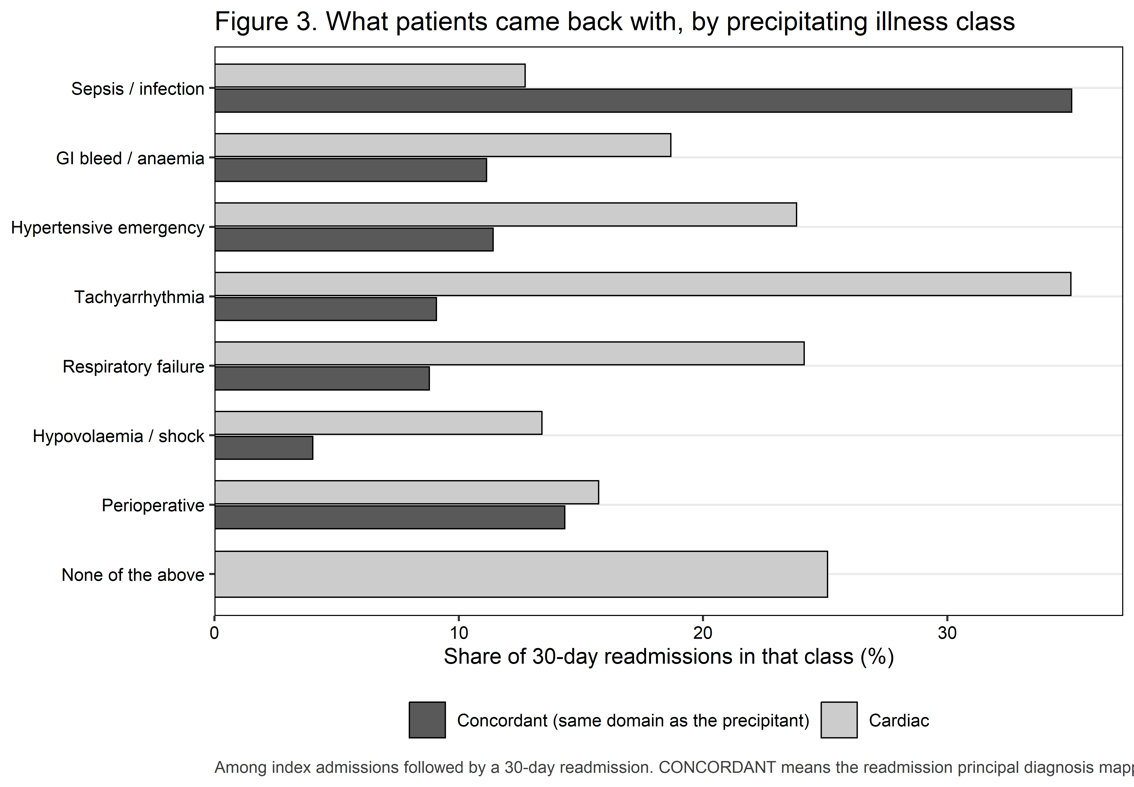
Figure 3. What patients came back with, by precipitating illness class.

8. Table 6. Cause of readmission
Table 6. Principal diagnosis category (DXCCSR v2025.1) of the first 30-day readmission.
Cause of readmission (DXCCSR category) | Overall, % (n) | Sepsis or severe infection | Acute GI bleed or blood-loss anaemia | Hypertensive emergency | Tachyarrhythmia | Acute respiratory failure | Hypovolaemia or non-cardiogenic shock | Perioperative | None of the above | Joint Wald p | BH q value
Heart failure | 15.6% (27,283) | 8.8% ( 3,792) | 12.1% (1,867) | 15.5% (1,321) | 22.0% (10,582) | 18.3% (2,679) | 8.7% ( 572) | 9.2% (197) | 17.3% ( 6,273) | <0.001 | <0.001
Septicemia | 13.5% (24,083) | 24.9% (11,086) | 10.0% (1,539) | 5.7% ( 492) | 10.1% ( 4,903) | 11.1% (1,648) | 13.4% ( 919) | 10.8% (240) | 8.9% ( 3,256) | <0.001 | <0.001
Cardiac dysrhythmias | 3.5% ( 6,081) | 1.7% ( 749) | 2.2% ( 339) | 1.6% ( 142) | 8.8% ( 4,188) | 1.1% ( 161) | 1.0% ( 66) | 1.6% ( 34) | 1.2% ( 402) | <0.001 | <0.001
Respiratory failure; insufficiency; arrest | 3.4% ( 5,875) | 3.3% ( 1,381) | 2.3% ( 342) | 2.9% ( 250) | 3.1% ( 1,445) | 6.0% ( 872) | 2.0% ( 138) | 2.1% ( 46) | 4.0% ( 1,401) | <0.001 | <0.001
Acute and unspecified renal failure | 3.4% ( 5,851) | 3.3% ( 1,421) | 2.9% ( 442) | 4.0% ( 334) | 3.4% ( 1,594) | 2.9% ( 419) | 5.8% ( 385) | 2.8% ( 58) | 3.3% ( 1,198) | <0.001 | <0.001
Acute myocardial infarction | 3.2% ( 5,628) | 1.6% ( 687) | 3.3% ( 503) | 4.7% ( 409) | 3.1% ( 1,496) | 3.4% ( 515) | 2.8% ( 186) | 3.6% ( 76) | 4.8% ( 1,756) | <0.001 | <0.001
Chronic kidney disease | 3.2% ( 5,687) | 1.9% ( 843) | 2.6% ( 418) | 8.9% ( 788) | 2.7% ( 1,338) | 4.8% ( 728) | 1.2% ( 87) | 4.2% ( 91) | 3.8% ( 1,394) | <0.001 | <0.001
Pneumonia (except that caused by tuberculosis) | 2.7% ( 4,539) | 3.1% ( 1,318) | 1.9% ( 291) | 1.5% ( 127) | 2.6% ( 1,202) | 3.6% ( 501) | 2.0% ( 130) | 2.6% ( 54) | 2.7% ( 916) | <0.001 | <0.001
Gastrointestinal hemorrhage | 2.5% ( 4,468) | 2.4% ( 1,060) | 8.4% (1,306) | 1.2% ( 109) | 2.1% ( 982) | 1.7% ( 258) | 1.9% ( 128) | 2.3% ( 49) | 1.6% ( 576) | <0.001 | <0.001
Diabetes mellitus with complication | 2.5% ( 4,364) | 2.6% ( 1,125) | 2.1% ( 335) | 3.0% ( 256) | 1.6% ( 758) | 2.3% ( 340) | 5.8% ( 387) | 5.0% (107) | 2.9% ( 1,056) | <0.001 | <0.001
COVID-19 | 2.1% ( 3,696) | 1.9% ( 842) | 1.4% ( 206) | 1.5% ( 135) | 2.2% ( 1,052) | 3.6% ( 526) | 2.1% ( 134) | 1.2% ( 30) | 2.2% ( 771) | <0.001 | <0.001
Fluid and electrolyte disorders | 1.9% ( 3,379) | 1.6% ( 691) | 1.4% ( 215) | 4.1% ( 355) | 1.6% ( 756) | 2.2% ( 322) | 2.8% ( 189) | 2.3% ( 44) | 2.3% ( 807) | <0.001 | <0.001
Cerebral infarction | 1.7% ( 2,964) | 1.1% ( 478) | 1.5% ( 248) | 2.9% ( 249) | 1.8% ( 859) | 1.3% ( 192) | 1.7% ( 124) | 1.6% ( 35) | 2.2% ( 779) | <0.001 | <0.001
Chronic obstructive pulmonary disease and bronchiectasis | 1.6% ( 2,766) | 1.0% ( 436) | 0.6% ( 90) | 1.0% ( 81) | 1.6% ( 742) | 2.6% ( 385) | 1.2% ( 88) | 0.6% ( 11) | 2.6% ( 933) | <0.001 | <0.001
Complication of other surgical or medical care, injury, initial encounter | 1.5% ( 2,601) | 2.3% ( 1,013) | 2.7% ( 422) | 1.2% ( 93) | 0.9% ( 413) | 0.9% ( 137) | 1.3% ( 93) | 6.8% (145) | 0.8% ( 285) | <0.001 | <0.001
Other | 37.7% (66,047) | 38.5% (16,586) | 44.7% (6,923) | 40.3% (3,475) | 32.8% (15,793) | 34.1% (5,003) | 46.2% (3,124) | 43.3% (939) | 39.4% (14,204) | <0.001 | —

Based on 175,312 unweighted 30-day readmissions with a recorded principal diagnosis, mapped to the AHRQ DXCCSR v2025.1 default inpatient category. 123 readmission principal diagnosis code(s) had no default CCSR assignment and are grouped under ‘Other’. The top 15 categories by overall weighted share are reported; all remaining categories are folded into ‘Other’, as are 0 categories that fell below the 11 unweighted discharge threshold in at least one precipitant class. Percentages are within-class shares of all readmissions in that class and therefore sum to 100% down each column. P values are design-based JOINT Wald tests across the whole eight-level precipitant block from survey-weighted logistic regression of the category indicator, not pairwise comparisons; q values are Benjamini-Hochberg adjusted across the reported categories. This table is descriptive; the pre-specified concordance endpoint in Table 5 is the analysis that answers whether patients return with their own precipitant.
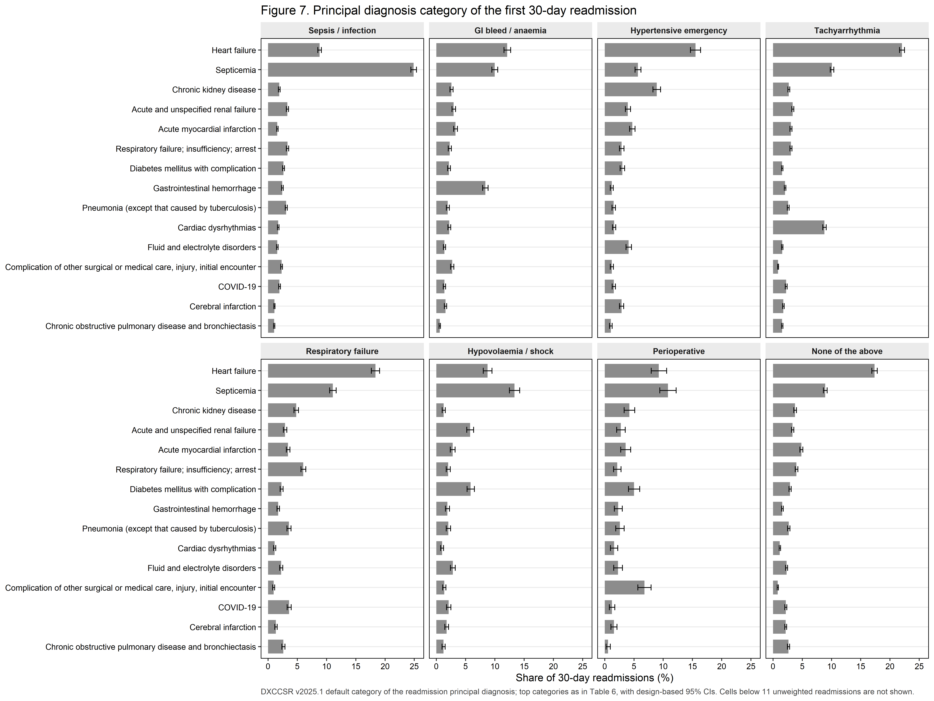
Figure 7. Cause of readmission by precipitating illness class, with design-based 95% CIs.
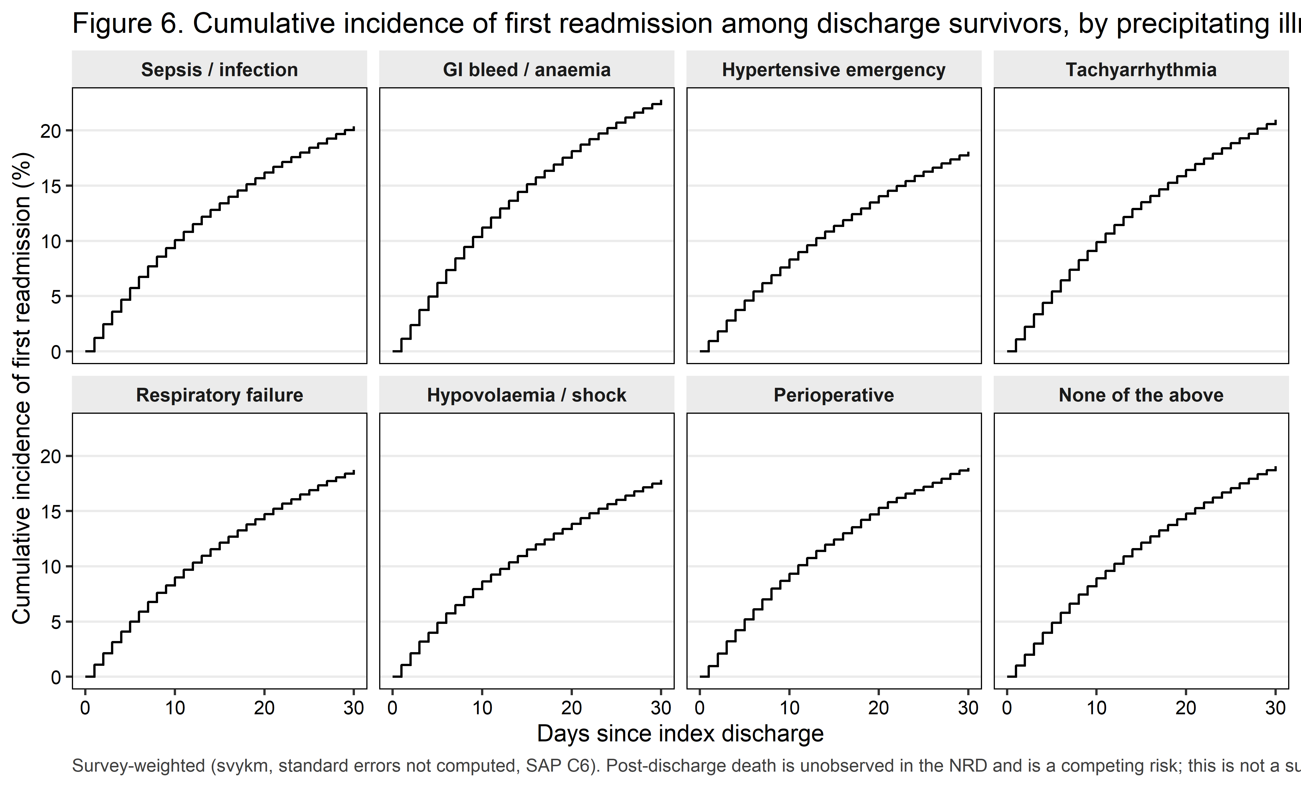
Figure 6. Cumulative incidence of first readmission among discharge survivors.
Table 6b. Numbers at risk for Figure 6 (unweighted).
Precipitant class | At risk, day 0 | At risk, day 10 | At risk, day 20 | At risk, day 30
Sepsis or severe infection | 212,755 | 192,811 | 179,257 | 169,961
Acute GI bleed or blood-loss anaemia | 67,482 | 60,412 | 55,552 | 52,259
Hypertensive emergency | 47,196 | 43,537 | 40,750 | 38,738
Tachyarrhythmia | 228,176 | 207,252 | 191,728 | 180,950
Acute respiratory failure | 77,718 | 71,217 | 66,529 | 63,290
Hypovolaemia or non-cardiogenic shock | 37,854 | 34,852 | 32,792 | 31,228
Perioperative | 11,520 | 10,530 | 9,845 | 9,389
None of the above | 187,785 | 172,291 | 160,834 | 152,475

9. Table 7. Type 2 versus type 1 myocardial infarction (descriptive, non-causal)
Descriptive and explicitly NON-CAUSAL
Type 1 and type 2 myocardial infarction are not competing treatments. No patient could have been assigned to one rather than the other, and the ‘effect’ of being coded type 2 is not a quantity that exists. What follows is a case-mix-standardized description of how the two coded populations differ, and it must be described that way in the manuscript.

Table 7. Type 2 versus type 1 myocardial infarction: cohort characteristics and crude 30-day readmission. DESCRIPTIVE AND NON-CAUSAL.
Myocardial infarction type | Unweighted n | Weighted N | Age, mean (SD) | Elixhauser count, mean | Crude 30-day readmission, % (95% CI) [readmissions]
Type 1 MI | 1,837,814 | 3,328,607 | 67.4 (13.5) | 4.4 | 14.8% (14.7–14.9) [273,682]
Type 2 MI | 871,136 | 1,528,841 | 70.4 (14.6) | 5.6 | 20.0% (19.9–20.2) [175,411]

Table 7b. Case-mix-standardized description of type 2 versus type 1 MI. NON-CAUSAL: not an effect estimate.
Quantity | Estimate
Case-mix-standardized DESCRIPTION (non-causal): type 2 vs type 1, odds ratio (95% CI) | 1.04 (1.03–1.05)
Case-mix-standardized DESCRIPTION (non-causal): type 2 minus type 1, risk difference, pp (95% CI) | 0.46 (0.33–0.59)

THIS COMPARISON IS DESCRIPTIVE AND IS NOT CAUSAL. Type 1 and type 2 myocardial infarction are not competing treatments; no patient could have been assigned to one rather than the other, and the ‘effect’ of being coded type 2 rather than type 1 is not a quantity that exists. The adjusted figure below is a case-mix-standardized DESCRIPTION of how the two coded populations differ, reported only because an unadjusted comparison between populations this dissimilar in age and comorbidity would be uninterpretable even descriptively. Standardized to the measured case mix of the combined cohort: adjusted OR 1.04 (1.03–1.05), adjusted risk difference 0.46 (0.33–0.59) percentage points. The precipitant class is deliberately absent from that model because it is undefined for the type 1 arm. Type 1 myocardial infarction was defined as any-listed I21.0-I21.4, I21.9 or I22.x WITHOUT I21.A1; 28,316 records carrying both a type 1 and a type 2 code were excluded from both arms, because such a record is uninterpretable as to which event drove the admission. A further 15,154 records coded I21.A9 (other myocardial infarction type) were excluded rather than pooled. The size of the type 1 / type 2 overlap is a finding in its own right and is worth a sentence in the Results.

10. Table 8. Exploratory subgroups
Table 8. Pre-specified subgroup analyses (EXPLORATORY; interaction tested on the whole block).
Subgroup | Level | Unweighted n | Readmissions (unweighted) | Joint Wald p (precipitant block) | Adjusted OR, Tachyarrhythmia vs Sepsis or severe infection (95% CI) | Interaction p
Overall (primary model) |  | 870,486 | 175,312 | <0.001 | 1.03 (1.02–1.05)
Age <65 vs ≥65 years | ≥65 years | 604,348 | 120,605 | <0.001 | 1.05 (1.03–1.07) | <0.001
 | <65 years | 266,138 | 54,707 | <0.001 | 0.98 (0.95–1.02)
Chronic kidney disease vs none | No coded CKD | 512,297 | 87,523 | <0.001 | 1.00 (0.97–1.02) | <0.001
 | Chronic kidney disease | 358,189 | 87,789 | <0.001 | 1.07 (1.04–1.10)
Pre-pandemic (2018-2019) vs pandemic (2020-2022) | Pre-pandemic (2018-2019) | 254,812 | 52,854 | <0.001 | 1.04 (1.00–1.07) | 0.063
 | Pandemic (2020-2022) | 615,674 | 122,458 | <0.001 | 1.03 (1.01–1.05)

ALL SUBGROUP RESULTS ARE EXPLORATORY and are not adjusted for multiplicity. Within each subgroup the primary model was refitted on the primary covariate block, and two quantities are reported: the design-based JOINT Wald test across the whole eight-level precipitant block, which is the substantive question in that subgroup, and the pre-specified headline contrast (Tachyarrhythmia versus Sepsis or severe infection), which is shown so that the direction of the association is visible. Effect modification is assessed by a design-based Wald test on the WHOLE interaction block, fitted on the rows with a non-missing modifier, with the modifier’s deterministic parent covariate removed from that model so that no coefficient is aliased (chronic kidney disease stage for the CKD grouping, discharge year for the pandemic-era grouping). Non-overlapping subgroup confidence intervals are NOT evidence of interaction and are not interpreted as such. Terms that became constant or sparse inside a subgroup were dropped from that fit and are listed in the run log. No subgroup finding appears in the Conclusions.
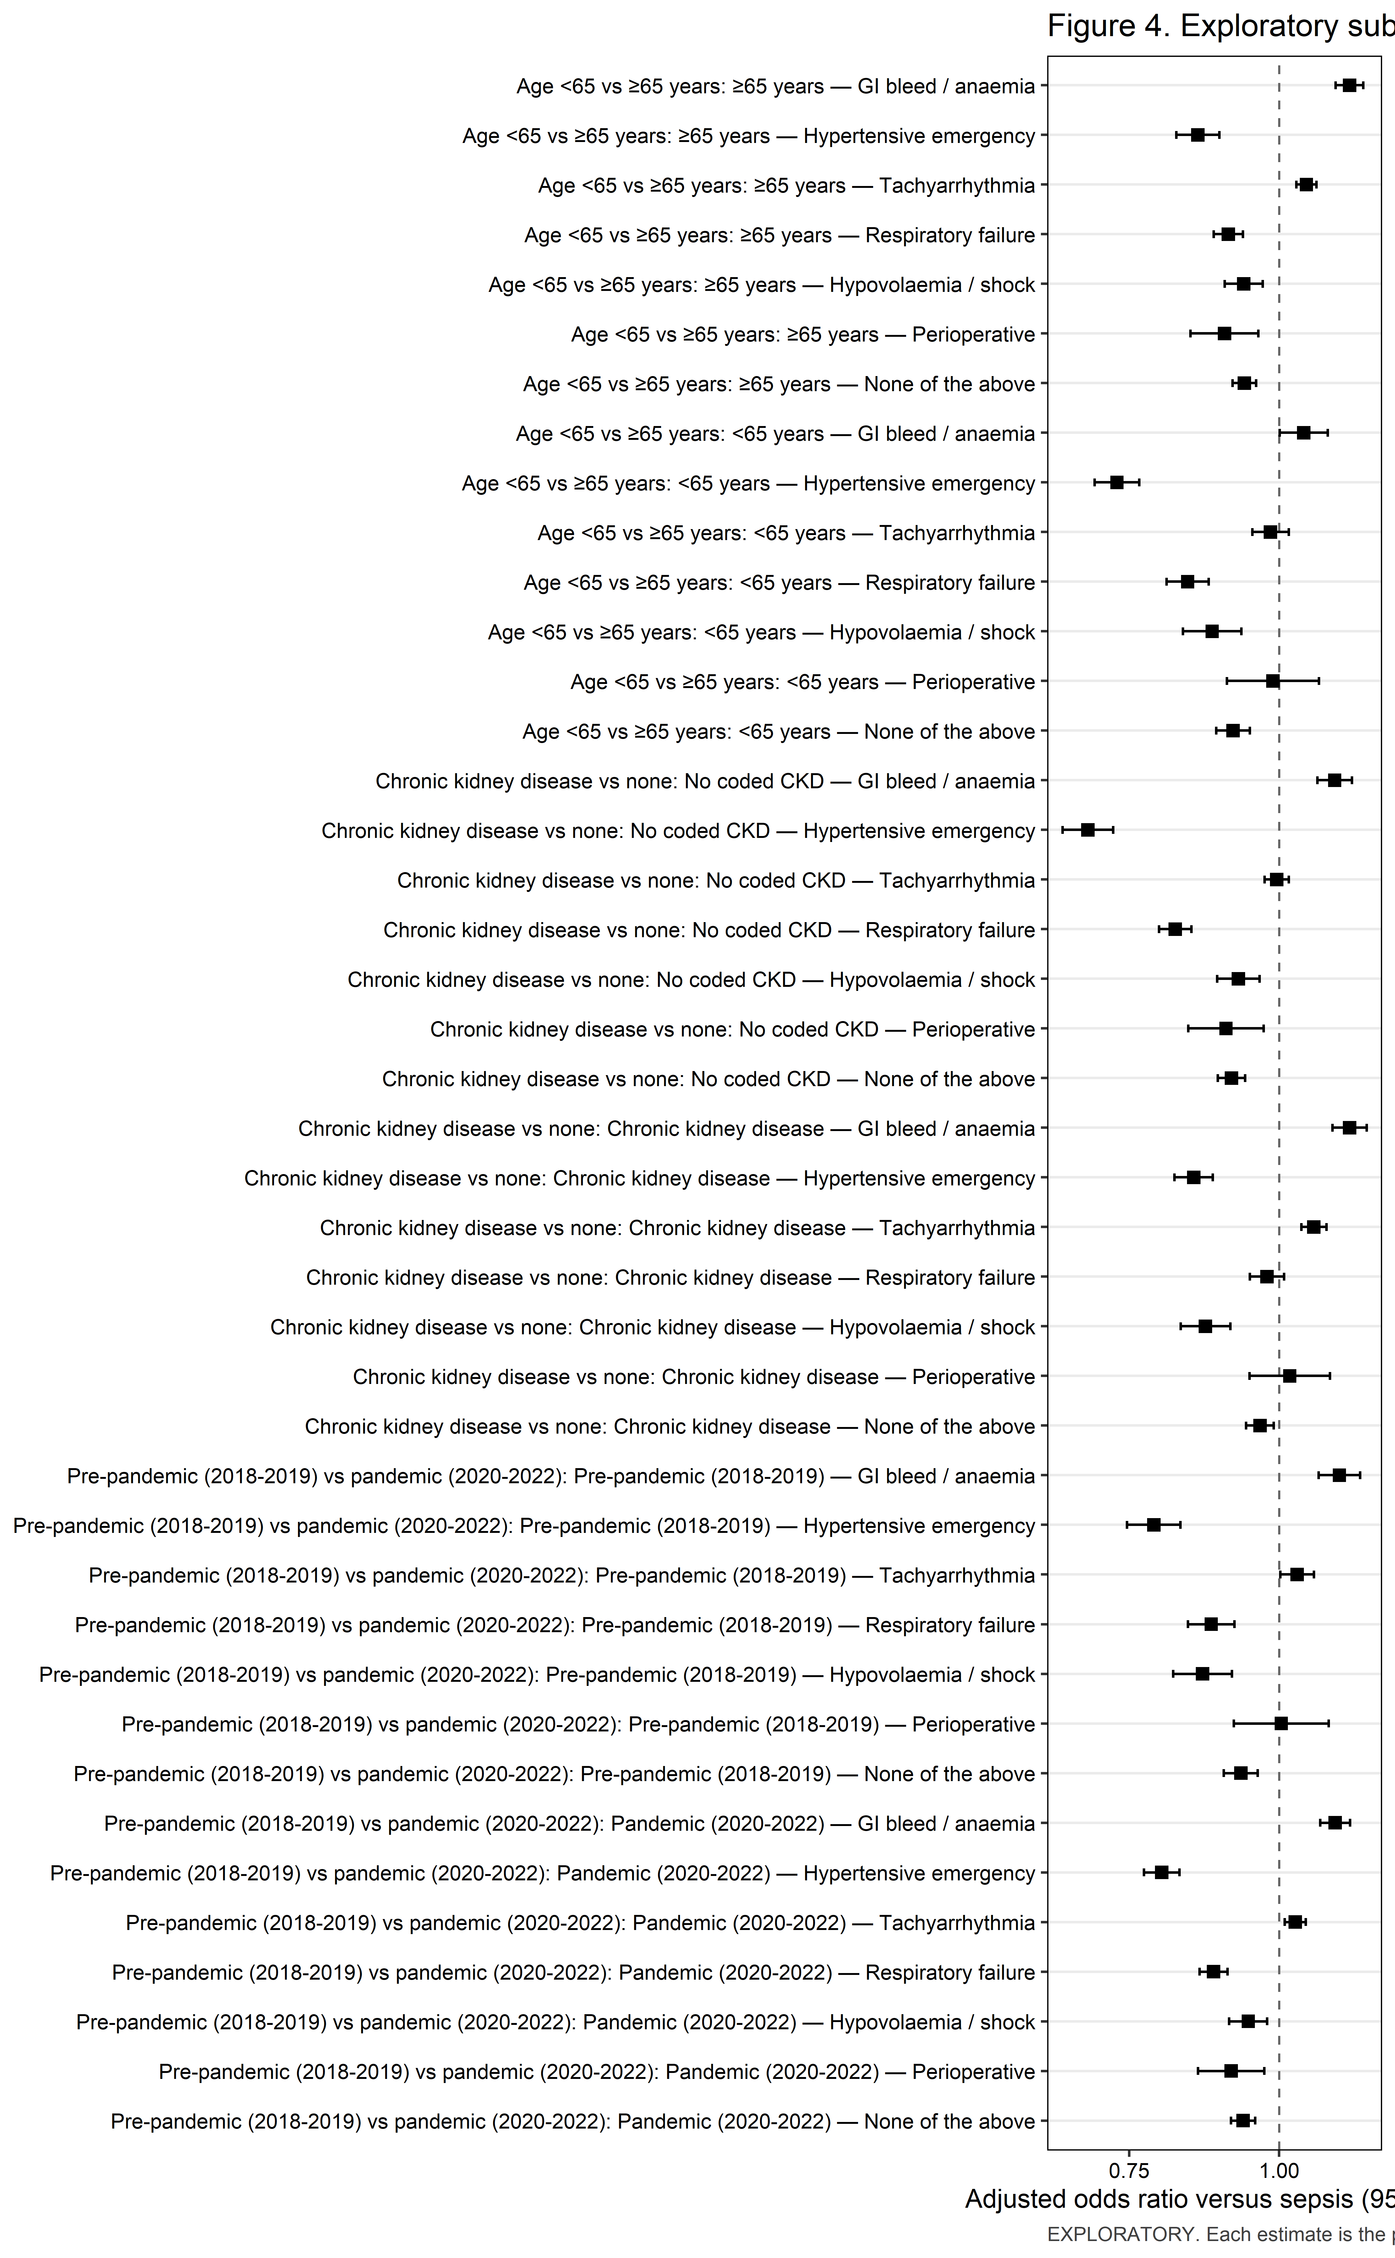
Figure 4. Exploratory subgroup analyses.

11. Temporal trends
Table S3. Weighted national volume and 30-day readmission rate by discharge year.
Year | Unweighted index admissions | Weighted national index admissions | 30-day readmission, % (95% CI)
2018 | 113,899 | 204,897 | 20.8% (20.4–21.2)
2019 | 140,913 | 245,383 | 20.4% (20.0–20.7)
2020 | 173,245 | 297,784 | 19.9% (19.6–20.2)
2021 | 205,508 | 362,215 | 19.8% (19.5–20.1)
2022 | 236,921 | 417,295 | 19.7% (19.4–20.0)
Design-based linear trend in the outcome: 0.98 (0.98–0.99) per calendar year (p <0.001)
Table S3b. 30-day readmission by discharge year within each precipitant class, % (95% CI) [readmissions].
Precipitant class | 2018 | 2019 | 2020 | 2021 | 2022
Sepsis or severe infection | 21.3% (20.7–21.9) [ 6,020] | 20.9% (20.4–21.4) [ 7,243] | 19.9% (19.4–20.3) [ 8,863] | 20.2% (19.7–20.6) [ 9,986] | 20.2% (19.8–20.6) [11,396]
Acute GI bleed or blood-loss anaemia | 23.7% (22.9–24.6) [2,360] | 22.9% (22.0–23.7) [2,662] | 22.5% (21.7–23.3) [3,161] | 22.3% (21.6–23.0) [3,557] | 22.8% (22.0–23.5) [3,746]
Hypertensive emergency | 18.4% (17.2–19.6) [1,006] | 18.3% (17.3–19.3) [1,313] | 18.2% (17.3–19.2) [1,679] | 17.9% (17.2–18.7) [2,075] | 17.9% (17.1–18.6) [2,543]
Tachyarrhythmia | 21.6% (20.9–22.2) [ 6,527] | 21.2% (20.7–21.7) [ 8,055] | 20.9% (20.4–21.4) [ 9,217] | 21.0% (20.5–21.4) [11,361] | 20.6% (20.2–21.0) [12,943]
Acute respiratory failure | 19.8% (18.9–20.7) [1,769] | 19.1% (18.3–20.0) [2,192] | 18.5% (17.8–19.2) [2,853] | 17.8% (17.2–18.4) [3,591] | 19.1% (18.4–19.7) [4,281]
Hypovolaemia or non-cardiogenic shock | 17.7% (16.7–18.8) [ 945] | 16.9% (15.9–17.9) [1,031] | 18.5% (17.5–19.5) [1,404] | 18.1% (17.3–19.0) [1,543] | 17.6% (16.8–18.4) [1,827]
Perioperative | 20.5% (18.4–22.7) [327] | 20.1% (18.3–22.0) [379] | 18.1% (16.5–19.7) [423] | 18.7% (17.1–20.3) [515] | 18.0% (16.4–19.5) [512]
None of the above | 19.7% (19.0–20.3) [5,000] | 19.5% (18.9–20.0) [6,025] | 19.2% (18.6–19.7) [7,036] | 19.0% (18.5–19.5) [8,247] | 18.5% (18.1–19.0) [9,699]

Table S3c. Design-based linear trend in the prevalence of each precipitant class (descriptive).
Precipitant class | OR per calendar year for being in this class (95% CI) | p value
Sepsis or severe infection | 0.985 (0.975–0.995) | 0.004
Acute GI bleed or blood-loss anaemia | 0.948 (0.937–0.958) | <0.001
Hypertensive emergency | 1.061 (1.035–1.088) | <0.001
Tachyarrhythmia | 1.004 (0.995–1.013) | 0.402
Acute respiratory failure | 1.054 (1.043–1.065) | <0.001
Hypovolaemia or non-cardiogenic shock | 0.993 (0.981–1.005) | 0.245
Perioperative | 0.968 (0.952–0.984) | <0.001
None of the above | 0.996 (0.986–1.006) | 0.435

Read this before quoting any trend number
Three qualifications apply to every trend result reported here and must appear alongside them in the manuscript. First, these are five independent annual cross-sections drawn from a partly changing hospital sample, not a longitudinal cohort; NRD patient linkage does not cross calendar years and hospital identifiers are reset each year. Second, and most importantly for this study, I21.A1 became effective on 1 October 2017 and was still diffusing into routine use across the study window, while high-sensitivity troponin assays were being adopted across US hospitals over the same period and the Fourth Universal Definition of Myocardial Infarction formalised the type 2 category in 2018. A rise in coded volume therefore reflects ASCERTAINMENT at least as much as incidence, and NO BIOLOGICAL TREND IS CLAIMED. Third, 2020 is anomalous because of pandemic admission avoidance, COVID-19 coding and capacity effects, and is examined in the leave-2020-out sensitivity analysis S2. The trend test enters discharge year as a continuous term replacing the year factor, which is a design-based test; Joinpoint and segmented regression on the annual point estimates are not appropriate because they ignore the survey design. Whether the association between precipitant class and readmission itself changed across the window was tested ONCE, as a single precipitant-by-year interaction (p 0.443), and not as five year-specific sets of estimates.

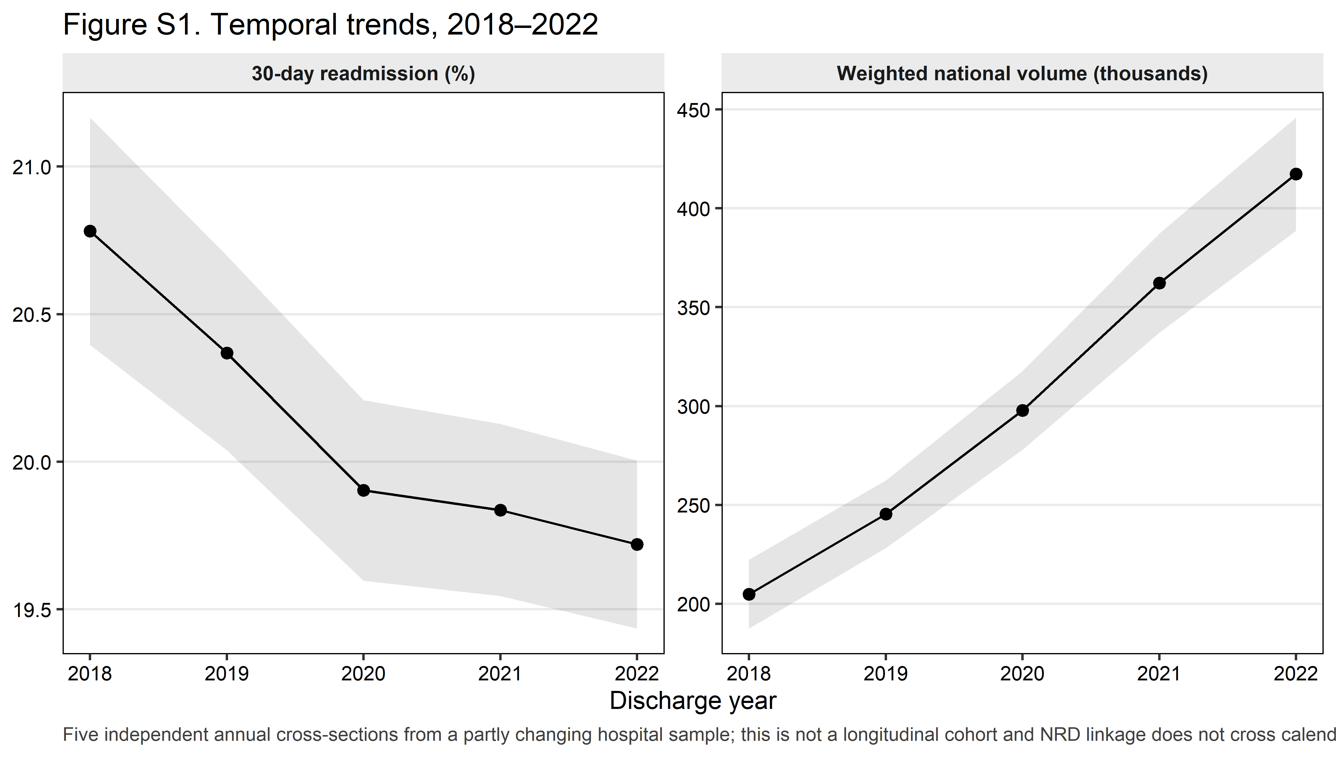
Figure S1. Temporal trends.
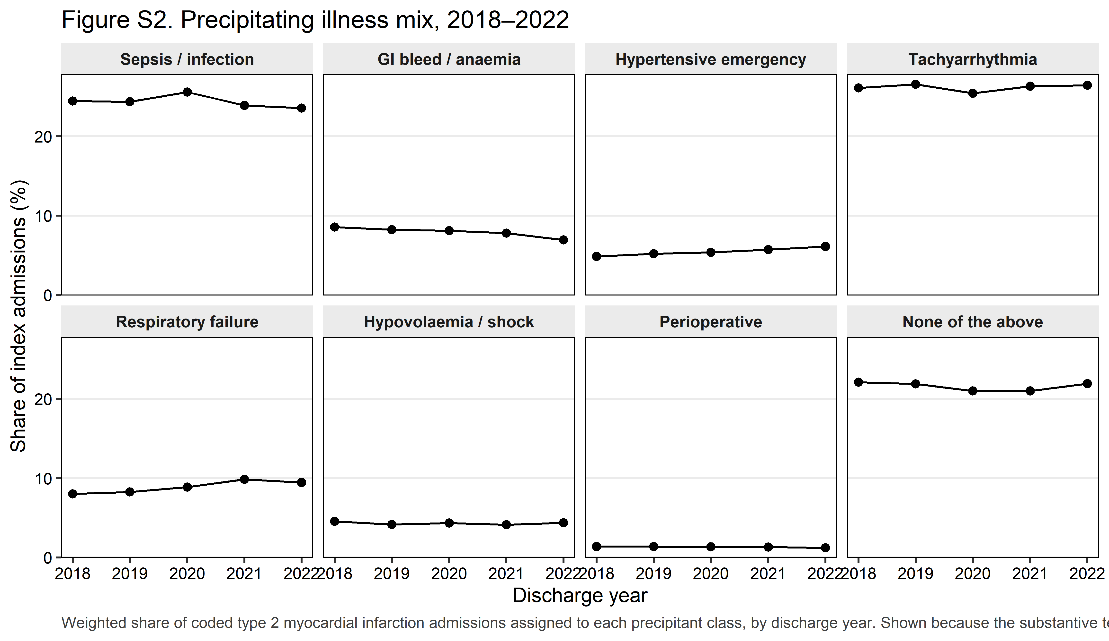
Figure S2. Precipitating illness mix over time.

12. Sensitivity analyses
Table 9. Sensitivity analyses: joint test on the precipitant block and the pre-specified headline contrast.
Analysis | Joint Wald p (whole precipitant block) | Adjusted OR (95% CI) | p value | Adjusted risk difference, pp (95% CI)
Primary model (reference) | <0.001 | 1.03 (1.02–1.05) | <0.001 | 0.51 (0.24–0.78)
S1. First qualifying index admission per patient-year only | <0.001 | 1.02 (1.00–1.04) | 0.055 | 0.27 (-0.01–0.54)
S2/S7. Leave-2020-out (common S2; also the SAP B3.5 S7, exclude 2020) | <0.001 | 1.03 (1.01–1.05) | 0.004 | 0.45 (0.14–0.76)
S3. Propensity-score overlap-weighted (ATO), pairwise versus sepsis | Not applicable (pairwise estimator) | 1.03 (1.01–1.05) | 0.002 | 0.44 (0.16–0.72)
S4. Cox model, administrative censoring at day 30, full cohort | <0.001 | HR 1.03 (1.01–1.04) | <0.001 | Not applicable (hazard scale)
S5. I21.A1 as the principal diagnosis (DX1) only | <0.001 | 0.97 (0.81–1.18) | 0.784 | -0.38 (-3.10–2.35)
S6. Present-on-admission-restricted precipitant assignment | Not estimable: no present-on-admission indicator exists in any NRD data year 2016-2022 | Not estimable: no present-on-admission indicator exists in any NRD data year 2016-2022 | — | —
S6b. Precipitant assigned from the principal diagnosis only (closest estimable substitute for S6) | <0.001 | 0.95 (0.92–0.97) | <0.001 | -0.84 (-1.27–-0.41)
DXF. Type 2 MI ascertained from I10_DX1-I10_DX30 only (uniform field depth) | Not applicable: the year audit shows 40 diagnosis fields populated in every year 2018-2022, so the SAP A6.6 condition for this row is not met | Not applicable: the year audit shows 40 diagnosis fields populated in every year 2018-2022, so the SAP A6.6 condition for this row is not met | — | —

Sensitivity analyses are consistency checks and are NOT corrected for multiplicity; they are judged on whether the point estimate moves, not on whether a p-value crosses 0.05. Every subset was taken with subset() on the survey design constructed ONCE on the full cohort. Each row reports the design-based joint Wald test across the whole precipitant block together with the pre-specified headline contrast (Tachyarrhythmia versus Sepsis or severe infection); all seven contrasts under every analysis are in Table 9b. S6, the PRESENT-ON-ADMISSION-RESTRICTED precipitant assignment pre-specified in SAP B3.5, is NOT ESTIMABLE: no NRD file in the 2016-2022 series carries a present-on-admission indicator. It is reported as such, and S6b (assignment from the principal diagnosis only) is shown beside it as the closest estimable substitute. The SAP’s study-specific S7 (exclude 2020) is the common leave-2020-out analysis and is reported once, as S2/S7. Overlap weighting is applied PAIRWISE; each estimate is the average treatment effect in the overlap population of that pair, with the propensity score fitted within the pair and the outcome model refitted on the pair’s subset of the full-cohort design re-weighted by the overlap weight. The design-based variance treats the estimated weights as fixed. Estimates derived from any class-by-outcome cell with fewer than 11 unweighted discharges are suppressed. The Cox model in S4 is a sensitivity analysis only, fitted on the full cohort with non-events retained and censored at day 30. The Cox design matrix was of full rank and required no further removals.
Table 9b. All seven contrasts under every sensitivity analysis (supplement).
Analysis | Precipitant class | Adjusted OR (95% CI)
Primary model (reference) | Acute GI bleed or blood-loss anaemia | 1.12 (1.09–1.14)
Primary model (reference) | Hypertensive emergency | 0.79 (0.77–0.82)
Primary model (reference) | Tachyarrhythmia | 1.03 (1.02–1.05)
Primary model (reference) | Acute respiratory failure | 0.88 (0.86–0.90)
Primary model (reference) | Hypovolaemia or non-cardiogenic shock | 0.92 (0.89–0.95)
Primary model (reference) | Perioperative | 0.94 (0.89–0.99)
Primary model (reference) | None of the above | 0.93 (0.91–0.95)
S1. First qualifying index admission per patient-year only | Acute GI bleed or blood-loss anaemia | 1.12 (1.09–1.14)
S1. First qualifying index admission per patient-year only | Hypertensive emergency | 0.78 (0.75–0.80)
S1. First qualifying index admission per patient-year only | Tachyarrhythmia | 1.02 (1.00–1.04)
S1. First qualifying index admission per patient-year only | Acute respiratory failure | 0.88 (0.86–0.90)
S1. First qualifying index admission per patient-year only | Hypovolaemia or non-cardiogenic shock | 0.91 (0.88–0.94)
S1. First qualifying index admission per patient-year only | Perioperative | 0.93 (0.88–0.98)
S1. First qualifying index admission per patient-year only | None of the above | 0.92 (0.90–0.93)
S2/S7. Leave-2020-out (common S2; also the SAP B3.5 S7, exclude 2020) | Acute GI bleed or blood-loss anaemia | 1.11 (1.08–1.14)
S2/S7. Leave-2020-out (common S2; also the SAP B3.5 S7, exclude 2020) | Hypertensive emergency | 0.79 (0.76–0.81)
S2/S7. Leave-2020-out (common S2; also the SAP B3.5 S7, exclude 2020) | Tachyarrhythmia | 1.03 (1.01–1.05)
S2/S7. Leave-2020-out (common S2; also the SAP B3.5 S7, exclude 2020) | Acute respiratory failure | 0.88 (0.86–0.90)
S2/S7. Leave-2020-out (common S2; also the SAP B3.5 S7, exclude 2020) | Hypovolaemia or non-cardiogenic shock | 0.90 (0.87–0.93)
S2/S7. Leave-2020-out (common S2; also the SAP B3.5 S7, exclude 2020) | Perioperative | 0.94 (0.89–1.00)
S2/S7. Leave-2020-out (common S2; also the SAP B3.5 S7, exclude 2020) | None of the above | 0.93 (0.91–0.95)
S5. I21.A1 as the principal diagnosis (DX1) only | Acute GI bleed or blood-loss anaemia | 1.24 (1.00–1.53)
S5. I21.A1 as the principal diagnosis (DX1) only | Hypertensive emergency | 0.82 (0.67–1.01)
S5. I21.A1 as the principal diagnosis (DX1) only | Tachyarrhythmia | 0.97 (0.81–1.18)
S5. I21.A1 as the principal diagnosis (DX1) only | Acute respiratory failure | 0.91 (0.74–1.12)
S5. I21.A1 as the principal diagnosis (DX1) only | Hypovolaemia or non-cardiogenic shock | 0.88 (0.71–1.10)
S5. I21.A1 as the principal diagnosis (DX1) only | Perioperative | 0.95 (0.64–1.41)
S5. I21.A1 as the principal diagnosis (DX1) only | None of the above | 0.87 (0.72–1.05)
S6b. Precipitant assigned from the principal diagnosis only (closest estimable substitute for S6) | Acute GI bleed or blood-loss anaemia | 1.13 (1.08–1.18)
S6b. Precipitant assigned from the principal diagnosis only (closest estimable substitute for S6) | Hypertensive emergency | 0.77 (0.74–0.81)
S6b. Precipitant assigned from the principal diagnosis only (closest estimable substitute for S6) | Tachyarrhythmia | 0.95 (0.92–0.97)
S6b. Precipitant assigned from the principal diagnosis only (closest estimable substitute for S6) | Acute respiratory failure | 0.92 (0.88–0.97)
S6b. Precipitant assigned from the principal diagnosis only (closest estimable substitute for S6) | Hypovolaemia or non-cardiogenic shock | 0.89 (0.80–0.98)
S6b. Precipitant assigned from the principal diagnosis only (closest estimable substitute for S6) | Perioperative | 1.09 (1.06–1.12)
S6b. Precipitant assigned from the principal diagnosis only (closest estimable substitute for S6) | None of the above | 1.00 (0.99–1.02)

Table 9c. Pre-specified negative control outcome.
Analysis | Joint Wald p (precipitant block) | Interpretation
Negative control: 30-day readmission with an eye or ear principal diagnosis | Suppressed (<11 unweighted discharges in a class-by-outcome cell) | Uninformative: at least one precipitant class has fewer than 11 unweighted eye/ear readmissions, so the joint test is withheld under the HCUP DUA.

Table S6. Covariate balance before and after overlap weighting, headline pair.
Variable | SMD before weighting | SMD after weighting | Balanced (absolute SMD < 0.10)
Age, years | 0.238 | 0.000 | Yes
Sex | 0.037 | 0.000 | Yes
Primary expected payer | 0.098 | 0.000 | Yes
Median household income quartile (patient ZIP code) | 0.013 | 0.000 | Yes
Patient residence (NCHS urban-rural classification) | 0.055 | 0.000 | Yes
Admission day | 0.043 | 0.000 | Yes
Admission type | 0.032 | 0.000 | Yes
Hospital bed size | 0.002 | 0.000 | Yes
Hospital location and teaching status | 0.015 | 0.000 | Yes
Hospital ownership | 0.026 | 0.000 | Yes
Discharge year | 0.041 | 0.000 | Yes
Congestive heart failure | 0.375 | 0.000 | Yes
Valvular disease | 0.316 | 0.000 | Yes
Pulmonary circulation disorders | 0.161 | 0.000 | Yes
Peripheral vascular disorders | 0.162 | 0.000 | Yes
Hypertension, uncomplicated | 0.101 | 0.000 | Yes
Paralysis | 0.047 | 0.000 | Yes
Other neurological disorders | 0.481 | 0.000 | Yes
Chronic pulmonary disease | 0.051 | 0.000 | Yes
Diabetes, uncomplicated | 0.037 | 0.000 | Yes
Diabetes, complicated | 0.067 | 0.000 | Yes
Hypothyroidism | 0.083 | 0.000 | Yes
Liver disease | 0.195 | 0.000 | Yes
Peptic ulcer disease | 0.018 | 0.000 | Yes
HIV/AIDS | 0.052 | 0.000 | Yes
Lymphoma | 0.029 | 0.000 | Yes
Metastatic cancer | 0.080 | 0.000 | Yes
Solid tumour without metastasis | 0.080 | 0.000 | Yes
Rheumatoid arthritis / collagen vascular disease | 0.016 | 0.000 | Yes
Coagulopathy | 0.251 | 0.000 | Yes
Obesity | 0.034 | 0.000 | Yes
Weight loss | 0.285 | 0.000 | Yes
Alcohol abuse | 0.013 | 0.000 | Yes
Drug abuse | 0.063 | 0.000 | Yes
Psychoses | 0.072 | 0.000 | Yes
Depression | 0.022 | 0.000 | Yes
Hypertension, complicated | 0.315 | 0.000 | Yes
Cardiogenic shock at index | 0.063 | 0.000 | Yes
Invasive mechanical ventilation at index | 0.499 | 0.000 | Yes
Chronic kidney disease stage | 0.149 | 0.000 | Yes
Known coronary artery disease (I25.1x/I25.7x) | 0.356 | 0.000 | Yes
Prior revascularization (Z95.1/Z95.5) | 0.254 | 0.000 | Yes
Coronary angiography or cardiac catheterization at index | 0.296 | 0.000 | Yes
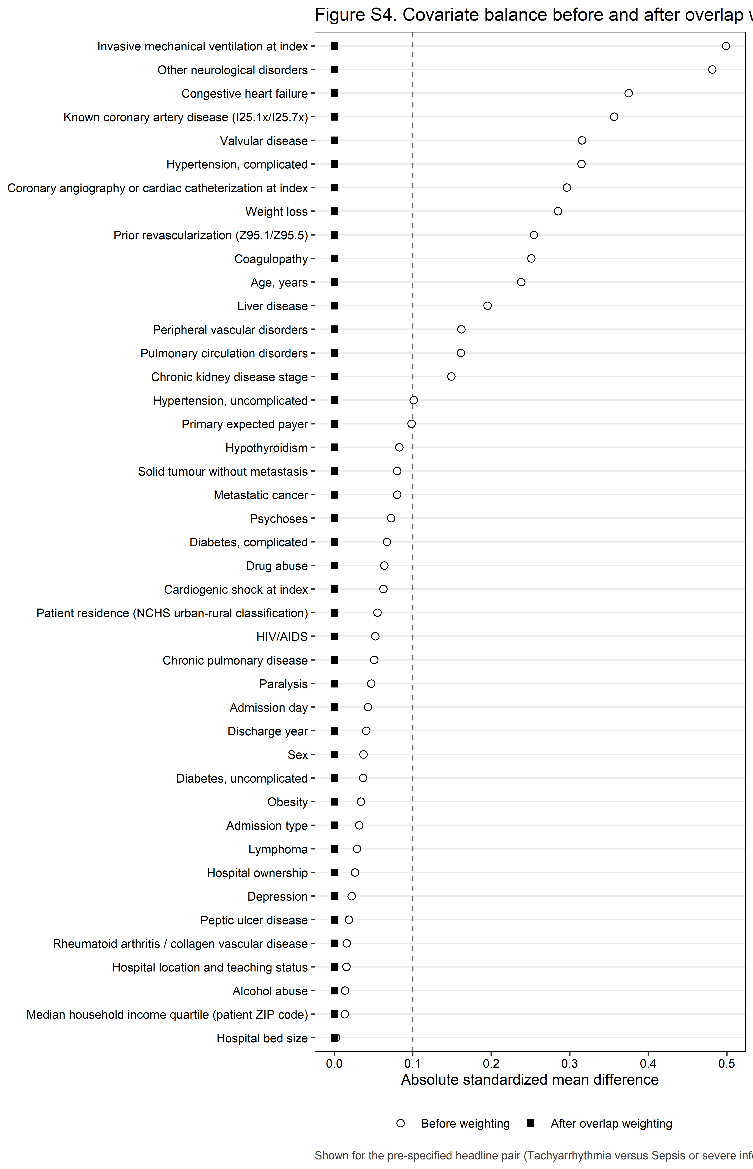
Figure S4. Covariate balance before and after overlap weighting.

13. Model diagnostics
Table S4. Model diagnostics.
Diagnostic | Value | Interpretation
Maximum variance inflation factor (per design-matrix column) | 3.55 | Below the pre-specified threshold of 5; no collinearity concern
Maximum VIF among the seven precipitant dummy columns | 1.72 | Reported separately because the exposure contributes seven dummy columns; an inflated value here would indicate that a covariate still overlaps a precipitant class despite the pre-specified removals
Survey-weighted c-statistic (tie-corrected) | 0.622 | Reported without a threshold; discrimination is not the objective of an aetiological model
Design-based decile calibration test (survey analogue of Hosmer-Lemeshow) | <0.001 | With a cohort of this size any calibration test will reject. Figure S3 is the substantive evidence; this p-value is reported for completeness only and is not interpreted alone.
Covariates removed by the sparse-cell guard | None | Every removal is named here and in the Methods section
Minimum unweighted cell enforced on every reported table | 11 | HCUP Data Use Agreement

Variance inflation factors are computed per design-matrix column rather than aggregated to a generalized VIF, which is the conservative reading: if no individual dummy column is inflated then no multi-level factor is either. The maximum among the seven precipitant dummy columns is reported separately, because the pre-specified removal of five Elixhauser flags was justified on the grounds that they overlap precipitant classes by construction, and this is the number that shows whether that removal succeeded. The c-statistic is survey-weighted and tie-corrected. The calibration test is the survey analogue of the Hosmer-Lemeshow test and is NOT the Archer-Lemeshow F-adjusted mean residual test; it should not be described as such. Singleton strata were centred at the grand mean (survey.lonely.psu = ‘adjust’) rather than removed; 5 stratum/strata contained a single primary sampling unit. All manually constructed intervals use t critical values on 8,928 design degrees of freedom rather than 1.96.
Table S4b. Variance inflation factors, per design-matrix column.
Term | VIF
Age, natural-spline basis 1 | 3.55
Age, natural-spline basis 3 | 2.9
Hypertension, complicated | 2.63
Age, natural-spline basis 2 | 2.42
Discharge year: 2022 | 2.26
Discharge year: 2021 | 2.16
Discharge year: 2020 | 2.03
Hospital bed size: Large | 2.01
Congestive heart failure | 1.91
Hospital bed size: Medium | 1.9
Hospital location and teaching status: Non-metropolitan | 1.89
Discharge year: 2019 | 1.88
Hypertension, uncomplicated | 1.88
Patient residence (NCHS urban-rural classification): Micropolitan | 1.75
Tachyarrhythmia (vs Sepsis or severe infection) | 1.72
None of the above (vs Sepsis or severe infection) | 1.65
Median household income quartile (patient ZIP code): 76th to 100th percentile | 1.64
Primary expected payer: Medicaid | 1.55
Median household income quartile (patient ZIP code): 51st to 75th percentile | 1.53
Patient residence (NCHS urban-rural classification): Fringe metro ≥1 million | 1.48
Median household income quartile (patient ZIP code): 26th to 50th percentile | 1.46
Chronic kidney disease stage: Stage 3 | 1.46
Known coronary artery disease (I25.1x/I25.7x) | 1.44
Patient residence (NCHS urban-rural classification): Metro 250,000-999,999 | 1.41
Metastatic cancer | 1.4
Solid tumour without metastasis | 1.4
Chronic kidney disease stage: Dialysis-dependent / ESKD | 1.37
Patient residence (NCHS urban-rural classification): Other | 1.35
Primary expected payer: Private | 1.34
Patient residence (NCHS urban-rural classification): Metro 50,000-249,999 | 1.34
Hospital location and teaching status: Metropolitan, teaching | 1.34
Prior revascularization (Z95.1/Z95.5) | 1.3
Acute respiratory failure (vs Sepsis or severe infection) | 1.29
Acute GI bleed or blood-loss anaemia (vs Sepsis or severe infection) | 1.27
Diabetes, complicated | 1.27
Hypertensive emergency (vs Sepsis or severe infection) | 1.26
Drug abuse | 1.21
Chronic kidney disease stage: Stage 4-5, not on dialysis | 1.21
Chronic kidney disease stage: Unspecified stage | 1.19
Invasive mechanical ventilation at index | 1.18
Hypovolaemia or non-cardiogenic shock (vs Sepsis or severe infection) | 1.16
Primary expected payer: Other/self-pay | 1.14
Alcohol abuse | 1.14
Sex: Female | 1.13
Other neurological disorders | 1.12
Liver disease | 1.12
Obesity | 1.12
Coronary angiography or cardiac catheterization at index | 1.12
Valvular disease | 1.11
Hospital ownership: Private, invest-own | 1.1
Chronic pulmonary disease | 1.08
Weight loss | 1.08
Patient residence (NCHS urban-rural classification): Missing/other | 1.07
Diabetes, uncomplicated | 1.07
Coagulopathy | 1.07
Perioperative (vs Sepsis or severe infection) | 1.06
Pulmonary circulation disorders | 1.06
Hypothyroidism | 1.06
Cardiogenic shock at index | 1.06
Chronic kidney disease stage: Stage 1-2 | 1.06
Hospital ownership: Government, nonfederal | 1.05
Peripheral vascular disorders | 1.05
Median household income quartile (patient ZIP code): Missing/other | 1.04
Depression | 1.03
Admission type: Elective | 1.02
Paralysis | 1.02
Rheumatoid arthritis / collagen vascular disease | 1.02
Psychoses | 1.02
Peptic ulcer disease | 1.01
HIV/AIDS | 1.01
Lymphoma | 1.01
Primary expected payer: Missing/other | 1
Admission day: Weekend (Sat-Sun) | 1
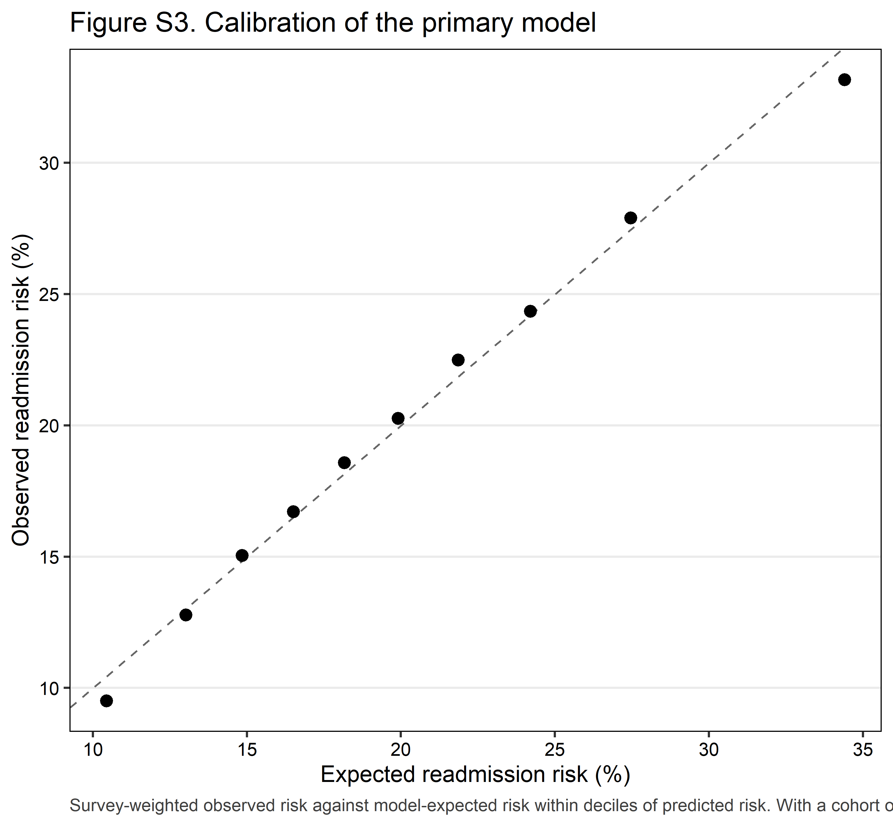
Figure S3. Calibration of the primary model.
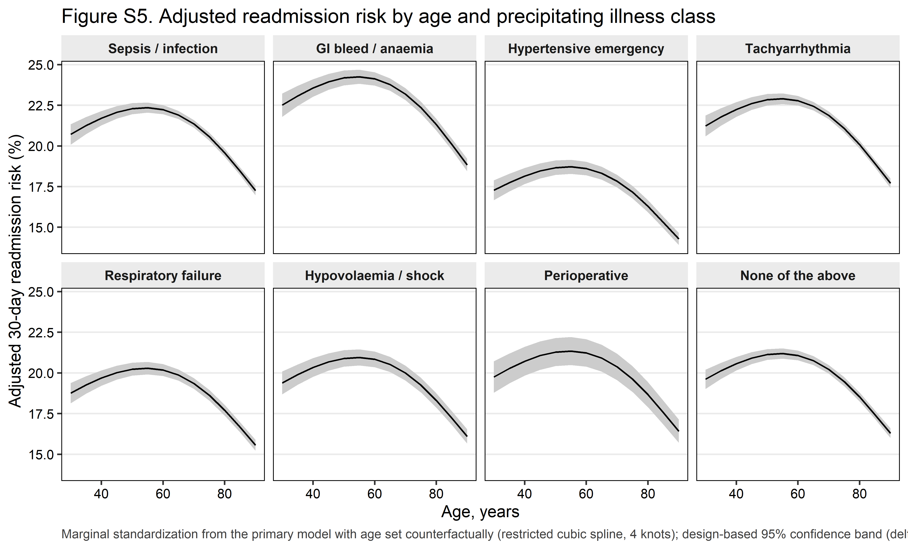
Figure S5. Adjusted readmission risk by age and precipitating illness class.

14. Missing data and code lists
Table S7. Missingness on primary-model covariates (only covariates with any missing value).
Variable | Missing n | Missing % | Handling
Admission type | 650 | 0.07% | Complete case
Categorical covariates retain an explicit ‘Missing/other’ level; only continuous covariates and variables with no defensible missing category are complete-cased. The pre-specified trigger for multiple imputation is 5% missingness on any primary-model covariate.
Table S9. Complete code lists, exactly as matched (SAP A17).
Group | System | Code
Type 2 myocardial infarction (any-listed, index cohort) | ICD-10-CM | I21A1
Other myocardial infarction type (excluded, not pooled) | ICD-10-CM | I21A9
Type 1 myocardial infarction (contamination exclusion; comparator arm) | ICD-10-CM | I210 (prefix)
Type 1 myocardial infarction (contamination exclusion; comparator arm) | ICD-10-CM | I211 (prefix)
Type 1 myocardial infarction (contamination exclusion; comparator arm) | ICD-10-CM | I212 (prefix)
Type 1 myocardial infarction (contamination exclusion; comparator arm) | ICD-10-CM | I213 (prefix)
Type 1 myocardial infarction (contamination exclusion; comparator arm) | ICD-10-CM | I214 (prefix)
Type 1 myocardial infarction (contamination exclusion; comparator arm) | ICD-10-CM | I219 (prefix)
Type 1 myocardial infarction (contamination exclusion; comparator arm) | ICD-10-CM | I22 (prefix)
Precipitant rank 1: sepsis or severe infection | ICD-10-CM | A40 (prefix)
Precipitant rank 1: sepsis or severe infection | ICD-10-CM | A41 (prefix)
Precipitant rank 1: sepsis or severe infection | ICD-10-CM | R6520 (prefix)
Precipitant rank 1: sepsis or severe infection | ICD-10-CM | R6521 (prefix)
Precipitant rank 2: acute GI bleed or blood-loss anaemia | ICD-10-CM | K920 (prefix)
Precipitant rank 2: acute GI bleed or blood-loss anaemia | ICD-10-CM | K921 (prefix)
Precipitant rank 2: acute GI bleed or blood-loss anaemia | ICD-10-CM | K922 (prefix)
Precipitant rank 2: acute GI bleed or blood-loss anaemia | ICD-10-CM | D62 (prefix)
Precipitant rank 3: hypertensive emergency | ICD-10-CM | I161
Precipitant rank 3: hypertensive emergency | ICD-10-CM | I169
NOT a precipitant: hypertensive URGENCY, counted and reported only | ICD-10-CM | I160
Precipitant rank 4: tachyarrhythmia | ICD-10-CM | I47 (prefix)
Precipitant rank 4: tachyarrhythmia | ICD-10-CM | I48 (prefix)
Precipitant rank 4: tachyarrhythmia | ICD-10-CM | I4901 (prefix)
Precipitant rank 4: tachyarrhythmia | ICD-10-CM | I4902 (prefix)
Precipitant rank 5: acute respiratory failure | ICD-10-CM | J9600 (prefix)
Precipitant rank 5: acute respiratory failure | ICD-10-CM | J9601 (prefix)
Precipitant rank 5: acute respiratory failure | ICD-10-CM | J9602 (prefix)
Precipitant rank 5: acute respiratory failure | ICD-10-CM | J80 (prefix)
Precipitant rank 6: hypovolaemia or non-cardiogenic shock | ICD-10-CM | E86 (prefix)
Precipitant rank 6: hypovolaemia or non-cardiogenic shock | ICD-10-CM | R571 (prefix)
Precipitant rank 6: hypovolaemia or non-cardiogenic shock | ICD-10-CM | R578 (prefix)
Precipitant rank 6: hypovolaemia or non-cardiogenic shock | ICD-10-CM | R579 (prefix)
Precipitant rank 7: perioperative | ICD-10-PCS | Section 0 (Medical and Surgical) with approach character 0 (open) or 4 (percutaneous endoscopic)
Cardiogenic shock (COVARIATE, never a precipitant) | ICD-10-CM | R570
Invasive mechanical ventilation | ICD-10-PCS | 5A1935Z
Invasive mechanical ventilation | ICD-10-PCS | 5A1945Z
Invasive mechanical ventilation | ICD-10-PCS | 5A1955Z
Chronic dialysis dependence | ICD-10-CM | N186
Chronic dialysis dependence | ICD-10-CM | Z992
Chronic dialysis dependence | ICD-10-CM | Z4901
Chronic dialysis dependence | ICD-10-CM | Z4902
Chronic dialysis dependence | ICD-10-CM | Z4931
Chronic dialysis dependence | ICD-10-CM | Z4932
Chronic dialysis dependence (5A1D90Z / CRRT deliberately excluded) | ICD-10-PCS | 5A1D60Z
Chronic dialysis dependence (5A1D90Z / CRRT deliberately excluded) | ICD-10-PCS | 5A1D70Z
Chronic dialysis dependence (5A1D90Z / CRRT deliberately excluded) | ICD-10-PCS | 5A1D80Z
Chronic dialysis dependence (5A1D90Z / CRRT deliberately excluded) | ICD-10-PCS | 3E1M39Z
Chronic kidney disease, stage 1-2 | ICD-10-CM | N181
Chronic kidney disease, stage 1-2 | ICD-10-CM | N182
Chronic kidney disease, stage 3 | ICD-10-CM | N183 (prefix)
Chronic kidney disease, stage 4-5 | ICD-10-CM | N184
Chronic kidney disease, stage 4-5 | ICD-10-CM | N185
Known coronary artery disease | ICD-10-CM | I251 (prefix)
Known coronary artery disease | ICD-10-CM | I257 (prefix)
Prior revascularization (status code) | ICD-10-CM | Z951
Prior revascularization (status code) | ICD-10-CM | Z955
Atrial fibrillation or flutter (Table 1 only, not a covariate) | ICD-10-CM | I48 (prefix)
COVID-19 (descriptive only, not a covariate) | ICD-10-CM | U071
Coronary angiography / cardiac catheterization (process measure) | ICD-10-PCS | 4A023N (prefix)
Coronary angiography / cardiac catheterization (process measure) | ICD-10-PCS | B211 (prefix)
Coronary angiography / cardiac catheterization (process measure) | ICD-10-PCS | B212 (prefix)
Coronary angiography / cardiac catheterization (process measure) | ICD-10-PCS | B213 (prefix)
Coronary angiography / cardiac catheterization (process measure) | ICD-10-PCS | B214 (prefix)
Coronary angiography / cardiac catheterization (process measure) | ICD-10-PCS | B215 (prefix)
Percutaneous coronary intervention (process measure) | ICD-10-PCS | 027 (prefix)
Coronary artery bypass grafting (process measure) | ICD-10-PCS | 021 (prefix)

15. Full model coefficients
Table S2. Complete coefficient set from the primary model.
Term | Adjusted OR (95% CI) | p value
Acute GI bleed or blood-loss anaemia (vs Sepsis or severe infection) | 1.12 (1.09–1.14) | <0.001
Hypertensive emergency (vs Sepsis or severe infection) | 0.79 (0.77–0.82) | <0.001
Tachyarrhythmia (vs Sepsis or severe infection) | 1.03 (1.02–1.05) | <0.001
Acute respiratory failure (vs Sepsis or severe infection) | 0.88 (0.86–0.90) | <0.001
Hypovolaemia or non-cardiogenic shock (vs Sepsis or severe infection) | 0.92 (0.89–0.95) | <0.001
Perioperative (vs Sepsis or severe infection) | 0.94 (0.89–0.99) | 0.021
None of the above (vs Sepsis or severe infection) | 0.93 (0.91–0.95) | <0.001
Age, natural-spline basis 1 | 0.98 (0.94–1.02) | 0.316
Age, natural-spline basis 2 | 1.19 (1.05–1.35) | 0.006
Age, natural-spline basis 3 | 0.73 (0.71–0.75) | <0.001
Sex: Female | 0.98 (0.97–1.00) | 0.007
Primary expected payer: Private | 0.75 (0.73–0.77) | <0.001
Primary expected payer: Medicaid | 1.04 (1.02–1.06) | <0.001
Primary expected payer: Other/self-pay | 0.79 (0.76–0.81) | <0.001
Primary expected payer: Missing/other | 0.70 (0.59–0.82) | <0.001
Median household income quartile (patient ZIP code): 26th to 50th percentile | 0.95 (0.93–0.97) | <0.001
Median household income quartile (patient ZIP code): 51st to 75th percentile | 0.91 (0.89–0.93) | <0.001
Median household income quartile (patient ZIP code): 76th to 100th percentile | 0.93 (0.90–0.95) | <0.001
Median household income quartile (patient ZIP code): Missing/other | 0.89 (0.84–0.94) | <0.001
Patient residence (NCHS urban-rural classification): Fringe metro ≥1 million | 1.01 (0.99–1.03) | 0.365
Patient residence (NCHS urban-rural classification): Metro 250,000-999,999 | 0.97 (0.95–1.00) | 0.030
Patient residence (NCHS urban-rural classification): Metro 50,000-249,999 | 0.93 (0.90–0.96) | <0.001
Patient residence (NCHS urban-rural classification): Micropolitan | 0.86 (0.83–0.88) | <0.001
Patient residence (NCHS urban-rural classification): Other | 0.85 (0.83–0.88) | <0.001
Patient residence (NCHS urban-rural classification): Missing/other | 1.54 (1.44–1.65) | <0.001
Admission day: Weekend (Sat-Sun) | 1.01 (1.00–1.02) | 0.184
Admission type: Elective | 0.94 (0.90–0.98) | 0.007
Hospital bed size: Medium | 1.00 (0.98–1.03) | 0.902
Hospital bed size: Large | 1.02 (1.00–1.05) | 0.041
Hospital location and teaching status: Metropolitan, teaching | 1.00 (0.98–1.02) | 0.723
Hospital location and teaching status: Non-metropolitan | 1.03 (0.99–1.07) | 0.123
Hospital ownership: Government, nonfederal | 1.02 (0.99–1.05) | 0.219
Hospital ownership: Private, invest-own | 1.11 (1.08–1.13) | <0.001
Discharge year: 2019 | 0.96 (0.93–0.99) | 0.014
Discharge year: 2020 | 0.93 (0.90–0.96) | <0.001
Discharge year: 2021 | 0.93 (0.90–0.96) | <0.001
Discharge year: 2022 | 0.92 (0.90–0.95) | <0.001
Congestive heart failure | 1.29 (1.26–1.31) | <0.001
Valvular disease | 1.13 (1.11–1.15) | <0.001
Pulmonary circulation disorders | 1.01 (1.00–1.03) | 0.079
Peripheral vascular disorders | 1.12 (1.10–1.14) | <0.001
Hypertension, uncomplicated | 0.92 (0.90–0.94) | <0.001
Paralysis | 1.02 (0.99–1.07) | 0.219
Other neurological disorders | 1.04 (1.02–1.05) | <0.001
Chronic pulmonary disease | 1.20 (1.19–1.22) | <0.001
Diabetes, uncomplicated | 1.09 (1.07–1.11) | <0.001
Diabetes, complicated | 1.21 (1.20–1.23) | <0.001
Hypothyroidism | 0.99 (0.98–1.01) | 0.549
Liver disease | 1.15 (1.12–1.17) | <0.001
Peptic ulcer disease | 1.10 (1.04–1.16) | 0.001
HIV/AIDS | 1.29 (1.18–1.42) | <0.001
Lymphoma | 1.45 (1.38–1.51) | <0.001
Metastatic cancer | 1.24 (1.19–1.29) | <0.001
Solid tumour without metastasis | 1.28 (1.25–1.32) | <0.001
Rheumatoid arthritis / collagen vascular disease | 1.21 (1.18–1.25) | <0.001
Coagulopathy | 1.06 (1.04–1.08) | <0.001
Obesity | 0.89 (0.88–0.91) | <0.001
Weight loss | 1.18 (1.16–1.20) | <0.001
Alcohol abuse | 0.98 (0.96–1.01) | 0.245
Drug abuse | 1.20 (1.17–1.23) | <0.001
Psychoses | 1.26 (1.21–1.31) | <0.001
Depression | 1.05 (1.03–1.06) | <0.001
Hypertension, complicated | 1.05 (1.03–1.07) | <0.001
Cardiogenic shock at index | 0.92 (0.88–0.95) | <0.001
Invasive mechanical ventilation at index | 0.92 (0.90–0.94) | <0.001
Chronic kidney disease stage: Stage 1-2 | 1.05 (1.00–1.09) | 0.038
Chronic kidney disease stage: Stage 3 | 1.19 (1.17–1.21) | <0.001
Chronic kidney disease stage: Stage 4-5, not on dialysis | 1.42 (1.39–1.46) | <0.001
Chronic kidney disease stage: Unspecified stage | 1.15 (1.12–1.18) | <0.001
Chronic kidney disease stage: Dialysis-dependent / ESKD | 1.77 (1.73–1.81) | <0.001
Known coronary artery disease (I25.1x/I25.7x) | 1.08 (1.06–1.09) | <0.001
Prior revascularization (Z95.1/Z95.5) | 1.01 (0.99–1.03) | 0.215
Coronary angiography or cardiac catheterization at index | 0.81 (0.79–0.83) | <0.001

16. Verification
Table V1. HCUP small-cell scan of every rendered table.
Table | Count cells scanned | Cells of 1-10 unweighted discharges
Table S0 (attrition) | 19 | 0
Table S0b (flow notes) | 10 | 0
Table S7 (missingness) | 1 | 0
Table S1 (design) | 2 | 0
Table 1 (baseline) | 999 | 0
Table S1b (co-occurrence) | 7 | 0
Table 2 (unadjusted outcomes) | 27 | 0
Table 2b (index mortality) | 18 | 0
Table 2c (process measures) | 25 | 0
Table 2d (readmission characteristics) | 27 | 0
Table 3 (primary model) | 7 | 0
Table 3b (adjusted risks) | 16 | 0
Table 3c (overlap weighting) | 7 | 0
Table 3d (effective sample size) | 7 | 0
Table 4 (sequential models) | 5 | 0
Table 4b (secondary outcomes) | 12 | 0
Table S5 (E-values) | 7 | 0
Table S5b (g-computation cross-check) | 0 | 0
Table 5 (concordance) | 23 | 0
Table 6 (cause of readmission) | 144 | 0
Table 7 (MI type) | 4 | 0
Table 7b (MI type, standardized) | 0 | 0
Table 8 (subgroups) | 21 | 0
Table S3 (trends) | 5 | 0
Table S3b (trends by class) | 40 | 0
Table S3c (class prevalence trend) | 0 | 0
Table 9 (sensitivity) | 9 | 0
Table 9b (sensitivity, all contrasts) | 35 | 0
Table 9c (negative control) | 1 | 0
Table S6 (balance) | 0 | 0
Table S4 (diagnostics) | 0 | 0
Table S4b (VIF) | 0 | 0
Table S2 (coefficients) | 0 | 0
Table 6b (numbers at risk) | 0 | 0
Table S1a (HCUP workbook benchmark) | 10 | 0
Table S9 (code lists) | 0 | 0
Synthetic parameter recovery | 0 | 0
0 violation(s) across 37 tables; nothing representing 1-10 unweighted discharges is printed.
Table V2. The scanner tested in both directions.
Test | Direction | Small cells flagged | Result
Injected parenthesised count of 7 in a Table 1 cell is caught | Must FAIL (catch) | 1 | Pass
Injected bare count of 8 in a subgroup n column is caught | Must FAIL (catch) | 1 | Pass
Injected smallest-cell value of 5 on a Table 3 model row is caught | Must FAIL (catch) | 1 | Pass
Injected header count of 9 in Table 6 is caught | Must FAIL (catch) | 1 | Pass
Injected bracketed event count of 6 in Table 2 is caught | Must FAIL (catch) | 1 | Pass
A clean table (all counts >= 11 or marked suppressed) passes | Must PASS | 0 | Pass
Complementary suppression leaves no row or column with a single hidden cell | Must hold | — | Pass

Table V3. Denominator guards (the render stops if any fails).
Check | Observed | Expected | Result
Analytic design rows = attrition final step (complete cases) | 870486 | 870486 | Pass
Index design rows before complete-case step = attrition step 8 | 871136 | 871136 | Pass
Attrition: every ‘excluded’ = difference of ‘remaining’ | checked | all equal | Pass
Attrition is non-increasing | checked | monotone | Pass
No in-hospital deaths in the index cohort | 0 | 0 | Pass
No December discharges, transfers out or minors in the index cohort | 0 | 0 | Pass
Type 1 comparator: same exclusions (no deaths, December, transfers) | 0 | 0 | Pass
Type 1 comparator has linked readmissions (audit P1.1) | 273682 | > 0 | Pass
Data years are exactly 2018-2022 | 2018,2019,2020,2021,2022 | 2018,2019,2020,2021,2022 | Pass
All-listed I21.A1 per year within 0.5% of the HCUP frequency workbook | max |diff| 0.000% | <= 0.5% | Pass
Precipitant classes are mutually exclusive and exhaustive (one class per index row) | 0 | 0 | Pass
I16.0 (urgency) is never the basis of the hypertensive-emergency class | codelist | I161, I169 only | Pass
Levels of ‘Precipitating acute illness class’ sum to the analytic cohort | 870486 | 870486 | Pass
Levels of ‘Discharge year’ sum to the analytic cohort | 870486 | 870486 | Pass
Levels of ‘Age group’ sum to the analytic cohort | 870486 | 870486 | Pass
Levels of ‘Chronic kidney disease’ sum to the analytic cohort | 870486 | 870486 | Pass
Levels of ‘Pandemic era’ sum to the analytic cohort | 870486 | 870486 | Pass
Levels of ‘Sex’ sum to the analytic cohort | 870486 | 870486 | Pass
Levels of ‘Primary expected payer’ sum to the analytic cohort | 870486 | 870486 | Pass
Levels of ‘Median household income quartile (patient ZIP code)’ sum to the analytic cohort | 870486 | 870486 | Pass
Levels of ‘Patient residence (NCHS urban-rural classification)’ sum to the analytic cohort | 870486 | 870486 | Pass
Levels of ‘Admission day’ sum to the analytic cohort | 870486 | 870486 | Pass
Levels of ‘Admission type’ sum to the analytic cohort | 870486 | 870486 | Pass
Levels of ‘Hospital bed size’ sum to the analytic cohort | 870486 | 870486 | Pass
Levels of ‘Hospital location and teaching status’ sum to the analytic cohort | 870486 | 870486 | Pass
Levels of ‘Hospital ownership’ sum to the analytic cohort | 870486 | 870486 | Pass
Levels of ‘Type 2 MI coded as the principal diagnosis’ sum to the analytic cohort | 870486 | 870486 | Pass
Levels of ‘Cardiogenic shock at index’ sum to the analytic cohort | 870486 | 870486 | Pass
Levels of ‘Invasive mechanical ventilation at index’ sum to the analytic cohort | 870486 | 870486 | Pass
Levels of ‘Chronic kidney disease stage’ sum to the analytic cohort | 870486 | 870486 | Pass
Levels of ‘Dialysis dependence at index’ sum to the analytic cohort | 870486 | 870486 | Pass
Levels of ‘Known coronary artery disease (I25.1x/I25.7x)’ sum to the analytic cohort | 870486 | 870486 | Pass
Levels of ‘Prior revascularization (Z95.1/Z95.5)’ sum to the analytic cohort | 870486 | 870486 | Pass
Levels of ‘Atrial fibrillation or flutter (I48)’ sum to the analytic cohort | 870486 | 870486 | Pass
Levels of ‘COVID-19 at index (U07.1)’ sum to the analytic cohort | 870486 | 870486 | Pass
Levels of ‘Congestive heart failure’ sum to the analytic cohort | 870486 | 870486 | Pass
Levels of ‘Valvular disease’ sum to the analytic cohort | 870486 | 870486 | Pass
Levels of ‘Pulmonary circulation disorders’ sum to the analytic cohort | 870486 | 870486 | Pass
Levels of ‘Peripheral vascular disorders’ sum to the analytic cohort | 870486 | 870486 | Pass
Levels of ‘Hypertension, uncomplicated’ sum to the analytic cohort | 870486 | 870486 | Pass
Levels of ‘Hypertension, complicated’ sum to the analytic cohort | 870486 | 870486 | Pass
Levels of ‘Other neurological disorders’ sum to the analytic cohort | 870486 | 870486 | Pass
Levels of ‘Chronic pulmonary disease’ sum to the analytic cohort | 870486 | 870486 | Pass
Levels of ‘Diabetes, uncomplicated’ sum to the analytic cohort | 870486 | 870486 | Pass
Levels of ‘Diabetes, complicated’ sum to the analytic cohort | 870486 | 870486 | Pass
Levels of ‘Liver disease’ sum to the analytic cohort | 870486 | 870486 | Pass
Levels of ‘Obesity’ sum to the analytic cohort | 870486 | 870486 | Pass
Levels of ‘Weight loss’ sum to the analytic cohort | 870486 | 870486 | Pass
Levels of ‘Coagulopathy’ sum to the analytic cohort | 870486 | 870486 | Pass
Levels of ‘Metastatic cancer’ sum to the analytic cohort | 870486 | 870486 | Pass
Levels of ‘Solid tumour without metastasis’ sum to the analytic cohort | 870486 | 870486 | Pass
Levels of ‘Psychoses’ sum to the analytic cohort | 870486 | 870486 | Pass
Levels of ‘Depression’ sum to the analytic cohort | 870486 | 870486 | Pass
Levels of ‘Alcohol abuse’ sum to the analytic cohort | 870486 | 870486 | Pass
Levels of ‘Drug abuse’ sum to the analytic cohort | 870486 | 870486 | Pass
Levels of ‘Cardiac arrhythmias (excluded from the model by pre-specification)’ sum to the analytic cohort | 870486 | 870486 | Pass
Levels of ‘Fluid and electrolyte disorders (excluded from the model by pre-specification)’ sum to the analytic cohort | 870486 | 870486 | Pass
Levels of ‘Renal failure (excluded from the model by pre-specification)’ sum to the analytic cohort | 870486 | 870486 | Pass
Levels of ‘Blood loss anaemia (excluded from the model by pre-specification)’ sum to the analytic cohort | 870486 | 870486 | Pass
Levels of ‘Deficiency anaemia (excluded from the model by pre-specification)’ sum to the analytic cohort | 870486 | 870486 | Pass
Readmission count identical in design, primary model and Table 5 | 175312 175312 175312 | all equal | Pass
Design/SRS standard-error ratio plausible (overall) | 1.68 | 0.5 to 10 | Pass
Design/SRS standard-error ratio plausible (Sepsis or severe infection) | 1.24 | 0.5 to 10 | Pass
Design/SRS standard-error ratio plausible (Acute GI bleed or blood-loss anaemia) | 1.12 | 0.5 to 10 | Pass
Design/SRS standard-error ratio plausible (Hypertensive emergency) | 1.15 | 0.5 to 10 | Pass
Design/SRS standard-error ratio plausible (Tachyarrhythmia) | 1.30 | 0.5 to 10 | Pass
Design/SRS standard-error ratio plausible (Acute respiratory failure) | 1.16 | 0.5 to 10 | Pass
Design/SRS standard-error ratio plausible (Hypovolaemia or non-cardiogenic shock) | 1.08 | 0.5 to 10 | Pass
Design/SRS standard-error ratio plausible (Perioperative) | 1.08 | 0.5 to 10 | Pass
Design/SRS standard-error ratio plausible (None of the above) | 1.33 | 0.5 to 10 | Pass
Overall rate lies within the range of ‘Precipitating acute illness class’ levels | 20.03% in [17.82%, 22.77%] | inside | Pass
Overall rate lies within the range of ‘Discharge year’ levels | 20.03% in [19.72%, 20.78%] | inside | Pass
Overall rate lies within the range of ‘Age group’ levels | 20.03% in [19.87%, 20.38%] | inside | Pass
Overall rate lies within the range of ‘Chronic kidney disease’ levels | 20.03% in [16.95%, 24.43%] | inside | Pass
Overall rate lies within the range of ‘Pandemic era’ levels | 20.03% in [19.81%, 20.56%] | inside | Pass
No non-finite or missing value (NA/NaN/Inf) in any rendered table cell | 0 | 0 | Pass
Every primary-model standard error finite | TRUE | TRUE | Pass
Design degrees of freedom > 100 (SAP D2) | 8928 | > 100 | Pass
Small-cell scan: zero violations across every rendered table | 0 | 0 | Pass
Suppression scanner self-test passes in both directions | 7 | 7 | Pass

17. Pre-specified analyses not estimable or not applicable
S6, present-on-admission-restricted precipitant assignment: NOT ESTIMABLE. No NRD file in the 2016-2022 series carries a present-on-admission indicator. It is reported as not estimable in Table 9, and S6b (assignment from the principal diagnosis only) is shown beside it as the closest estimable substitute: a precipitant recorded as the principal diagnosis is necessarily the reason for admission.
- S6 (Present-on-admission-restricted precipitant assignment): Not estimable: no present-on-admission indicator exists in any NRD data year 2016-2022.
- DX-field-restricted ascertainment: Not applicable: the year audit shows 40 diagnosis fields populated in every year 2018-2022, so the SAP A6.6 condition for this row is not met.

