**DW analysis**

**Q1 Present total sales of all products supplied by each supplier with respect to quarter and**

**month**

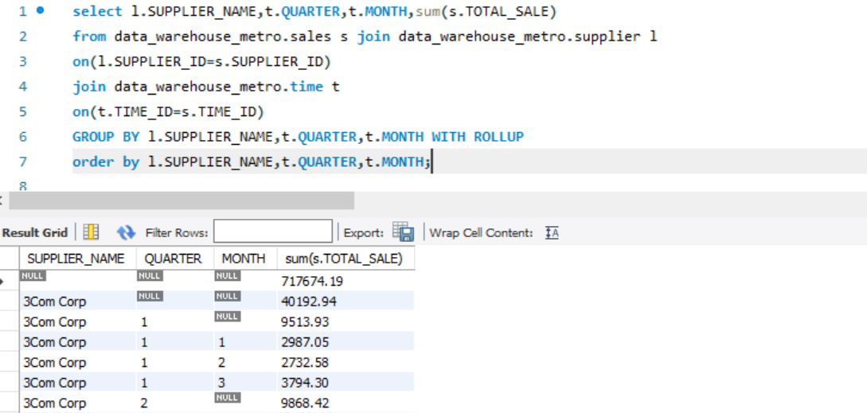

**Q2 Present total sales of each product sold by each store. The output should be organised store wise and then product wise under each store.**

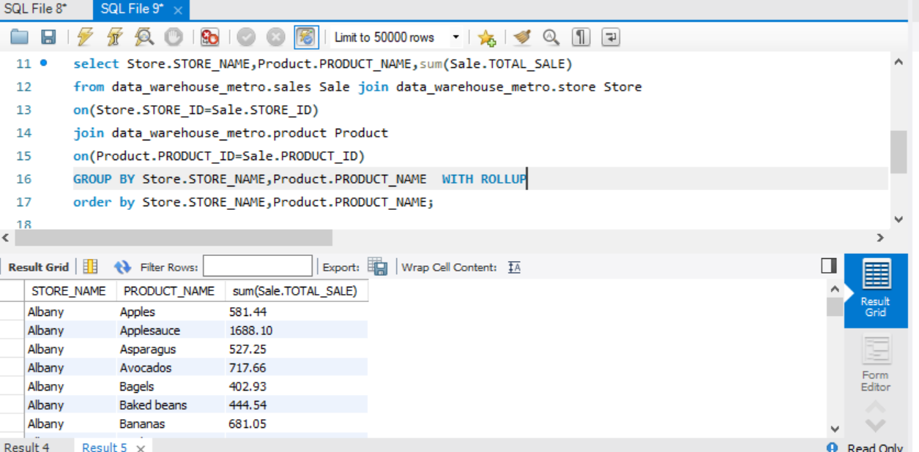

**Q3 Find the 5 most popular products sold over the weekends.**

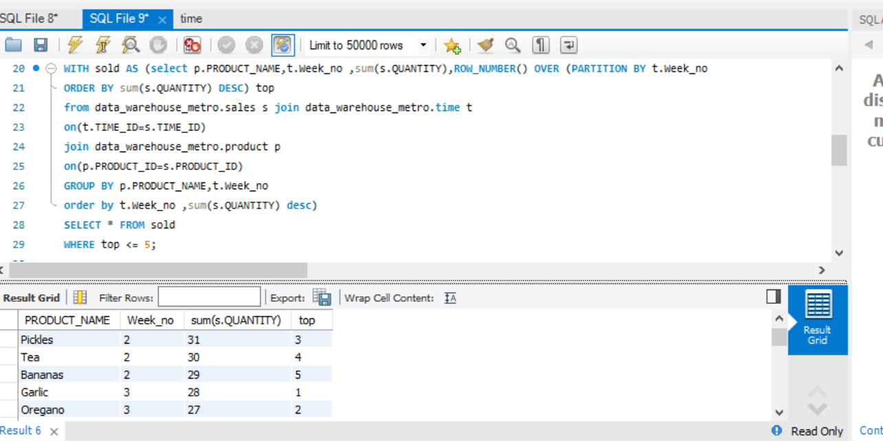

**Q4 Present the quarterly sales of each product for year 2016 using drill down query concept. Note: each quarter sale must be a column.**

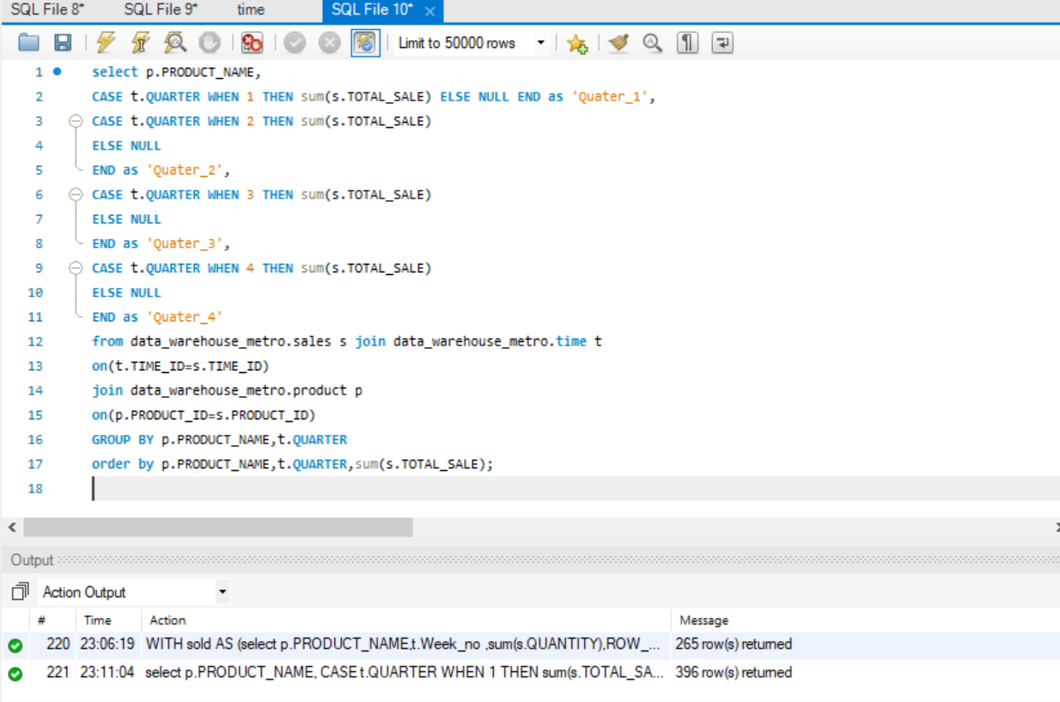

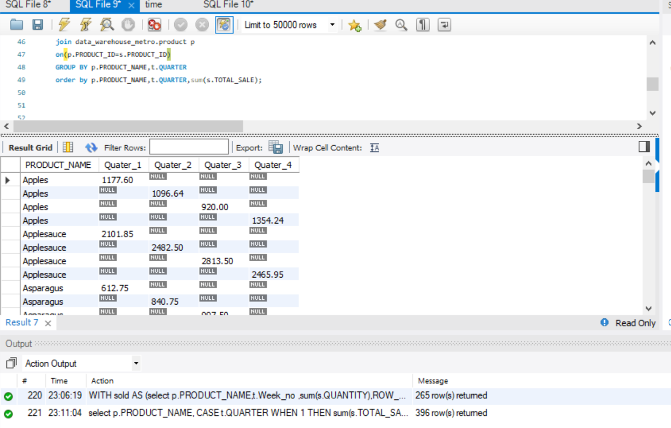

**Q5 Extract total sales of each product for the first and second half of year 2016 along with its total yearly sales.**

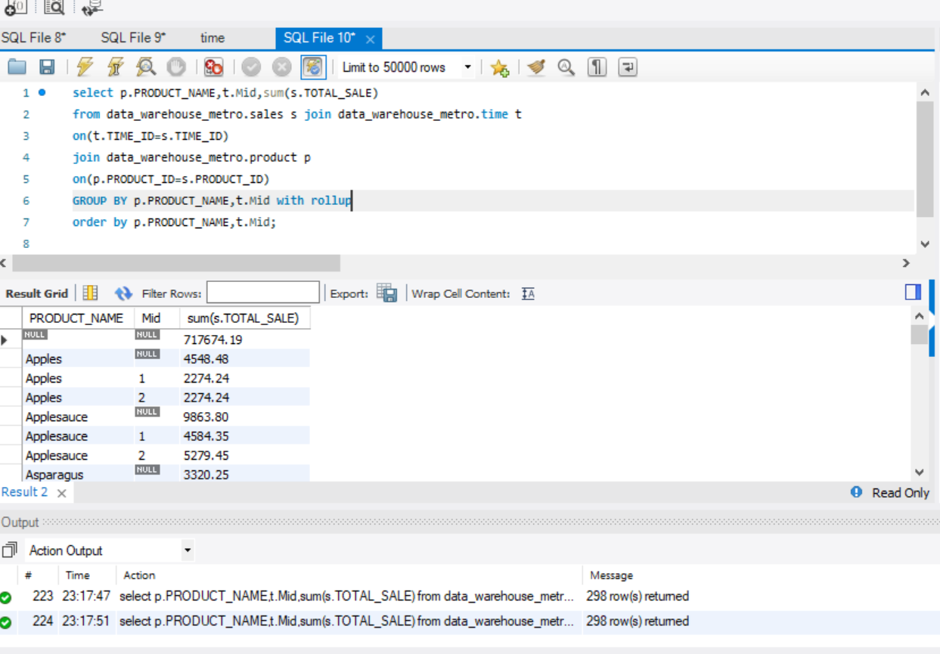

**Q6 Find an anomaly in the data warehouse dataset. write a query to show the anomaly and explain the anomaly in your project report.**

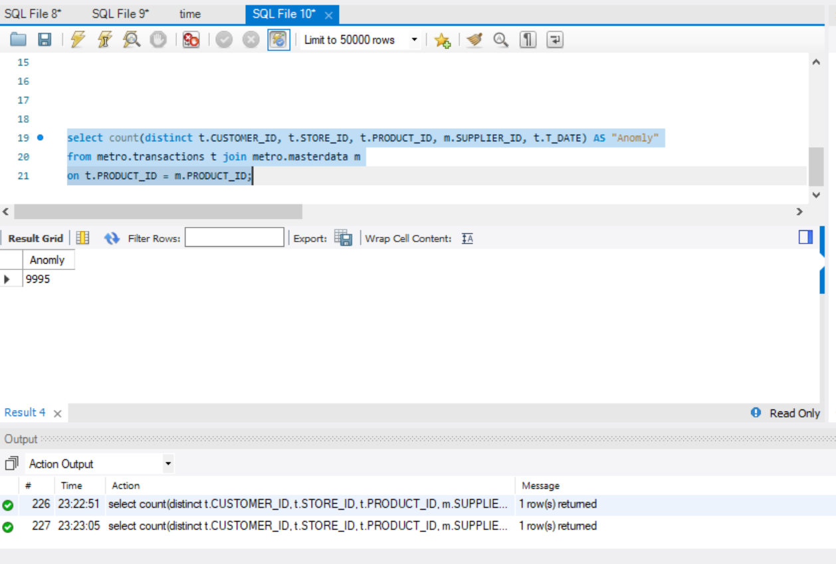

**Q7 Create a materialised view with the name “STOREANALYSIS_MV” that presents the product- wise sales analysis for each store.**

