LAB TASKS 5
Muhammad Saad Tahir
BCS-5B
Task1:Design and implement the topology given in the following figure in Cisco Packet Tracer. The
network consists of two subnets joined by a router: a client LAN and a server LAN that hosts the
FTP server. The router must be configured through the CLI. Attach all the necessary screenshots
in this Word file and upload the PKT file to your drive.
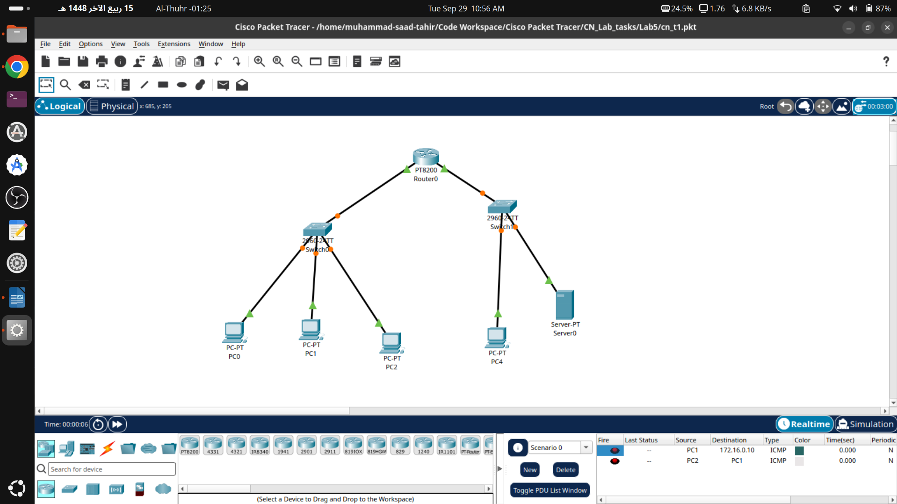
Task2:
Design and implement the topology given in the following figure. The mail server is connected
directly to the router with a copper cross-over cable and provides three services: SMTP, POP3
and DNS. The clients must send and receive email using a domain name, not an IP address. The
router must again be configured through the CLI.

