**Identify two embedded systems that are sold on the market today and analyse their interfaces.**

# Automated Teller machine:

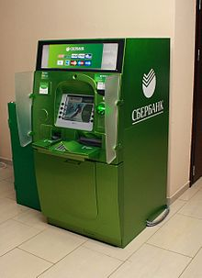

[This Photo](https://en.wikipedia.org/wiki/Automated_teller_machine) by Unknown Author is licensed under [CC BY-SA](https://creativecommons.org/licenses/by-sa/3.0/)

* Automated Teller Machines (ATMs) are electronic devices used to perform financial transactions like cash withdrawal, deposits, transfer, account information without interacting directly with bank officials
* It is an embedded System because it is based on computing system and it is designed for a specific task of banking that is its hardware and software are specifically designed for the task of banking.

## User Interfaces:

* Keypad
* Display Window
* Touch Panel
* Buttons
* Cash Withdrawing port
* Card reader
* Statement Printer
* Camera for Security purposes

# Washing Machine:

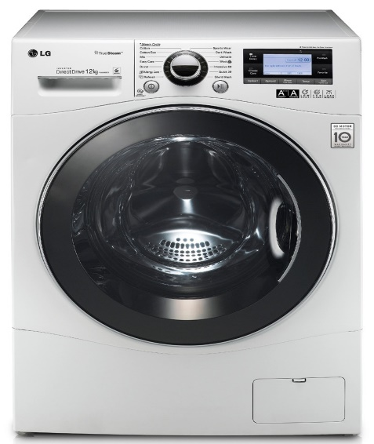

[This Photo](https://www.wikidata.org/wiki/Q124441) by Unknown Author is licensed under [CC BY-SA](https://creativecommons.org/licenses/by-sa/3.0/)

* Washing machines is a home appliance used for washing laundry
* It is an embedded system because it is a combination of hardware and software which are specifically designed for the task of washing laundry

## User Interfaces:

* Touch panel
* Rotating Switch (Mode Selector)
* Water inlet
* Drum
* Soap Dispenser

### Describe all inputs to each system and outputs from each system.

# ATM

## Inputs:

* Card scanning through Card Reader (Magnetic)
* Information (like password, amount) through keypad
* Selection of modes through touch panel or buttons
* Power Supply
* Camera for Security Purposes

## Outputs:

* Information (like transaction details, banking modes) are visualised through display Window
* Cash output through Cash withdrawing port
* Statement output through Statement printer

# WASHING MACHINES:

## Inputs:

* Water from Water inlet
* Detergent from detergent chamber
* Selection of mode through rotating Switch
* Adjusting Parameters through touch Panel

## Outputs:

* Information (like time remaining, mode details) through display Window
* Washed and drained clothes through drum
* Sound after completion of Washing through buzzer

### Classify the inputs and outputs based on their mode of interaction.

# ATM

|  |  |
| --- | --- |
| Input/output | Mode of Interaction |
| Card reader | Electronic |
| Keypad | Tactile |
| Touch Panel | Tactile |
| Camera | Visual |
| Cash Withdrawing port | Tactile |
| Display Window | Visual |
| Statement Printer | Tactile |

# WASHING MACHINES:

|  |  |
| --- | --- |
| Input/output | Mode of Interaction |
| Water inlet | Tactile |
| Detergent Chamber | Tactile |
| Touch Panel | Tactile |
| Rotating Switch | Tactile |
| Display Window | Visual |
| Buzzer | Audio |