Peer Assessment 1 of Reproducible Research course on Coursera by M. Sabelnikov

## Loading and preprocessing the data

Loading packages adn setting time settings

library(dplyr)  
library(data.table)  
library(ggplot2)  
Sys.setlocale("LC_TIME", "USA")

Reading data from CSV in working directory:

data<-read.csv("activity.csv")

Checking the structure of the data:

str(data)

## 'data.frame': 17568 obs. of 3 variables:  
## $ steps : int NA NA NA NA NA NA NA NA NA NA ...  
## $ date : Factor w/ 61 levels "2012-10-01","2012-10-02",..: 1 1 1 1 1 1 1 1 1 1 ...  
## $ interval: int 0 5 10 15 20 25 30 35 40 45 ...

## What is mean total number of steps taken per day?

Calculating mean, sum and median by day

mean_steps<-data %>% group_by(date) %>% summarize(steps=mean(steps,na.rm=T))  
sum_steps<-data %>% group_by(date) %>% summarize(steps=sum(steps,na.rm=T))  
median_steps<-data %>% group_by(date) %>% summarize(steps=median(steps,na.rm=T))

Make a histogram of the total number of steps taken each day

hist(sum_steps$steps,main="Sum of steps by day (Without NA values)",xlab="Steps")

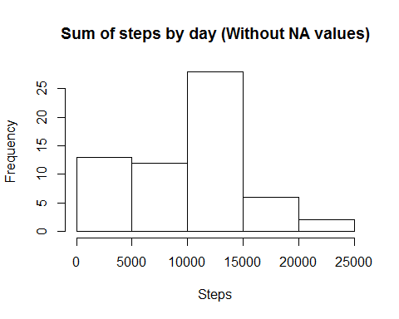

Mean and meadian steps by day table

mean_steps<-data.table(mean_steps)  
mean_steps<-cbind(mean_steps,median_steps$steps)  
setnames(mean_steps,c("date","mean","median"))  
mean_steps

## date mean median  
## 1: 2012-10-01 NA NA  
## 2: 2012-10-02 0.4375000 0  
## 3: 2012-10-03 39.4166667 0  
## 4: 2012-10-04 42.0694444 0  
## 5: 2012-10-05 46.1597222 0  
## 6: 2012-10-06 53.5416667 0  
## 7: 2012-10-07 38.2465278 0  
## 8: 2012-10-08 NaN NA  
## 9: 2012-10-09 44.4826389 0  
## 10: 2012-10-10 34.3750000 0  
## 11: 2012-10-11 35.7777778 0  
## 12: 2012-10-12 60.3541667 0  
## 13: 2012-10-13 43.1458333 0  
## 14: 2012-10-14 52.4236111 0  
## 15: 2012-10-15 35.2048611 0  
## 16: 2012-10-16 52.3750000 0  
## 17: 2012-10-17 46.7083333 0  
## 18: 2012-10-18 34.9166667 0  
## 19: 2012-10-19 41.0729167 0  
## 20: 2012-10-20 36.0937500 0  
## 21: 2012-10-21 30.6284722 0  
## 22: 2012-10-22 46.7361111 0  
## 23: 2012-10-23 30.9652778 0  
## 24: 2012-10-24 29.0104167 0  
## 25: 2012-10-25 8.6527778 0  
## 26: 2012-10-26 23.5347222 0  
## 27: 2012-10-27 35.1354167 0  
## 28: 2012-10-28 39.7847222 0  
## 29: 2012-10-29 17.4236111 0  
## 30: 2012-10-30 34.0937500 0  
## 31: 2012-10-31 53.5208333 0  
## 32: 2012-11-01 NaN NA  
## 33: 2012-11-02 36.8055556 0  
## 34: 2012-11-03 36.7048611 0  
## 35: 2012-11-04 NaN NA  
## 36: 2012-11-05 36.2465278 0  
## 37: 2012-11-06 28.9375000 0  
## 38: 2012-11-07 44.7326389 0  
## 39: 2012-11-08 11.1770833 0  
## 40: 2012-11-09 NaN NA  
## 41: 2012-11-10 NaN NA  
## 42: 2012-11-11 43.7777778 0  
## 43: 2012-11-12 37.3784722 0  
## 44: 2012-11-13 25.4722222 0  
## 45: 2012-11-14 NaN NA  
## 46: 2012-11-15 0.1423611 0  
## 47: 2012-11-16 18.8923611 0  
## 48: 2012-11-17 49.7881944 0  
## 49: 2012-11-18 52.4652778 0  
## 50: 2012-11-19 30.6979167 0  
## 51: 2012-11-20 15.5277778 0  
## 52: 2012-11-21 44.3993056 0  
## 53: 2012-11-22 70.9270833 0  
## 54: 2012-11-23 73.5902778 0  
## 55: 2012-11-24 50.2708333 0  
## 56: 2012-11-25 41.0902778 0  
## 57: 2012-11-26 38.7569444 0  
## 58: 2012-11-27 47.3819444 0  
## 59: 2012-11-28 35.3576389 0  
## 60: 2012-11-29 24.4687500 0  
## 61: 2012-11-30 NaN NA  
## date mean median

Mean number of steps is **37.3825996**  
Median number of steps is **0**

## What is the average daily activity pattern?

Make a time series plot (i.e. type = "l") of the 5-minute interval (x-axis) and the average number of steps taken, averaged across all days (y-axis)

Cleaning data

data_clean1<-complete.cases(data$steps)  
data_clean<-data[data_clean1,]

Calculating summary table and plotting

interval<-group_by(data_clean,interval)  
int<-summarize(interval,steps=mean(steps))  
plot(int$interval,int$steps,type="l",xlab="Interval",ylab="Steps")

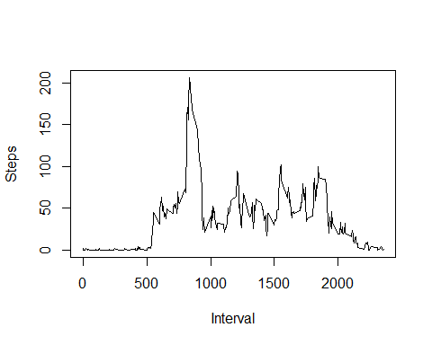

Which 5-minute interval, on average across all the days in the dataset, contains the maximum number of steps?

m<-int[int$steps==max(int$steps),1]

The interval with maximum number of steps is interval # **835**

## Imputing missing values

Calculate and report the total number of missing values in the dataset (i.e. the total number of rows with NAs)

nas<-table(data_clean1)

The total number of missing values in the dataset is **2304**

Filling in all of the missing values in the dataset

data_wo_nas <-merge(data,int,by="interval")  
  
id<-1:17568  
for (i in id){  
 if (is.na(data_wo_nas[i,2])){  
 data_wo_nas[i,2]<-data_wo_nas[i,4]}  
 else {}  
   
}

Create a new dataset that is equal to the original dataset but with the missing data filled in.

data_new<-select(data_wo_nas,steps=steps.x,interval,date)

Make a histogram of the total number of steps taken each day

sum_steps_new<-data_new %>% group_by(date) %>% summarize(steps=sum(steps,na.rm=T))  
hist(sum_steps_new$steps,main="Sum of steps by day (with NAs reaplaces by mean)",xlab="Steps")

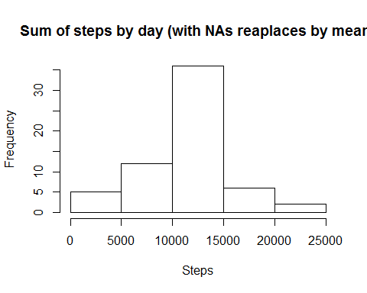

**Here is initial histogram**

hist(sum_steps$steps,main="Sum of steps by day (Without NA values)",xlab="Steps")



Mean number of steps in data with NAs replaced is **37.3825996**  
Median number of steps in data with NAs replaced is **0**

As we can see total mean didn't change from the estimation of the 1st part of assignment.

## Are there differences in activity patterns between weekdays and weekends?

Adding column with weekdays

data_new$weekday<-weekdays(as.Date(data_new$date))  
data_new$weekday<-ifelse(data_new$weekday %in% c("Saturday", "Sunday"),"weekend", "weekday")

Calculate averages and plot.

data_new2<-data_new %>% group_by(interval,weekday) %>% summarize(steps=mean(steps,na.rm=T))  
ggplot(data_new2, aes(x=interval, y=steps, fill=weekday)) +  
 geom_line(stat="identity") +   
 facet_grid(weekday ~ ., scales="free") +  
 ylab("Steps") +   
 xlab("Intervals") +  
 ggtitle(expression("Average number of steps taken"))

