**Polling-Application (project 1)**

The following instruction will help u to run the application on to your local machine.

**Prerequisites**

1) Python 3.5 or above

2) Django 2.0 or above

**Installation**

1. Download the zip file and open the whole project in pycharm (preferred).
2. Open the terminal in pycharm and write the command to install django

pip install django

1. After the complete installation of Django type the following commands and use python3 if the version is greater than 3.8 or just use python
   1. python manage.py makemigration
   2. python manage.py migrate
2. Now we need to create a super user or a admin to control the activities of the application.

Python manage.py createsuperuser

1. Here the terminal will be waiting for the input
   1. Username
   2. Email id
   3. Password (won’t be visible)
   4. Password again (won’t be visible)
2. Now to open the website in the local host type the command in terminal

Python manage.py runserver

1. Now the server will be running now you need to copy this link and paste in your browser.

[http://127.0.0.1:8000/home](http://127.0.0.1:8000/home%20)

**Execution**



Now click on register if your are new to this website

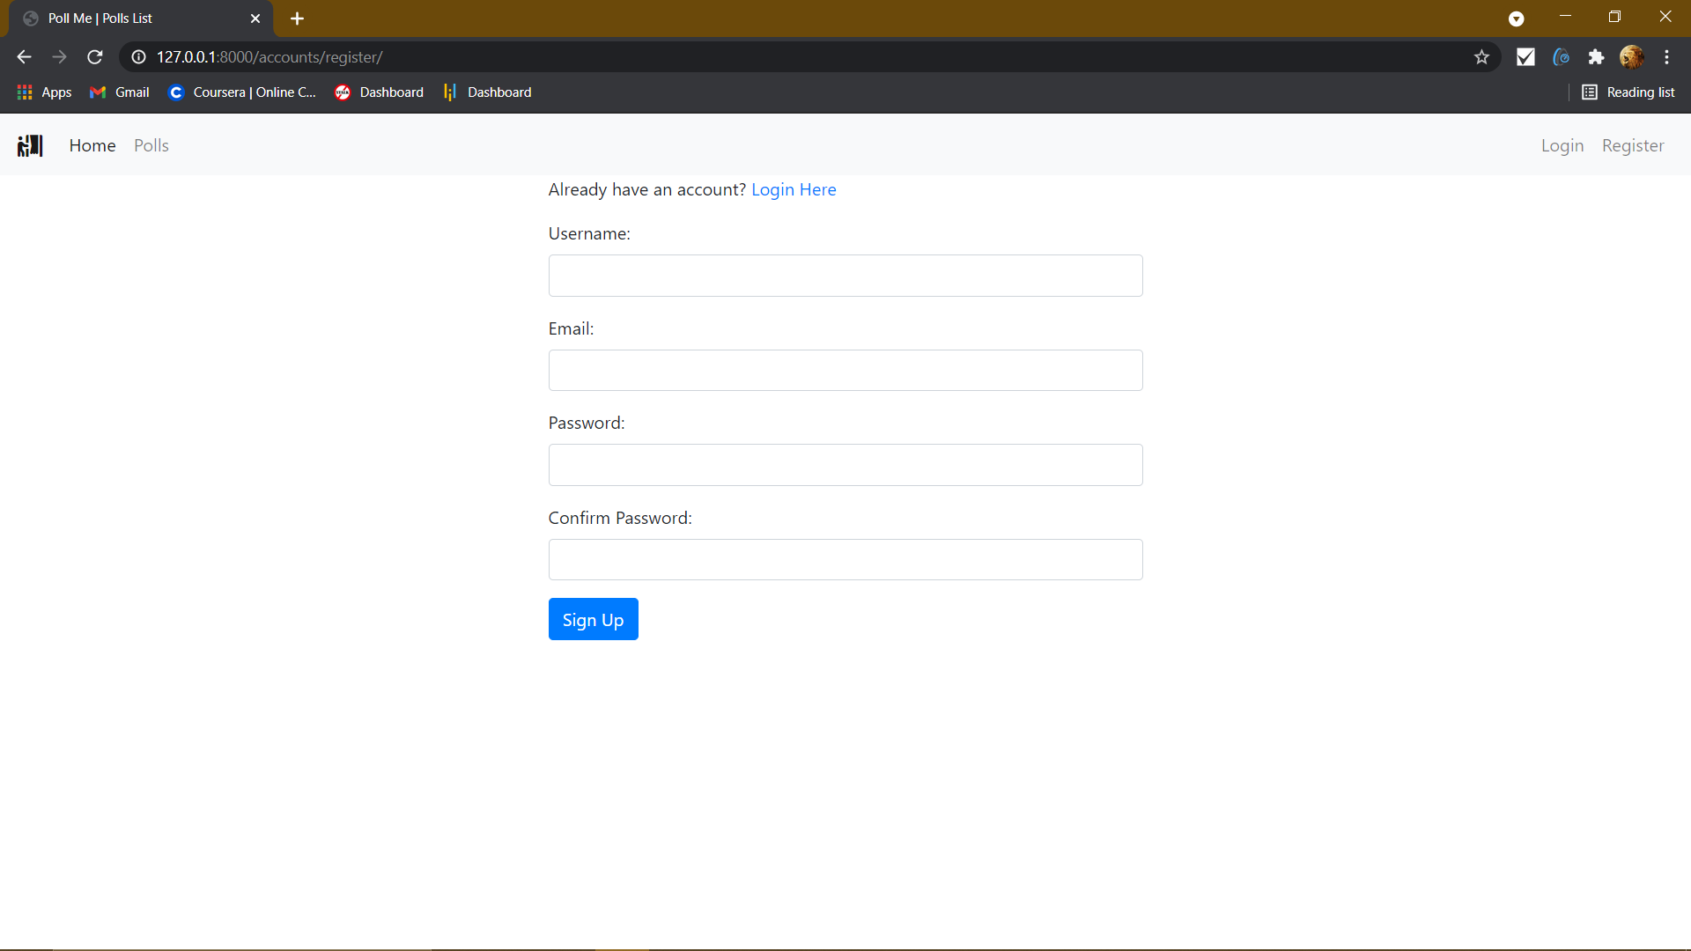

Fill in the appropriate details

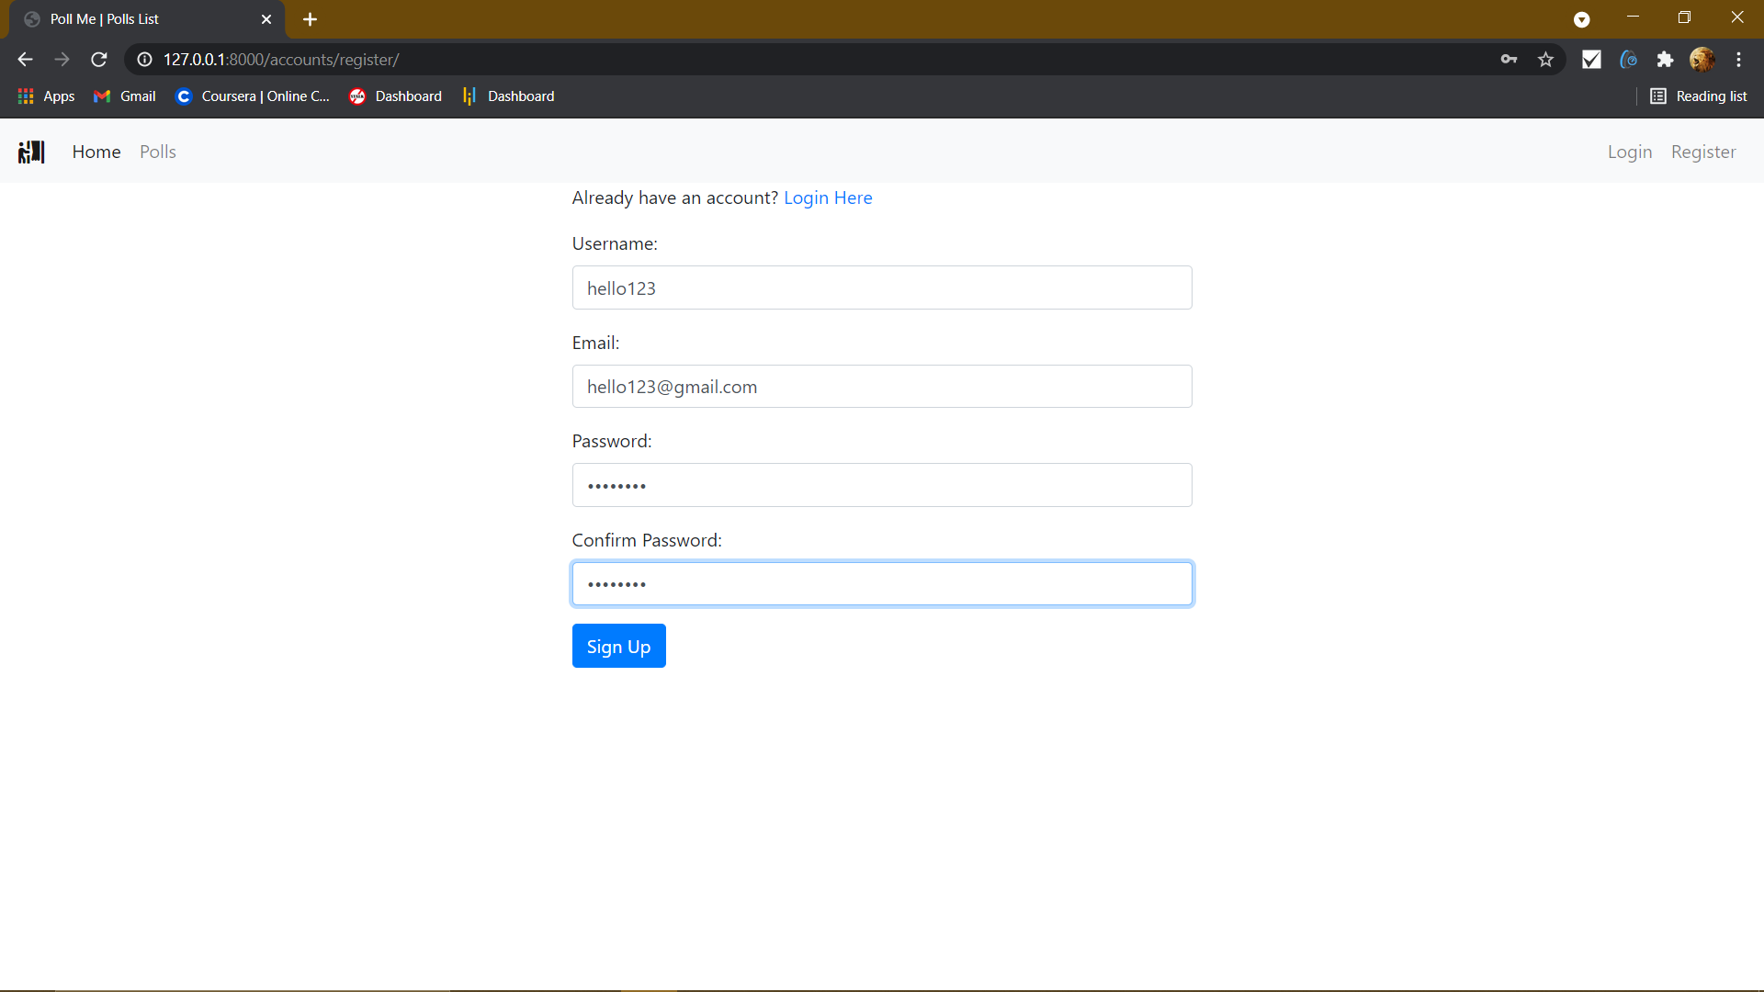

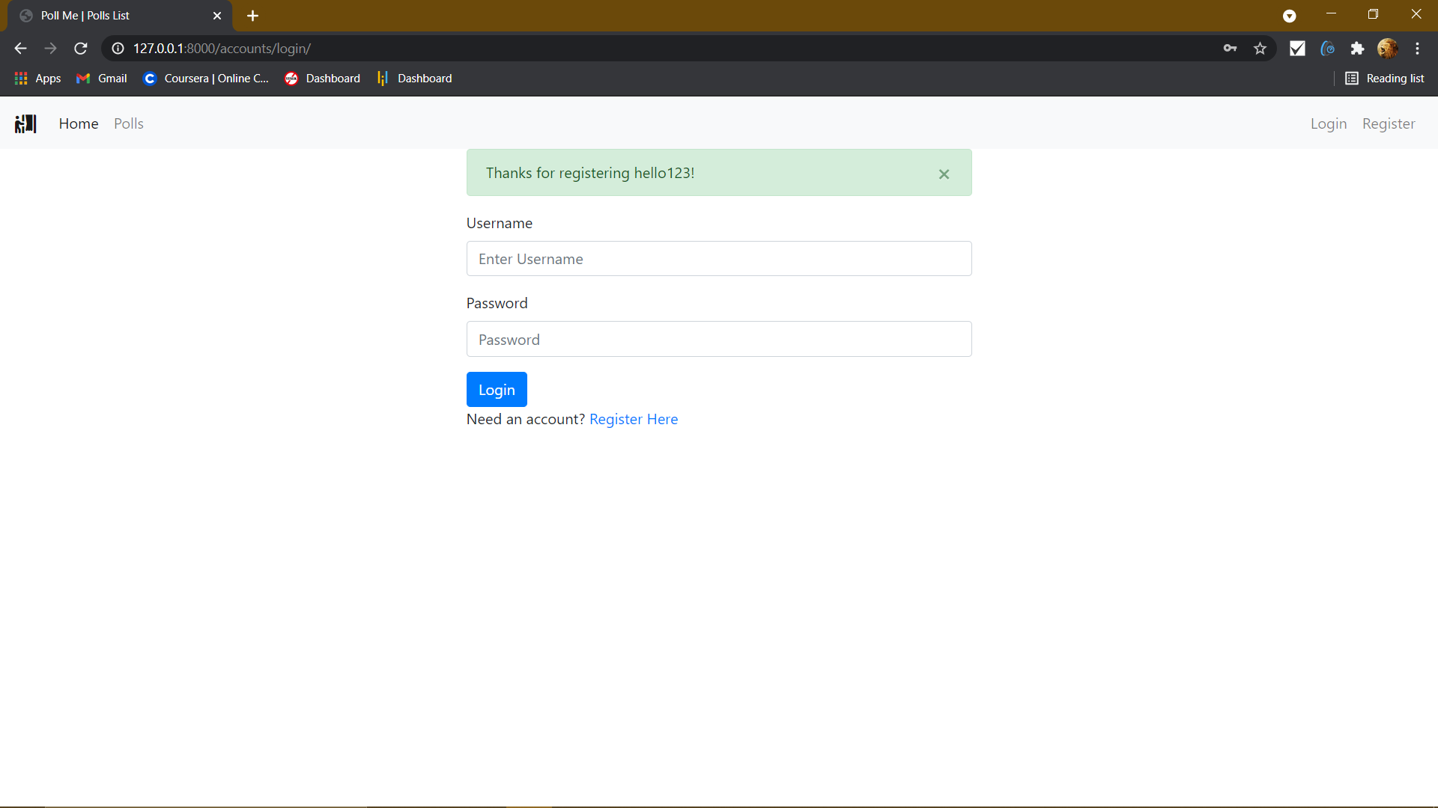

After logging in we need to navigate to polls beside home

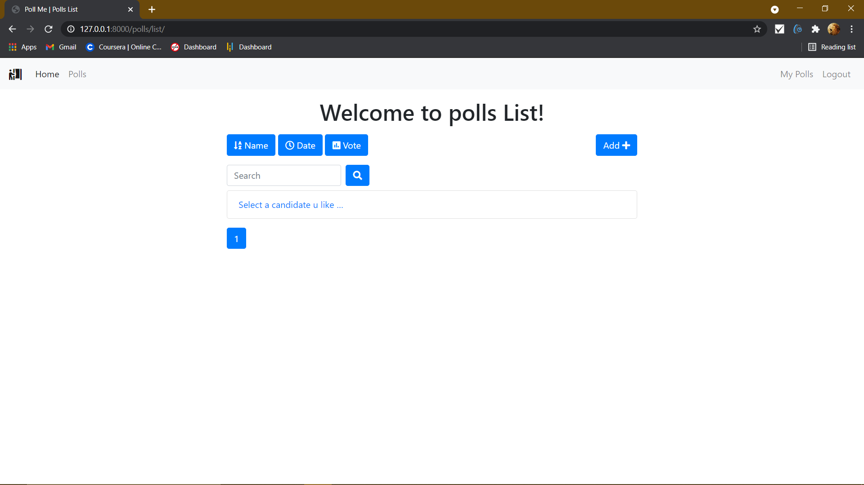

After that we can select the poll

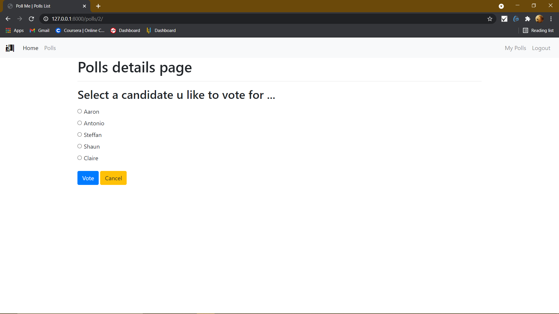

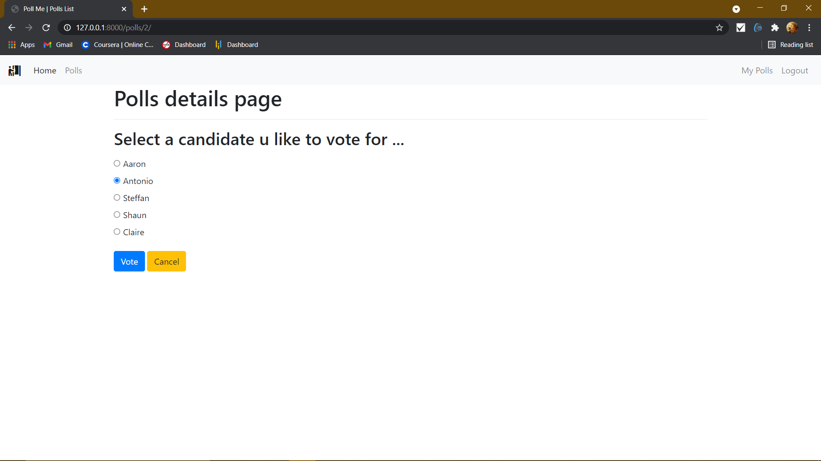

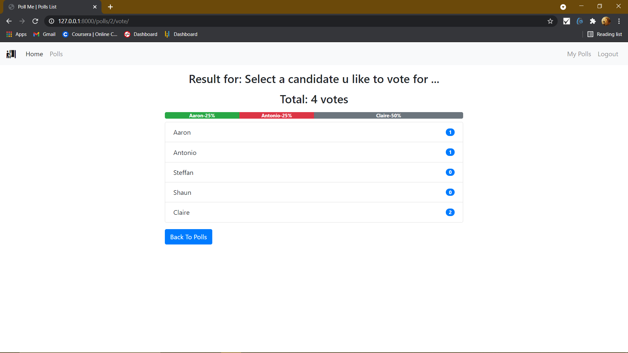

We can see the count and the percentage a person in getting voted.

Aaron has 1 vote.

Antonio even has 1 vote.

Steffen has 0 vote.

Shaun has 0 vote.

Claire has 2 votes.

**Important** once a user voted he cannot revote.

**Now the admin part**

**Admin page**

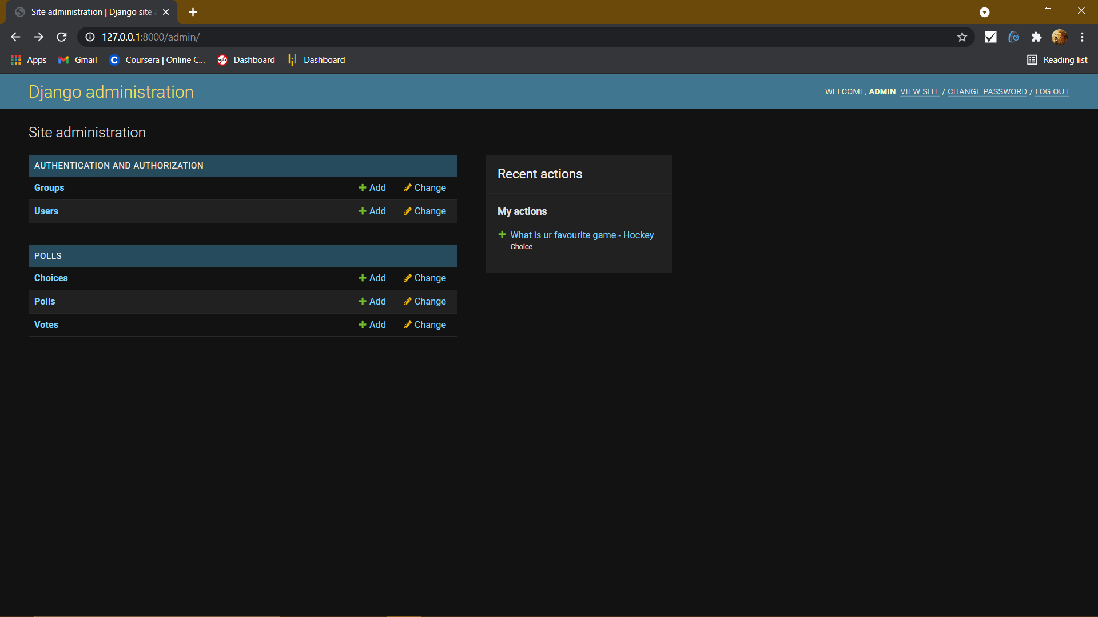

The user who registered

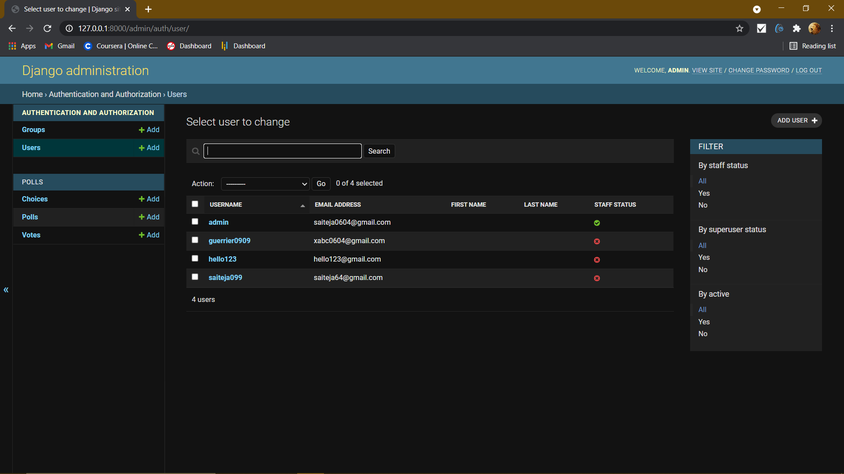

The poll and their choices

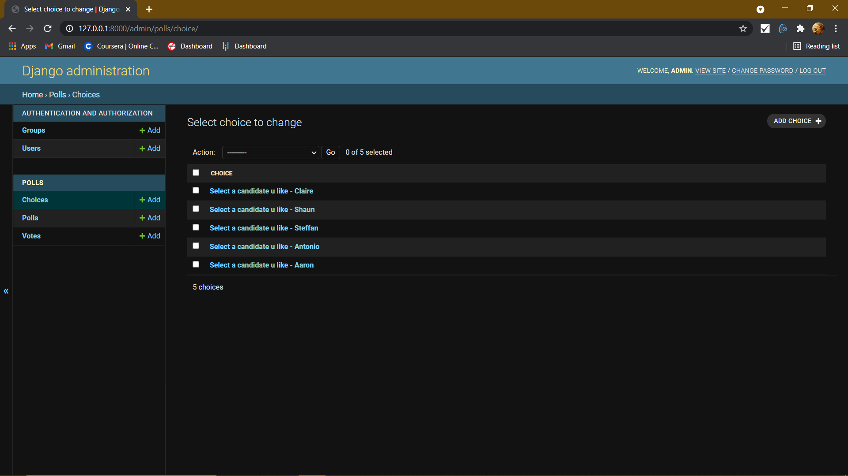

Number of polls created

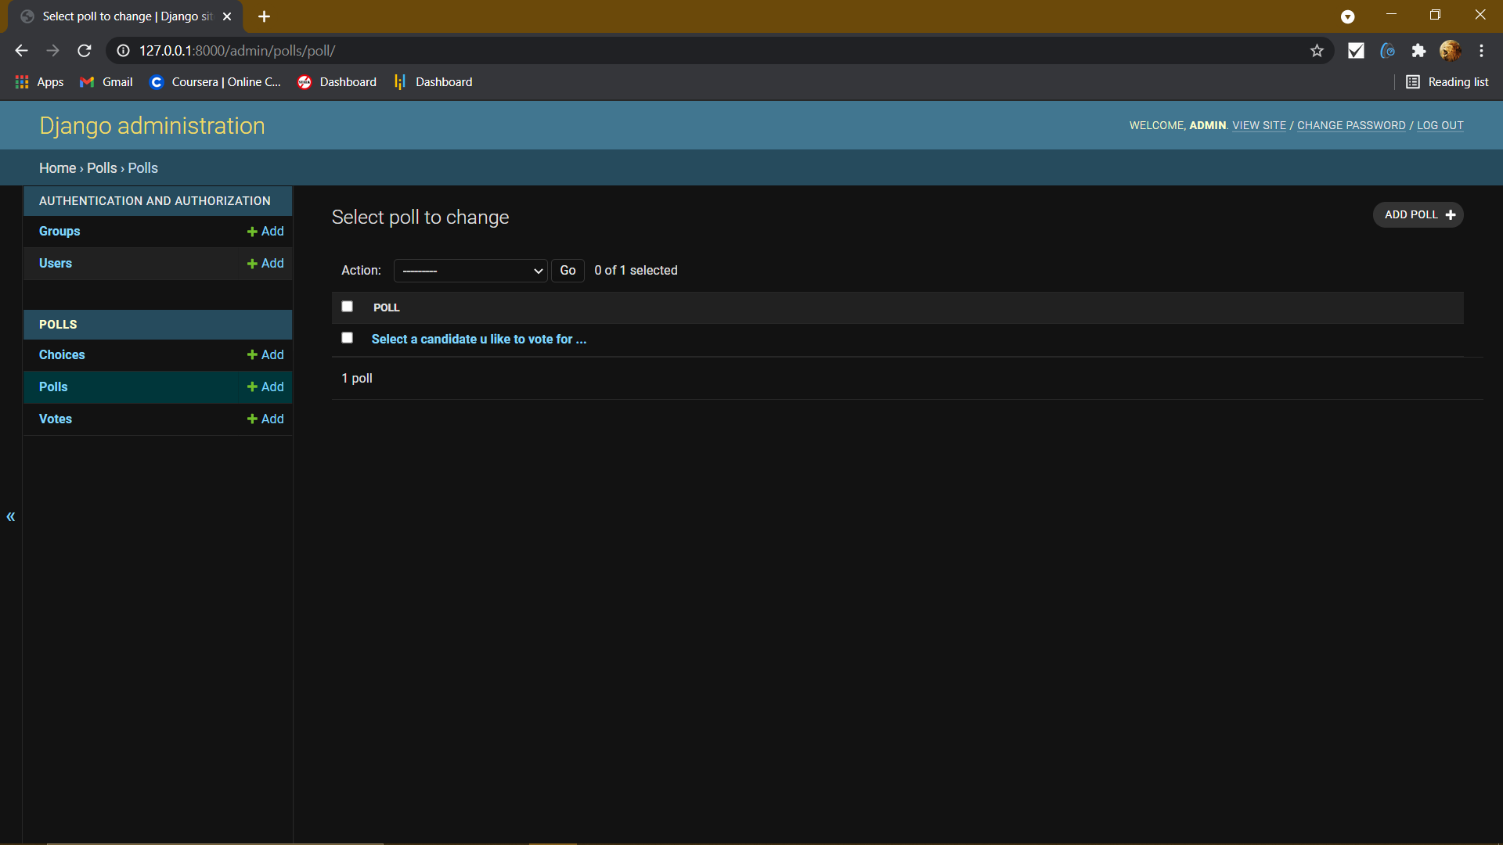

Deleting a poll

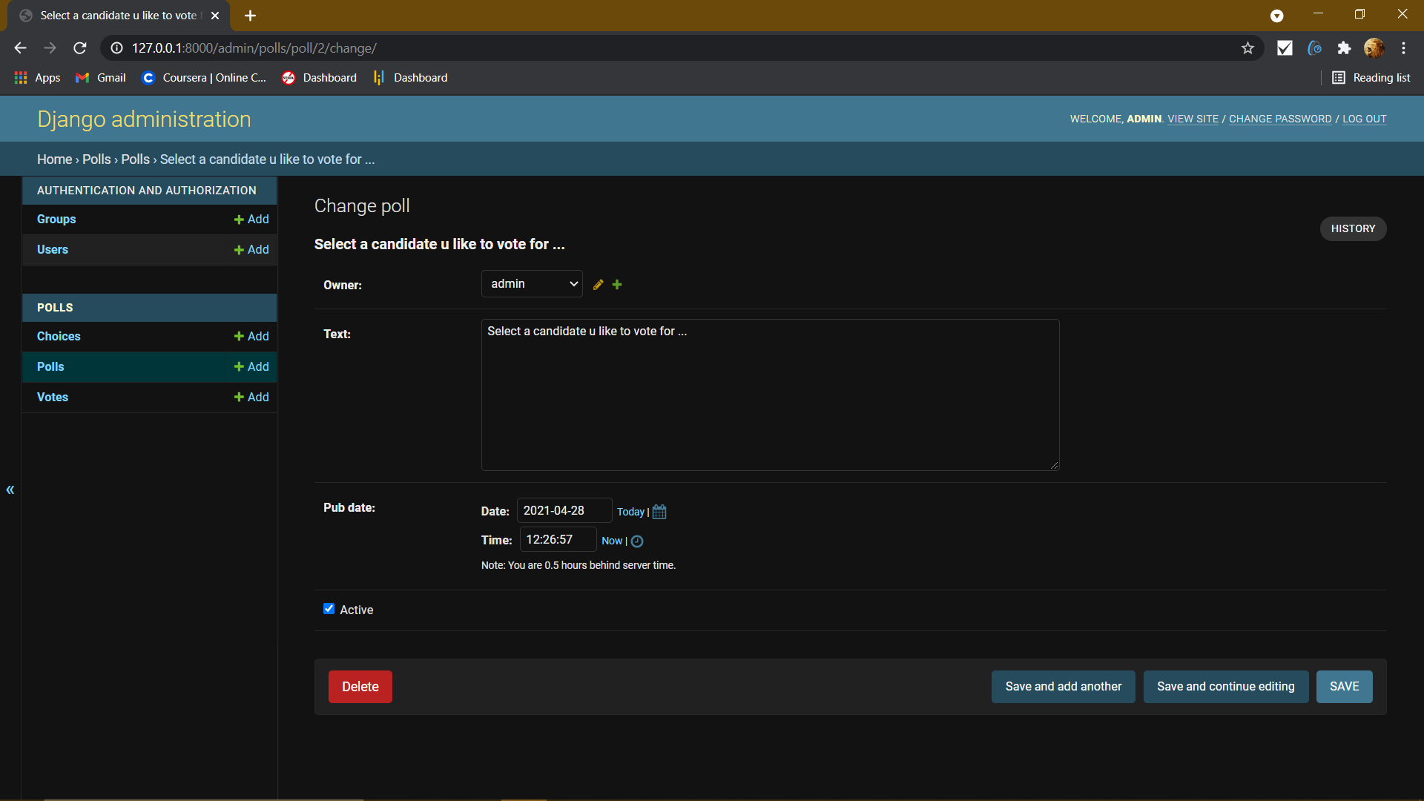

See the votes which user has voted for what

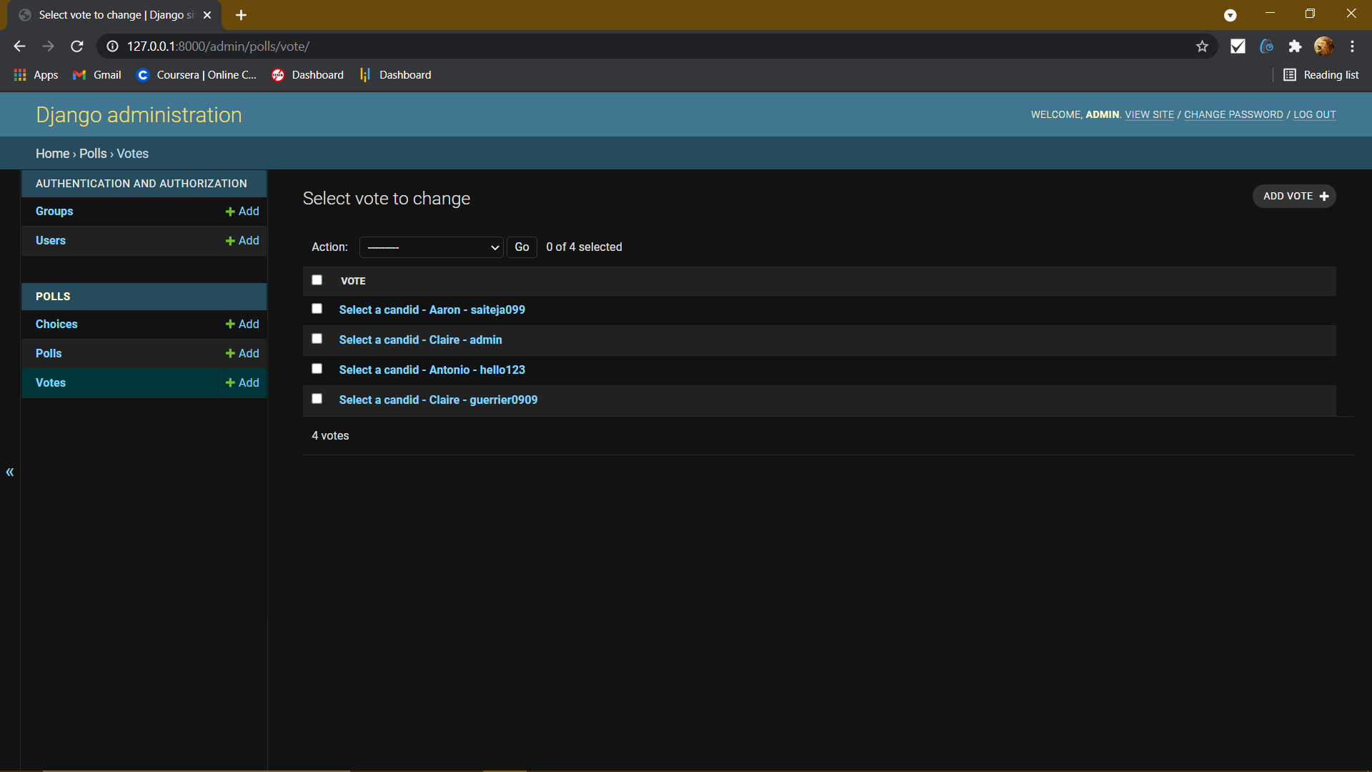

The admin can edit the poll

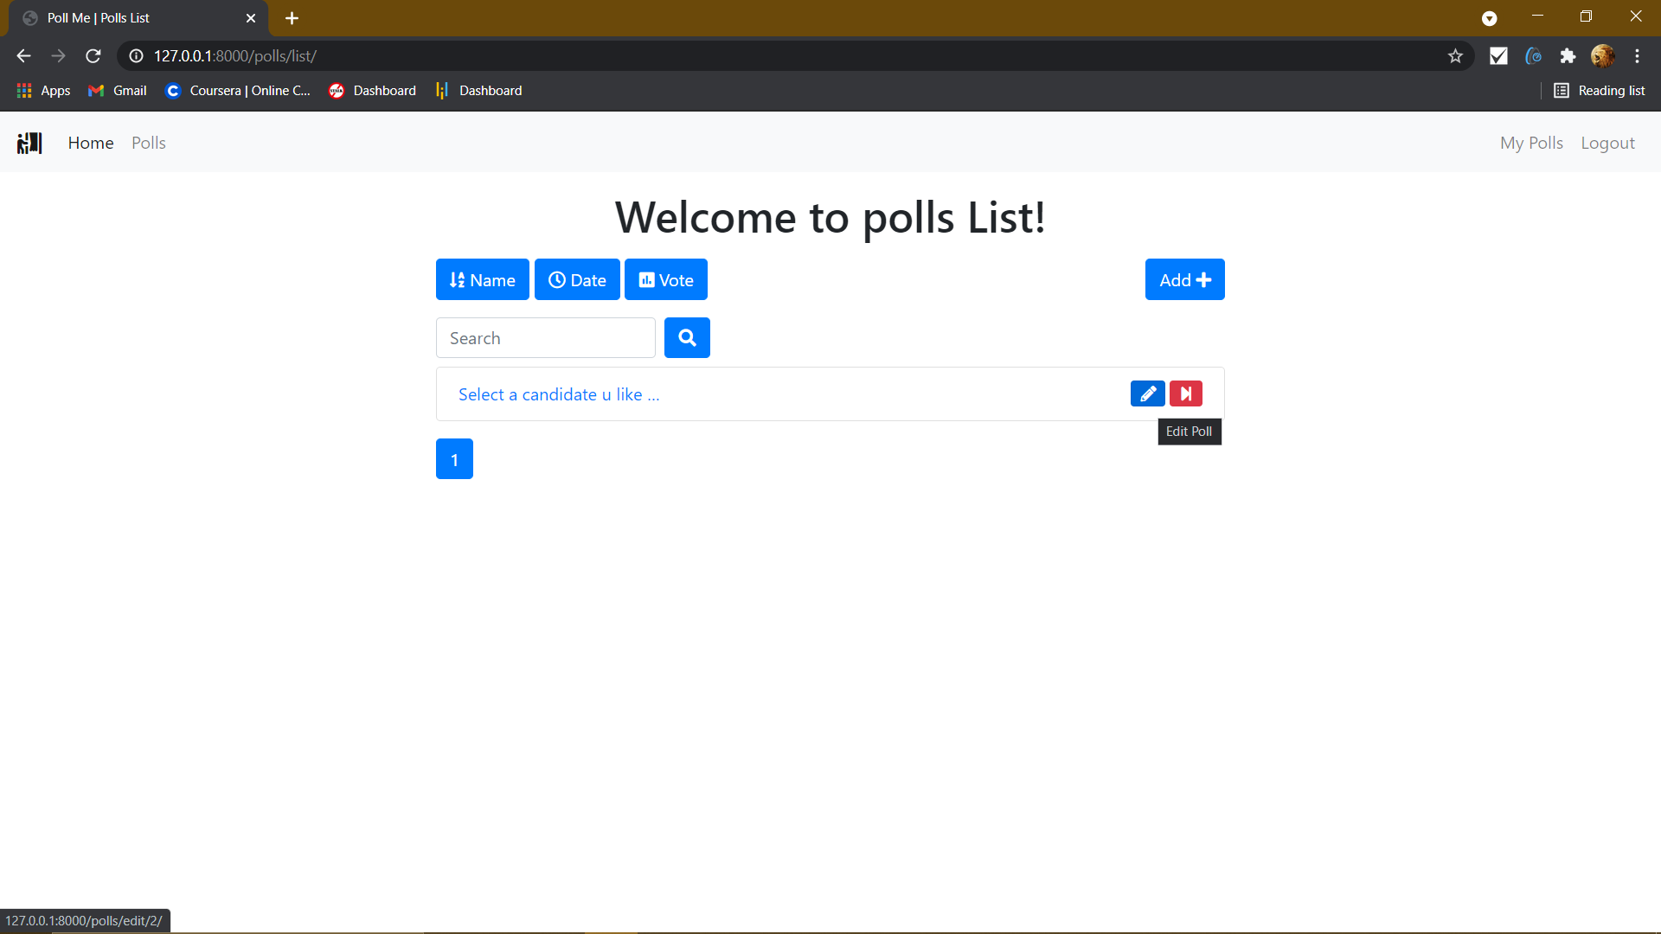

End the poll

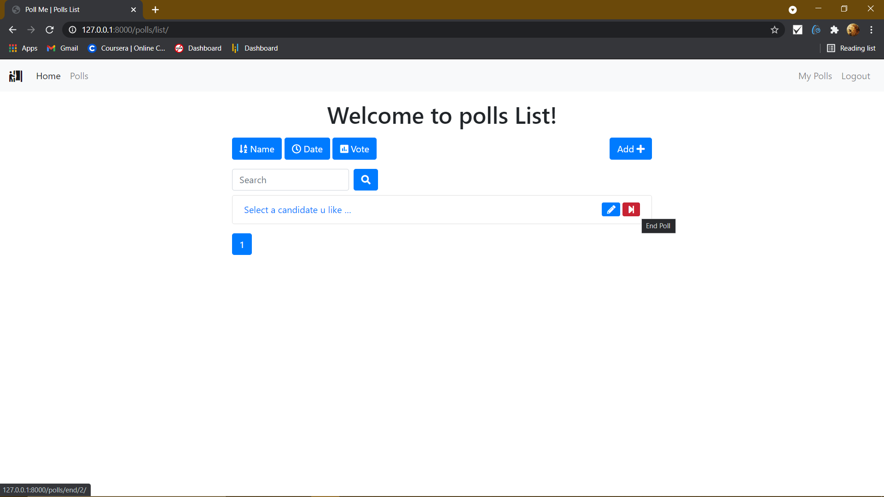

Add new polls

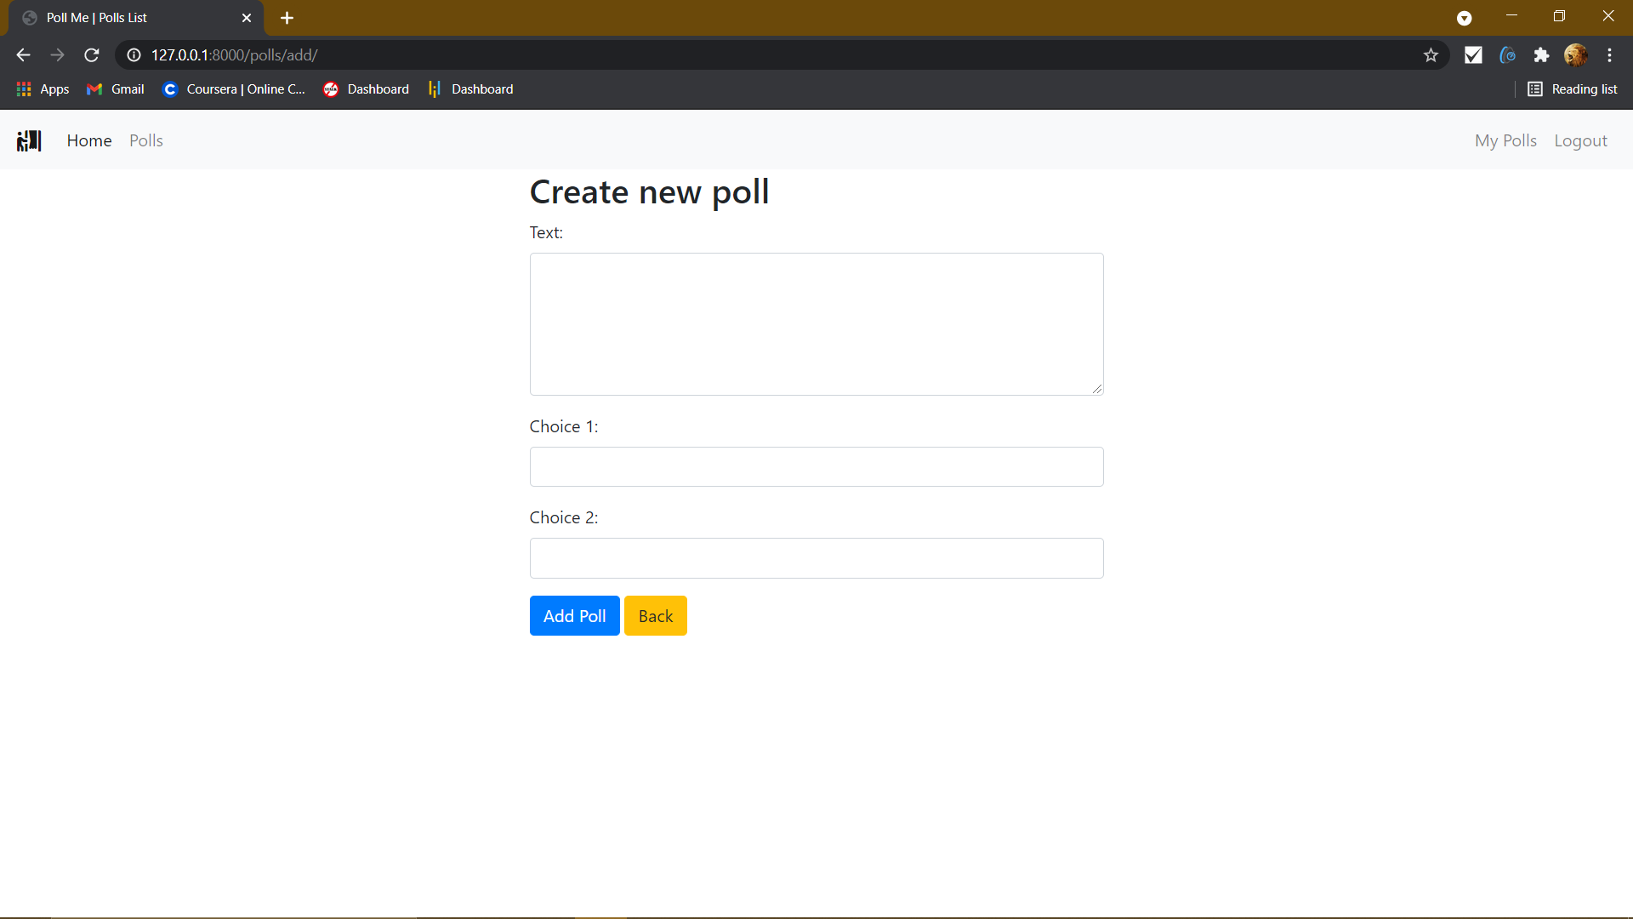

**Done by:**

**M Sai Teja**