**8. Prilozi**

**Tablica 8.1** *Odrasla skupina* – iscrpna lista pronađenih kompozicija s dodatnim informacijama

|  |  |  |  |  |  |  |  |  |
| --- | --- | --- | --- | --- | --- | --- | --- | --- |
| Frakcija | Mjereni m/z | Naboj | Izračunati  [MProAH]+ (Da) | Teorijski  [MProAH]+ (Da) | Odstupanje  (teor. - izr.) | Teorijski  [MH]+ (Da) | Skraćeno | Kompozicija |
| 1 | 1276.41000 | 1 | 1276.41000 | 1276.56593 | -0.156 | 1057.39293 | H3N2F1 | (Hex)3 (HexNAc)2 (Deoxyhexose)1 |
| 2 | 1292.40200 | 1 | 1292.40200 | 1292.56083 | -0.159 | 1073.38783 | H4N2 | (Hex)4 (HexNAc)2 |
| 3a | 1479.46700 | 1 | 1479.46700 | 1479.64533 | -0.178 | 1260.47233 | H3N3F1 | (HexNAc)1 (Deoxyhexose)1 + (Man)3(GlcNAc)2 |
| 3b | 768.74590 | 2 | 1536.48453 | 1536.66683 | -0.182 | 1317.49383 | H3N4 | (HexNAc)2 + (Man)3(GlcNAc)2 |
| 4 | 719.72800 | 2 | 1438.44873 | 1438.61873 | -0.17 | 1219.44573 | H4N2F1 | (Hex)4 (HexNAc)2 (Deoxyhexose)1 |
| 5a | 841.76300 | 2 | 1682.51873 | 1682.72473 | -0.206 | 1463.55173 | H3N4F1 | (HexNAc)2 (Deoxyhexose)1 + (Man)3(GlcNAc)2 |
| 5b | 870.27300 | 2 | 1739.53873 | 1739.74623 | -0.207 | 1520.57323 | H3N5 | (HexNAc)3 + (Man)3(GlcNAc)2 |
| 6 | 1454.44700 | 1 | 1454.44700 | 1454.61363 | -0.167 | 1235.44063 | H5N2 | (Hex)2 + (Man)3(GlcNAc)2 |
| 7 | 943.29400 | 2 | 1885.58073 | 1885.80413 | -0.223 | 1666.63113 | H3N5F1 | (HexNAc)3 (Deoxyhexose)1 + (Man)3(GlcNAc)2 |
| 8 | 943.29400 | 2 | 1885.58073 | 1885.80413 | -0.223 | 1666.63113 | H3N5F1 | (HexNAc)3 (Deoxyhexose)1 + (Man)3(GlcNAc)2 |
| 9a | 922.78000 | 2 | 1844.55273 | 1844.77753 | -0.225 | 1625.60453 | H4N4F1 | (Hex)1 (HexNAc)2 (Deoxyhexose)1 + (Man)3(GlcNAc)2 |
| 9b | 942.28900 | 2 | 1883.57073 | 1883.71723 | -0.147 | 1664.54423 | H5N3F1Phos1 | (Hex)2 (HexNAc)1 (Deoxyhexose)1 (Phos)1 + (Man)3(GlcNAc)2 |
| 9c | 1064.28270 | 2 | 2127.55810 | 2127.81373 | -0.256 | 1908.64073 | H4N5F1Sulph1 | (Hex)1 (HexNAc)3 (Deoxyhexose)1 (Sulph)1 + (Man)3(GlcNAc)2 |
| 10a | 922.78000 | 2 | 1844.55273 | 1844.77753 | -0.225 | 1625.60453 | H4N4F1 | (Hex)1 (HexNAc)2 (Deoxyhexose)1 + (Man)3(GlcNAc)2 |
| 10b | 829.25070 | 2 | 1657.47413 | 1657.69303 | -0.219 | 1438.52003 | H5N3 | (Hex)2 (HexNAc)1 + (Man)3(GlcNAc)2 |
| 11 | 922.78000 | 2 | 1844.55273 | 1844.77753 | -0.225 | 1625.60453 | H4N4F1 | (Hex)1 (HexNAc)2 (Deoxyhexose)1 + (Man)3(GlcNAc)2 |
| 12a | 1024.30600 | 2 | 2047.60473 | 2047.85693 | -0.252 | 1828.68393 | H4N5F1 | (Hex)1 (HexNAc)3 (Deoxyhexose)1 + (Man)3(GlcNAc)2 |
| 12b | 930.77730 | 2 | 1860.54733 | 1860.77243 | -0.225 | 1641.59943 | H5N4 | (Hex)2 (HexNAc)2 + (Man)3(GlcNAc)2 |
| 13 | 808.74500 | 2 | 1616.48273 | 1616.66643 | -0.184 | 1397.49343 | H6N2 | (Hex)3 + (Man)3(GlcNAc)2 |
| 14a | 807.72780 | 2 | 1614.44832 | 1614.54623 | -0.098 | 1395.37323 | H5N2Phos2 | (Hex)2 (Phos)2 + (Man)3(GlcNAc)2 |
| 14b | 1024.30570 | 2 | 2047.60413 | 2047.85693 | -0.253 | 1828.68393 | H4N5F1 | (Hex)1 (HexNAc)3 (Deoxyhexose)1 + (Man)3(GlcNAc)2 |
| 14c | 930.77730 | 2 | 1860.54733 | 1860.77243 | -0.225 | 1641.59943 | H5N4 | (Hex)2 (HexNAc)2 + (Man)3(GlcNAc)2 |
| 15a | 930.77730 | 2 | 1860.54733 | 1860.77243 | -0.225 | 1641.59943 | H5N4 | (Hex)2 (HexNAc)2 + (Man)3(GlcNAc)2 |
| 15b | 1068.30100 | 2 | 2135.59473 | 2135.87293 | -0.278 | 1916.69993 | H4N4F1S1 | (Hex)1 (HexNAc)2 (Deoxyhexose)1 (NeuAc)1 + (Man)3(GlcNAc)2 |
| 16a | 995.80610 | 2 | 1990.60493 | 1990.83543 | -0.231 | 1771.66243 | H4N4F2 | (Hex)1 (HexNAc)2 (Deoxyhexose)2 + (Man)3(GlcNAc)2 |
| 16b | 1003.79520 | 2 | 2006.58313 | 2006.83033 | -0.247 | 1787.65733 | H5N4F1 | (Hex)2 (HexNAc)2 (Deoxyhexose)1 + (Man)3(GlcNAc)2 |
| 16c | 1024.30600 | 2 | 2047.60473 | 2047.85693 | -0.252 | 1828.68393 | H4N5F1 | (Hex)1 (HexNAc)3 (Deoxyhexose)1 + (Man)3(GlcNAc)2 |
| 17a | 1003.77500 | 2 | 2006.54273 | 2006.83033 | -0.288 | 1787.65733 | H5N4F1 | (Hex)2 (HexNAc)2 (Deoxyhexose)1 + (Man)3(GlcNAc)2 |
| 17b | 1169.83300 | 2 | 2338.65873 | 2338.95233 | -0.294 | 2119.77933 | H4N5F1S1 | (Hex)1 (HexNAc)3 (Deoxyhexose)1 (NeuAc)1 + (Man)3(GlcNAc)2 |
| 17c | 995.80610 | 2 | 1990.60493 | 1990.83543 | -0.231 | 1771.66243 | H4N4F2 | (Hex)1 (HexNAc)2 (Deoxyhexose)2 + (Man)3(GlcNAc)2 |
| 18a | 995.80600 | 2 | 1990.60473 | 1990.83543 | -0.231 | 1771.66243 | H4N4F2 | (Hex)1 (HexNAc)2 (Deoxyhexose)2 + (Man)3(GlcNAc)2 |
| 18b | 1003.79500 | 2 | 2006.58273 | 2006.83033 | -0.248 | 1787.65733 | H5N4F1 | (Hex)2 (HexNAc)2 (Deoxyhexose)1 + (Man)3(GlcNAc)2 |
| 18c | 1169.83300 | 2 | 2338.65873 | 2338.95233 | -0.294 | 2119.77933 | H4N5F1S1 | (Hex)1 (HexNAc)3 (Deoxyhexose)1 (NeuAc)1 + (Man)3(GlcNAc)2 |
| 18d | 1068.31530 | 2 | 2135.62333 | 2135.87293 | -0.25 | 1916.69993 | H4N4F1S1 | (Hex)1 (HexNAc)2 (Deoxyhexose)1 (NeuAc)1 + (Man)3(GlcNAc)2 |
| 19a | 1097.33600 | 2 | 2193.66473 | 2193.91483 | -0.25 | 1974.74183 | H4N5F2 | (Hex)1 (HexNAc)3 (Deoxyhexose)2 + (Man)3(GlcNAc)2 |
| 19b | 1105.31510 | 2 | 2209.62293 | 2209.90973 | -0.287 | 1990.73673 | H5N5F1 | (Hex)2 (HexNAc)3 (Deoxyhexose)1 + (Man)3(GlcNAc)2 |
| 20.1a | 1097.32100 | 2 | 2193.63473 | 2193.91483 | -0.28 | 1974.74183 | H4N5F2 | (Hex)1 (HexNAc)3 (Deoxyhexose)2 + (Man)3(GlcNAc)2 |
| 20.1b | 975.28400 | 2 | 1949.56073 | 1949.80883 | -0.248 | 1730.63583 | H5N3F2 | (Hex)2 (HexNAc)1 (Deoxyhexose)2 + (Man)3(GlcNAc)2 |
| 20.2 | 889.75500 | 2 | 1778.50273 | 1778.71923 | -0.216 | 1559.54623 | H7N2 | (Hex)4 + (Man)3(GlcNAc)2 |
| 21a | 1076.81900 | 2 | 2152.63073 | 2152.88823 | -0.258 | 1933.71523 | H5N4F2 | (Hex)2 (HexNAc)2 (Deoxyhexose)2 + (Man)3(GlcNAc)2 |
| 21b | 888.77980 | 2 | 1776.55232 | 1776.59903 | -0.047 | 1557.42603 | H6N2Phos2 | (Hex)3 (Phos)2 + (Man)3(GlcNAc)2 |
| 22a | 1169.83300 | 2 | 2338.65873 | 2338.95233 | -0.294 | 2119.77933 | H4N5F1S1 | (Hex)1 (HexNAc)3 (Deoxyhexose)1 (NeuAc)1 + (Man)3(GlcNAc)2 |
| 22b | 1076.81870 | 2 | 2152.63013 | 2152.88823 | -0.258 | 1933.71523 | H5N4F2 | (Hex)2 (HexNAc)2 (Deoxyhexose)2 + (Man)3(GlcNAc)2 |
| 23.1 | 983.28700 | 2 | 1965.56673 | 1965.80373 | -0.237 | 1746.63073 | H6N3F1 | (Hex)3 (HexNAc)1 (Deoxyhexose)1 + (Man)3(GlcNAc)2 |
| 23.2a | 1198.84660 | 2 | 2396.68593 | 2396.99423 | -0.308 | 2177.82123 | H4N6F2 | (Hex)1 (HexNAc)4 (Deoxyhexose)2 + (Man)3(GlcNAc)2 |
| 23.2b | 1076.31770 | 2 | 2151.62813 | 2151.86783 | -0.24 | 1932.69483 | H5N4S1 | (Hex)2 (HexNAc)2 (NeuAc)1 + (Man)3(GlcNAc)2 |
| 24a | 1178.34000 | 2 | 2355.67273 | 2355.96763 | -0.295 | 2136.79463 | H5N5F2 | (Hex)2 (HexNAc)3 (Deoxyhexose)2 + (Man)3(GlcNAc)2 |
| 24b | 1084.82410 | 2 | 2168.64093 | 2168.88313 | -0.242 | 1949.71013 | H6N4F1 | (Hex)3 (HexNAc)2 (Deoxyhexose)1 + (Man)3(GlcNAc)2 |
| 24c | 1242.83310 | 2 | 2484.65893 | 2485.01023 | -0.351 | 2265.83723 | H4N5F2S1 | (Hex)1 (HexNAc)3 (Deoxyhexose)2 (NeuAc)1 + (Man)3(GlcNAc)2 |

**Tablica 8.1** (*Nastavak*)

|  |  |  |  |  |  |  |  |  |
| --- | --- | --- | --- | --- | --- | --- | --- | --- |
| Frakcija | Mjereni m/z | Naboj | Izračunati  [MProAH]+ (Da) | Teorijski  [MProAH]+ (Da) | Odstupanje  (teor. - izr.) | Teorijski  [MH]+ (Da) | Skraćeno | Kompozicija |
| 25a | 970.77900 | 2 | 1940.55073 | 1940.77203 | -0.221 | 1721.59903 | H8N2 | (Hex)5 + (Man)3(GlcNAc)2 |
| 25b | 1193.32300 | 2 | 2385.63873 | 2385.94173 | -0.303 | 2166.76873 | H5N3F1S2 | (Hex)2 (HexNAc)1 (Deoxyhexose)1 (NeuAc)2 + (Man)3(GlcNAc)2 |
| 26a | 970.76530 | 2 | 1940.52333 | 1940.77203 | -0.249 | 1721.59903 | H8N2 | (Hex)5 + (Man)3(GlcNAc)2 |
| 26b | 1149.31190 | 2 | 2297.61653 | 2297.92573 | -0.309 | 2078.75273 | H5N4F1S1 | (Hex)2 (HexNAc)2 (Deoxyhexose)1 (NeuAc)1 + (Man)3(GlcNAc)2 |
| 27.1a | 969.75940 | 2 | 1938.51152 | 1938.65183 | -0.14 | 1719.47883 | H7N2Phos2 | (Hex)4 (Phos)2 + (Man)3(GlcNAc)2 |
| 27.1b | 1157.81900 | 2 | 2314.63073 | 2314.94103 | -0.31 | 2095.76803 | H6N4F2 | (Hex)3 (HexNAc)2 (Deoxyhexose)2 + (Man)3(GlcNAc)2 |
| 27.2a | 1250.84570 | 2 | 2500.68413 | 2501.00513 | -0.321 | 2281.83213 | H5N5F1S1 | (Hex)2 (HexNAc)3 (Deoxyhexose)1 (NeuAc)1 + (Man)3(GlcNAc)2 |
| 27.2b | 1222.33500 | 2 | 2443.66273 | 2443.98363 | -0.321 | 2224.81063 | H5N4F2S1 | (Hex)2 (HexNAc)2 (Deoxyhexose)2 (NeuAc)1 + (Man)3(GlcNAc)2 |
| 28a | 1222.33500 | 2 | 2443.66273 | 2443.98363 | -0.321 | 2224.81063 | H5N4F2S1 | (Hex)2 (HexNAc)2 (Deoxyhexose)2 (NeuAc)1 + (Man)3(GlcNAc)2 |
| 28b | 1294.85680 | 2 | 2588.70633 | 2589.02113 | -0.315 | 2369.84813 | H5N4F1S2 | (Hex)2 (HexNAc)2 (Deoxyhexose)1 (NeuAc)2 + (Man)3(GlcNAc)2 |
| 29a | 1149.84450 | 2 | 2298.68173 | 2298.94613 | -0.264 | 2079.77313 | H5N4F3 | (Hex)2 (HexNAc)2 (Deoxyhexose)3 + (Man)3(GlcNAc)2 |
| 29b | 1222.33500 | 2 | 2443.66273 | 2443.98363 | -0.321 | 2224.81063 | H5N4F2S1 | (Hex)2 (HexNAc)2 (Deoxyhexose)2 (NeuAc)1 + (Man)3(GlcNAc)2 |
| 30 | 1251.35510 | 2 | 2501.70293 | 2502.02553 | -0.323 | 2282.85253 | H5N5F3 | (Hex)2 (HexNAc)3 (Deoxyhexose)3 + (Man)3(GlcNAc)2 |
| 31 | 1051.79200 | 2 | 2102.57673 | 2102.82483 | -0.248 | 1883.65183 | H9N2 | (Hex)6 + (Man)3(GlcNAc)2 |
| 32a | 1425.41900 | 2 | 2849.83073 | 2850.14243 | -0.312 | 2630.96943 | H5N6F2S1 | (Hex)2 (HexNAc)4 (Deoxyhexose)2 (NeuAc)1 + (Man)3(GlcNAc)2 |
| 32b | 1050.77310 | 2 | 2100.53893 | 2100.70463 | -0.166 | 1881.53163 | H8N2Phos2 | (Hex)5 (Phos)2 + (Man)3(GlcNAc)2 |
| 32c | 1221.83120 | 2 | 2442.65513 | 2442.96323 | -0.308 | 2223.79023 | H5N4S2 | (Hex)2 (HexNAc)2 (NeuAc)2 + (Man)3(GlcNAc)2 |
| 33a | 882.90830 | 3 | 2646.71036 | 2647.06303 | -0.353 | 2427.89003 | H5N5F2S1 | (Hex)2 (HexNAc)3 (Deoxyhexose)2 (NeuAc)1 + (Man)3(GlcNAc)2 |
| 33b | 902.26860 | 3 | 2704.79126 | 2705.10493 | -0.314 | 2485.93193 | H5N6F3 | (Hex)2 (HexNAc)4 (Deoxyhexose)3 + (Man)3(GlcNAc)2 |
| 34a | 912.25800 | 3 | 2734.75946 | 2735.07903 | -0.32 | 2515.90603 | H5N4F2S2 | (Hex)2 (HexNAc)2 (Deoxyhexose)2 (NeuAc)2 + (Man)3(GlcNAc)2 |
| 34b | 960.59500 | 3 | 2879.77046 | 2880.11653 | -0.346 | 2660.94353 | H5N4F1S3 | (Hex)2 (HexNAc)2 (Deoxyhexose)1 (NeuAc)3 + (Man)3(GlcNAc)2 |
| 34c | 1294.85680 | 2 | 2588.70633 | 2589.02113 | -0.315 | 2369.84813 | H5N4F1S2 | (Hex)2 (HexNAc)2 (Deoxyhexose)1 (NeuAc)2 + (Man)3(GlcNAc)2 |
| 34d | 902.26860 | 3 | 2704.79126 | 2705.10493 | -0.314 | 2485.93193 | H5N6F3 | (Hex)2 (HexNAc)4 (Deoxyhexose)3 + (Man)3(GlcNAc)2 |
| 35a | 931.27000 | 3 | 2791.79546 | 2792.10053 | -0.305 | 2572.92753 | H5N5F1S2 | (Hex)2 (HexNAc)3 (Deoxyhexose)1 (NeuAc)2 + (Man)3(GlcNAc)2 |
| 35b | 1047.60680 | 3 | 3140.80586 | 3141.23783 | -0.432 | 2922.06483 | H5N6F2S2 | (Hex)2 (HexNAc)4 (Deoxyhexose)2 (NeuAc)2 + (Man)3(GlcNAc)2 |
| 35c | 1132.80240 | 2 | 2264.59753 | 2264.87763 | -0.28 | 2045.70463 | H10N2 | (Hex)7 + (Man)3(GlcNAc)2 |
| 36a | 985.27200 | 3 | 2953.80146 | 2954.15333 | -0.352 | 2734.98033 | H6N5F1S2 | (Hex)3 (HexNAc)3 (Deoxyhexose)1 (NeuAc)2 + (Man)3(GlcNAc)2 |
| 36b | 1004.61110 | 3 | 3011.81876 | 3012.19523 | -0.376 | 2793.02223 | H6N6F2S1 | (Hex)3 (HexNAc)4 (Deoxyhexose)2 (NeuAc)1 + (Man)3(GlcNAc)2 |
| 36c | 956.27160 | 3 | 2866.80026 | 2867.15773 | -0.357 | 2647.98473 | H6N6F3 | (Hex)3 (HexNAc)4 (Deoxyhexose)3 + (Man)3(GlcNAc)2 |
| 36d | 936.92490 | 3 | 2808.76016 | 2809.11583 | -0.356 | 2589.94283 | H6N5F2S1 | (Hex)3 (HexNAc)3 (Deoxyhexose)2 (NeuAc)1 + (Man)3(GlcNAc)2 |
| 37a | 936.92490 | 3 | 2808.76016 | 2809.11583 | -0.356 | 2589.94283 | H6N5F2S1 | (Hex)3 (HexNAc)3 (Deoxyhexose)2 (NeuAc)1 + (Man)3(GlcNAc)2 |
| 37b | 1047.60680 | 3 | 3140.80586 | 3141.23783 | -0.432 | 2922.06483 | H5N6F2S2 | (Hex)2 (HexNAc)4 (Deoxyhexose)2 (NeuAc)2 + (Man)3(GlcNAc)2 |
| 37c | 1004.61110 | 3 | 3011.81876 | 3012.19523 | -0.376 | 2793.02223 | H6N6F2S1 | (Hex)3 (HexNAc)4 (Deoxyhexose)2 (NeuAc)1 + (Man)3(GlcNAc)2 |
| 37c | 985.27200 | 3 | 2953.80146 | 2954.15333 | -0.352 | 2734.98033 | H6N5F1S2 | (Hex)3 (HexNAc)3 (Deoxyhexose)1 (NeuAc)2 + (Man)3(GlcNAc)2 |
| 38a | 1057.61650 | 3 | 3170.83496 | 3171.21193 | -0.377 | 2952.03893 | H5N4F1S4 | (Hex)2 (HexNAc)2 (Deoxyhexose)1 (NeuAc)4 + (Man)3(GlcNAc)2 |
| 38b | 1053.29250 | 3 | 3157.86296 | 3158.25313 | -0.39 | 2939.08013 | H6N6F3S1 | (Hex)3 (HexNAc)4 (Deoxyhexose)3 (NeuAc)1 + (Man)3(GlcNAc)2 |
| 39 | 1053.29250 | 3 | 3157.86296 | 3158.25313 | -0.39 | 2939.08013 | H6N6F3S1 | (Hex)3 (HexNAc)4 (Deoxyhexose)3 (NeuAc)1 + (Man)3(GlcNAc)2 |
| 40a | 1033.93700 | 3 | 3099.79646 | 3100.21123 | -0.415 | 2881.03823 | H6N5F2S2 | (Hex)3 (HexNAc)3 (Deoxyhexose)2 (NeuAc)2 + (Man)3(GlcNAc)2 |
| 40b | 985.27200 | 3 | 2953.80146 | 2954.15333 | -0.352 | 2734.98033 | H6N5F1S2 | (Hex)3 (HexNAc)3 (Deoxyhexose)1 (NeuAc)2 + (Man)3(GlcNAc)2 |
| 41 | 937.25890 | 3 | 2809.76216 | 2810.13623 | -0.374 | 2590.96323 | H6N5F4 | (Hex)3 (HexNAc)3 (Deoxyhexose)4 + (Man)3(GlcNAc)2 |
| 42a | 1149.96290 | 3 | 3447.87416 | 3448.32813 | -0.454 | 3229.15513 | H6N6F1S3 | (Hex)3 (HexNAc)4 (Deoxyhexose)1 (NeuAc)3 + (Man)3(GlcNAc)2 |
| 42b | 1120.95150 | 3 | 3360.83996 | 3361.33253 | -0.493 | 3142.15953 | H6N7F3S1 | (Hex)3 (HexNAc)5 (Deoxyhexose)3 (NeuAc)1 + (Man)3(GlcNAc)2 |
| 42c | 1130.95250 | 3 | 3390.84296 | 3391.30663 | -0.464 | 3172.13363 | H6N5F2S3 | (Hex)3 (HexNAc)3 (Deoxyhexose)2 (NeuAc)3 + (Man)3(GlcNAc)2 |
| 43a | 1203.98930 | 3 | 3609.95336 | 3610.38093 | -0.428 | 3391.20793 | H7N6F1S3 | (Hex)4 (HexNAc)4 (Deoxyhexose)1 (NeuAc)3 + (Man)3(GlcNAc)2 |
| 43b | 1155.65230 | 3 | 3464.94236 | 3465.34343 | -0.401 | 3246.17043 | H7N6F2S2 | (Hex)4 (HexNAc)4 (Deoxyhexose)2 (NeuAc)2 + (Man)3(GlcNAc)2 |
| 44a | 1155.97880 | 3 | 3465.92186 | 3466.36383 | -0.442 | 3247.19083 | H7N6F4S1 | (Hex)4 (HexNAc)4 (Deoxyhexose)4 (NeuAc)1 + (Man)3(GlcNAc)2 |
| 44b | 1203.98930 | 3 | 3609.95336 | 3610.38093 | -0.428 | 3391.20793 | H7N6F1S3 | (Hex)4 (HexNAc)4 (Deoxyhexose)1 (NeuAc)3 + (Man)3(GlcNAc)2 |
| 44c | 1252.65220 | 3 | 3755.94206 | 3756.43883 | -0.497 | 3537.26583 | H7N6F2S3 | (Hex)4 (HexNAc)4 (Deoxyhexose)2 (NeuAc)3 + (Man)3(GlcNAc)2 |
| 45a | 1252.65220 | 3 | 3755.94206 | 3756.43883 | -0.497 | 3537.26583 | H7N6F2S3 | (Hex)4 (HexNAc)4 (Deoxyhexose)2 (NeuAc)3 + (Man)3(GlcNAc)2 |
| 45b | 1301.00370 | 3 | 3900.99656 | 3901.47633 | -0.48 | 3682.30333 | H7N6F1S4 | (Hex)4 (HexNAc)4 (Deoxyhexose)1 (NeuAc)4 + (Man)3(GlcNAc)2 |
| 46 | 1301.0037 | 3 | 3900.99656 | 3901.47633 | -0.48 | 3682.30333 | H7N6F1S4 | (Hex)4 (HexNAc)4 (Deoxyhexose)1 (NeuAc)4 + (Man)3(GlcNAc)2 |

**Tablica 8.2** *Skupina 48h* – iscrpna lista pronađenih kompozicija s dodatnim informacijama

|  |  |  |  |  |  |  |  |  |
| --- | --- | --- | --- | --- | --- | --- | --- | --- |
| Frakcija | Mjereni m/z | Naboj | Izračunati  [MProAH]+ (Da) | Teorijski  [MProAH]+ (Da) | Odstupanje  (teor. - izr.) | Teorijski  [MH]+ (Da) | Skraćeno | Kompozicija |
| 1 | 1276.4719 | 1 | 1276.47190 | 1276.56593 | -0.094 | 1057.39293 | H3N2F1 | (Hex)3 (HexNAc)2 (Deoxyhexose)1 |
| 2 | 1292.4396 | 1 | 1292.43960 | 1292.56083 | -0.121 | 1073.38783 | H4N2 | (Hex)4 (HexNAc)2 |
| 3a | 740.2431 | 2 | 1479.47893 | 1479.64533 | -0.166 | 1260.47233 | H3N3F1 | (HexNAc)1 (Deoxyhexose)1 + (Man)3(GlcNAc)2 |
| 3b | 768.7459 | 2 | 1536.48453 | 1536.66683 | -0.182 | 1317.49383 | H3N4 | (HexNAc)2 + (Man)3(GlcNAc)2 |
| 4 | 719.7285 | 2 | 1438.44973 | 1438.61873 | -0.169 | 1219.44573 | H4N2F1 | (Hex)4 (HexNAc)2 (Deoxyhexose)1 |
| 5a | 870.2854 | 2 | 1739.56353 | 1739.74623 | -0.183 | 1520.57323 | H3N5 | (HexNAc)3 + (Man)3(GlcNAc)2 |
| 5b | 841.7761 | 2 | 1682.54493 | 1682.72473 | -0.180 | 1463.55173 | H3N4F1 | (HexNAc)2 (Deoxyhexose)1 + (Man)3(GlcNAc)2 |
| 6 | 727.7349 | 2 | 1454.46253 | 1454.61363 | -0.151 | 1235.44063 | H5N2 | (Hex)2 + (Man)3(GlcNAc)2 |
| 7 | 943.3071 | 2 | 1885.60693 | 1885.80413 | -0.197 | 1666.63113 | H3N5F1 | (HexNAc)3 (Deoxyhexose)1 + (Man)3(GlcNAc)2 |
| 8 | 943.3071 | 2 | 1885.60693 | 1885.80413 | -0.197 | 1666.63113 | H3N5F1 | (HexNAc)3 (Deoxyhexose)1 + (Man)3(GlcNAc)2 |
| 9a | 922.7931 | 2 | 1844.57893 | 1844.77753 | -0.199 | 1625.60453 | H4N4F1 | (Hex)1 (HexNAc)2 (Deoxyhexose)1 + (Man)3(GlcNAc)2 |
| 9b | 942.2888 | 2 | 1883.57033 | 1883.71723 | -0.147 | 1664.54423 | H5N3F1Phos1 | (Hex)2 (HexNAc)1 (Deoxyhexose)1 (Phos)1 + (Man)3(GlcNAc)2 |
| 9c | 1064.2969 | 2 | 2127.58653 | 2127.81373 | -0.227 | 1908.64073 | H4N5F1Sulph1 | (Hex)1 (HexNAc)3 (Deoxyhexose)1 (Sulph)1 + (Man)3(GlcNAc)2 |
| 10a | 922.7931 | 2 | 1844.57893 | 1844.77753 | -0.199 | 1625.60453 | H4N4F1 | (Hex)1 (HexNAc)2 (Deoxyhexose)1 + (Man)3(GlcNAc)2 |
| 10b | 829.2507 | 2 | 1657.49413 | 1657.69303 | -0.199 | 1438.52003 | H5N3 | (Hex)2 (HexNAc)1 + (Man)3(GlcNAc)2 |
| 10c | 951.2852 | 2 | 1901.56313 | 1901.79903 | -0.236 | 1682.62603 | H4N5 | (Hex)1 (HexNAc)3 + (Man)3(GlcNAc)2 |
| 10d | 1044.8262 | 2 | 2088.64513 | 2088.88353 | -0.238 | 1869.71053 | H3N6F1 | (HexNAc)4 (Deoxyhexose)1 + (Man)3(GlcNAc)2 |
| 11 | 922.7931 | 2 | 1844.57893 | 1844.77753 | -0.199 | 1625.60453 | H4N4F1 | (Hex)1 (HexNAc)2 (Deoxyhexose)1 + (Man)3(GlcNAc)2 |
| 12a | 1024.3197 | 2 | 2047.63213 | 2047.85693 | -0.225 | 1828.68393 | H4N5F1 | (Hex)1 (HexNAc)3 (Deoxyhexose)1 + (Man)3(GlcNAc)2 |
| 12b | 930.7906 | 2 | 1860.57393 | 1860.77243 | -0.198 | 1641.59943 | H5N4 | (Hex)2 (HexNAc)2 + (Man)3(GlcNAc)2 |
| 12c | 922.7931 | 2 | 1844.57893 | 1844.77753 | -0.199 | 1625.60453 | H4N4F1 | (Hex)1 (HexNAc)2 (Deoxyhexose)1 + (Man)3(GlcNAc)2 |
| 13 | 808.7451 | 2 | 1616.48293 | 1616.66643 | -0.184 | 1397.49343 | H6N2 | (Hex)3 + (Man)3(GlcNAc)2 |
| 14a | 807.7402 | 2 | 1614.47312 | 1614.54623 | -0.073 | 1395.37323 | H5N2Phos2 | (Hex)2 (Phos)2 + (Man)3(GlcNAc)2 |
| 14b | 1024.3197 | 2 | 2047.63213 | 2047.85693 | -0.225 | 1828.68393 | H4N5F1 | (Hex)1 (HexNAc)3 (Deoxyhexose)1 + (Man)3(GlcNAc)2 |
| 14c | 930.7906 | 2 | 1860.57393 | 1860.77243 | -0.198 | 1641.59943 | H5N4 | (Hex)2 (HexNAc)2 + (Man)3(GlcNAc)2 |
| 15a | 930.7906 | 2 | 1860.57393 | 1860.77243 | -0.198 | 1641.59943 | H5N4 | (Hex)2 (HexNAc)2 + (Man)3(GlcNAc)2 |
| 15b | 1024.3197 | 2 | 2047.63213 | 2047.85693 | -0.225 | 1828.68393 | H4N5F1 | (Hex)1 (HexNAc)3 (Deoxyhexose)1 + (Man)3(GlcNAc)2 |
| 15c | 995.8199 | 2 | 1990.63253 | 1990.83543 | -0.203 | 1771.66243 | H4N4F2 | (Hex)1 (HexNAc)2 (Deoxyhexose)2 + (Man)3(GlcNAc)2 |
| 16a | 1003.8090 | 2 | 2006.61073 | 2006.83033 | -0.220 | 1787.65733 | H5N4F1 | (Hex)2 (HexNAc)2 (Deoxyhexose)1 + (Man)3(GlcNAc)2 |
| 16b | 1024.3197 | 2 | 2047.63213 | 2047.85693 | -0.225 | 1828.68393 | H4N5F1 | (Hex)1 (HexNAc)3 (Deoxyhexose)1 + (Man)3(GlcNAc)2 |
| 16c | 995.8199 | 2 | 1990.63253 | 1990.83543 | -0.203 | 1771.66243 | H4N4F2 | (Hex)1 (HexNAc)2 (Deoxyhexose)2 + (Man)3(GlcNAc)2 |
| 17a | 1024.3197 | 2 | 2047.63213 | 2047.85693 | -0.225 | 1828.68393 | H4N5F1 | (Hex)1 (HexNAc)3 (Deoxyhexose)1 + (Man)3(GlcNAc)2 |
| 17b | 1003.8090 | 2 | 2006.61073 | 2006.83033 | -0.220 | 1787.65733 | H5N4F1 | (Hex)2 (HexNAc)2 (Deoxyhexose)1 + (Man)3(GlcNAc)2 |
| 17c | 902.2817 | 2 | 1803.55613 | 1803.75093 | -0.195 | 1584.57793 | H5N3F1 | (Hex)2 (HexNAc)1 (Deoxyhexose)1 + (Man)3(GlcNAc)2 |
| 18a | 1003.8090 | 2 | 2006.61073 | 2006.83033 | -0.220 | 1787.65733 | H5N4F1 | (Hex)2 (HexNAc)2 (Deoxyhexose)1 + (Man)3(GlcNAc)2 |
| 18b | 1169.8479 | 2 | 2338.68853 | 2338.95233 | -0.264 | 2119.77933 | H4N5F1S1 | (Hex)1 (HexNAc)3 (Deoxyhexose)1 (NeuAc)1 + (Man)3(GlcNAc)2 |
| 18c | 995.8061 | 2 | 1990.60493 | 1990.83543 | -0.231 | 1771.66243 | H4N4F2 | (Hex)1 (HexNAc)2 (Deoxyhexose)2 + (Man)3(GlcNAc)2 |
| 19a | 1097.3356 | 2 | 2193.66393 | 2193.91483 | -0.251 | 1974.74183 | H4N5F2 | (Hex)1 (HexNAc)3 (Deoxyhexose)2 + (Man)3(GlcNAc)2 |
| 19b | 1105.3440 | 2 | 2209.68073 | 2209.90973 | -0.229 | 1990.73673 | H5N5F1 | (Hex)2 (HexNAc)3 (Deoxyhexose)1 + (Man)3(GlcNAc)2 |
| 20.1a | 1097.3356 | 2 | 2193.66393 | 2193.91483 | -0.251 | 1974.74183 | H4N5F2 | (Hex)1 (HexNAc)3 (Deoxyhexose)2 + (Man)3(GlcNAc)2 |
| 20.1b | 889.7679 | 2 | 1778.52853 | 1778.71923 | -0.191 | 1559.54623 | H7N2 | (Hex)4 + (Man)3(GlcNAc)2 |
| 20.2 | 889.7679 | 2 | 1778.52853 | 1778.71923 | -0.191 | 1559.54623 | H7N2 | (Hex)4 + (Man)3(GlcNAc)2 |
| 21a | 1076.8330 | 2 | 2152.65873 | 2152.88823 | -0.229 | 1933.71523 | H5N4F2 | (Hex)2 (HexNAc)2 (Deoxyhexose)2 + (Man)3(GlcNAc)2 |
| 21b | 888.75290 | 2 | 1776.49852 | 1776.59903 | -0.101 | 1557.42603 | H6N2Phos2 | (Hex)3 (Phos)2 + (Man)3(GlcNAc)2 |
| 22a | 1152.3021 | 2 | 2303.59693 | 2303.84582 | -0.249 | 2084.67282 | H4N5F1Sulph1HexA1 | (Hex)1 (HexNAc)3 (Deoxyhexose)1 (HexA)1 (Sulph)1 + (Man)3(GlcNAc)2 |
| 22b | 1149.3414 | 2 | 2297.67553 | 2297.92573 | -0.250 | 2078.75273 | H5N4F1S1 | (Hex)2 (HexNAc)2 (Deoxyhexose)1 (NeuAc)1 + (Man)3(GlcNAc)2 |
| 23a | 1169.8479 | 2 | 2338.68853 | 2338.95233 | -0.264 | 2119.77933 | H4N5F1S1 | (Hex)1 (HexNAc)3 (Deoxyhexose)1 (NeuAc)1 + (Man)3(GlcNAc)2 |
| 23b | 1084.8241 | 2 | 2168.64093 | 2168.88313 | -0.242 | 1949.71013 | H6N4F1 | (Hex)3 (HexNAc)2 (Deoxyhexose)1 + (Man)3(GlcNAc)2 |
| 23c | 983.3006 | 2 | 1965.59393 | 1965.80373 | -0.210 | 1746.63073 | H6N3F1 | (Hex)3 (HexNAc)1 (Deoxyhexose)1 + (Man)3(GlcNAc)2 |
| 23d | 1076.3177 | 2 | 2151.62813 | 2151.86783 | -0.240 | 1932.69483 | H5N4S1 | (Hex)2 (HexNAc)2 (NeuAc)1 + (Man)3(GlcNAc)2 |
| 24a | 1178.3561 | 2 | 2355.70493 | 2355.96763 | -0.263 | 2136.79463 | H5N5F2 | (Hex)2 (HexNAc)3 (Deoxyhexose)2 + (Man)3(GlcNAc)2 |
| 24b | 1084.8241 | 2 | 2168.64093 | 2168.88313 | -0.242 | 1949.71013 | H6N4F1 | (Hex)3 (HexNAc)2 (Deoxyhexose)1 + (Man)3(GlcNAc)2 |
| 25a | 970.7789 | 2 | 1940.55053 | 1940.77203 | -0.222 | 1721.59903 | H8N2 | (Hex)5 + (Man)3(GlcNAc)2 |
| 25b | 1178.3561 | 2 | 2355.70493 | 2355.96763 | -0.263 | 2136.79463 | H5N5F2 | (Hex)2 (HexNAc)3 (Deoxyhexose)2 + (Man)3(GlcNAc)2 |

**Tablica 8.2** (*Nastavak*)

|  |  |  |  |  |  |  |  |  |
| --- | --- | --- | --- | --- | --- | --- | --- | --- |
| Frakcija | Mjereni m/z | Naboj | Izračunati  [MProAH]+ (Da) | Teorijski  [MProAH]+ (Da) | Odstupanje  (teor. - izr.) | Teorijski  [MH]+ (Da) | Skraćeno | Kompozicija |
| 26a | 970.7789 | 2 | 1940.55053 | 1940.77203 | -0.222 | 1721.59903 | H8N2 | (Hex)5 + (Man)3(GlcNAc)2 |
| 26b | 1128.8550 | 2 | 2256.70273 | 2256.89913 | -0.196 | 2037.72613 | H6N3F1S1 | (Hex)3 (HexNAc)1 (Deoxyhexose)1 (NeuAc)1 + (Man)3(GlcNAc)2 |
| 26c | 1193.3230 | 2 | 2385.63873 | 2385.94173 | -0.303 | 2166.76873 | H5N3F1S2 | (Hex)2 (HexNAc)1 (Deoxyhexose)1 (NeuAc)2 + (Man)3(GlcNAc)2 |
| 27.1a | 969.7720 | 2 | 1938.53672 | 1938.65183 | -0.115 | 1719.47883 | H7N2Phos2 | (Hex)4 (Phos)2 + (Man)3(GlcNAc)2 |
| 27.1b | 1157.8341 | 2 | 2314.66093 | 2314.94103 | -0.280 | 2095.76803 | H6N4F2 | (Hex)3 (HexNAc)2 (Deoxyhexose)2 + (Man)3(GlcNAc)2 |
| 27.2a | 1250.8612 | 2 | 2500.71513 | 2501.00513 | -0.290 | 2281.83213 | H5N5F1S1 | (Hex)2 (HexNAc)3 (Deoxyhexose)1 (NeuAc)1 + (Man)3(GlcNAc)2 |
| 28a | 1294.8724 | 2 | 2588.73753 | 2589.02113 | -0.284 | 2369.84813 | H5N4F1S2 | (Hex)2 (HexNAc)2 (Deoxyhexose)1 (NeuAc)2 + (Man)3(GlcNAc)2 |
| 28b | 1222.3804 | 2 | 2443.75353 | 2443.98363 | -0.230 | 2224.81063 | H5N4F2S1 | (Hex)2 (HexNAc)2 (Deoxyhexose)2 (NeuAc)1 + (Man)3(GlcNAc)2 |
| 29a | 1222.3499 | 2 | 2443.69253 | 2443.98363 | -0.291 | 2224.81063 | H5N4F2S1 | (Hex)2 (HexNAc)2 (Deoxyhexose)2 (NeuAc)1 + (Man)3(GlcNAc)2 |
| 29b | 1149.8445 | 2 | 2298.68173 | 2298.94613 | -0.264 | 2079.77313 | H5N4F3 | (Hex)2 (HexNAc)2 (Deoxyhexose)3 + (Man)3(GlcNAc)2 |
| 29c | 890.9137 | 3 | 2670.72656 | 2671.07433 | -0.348 | 2451.90133 | H3N6F1S2 | (HexNAc)4 (Deoxyhexose)1 (NeuAc)2 + (Man)3(GlcNAc)2 |
| 30 | 1251.3705 | 2 | 2501.73373 | 2502.02553 | -0.292 | 2282.85253 | H5N5F3 | (Hex)2 (HexNAc)3 (Deoxyhexose)3 + (Man)3(GlcNAc)2 |
| 31 | 1051.7917 | 2 | 2102.57613 | 2102.82483 | -0.249 | 1883.65183 | H9N2 | (Hex)6 + (Man)3(GlcNAc)2 |
| 32a | 1050.7872 | 2 | 2100.56713 | 2100.70463 | -0.138 | 1881.53163 | H8N2Phos2 | (Hex)5 (Phos)2 + (Man)3(GlcNAc)2 |
| 32b | 1425.4025 | 2 | 2849.79773 | 2850.14243 | -0.345 | 2630.96943 | H5N6F2S1 | (Hex)2 (HexNAc)4 (Deoxyhexose)2 (NeuAc)1 + (Man)3(GlcNAc)2 |
| 32c | 1221.8312 | 2 | 2442.65513 | 2442.96323 | -0.308 | 2223.79023 | H5N4S2 | (Hex)2 (HexNAc)2 (NeuAc)2 + (Man)3(GlcNAc)2 |
| 32d | 1294.8568 | 2 | 2588.70633 | 2589.02113 | -0.315 | 2369.84813 | H5N4F1S2 | (Hex)2 (HexNAc)2 (Deoxyhexose)1 (NeuAc)2 + (Man)3(GlcNAc)2 |
| 33a | 882.9212 | 3 | 2646.74906 | 2647.06303 | -0.314 | 2427.89003 | H5N5F2S1 | (Hex)2 (HexNAc)3 (Deoxyhexose)2 (NeuAc)1 + (Man)3(GlcNAc)2 |
| 33b | 950.5989 | 3 | 2849.78216 | 2850.14243 | -0.360 | 2630.96943 | H5N6F2S1 | (Hex)2 (HexNAc)4 (Deoxyhexose)2 (NeuAc)1 + (Man)3(GlcNAc)2 |
| 33b | 902.2948 | 3 | 2704.86986 | 2705.10493 | -0.235 | 2485.93193 | H5N6F3 | (Hex)2 (HexNAc)4 (Deoxyhexose)3 + (Man)3(GlcNAc)2 |
| 34a | 1294.8568 | 2 | 2588.70633 | 2589.02113 | -0.315 | 2369.84813 | H5N4F1S2 | (Hex)2 (HexNAc)2 (Deoxyhexose)1 (NeuAc)2 + (Man)3(GlcNAc)2 |
| 34b | 960.59470 | 3 | 2879.77046 | 2880.11653 | -0.346 | 2660.94353 | H5N4F1S3 | (Hex)2 (HexNAc)2 (Deoxyhexose)1 (NeuAc)3 + (Man)3(GlcNAc)2 |
| 34c | 912.25820 | 3 | 2734.75946 | 2735.07903 | -0.32 | 2515.90603 | H5N4F2S2 | (Hex)2 (HexNAc)2 (Deoxyhexose)2 (NeuAc)2 + (Man)3(GlcNAc)2 |
| 34d | 902.28170 | 3 | 2704.79126 | 2705.10493 | -0.314 | 2485.93193 | H5N6F3 | (Hex)2 (HexNAc)4 (Deoxyhexose)3 + (Man)3(GlcNAc)2 |
| 35a | 931.2567 | 3 | 2791.75556 | 2792.10053 | -0.345 | 2572.92753 | H5N5F1S2 | (Hex)2 (HexNAc)3 (Deoxyhexose)1 (NeuAc)2 + (Man)3(GlcNAc)2 |
| 35c | 1132.8024 | 2 | 2264.59753 | 2264.87763 | -0.280 | 2045.70463 | H10N2 | (Hex)7 + (Man)3(GlcNAc)2 |
| 36a | 985.2720 | 3 | 2953.80146 | 2954.15333 | -0.352 | 2734.98033 | H6N5F1S2 | (Hex)3 (HexNAc)3 (Deoxyhexose)1 (NeuAc)2 + (Man)3(GlcNAc)2 |
| 36b | 960.5947 | 3 | 2879.76956 | 2880.11653 | -0.347 | 2660.94353 | H5N4F1S3 | (Hex)2 (HexNAc)2 (Deoxyhexose)1 (NeuAc)3 + (Man)3(GlcNAc)2 |
| 36c | 1004.6111 | 3 | 3011.81876 | 3012.19523 | -0.376 | 2793.02223 | H6N6F2S1 | (Hex)3 (HexNAc)4 (Deoxyhexose)2 (NeuAc)1 + (Man)3(GlcNAc)2 |
| 36d | 956.2851 | 3 | 2866.84076 | 2867.15773 | -0.317 | 2647.98473 | H6N6F3 | (Hex)3 (HexNAc)4 (Deoxyhexose)3 + (Man)3(GlcNAc)2 |
| 37a | 1052.9667 | 3 | 3156.88556 | 3157.23273 | -0.347 | 2938.05973 | H6N6F1S2 | (Hex)3 (HexNAc)4 (Deoxyhexose)1 (NeuAc)2 + (Man)3(GlcNAc)2 |
| 37b | 985.2720 | 3 | 2953.80146 | 2954.15333 | -0.352 | 2734.98033 | H6N5F1S2 | (Hex)3 (HexNAc)3 (Deoxyhexose)1 (NeuAc)2 + (Man)3(GlcNAc)2 |
| 38a | 1101.6332 | 3 | 3302.88506 | 3303.29063 | -0.406 | 3084.11763 | H6N6F2S2 | (Hex)3 (HexNAc)4 (Deoxyhexose)2 (NeuAc)2 + (Man)3(GlcNAc)2 |
| 38b | 1053.2925 | 3 | 3157.86296 | 3158.25313 | -0.390 | 2939.08013 | H6N6F3S1 | (Hex)3 (HexNAc)4 (Deoxyhexose)3 (NeuAc)1 + (Man)3(GlcNAc)2 |
| 39 | 1053.2925 | 3 | 3157.86296 | 3158.25313 | -0.390 | 2939.08013 | H6N6F3S1 | (Hex)3 (HexNAc)4 (Deoxyhexose)3 (NeuAc)1 + (Man)3(GlcNAc)2 |
| 40a | 1033.9510 | 3 | 3099.83846 | 3100.21123 | -0.373 | 2881.03823 | H6N5F2S2 | (Hex)3 (HexNAc)3 (Deoxyhexose)2 (NeuAc)2 + (Man)3(GlcNAc)2 |
| 40b | 1101.6332 | 3 | 3302.88506 | 3303.29063 | -0.406 | 3084.11763 | H6N6F2S2 | (Hex)3 (HexNAc)4 (Deoxyhexose)2 (NeuAc)2 + (Man)3(GlcNAc)2 |
| 40c | 1082.2959 | 3 | 3244.87316 | 3245.24873 | -0.376 | 3026.07573 | H6N5F1S3 | (Hex)3 (HexNAc)3 (Deoxyhexose)1 (NeuAc)3 + (Man)3(GlcNAc)2 |
| 40d | 1053.2925 | 3 | 3157.86296 | 3158.25313 | -0.390 | 2939.08013 | H6N6F3S1 | (Hex)3 (HexNAc)4 (Deoxyhexose)3 (NeuAc)1 + (Man)3(GlcNAc)2 |
| 41a | 1082.2959 | 3 | 3244.87316 | 3245.24873 | -0.376 | 3026.07573 | H6N5F1S3 | (Hex)3 (HexNAc)3 (Deoxyhexose)1 (NeuAc)3 + (Man)3(GlcNAc)2 |
| 41b | 1053.2925 | 3 | 3157.86296 | 3158.25313 | -0.390 | 2939.08013 | H6N6F3S1 | (Hex)3 (HexNAc)4 (Deoxyhexose)3 (NeuAc)1 + (Man)3(GlcNAc)2 |
| 42a | 1120.9807 | 3 | 3360.92756 | 3361.33253 | -0.405 | 3142.15953 | H6N7F3S1 | (Hex)3 (HexNAc)5 (Deoxyhexose)3 (NeuAc)1 + (Man)3(GlcNAc)2 |
| 42b | 1169.3406 | 3 | 3506.00726 | 3506.37003 | -0.363 | 3287.19703 | H6N7F2S2 | (Hex)3 (HexNAc)5 (Deoxyhexose)2 (NeuAc)2 + (Man)3(GlcNAc)2 |
| 42c | 1082.3246 | 3 | 3244.95926 | 3245.24873 | -0.289 | 3026.07573 | H6N5F1S3 | (Hex)3 (HexNAc)3 (Deoxyhexose)1 (NeuAc)3 + (Man)3(GlcNAc)2 |
| 42d | 1150.3477 | 3 | 3449.02856 | 3449.34853 | -0.320 | 3230.17553 | H6N6F3S2 | (Hex)3 (HexNAc)4 (Deoxyhexose)3 (NeuAc)2 + (Man)3(GlcNAc)2 |
| 42e | 1107.0131 | 3 | 3319.02476 | 3319.28553 | -0.261 | 3100.11253 | H7N6F1S2 | (Hex)4 (HexNAc)4 (Deoxyhexose)1 (NeuAc)2 + (Man)3(GlcNAc)2 |
| 43a | 1203.9898 | 3 | 3609.95486 | 3610.38093 | -0.426 | 3391.20793 | H7N6F1S3 | (Hex)4 (HexNAc)4 (Deoxyhexose)1 (NeuAc)3 + (Man)3(GlcNAc)2 |
| 43b | 1155.6523 | 3 | 3464.94236 | 3465.34343 | -0.401 | 3246.17043 | H7N6F2S2 | (Hex)4 (HexNAc)4 (Deoxyhexose)2 (NeuAc)2 + (Man)3(GlcNAc)2 |
| 44a | 1301.0037 | 3 | 3900.99656 | 3901.47633 | -0.480 | 3682.30333 | H7N6F1S4 | (Hex)4 (HexNAc)4 (Deoxyhexose)1 (NeuAc)4 + (Man)3(GlcNAc)2 |
| 44b | 1252.6522 | 3 | 3755.94206 | 3756.43883 | -0.497 | 3537.26583 | H7N6F2S3 | (Hex)4 (HexNAc)4 (Deoxyhexose)2 (NeuAc)3 + (Man)3(GlcNAc)2 |
| 45a | 1301.0037 | 3 | 3900.99656 | 3901.47633 | -0.480 | 3682.30333 | H7N6F1S4 | (Hex)4 (HexNAc)4 (Deoxyhexose)1 (NeuAc)4 + (Man)3(GlcNAc)2 |
| 45b | 1252.6522 | 3 | 3755.94206 | 3756.43883 | -0.497 | 3537.26583 | H7N6F2S3 | (Hex)4 (HexNAc)4 (Deoxyhexose)2 (NeuAc)3 + (Man)3(GlcNAc)2 |
| 46a | 1422.6689 | 3 | 4265.99216 | 4266.60853 | -0.616 | 4047.43553 | H8N7F1S4 | (Hex)5 (HexNAc)5 (Deoxyhexose)1 (NeuAc)4 + (Man)3(GlcNAc)2 |
| 46b | 1374.3500 | 3 | 4121.03546 | 4121.57103 | -0.536 | 3902.39803 | H8N7F2S3 | (Hex)5 (HexNAc)5 (Deoxyhexose)2 (NeuAc)3 + (Man)3(GlcNAc)2 |

**Tablica 8.3** *Skupina 24h* – iscrpna lista pronađenih kompozicija s dodatnim informacijama

|  |  |  |  |  |  |  |  |  |
| --- | --- | --- | --- | --- | --- | --- | --- | --- |
| Frakcija | Mjereni m/z | Naboj | Izračunati  [MProAH]+ | Teorijski  [MProAH]+ | Odstupanje  (teor. - izr.) | Teorijski  [MH]+ (Da) | Skraćeno | Kompozicija |
| 1 | 1276.4719 | 1 | 1276.47190 | 1276.56593 | -0.094 | 1057.39293 | H3N2F1 | (Hex)3 (HexNAc)2 (Deoxyhexose)1 |
| 2 | 1292.4553 | 1 | 1292.45530 | 1292.56083 | -0.106 | 1073.38783 | H4N2 | (Hex)4 (HexNAc)2 |
| 3a | 740.2668 | 2 | 1479.52633 | 1479.64533 | -0.119 | 1260.47233 | H3N3F1 | (HexNAc)1 (Deoxyhexose)1 + (Man)3(GlcNAc)2 |
| 3b | 768.7701 | 2 | 1536.53293 | 1536.66683 | -0.134 | 1317.49383 | H3N4 | (HexNAc)2 + (Man)3(GlcNAc)2 |
| 4 | 719.7519 | 2 | 1438.49653 | 1438.61873 | -0.122 | 1219.44573 | H4N2F1 | (Hex)4 (HexNAc)2 (Deoxyhexose)1 |
| 5a | 870.3112 | 2 | 1739.61513 | 1739.74623 | -0.131 | 1520.57323 | H3N5 | (HexNAc)3 + (Man)3(GlcNAc)2 |
| 5b | 1372.4578 | 1 | 1372.4578 | 1372.52713 | -0.069 | 1153.35413 | H4N2Phos1 | (Hex)4 (HexNAc)2 (Phos)1 |
| 5c | 841.7630 | 2 | 1682.51873 | 1682.72473 | -0.206 | 1463.55173 | H3N4F1 | (HexNAc)2 (Deoxyhexose)1 + (Man)3(GlcNAc)2 |
| 6 | 1454.4965 | 1 | 1454.49650 | 1454.61363 | -0.117 | 1235.44063 | H5N2 | (Hex)2 + (Man)3(GlcNAc)2 |
| 7 | 943.3339 | 2 | 1885.66053 | 1885.80413 | -0.144 | 1666.63113 | H3N5F1 | (HexNAc)3 (Deoxyhexose)1 + (Man)3(GlcNAc)2 |
| 8 | 943.2940 | 2 | 1885.58073 | 1885.80413 | -0.223 | 1666.63113 | H3N5F1 | (HexNAc)3 (Deoxyhexose)1 + (Man)3(GlcNAc)2 |
| 9a | 922.8196 | 2 | 1844.63193 | 1844.77753 | -0.146 | 1625.60453 | H4N4F1 | (Hex)1 (HexNAc)2 (Deoxyhexose)1 + (Man)3(GlcNAc)2 |
| 9b | 942.3156 | 2 | 1883.62393 | 1883.71723 | -0.093 | 1664.54423 | H5N3F1Phos1 | (Hex)2 (HexNAc)1 (Deoxyhexose)1 (Phos)1 + (Man)3(GlcNAc)2 |
| 9c | 1064.3253 | 2 | 2127.64333 | 2127.81373 | -0.170 | 1908.64073 | H4N5F1Sulph1 | (Hex)1 (HexNAc)3 (Deoxyhexose)1 (Sulph)1 + (Man)3(GlcNAc)2 |
| 10a | 922.8196 | 2 | 1844.63193 | 1844.77753 | -0.146 | 1625.60453 | H4N4F1 | (Hex)1 (HexNAc)2 (Deoxyhexose)1 + (Man)3(GlcNAc)2 |
| 10b | 829.2759 | 2 | 1657.54453 | 1657.69303 | -0.149 | 1438.52003 | H5N3 | (Hex)2 (HexNAc)1 + (Man)3(GlcNAc)2 |
| 10c | 951.3121 | 2 | 1901.61693 | 1901.79903 | -0.182 | 1682.62603 | H4N5 | (Hex)1 (HexNAc)3 + (Man)3(GlcNAc)2 |
| 11 | 922.8196 | 2 | 1844.63193 | 1844.77753 | -0.146 | 1625.60453 | H4N4F1 | (Hex)1 (HexNAc)2 (Deoxyhexose)1 + (Man)3(GlcNAc)2 |
| 12a | 1024.3475 | 2 | 2047.68773 | 2047.85693 | -0.169 | 1828.68393 | H4N5F1 | (Hex)1 (HexNAc)3 (Deoxyhexose)1 + (Man)3(GlcNAc)2 |
| 12b | 930.8039 | 2 | 1860.60053 | 1860.77243 | -0.172 | 1641.59943 | H5N4 | (Hex)2 (HexNAc)2 + (Man)3(GlcNAc)2 |
| 12c | 922.8196 | 2 | 1844.63193 | 1844.77753 | -0.146 | 1625.60453 | H4N4F1 | (Hex)1 (HexNAc)2 (Deoxyhexose)1 + (Man)3(GlcNAc)2 |
| 13 | 808.7699 | 2 | 1616.53253 | 1616.66643 | -0.134 | 1397.49343 | H6N2 | (Hex)3 + (Man)3(GlcNAc)2 |
| 14a | 807.7650 | 2 | 1614.52272 | 1614.54623 | -0.024 | 1395.37323 | H5N2Phos2 | (Hex)2 (Phos)2 + (Man)3(GlcNAc)2 |
| 14b | 1024.3457 | 2 | 2047.68413 | 2047.85693 | -0.173 | 1828.68393 | H4N5F1 | (Hex)1 (HexNAc)3 (Deoxyhexose)1 + (Man)3(GlcNAc)2 |
| 14c | 930.8172 | 2 | 1860.62713 | 1860.77243 | -0.145 | 1641.59943 | H5N4 | (Hex)2 (HexNAc)2 + (Man)3(GlcNAc)2 |
| 15a | 930.8039 | 2 | 1860.60053 | 1860.77243 | -0.172 | 1641.59943 | H5N4 | (Hex)2 (HexNAc)2 + (Man)3(GlcNAc)2 |
| 15b | 1024.3457 | 2 | 2047.68413 | 2047.85693 | -0.173 | 1828.68393 | H4N5F1 | (Hex)1 (HexNAc)3 (Deoxyhexose)1 + (Man)3(GlcNAc)2 |
| 16a | 1003.7952 | 2 | 2006.58313 | 2006.83033 | -0.247 | 1787.65733 | H5N4F1 | (Hex)2 (HexNAc)2 (Deoxyhexose)1 + (Man)3(GlcNAc)2 |
| 16b | 1024.3475 | 2 | 2047.68773 | 2047.85693 | -0.169 | 1828.68393 | H4N5F1 | (Hex)1 (HexNAc)3 (Deoxyhexose)1 + (Man)3(GlcNAc)2 |
| 16c | 995.8061 | 2 | 1990.60493 | 1990.83543 | -0.231 | 1771.66243 | H4N4F2 | (Hex)1 (HexNAc)2 (Deoxyhexose)2 + (Man)3(GlcNAc)2 |
| 17a | 1024.3475 | 2 | 2047.68773 | 2047.85693 | -0.169 | 1828.68393 | H4N5F1 | (Hex)1 (HexNAc)3 (Deoxyhexose)1 + (Man)3(GlcNAc)2 |
| 17b | 1003.8229 | 2 | 2006.63853 | 2006.83033 | -0.192 | 1787.65733 | H5N4F1 | (Hex)2 (HexNAc)2 (Deoxyhexose)1 + (Man)3(GlcNAc)2 |
| 17c | 1032.3521 | 2 | 2063.69693 | 2063.85183 | -0.155 | 1844.67883 | H5N5 | (Hex)2 (HexNAc)3 + (Man)3(GlcNAc)2 |
| 17d | 902.3079 | 2 | 1803.60853 | 1803.75093 | -0.142 | 1584.57793 | H5N3F1 | (Hex)2 (HexNAc)1 (Deoxyhexose)1 + (Man)3(GlcNAc)2 |
| 18a | 1003.8367 | 2 | 2006.66613 | 2006.83033 | -0.164 | 1787.65733 | H5N4F1 | (Hex)2 (HexNAc)2 (Deoxyhexose)1 + (Man)3(GlcNAc)2 |
| 18b | 1169.8927 | 2 | 2338.77813 | 2338.95233 | -0.174 | 2119.77933 | H4N5F1S1 | (Hex)1 (HexNAc)3 (Deoxyhexose)1 (NeuAc)1 + (Man)3(GlcNAc)2 |
| 19a | 1097.3789 | 2 | 2193.75053 | 2193.91483 | -0.164 | 1974.74183 | H4N5F2 | (Hex)1 (HexNAc)3 (Deoxyhexose)2 + (Man)3(GlcNAc)2 |
| 19b | 1105.3585 | 2 | 2209.70973 | 2209.90973 | -0.200 | 1990.73673 | H5N5F1 | (Hex)2 (HexNAc)3 (Deoxyhexose)1 + (Man)3(GlcNAc)2 |
| 20.1a | 1097.3789 | 2 | 2193.75053 | 2193.91483 | -0.164 | 1974.74183 | H4N5F2 | (Hex)1 (HexNAc)3 (Deoxyhexose)2 + (Man)3(GlcNAc)2 |
| 20.1b | 889.7939 | 2 | 1778.58053 | 1778.71923 | -0.139 | 1559.54623 | H7N2 | (Hex)4 + (Man)3(GlcNAc)2 |
| 20.2 | 889.7939 | 2 | 1778.58053 | 1778.71923 | -0.139 | 1559.54623 | H7N2 | (Hex)4 + (Man)3(GlcNAc)2 |
| 21a | 1076.8618 | 2 | 2152.71633 | 2152.88823 | -0.172 | 1933.71523 | H5N4F2 | (Hex)2 (HexNAc)2 (Deoxyhexose)2 + (Man)3(GlcNAc)2 |
| 21b | 888.7789 | 2 | 1776.55052 | 1776.59903 | -0.049 | 1557.42603 | H6N2Phos2 | (Hex)3 (Phos)2 + (Man)3(GlcNAc)2 |
| 22a | 1152.3318 | 2 | 2303.65633 | 2303.84582 | -0.189 | 2084.67282 | H4N5F1Sulph1HexA1 | (Hex)1 (HexNAc)3 (Deoxyhexose)1 (HexA)1 (Sulph)1 + (Man)3(GlcNAc)2 |
| 22b | 1149.3710 | 2 | 2297.73473 | 2297.92573 | -0.191 | 2078.75273 | H5N4F1S1 | (Hex)2 (HexNAc)2 (Deoxyhexose)1 (NeuAc)1 + (Man)3(GlcNAc)2 |
| 23a | 1076.3463 | 2 | 2151.68533 | 2151.86783 | -0.183 | 1932.69483 | H5N4S1 | (Hex)2 (HexNAc)2 (NeuAc)1 + (Man)3(GlcNAc)2 |
| 23b | 1169.8778 | 2 | 2338.74833 | 2338.95233 | -0.204 | 2119.77933 | H4N5F1S1 | (Hex)1 (HexNAc)3 (Deoxyhexose)1 (NeuAc)1 + (Man)3(GlcNAc)2 |
| 23c | 983.3279 | 2 | 1965.64853 | 1965.80373 | -0.155 | 1746.63073 | H6N3F1 | (Hex)3 (HexNAc)1 (Deoxyhexose)1 + (Man)3(GlcNAc)2 |
| 24a | 1178.3860 | 2 | 2355.76473 | 2355.96763 | -0.203 | 2136.79463 | H5N5F2 | (Hex)2 (HexNAc)3 (Deoxyhexose)2 + (Man)3(GlcNAc)2 |
| 24b | 1084.8528 | 2 | 2168.69833 | 2168.88313 | -0.185 | 1949.71013 | H6N4F1 | (Hex)3 (HexNAc)2 (Deoxyhexose)1 + (Man)3(GlcNAc)2 |
| 24c | 1242.8794 | 2 | 2484.75153 | 2485.01023 | -0.259 | 2265.83723 | H4N5F2S1 | (Hex)1 (HexNAc)3 (Deoxyhexose)2 (NeuAc)1 + (Man)3(GlcNAc)2 |
| 25a | 970.8061 | 2 | 1940.60493 | 1940.77203 | -0.167 | 1721.59903 | H8N2 | (Hex)5 + (Man)3(GlcNAc)2 |
| 25b | 1178.3710 | 2 | 2355.73473 | 2355.96763 | -0.233 | 2136.79463 | H5N5F2 | (Hex)2 (HexNAc)3 (Deoxyhexose)2 + (Man)3(GlcNAc)2 |

**Tablica 8.3** (*Nastavak*)

|  |  |  |  |  |  |  |  |  |
| --- | --- | --- | --- | --- | --- | --- | --- | --- |
| Frakcija | Mjereni m/z | Naboj | Izračunati  [MProAH]+ | Teorijski  [MProAH]+ | Odstupanje  (teor. - izr.) | Teorijski  [MH]+ (Da) | Skraćeno | Kompozicija |
| 26a | 970.8061 | 2 | 1940.60493 | 1940.77203 | -0.167 | 1721.59903 | H8N2 | (Hex)5 + (Man)3(GlcNAc)2 |
| 26b | 1193.3230 | 2 | 2385.63873 | 2385.94173 | -0.303 | 2166.76873 | H5N3F1S2 | (Hex)2 (HexNAc)1 (Deoxyhexose)1 (NeuAc)2 + (Man)3(GlcNAc)2 |
| 26c | 1128.8550 | 2 | 2256.70273 | 2256.89913 | -0.196 | 2037.72613 | H6N3F1S1 | (Hex)3 (HexNAc)1 (Deoxyhexose)1 (NeuAc)1 + (Man)3(GlcNAc)2 |
| 27.1a | 969.7594 | 2 | 1938.51152 | 1938.65183 | -0.140 | 1719.47883 | H7N2Phos2 | (Hex)4 (Phos)2 + (Man)3(GlcNAc)2 |
| 27.1b | 1157.8638 | 2 | 2314.72033 | 2314.94103 | -0.221 | 2095.76803 | H6N4F2 | (Hex)3 (HexNAc)2 (Deoxyhexose)2 + (Man)3(GlcNAc)2 |
| 27.2a | 1250.8920 | 2 | 2500.77673 | 2501.00513 | -0.228 | 2281.83213 | H5N5F1S1 | (Hex)2 (HexNAc)3 (Deoxyhexose)1 (NeuAc)1 + (Man)3(GlcNAc)2 |
| 27.2b | 1222.3956 | 2 | 2443.78393 | 2443.98363 | -0.200 | 2224.81063 | H5N4F2S1 | (Hex)2 (HexNAc)2 (Deoxyhexose)2 (NeuAc)1 + (Man)3(GlcNAc)2 |
| 28a | 1222.3804 | 2 | 2443.75353 | 2443.98363 | -0.230 | 2224.81063 | H5N4F2S1 | (Hex)2 (HexNAc)2 (Deoxyhexose)2 (NeuAc)1 + (Man)3(GlcNAc)2 |
| 28b | 1294.9038 | 2 | 2588.80033 | 2589.02113 | -0.221 | 2369.84813 | H5N4F1S2 | (Hex)2 (HexNAc)2 (Deoxyhexose)1 (NeuAc)2 + (Man)3(GlcNAc)2 |
| 29a | 1149.8445 | 2 | 2298.68173 | 2298.94613 | -0.264 | 2079.77313 | H5N4F3 | (Hex)2 (HexNAc)2 (Deoxyhexose)3 + (Man)3(GlcNAc)2 |
| 29b | 1222.3956 | 2 | 2443.78393 | 2443.98363 | -0.200 | 2224.81063 | H5N4F2S1 | (Hex)2 (HexNAc)2 (Deoxyhexose)2 (NeuAc)1 + (Man)3(GlcNAc)2 |
| 30 | 1251.4014 | 2 | 2501.79553 | 2502.02553 | -0.230 | 2282.85253 | H5N5F3 | (Hex)2 (HexNAc)3 (Deoxyhexose)3 + (Man)3(GlcNAc)2 |
| 31 | 1051.7920 | 2 | 2102.57673 | 2102.82483 | -0.248 | 1883.65183 | H9N2 | (Hex)6 + (Man)3(GlcNAc)2 |
| 32a | 1050.7731 | 2 | 2100.53893 | 2100.70463 | -0.166 | 1881.53163 | H8N2Phos2 | (Hex)5 (Phos)2 + (Man)3(GlcNAc)2 |
| 32b | 1294.9038 | 2 | 2588.80033 | 2589.02113 | -0.221 | 2369.84813 | H5N4F1S2 | (Hex)2 (HexNAc)2 (Deoxyhexose)1 (NeuAc)2 + (Man)3(GlcNAc)2 |
| 32c | 1425.4519 | 2 | 2849.89653 | 2850.14243 | -0.246 | 2630.96943 | H5N6F2S1 | (Hex)2 (HexNAc)4 (Deoxyhexose)2 (NeuAc)1 + (Man)3(GlcNAc)2 |
| 32d | 1221.8770 | 2 | 2442.74673 | 2442.96323 | -0.216 | 2223.79023 | H5N4S2 | (Hex)2 (HexNAc)2 (NeuAc)2 + (Man)3(GlcNAc)2 |
| 33a | 882.9471 | 3 | 2646.82676 | 2647.06303 | -0.236 | 2427.89003 | H5N5F2S1 | (Hex)2 (HexNAc)3 (Deoxyhexose)2 (NeuAc)1 + (Man)3(GlcNAc)2 |
| 33b | 902.2948 | 3 | 2704.86986 | 2705.10493 | -0.235 | 2485.93193 | H5N6F3 | (Hex)2 (HexNAc)4 (Deoxyhexose)3 + (Man)3(GlcNAc)2 |
| 33c | 1221.8770 | 2 | 2442.74673 | 2442.96323 | -0.216 | 2223.79023 | H5N4S2 | (Hex)2 (HexNAc)2 (NeuAc)2 + (Man)3(GlcNAc)2 |
| 34a | 1294.9038 | 2 | 2588.80033 | 2589.02113 | -0.221 | 2369.84813 | H5N4F1S2 | (Hex)2 (HexNAc)2 (Deoxyhexose)1 (NeuAc)2 + (Man)3(GlcNAc)2 |
| 34b | 960.62180 | 3 | 2879.85085 | 2880.11653 | -0.346 | 2660.94353 | H5N4F1S3 | (Hex)2 (HexNAc)2 (Deoxyhexose)1 (NeuAc)3 + (Man)3(GlcNAc)2 |
| 34c | 912.28450 | 3 | 2734.83895 | 2735.07903 | -0.32 | 2515.90603 | H5N4F2S2 | (Hex)2 (HexNAc)2 (Deoxyhexose)2 (NeuAc)2 + (Man)3(GlcNAc)2 |
| 34d | 902.28170 | 3 | 2704.83055 | 2705.10493 | -0.314 | 2485.93193 | H5N6F3 | (Hex)2 (HexNAc)4 (Deoxyhexose)3 + (Man)3(GlcNAc)2 |
| 35a | 931.2833 | 3 | 2791.83536 | 2792.10053 | -0.265 | 2572.92753 | H5N5F1S2 | (Hex)2 (HexNAc)3 (Deoxyhexose)1 (NeuAc)2 + (Man)3(GlcNAc)2 |
| 35c | 1132.8318 | 2 | 2264.65633 | 2264.87763 | -0.221 | 2045.70463 | H10N2 | (Hex)7 + (Man)3(GlcNAc)2 |
| 36a | 985.2994 | 3 | 2953.88366 | 2954.15333 | -0.270 | 2734.98033 | H6N5F1S2 | (Hex)3 (HexNAc)3 (Deoxyhexose)1 (NeuAc)2 + (Man)3(GlcNAc)2 |
| 36b | 1004.6387 | 3 | 3011.90156 | 3012.19523 | -0.294 | 2793.02223 | H6N6F2S1 | (Hex)3 (HexNAc)4 (Deoxyhexose)2 (NeuAc)1 + (Man)3(GlcNAc)2 |
| 36c | 956.3121 | 3 | 2866.92176 | 2867.15773 | -0.236 | 2647.98473 | H6N6F3 | (Hex)3 (HexNAc)4 (Deoxyhexose)3 + (Man)3(GlcNAc)2 |
| 36d | 936.9650 | 3 | 2808.88046 | 2809.11583 | -0.235 | 2589.94283 | H6N5F2S1 | (Hex)3 (HexNAc)3 (Deoxyhexose)2 (NeuAc)1 + (Man)3(GlcNAc)2 |
| 37a | 1052.9950 | 3 | 3156.97046 | 3157.23273 | -0.262 | 2938.05973 | H6N6F1S2 | (Hex)3 (HexNAc)4 (Deoxyhexose)1 (NeuAc)2 + (Man)3(GlcNAc)2 |
| 37b | 985.2720 | 3 | 2953.80146 | 2954.15333 | -0.352 | 2734.98033 | H6N5F1S2 | (Hex)3 (HexNAc)3 (Deoxyhexose)1 (NeuAc)2 + (Man)3(GlcNAc)2 |
| 38a | 1053.3208 | 3 | 3157.94786 | 3158.25313 | -0.305 | 2939.08013 | H6N6F3S1 | (Hex)3 (HexNAc)4 (Deoxyhexose)3 (NeuAc)1 + (Man)3(GlcNAc)2 |
| 38b | 985.2720 | 3 | 2953.80146 | 2954.15333 | -0.352 | 2734.98033 | H6N5F1S2 | (Hex)3 (HexNAc)3 (Deoxyhexose)1 (NeuAc)2 + (Man)3(GlcNAc)2 |
| 39 | 1053.3208 | 3 | 3157.94786 | 3158.25313 | -0.305 | 2939.08013 | H6N6F3S1 | (Hex)3 (HexNAc)4 (Deoxyhexose)3 (NeuAc)1 + (Man)3(GlcNAc)2 |
| 40a | 1033.9791 | 3 | 3099.92276 | 3100.21123 | -0.288 | 2881.03823 | H6N5F2S2 | (Hex)3 (HexNAc)3 (Deoxyhexose)2 (NeuAc)2 + (Man)3(GlcNAc)2 |
| 40b | 1053.3208 | 3 | 3157.94786 | 3158.25313 | -0.305 | 2939.08013 | H6N6F3S1 | (Hex)3 (HexNAc)4 (Deoxyhexose)3 (NeuAc)1 + (Man)3(GlcNAc)2 |
| 40c | 1082.3246 | 3 | 3244.95926 | 3245.24873 | -0.289 | 3026.07573 | H6N5F1S3 | (Hex)3 (HexNAc)3 (Deoxyhexose)1 (NeuAc)3 + (Man)3(GlcNAc)2 |
| 41 | 1082.3246 | 3 | 3244.95926 | 3245.24873 | -0.289 | 3026.07573 | H6N5F1S3 | (Hex)3 (HexNAc)3 (Deoxyhexose)1 (NeuAc)3 + (Man)3(GlcNAc)2 |
| 42a | 1107.0131 | 3 | 3319.02476 | 3319.28553 | -0.261 | 3100.11253 | H7N6F1S2 | (Hex)4 (HexNAc)4 (Deoxyhexose)1 (NeuAc)2 + (Man)3(GlcNAc)2 |
| 42b | 1169.3406 | 3 | 3506.00726 | 3506.37003 | -0.363 | 3287.19703 | H6N7F2S2 | (Hex)3 (HexNAc)5 (Deoxyhexose)2 (NeuAc)2 + (Man)3(GlcNAc)2 |
| 42c | 1082.3246 | 3 | 3244.95926 | 3245.24873 | -0.289 | 3026.07573 | H6N5F1S3 | (Hex)3 (HexNAc)3 (Deoxyhexose)1 (NeuAc)3 + (Man)3(GlcNAc)2 |
| 42d | 1150.3477 | 3 | 3449.02856 | 3449.34853 | -0.320 | 3230.17553 | H6N6F3S2 | (Hex)3 (HexNAc)4 (Deoxyhexose)3 (NeuAc)2 + (Man)3(GlcNAc)2 |
| 42e | 1179.3298 | 3 | 3535.97486 | 3536.34413 | -0.369 | 3317.17113 | H6N5F1S4 | (Hex)3 (HexNAc)3 (Deoxyhexose)1 (NeuAc)4 + (Man)3(GlcNAc)2 |
| 43a | 1204.0195 | 3 | 3610.04396 | 3610.38093 | -0.337 | 3391.20793 | H7N6F1S3 | (Hex)4 (HexNAc)4 (Deoxyhexose)1 (NeuAc)3 + (Man)3(GlcNAc)2 |
| 43b | 1155.6671 | 3 | 3464.98676 | 3465.34343 | -0.357 | 3246.17043 | H7N6F2S2 | (Hex)4 (HexNAc)4 (Deoxyhexose)2 (NeuAc)2 + (Man)3(GlcNAc)2 |
| 44a | 1301.0353 | 3 | 3901.09136 | 3901.47633 | -0.385 | 3682.30333 | H7N6F1S4 | (Hex)4 (HexNAc)4 (Deoxyhexose)1 (NeuAc)4 + (Man)3(GlcNAc)2 |
| 44b | 1252.6985 | 3 | 3756.08096 | 3756.43883 | -0.358 | 3537.26583 | H7N6F2S3 | (Hex)4 (HexNAc)4 (Deoxyhexose)2 (NeuAc)3 + (Man)3(GlcNAc)2 |
| 44c | 1204.0195 | 3 | 3610.04396 | 3610.38093 | -0.337 | 3391.20793 | H7N6F1S3 | (Hex)4 (HexNAc)4 (Deoxyhexose)1 (NeuAc)3 + (Man)3(GlcNAc)2 |
| 45a | 1301.0353 | 3 | 3901.09136 | 3901.47633 | -0.385 | 3682.30333 | H7N6F1S4 | (Hex)4 (HexNAc)4 (Deoxyhexose)1 (NeuAc)4 + (Man)3(GlcNAc)2 |
| 45b | 1252.6985 | 3 | 3756.08096 | 3756.43883 | -0.358 | 3537.26583 | H7N6F2S3 | (Hex)4 (HexNAc)4 (Deoxyhexose)2 (NeuAc)3 + (Man)3(GlcNAc)2 |
| 46a | 1374.3984 | 3 | 4121.18066 | 4121.57103 | -0.390 | 3902.39803 | H8N7F2S3 | (Hex)5 (HexNAc)5 (Deoxyhexose)2 (NeuAc)3 + (Man)3(GlcNAc)2 |
| 46b | 1422.7512 | 3 | 4266.23906 | 4266.60853 | -0.369 | 4047.43553 | H8N7F1S4 | (Hex)5 (HexNAc)5 (Deoxyhexose)1 (NeuAc)4 + (Man)3(GlcNAc)2 |

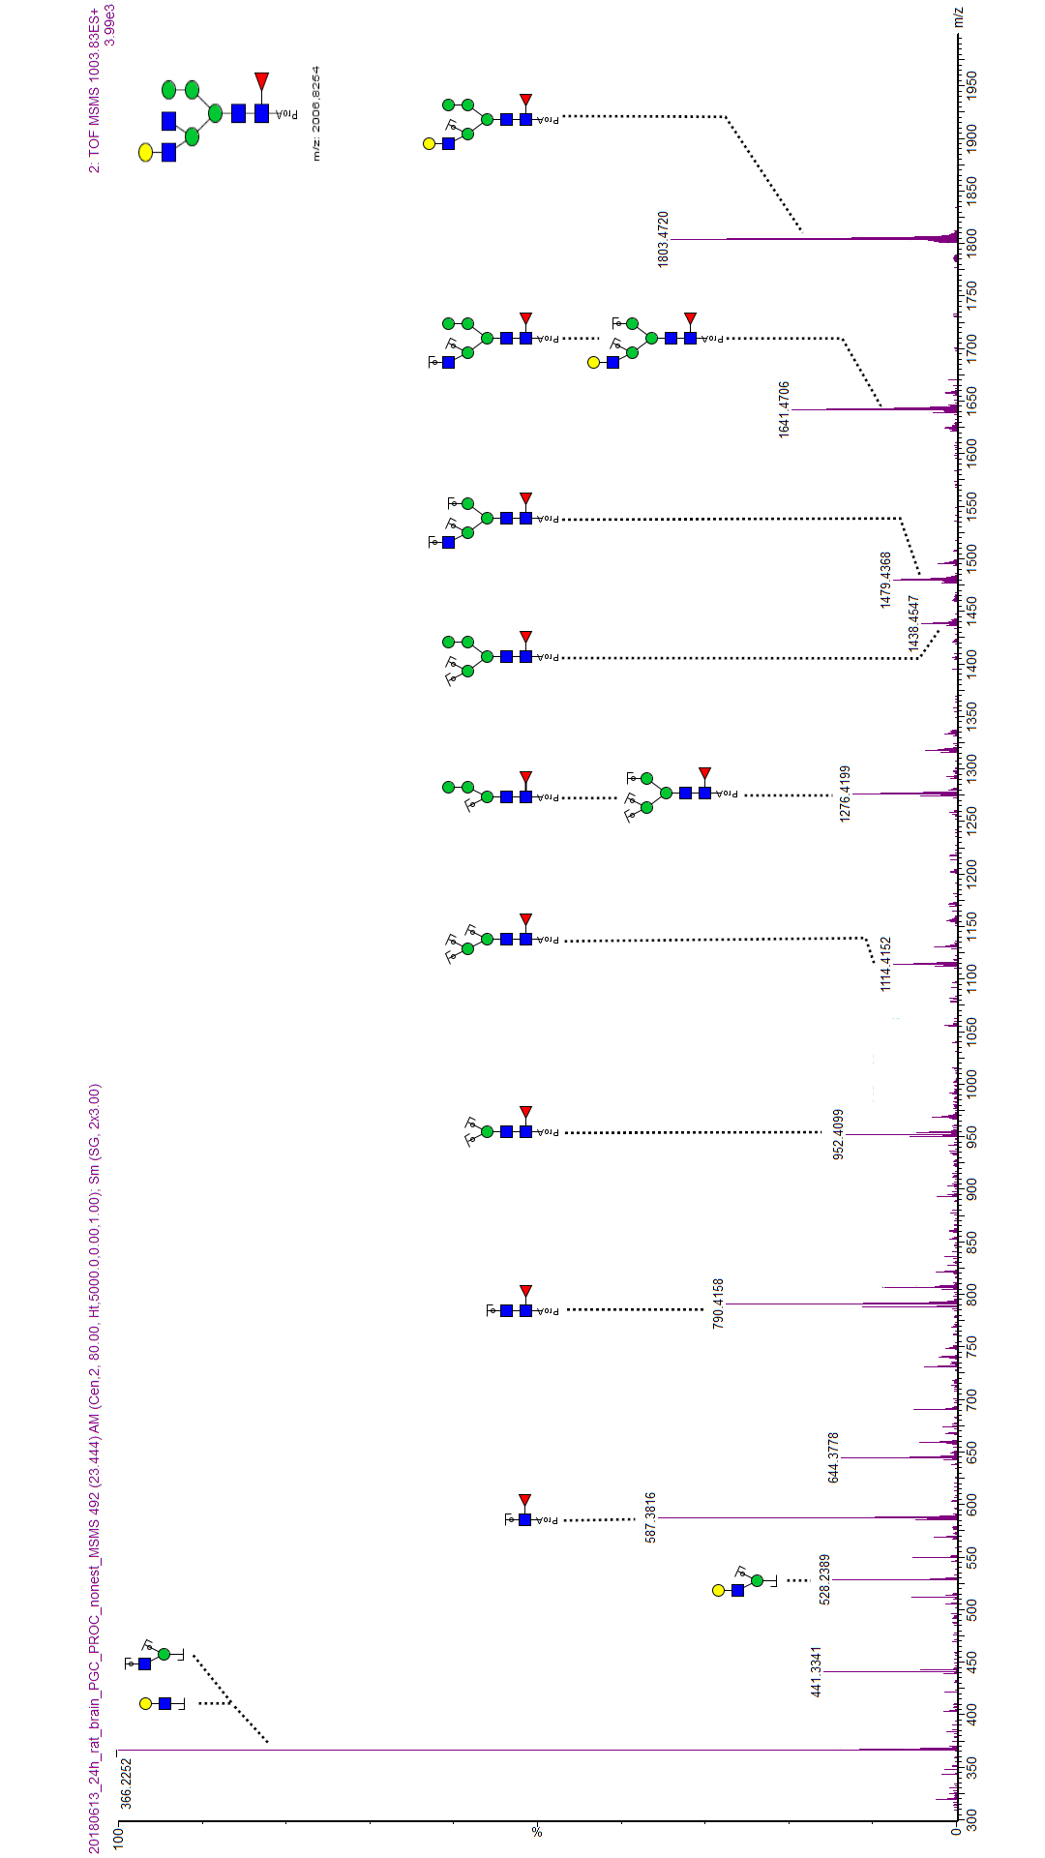

**Slika 8.1** Primjer anotiranog fragmentacijskog spektra

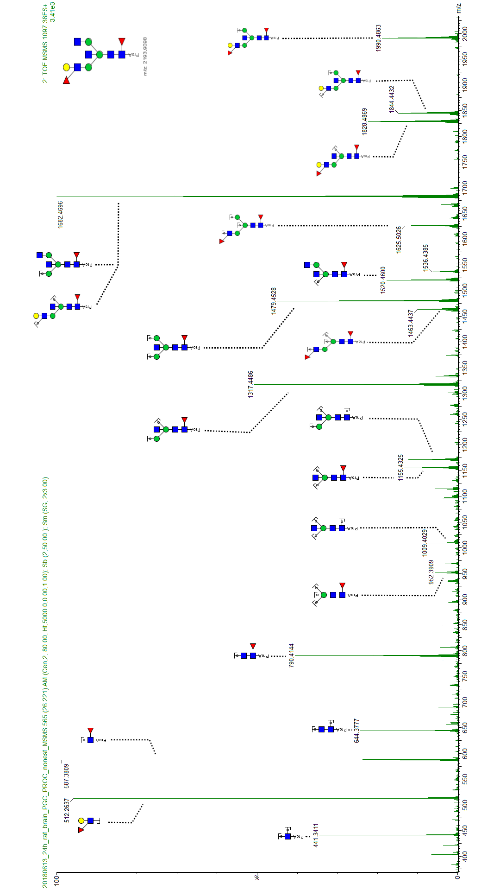

**Slika 8.2** Primjer anotiranog fragmentacijskog spektra

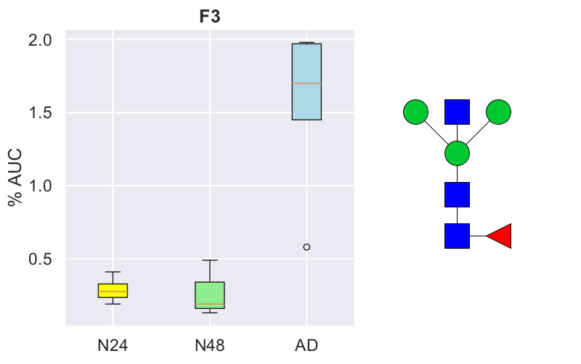

**Slika 8.3** Dodatak slici 4.12 – F3 (AD/N24/N48 označavaju skupinu uzoraka)

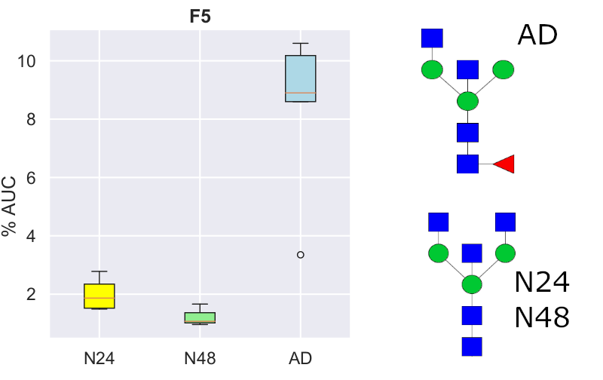

**Slika 8.5** Dodatak slici 4.12 – F5 (AD/N24/N48 označavaju skupinu uzoraka)

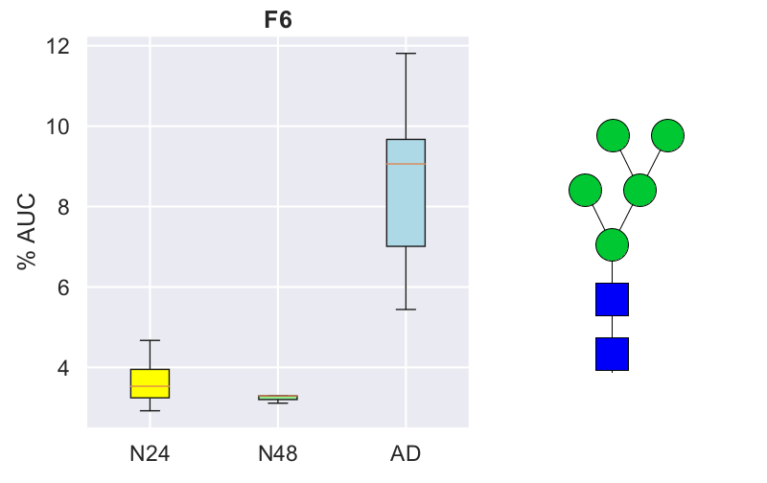

**Slika 8.4** Dodatak slici 4.12 – F6 (AD/N24/N48 označavaju skupinu uzoraka)

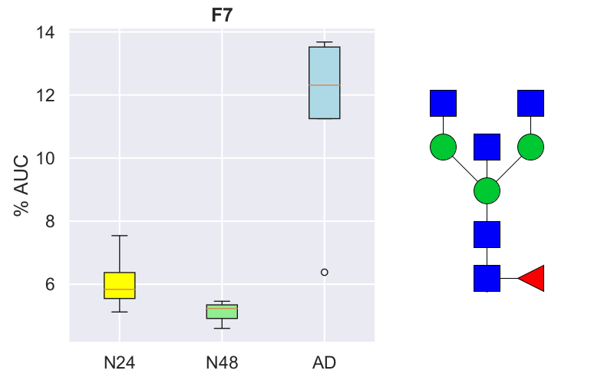

**Slika 8.6** Dodatak slici 4.12 – F7 (AD/N24/N48 označavaju skupinu uzoraka)

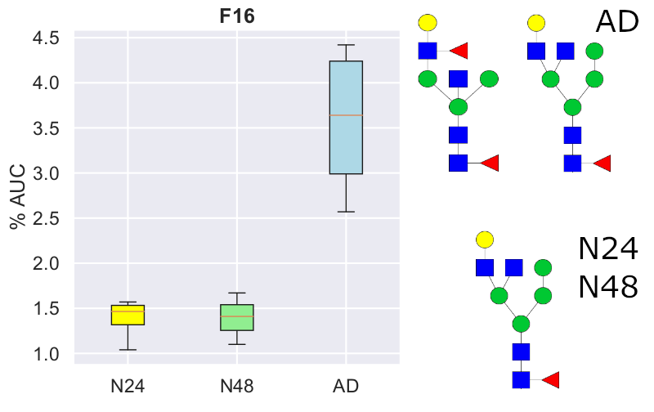

**Slika 8.7** Dodatak slici 4.12 – F16 (AD/N24/N48 označavaju skupinu uzoraka)

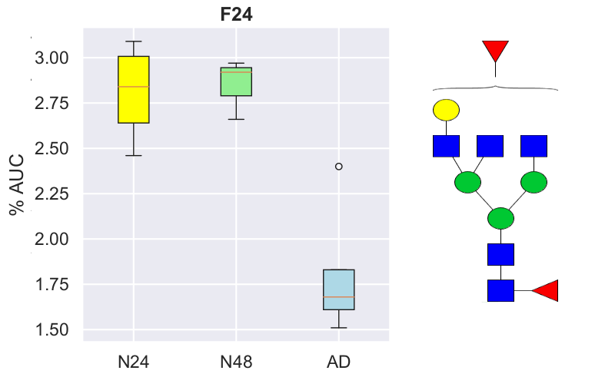

**Slika 8.9** Dodatak slici 4.12 – F24 (AD/N24/N48 označavaju skupinu uzoraka)

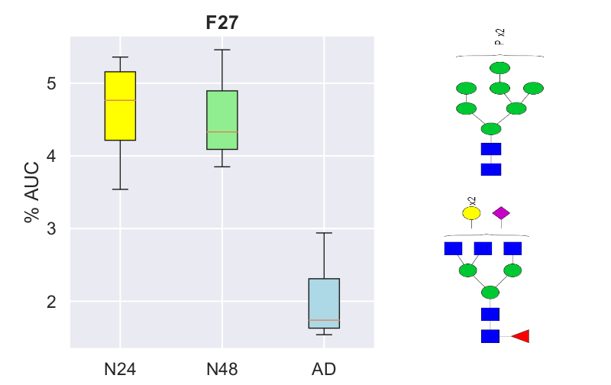

**Slika 8.8** Dodatak slici 4.12 – F27 (AD/N24/N48 označavaju skupinu uzoraka)

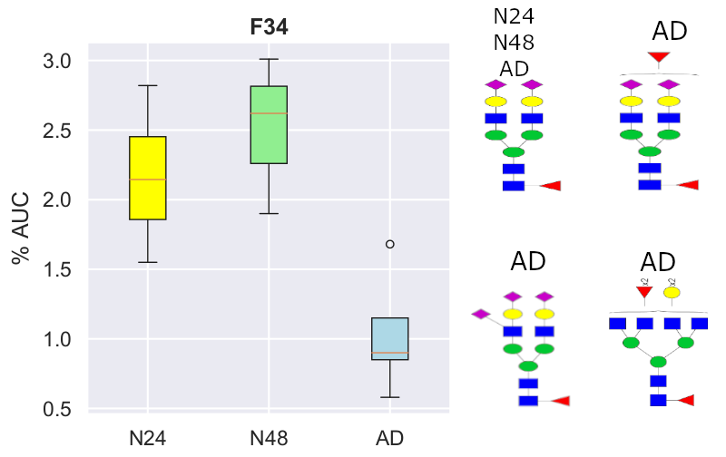

**Slika 8.10** Dodatak slici 4.12 – F34 (AD/N24/N48 označavaju skupinu uzoraka)

**Slika 8.11** Formula korištena pri izračunu i korekciji Hedgesove g vrijednosti. U crvenom Pravokutniku nalazi se korekcijski faktor. N – ukupni broj uzoraka. M1/2 srednje vrijednosti skupina. SDpooled – ukupna standardna devijacija.