eProject: Book Lawyer

# Book Lawyer

|  |  |  |
| --- | --- | --- |
| **Supervisor.** | **Sir JUNAID ABBASI** |  |
| **Batch.** | PR202002C |  |
| **Group.** | B |  |
| **Serial No.** | **Enrollment Number** | **Student Name** |
| 1. | 1258856 | M.SAMEE RAZA |
| 2. |  | HAMZA MAZHAR |
| 3. |  | M.ASHHAR |
| 4. |  | SHAHZAIB ABBASI |

eProject: Book Lawyer

## ACKNOWLEDGEMENT

The first, we would like to express my special thanks of gratitude to my teacher **Sir Junaid Abbasi**, who helped us a lot in finalizing this project within the limited time frame, valuable counselling and assistance for the accomplishment of this project.

Secondly we would also like to thank the eProject team at Aptech Head Office, who gave us the golden opportunity to do this wonderful project about Book Lawyer.

Thirdly, we also thank the eProject team, some of the benefits are as under:

* Re-enforcement of skills happens in the experiential learning process. 
* A mentor, ensuring that we do not get drifted, constantly guides us. 
* It gives us a lot of confidence to face an interview as we have worked on a project. We can explain virtually everything on the subject we have learnt. 

eProject: Aura Watches

***SYNOPSIS***

Follow the strong development of the internet, technology Booking Lawyers and the growth of Higher Cases, every business needs a website design to display products on the internet.

The following Lawyer project are designed with many different designs, suitable for all styles and preferences, which are the most special suggestions from Book Lawyer.

So Book Lawyer Show the best Lawyer through the website for everyone to know.

.

However, purchases are not made directly on the website

2 eProject: Aura Watches

***PROBLEM DEFINITION***

Book Lawyer is into business of Booking Of Lawyers as you want. They have been advertising about their Case and Picture through newspapers, pamphlets, television. Now with changing times, they have decided to go online as customers today use Internet extensively. They have planned for a website with complete details about their Lawyers and Case So, we solved many particular queries as followed:

* How the sitemap possibly looks alike?
* What information should be displayed on each page?
* How to put every comment is friendly?
* How to give users the best experience when using the website?
* How to let the website properly functioning along with the system requirement?

eProject: Aura Watches

## CUSTOMER REQUIREMENT SPECIFICATION (CRS)

After discussion, we are supposed to create a website for them with the below mentioned requirement specifications:

* + The Home Page should have suitable logo, and decent color combinations.

### The site should display a menu which will contain the options as Divorce,

Kidnapping, Criminal, Rape Case, About Us, Contact us etc.

* When a user selects any product line-up, complete list of watches for that product line-up will be displayed.
* Details of the watches should be displayed on the Web Page along with the title and it should be stored in Individual Word documents which can be downloaded or viewed by the User who wishes to see the same
* Price List for all watches should be available for download. 
* There should be a “Contact Us” page which will have the Address of the Stores selling watches and the mail address which when clicked will invoke the local mail client from where they can send an email. Address of the Company should be displayed using Geo Location API (e.g. Google Maps).

eProject: Aura Watches

## SCOPE OF THE WORK (IN BRIEF)

The website is to be developed for the Windows Platform using HTML5, JavaScript and Laravel. The site should work well in all leading browsers including Chrome, IE, Firefox etc..

Homepage show Top best Lawyers….

Every content direct to relative content.

eProject: Aura Watches

## AGGREGATED SITEMAP

Book Lawyer

(

0

.Welcome.html

)

Book Lawyer English

English

(

.Index.html

1

)

Aura Watches

Vietnamese

(

1

d

-

VN.html

)

eProject: Aura Watches

## WIREFRAMES

1. Main Layout

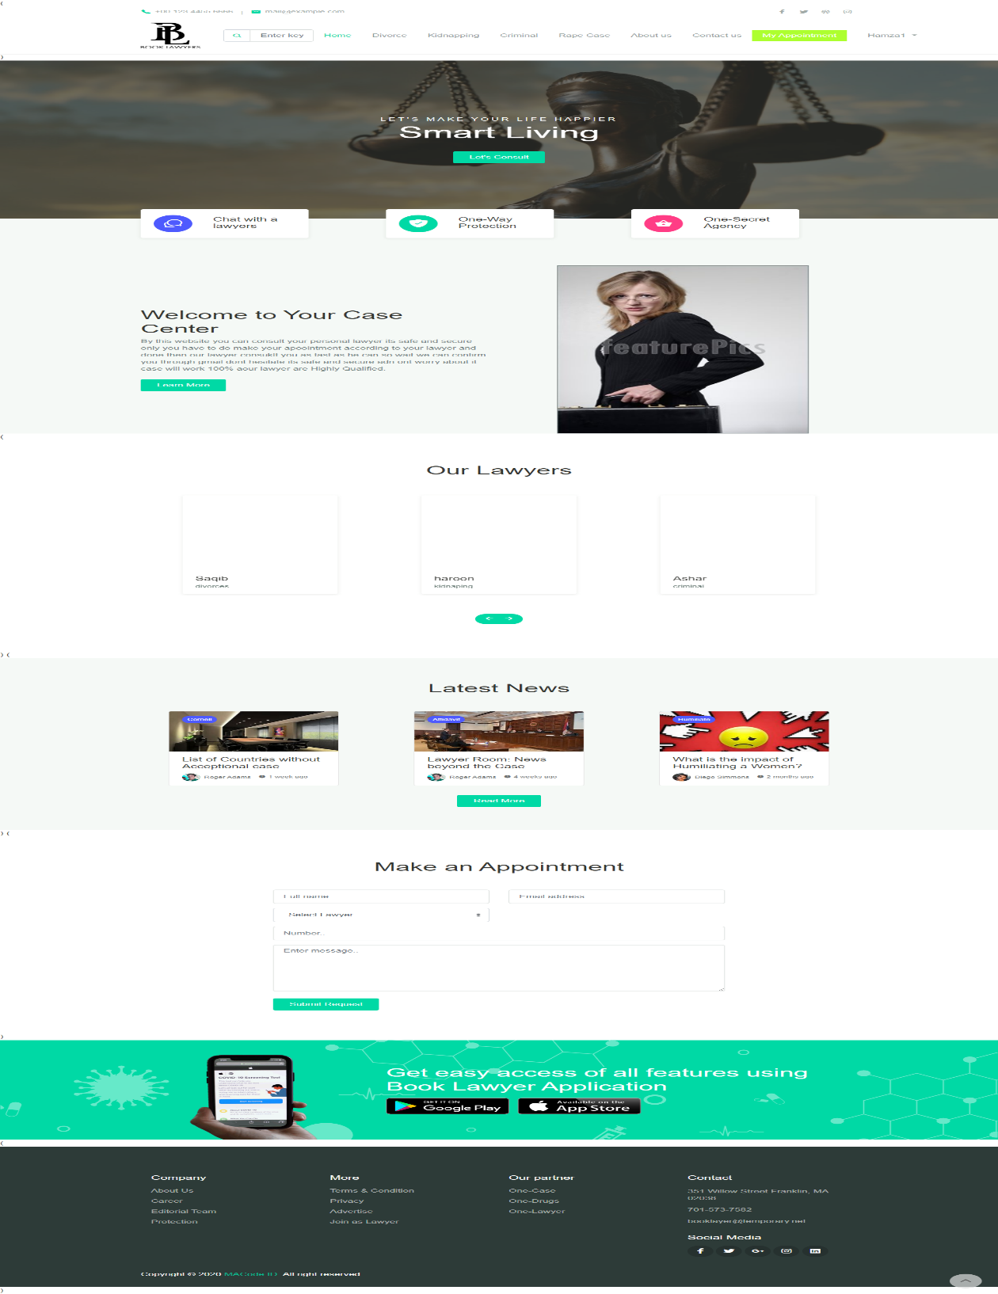

eProject: Aura Watches

Admin Page (1.Index.html

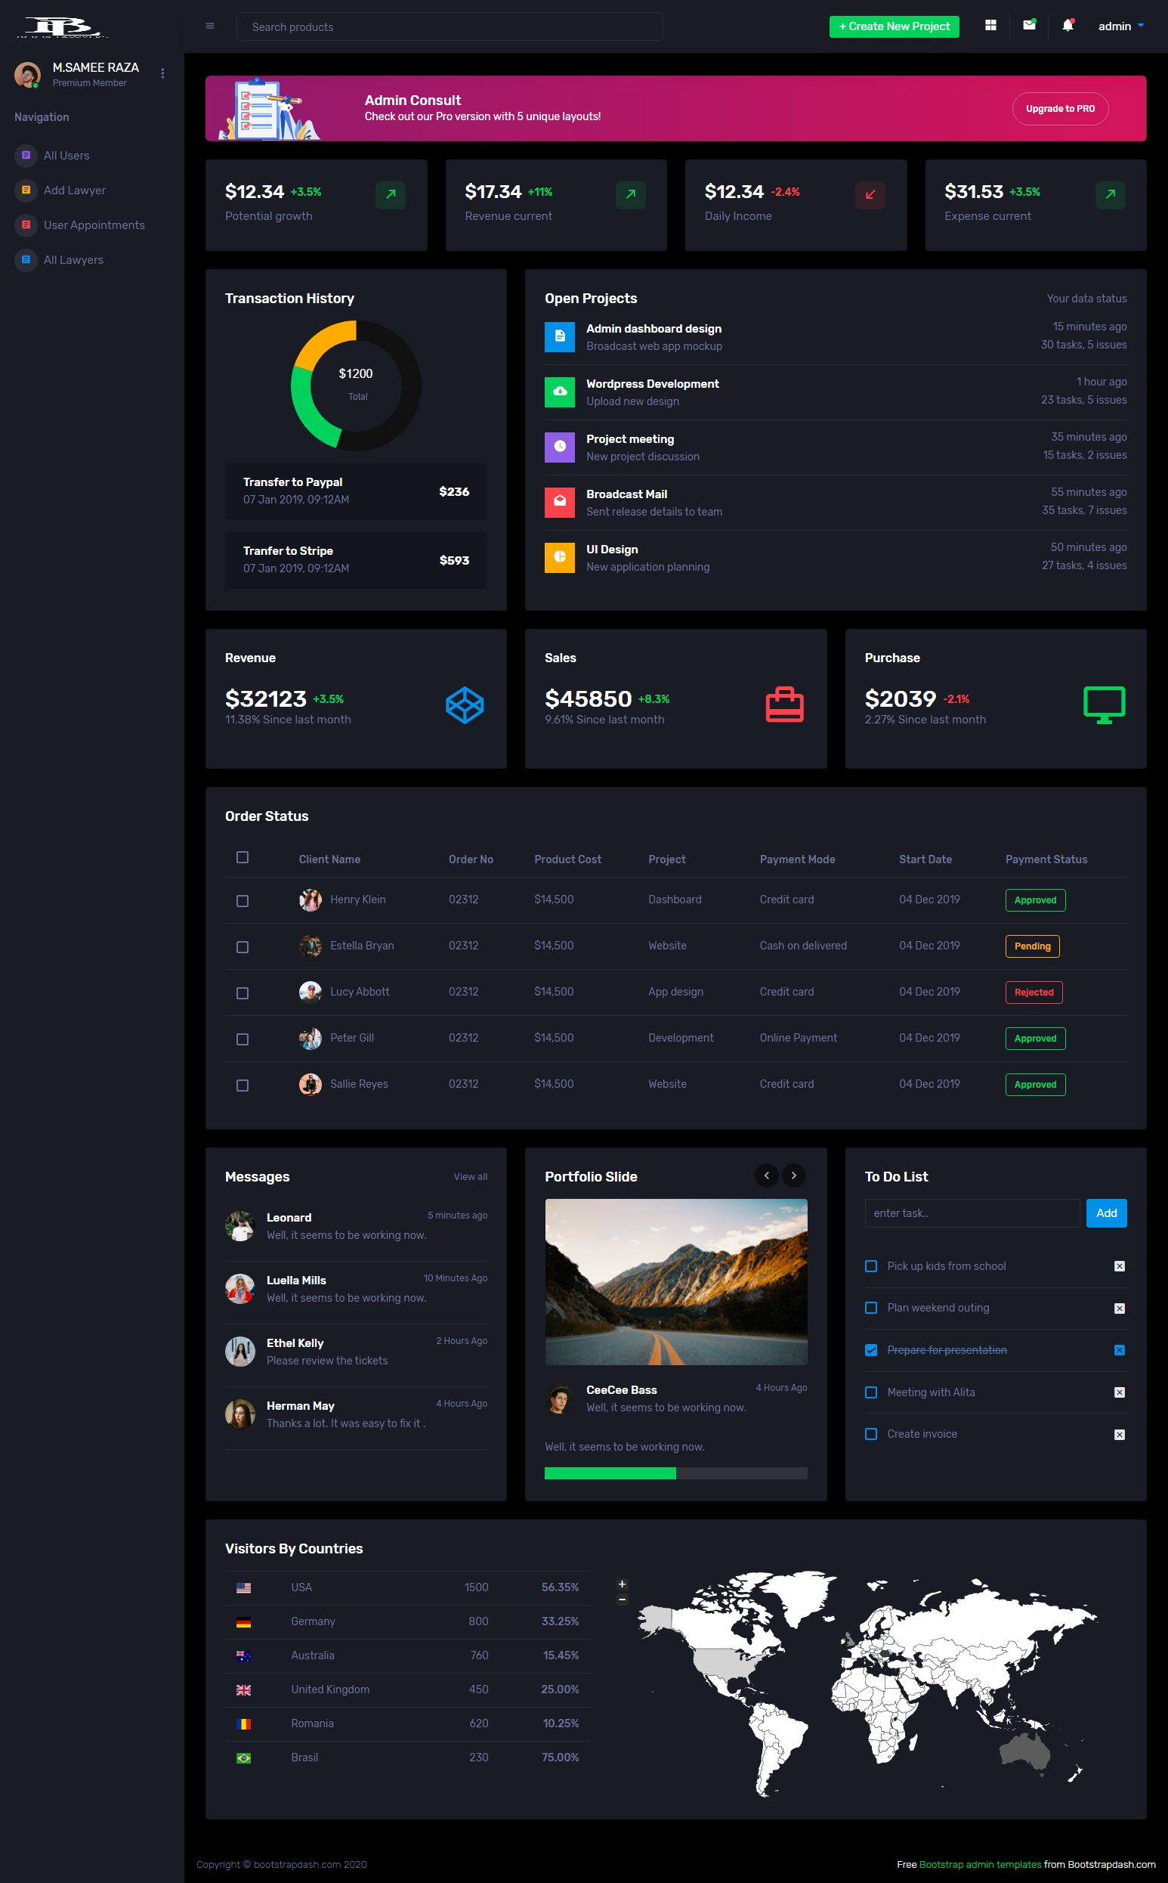

1. Lawyer Page (1.Index.html)

Sd

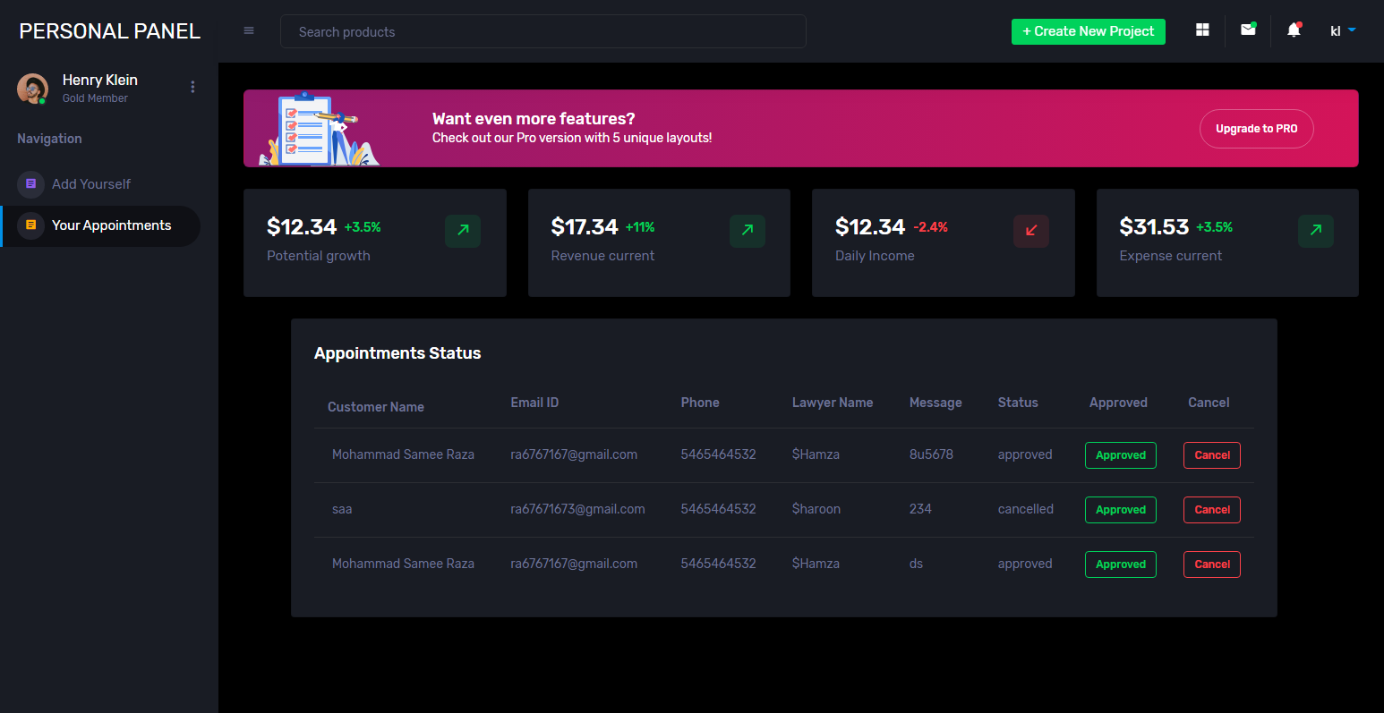

eProject: Aura Watches

3.Divorce Page

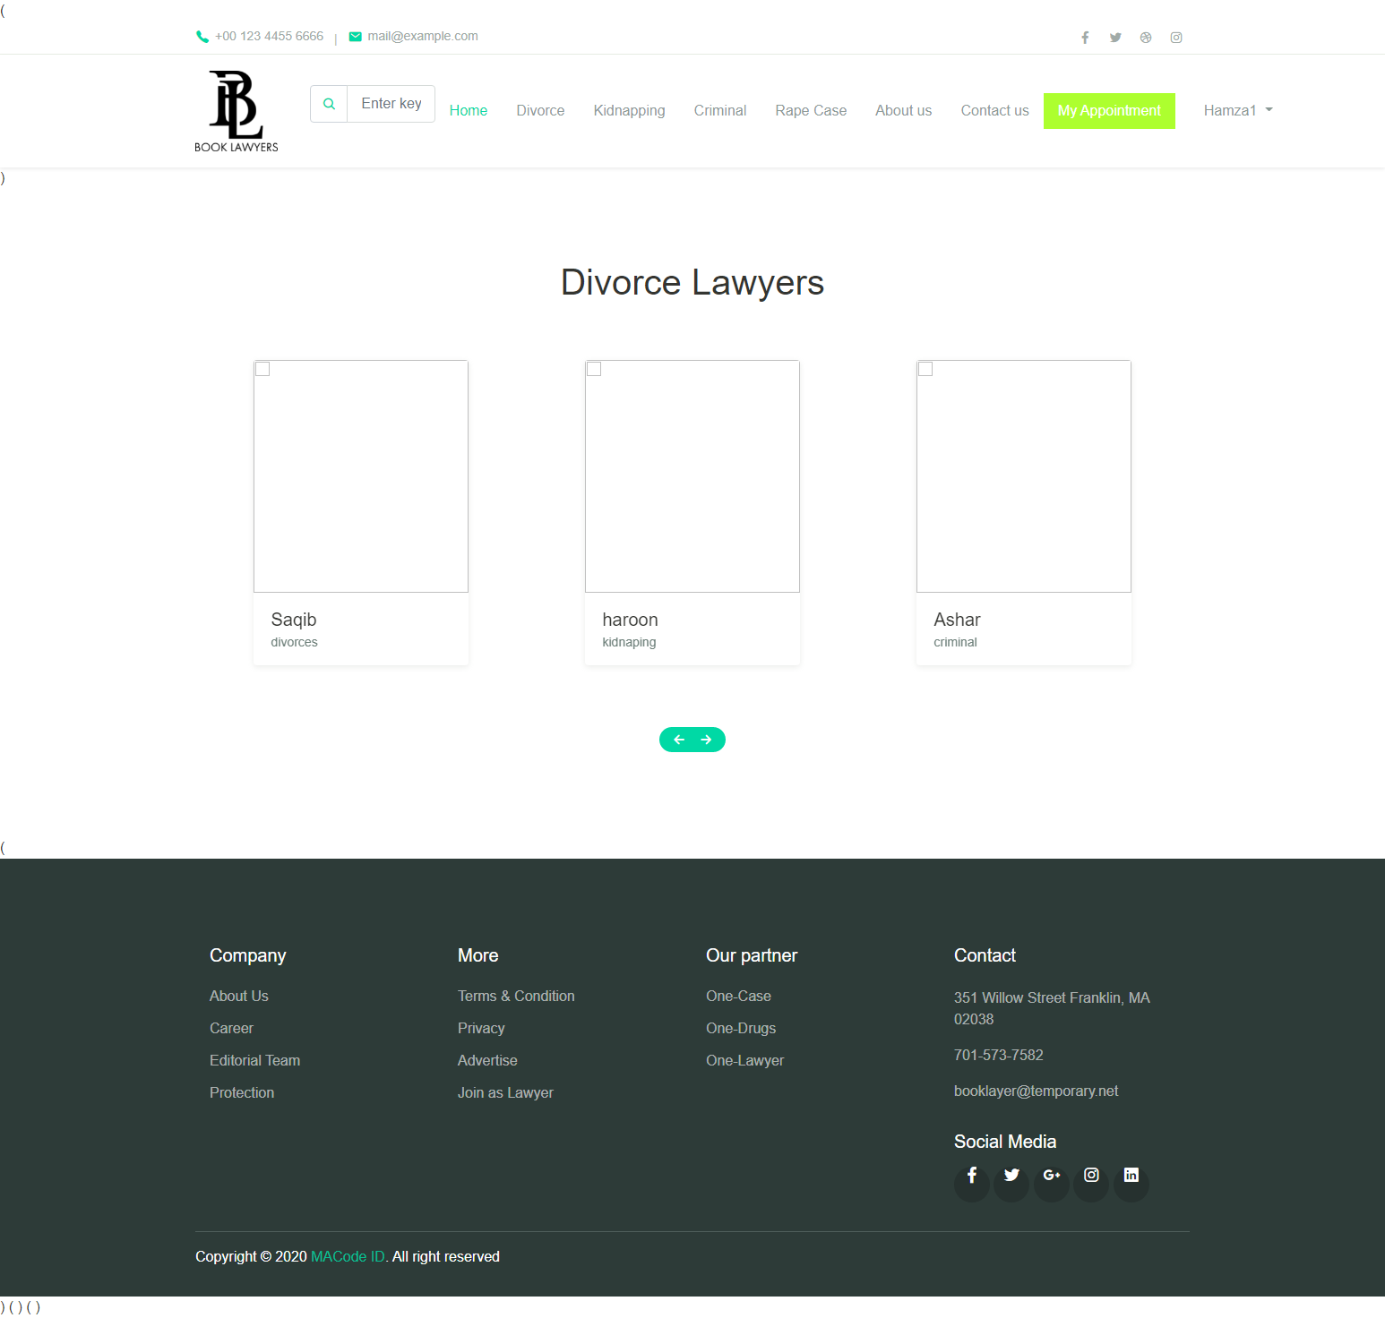

eProject: Aura Watches

4.Kidnapping Page

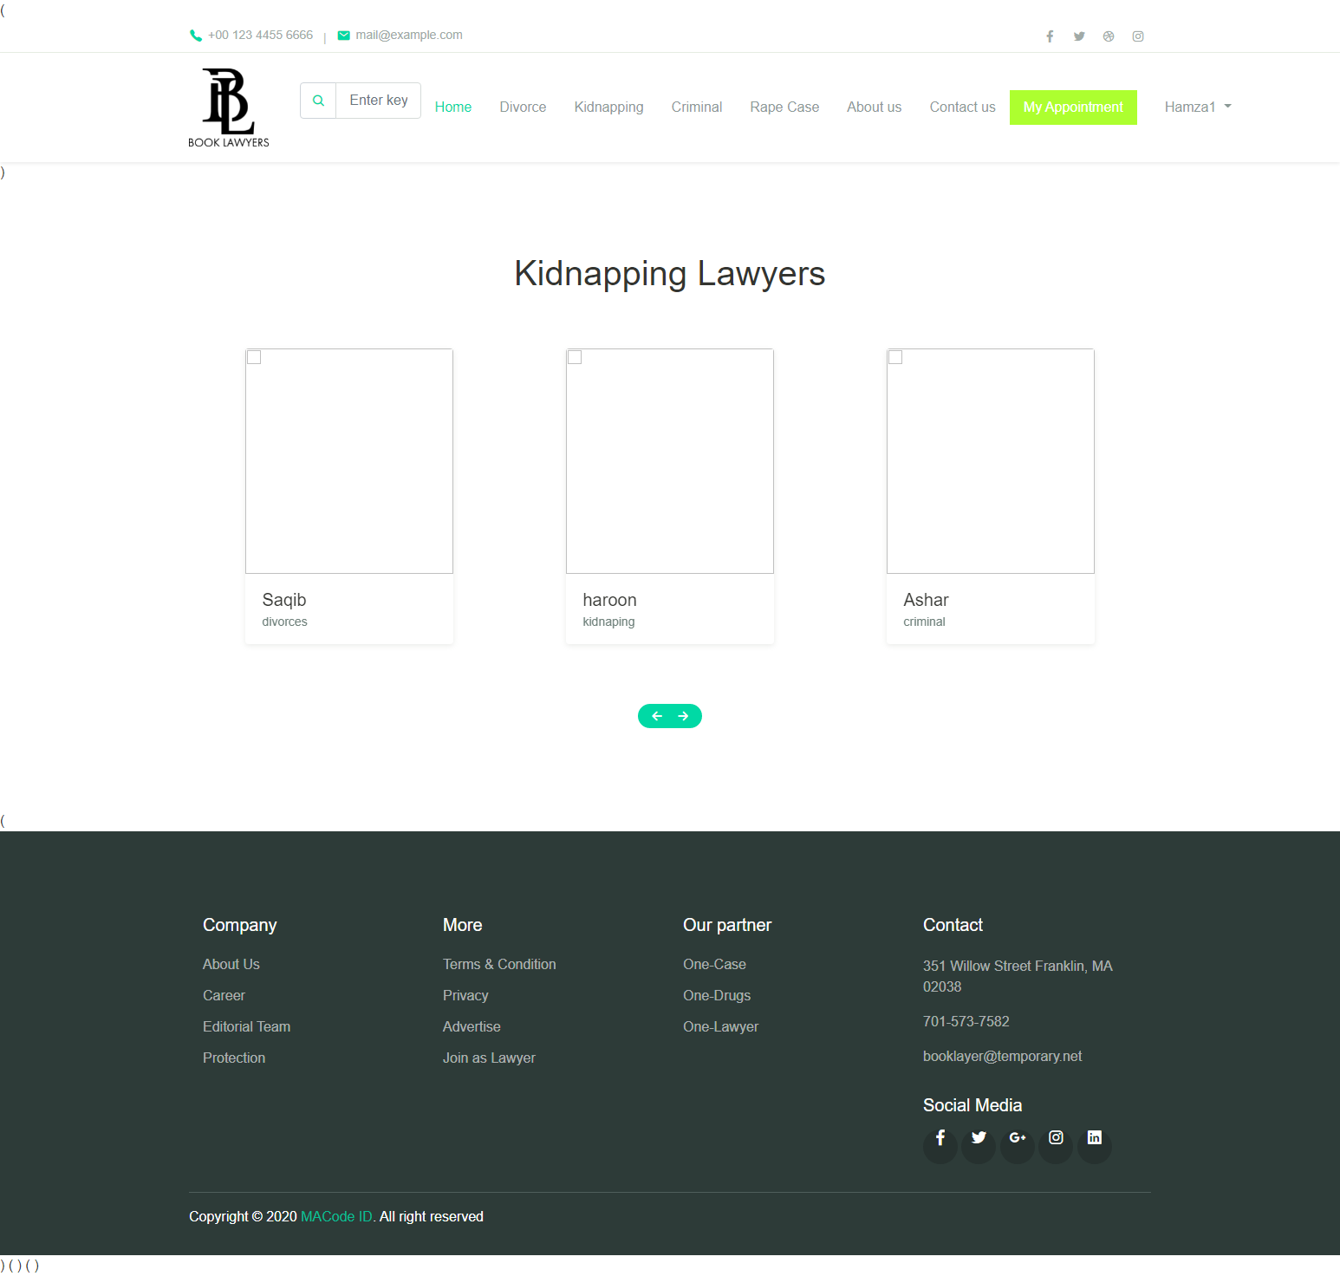

eProject: Aura Watches

5.Criminal Page

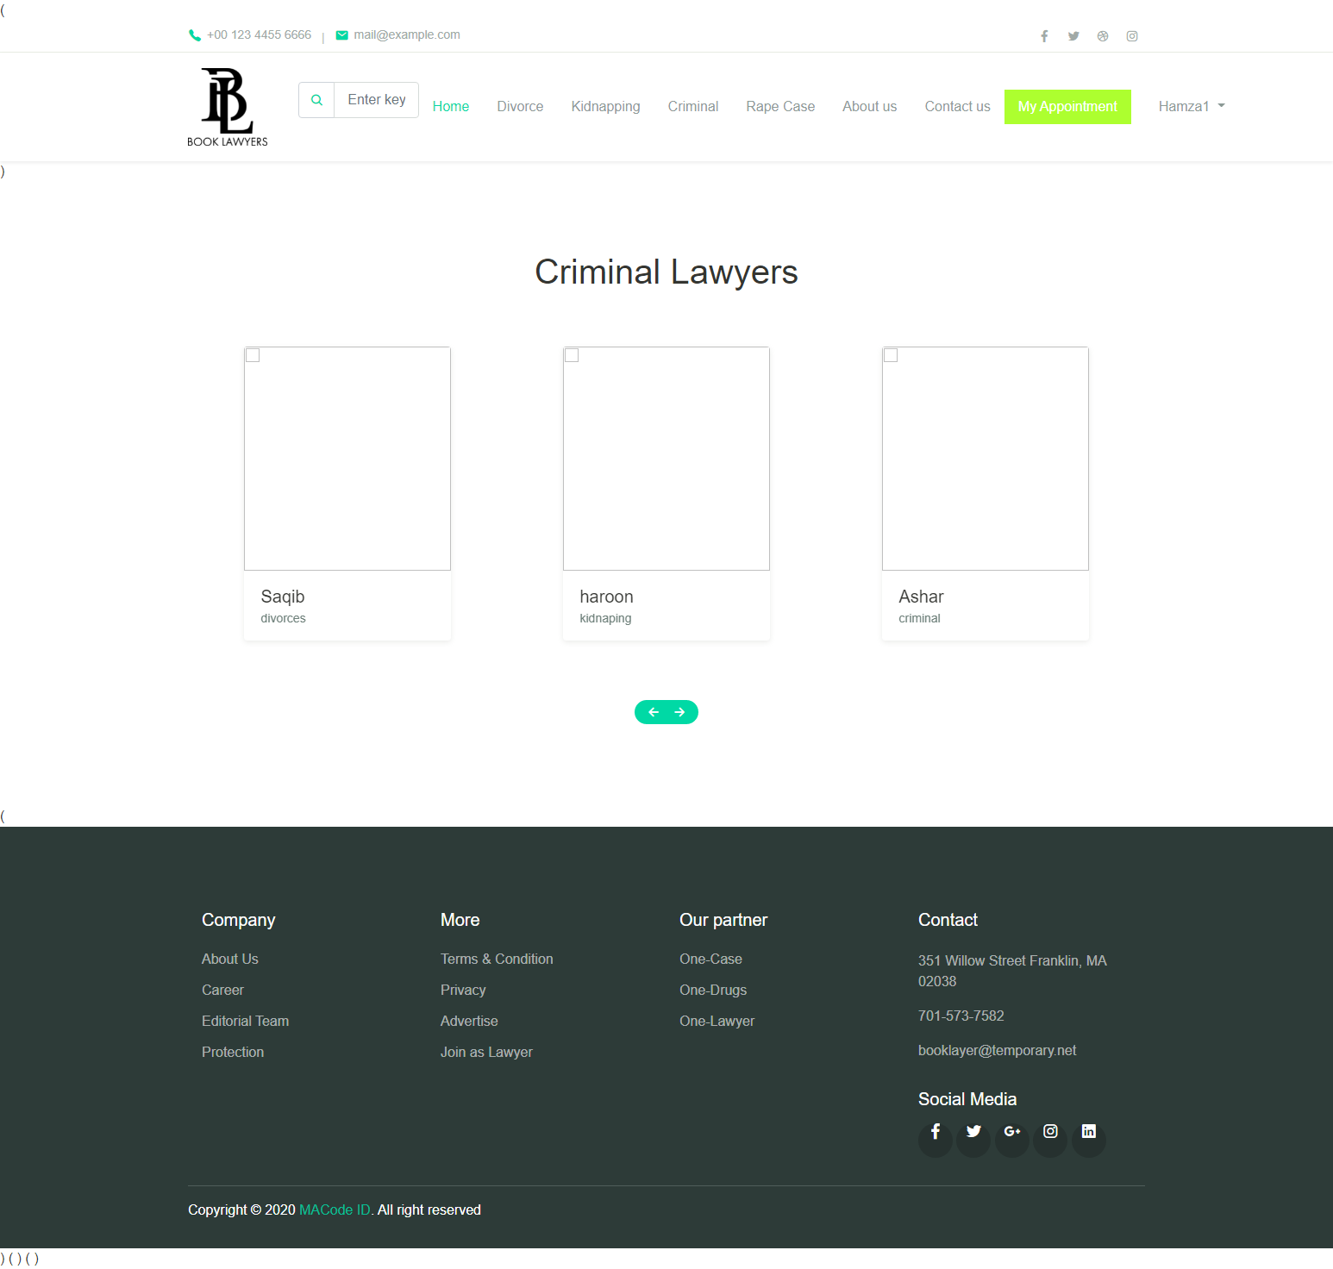

eProject: Aura Watches

6.Rape Case Page

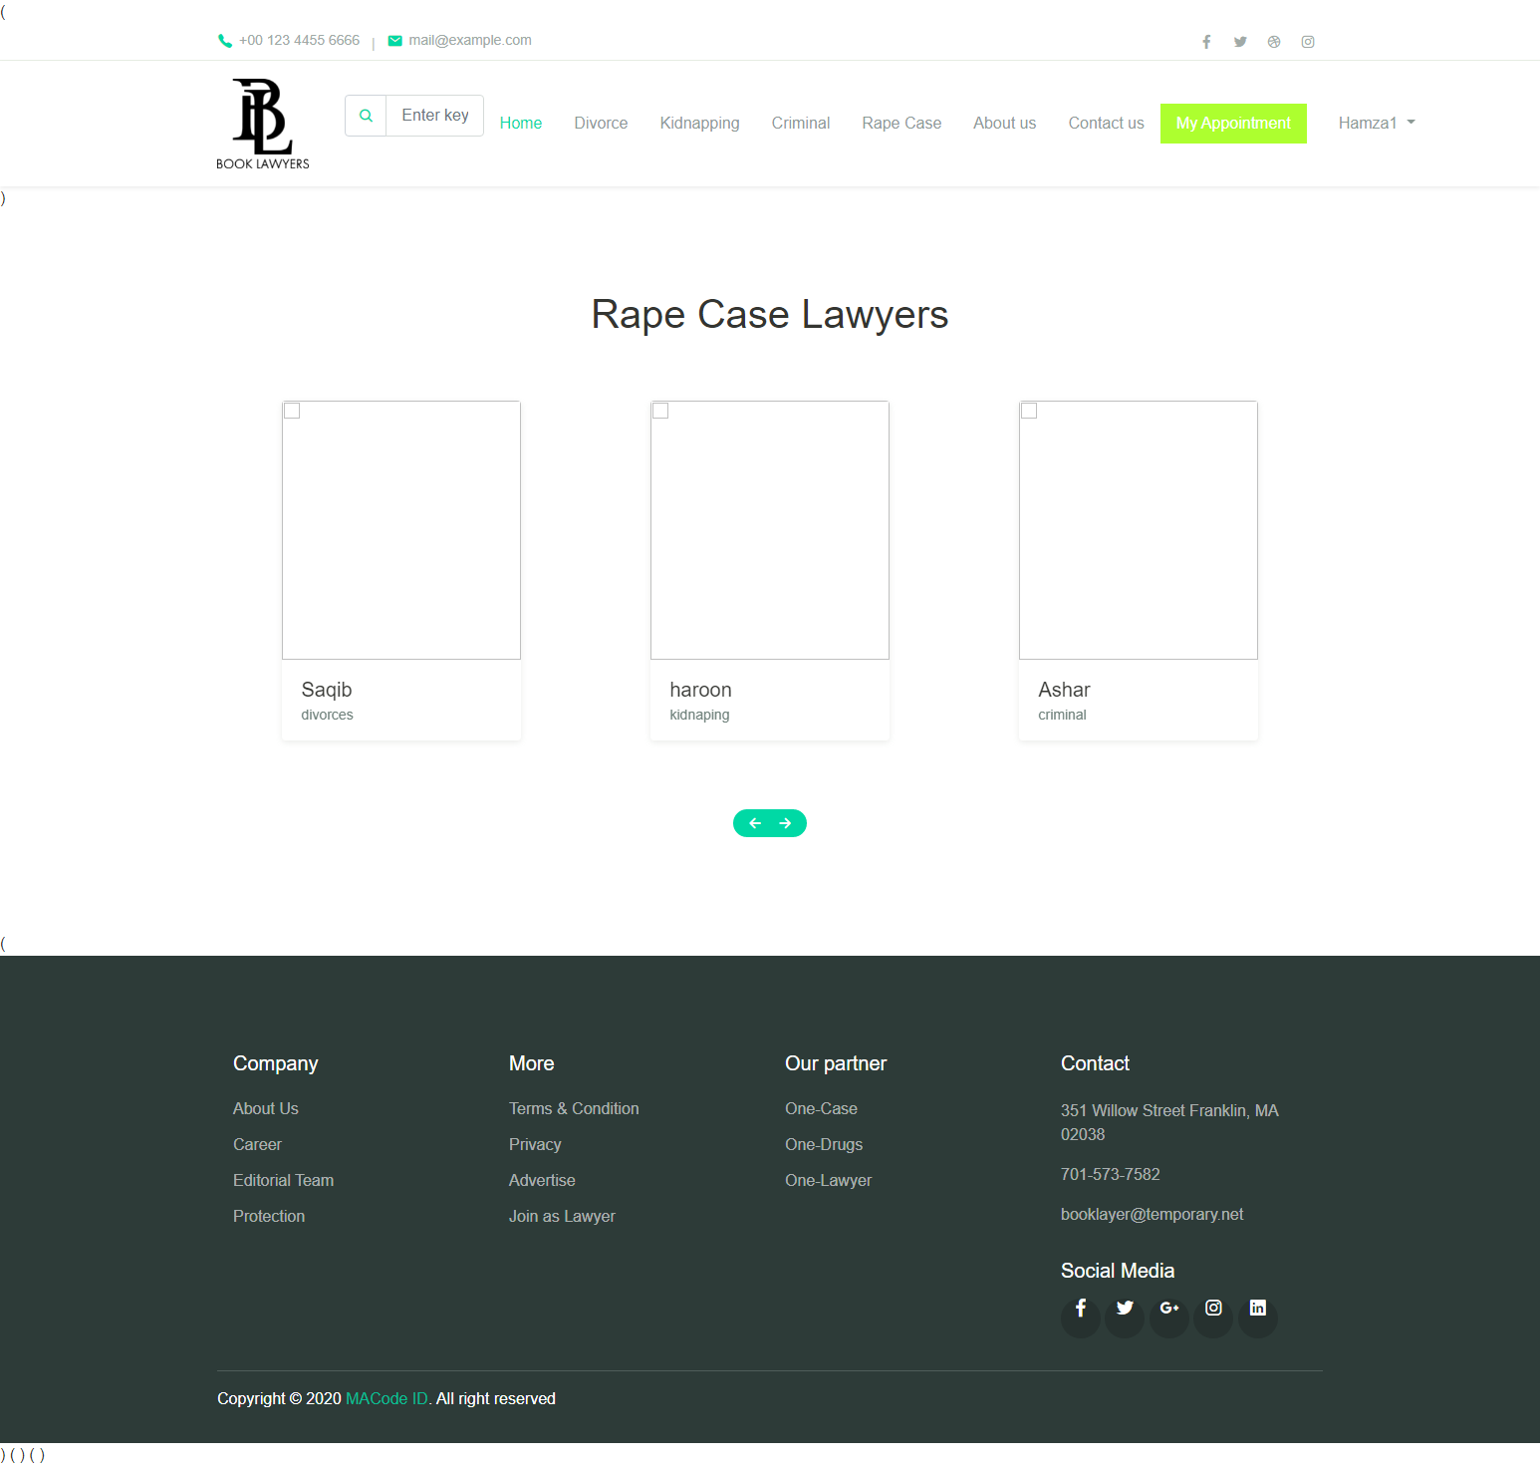

eProject: Aura Watches

7.Login Page

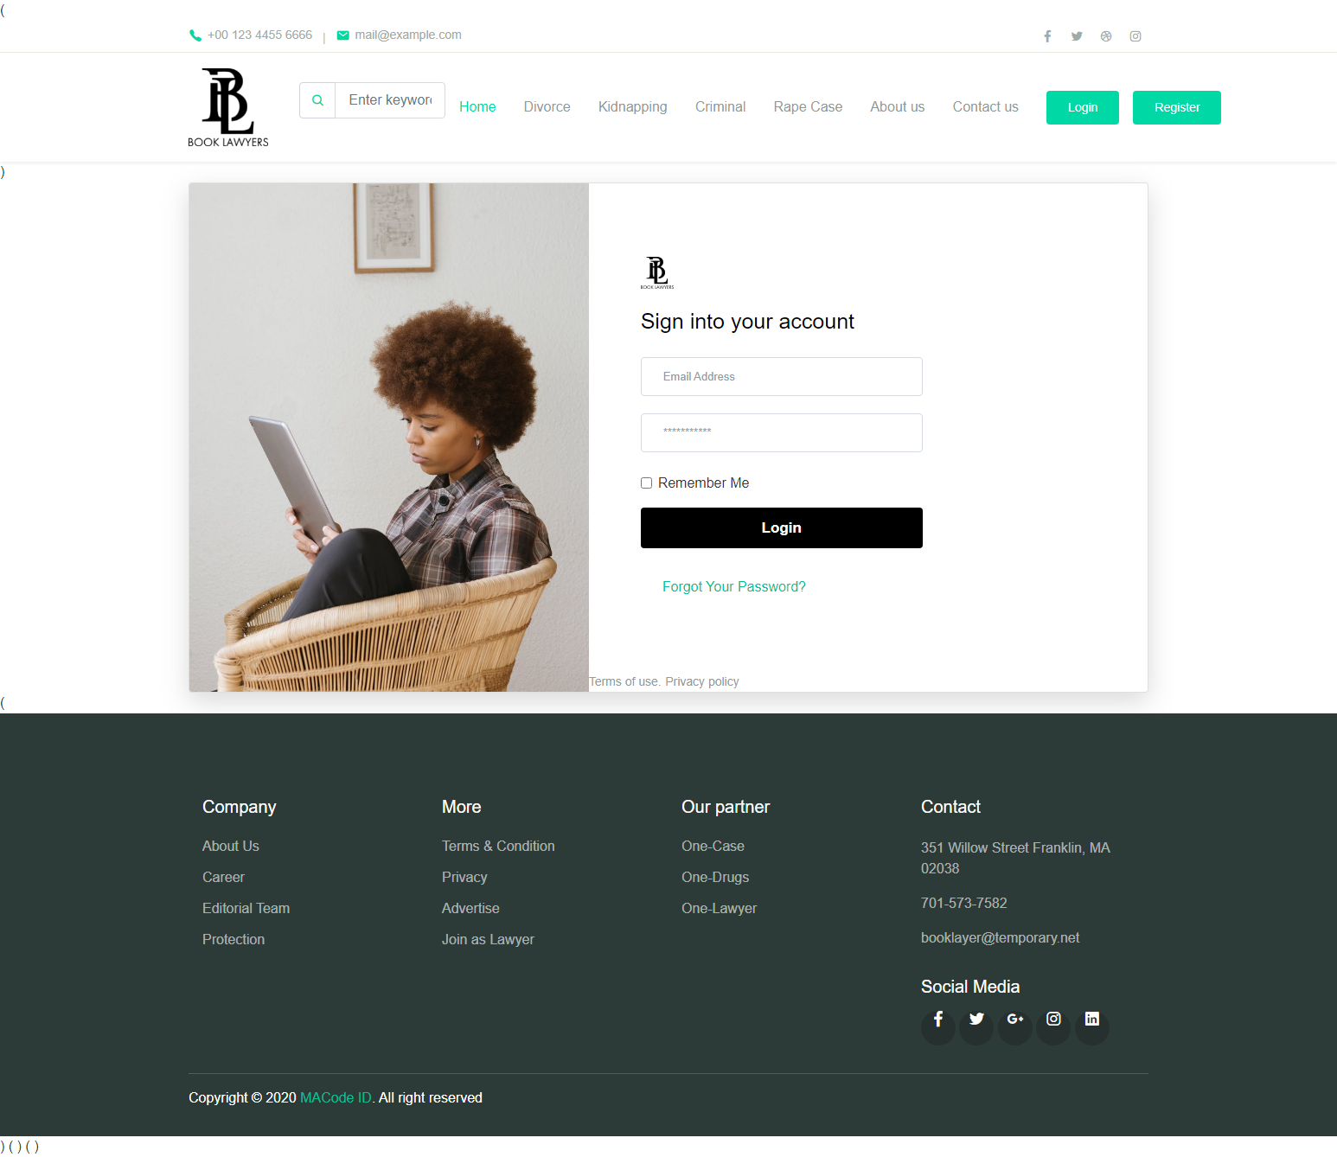

eProject: Aura Watches

8.Register Page

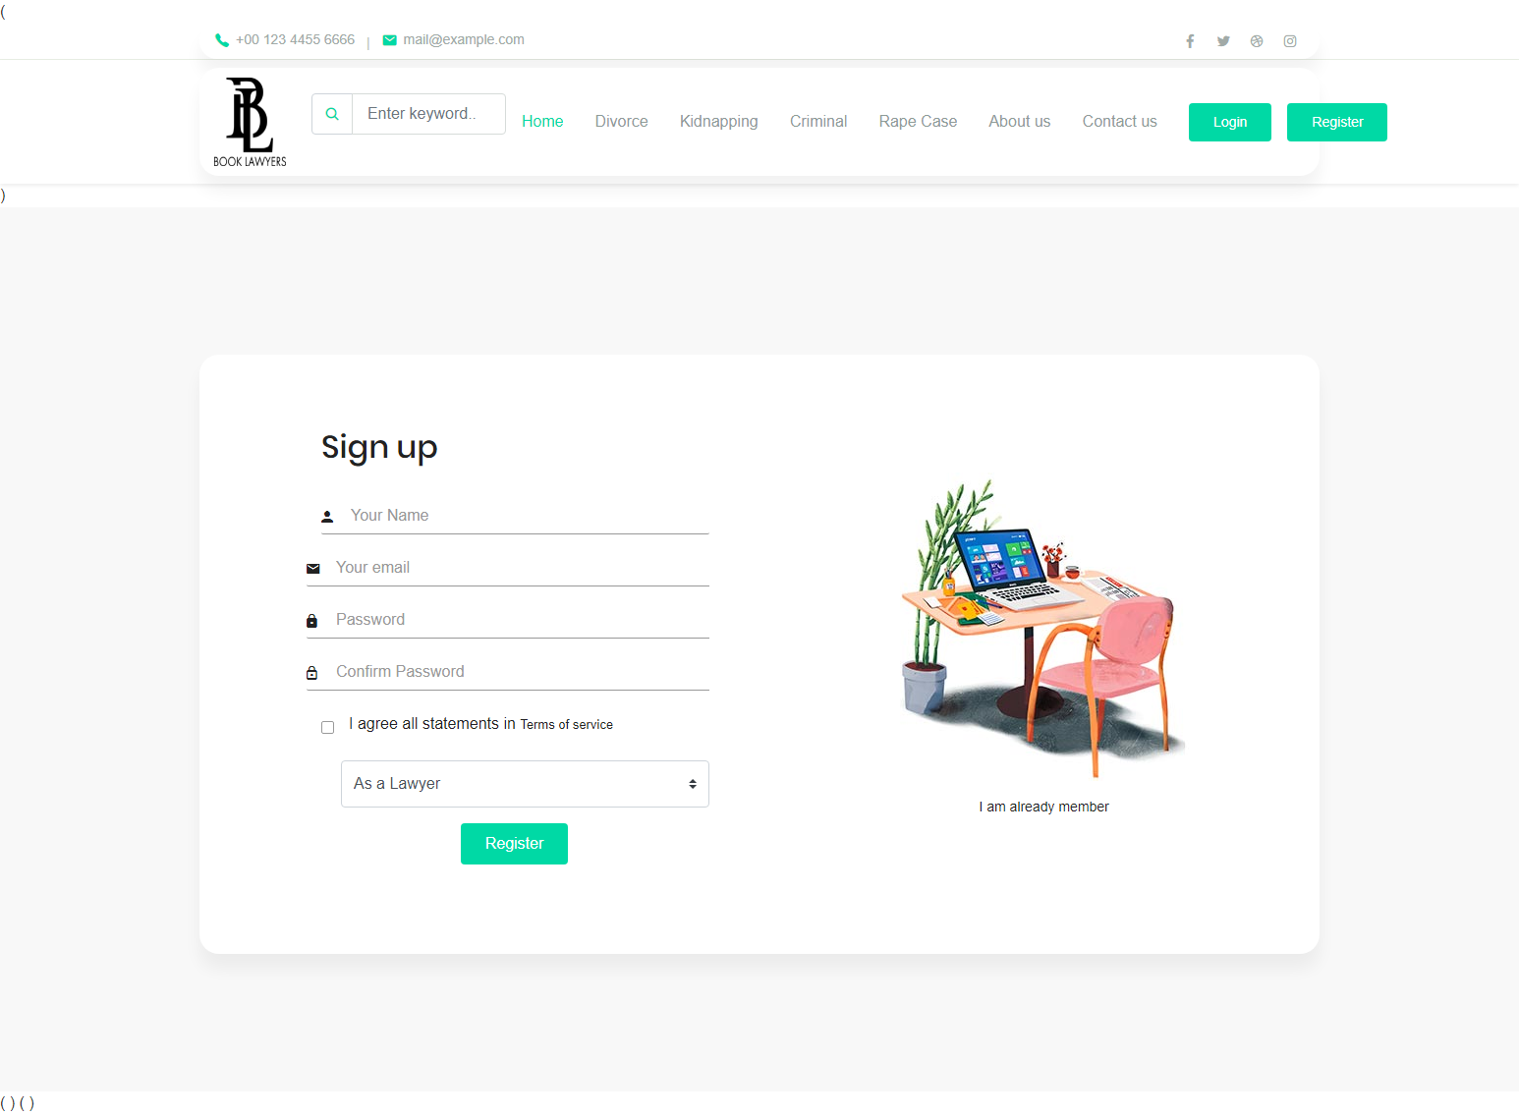

eProject: Aura Watches

8.Contact Page

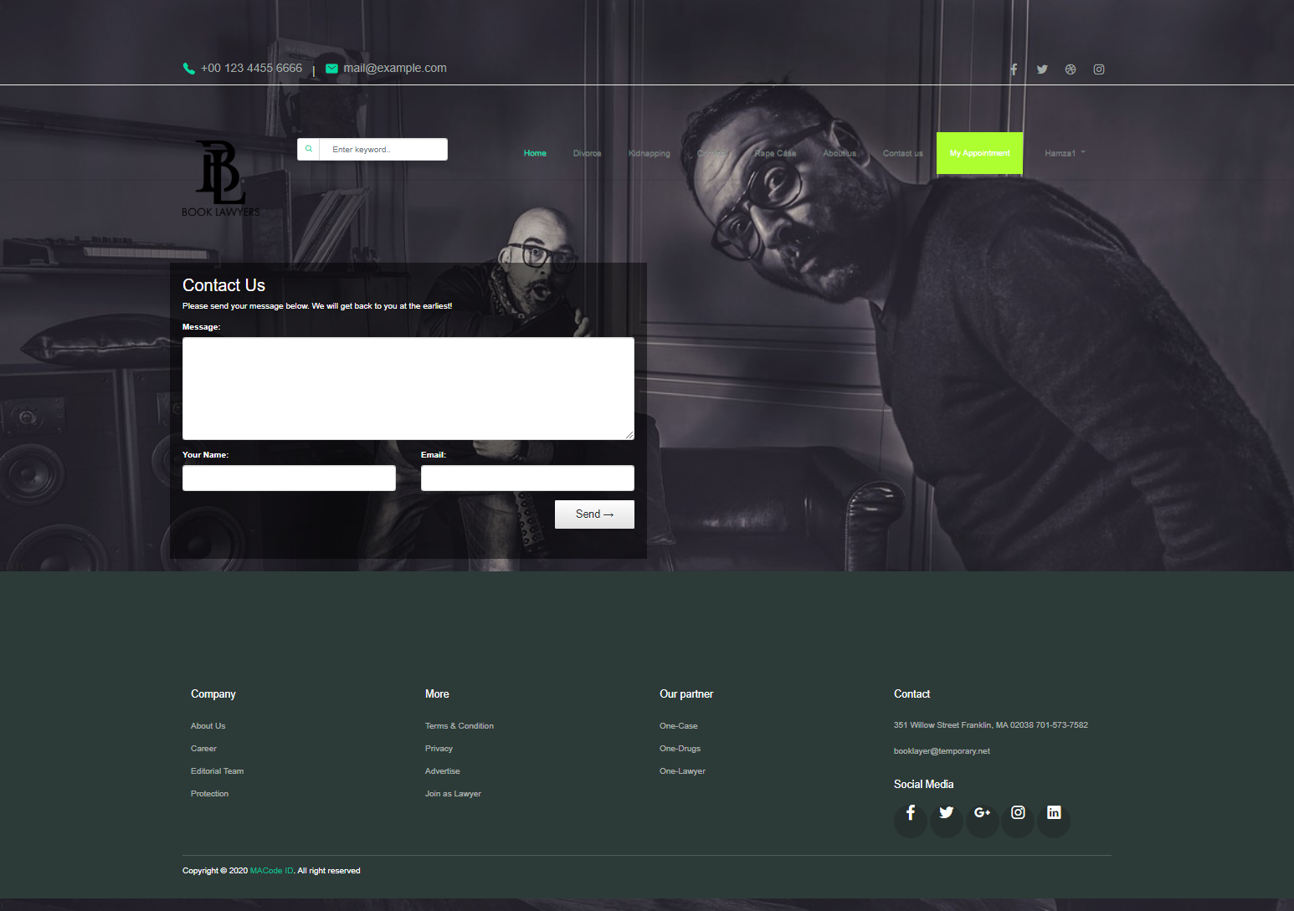

eProject: Aura Watches