Final Project Report

<<MICRO VOLUNTEER MANAGEMENT SYSTEM>>



Project Supervisor
<<ADULLAH QAMAR>>

Submitted By

<<s22O28E6FC>>

<<MUHAMMAD SAMEET UL HASSAN>> <<MC210201178>>

Software Projects & Research Section,
Department of Computer Sciences,
Virtual University of Pakistan


CERTIFICATE

This is to certify that <<Muhammad Sameet Ul Hassan>> (<<mc210201178>>) have worked on and completed their Software Project at Software & Research Projects Section, Department of Computer Sciences, Virtual University of Pakistan in partial fulfillment of the requirement for the degree of BS in Computer Sciences under my guidance and supervision.

In our opinion, it is satisfactory and up to the mark and therefore fulfills the requirements of BS in Computer Sciences.

Supervisor / Internal Examiner

<<Project Supervisor Name>>
Supervisor,
Software Projects & Research Section,
Department of Computer Sciences
Virtual University of Pakistan

___________________
(Signature)

External Examiner/Subject Specialist
<<External Supervisor Name>>

___________________
(Signature)

Accepted By:

_____________
(For office use)

EXORDIUM

In the name of Allah, the Compassionate, the Merciful.

Praise be to Allah, Lord of Creation,
The Compassionate, the Merciful,
King of Judgment-day!

You alone we worship, and to You alone we pray for help,
Guide us to the straight path

The path of those who You have favored,

Not of those who have incurred Your wrath,
Nor of those who have gone astray.

DEDICATION

The nonprofit sector is an important part of the economic system, one that relies heavily on volunteer labor. Understanding higher participation levels among volunteers, particularly volunteering marketing professionals, not only affects the performance of individual nonprofit organizations but also has profound impact on the entire nonprofit sector of the economy. Using identity theory adapted from the consumer behavior literature, the authors investigate the motivation of dedicated volunteers. Results suggest that organizational attachment, involvement, emotions, and identity importance are useful for understanding volunteers' dedication. In this context, devoted volunteers make a significant impact on societal welfare.

ACKNOWLEDGEMENT
PREFACE
TABLE OF CONTENTS

CHAPTER NO. 1
gathering & Analyzing info 10

1.1 Introduction

1.2 purpose

1.3 scope

1.4 definitions, acronyms and abbreviations

1.5 use cases and usage scenarios

1.5.1 Use Case Diagrams

1.5.2 Usage Scenarios

1.6 supplementary requirements

1.6.1 Usability

1.6.2 Reliability

1.6.3 Supportability

1.6.4 System Requirements

CHAPTER NO. 2
planning the project 11
2.1 Introduction

2.2 Methodology

  - Available Methodologies

  - Chosen Methodology

  - Reasons for Chosen Methodology

  - Work Plan
  - Project Structure

    - Team Structure

    - Project Schedule (Submission Calendar)

CHAPTER NO. 3
designing the project 12

3.1 Introduction

3.2 purpose

3.3 scope

  - definitions, acronyms and abbreviations

  - Architectural Representation (Architecture Diagram)

  - Dynamic Model: Sequence Diagrams

  - Object Model/Logical Model: Class Diagram

  - Database Model (Database Diagram)

  - Graphical User Interfaces

Chapter no.4
DEvelopment 13
4.1 Development plan (Architecture Diagram)

<<Dear Students, you have to take special care of page numbers, which are written against each Chapter and sub headings. You have to mention your own page numbers and correct one against each document heading. Make proper table of contents. Remember that if there are any new headings or you have included more headings in your documents then you also have to write these in table of contents and modify table of contents according to your documents material>>

<<Dear Students, before starting each chapter the following would be the title page for each chapter on a separate page>>

CHAPTER 1
Gathering & Analyzing Info

INTRODUCTION

A human resource management system (HRMS) is an integral part in any enterprise seeking to thrive in the current global business climate to strive. HRMS encompasses a wide range of aspects in the successful management of employees. These include; payroll, time and attendance, performance appraisal, scheduling and et cetera [1]. Though HRMS are usually implemented throughout the entire company there are certain branches that are isolated from the main system framework. In a local science center, namely Petrosains, volunteers are employed to aid the staff in its day to day operations. These volunteers are working on a part time basis and may pick the days in which day wish to work. The process of assigning these volunteers to their post and work schedules is handled by a subdivision of Petrosains Human Resource Department, namely the Volunteer Management Unit. The current process of constructing a weekly roster (work schedule) for the volunteer involves: The volunteers sign up on a weekly availability list, where they would fill in their name, contact number, the departments in which they are assigned to and the days that they wish to work on. At the end of the working week (typically a Friday) the VMU staff would construct a weekly roster manually using Microsoft Excel and then posting it on a notice board outside their office. In the matter of remuneration, the volunteer’s receive an honorarium at the end of the month according to the amount of hours. The volunteers working hours are tallied by punch card and the total hours will be tallied manually at the end of the month by the VMU staff.

1.2 Purpose

- Serve as a platform to store volunteer information
- Provide a more efficient way to allocate resources(manpower/volunteer) via scheduling
- Provide a means to track timesheet hours.

1.3 Scope

- The study will cover several aspects of the volunteer management process
    - Scheduling.
    - Timesheet
- . User Base:
    - HR staff
    - Volunteers
1.4 definitions, acronyms and abbreviations

The need to develop customized application software is quite high now-a-days with the ever increasing automation process within many companies with the use of HRM S and enterprise application software(EAS) like SAP being commonplace in today’s business environment, the use of manual practices in human resource management is becoming obsolete, necessitating the use of a software application to facilitate their management of the volunteers.

1.5 use cases and usage scenarios

In this project, we will build a web-based application named as “Micro-Volunteer management System (mVMS)”. Web application the Micro-Volunteer management System (mVMS) is about to facilitate non-profit organization and charity to find skilled persons as volunteers besides donations. This application remove crucial part of that is different volunteers will have different skill sets and different charities require volunteers according to their needs as projects. Using this applications organizations will find skilled volunteer according to their needs. This application also help to volunteer to find organization according to their skill on just one move. To develop this project we are going to propose a design. In design Document we provide different types of proposes solutions for front end and as well as for back end too, which includes the following information:
- Entity relationship diagram
- Database diagram
- Class diagram
- Sequence diagram
- Architecture design
- GUI design
- Test cases

1.5.1 Use Case Diagrams

All this information is provided to help out the development team so that they can easily develop the required application. The purpose of this document is to provide a detailed description of the design of the project, as we can see that ERD will provide the facility to development team regarding database to deal with the data who we can store and retrieve data. Sequence diagram will provide the sequence of the execution of different tasks. Class diagram will deals with the objects that we are going to handle them. Interface design tells us what type of GUI we have to develop for the customer to interact with the system. Architecture design shows us how the data is going to process in every layer of the system. Test cases are used to check the functionalities of the project with the help of use cases as we have designed by using the functional requirements in SRS, it will help us in testing the functionality of the project, who to check it.

1.5.2 Usage Scenarios

The benefits of this phase of the project are given below:
- Easy to develop the project.
- A proposed solution is provided.
- Can be able to view the project in a glance.
- GUI can be developed in easy way.
- Testing of project functions can be carried out.
- Data can be stored in a good manner.

1.6 supplementary requirements

1.6.1 Usability
A. Technology and system feasibility
Built using an open-source platform framework
1.6.2 Reliability
Marked improvement over old pen and paper method of scheduling

1.6.3 Supportability
a. 28 weeks allotted sufficient for project entirety
b. 14 weeks for research analysis & 14 weeks for development and implement
c. Cyclical methodology

1.6.4 System Requirements

- Mongodb
- ExpressJS
- NodeJS
- ReactJS

CHAPTER 2
Planning the Project

2.1 Introduction

In the planning phase, background study is conducted thoroughly. Based on the prior studies, several challenges are identified as the main problems in human resource management. To get more thorough understanding on the topic, several journals, website, books and article were reviewed. The problems identified were required to be proven correct and supported by various legitimate sources. In addition, the feasibility analysis also required to assess the project capabilities to be completed.

2.2 Methodology

For any software development process it is integral to plan the project well by gathering the requirements before designing and implementing the software. There are numerous methodologies designed to cater different types of software with varying constraints. This section will elaborate more on
• Choosing Software Development Methodology
• Planning, Analysis, Design and Implementation Phases
• Tools
• Key Milestone

  - Available Methodologies

- WATER FALL MODEL
- SPIRAL MODEL
- SPIRAL MODEL – DESIGN
- VU PROCESS MODEL

  - Chosen Methodology

VU process model was chosen model for the following reasons
- Waterfall methodology is simplest of all methodologies, but it has following drawbacks
- Waterfall methodology is strictly sequential which does not allow any development out of sequence which is not good for this project
- In waterfall testing of software is not easy as the next iteration is only started after fully completing the last iteration.
- If some changes are to be made in the software in some later stages, it is virtually impossible in waterfall methodology
- Agile model is only for small and team work projects, so it was not an option
- Spiral model which is an extension of waterfall model is the right model. For added simplicity the original waterfall model is mixed with it
- With this model
  - Reasons for Chosen Methodology

When embarking on a field research project, there are two major aspects to consider. The first is where to observe and the second is what role you will take in your field site. Your decision about each of these will be shaped by a number of factors, over some of which you will have control and others you will not. Your decision about where to observe and what role to play will also have consequences for the data you are able to gather and how you analyze and share those data with others. We will examine each of these contingencies in the following subsections.
  - Work Plan

The organizational analysis is also important to ensure the expected product will solve the problems and needs of the user. The most important analysis is the technical analysis where developer needs to identify the feasibility of developing the application. Taking technology familiarity into consideration, the product should not focus on the right customer to be targeted instead; developer should ensure that this application is the right product for the customer
  - Project Structure

    - Team Structure
Muhammad Sameet Ul Hassan (Developer)

    - Project Schedule (Submission Calendar)

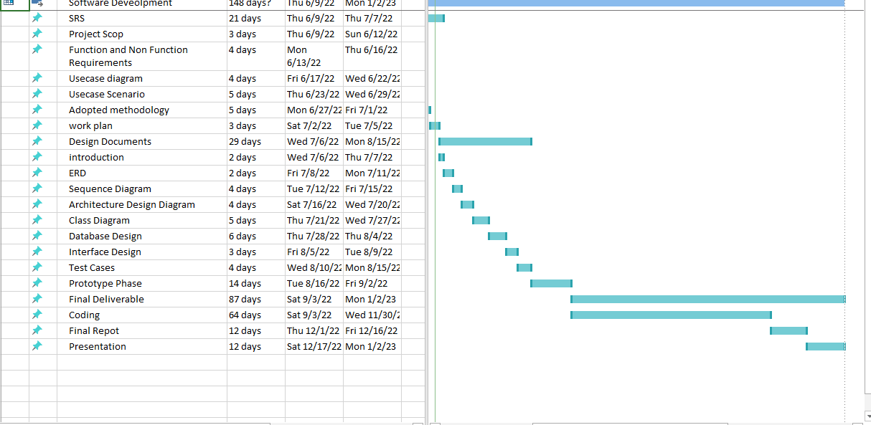

CHAPTER 3
Designing the Project

3.1 Introduction

In this project, we will build a web-based application named as “Micro-Volunteer management System (mVMS)”. Web application the Micro-Volunteer management System (mVMS) is about to facilitate non-profit organization and charity to find skilled persons as volunteers besides donations
3.2 purpose

- Serve as a platform to store volunteer information
- Provide a more efficient way to allocate resources(manpower/volunteer) via scheduling
- Provide a means to track timesheet hours.

3.3 scope

In this project, we will build a web-based application named as “Micro-Volunteer management System (mVMS)”. Web application the Micro-Volunteer management System (mVMS) is about to facilitate non-profit organization and charity to find skilled persons as volunteers besides donations. This application remove crucial part of that is different volunteers will have different skill sets and different charities require volunteers according to their needs as projects. Using this applications organizations will find skilled volunteer according to their needs. This application also help to volunteer to find organization according to their skill on just one move.

  - definitions, acronyms and abbreviations
A functional requirement shows that what the system must do what services the system present to users.

  - Architectural Representation (Architecture Diagram)

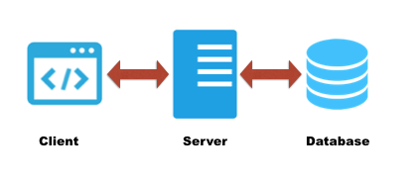

  - Dynamic Model: Sequence Diagrams
register
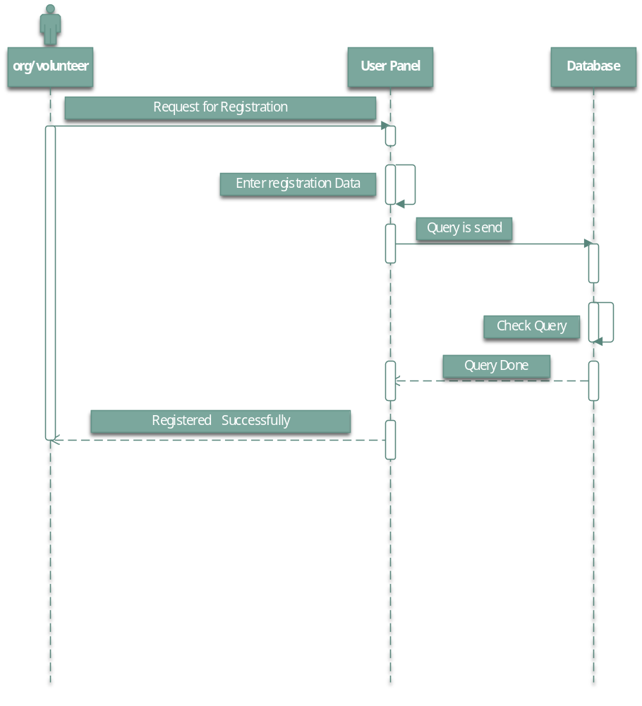

Login
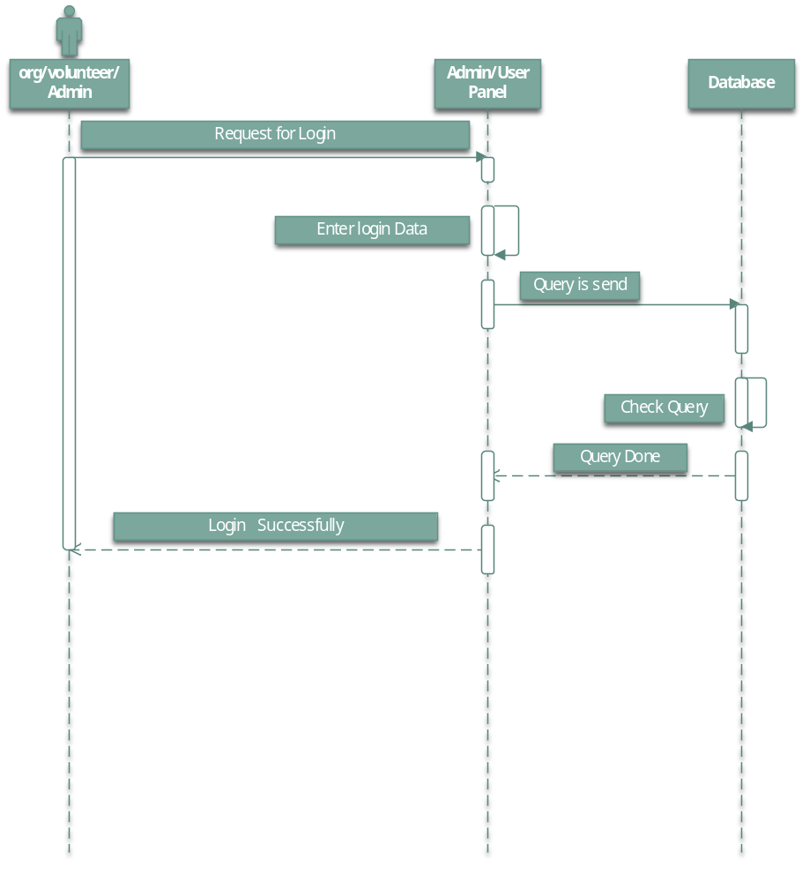
Management
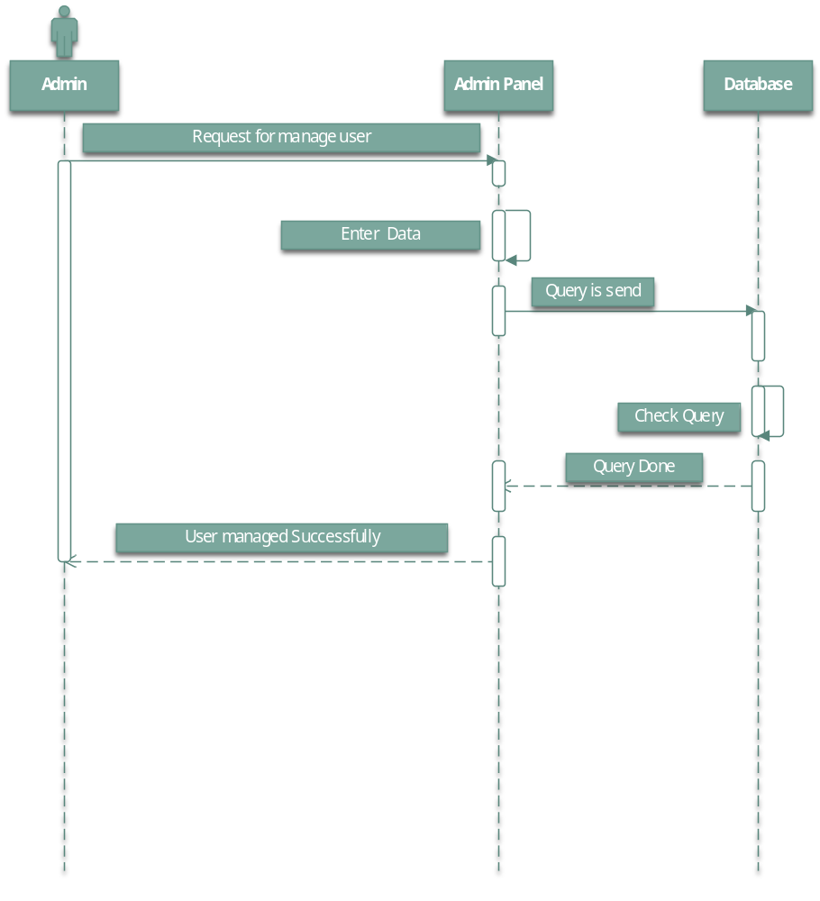
  - Object Model/Logical Model: Class Diagram

Class Diagram, Object Model or Logical Model is a type of structure diagram that describe the structure of a system by showing the system’s classes, their attributes, operation, and the relationship among the objects. The class diagram is the main building block of object-oriented modeling. The classes in a class represent both the main objects, interaction in the application and the classes to be programmed. The class diagram of Micro-Volunteer management System (mVMS) is given below

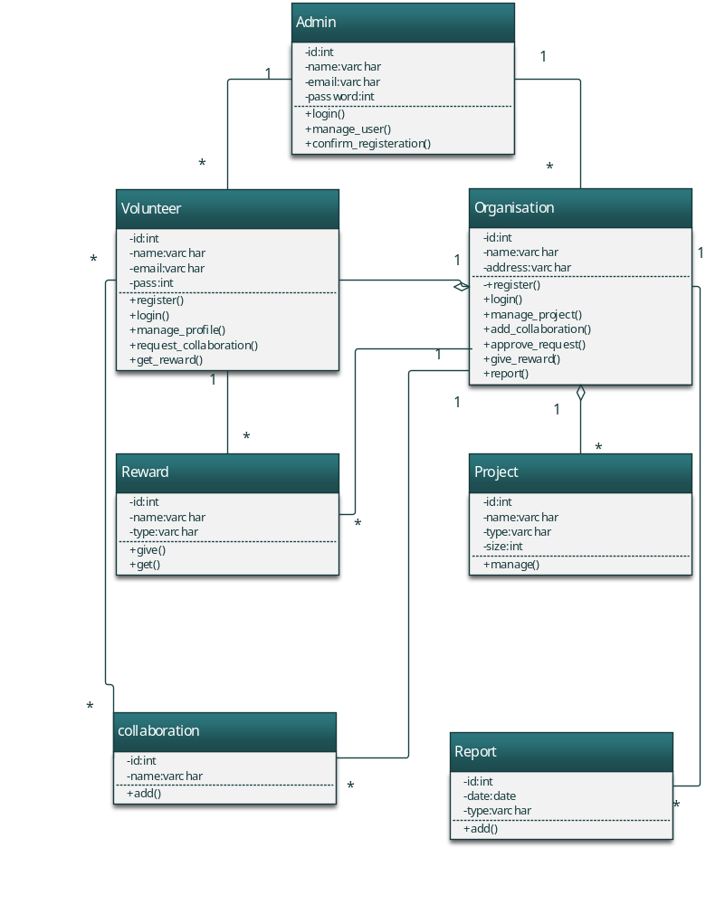
  - Database Model (Database Diagram)
A database model shows the logical structure of a database, including the relationships and constraints that determine how data can be stored and accessed. The database diagram of Micro-Volunteer management System (mVMS) is given below

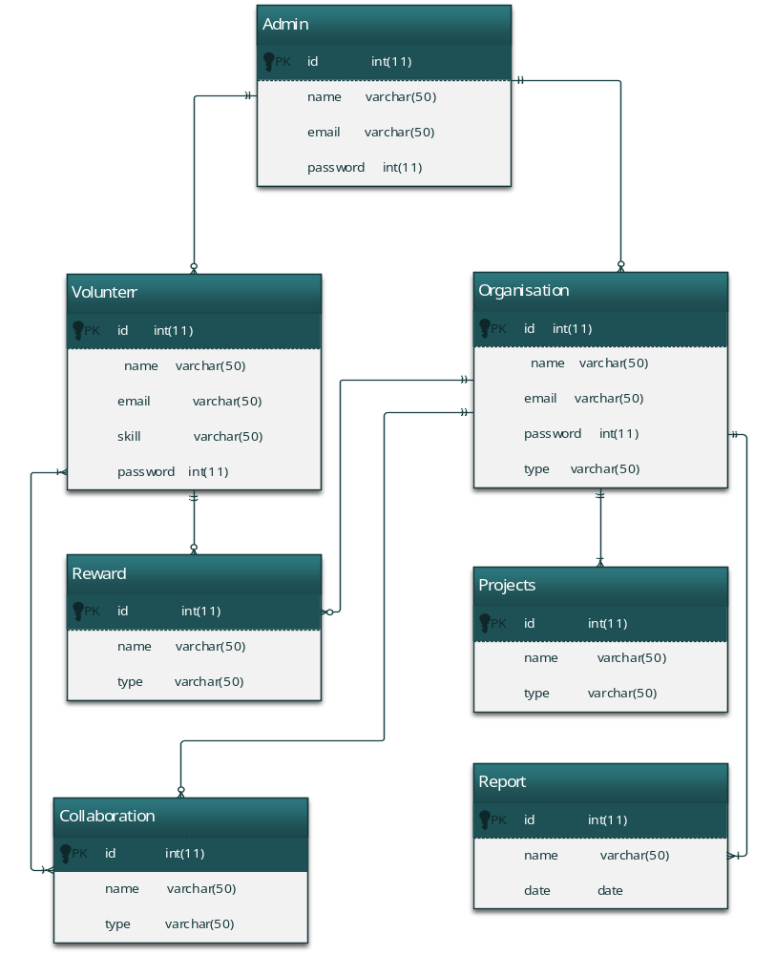

  - Graphical User Interfaces

CHAPTER 4
Development

4.1 Development plan (Architecture Diagram)

REFERENCES

APPENDIX

