Pacific Telecom
Mobility Bill
{{BILL_PERIOD_MONTH}}-{{BILL_PERIOD_YEAR}}
Customer ID : {{CustomerID}}  Customer Name : {{CustomerName}}  Address : {{Address_line1}}  {{Address_line2}}  Bill Period : {{BILL_PERIOD_STARTDATE}} - {{BILL_PERIOD_ENDDATE}}  Bill Date : {{BillDate}} | 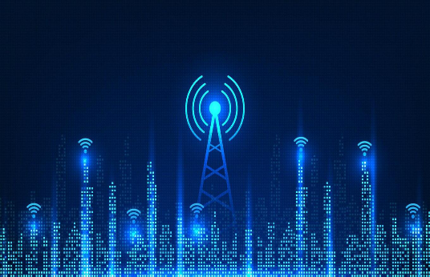

Bill Summary
Monthly Recurring Charges : ₹{{totalMonthlyRecurringCharges}}
Usage Charges: ₹{{totalUsageCharges}}
Other Charges: ₹{{totalOtherCharges}}
Taxes : ₹{{total_taxes}}
Total Amount Due : ₹{{TotalAmount}}
Due Date : {{DueDate}}
Standard Terms and Conditions:
Ipsum lorem Ipsum lorem Ipsum lorem Ipsum lorem Ipsum lorem Ipsum lorem Ipsum lorem Ipsum lorem
Ipsum lorem Ipsum lorem Ipsum lorem Ipsum lorem Ipsum lorem Ipsum lorem Ipsum lorem Ipsum lorem
Ipsum lorem Ipsum lorem Ipsum lorem Ipsum lorem Ipsum lorem Ipsum lorem Ipsum lorem Ipsum lorem

Important Information:
Ipsum lorem Ipsum lorem Ipsum lorem Ipsum lorem Ipsum lorem Ipsum lorem Ipsum lorem Ipsum lorem
Ipsum lorem Ipsum lorem Ipsum lorem Ipsum lorem Ipsum lorem Ipsum lorem Ipsum lorem Ipsum lorem
Ipsum lorem Ipsum lorem Ipsum lorem Ipsum lorem Ipsum lorem Ipsum lorem Ipsum lorem Ipsum lorem

New Products and Services Available:
Ipsum lorem Ipsum lorem Ipsum lorem Ipsum lorem Ipsum lorem Ipsum lorem Ipsum lorem Ipsum lorem
Ipsum lorem Ipsum lorem Ipsum lorem Ipsum lorem Ipsum lorem Ipsum lorem Ipsum lorem Ipsum lorem
Ipsum lorem Ipsum lorem Ipsum lorem Ipsum lorem Ipsum lorem Ipsum lorem Ipsum lorem Ipsum lorem

Customer Specific:
{{Customer_specific_messages}}
Charges Details
Monthly Recurring Charges
Products/Offers | Effective Period | Amt
{%tr for mrc in MrcCharges %}
{{ mrc.planname }} | {{ mrc.startdt }} - {{ mrc.enddt }} | {{ mrc.chrgamt }}
{%tr endfor %}

Usage Charges
Type |  | Total Units Consumed | Free Units | Charged | Rate | Amt
{%tr for uc in UsageCharges %}
{{ uc.servtype }} Call Charges -– {{ uc.category }} |  | {{ uc.totalunit }} | {{ uc.allowance }} | {{ uc.overage }} | {{ uc.rate }} | {{ uc.charge }}
{%tr endfor %}

Other Charges
Products/Offers | Effective Period | Amt
{%tr for oc in OtherCharges %}
{{ oc.chrgdesc }} | {{ oc.chrgdt }} | {{ oc.chrgamt }}
{%tr endfor %}

Call Details

No. | Date | Time | Direction (In/Out) | Called /Calling Number | Category | Duration | Charge
{%tr for call in CallDetails %}
{{call.RowNo}} | {{call.CallDate}} | {{call.CallTime}} | {{call.Direction}} | {{call.PhoneNumber}} | {{call.CallCategory}} | {{call.Duration}} | {{call.CallCharge}}
{%tr endfor %}

