RESULTS

# QUESTION#1

Explain the output of this C program. Why the wrong value is being displayed in the output?

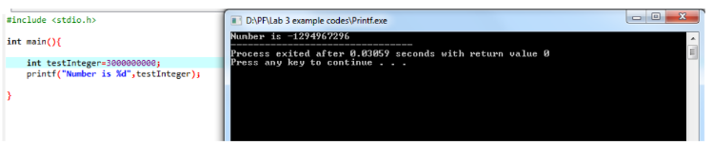

ANSWER: the integer only has 4 bit limit so this number exceeded the 4 bit limit that’s why the output has this incorrect value.

# QUESTION#2

Write a C program that takes two integer values as input from the user. Then swap the values

taken from the user and display the output of the variables.

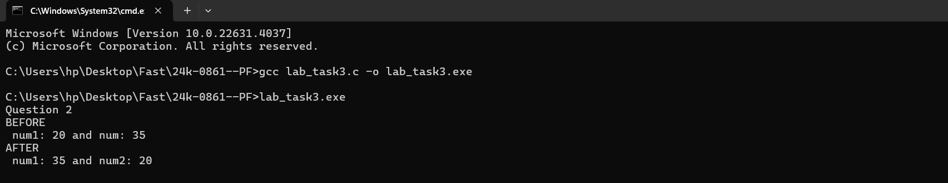

# QUESTION#3

A customer asks the IT firm to develop a program in C language, which can take tax rate and

salary from the user on runtime and then calculate the tax, the user has to pay and the salary

he/she will have after paying the tax. This information is then provided to the user.

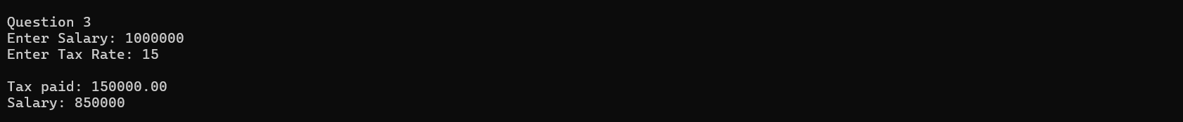

# QUESTION#4

A car travelled back and forth from point A to point B. With a distance being (single trip)

1207KM. During the forward trip fuel price was 118/liter while returning it was 123/liter.

Calculate the total fuel cost (both ways) and the fuel consumed (total trip). Use the car’s fuel

average as input from the user (Input must be positive make some restrictions on only accepting

positive input)



# QUESTION#5

Construct a C program with the flowchart below. The input value of the principle must be

between 100 Rs. To 1,000,000 Rs. The Rate of interest must be between 5% to 10% and Time

Period must be between 1 to 10 years. Hint: these restrictions can be displayed in the form of

message on the window.

# Question#6

Construct a C program where you calculate the slope of two point (5,4), (3,2). Use format

specifiers to cap the result to 3 decimal places.

