To run the Demo, you are recommended to install all the required libraries provided in “requirements.txt” in your terminal via:

* pip install –r requirements.txt



And then to run the Demo via:

* uvicorn main:app



And you may see the following output:

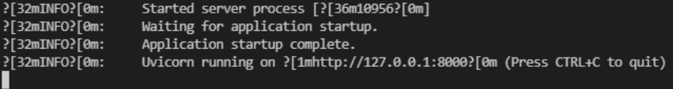

To run the Demo in your browser, you are recommended to use Chrome and install the apps named “web server for chrome”

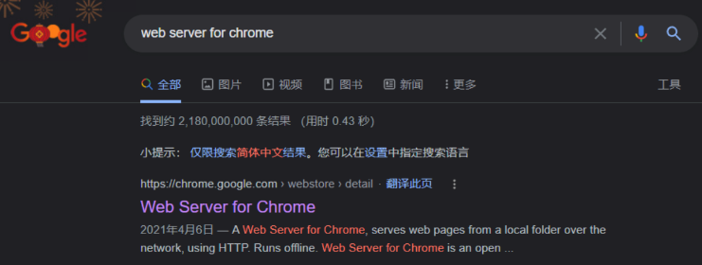

And set up the configuration as follows

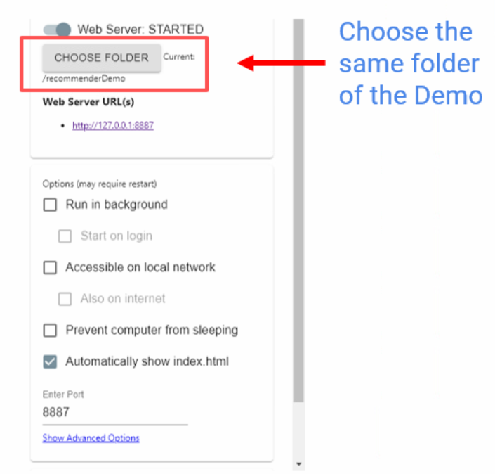

Then you can click the Web Server URL(s) to see the interface of the Web Demo like

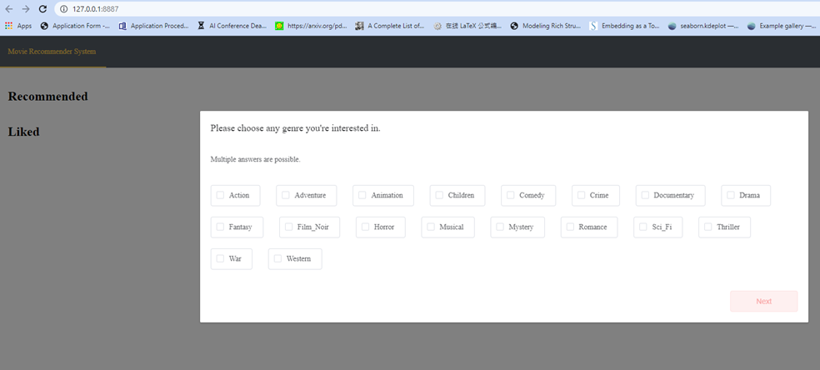

It is a simple Demo which realizes the basic function for recommendation, you can try it by yourself and develop other functions based on that.

If you have any question about the Demo, you can email Jianing Zhu via [csjnzhu@comp.hkbu.edu.hk](mailto:csjnzhu@comp.hkbu.edu.hk)