

UNIVERSITY OF HERTFORDSHIRE

School of Physics, Engineering and Computer Science

MSc in Artificial Intelligence and Robotics

7COM1039-0901-2025-Advanced Computer Science Masters Project
03-11-2025

Interim Progress Report on

J-BOT: An AI Driven Job Recommendation System

Name: Gagan Nagaraja
Student ID: 23071518
Supervisor: Epaminondas Kapetanios

Abstract
Artificial Intelligence and Natural Language Processing play important roles in the job market by enabling the effective analysis of resumes. This innovative research leverages cutting-edge machine learning techniques and advanced NLP algorithms to enhance the recruitment process through improved job matching. The present project is based on recommending appropriate and suitable jobs to the candidates by analysing their resume through an AI-Driven Robot. Presently, the data has been collected from Kaggle containing 962 resume records. The text analytics have been applied to the data through text cleaning, sentiment analysis and resume length analysis. The artefact has been prepared using the Python tool (version 3) using Jupyter Notebook as an IDE.

Table of Contents
1 Introduction 4
1.1 Description OF Research 4
1.1.1 Overview of Research 4
1.1.2 Technologies on Play 4
1.1.3 Challenges 4
1.1.4 Scopes 5
1.1.5 Problem Statement 5
1.2 Research Questions 5
1.3 Aim and Objectives 5
1.3.1 Aim 5
1.3.2 Objectives 6
2 Literature Review 6
2.1 Textual Data Preprocessing Techniques 6
2.1.1 Feature Extraction 6
2.2 Analysis of Resume 6
2.3 Recommendation of Jobs 8
2.3.1 Applying Machine Learning 8
2.3.2 Applying Deep Learning 8
2.4 Research Paper Analysis 9
2.4.1 Identification of Drawbacks and Strengths 9
2.4.2 Research Implications 10
3 Methodology 11
3.1 Proposed Methodology 11
3.1.1 Methodology 11
3.1.2 Description of Works 11
3.2 Data Chosen 12
3.2.1 Origin of Chosen Data 12
3.2.2 Attribute Description 12
3.2.3 Data Description 12
3.2.4 Data Ethics 13
3.3 Selected Tool 13
3.4 Algorithm and Evaluation Process 13
3.4.1 Algorithms Chosen 13
3.4.2 Evaluation Process 14
4 Evidence of Practical Work 14
4.1 Preparation of Artefact 14
4.2 Results Obtained 15
4.2.1 Reading Resume Data 15
4.2.2 Cleaning Resume Texts 15
4.2.3 Sentiment Analysis 15
4.2.4 Analysis of Resume Length 16
4.2.5 Data Visualisation 16
5 Research Issues and Considerations 17
5.1 Social Issues 17
5.2 Legal Issues 17
5.3 Ethical Issues 17
5.4 Professional Issues 18
6 Future work 18
7 Timeline 18
7.1 Gantt Chart 18
7.2 Tasks and Description 19
8 Conclusion 19
References 21
Appendix 24
Code 24

Introduction

Description OF Research

Overview of Research
The advent of artificial intelligence (AI) has revolutionised numerous aspects of our lives, and the job market is no exception. An AI-driven job recommendation system is an innovative approach that leverages the power of machine learning algorithms to connect job seekers with relevant employment opportunities (Bansal , et al., 2017). The concept of an AI-driven job recommendation system is built upon the idea of utilising machine learning algorithms to analyse the preferences, skills, and experiences of job seekers and match them with suitable job openings. This is achieved by collecting and processing vast amounts of data from various sources, including job postings, resumes, and social media profiles. The system's primary objective is to provide personalised job recommendations that cater to the unique needs and aspirations of each individual, thereby enhancing the overall job search experience (Ali, et al., 2022). By streamlining the recruitment process, AI-driven job recommendation systems can significantly reduce the time and effort required for both job seekers and employers to find the perfect match.

Technologies on Play
AI-driven job recommendation systems rely on a range of advanced technologies, including natural language processing (NLP), collaborative filtering, and machine learning. NLP enables the system to extract relevant information from unstructured data, such as job descriptions and resumes, while collaborative filtering helps identify patterns and preferences among job seekers and employers (Kamineni, et al., 2023). Deep learning algorithms, on the other hand, facilitate the development of complex models that can learn from large datasets and make accurate predictions. Additionally, the integration of big data analytics and cloud computing enables the system to handle vast amounts of data and provide scalable solutions.

Challenges
Several challenges may be faced during the commencement of the research. Those are discussed below:
- One of the primary concerns is the issue of data quality and availability, as the system's accuracy relies heavily on the accuracy and completeness of the data used to train the algorithms.
- The system must also contend with issues of bias and fairness, ensuring that the recommendations are unbiased and do not discriminate against certain groups of job seekers.
- Another challenge is the need for continuous updating and refinement of the algorithms to keep pace with the rapidly evolving job market.
- The system must also be designed to provide transparency and explainability, allowing users to understand the reasoning behind the recommendations.

Scopes
The scope of AI-driven job recommendation systems is vast and expanding rapidly. As the job market continues to evolve, these systems can play a vital role in addressing the emerging challenges, such as the rising demand for skilled workers, the increasing complexity of job requirements, and the need for more efficient recruitment processes ( Chandak, et al., 2024). By employing AI and machine learning, job recommendation systems can cover the gap between job seekers and employers, promoting more effective and efficient matching. These systems can also provide valuable insights and analytics to help employers and policymakers better understand the job market and make informed decisions. The recommendation of suitable jobs will be made to the candidates through the AI-Driven agent, which will take a resume as input (Soni & Shah, 2025). This agent will act as a Robot that will analyse the resume and predict the best-suited job for the candidate. Finally, the candidate will be referred to the most suitable job.

Problem Statement
To fully realise the potential of the present research, it is essential to address the problem statements associated with its development, including the need for high-quality data, the prevention of bias and discrimination, and the provision of transparency and explainability. Hence, the problem statement is stated below:
Can the AI-driven Robotic System recommend the correct job to the candidates according to their qualifications described in the resume?

Research Questions
The research questions are stated below:
- How is the application of Artificial Intelligence helpful in analysing the resume for the purpose of recommendation?
- Can the AI-driven robotic system recommend satisfactory jobs to the candidates by analysing the resume?

Aim and Objectives

Aim
The project aims to recommend appropriate jobs through an AI-driven Soft-Robot, which can analyse the resumes of the candidates and suggest the most suitable jobs.

Objectives
The objectives framed for the research to fulfil the aim for AI-driven job recommendations are stated below:
- To develop and execute models related to Natural Language Processing (NLP) and Machine Learning aimed at classifying and predicting job categories through the Multiclass Classification Technique, while also assessing the accuracy to identify the most effective model.
- To evaluate the performance of the most effective model against existing research to ascertain advancements in identifying job categories from candidates' resumes.
- To suggest an appropriate job for the candidate through the Recommendation Robot by analysing the resume text and verifying the recommendation outcomes with actual records to evaluate the real-world impact of the job recommendation system.

Literature Review

Textual Data Preprocessing Techniques

Feature Extraction
Lee et al. (2018) suggested a flexible robot-based recommendation system based on a text-mining methodology that supports non-determined expressions. The system produces flexible reactions of external corpora and a knowledge learning process by integrating the use of TF-IDF and LDA. This allows robots to go beyond set responses, improving human-robot interaction. Experiment findings indicate better accuracy and F-score than when TF-IDF or LDA are used independently.
Yamout & Lakkis (2018) complemented TF-IDF weighting in information retrieval with three methods: DWWA pays more attention to words that appear in several paragraphs, TWA pays more attention to words that appear in titles and opening paragraphs, and FRWWA increases the weight of frequent words. These methods enhance lexical matching and document relevance with the use of the vector space model. The experiments demonstrate that the hybrid method retrieves more relevant documents as compared to basic TF-IDF.
Liang & Niu (2022) applied the text classification using the modification of input structures of TF-IDF and LSTM (bidirectional) models. It employs bidirectional LSTM to decode sequences and extract local features with Text-CNN with the help of a sliding window and word2vec embeddings. Deep learning can be trained to lower manual feature engineering and enhance classification accuracy, which is useful in sentiment analysis, recommendation systems, and intelligent question and answer systems.

Analysis of Resume
According to Kamineni et al. (2023), the automation of resume analysis is essential during recruitment because of the large number of applications. It suggests a solution based on text analysis and classification algorithms, especially the Support Vector Machines, that compare resumes with job descriptions and job roles. It is aimed at streamlining the process of selecting the candidates, and it will be efficient to narrow down to the right candidates, with less manual work and better accuracy in recruiting.
Patil (2023) discussed how to use machine learning to automate personality classification and resume categorisation. K-means clustering is used to predict personality types, and Random Forest is used to help in the resume classification. As the number of remote workers increases after the epidemic, automating the recruitment process, in particular, resumes, will help make it more efficient and minimise possible errors. The suggested system simplifies the process of selecting the applicants and enables quicker and more precise hiring choices in a more digitalised recruitment environment.
Trinh et al. (2023) implemented a domain adaptation algorithm based on a graph neural network (GNN) in the classification of automatic resumes in recruitment databases. It resolves the shortage of labelled resume information by deriving latent job post features and comparing semantic similarity with resumes. The process has been tested on real recruitment data, resulting in the elimination of retraining requirements and high precision, which simplifies the database management and improves hiring efficiency.
As mentioned by Rivest et al. (2021), deep learning classification algorithm is a benchmark process based on convolutional neural networks to analyse the document. The deep learning approach is just as effective compared to the bibliographic coupling, direct citation, and manual classification. Although there is no way of doing it more effectively than direct citation, deep learning will have more opportunities to be improved in the future, particularly with the inclusion of citation network data to improve the level of classification accuracy and scalability.
Ali et al. (2022) proposed an NLP-based and ML-based automated Resume Classification System (RCS) to simplify the screening of an applicant. The system was tested on nine classifiers with TF-IDF features, and the accuracy was more than 96% with One-Vs-Rest SVM. Its reliability is ensured by such metrics as precision, recall, and F-score. The methodology shows good prospects, efficacy, and extensible resume categorisation in the recruitment procedures.
As per Gopalakrishna & Vijayaraghavan (2019), a dynamic resume classifier has been proposed in this research based on ensemble learning and topic modelling to automatically allot projects to IT recruits. It organises the profiles of the candidates into areas of interest and knowledge, using Stack Overflow APIs to create new fields where the confidence levels fail to reach. The model retrains periodically, increases accuracy and flexibility, automating HR efforts, and increasing the efficiency of recruitment in the changing enterprise environment.
As described by Surendiran & Paturu (2023) suggested an automated mechanism of classifying resumes in order to match applicants with the appropriate employment positions to ease the hiring process. It analyses various machine learning models- Decision Tree, Random Forest, KNN and Support Vector to find the most precise model. The solution will minimise manual screening, minimise costs of recruitment, save time and encourage fairness during the recruitment process.

Recommendation of Jobs

Applying Machine Learning
Bhavsar et al. (2024) designed the SATYA AI-based system that automates the process of screening resumes and validating recommendations with the help of NLP, ML and graph-based methods. Having been trained on 1,000 expert-rated resumes, SATYA had 91.4% accuracy, which was higher than the traditional means. It also analysed skills, recommendation credibility and scores of the candidates, providing a scalable interface with Applicant Tracking Systems to improve efficiency in recruitment processes and decision-making in complicated hiring scenarios.
Chandak et al. (2024) proposed a machine learning and NLP-based system that will identify skills on resumes and suggest appropriate job openings. It has a Resume Parser with Python packages such as spaCy and PDFMiner, and a Job Recommender with TF-IDF vectors and cosine similarity to analyse job titles. The strategy makes the hiring process effective through efficient and precise matching of the skills of job applicants with the job vacancies.
Aithal et al. (2023) presented a machine learning-based job recommendation system that is focused on fresh graduates having no experience or awareness. It is based on the educational and skills of the candidates, their interests, and profile information, as well as the company demographics and preferences. The point of the system is to address the traditional constraints of recruitment, simplify job hunting, and provide domain-specific and personalised recommendations, which, in turn, will help to save the time and enhance the precision of the recruitment process.
As described by Singh et al. (2023), a hybrid job recommendation framework that incorporates machine learning and deep learning can enhance the accuracy of the recommendation system. It analyses various types of data and finds multifaceted trends, providing personalised fair suggestions to all demographics. The model can optimise the job market by improving the experience of the candidates and simplifying recruitment in a manner that is inclusive and transparent.
Sahoo et al. (2023) designed an Intelligent Job Recommendation System which employs AI and machine learning to pair candidates with the right jobs. It develops comprehensive profiles of applicants and processes many job advertisements. The system also promotes effectiveness in recruitment by making customised recommendations and visual elucidation of the match, which transforms the employment seek process.

Applying Deep Learning
Soni & Shah (2025) proposed a hybrid AI job recommendation system that operates on deep learning, knowledge graph reasoning, and reinforcement learning. It is proven in practice on real-world data and performs better in terms of recall, precision, and user satisfaction than the traditional methods and provides with personalised, semantic-rich recommendations to digital recruitment sites.
According to Alsaif et al. (2022), the content-based job recommender system allows matching resumes with appropriate job postings and finding the similarity between the skills. It determines the most demanded skills and suggests jobs to the top-n of available jobs, using scraped data on Saudi cities on Indeed. Its effectiveness is tested by decision support measures, which enhance the accuracy of job matching of seekers by multiple offers.
Feng et al. (2019) presented a publication recommender for biomedical publications, Pubmender, which uses word2vec and deep CNNs to provide suggested PubMed journals based on abstracts. It tested Pubmender on a corpus of 880,165 papers and found substantial improvement over currently available systems (e.g., MAS, ACM, CiteSeer, Elsevier’s Journal Finder, and Springer’s Journal Suggester) in top-10, recommendation accuracy.
Pessach et al. (2020) developed a two-phase analytics process using Variable-Order Bayesian Networks to inform HR recruitment decisions. During the first phase, the analytic process estimates the chances of success for each individual if hired, and in the second phase, the analytics suggest ways to improve induction. The analyses were conducted using real recruitment data and were successful, as they improved accuracy, interpretability, diversity and success, while also enhancing the balance between data and decision-making approach to workforce planning.

Research Paper Analysis
The research papers concerning the application of machine learning and other relevant techniques have been done for a job recommendation system. The gaps will be identified by analysing the research papers concerning the applications of their techniques and the drawbacks that were found in that research. Those gaps will be addressed in the present research to frame a better job recommendation system.

Identification of Drawbacks and Strengths
The strengths and drawbacks have been identified from the previous research, which have been presented below:
Table 1 Strengths and Drawbacks in Previous Research Papers
Research | Predicting Model |  | Data Preparation Technique |  |  |  | Model Optimization | Recommendation System Design
Research | Machine Learning | Deep Learning | Data Cleaning | Text Cleaning | Feature extraction | Sentiment Analysis | Model Optimization | General | Interface (AI-Agent)
Kamineni et al. (2023) | Used | Not Used | Used | Used | Used | Done | Used | Not Prepared | Not Designed
Patil (2023) | Used | Not Used | Used | Used | Used | Not Done | Used | Not Prepared | Not Designed
Trinh et al. (2023) | Not Used | Used | Used | Used | Not Used | Not Done | Not Used | Not Prepared | Not Designed
Rivest et al. (2021) | Not Used | Used | Not Used | Used | Not Used | Not Done | Not Used | Not Prepared | Not Designed
Ali et al. (2022) | Used | Not Used | Not Used | Not Used | Used | Not Done | Not Used | Not Prepared | Not Designed
Bhavsar et al. (2024) | Used | Not Used | Not Used | Not Used | Used | Done | Not Used | Not Prepared | Designed
Chandak et al. (2024) | Used | Not Used | Not Used | Not Used | Used | Done | Not Used | Not Prepared | Not Designed
Aithal et al. (2023) | Used | Not Used | Not Used | Used | Used | Not Done | Used | Prepared | Not Designed
Singh et al. (2023) | Used | Not Used | Not Used | Used | Used | Not Done | Used | Prepared | Not Designed
Sahoo et al. (2023) | Used | Not Used | Not Used |  | Used | Not Done | Used | Not Prepared | Not Designed
Soni & Shah (2025) | Used | Not Used | Not Used | Used | Used | Done | Not Used | Not Prepared | Not Designed
Alsaif et al. (2022) | Not Used | Used | Not Used | Used | Not Used | Not Done | Not Used | Not Prepared | Designed
Feng et al. (2019) | Not Used | Used | Not Used | Not Used | Not Used | Not Done | Not Used | Not Prepared | Not Designed
Pessach et al. (2020) | Not Used | Used | Not Used | Not Used | Not Used | Not Done | Not Used | Prepared | Not Designed

Research Implications
The drawbacks and strengths of the research papers have been presented in the previous table. Based on those identifications, the implications have been planned for the present research which are stated below:
Table 2 Gap and Implications
Gaps | Respective Implications
The application of Machine Learning and Deep Learning or Neural Network models has not been seen together. | The algorithms from both categories will be chosen and applied for job classification and recommendations.
Few researchers have employed model optimisation. | Chosen models will be optimised using the grid-search method through a cross-validation process.
The agent for job recommendation has not been designed widely. | The AI-based robotic agent will be designed for analysing resumes and recommending jobs.
Sentiment Analysis for job recommendations has not been done widely. | Sentiment Analysis for job recommendations will be done for job recommendations.

Methodology

Proposed Methodology

Methodology
The research includes two major sections, based on which the complete project will commence. The first part of the project is the application of artificial intelligence for data analytics and the prediction of jobs by analysing the resume. In this section, the optimum model (based on the top accuracy among the algorithms applied) will be stored in the device (such as a Laptop). This model will be integrated with the Job Recommendation System (J-Bot), which is the second section of the research and the implementation of the J-Bot. The proposed methodology has been presented below:
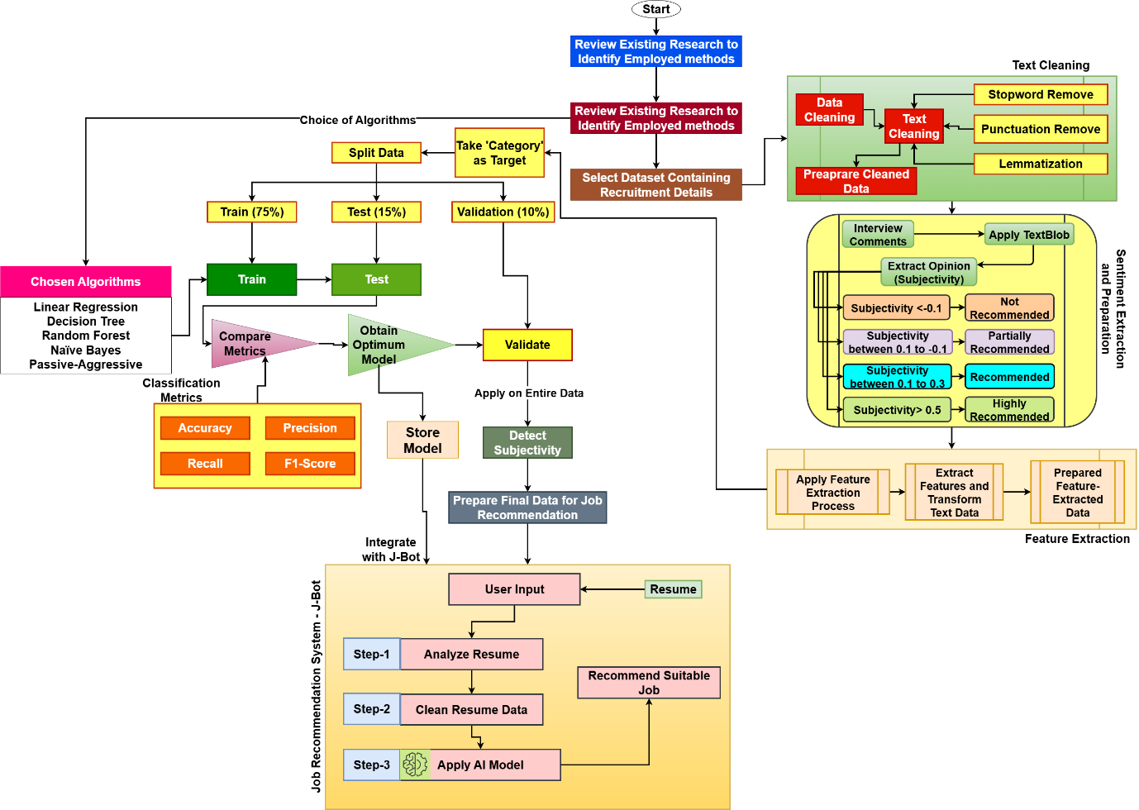
Figure 1 Proposed Methodology

Description of Works
The works that are included in the research are stated below according to the proposed methodology:
- The review of existing research papers will be conducted to identify applicable artificial intelligence algorithms for job classification and recommendations. This comprehensive analysis will not only focus on the methodologies employed in previous studies but will also examine the gaps identified in this existing research. These gaps will be addressed and incorporated into the present research framework, allowing for a more effective approach for job recommendations.
- In the next phase, the dataset will be selected, which will include resumes along with corresponding job categories.
- The natural language processing (NLP) techniques will be employed to prepare the data, utilising various text analytics processes. This will include tasks such as text cleaning to remove any irrelevant information, feature extraction to identify key components of the resumes, and sentiment analysis to gauge the overall tone and context of the resumes relative to the jobs they correspond to.
- Once the data has been prepared, the various artificial intelligence algorithms will be prepared and applied to effectively classify the jobs. The aim will be to determine the optimum model, which will be selected based on the highest accuracy achieved during testing with unseen data. Once established, this model will be stored on the device so that it can be integrated with J-Bot.
- Finally, a job recommending robot, referred to as J-Bot, will be developed, integrating the optimum model that has been established. This J-Bot will function by analysing the resumes submitted by candidates and providing tailored job recommendations that align closely with their qualifications and experiences.

Data Chosen

Origin of Chosen Data
The dataset chosen for this project, aimed at job classification and recommendation, will be taken from Kaggle, a well-known platform for data science and machine learning resources (Gaurav, 2020). This particular dataset comprises 25 distinct job categories and a total of 962 job records. These categories will serve as the classes within the dataset and will be utilised during the process of predicting various job types. Each job record provides valuable insights that will enhance the recommendation system, allowing for more accurate and personalised job suggestions.

Attribute Description
The dataset includes two primary attributes, each of which is detailed below:
- Category: The first attribute is the Category, which refers to the specific job category associated with the resume that the job seeker has uploaded and submitted to the organisation. This dataset encompasses a diverse range of job categories, allowing for a comprehensive analysis of various professions and roles.
- Resume: The second attribute is Resume, where the actual textual content of the resume is stored. Here, a total of 962 resumes has been enlisted. This feature contains all the textual data that will serve as the foundation for various text analytics processes. These processes include text cleaning, sentiment extraction, and feature extraction, among others.

Data Description
The information of the data, as obtained from the data origin, is given below:
- Size of Data: 3.11 MB
- Data Format: CSV Data
- Number of Features: 2
- Number of Instances: 962
- Types of Variables: Categorical and Textual Features
- Hosted By: Kaggle
- Host of Data in Kaggle: Gaurav Dutta
- Data Licence: CC0: Public Domain

Data Ethics
The data for job recommendations has been selected from Kaggle. This particular dataset can be accessed without the need for any registration or special permissions, making it easily available for users interested in this area of research or application (EPRS, 2020). Furthermore, it is important to note that this dataset is provided under an open-source license, specifically CC0: Public Domain, which allows for unrestricted usage by individuals and organizations alike.
Given that the data can be accessed freely, there are no ethical concerns associated with its use. This openness enables researchers and developers to harness the data for a variety of purposes, including enhancing job matching algorithms, conducting analyses, or developing educational tools without encountering legal hurdles (Burrell, 2016). Additionally, the dataset is devoid of any personal information, which significantly reduces the risk of ethical conflicts and ensures the privacy of individuals is maintained.

Selected Tool
Python version 3 will be selected for the research and development of the artefact. Consequently, the job recommendation artefact will be created and executed using the Jupyter Notebook IDE. Python has been chosen as the programming language for several compelling reasons, including the extensive availability of libraries, strong community support, and the overall ease of coding, particularly in the fields of Natural Language Processing and Artificial Intelligence (Aithal S, et al., 2023). These features make Python an ideal choice for developing sophisticated models that can efficiently analyse data and generate insightful recommendations for job seekers.

Algorithm and Evaluation Process

Algorithms Chosen
The study and evaluation of past research papers have chosen the artificial intelligence algorithms. This choice process helps to enable a straight comparison of job classification performance using the allocated dataset against the benchmarks established by earlier research, hence allowing for a thorough assessment of the current project's progress. Utilizing this approach, the current project's better job classification and recommendations can be shown dramatically against those of therefore justifying the strategic approach used in improving job classification techniques. Hence, the selected algorithms of AI and their justifications are listed below:
Table 3 Chosen Algorithms
Selected Algorithm | Employed by Earlier Researchers
Random Forest | Ali et al. (2022)  Surendiran & Paturu (2023)  Chandak et al. (2024)
Naïve Bayes | Gopalakrishna & Vijayaraghavan (2019)  Sahoo et al. (2023)
Logistic Regression | Bhavsar et al. (2024)  Surendiran & Paturu (2023)  Gopalakrishna & Vijayaraghavan (2019)
K-Neighbours | Surendiran & Paturu (2023)  Ali et al. (2022)
Decision Tree | Surendiran & Paturu (2023)  Gopalakrishna & Vijayaraghavan (2019)  Bhavsar et al. (2024)

Evaluation Process
The evaluation process will be done by comparing the effectiveness of the applied AI models. The concerned effectiveness for these measures as accuracy, precision, etc. The evaluation metrics and their relevant equations are presented below:
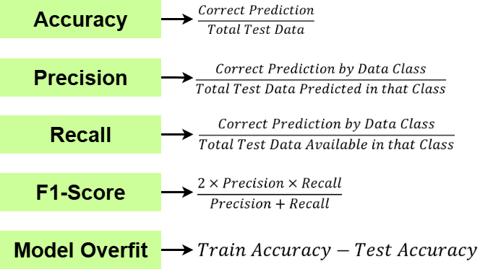
Figure 2 Evaluation Metrics and Equations

Evidence of Practical Work

Preparation of Artefact
The process was initiated by extracting the resume dataset and converting it into a format suitable for AI applications using text analytics. The dataset was then imported into the Jupyter notebook through the Python tool for further analysis.
Currently, the data has undergone thorough cleaning through a text cleaning procedure. Furthermore, sentiment analysis was performed to identify the subjective aspects of the resumes. Additionally, the data was visualised to provide a more comprehensive representation of the information gathered. The various steps taken highlight the meticulous approach to handling and analysing the resume dataset for better insights and decision-making.

Results Obtained

Reading Resume Data
The data has been accessed through the chosen tool (Python v3) through the Jupyter notebook IDE. The data comprises two categorical features: 'Category', which defines the various job types represented, and 'Resume', which contains the text of the resumes themselves. In total, the dataset includes 962 resume records. The feature information reveals that, out of these 962 resume records, none of the features have any null values, indicating that the dataset is complete and does not require further data cleaning at this stage. The data is shown below:
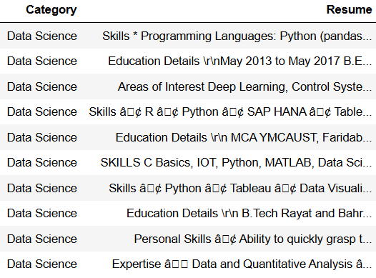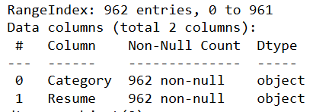
Figure 3 Data Reading

Cleaning Resume Texts
The resume text contains a number of discrepancies, including the presence of stop words, numerical values, and special characters that may affect the quality of the analysis. To address these issues, various natural language processing (NLP) techniques have been employed to clean the texts effectively, ensuring that the text is more suitable for subsequent processing and analysis. The process and outcomes are shown below:
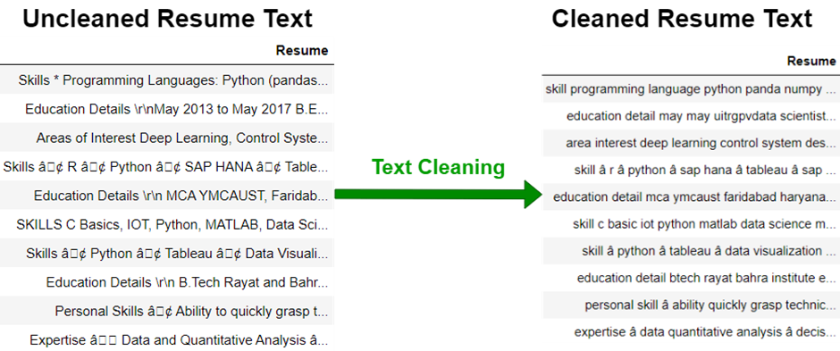
Figure 4 Text Cleaning and Outcomes

Sentiment Analysis
The recommendation sentiments have been prepared from the data by extracting subjectivity from the resume texts. This will play an important role in the job recommendation process. This subjectivity has been extracted from the resume text using the TextBlob module within the Python programming environment. By analysing the emotional tone and personal perspectives reflected in the resumes, valuable insights can be gained into the candidates' qualifications and preferences. These insights will enhance the recommendation system's ability to match candidates with job opportunities that suit their skills and aspirations more closely. The recommendation sentiment preparation values are shown below:
Table 4 Preparation of Recommendation Sentiments
Recommendation Type | Values of Resume Subjectivity
Highly Recommended | The value higher than 0.5
Partially Recommended | The values between 0.1 and -0.1
Recommended | The values between 0.3 and 0.1
Less Recommended | Otherwise

After applying the filter, the subjectivity values and the corresponding recommendation sentiments have been stored in the data as shown below:
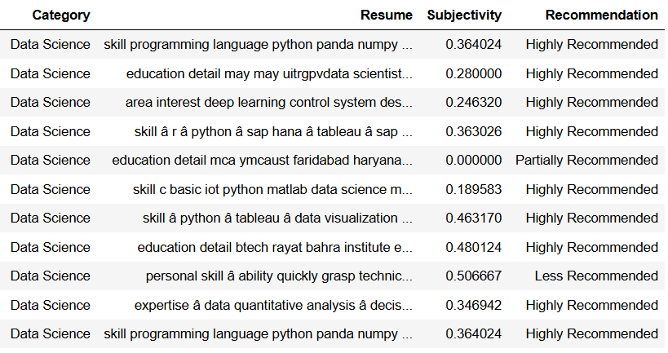
Figure 5 Data With Recommendation Sentiments and Subjectivities

Analysis of Resume Length
The lengths of the resumes (computed by taking the sum of all stored and cleaned characters of a resume) have been analysed and stored in the data as shown below:
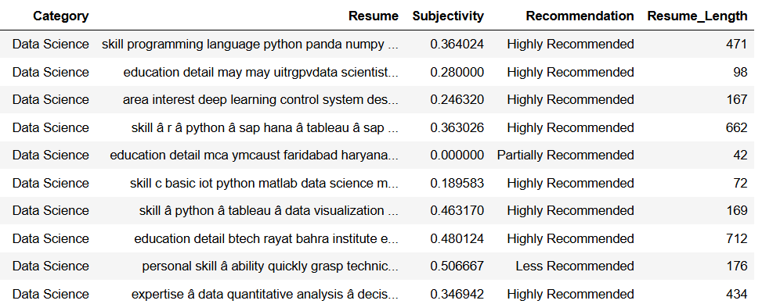
Figure 6 Resume Length Computation

Data Visualisation
The features of the data have been analysed and presented below in the form of graphs:
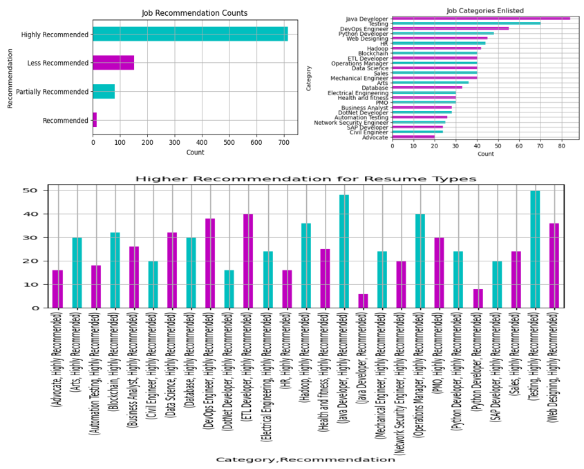
Figure 7 Data Visualisation

Research Issues and Considerations

Social Issues
The system must consider the potential impact on the job market, including the risk of exacerbating existing inequalities and biases (Burrell, 2016). For instance, if the algorithm is trained on historical data that reflects discriminatory hiring practices, it may perpetuate these biases, leading to unfair treatment of certain groups of people. Furthermore, the system must be designed to ensure accessibility and usability for all individuals, regardless of their socio-economic background, age, or abilities.

Legal Issues
The present research must comply with existing laws and regulations, such as equal employment opportunity laws and data protection regulations (Suen, 2016). The system must ensure that it does not discriminate against individuals based on protected characteristics, such as race, gender, or age, and that it obtains informed consent from users before collecting and processing their personal data (Barocas & Selbst, 2016). Additionally, the system must be transparent about its decision-making processes and provide explanations for its recommendations, to enable users to understand and challenge the outcomes if necessary.

Ethical Issues
Ethically, the research raises concerns about accountability, transparency, and fairness. The system must be designed to prioritise the well-being and interests of its users, ensuring that its recommendations are in their best interests and do not prioritise the interests of employers or other stakeholders over those of the job seekers (Taylor, 2017). The system must also be transparent about its limitations and potential biases, and provide users with the opportunity to correct or disagree with its recommendations. Moreover, the system must be designed to respect the autonomy and privacy of its users, ensuring that their personal data is protected and not used for unauthorised purposes (Derakhshan, 2017).

Professional Issues
The development and implementation of an AI-driven job recommendation system require careful consideration of the potential impact on the careers and livelihoods of its users (EPRS, 2020). The system must be designed to provide accurate and reliable recommendations, and to ensure that users are not misled or deceived by its outputs. The system must also be designed to respect the professional boundaries and expertise of recruiters, hiring managers, and other stakeholders, ensuring that its recommendations are seen as augmenting, rather than replacing, human judgment and expertise.

Future work
The research began by collecting and understanding initial concepts and comprehending the key challenges associated with resume analysis and job recommendations. This initial phase involved a comprehensive review of existing research papers in the field, enriching the project's foundation with valuable insights and perspectives. Subsequently, substantial progress has been made in the creation of the project artefact, laying the groundwork for further development. Moving forward, the next phase will focus on refining the artefact through the strategic implementation of advanced AI tools geared towards enhancing resume analysis and job recommendations. This step will employ advanced technologies to ensure the project meets its objectives and delivers innovative solutions. As the project evolves, present research work will be conducted and comprehensive documentation will be prepared, culminating in the finalisation of the project.

Timeline

Gantt Chart
The Gantt chart containing the approximate dates and the tasks to be commenced is presented below:
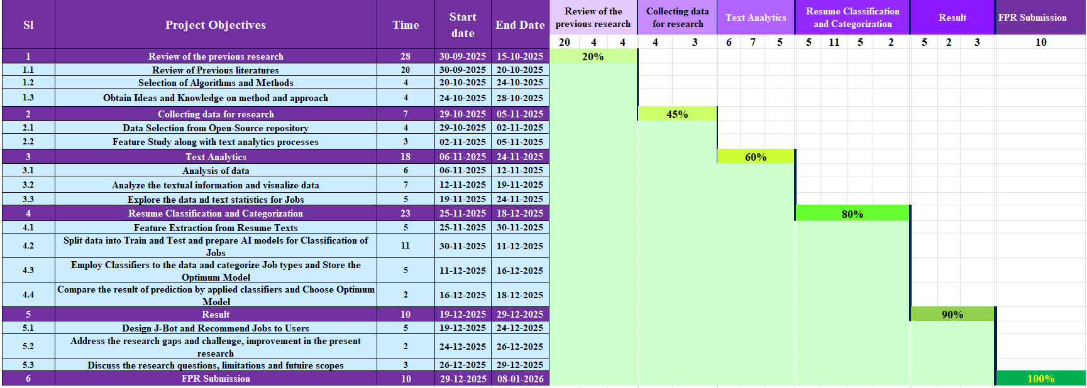
Figure 8 Gantt Chart

Tasks and Description
The tasks are described below:
- In the initial phase of the research, an introductory study will be conducted to delve into text analytics applied to resume data and job recommendations. This will be followed by the formulation of the research aim, research questions, problem statement, and objectives to guide the study effectively.
- A comprehensive review of existing research papers on text analytics related to resume data and job recommendations will be undertaken to explore the utilisation of machine learning and identify any research gaps that could be addressed.
- The research methodology will be meticulously crafted, encompassing the selection of an appropriate dataset, tools, algorithms, and evaluation methods to ensure a robust framework for the study.
- Taking a hands-on approach, coding will be developed based on the established research methodology using the selected tool, incorporating the chosen dataset to drive the analysis further.
- The outcomes acquired from the coded artefacts pertaining to text sentiment detection will form the basis for presenting the results derived from the study, shedding light on the effectiveness of the applied methods.
- A thorough comparison of the performance metrics of the selected algorithms will be conducted to ascertain the most optimal model that can achieve the highest accuracy in detecting text sentiments.
- Finally, a comprehensive evaluation of the performance will be carried out, aligning with the research questions to provide insightful conclusions based on the outcomes derived from the study artefacts.

Conclusion
The current research is primarily dedicated to job recommendation, which involves the thorough analysis of a candidate's resume using advanced AI techniques. This research has already initiated various stages such as conducting a comprehensive literature review, formulating a robust methodology, gathering relevant data, and selecting appropriate tools, along with detailed descriptions of the algorithms being employed. The practical implementation has also begun, which entails loading and accessing database files, performing text analytics, and conducting sentiment analysis to extract valuable insights.

References
Chandak, A. V., Pandey, H., Rushiya, G. & Sharma, H., 2024. Resume Parser and Job Recommendation System using Machine Learning. 2024 International Conference on Emerging Systems and Intelligent Computing (ESIC).
Gopalakrishna, S. T. & Vijayaraghavan, V., 2019. Automated Tool for Resume Classification Using Sementic Analysis. International Journal of Artificial Intelligence and Applications (IJAIA), Vol.10, No.1.
Jain, T. J. S., Jacob, I. J. & Mandava, A. K., 2023. SRNN-MAFM-based Unimodal Text Sentiment Analysis. 2023 International Conference on Applied Intelligence and Sustainable Computing (ICAISC).
Junior , A. P. C., Wainer, G. A. & Calixto, W. P., 2022. Weighting construction by bag-of-words with similarity-learning and supervised training for classification models in court text document. Applied Soft Computing.
Li , P. et al., 2020. Bag-of-Concepts representation for document classification based on automatic knowledge acquisition from probabilistic knowledge base. Knowledge-Based Systems.
Surendiran, B. & Paturu, T., 2023. Resume Classification Using ML Techniques. 2023 International Conference on Signal Processing, Computation, Electronics, Power and Telecommunication (IConSCEPT).
Aithal S, S. K., S, S., M, A. S. & S, S. K., 2023. Machine Learning based Ideal Job Role Fit and Career Recommendation System. 2023 7th International Conference on Computing Methodologies and Communication (ICCMC).
Ali, I. et al., 2022. Resume Classification System using Natural Language Processing and Machine Learning Techniques. Mehran University Research Journal of Engineering and Technology.
Alsaif, S. A. et al., 2022. Learning-Based Matched Representation System for Job Recommendation. MDPI.
Bansal , S., Srivastava, A. & Arora , A., 2017. Topic Modeling Driven Content Based Jobs Recommendation Engine for Recruitment Industry. Procedia Computer Science.
Barocas, S. & Selbst, A. D., 2016. Big data's disparate impact. California Law Review, Volume 104, pp. 665-671.
Bhavsar, N. et al., 2024. SATYA: Smart AI-driven Talent Yield Analyzer for Resume Screening and Recommendation Evaluation. 2024 4th International Conference on Robotics, Automation and Artificial Intelligence (RAAI).
Burrell, J., 2016. How the machine 'thinks': Understanding opacity in machine learning algorithms. Big Data & Society, pp. 1-7.
Dash, A., Mohanty, A. & Ghosh, S., 2023. Advanced NLP Based Entity Key Phrase Extraction and Text-Based Similarity Measures in Hadoop Environment. 2023 6th International Conference on Information Systems and Computer Networks (ISCON).
Derakhshan, W. &., 2017. Information Disorder: Toward an Interdisciplinary Framework for Research and Policy Making, London: Council of Europe Report.
EPRS, 2020. The impact of the General Data Protection Regulation (GDPR) on artificial intelligence. Panel for the Future of Science and Technology, Issue https://www.europarl.europa.eu/RegData/etudes/STUD/2020/641530/EPRS_STU(2020)641530_EN.pdf.
Feng , X. et al., 2019. The Deep Learning–Based Recommender System “Pubmender” for Choosing a Biomedical Publication Venue: Development and Validation Study. National library of medicine.
Gaurav, D., 2020. Dataset containing resume from different profession. [Online]
Available at: https://www.kaggle.com/datasets/gauravduttakiit/resume-dataset
[Accessed 2025].
Guo, A. & Yang, T., 2016. Research and improvement of feature words weight based on TFIDF algorithm. 2016 IEEE Information Technology, Networking, Electronic and Automation Control Conference.
Kamineni, G., Sai, K. A. & Rao, G. S. N., 2023. Resume Classification using Support Vector Machine. 2023 3rd International Conference on Pervasive Computing and Social Networking (ICPCSN).
Kuilboer, J.-P. & Stull, T., 2021. Text Analytics and Big Data in the Financial domain. 2021 16th Iberian Conference on Information Systems and Technologies (CISTI).
Kurek , J. et al., 2024. Zero-Shot Recommendation AI Models for Efficient Job–Candidate Matching in Recruitment Process. MDPI.
Lee, N., Kim, E. & Kwon, O., 2018. Combining TF-IDF and LDA to generate flexible communication for recommendation services by a humanoid robot. Springer Science+Business Media, LLC..
Liang , M. & Niu , T., 2022. Research on Text Classification Techniques Based on Improved TF-IDF Algorithm and LSTM Inputs. Procedia Computer Science.
Liang, Y., Lin, Z., Shi, X. & Ma, H., 2023. Fast and Accurate Resume Parsing Method Based on Multi-Task Learning. 2023 International Conference on Asian Language Processing (IALP).
Marinov, M. & Efremov, A., 2019. Representing Character Sequences as Sets : A simple and intuitive string encoding algorithm for NLP data cleaning. 2019 IEEE International Conference on Advanced Scientific Computing (ICASC).
Parida, B., KumarPatra, P. & Mohanty, S., 2022. Prediction of recommendations for employment utilizing machine learning procedures and geo-area based recommender framework. Sustainable Operations and Computers.
Patil, R., 2023. Resume classification-based on personality using Machine Learning Algorithm. International Journal of Scientific and Research Publications.
Pessach, D. et al., 2020. Employees recruitment: A prescriptive analytics approach via machine learning and mathematical programming.
Qais, E. & M. N., V., 2023. TxtPrePro: Text Data Preprocessing Using Streamlit Technique for Text Analytics Process. 2023 International Conference on Network, Multimedia and Information Technology (NMITCON).
Qaiser, S. & Ali, R., 2018. Text Mining: Use of TF-IDF to Examine the Relevance of Words to Documents. International Journal of Computer Applications.
Rivest, M., Vignola-Gagné, E. & Archambault, É., 2021. Article-level classification of scientific publications: A comparison of deep learning, direct citation and bibliographic coupling. research collaboration.
Sahoo, D. et al., 2023. Designed Framework for Advanced Intelligent Job Recommendation System. 2023 OITS International Conference on Information Technology (OCIT).
Singh, D., Patel, N. & Singh, U., 2023. Method for Job Recommendation based on Machine Learning and Deep Learning Model. 2023 2nd International Conference on Automation, Computing and Renewable Systems (ICACRS).
Soni, S. & Shah, S., 2025. Job Recommendation Systems Through AI and Machine Learning. International Journal of Basic and Applied Sciences.
Suen, A., 2016. Technological Unemployment: Educating for the Fourth Industrial Revolution.. Journal of Self-Governance and Management Economics, 4(3), pp. 25-33.
Taylor, L., 2017. What is data justice? The case for connecting digital rights and freedoms globally. Big Data & Society, 4(2), pp. 1-8.
Trinh, T.-T.-Q., Chung , Y.-C. & Kuo, R., 2023. A domain adaptation approach for resume classification using graph attention networks and natural language processing. Knowledge-Based Systems.
Xu, Q. et al., 2020. A Block-Level RNN Model for Resume Block Classification. 2020 IEEE International Conference on Big Data (Big Data).
Yamout, F. & Lakkis, R., 2018. Improved TFIDF weighting techniques in document Retrieval. 2018 Thirteenth International Conference on Digital Information Management (ICDIM).

Appendix

Code
import nltk
nltk.download('punkt')
nltk.download('stopwords')
nltk.download('wordnet')
from textblob import TextBlob
from nltk import corpus
import datetime
stop_words = list(corpus.stopwords.words('english'))
from nltk.corpus import stopwords
from nltk.stem import WordNetLemmatizer
lemmatizer = WordNetLemmatizer()
import numpy, pandas, matplotlib.pyplot as rsmvs, seaborn, wordcloud
import sklearn
from sklearn import metrics,model_selection,preprocessing, utils,pipeline,preprocessing
from sklearn.utils import resample
from sklearn.feature_extraction.text import TfidfVectorizer, CountVectorizer
from plotly import express
RCJob=pandas.read_csv("UpdatedResumeDataSet.csv")
ClfResume=RCJob.copy()
ClfResume.head(10)
ClfResume.info()
pandas.DataFrame(ClfResume['Category'].value_counts()[::-1]).to_csv("JC.csv")
ClfResume['Category'].value_counts()[::-1].plot(kind='barh', title="Job Categories Enlisted", figsize=(6,4), color=["m","c"])
rsmvs.xlabel("Count")
rsmvs.grid()
rsmvs.show()
def LmtzResumeTokens(rusmlm):
return [lemmatizer.lemmatize(lm) for lm in rusmlm]
def CleanResume(rusmdt):
rusm_stp = list(stopwords.words('english'))
rusm_pcl=""
rusm_tg=["rt","RT","http","HTTP","https","HTTPS","com","COM"]
for tt in rusmdt:
if tt.isalpha()==True:
rusm_pcl+=tt
if tt.isalnum()==False:
pass
if tt==" ":
rusm_pcl+=" "
rusm_pcl=rusm_pcl.lower()
rusm_tk=rusm_pcl.split()
rusm_tk1=[]
for t1 in rusm_tk:
if t1 not in rusm_tg:
rusm_tk1.append(t1)
rusm_tk2=[]
for t2 in rusm_tk1:
if t2 not in rusm_stp:
rusm_tk2.append(t2)
rusm_tk2=LmtzResumeTokens(rusm_tk2)
return ' '.join(rusm_tk2)
RsmFetCl=[]
rstxts=ClfResume["Resume"].tolist()
for x in rstxts:
RsmFetCl.append(CleanResume(x))
ClfResume['Resume']=RsmFetCl
ClfResume.head(10)
Rusm_FetCl=ClfResume['Resume'].tolist()
rusm_sbval=[]
rusm_recom_type=[]
for i in Rusm_FetCl:
tbresume=TextBlob(str(i)).sentiment
rusm_sbval.append(tbresume[1])
for i in range(len(rusm_sbval)):
if rusm_sbval[i]<0.5 and rusm_sbval[i]>0.1:
rusm_recom_type.append("Highly Recommended")
elif rusm_sbval[i]<0.3 and rusm_sbval[i]==0.1:
rusm_recom_type.append("Recommended")
elif rusm_sbval[i]<0.1 and rusm_sbval[i]>=-0.1:
rusm_recom_type.append("Partially Recommended")
elif rusm_sbval[i]>0:
rusm_recom_type.append("Less Recommended")
else:
rusm_recom_type.append("Not Recommended")
ClfResume['Subjectivity']=rusm_sbval
ClfResume['Recommendation']=rusm_recom_type
ClfResume=ClfResume.reset_index(drop=True)
ClfResume.head(20)
print(ClfResume['Recommendation'].value_counts())
ClfResume['Recommendation'].value_counts()[::-1].plot(kind='barh', title="Job Sentiment Counts", figsize=(6,3),color=["m","c"])
rsmvs.xlabel("Count")
rsmvs.grid()
rsmvs.show()
rslist=ClfResume['Resume'].tolist()
lenresume=[]
for l in range(len(rslist)):
lenresume.append(len(rslist[l].split()))
ClfResume['Resume_Length']=lenresume
ClfResume.head(10)

ClfResume.groupby('Category').agg({'Resume_Length':numpy.mean}).sort_values(by=('Resume_Length')
,ascending=False).plot(kind='barh', title="Resume Category with Length", figsize=(6,4), color=["m","c"])
rsmvs.grid()
rsmvs.show()

ClfResume.groupby('Recommendation').agg({'Resume_Length':numpy.mean}).sort_values(by=('Resume_Length')
,ascending=False).plot(kind='barh', title="Resume Length by Sentiment", figsize=(6,3), color=["m","c"])
rsmvs.grid()
rsmvs.show()

ClfResume.groupby(['Category','Recommendation']).size().plot(kind='bar',
figsize=(10,4), title='Recommendation for Resume Types', color=["m","c"])
rsmvs.grid()
rsmvs.show()

RcmJD=ClfResume[(ClfResume['Recommendation']=='Recommended')|(ClfResume['Recommendation']=='Highly Recommended')]
RcmJD.groupby(['Category','Recommendation']).size().plot(kind='bar', figsize=(7,4),
title='Higher Recommendation for Resume Types', color=["m","c"])
rsmvs.grid()
rsmvs.show()

print(ClfResume.Category.value_counts())
rsmct=ClfResume.Category.value_counts().index.tolist()
rsmvl=ClfResume.Category.value_counts().tolist()
mxval=max(rsmvl)
blncd_rusm=[]
for ac in rsmct:
bldf=ClfResume[ClfResume['Category']==ac]
bldf=utils.resample(bldf, replace = True, n_samples = mxval, random_state = 0)
blncd_rusm.append(bldf)
ClfResumeBlnc=pandas.concat(blncd_rusm).sample(frac=1).reset_index(drop=True)
print(ClfResumeBlnc.Category.value_counts())
print(len(ClfResumeBlnc.Category.value_counts()))

Double click to open the PDF File

