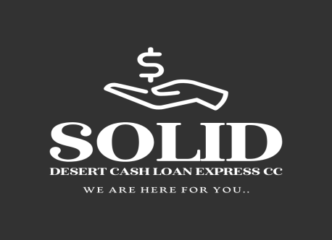

Solid Desert Cash Loan Express CC

We are here for you.

SOLID DESERT CASH LOAN EXPRESS CC DATA PROCESSING CONSENT & AUTHORIZATION
- Consent to Data Processing
I hereby grant Solid Desert Cash Loan Express cc explicit consent to process my personal data for the following purposes:
  - Verification of my credit history through third-party credit bureaus, databases, and other relevant information sources.
  - Use of such data for affordability assessments, processing of loan applications, decision-making regarding loan issuance, and debt collection activities.
  - Use of my data for marketing communications regarding future products, services, and offers from Solid Desert Cash Loan Express cc.
  - In the event of assignment of rights under this agreement, disclosure of my data to third parties who acquire such rights from Solid Desert Cash Loan Express cc.

- Validity & Scope
This consent shall remain valid for a period of one (1) year from the date of signing. It may be used repeatedly by Solid Desert Cash Loan Express cc for any loan applications I submit during this period, regardless of prior application outcomes.

- Revocation Rights
I understand that I may withdraw this consent at any time by notifying Solid Desert Cash Loan Express cc in writing, subject to any legal or contractual obligations already in effect.

- Payment Authorization
I hereby authorize Solid Desert Cash Loan Express CC to deduct all agreed payments directly from my bank account.

Date: ${date}
Applicant Name: ${applicant_name}
Signature: ${signature}

Swartkop
Oranjemund,Namibia
Soliddesertcashloan@gmail.com
264813719403
264857714071

