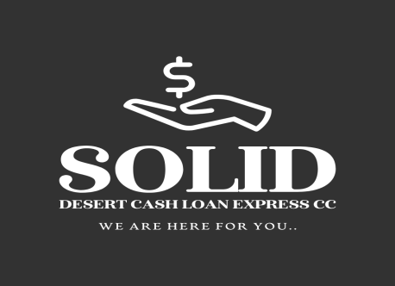

Solid Desert Cash Loan Express CC

We are here for you.

Solid Desert Cash Loan Express CC
+26463234341
info@solid-desert.com
Date: ${CURRENT_DATE}
VIA EMAIL AND REGISTERED MAIL
To: ${CLIENT_NAME}
Address: ${CLIENT_ADDRESS}
Account Number: ${ACCOUNT_NUMBER}
Loan Reference: ${LOAN_REFERENCE}
RE: FINAL NOTICE OF DEFAULT AND DEMAND FOR PAYMENT
Dear ${CLIENT_NAME},
We are writing to you regarding your loan account with Solid Desert Cash Loan Express CC, which is currently in arrears.
As of the date of this letter, your account is overdue by ${DAYS_OVERDUE} days. The total amount required to bring your account up to date is ${OVERDUE_AMOUNT} , which includes the overdue installments and any applicable late fees.
We have previously attempted to contact you regarding this matter, but we have not received the required payment or a satisfactory arrangement to settle the debt.
Please take note of the following consequences should this debt remain unpaid:
- Handover to Debt Collectors: We will immediately hand over your account to a registered external debt collection agency. Please be aware that this will result in additional collection costs, commission, and legal fees being added to your outstanding balance, significantly increasing the total amount you owe.
- Legal Action: We reserve the right to institute legal action against you to recover the debt. This may result in a Judgment being taken against you in a court of law. If a judgment is granted, we may proceed with a Warrant of Execution, which could lead to the attachment and sale of your assets or a garnishee order on your salary.
- Credit Bureau Listing: We will submit your name to all major Credit Bureaus as a defaulting debtor. This will result in a negative credit listing (blacklisting) on your credit profile. This will severely impact your ability to obtain credit, bonds, or loans in the future for a period of up to ${CREDIT_LISTING_YEARS} years.
FINAL OPPORTUNITY TO RESOLVE:
We are willing to provide you with one final opportunity to rectify this situation before we proceed with the actions listed above.
You must pay the amount of ${OVERDUE_AMOUNT} by no later than ${CURE_DEADLINE_DATE}.
Payment Methods:
- EFT/Bank Transfer:
  - Bank: FIRST NATIONAL BANK
  - Account Holder: SOLID DESERT CASH LOAN EXPRESS CC
  - Account Number: 64277319230
  - Branch Code: 280671

- Alternatively, if you are unable to pay the full arrears amount immediately, please contact our office immediately at +26463234341 to discuss a possible repayment plan. Note: Entering into a repayment plan is subject to approval and does not guarantee that legal action will be suspended.
If we do not receive payment or hear from you by ${CURE_DEADLINE_DATE} , we will proceed with the handover and legal processes without further notice.
We urge you to treat this matter with the urgency it requires to avoid the severe financial and legal consequences.
Sincerely,
${SENDER_NAME}
${COMPANY_NAME}

Swartkop
Oranjemund,Namibia
Soliddesertcashloan@gmail.com
264813719403
264857714071

