Date:
Customer Name: MR
ACCOUNT NO:
 |  |  |  |  | APPLICANT DISCLOSURE |  |  | BUREAU/REGULATORY
 |  |  |  |  |  |  |  | LIVING EXPENSES CALC.
SALARY (NETT-AFTER DEDUCTIONS)
COMMISSION
PENSION
OWN BUSINESS INCOME
TOTAL MONTHLY INCOME
LESS MONTHLY CONTRACTUAL PAYMENTS/INSTALLMENT
 |  |  |  |  | APPLICANT DISCLOSURE |  |  | BUREAU/REGULATORY
GROCERIES |  |  |  |  |  |  |  | LIVING EXPENSES CALC.
SCHOOL FEES
TRANSPORT COST
TOTAL LIVING EXPENSES
LESS MONTHLY CONTRACTUAL PAYMENTS/INSTALLMENT
 |  |  |  |  | APPLICANT DISCLOSURE |  |  | BUREAU/REGULATORY
 |  |  |  |  |  |  |  | LIVING EXPENSES CALC.
HOME LOAN ACCOUNT
HOME RENTAL
CREDIT CARD/ MONTHLY PAYMENT
PERSONAL AND MICRO LOANS
EDUCATIONAL LOAN
INSURANCE (SHORT & LONG TERM)
CAR PAYMENTS
CELL PHONE CONTRACT PAYMENT (ELECTRONIC DEVICE)
OTHER CREDIT
TOTAL PAYMENT INSTALLMENT
EQUAL APPLICANT MONTHLY DISPOSABLE INCOME
 |  | APPLICANT DISCLOSURE
 |  | MAXIMUM ISTALMENT VALUE PERMITED
 |  |  | MONTHLY INSTALMENT
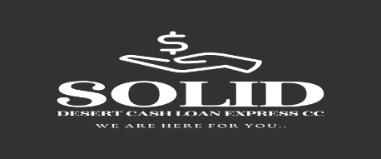
Solid Desert Cash Loan Express CC

We are here for you
The Applicant Hereby Information Submitted By His/her And Recorded In This Affordability Assessment For Credit Is Complete And True And Correct In Every Detail And That’s HIS/She Will Have Sufficient Disposable Income Per Maximum Installment Value Permitted And Will Be Abe To Afford The Payment Of The Monthly Installment On This Credit Application.

…………………………………….. …………………………………..
SIGNATURE OF CREDIT APPLICANT SIGNATURE OF WITNESS
Oranjemund OMD 2030
264813719403
264857714071
Soliddesertcashloan@gmail.com

