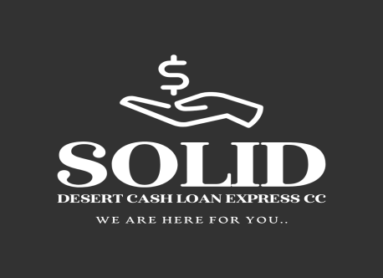

Solid Desert Cash Loan Express CC

We are here for you

${CURRENT_DATE}
Dear Sir/Madam

RE: CONFIRMATION OF DEBT SETTLEMENT FOR ${CLIENT_NAME}.

This letter serves as an official confirmation from Solid Desert Cash Loan Express CC regarding the account of the following individual:

· Full Name: ${CLIENT_NAME}
· ID Number: ${ID_NUMBER}

We hereby confirm that the account held by ${CLIENT_NAME} has been settled in full. The outstanding balance of NAD ${CLEARED_BALANCE} ( ${WORDS} ) has been paid in its entirety.

As of the date of this letter, ${CLIENT_NAME} has no outstanding liabilities with Solid Desert Cash Loan Express CC, and his account is considered closed with a zero balance.

This letter may be presented to any financial institution or other body as formal verification of his clear financial standing with our company.

Should you require any further clarification, please do not hesitate to contact the undersigned.

Yours Sincerely,

................................................
Sheddai Jossob
Administrator
Solid Desert Cash Loan Express CC

Swartkop
Oranjemund,Namibia
info@solid-desert.com
063234341
+264813719403

