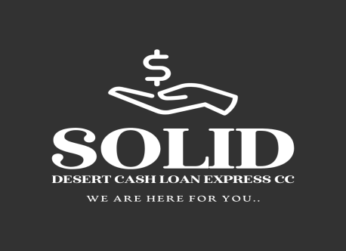

Solid Desert Cash Loan Express CC

We are here for you.

Dear Sir/Madam

RE: CONFIRMATION OF OUTSTANDING DEBT FOR ${CLIENT_NAME}.

This letter serves as an official statement from Solid Desert Cash Loan Express CC regarding the debt obligation of the following individual:

· Full Name: ${CLIENT_NAME}
· ID Number: ${ID_NUMBER}

We hereby confirm that the total outstanding balance on the aforementioned individual's account, inclusive of all accrued interest as of this date, is:

NAD ${OUTSTANDING_BALANCE} ( ${WORDS} )

This total amount is due for payment in full on or before ${LOAN_END_DATE}.

The details provided herein are accurate and may be relied upon for the purpose of debt consolidation or financial assessment. Should you require any further verification, please do not hesitate to contact the undersigned.

Yours Sincerely,

................................................
Raphael Karomo
Senior Administrator
Solid Desert Cash Loan Express CC

BANKING DETAILS FOR SETTLEMENT:
Account Name | SOLID DESERT CASH LOAN EXPRESS CC
Account type | GOLD BUSINESS ACCOUNT | Account Number | 64277319230
Branch code | 280671 | Branch Code | ORANJEMUND
Swift/BIC Code | FIRNNANX | Date Opened | 2023/05/03

Swartkop
Oranjemund,Namibia
info@solid-desert.com

063234341
+264813719403

