RE: Refund of Over-Deduction on Loan Account

Dear Mr./Ms. ${CLIENT_NAME}

We are writing to sincerely apologize for an administrative error that occurred on ${DATE_CREATED}, resulting in an incorrect deduction from your account.

The agreed repayment amount, as per your loan contract, was N$ ${TOTAL_REPAYMENT}. However, an amount of N$ ${AMOUNT_PROCESSED} was mistakenly processed, resulting in an over-deduction of N$ ${AMOUNT_CLAIMED}.

We deeply regret any frustration or inconvenience this error may have caused. At Solid Desert Cash Loan Express, we are committed to accuracy and customer satisfaction, and we have taken steps to ensure this will not be repeated.

A refund for the over-deduced amount of N$ ${AMOUNT_CLAIMED} will be credited to your account. This process has been initiated and the funds should reflect in your account within 24 hours

We thank you for your patience and understanding in this matter.

Sincerely,

.....................................
Raphael K Karomo
Manager
Solid Desert Cash Loan Express CC
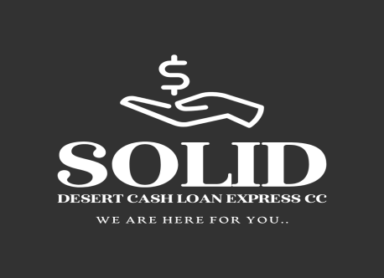
Solid Desert Cash Loan Express CC

We are here for you

Swartkop
Oranjemund,Namibia
info@solid-desert.com

063234341
+264813719403

