Cloud Incident Monitoring and Response Platform

Table of Contents

1. Introduction 1
1.1 Background and Research 1
1.2 Report Structure 2
2. Project Overview 2
2.1 Problem Statement 2
2.2 Full-Stack Objectives 3
3. System Requirements 3
3.1 Functional Requirements 3
3.2 Non-Functional Requirements 4
4. System Architecture 4
4.1 Client-Server Design 4
4.2 Folder Structure 5
5. Data Model 5
5.1 Incident Document 5
5.2 User Document 6
6. CRUD Operations 6
6.1 Create 6
6.2 Read 7
6.3 Update 7
6.4 Delete 8
7. Additional Features 8
8. Testing and Validation 9
9. External API Integration 10
10. Conclusion 11
Reflective Learning Experience 11
References 12

1. Introduction
1.1 Background and Research
Modern web applications are rarely built as a single block of code. A typical full-stack project combines a browser-based frontend, a server-side API, a database, authentication, and often a cloud hosting layer. For the B9IS109 Web Development for Information Systems module, I planned and built a complete information system from scratch rather than a small isolated exercise. The chosen topic was cloud incident monitoring because it touches all of these layers in a realistic way.
Research covered how REST APIs are used in client-server systems (Fielding, 2000), how JWT tokens support stateless login (JSON Web Token Introduction, 2024), and how MongoDB stores nested document data compared with flat relational tables (MongoDB Inc., 2025). Requirements were written down in docs/requirements.md and tracked through weekly milestones on GitHub. Risks such as security mistakes and database connection failures were noted in docs/risk-assessment.md before implementation started.
1.2 Report Structure
This report describes a full-stack Cloud Incident Monitoring and Response Platform. The frontend uses HTML, CSS, and vanilla JavaScript modules. The backend uses Node.js with Express. Data is stored in MongoDB Atlas. Real-time updates use Socket.IO. The system is deployed on AWS EC2 with Nginx and PM2. The report covers project overview, requirements, architecture, data model, CRUD operations, additional features, testing, external API integration, and conclusion. Source code: [Insert your public GitHub repository URL here].
2. Project Overview
2.1 Problem Statement
When cloud services fail or slow down, teams need a structured place to record what happened, who is handling the issue, and when it was fixed. Alerts may arrive from AWS CloudWatch, Azure Monitor, or Google Cloud Monitoring, but the response work still needs one shared register. Without that, details get lost in chat messages and spreadsheets.
2.2 Full-Stack Objectives
The project aimed to deliver a working end-to-end web application. On the frontend, users log in, view a dashboard, search incidents, create records, and update status through a single-page interface. On the backend, Express routes handle validation, JWT checks, and MongoDB persistence. Additional goals included role-based access for Guest, User, and Administrator roles, webhook ingestion for external alerts, responsive layout for smaller screens, and deployment to a live cloud server.

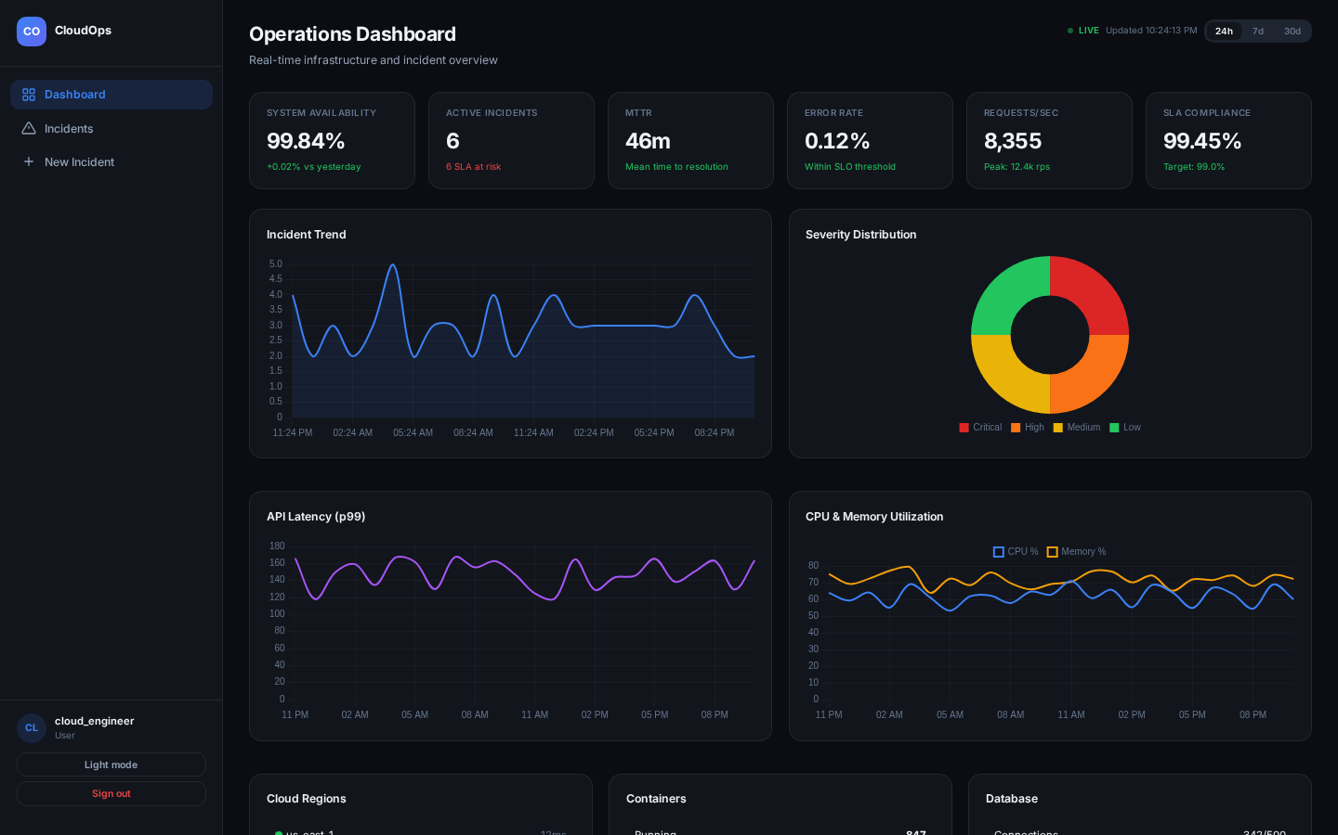
Figure 1: The Dashboard

3. System Requirements
3.1 Functional Requirements
The system was designed around the following functional needs. Users must register and log in securely. Authorised users must create incidents with a title, description, severity, cloud provider, affected service, region, assigned team, and status. All incidents appear in a table that supports text search, filters for severity and status, and pagination. Users must edit individual incidents, update status and root cause, and post comments. Administrators must delete incidents. Input must be validated before it reaches the database. A dashboard must show active incident counts, charts, and infrastructure health summary panels. External monitoring systems must submit alerts through a webhook endpoint. Each incident must keep a timeline of status changes and comments for audit purposes.
3.2 Non-Functional Requirements
The server runs on Node.js with Express and stores data in MongoDB Atlas. API responses use standard HTTP status codes such as 201 for create, 400 for validation failure, 401 for unauthorised access, and 404 when a record is not found. The interface must work on desktop and smaller screens through responsive CSS. Security requirements include JWT login, role-based access for Guest, User, and Administrator roles, password hashing with bcrypt, rate limiting on auth routes, and Helmet security headers. The application must deploy to a cloud platform. Errors must be handled in one place on the server with useful logging for troubleshooting.
4. System Architecture
4.1 Client-Server Design
The application follows the client-server pattern that is common in modern web information systems (Fielding, 2000). The server is built with Node.js and Express 5. It exposes REST endpoints under /api/auth, /api/incidents, /api/observability, and /api/cost. The frontend is a single HTML page that loads JavaScript modules and uses the browser Fetch API to call the backend (Mozilla Developer Network, 2024). Socket.IO is used so that when one user creates or updates an incident, other open browser sessions refresh without manual reload.
This split of responsibilities matters. The backend handles storage, validation, authentication, and business rules. The frontend displays data and captures user actions. Because everything goes through API calls, the same backend could later serve a mobile app or another client without major changes.
4.2 Folder Structure
The server entry point, route files, controllers, Mongoose models, and middleware sit in the server/ folder. The single-page client HTML, CSS, and JavaScript modules are in client/. Shared enum values for severity, status, teams, and SLA minutes live in server/shared-taxonomy.js so the client and server stay aligned. Deployment scripts for Nginx and PM2 are in deploy/. Dependencies and npm scripts are defined in server/package.json. In production the path is: browser to Nginx on port 80, then PM2-managed Node.js on port 5000, then MongoDB Atlas.

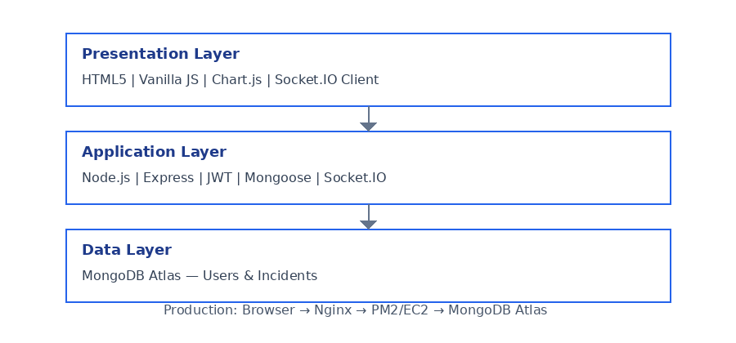
Figure 2: Architecture of the System

5. Data Model
5.1 Incident Document
Incidents are stored as documents in MongoDB through Mongoose. Each record has an incidentId generated automatically in the form INC-YYYY-####, for example INC-2026-0004. Required fields include title, description, severity (Critical, High, Medium, Low), status (Investigating, Identified, Monitoring, Resolved), cloudProvider (AWS, Azure, GCP, Other), affectedService, and region. assignedTeam and assignedToPerson route the work. detectedAt, slaDeadline, and resolvedAt track timing. A pre-save hook sets slaDeadline from severity: Critical allows sixty minutes, High four hours, Medium eight hours, and Low twenty-four hours.
Two nested arrays hold history. timeline stores detection events, status changes, and comment entries with author and timestamp. comments stores user updates separately. The source field records whether the incident was created manually, from a cloud webhook, or from monitoring. reportedBy links to the user who logged it. Indexes on status, severity, and createdAt speed up list queries; a text index supports search.
5.2 User Document
Users have username, email, bcrypt-hashed password, and role. Roles are Guest, User, or Administrator. Passwords are hashed before save with ten salt rounds and are never sent back in API responses. Registration cannot grant Administrator directly; that role is seeded for demo accounts such as ops@platform.com.
6. CRUD Operations
The core of the system is CRUD on incidents through /api/incidents. Logic sits in incidentController.js and routes in incidentRoutes.js.
6.1 Create
Create is handled by POST /api/incidents. The user must be logged in with User or Administrator role. express-validator checks the body—title length, valid enums, and that the affected service matches the chosen cloud provider. The controller saves a new document with source Manual, an opening timeline entry, and reportedBy taken from the JWT. On success the server returns HTTP 201 and emits incident:created through Socket.IO. Missing or invalid fields return HTTP 400.
6.2 Read
Read uses several GET endpoints. GET /api/incidents returns a paginated list. Query parameters support search text, status, severity, team, page, and limit. Search matches title, incidentId, and affectedService without case sensitivity. GET /api/incidents/:id returns one full record. GET /api/incidents/metrics returns counts and SLA breach figures for the dashboard. If the id does not exist the server returns HTTP 404.
6.3 Update
Update uses PUT /api/incidents/:id. Only fields sent in the body are changed; others stay as they were. When status changes, a new timeline entry is added. If status becomes Resolved, resolvedAt is set. Comments are added through POST /api/incidents/:id/comments, which also writes to the timeline. A successful update returns HTTP 200 and broadcasts incident:updated.
6.4 Delete
Delete uses DELETE /api/incidents/:id and is limited to Administrator. The handler checks the record exists, removes it, returns HTTP 200, and emits incident:deleted. Unknown ids return HTTP 404.

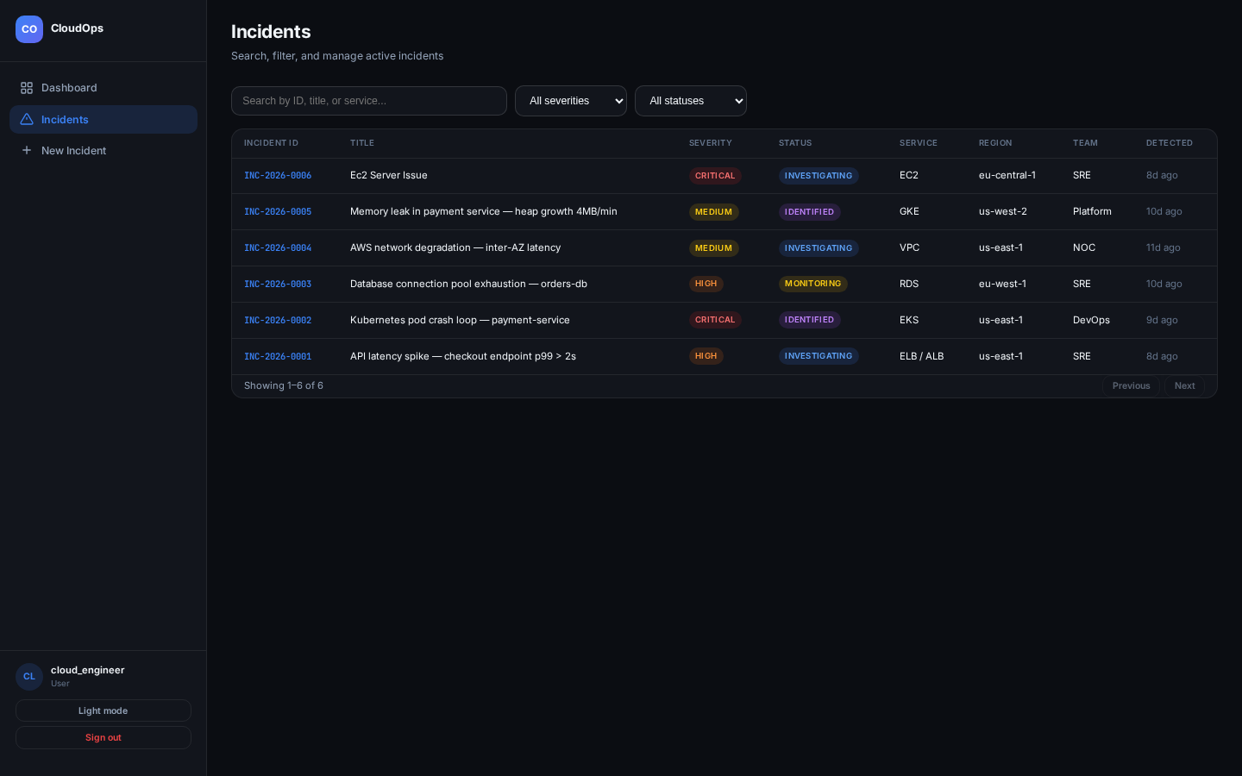
Figure 3: Searching of Incidents with Edit and Delete

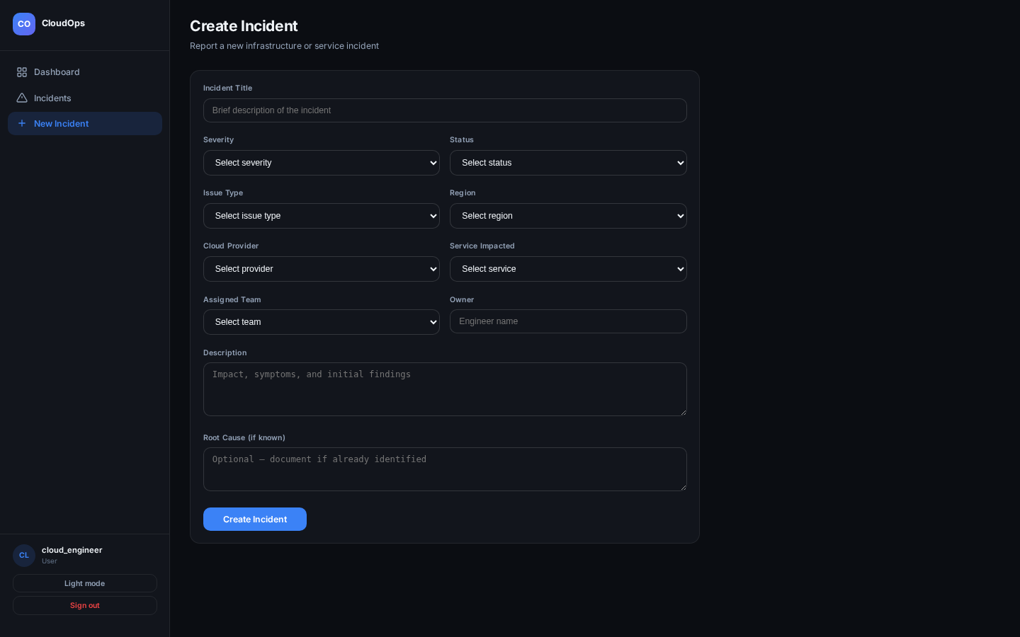
Figure 4: Form for Add and Edit Incident

7. Additional Features
Search takes a text query and compares it against title, incidentId, and affectedService. Severity and status dropdowns narrow the list further. Pagination handles larger datasets. Input on the search box is debounced so the API is not called on every keystroke.
The dashboard shows KPI cards for availability, active incidents, mean time to resolve, and error rate. Chart.js draws graphs for incident trends, API latency, CPU, and memory. Values refresh every thirty seconds and also when Socket.IO events arrive. Severity badges use colour coding so Critical rows stand out at a glance.
The incident detail page shows an SLA countdown, root cause field, and full timeline. JWT authentication and role-based access control gate what each user can do. Guests can view only; Users create and update; Administrators can delete. Helmet, rate limits, and input validation run on the server. CSS media queries at 1024px and 900px collapse the sidebar and stack columns on smaller screens. Theme toggle switches between dark and light mode.
8. Testing and Validation
Testing was carried out manually during development and before deployment. Login was checked for valid and invalid credentials. Create, read, update, and delete paths were exercised through the web interface and with direct HTTP requests. Search and filter combinations were tried to confirm the correct rows returned. RBAC was tested by logging in as Guest, User, and Administrator and confirming that forbidden actions returned HTTP 403. The webhook endpoint was tested with curl using the x-webhook-secret header. The /api/health endpoint was used to confirm database connectivity on EC2.
Validation errors were checked by submitting empty required fields and confirming HTTP 400 responses. Two browser windows were opened to confirm Socket.IO updated the incident list when one session created a record. Automated Jest and Supertest suites are not yet part of this codebase but would be a sensible next step for regression testing.

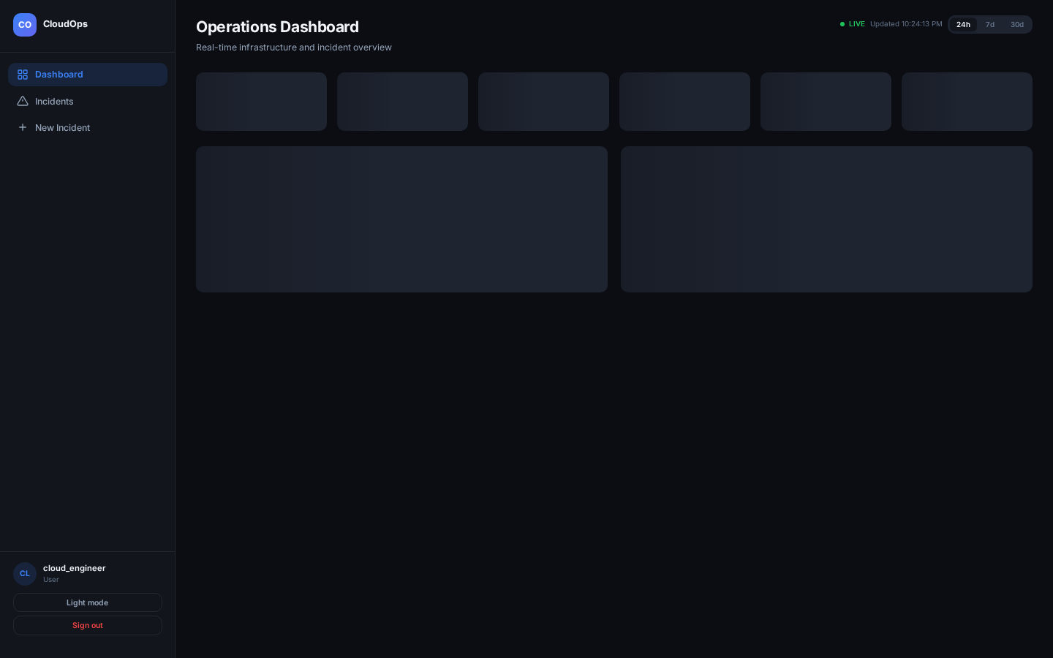
Figure 5: Manual Test Results

9. External API Integration
The system consumes and exposes web services using JSON throughout. The frontend api.js module calls internal REST endpoints for auth, incidents, metrics, observability, and cost data.
For external integration, the cost controller supports an optional COST_API_URL environment variable. When set, the server fetches billing or utilisation data from that remote service and forwards the JSON response to the client. If the remote call fails, the handler logs a warning and returns structured simulated multi-cloud figures so the demo still works offline.
Inbound webhook integration allows CloudWatch, Azure Monitor, or similar tools to POST alerts to /api/incidents/webhook. These systems cannot use JWT login, so they authenticate with a shared secret header instead. Valid payloads create incidents with source CloudWebhook and appear on the dashboard through Socket.IO. This pattern matches how alert forwarders integrate with ticketing systems in production.

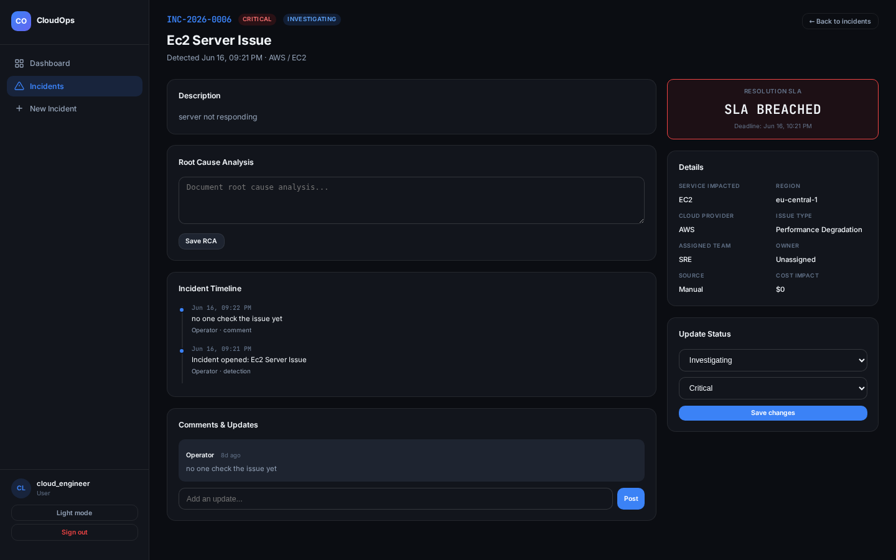
Figure 6: Incident Detail and Timeline

10. Conclusion
The Cloud Incident Monitoring and Response Platform meets the requirements set out in the B9IS109 brief. A REST API provides full CRUD on incidents. The web interface talks to the backend only through API and WebSocket calls. Search, dashboards, SLA tracking, real-time sync, webhook ingestion, JWT authentication, role-based access, responsive layout, and AWS EC2 deployment are all in place.
The application is built entirely in JavaScript: Node.js and Express on the server, HTML and ES modules on the client, with MongoDB Atlas for storage. The code is split into routes, controllers, models, and client modules, and third-party libraries such as Chart.js and Socket.IO are listed in package.json.
The project demonstrates a complete full-stack web information system: frontend, API, database, security, real-time communication, and cloud deployment working together as one deliverable.
Reflective Learning Experience
Working on this project helped me connect separate coding tasks into one complete system. Following a login from the form through JWT middleware to a MongoDB query made the three-tier architecture easier to understand. Socket.IO was new to me—I had to make sure the server emitted events only after a successful save and that the client refreshed the open view. Deploying to EC2 showed issues that localhost hides, such as opening port 80, whitelisting the server IP in MongoDB Atlas, and setting environment variables correctly. I also saw why role checks on the server matter even when the UI hides buttons. If I did the project again I would write automated tests earlier. Overall it was a useful introduction to building and hosting a real web application for cloud operations.
References
Amazon Web Services (2024) Amazon CloudWatch User Guide. Available at: https://docs.aws.amazon.com/AmazonCloudWatch/latest/monitoring/ (Accessed: 24 June 2026).
Amazon Web Services (2024) Amazon EC2 User Guide. Available at: https://docs.aws.amazon.com/ec2/ (Accessed: 24 June 2026).
Chart.js (2025) Chart.js documentation. Available at: https://www.chartjs.org/docs/latest/ (Accessed: 24 June 2026).
Crockford, D. (2008) JavaScript: The Good Parts. Sebastopol: O'Reilly Media.
Express.js (2025) Express – Node.js web application framework. Available at: https://expressjs.com (Accessed: 24 June 2026).
express-rate-limit (2024) express-rate-limit documentation. Available at: https://express-rate-limit.mintlify.app/ (Accessed: 24 June 2026).
express-validator (2024) express-validator documentation. Available at: https://express-validator.github.io/docs/ (Accessed: 24 June 2026).
Fielding, R.T. (2000) Architectural Styles and the Design of Network-based Software Architectures. Doctoral dissertation, University of California, Irvine. Available at: https://ics.uci.edu/~fielding/pubs/dissertation/top.htm (Accessed: 24 June 2026).
Google (2024) Cloud Monitoring documentation. Available at: https://cloud.google.com/monitoring/docs (Accessed: 24 June 2026).
Helmet (2025) Helmet.js documentation. Available at: https://helmetjs.github.io (Accessed: 24 June 2026).
JSON Web Token Introduction (2024) jwt.io. Available at: https://jwt.io/introduction (Accessed: 24 June 2026).
Microsoft (2024) Azure Monitor documentation. Available at: https://learn.microsoft.com/en-us/azure/azure-monitor/ (Accessed: 24 June 2026).
MongoDB Inc. (2025) MongoDB Atlas documentation. Available at: https://www.mongodb.com/docs/atlas/ (Accessed: 24 June 2026).
Mongoose (2025) Mongoose ODM documentation. Available at: https://mongoosejs.com/docs/ (Accessed: 24 June 2026).
Mozilla Developer Network (2024) Fetch API. Available at: https://developer.mozilla.org/en-US/docs/Web/API/Fetch_API (Accessed: 24 June 2026).
Mozilla Developer Network (2024) JavaScript modules. Available at: https://developer.mozilla.org/en-US/docs/Web/JavaScript/Guide/Modules (Accessed: 24 June 2026).
Node.js (2025) Node.js documentation. Available at: https://nodejs.org/docs/latest/api/ (Accessed: 24 June 2026).
Nginx (2024) NGINX documentation. Available at: https://nginx.org/en/docs/ (Accessed: 24 June 2026).
OWASP Foundation (2021) Password Storage Cheat Sheet. Available at: https://cheatsheetseries.owasp.org/cheatsheets/Password_Storage_Cheat_Sheet.html (Accessed: 24 June 2026).
PM2 (2024) PM2 process manager. Available at: https://pm2.keymetrics.io/docs/usage/quick-start/ (Accessed: 24 June 2026).
Socket.IO (2025) Socket.IO documentation. Available at: https://socket.io/docs/v4/ (Accessed: 24 June 2026).
bcryptjs (2024) bcryptjs npm package. Available at: https://www.npmjs.com/package/bcryptjs (Accessed: 24 June 2026).

