DevOps Final Project Reflection

# 1. Project Overview

This project is a fully automated CI/CD pipeline that deploys a Flutter Web application using a combination of DevOps tools and technologies. The infrastructure is provisioned on Microsoft Azure using Terraform, configured with Ansible, and deployed through Jenkins pipeline automation. This project demonstrates Infrastructure as Code (IaC), Configuration Management, and Continuous Deployment in a real-world scenario.

# 2. Tech Stack Used

- Jenkins: For CI/CD pipeline automation  
- Docker: For containerizing Jenkins  
- Terraform: For provisioning Azure infrastructure  
- Ansible: For server configuration and app deployment  
- Azure: As the cloud provider for hosting resources  
- Flutter Web: As the deployed static frontend application  
- GitHub: For version control and Jenkinsfile storage

# 3. Project File Structure

Devops-Project/

├── Jenkinsfile

├── terraform/

│   ├── main.tf

│   ├── variables.tf

│   └──terraform.tfvars [not uploaded to github]

├── ansible/

│   └── install_web.yml

├── screenshots/

│   └── <include all screen shots>

├── .gitignore

├──  README.md

└── app/

    └── <build of flutter web app>

# 4. How I Achieved the Project

I started by creating a GitHub repository and preparing the Terraform scripts to provision a resource group, network components, and a Linux VM on Azure. Then I wrote an Ansible playbook to install Apache and deploy the Flutter Web app. After that, I created a Jenkins pipeline using a `Jenkinsfile` to automate the entire flow: creating a .tfvars file, running `terraform apply`, extracting the public IP, generating the Ansible inventory, and running the playbook. Finally, I added a verification step using `curl` to confirm deployment success.

# 5. Problems I Faced

- GitHub connection errors due to host key verification  
- Jenkins SSH key setup and permissions  
- Terraform output handling inside Jenkins pipeline  
- Ansible host key checking and SSH access  
- Proper placement and permissions of `id_rsa` private key  
- Ensuring Flutter build files were correctly copied to the server  
- Debugging VM provisioning issues on Azure

# 6. Screenshots

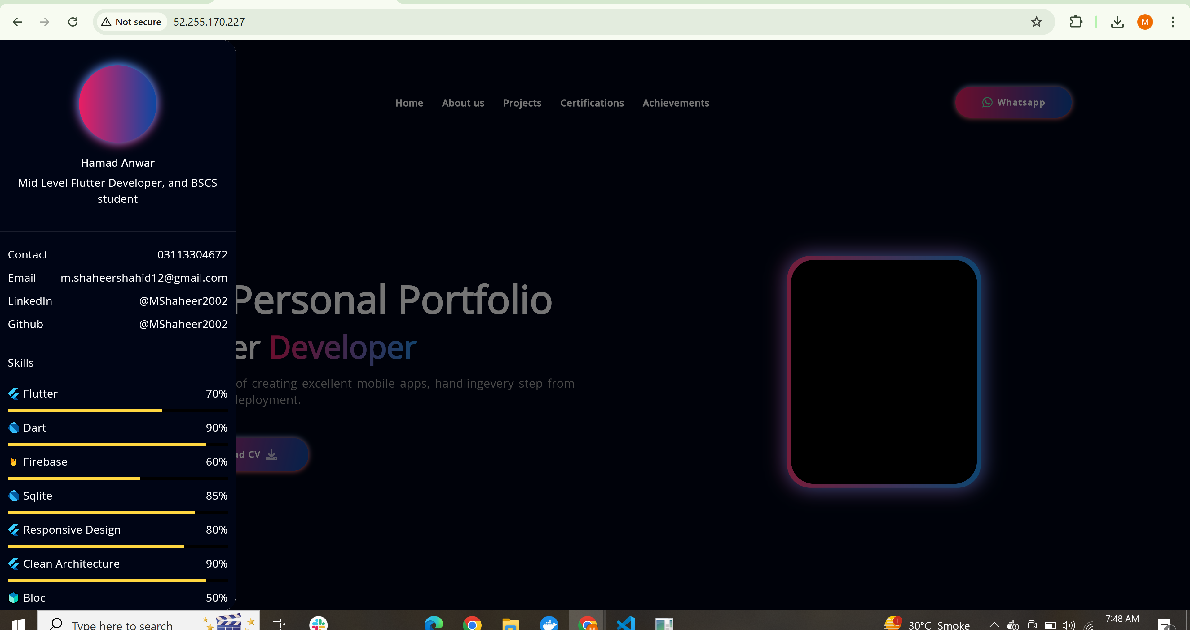

Figure 1 (Deployed Web App)

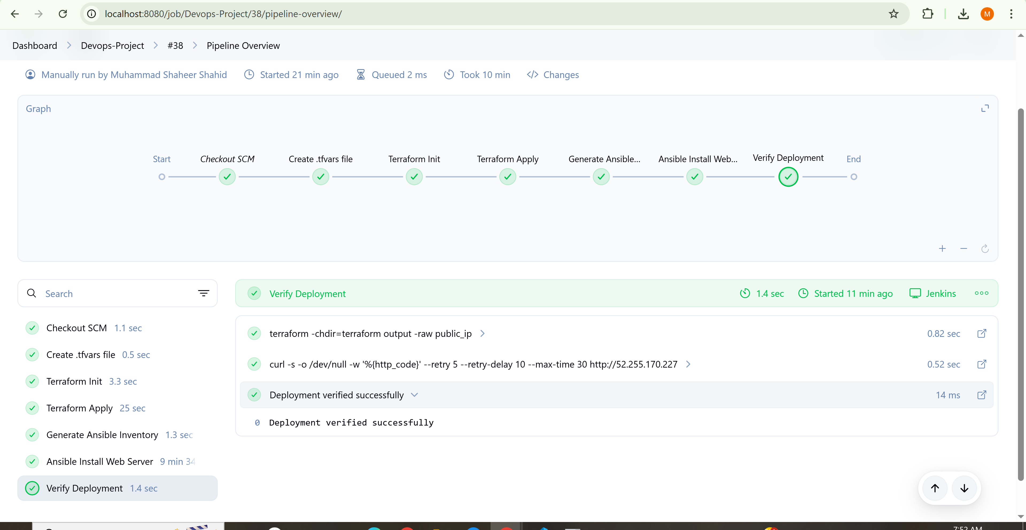

Figure 2 (working Jenkins pipeline)

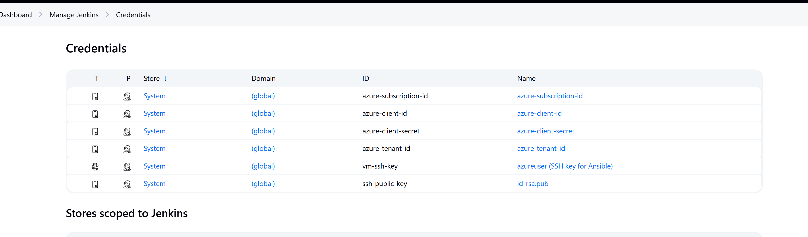

Figure 3 (Jenkins Credentials overview)

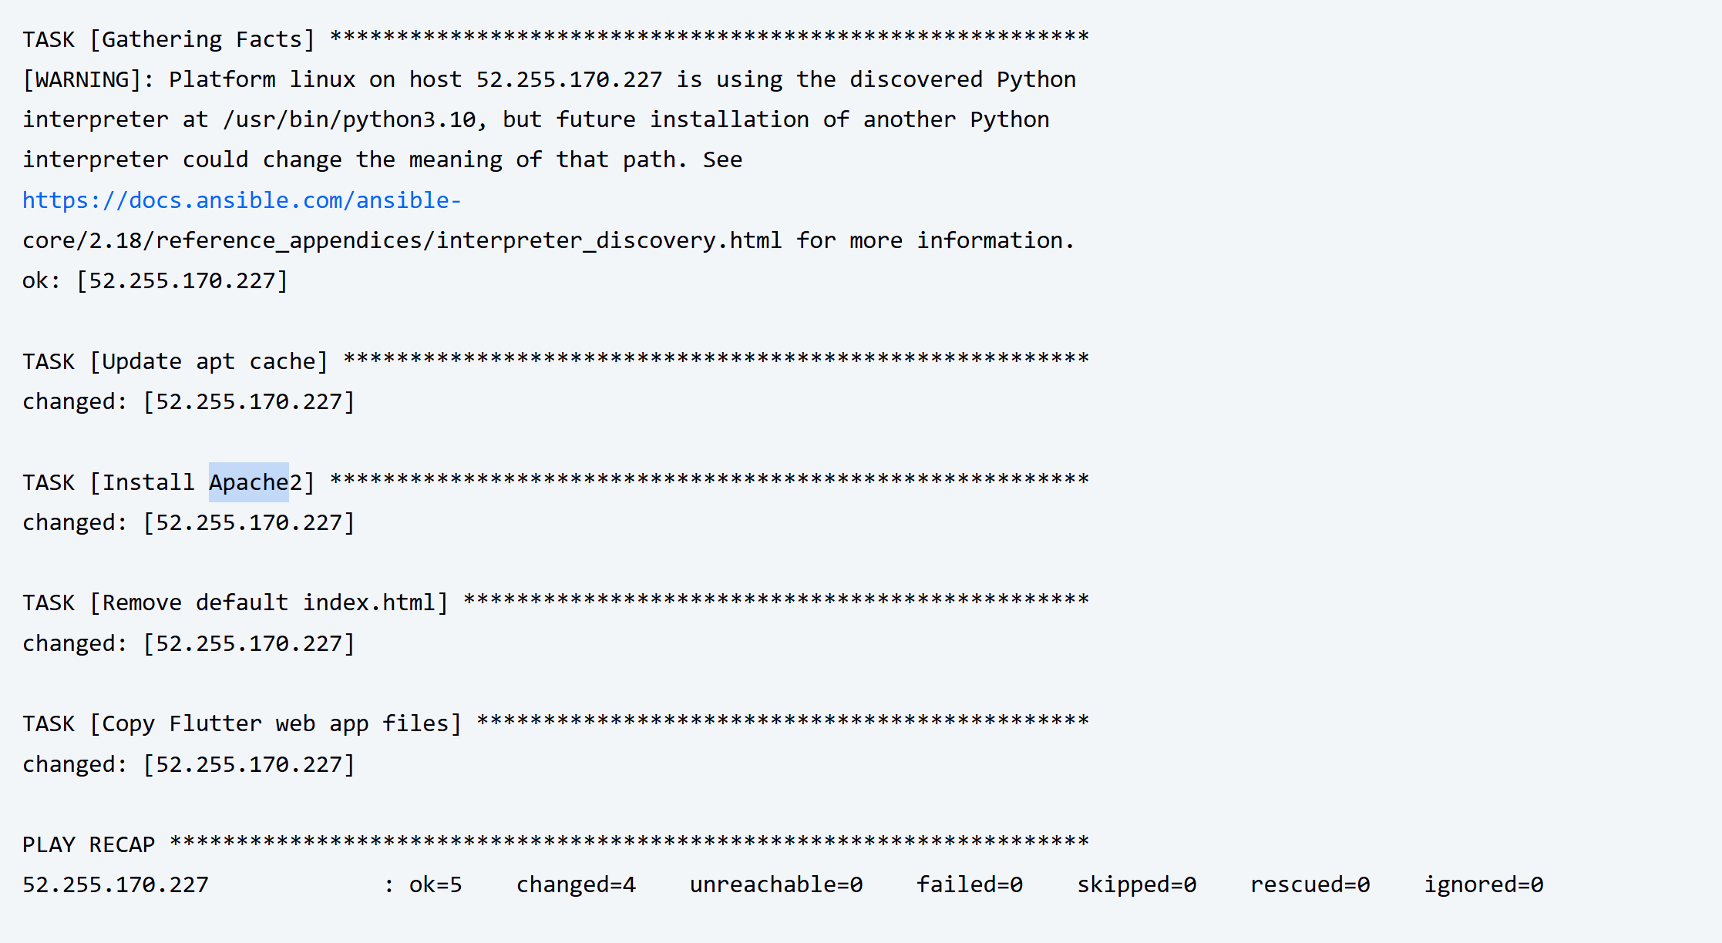

Figure 4 (Apache2 flow)

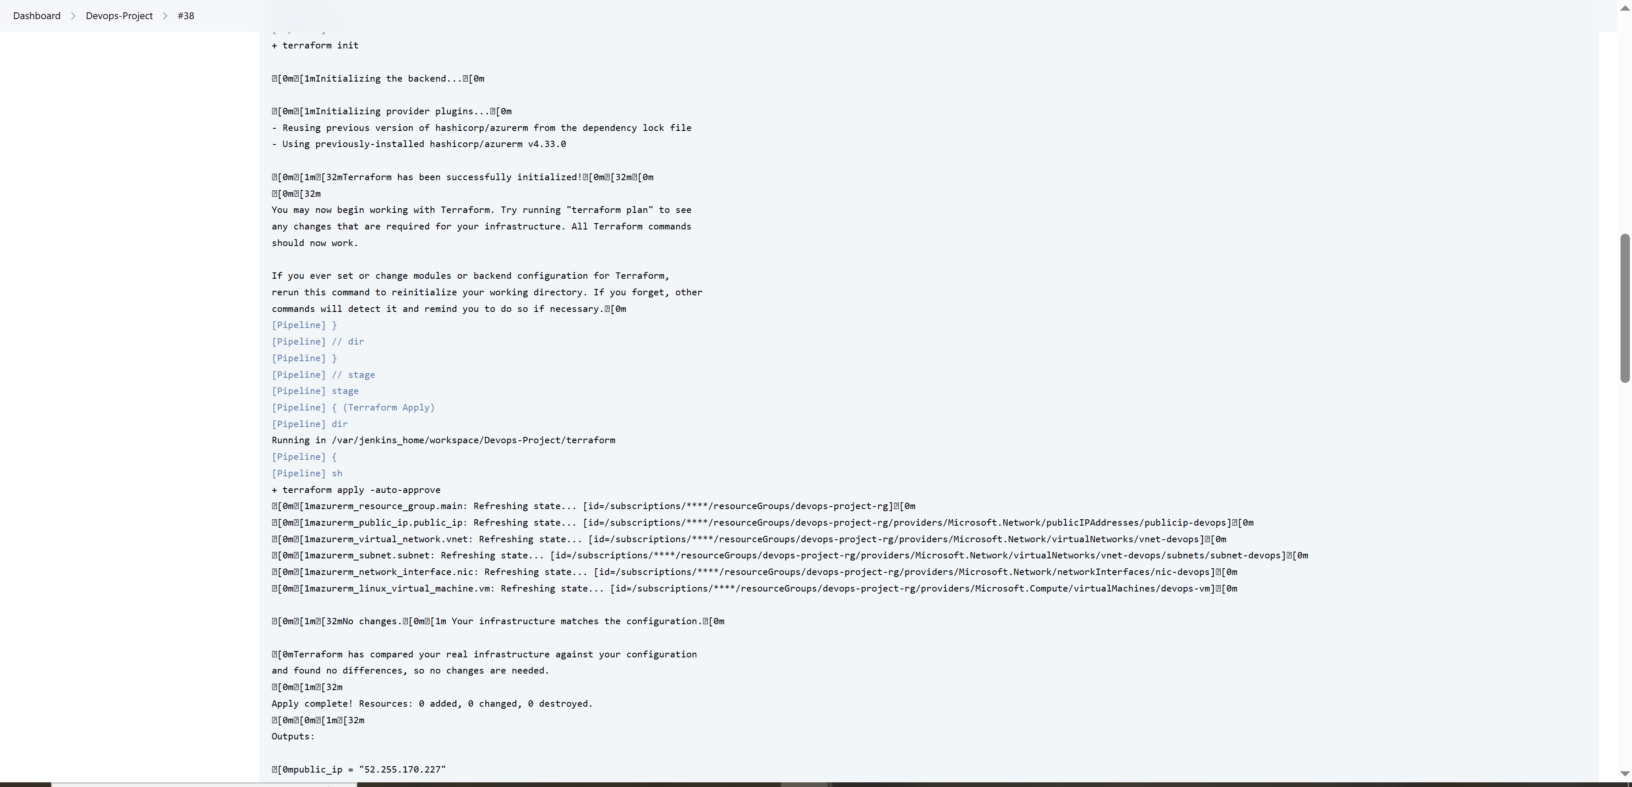

Figure 5 (Terraform working flow)

# 6. Repository & Personal Details

GitHub Repository: https://github.com/MShaheer2002/Devops-Project

Name: Muhammad Shaheer Shahid

Univerisity Name: Szabist Karachi | University ID: 2112351 BScs 8th D

Email: [bscs2112351@gmail.com](mailto:bscs2112351@gmail.com)