Miles Shinsato
10/24/2026
CSD430-306J_2273_DD

Module 1.3 Assignment – JSP

Screenshot of Java Configuration
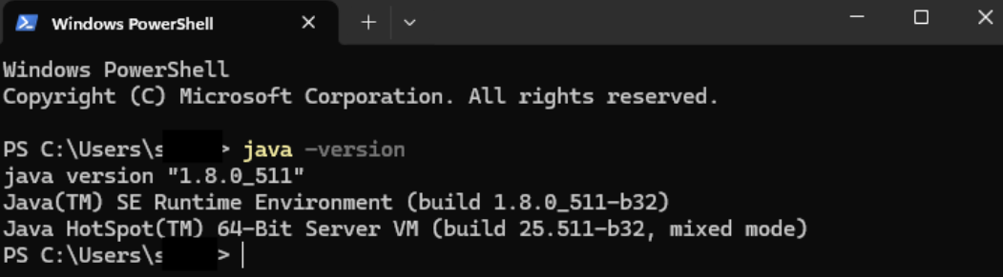

Screenshot of Apache Tomcat
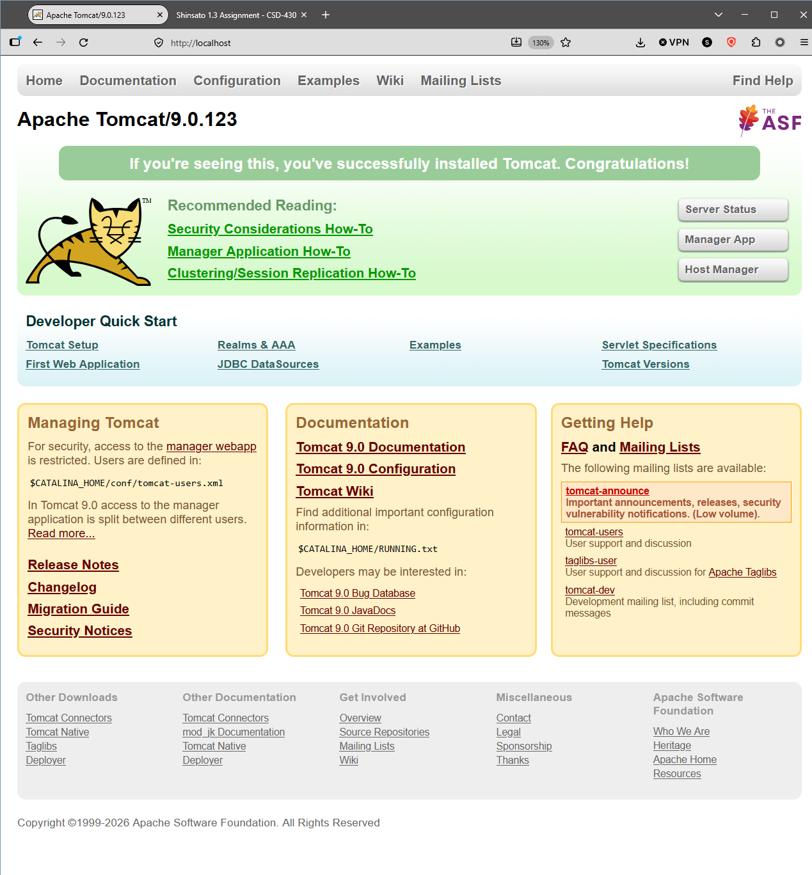

Screenshot of Selected IDE – IntelliJ IDEA 2024.3.1.1 (Ultimate Edition)
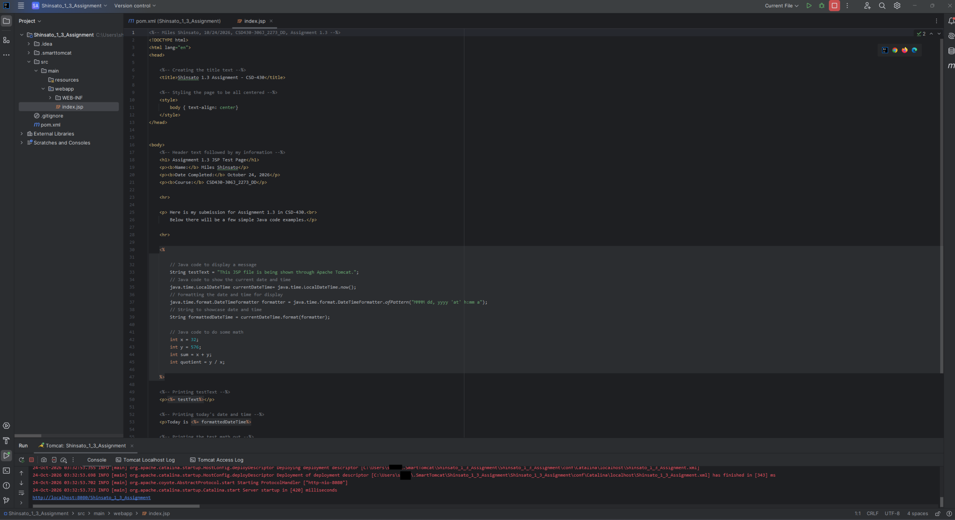

Screenshot of JSP File
