JavaBeans
Shinsato, Miles
Bellevue University, CSD-430
Assignment 4.2
November 14, 2026

JavaBeans

Webpage Screenshot
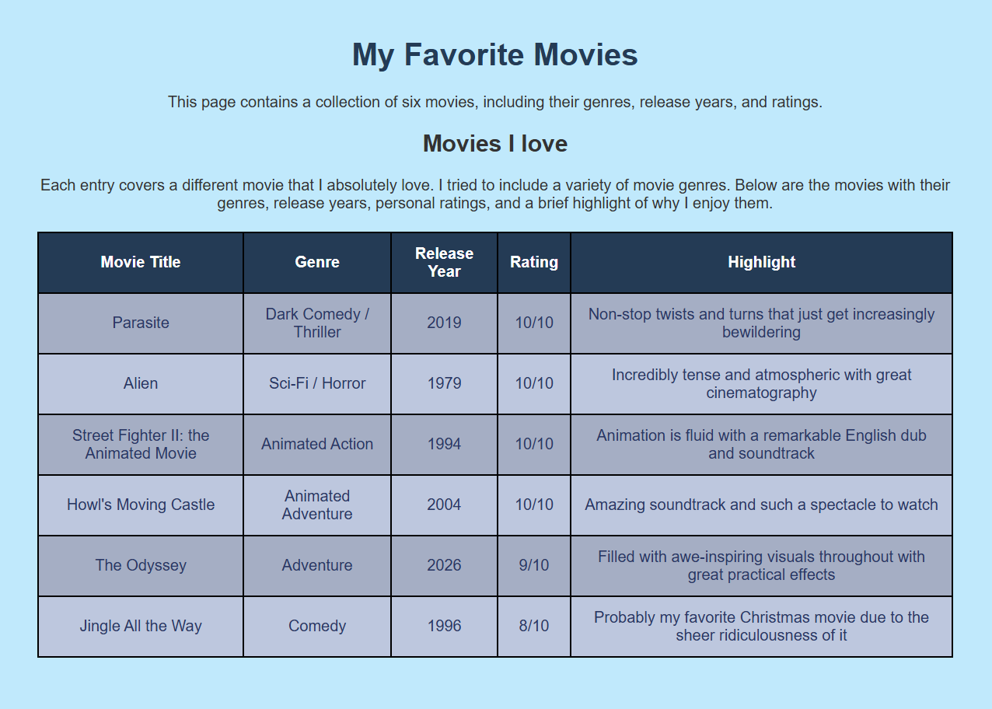

IntelliJ & Webpage Screenshot
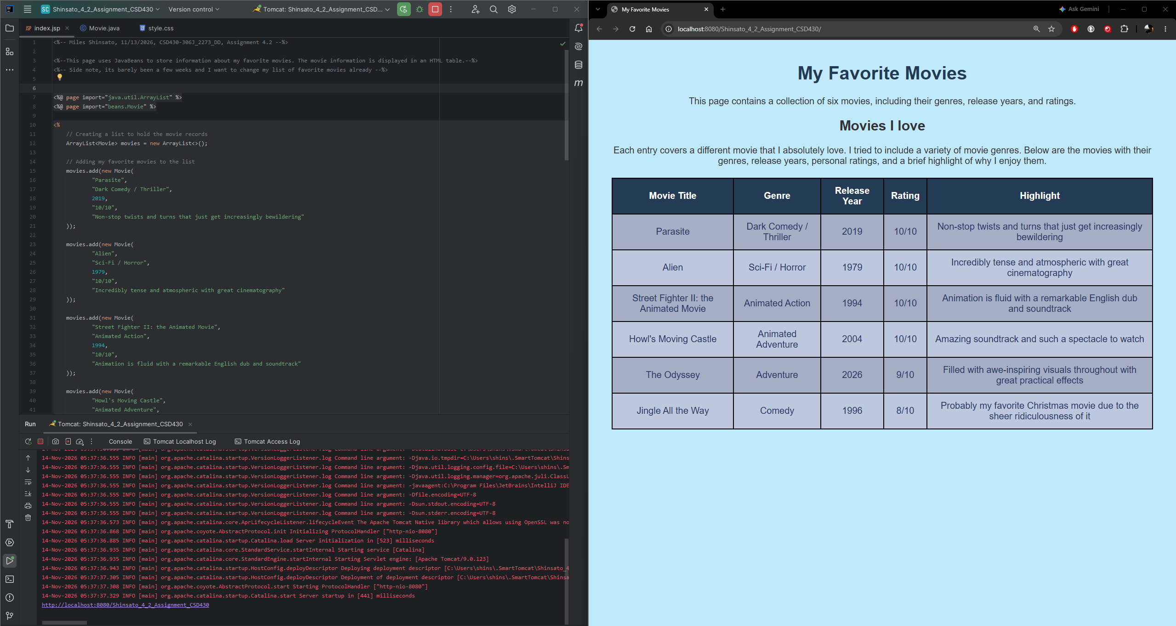

GitHub Link

https://github.com/MShinBV/CSD-430/tree/main/module-4

