Java Scriptlet – Data Display
Shinsato, Miles
Bellevue University, CSD-430
Assignment 2.2
October 30, 2026

Java Scriptlet – Data Display

Webpage Screenshot
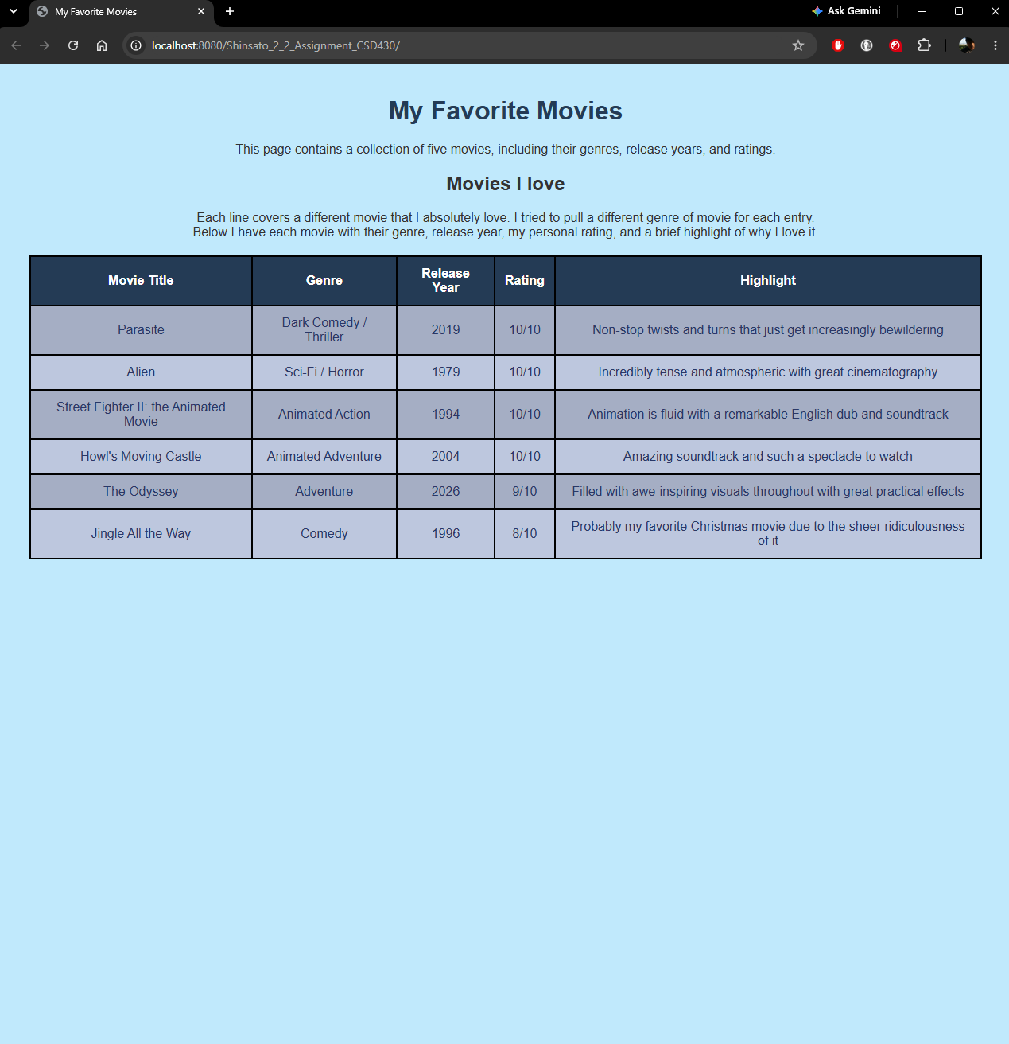

IntelliJ & Webpage Screenshot
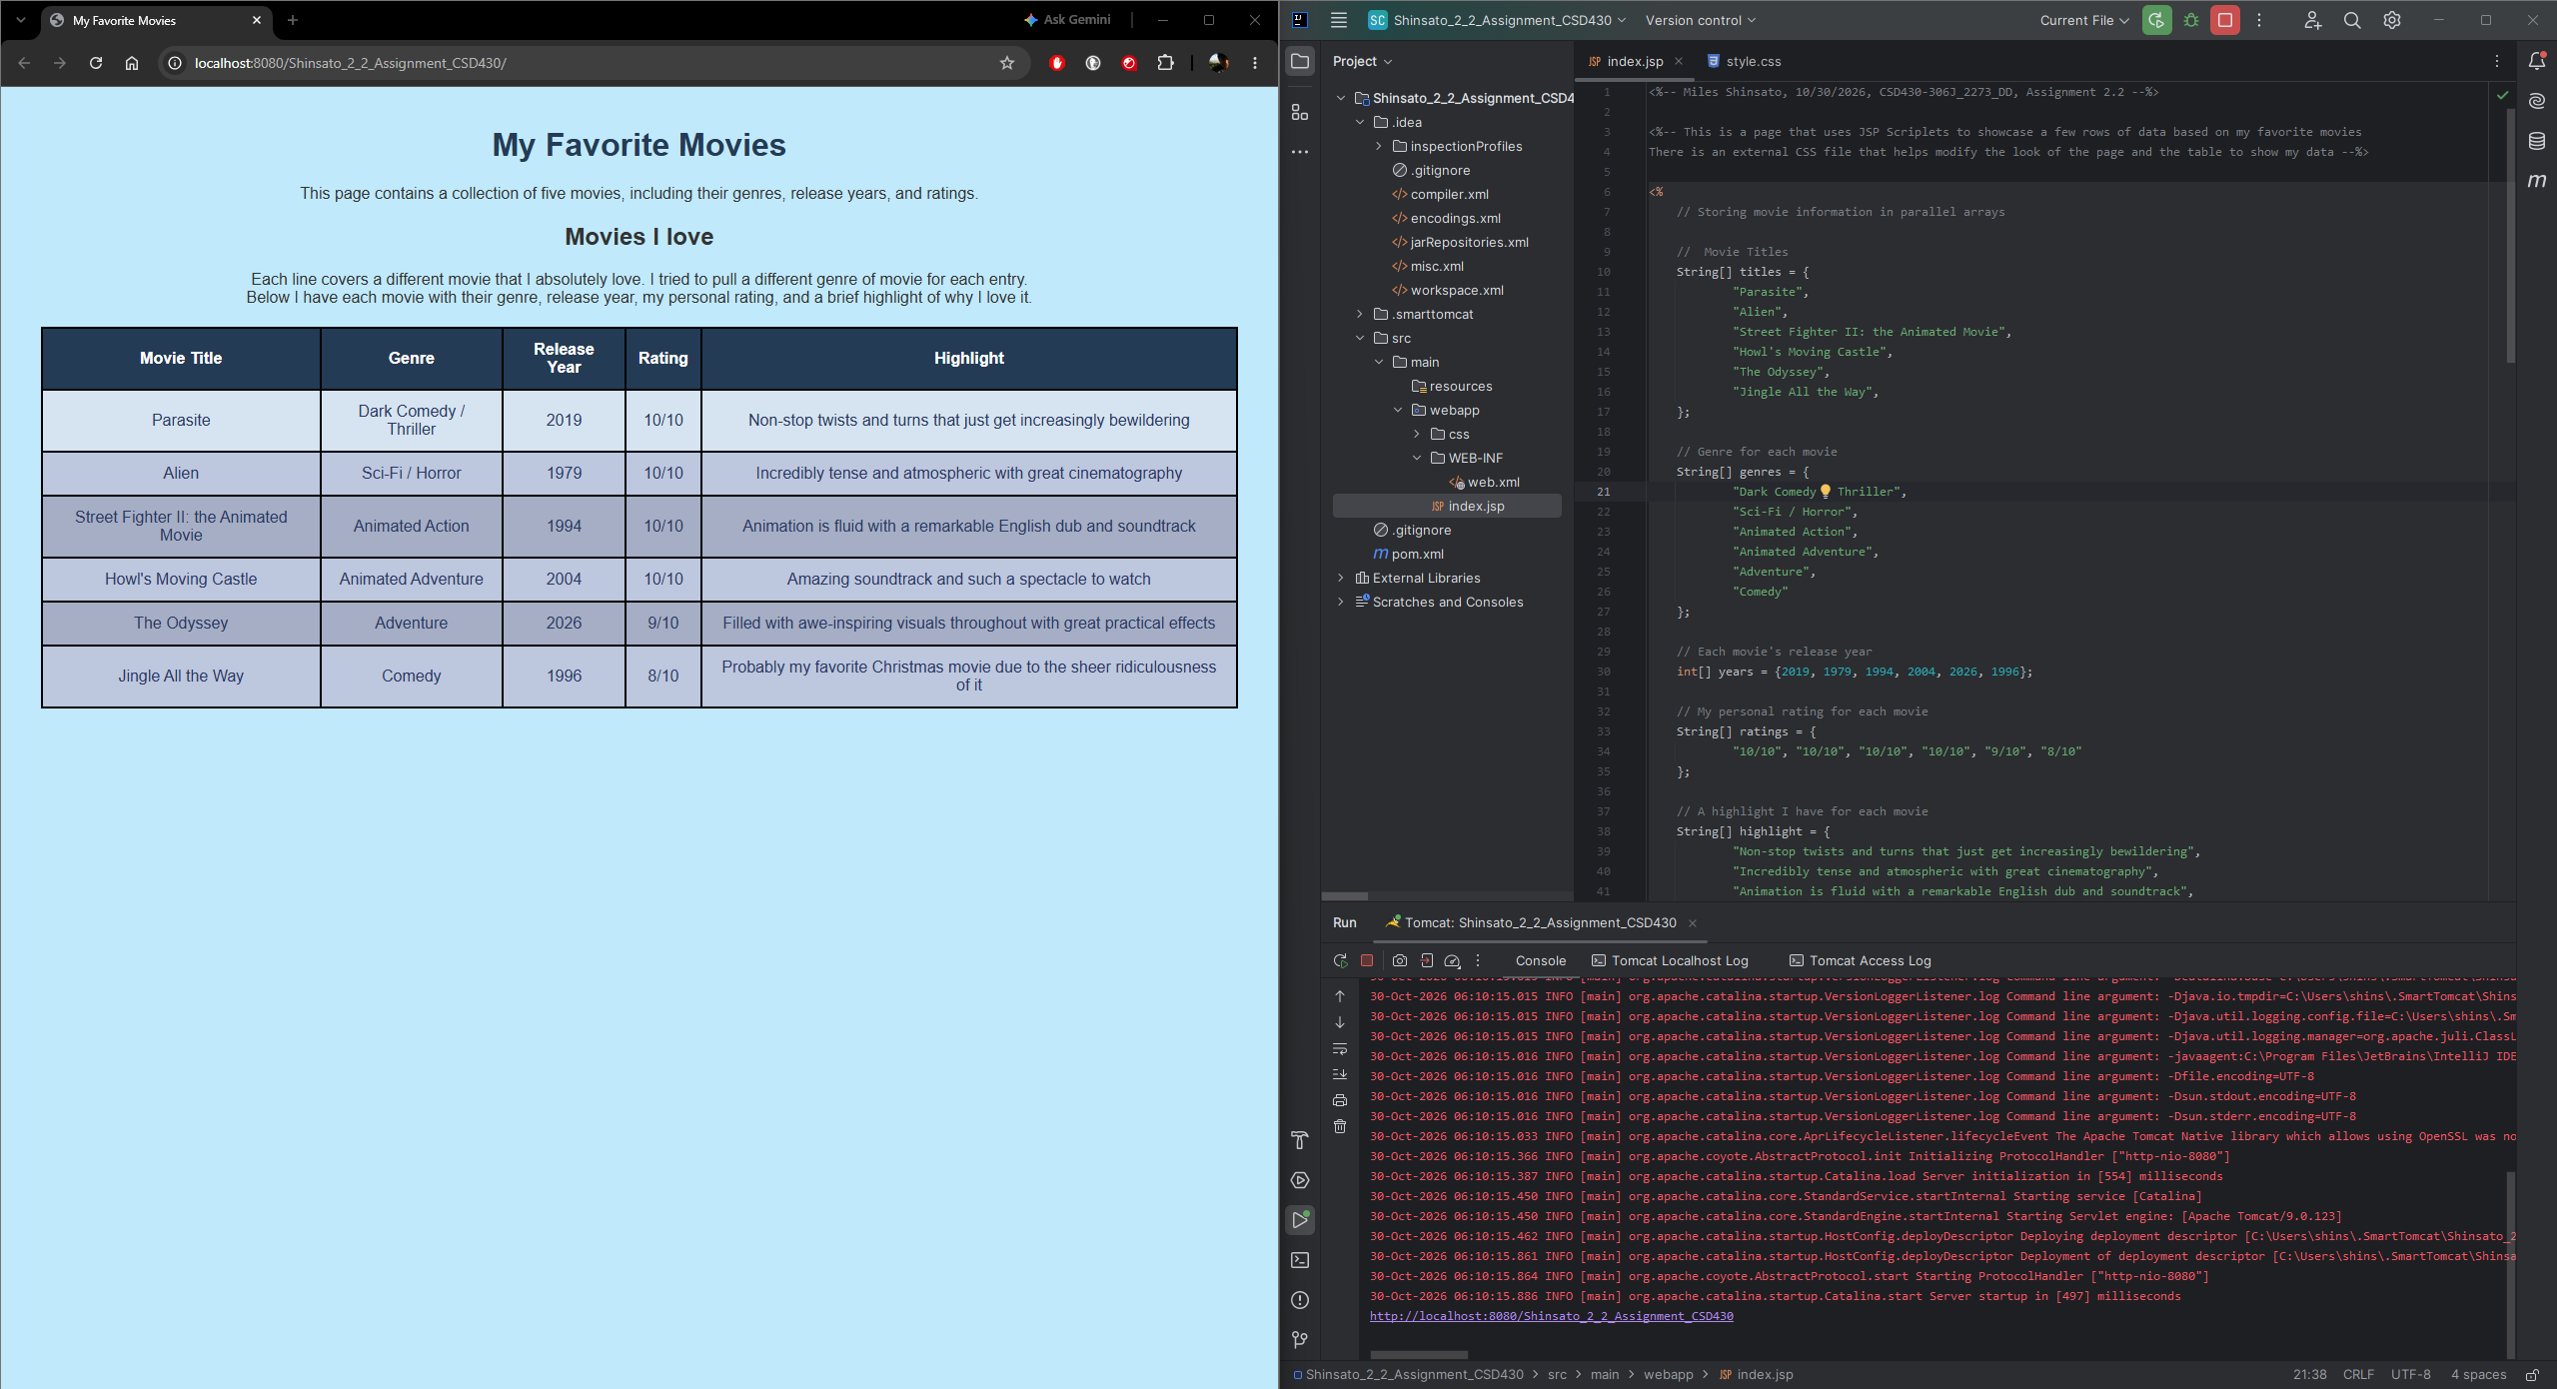

GitHub Link
https://github.com/MShinBV/CSD-430/tree/main/module-2

