JSP Forms – Theater Rating
Shinsato, Miles
Bellevue University, CSD-430
Assignment 3.2
November 08, 2026

JSP Forms – Theater Rating

Webpage Screenshot (Before Submission)
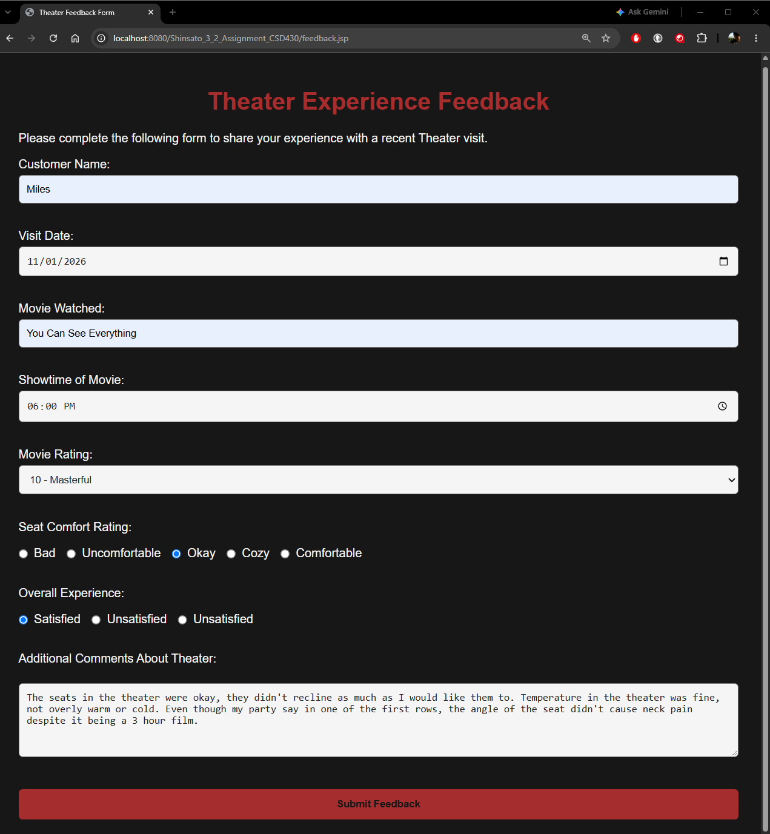

Webpage Screenshot (After Submission)
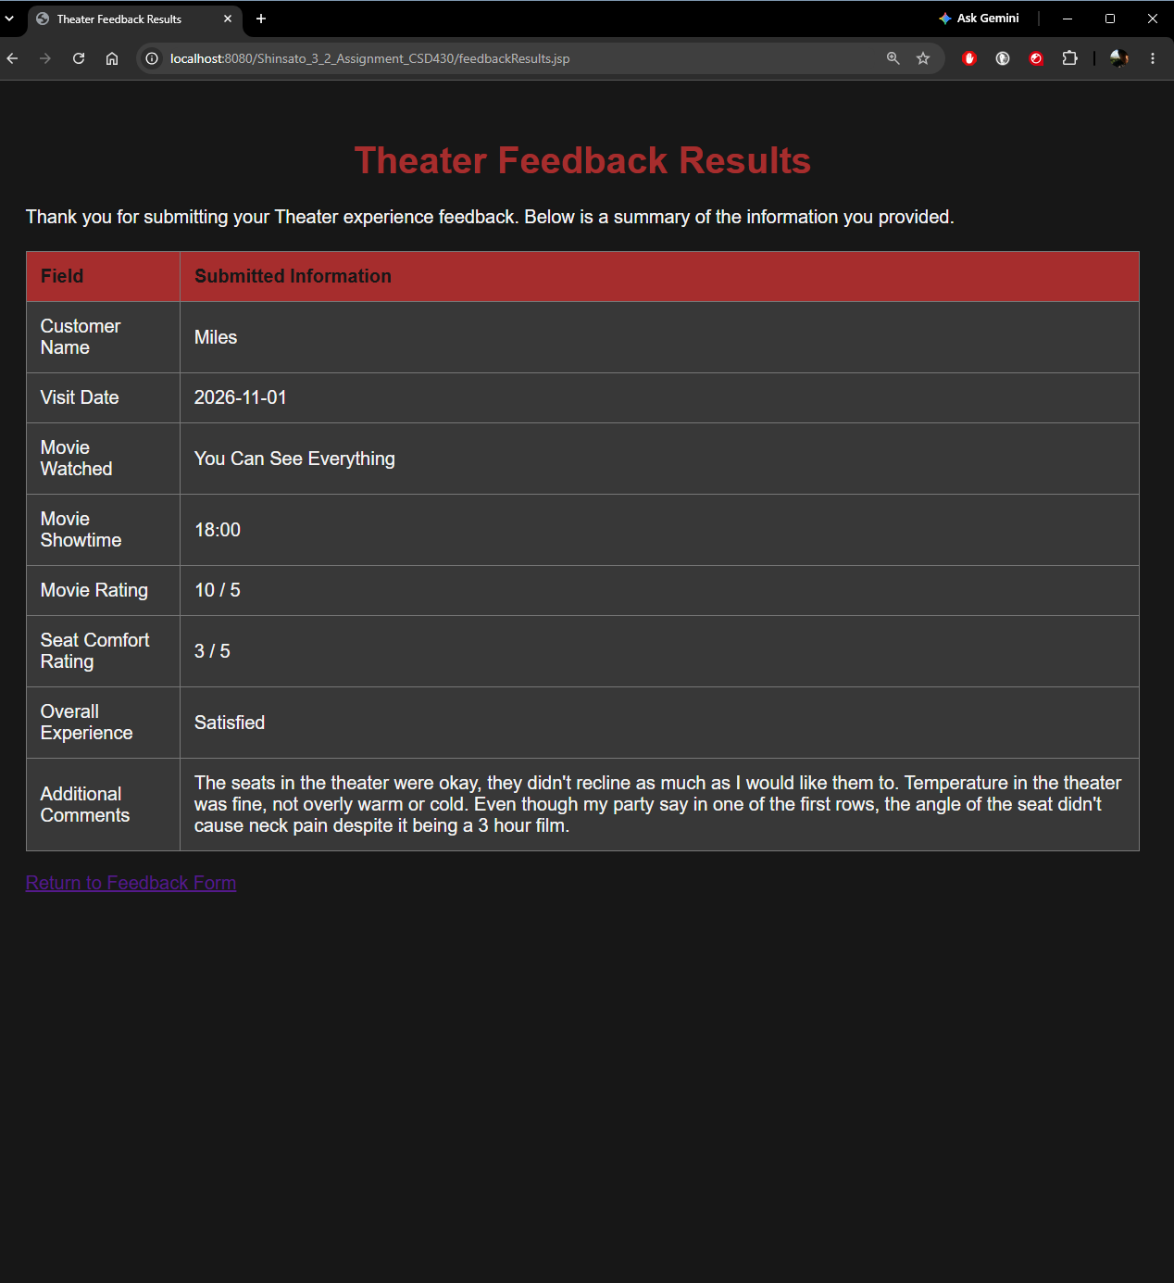

IntelliJ & Webpage Screenshot
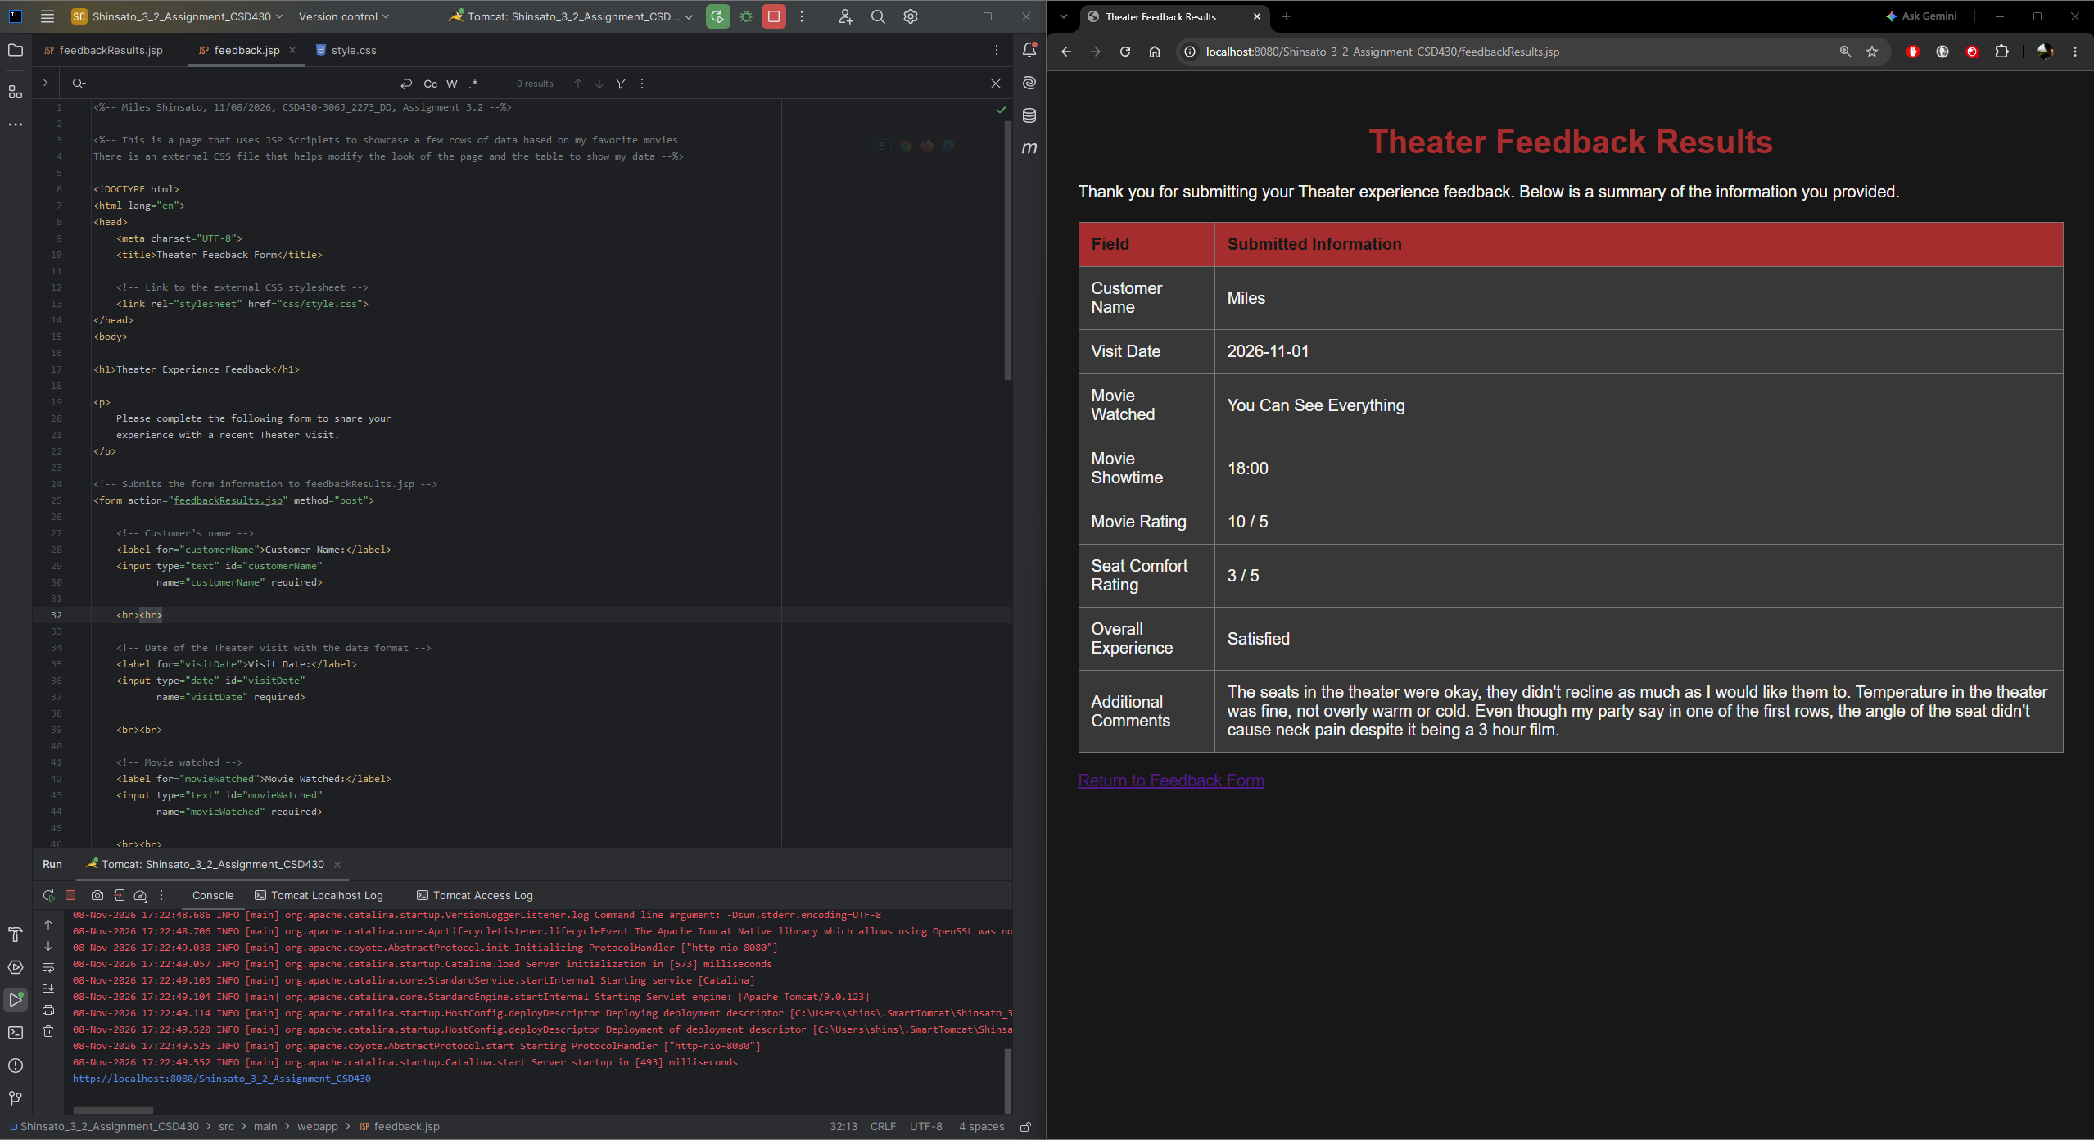

GitHub Link
https://github.com/MShinBV/CSD-430/tree/main/module-3

