Miles Shinsato
10/23/2026
CSD430-306J_2273_DD

Module 1.2 Assignment - GitHub

Link to GitHub Repository
https://github.com/MShinBV/CSD-430

Screenshot of GitHub Repository
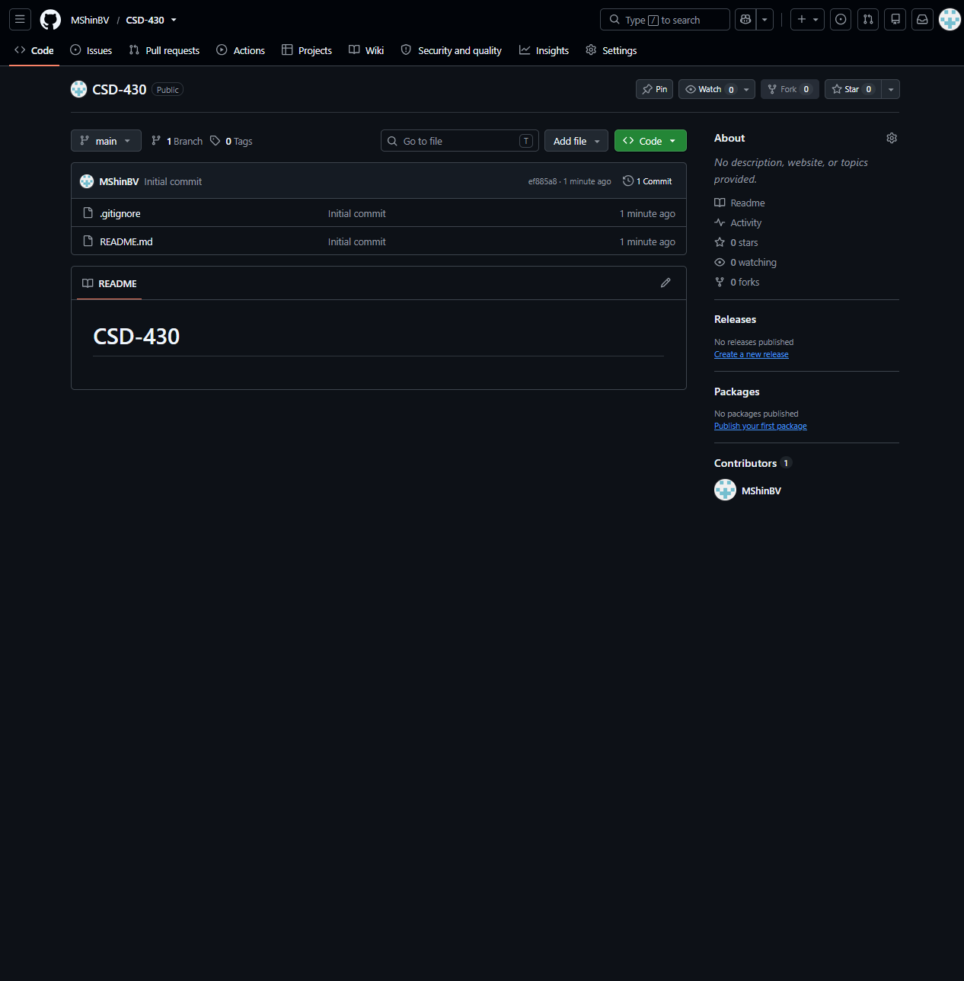

Screenshot of Local Directory
