Miles Shinsato
March 26, 2026
CSD420-308A

Module 1.2 Assignment – GitHub

Github URL of Repository: https://github.com/MShinBV/csd-420.git
Screenshot of GitHub Repository
Screenshot of local directory through Command Line
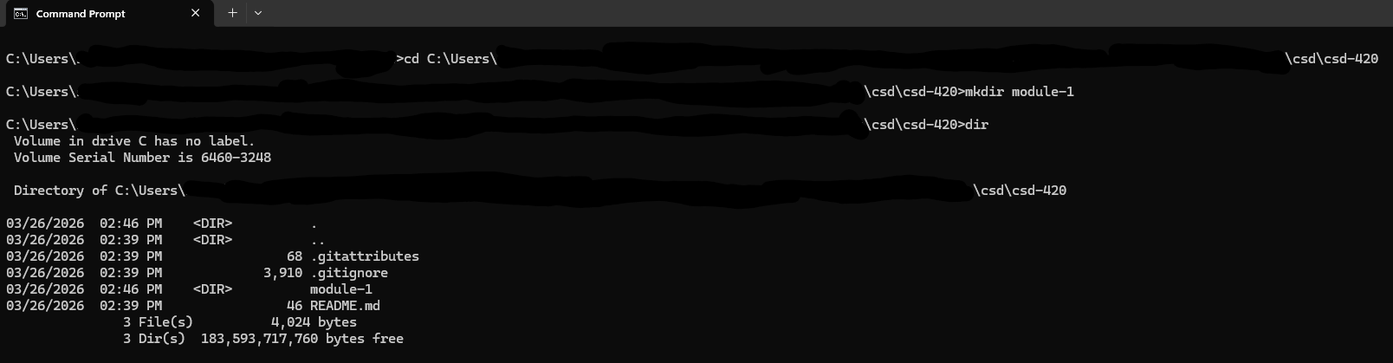
Screenshot of local directory through Windows Explorer
