MySQL Java
Shinsato, Miles
Bellevue University, CSD-420
Assignment 9.2
May 8, 2026

MySQL Java

Establishing Connection

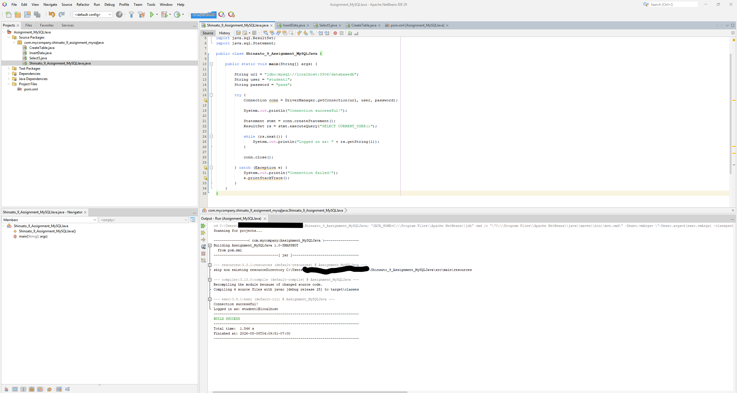

CreateTable.Java
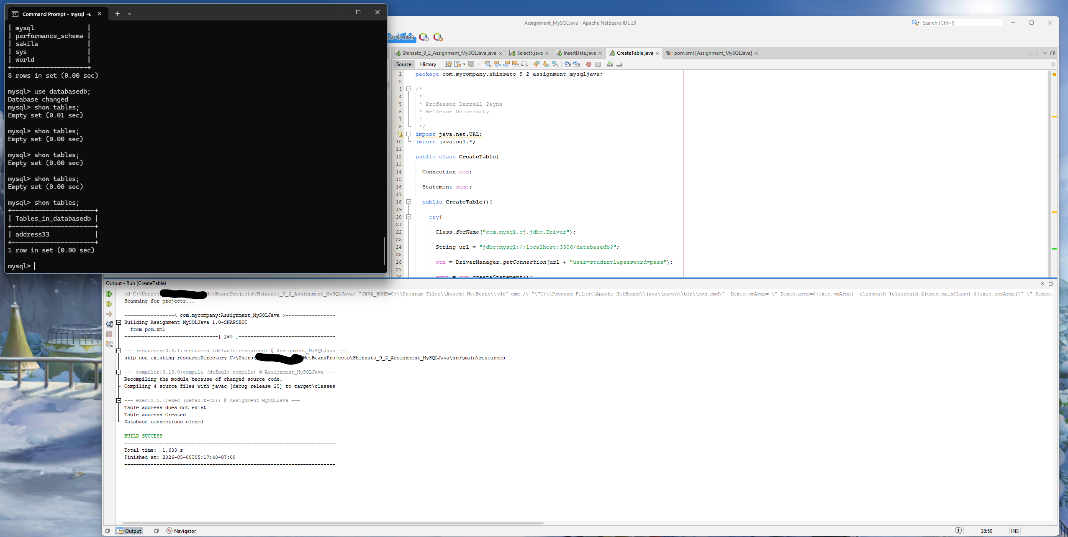

InsertData.Java
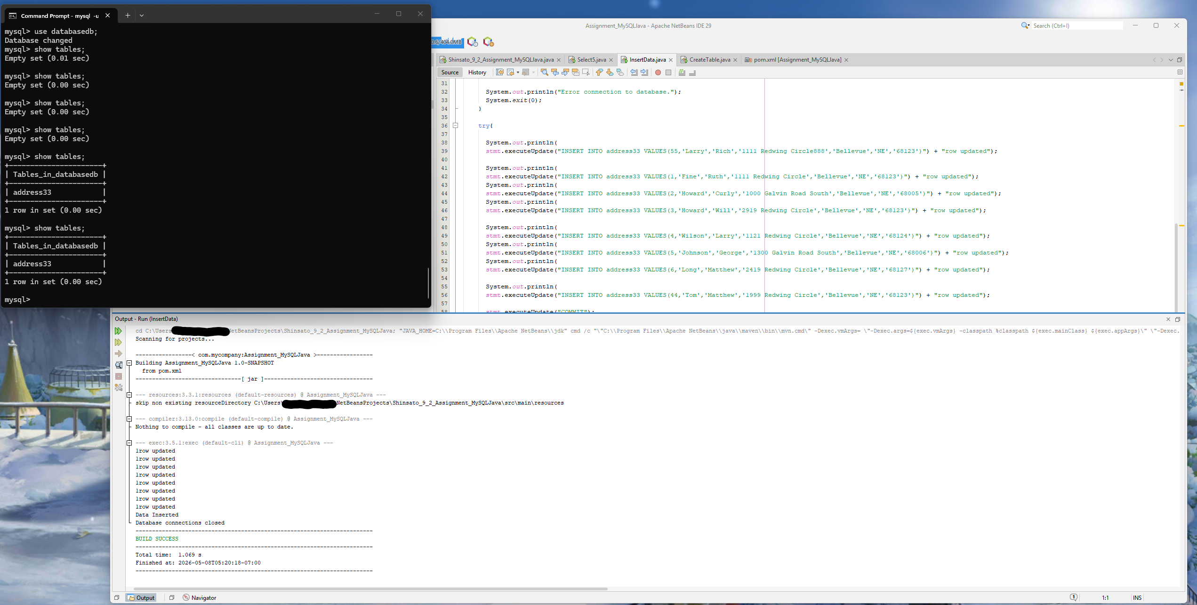

Select5.Java
