Hotel Review Analysis

LIL

September 24, 2018

## Hotel Review

This report is about the analysis of Hotel review :

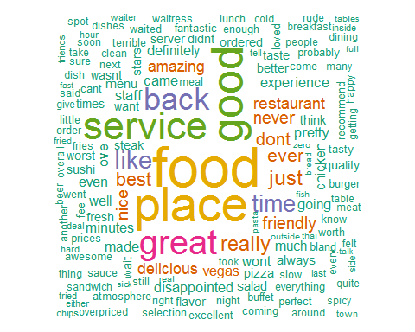

## Cooccurance of words while talking about Business

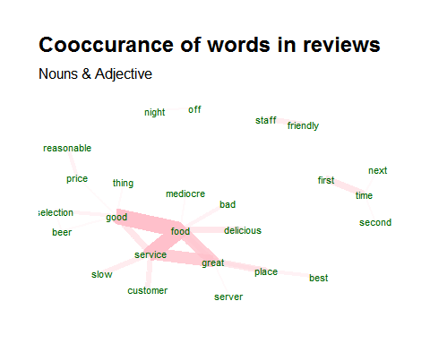

## Most Occurred Nouns and Adjective in Hotel review

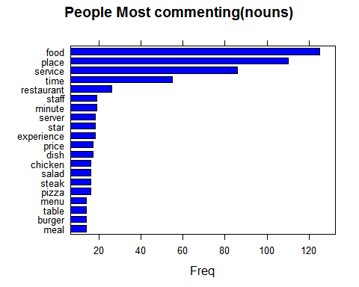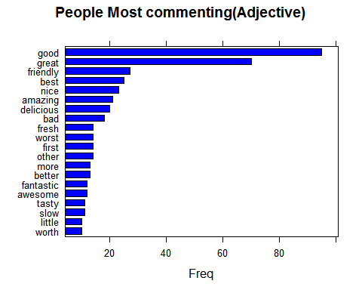

## Reviews commenting about service

Analysis of the reviews while talking about the service

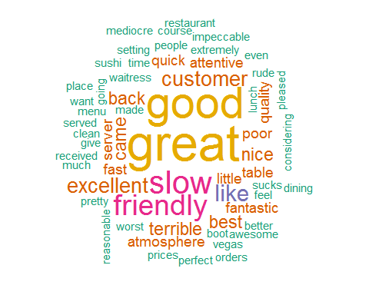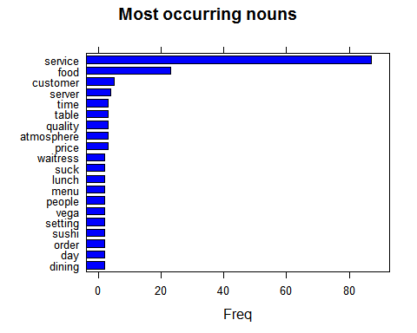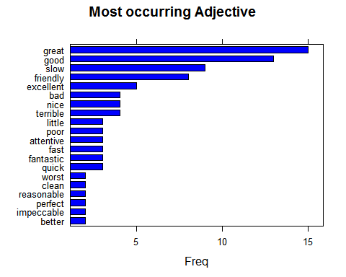

## Reviews about Food Analysis

Analysis of reviews while talking about the Food

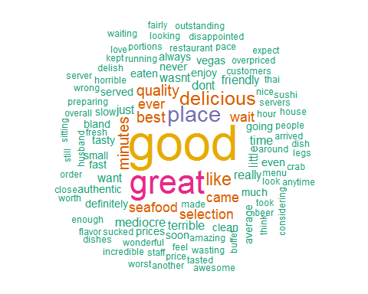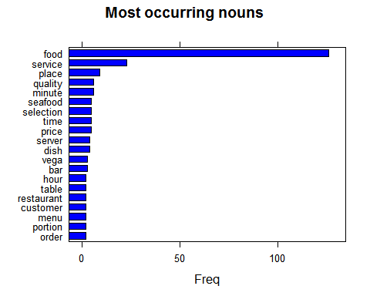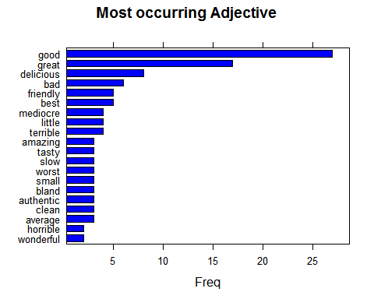

## Natural Language Processing

With the data input of 1000 reviews, we have build the model to classify the review into positive or negative. If we apply same model to sample 200 reviews we will get following result to validate the model.

## y_pred  
## 0 1  
## 0 82 18  
## 1 23 77

## [1] "Sensitivity of Model:"

## [1] 0.7809524

## [1] "specificity of Model:"

## [1] 0.8105263