Restaurant Review Analysis

LIL

September 25, 2018

## Restaurant User Review Analysis

## Natural Language Processing

This report is about the analysis of Restaurant review received by a user after availing the service.

For Model building we have 1000 review sample data which is classified into Positive and Negative reviews in the dataset.

Out of this 1000 reviews using 800 reviews we have build a model. This model will help us to classify the unidentified review into positive or negative.

To check the accuracy of the model we have kept 200 reviews aside on which we can run this pre-build model.

The result of those 200 test reviews is as follow:

## y_pred  
## Pred_Neg Pred_Pos  
## Actual_Neg 82 18  
## Actual_Pos 23 77

## [1] "Sensitivity of Model: 78 %"

## [1] "specificity of Model: 81 %"

## [1] "Accuracy of Model: 79 %"

## Terms used in NLP model

## Sensitivity:

It measures the proportion of actual positives that are correctly identified as such (e.g., the percentage of positive review which are correctly identified as positive).

## Specificity:

It measures the proportion of actual negatives that are correctly identified as such (e.g., the percentage of negative review which are correctly identified as negative).

## Accuracy:

Accuracy is how close you are to the true value(e.g.,How correctly model classified positive and negative reviews).

## Graphical Presentation for Restaurant Review Analysis

Most used words in Restaurant reviews :

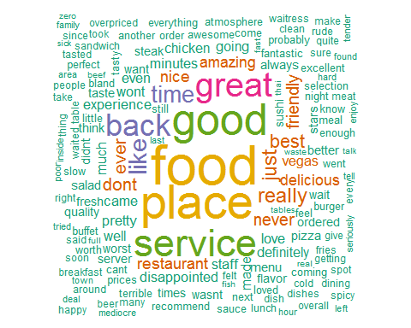

## Cooccurance of words while talking about Restaurant

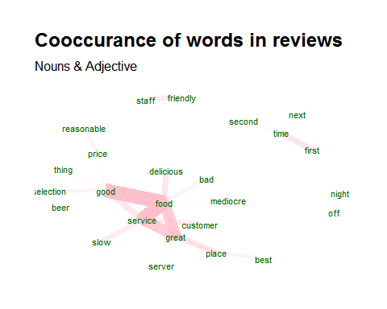

## Most Occurred Nouns and Adjective in Restaurant review

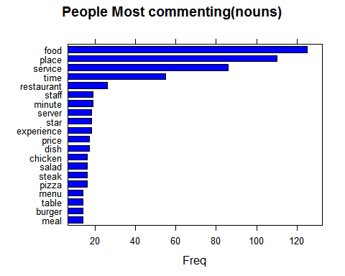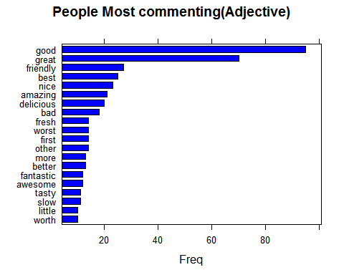

## Reviews commenting about Restaurant service

Analysis of the reviews while talking about the service

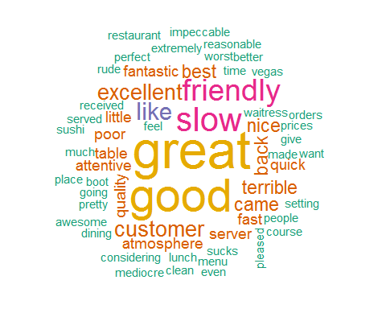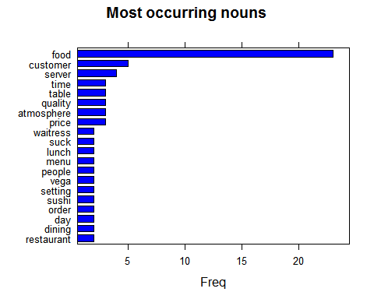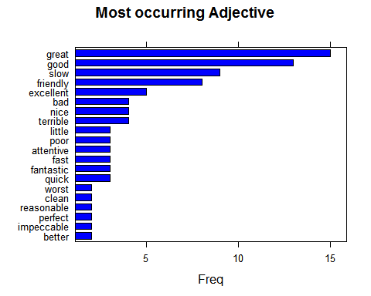

## Reviews about Restaurant Food Analysis

Analysis of reviews while talking about the Food

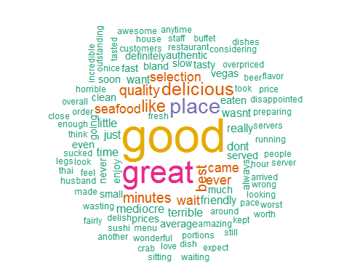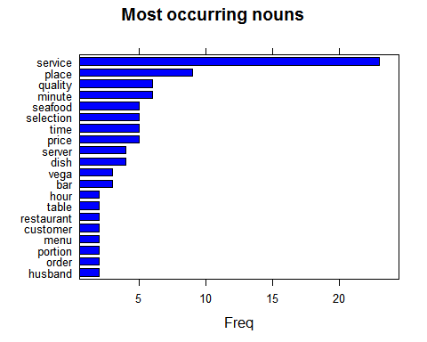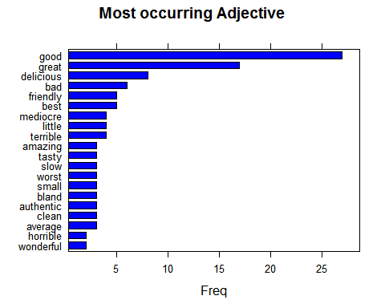

## Reviews commenting about Restaurant staff

Analysis of the reviews while talking about the staff

