*Growth rate analysis*

Before we begin our analysis of the growth rate distribution across the AIDA firms, we define “growth” and make some assumptions in the context of this study.

First, the consecutive yearly growth of every firm is calculated using the formula: $ln(\frac{S\left(t\right)}{S\left(t-1\right)})$

Where **S(t)** represents the firm size (revenue) in the current year and **S(t-1)** represents the firm size in the previous year. Given that the revenue is used as a size metric, we replaced every row in the dataset for which “R=0” with “R=1” to properly reflect the (lack of) growth under the natural logarithm.

Second, we embrace the assumptions widely used in literature regarding the distribution of growth rate, namely:

1. The growth time series of each individual firm is a specific and independent realization of the same stochastic process.
2. All firms have the same specific functional form of the growth rate distribution, although respective parameters may differ from firm to firm.
   1. – *Firm growth rate distribution in AIDA*

In the beginning, we depict the growth rate distribution (GRT) of the entire AIDA database using non-parametric estimates such as the kernel density estimate and histogram plot in order to create an initial idea about the potential family of distributions that characterizes the empirical data:

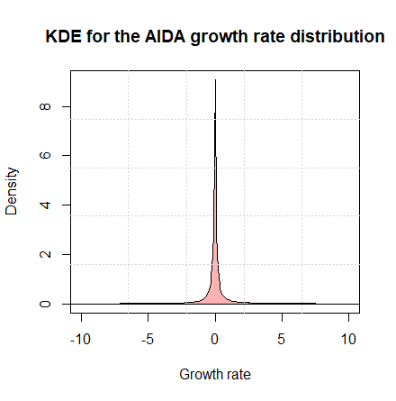

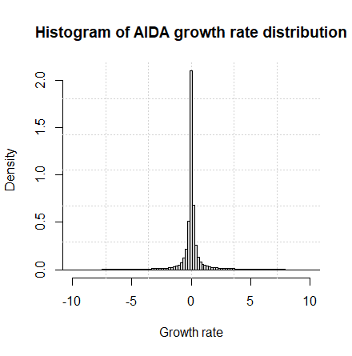

One thing that should be emphasized is the presence of considerable firms that have a growth of zero. This is reflected in the high peak located at the center of the graph above.

Some basic stats are shown below:

* Skewness ≈ 0.4
* Kurtosis ≈ 11.8
* Median = 0
* Mean ≈ 0.03

The distribution seems to be slightly positively skewed, indicating a lack of symmetry and that the tail on the right side is fatter that its counterpart on the left (i.e. there is more data on the right tail). As a rule of thumb, this also means that the mean is on the right of the median, as it is in fact the case. A positive value for the kurtosis indicates the presence of heavy tails. The typical normal distribution has a kurtosis of 3 and is known as a mesokurtic distribution. In our case, the kurtosis is much higher than that. This potentially hints at the presence of a non-normal leptokurtic distribution.

To determine which theoretical distribution fits the empirical data of AIDA best, we adopted the parametric maximum likelihood estimation (MLE) approach. The MLE functions used were **fitdist()** and **mle2()** of the *fitdistrplus* and *bbmle* packages respectively.

Normal, Laplace, Cauchy, Logistic, Lognormal, Exponential, Pareto, Gamma, Weibull and Beta were among the families tested. Random samples with varying sizes were extracted and fitted for each type of distribution. In order to avoid sampling bias, for every sample size we performed a thousand random re samplings of the same size, drawn from the dataset. The idea is to infer a 95% confidence interval for the parameters belonging to a certain family (for example, the mean and standard deviation for Gaussian) based on the empirical distribution, as we plotted below:

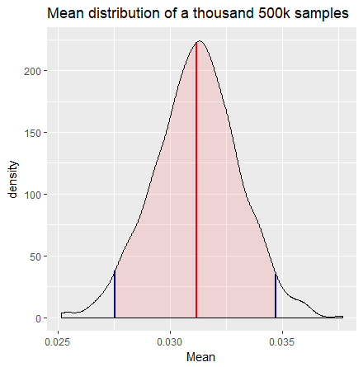

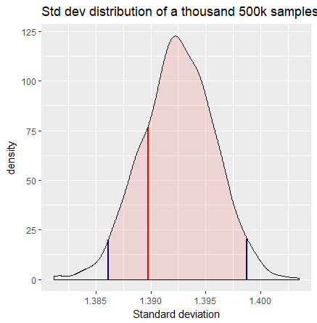

Parameters for every selected sample are estimated via MLE. The thin red line indicates the value of the mean and standard deviation respectively for **our** 500k sample (i.e. the one that we actually analyze). The blue lines on both sides represent the confidence interval limits. Given that our sample parameters are well within the CIs, it is safe to assume that it is unbiased; hence, it is an appropriate choice for further analysis. We have followed the very same line of reasoning for all other sample sizes and parameters associated with the rest of theoretical distributions, selecting to work only on those samples that have parameters confined within the boundaries of their respective CIs and rejecting those who do not fulfil this criterion.

It is only now that we are able to safely proceed with trials of fitting empirical data with different continuous distribution functions. The one-sample Kolmogorov-Smirnoff test along with the Chi-squared test were used to determine the goodness of fit for the maximum likelihood approximation. The KS test quantifies the maximal distance D between the empirical distribution function of the sample and the cumulative distribution function of the reference distribution, whereas in the Chi-squared test, the observations are classified into mutually exclusive bins, and the probability that any observation falls into the corresponding class is calculated. We describe the null and alternative hypotheses as follows:

* *Null Hypothesis* : the sample is drawn from the referenced distribution
* *Alternative Hypothesis*: the sample is **not** drawn from the referenced distribution

Given a significance level of α=5% (i.e. the largest acceptable probability of committing a type I error) and various sample sizes, we extracted the relevant stats from the KS-test and ranked them in the following table (for the top four fits):

|  |  |  |  |  |  |
| --- | --- | --- | --- | --- | --- |
| Sample size | Fit | D-statistic | p-value | AIC score | Null Hypothesis |
| 500,000 | Cauchy | 0.079343 | < 2.2e-16 | 829940 | Rejected |
| 500,000 | Laplace | 0.17203 | < 2.2e-16 | 1202469 | Rejected |
| 500,000 | Logistic | 0.1929 | <2.2e-16 | 1467071 | Rejected |
| 500,000 | Normal | 0.25386 | < 2.2e-16 | 1745741 | Rejected |
| 50,000 | Cauchy | 0.07903103 | < 2.2e-16 | 82465.17 | Rejected |
| 50,000 | Laplace | 0.152071 | < 2.2e-16 | 119999.9 | Rejected |
| 50,000 | Logistic | 0.1930132 | < 2.2e-16 | 146519.4 | Rejected |
| 50,000 | Normal | 0.2535603 | < 2.2e-16 | 174598.3 | Rejected |
| 5,000 | Cauchy | 0.08313392 | < 2.2e-16 | 7939.525 | Rejected |
| 5,000 | Laplace | 0.1473177 | < 2.2e-16 | 11523.29 | Rejected |
| 5,000 | Logistic | 0.1863629 | < 2.2e-16 | 14128.57 | Rejected |
| 5,000 | Normal | 0.2509302 | < 2.2e-16 | 17011.87 | Rejected |

Given that the p-value is below the given significance level in every case, it is would wrong from a statistical point of view to claim that the Cauchy fit is a ‘good’ fit. Moreover, this issue was present throughout every test, independent form sample type or size, as we will see in the further experiments. However, based on the D-statistic and Akaike Information Criterion (AIC) score, we can conclude that the Cauchy fit **consistently** explains the empirical distribution of the growth considerably better compared to the other family of distributions taken into account. AIC estimates the quality of each model, relative to each of the other models. The lower it is the better. A similar thing can be said about the D-statistic, which is the lowest for Cauchy in every instance. Below, we graphically represent the four above-mentioned fits for an unbiased sample of 50,000 empirical data:

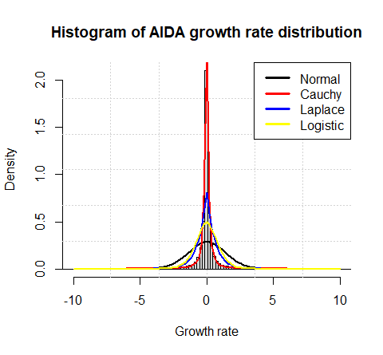

As expected, also visually the Cauchy distribution provides the best fit for the growth distribution since it is characterized (like the empirical data) by the presence of heavy tails.

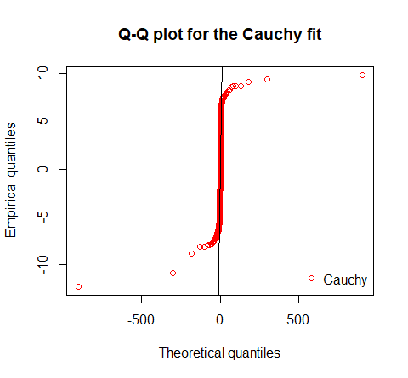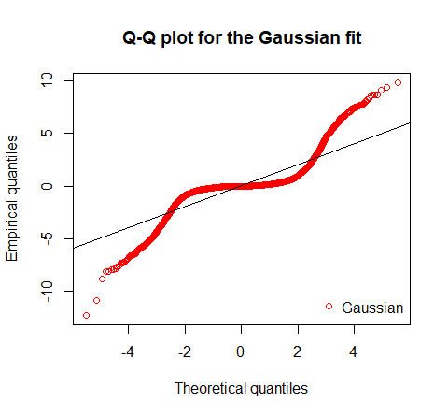Below, we compare the Q-Q and P-P plots between the Gaussian and Cauchy fit on the same sample:

Ideally, in a Quantile-Quantile plot, the data should follow a diagonal-like direction if the referenced distribution is a good one. We can clearly see that on the right side graph, although far from perfect, explains the variation of the data much better, especially around the mean, than the left side (Gaussian) representation.

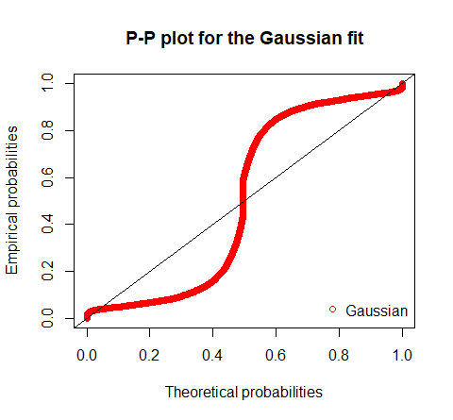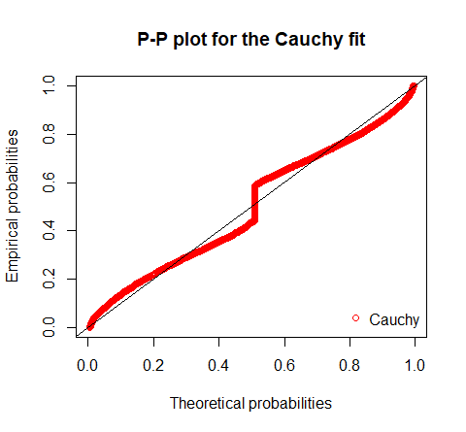

A similar interpretation can be laid out over the Probability-Probability plots, where we see that Cauchy provides a more acceptable description of the empirical probabilities.

Furthermore, we plotted the cumulative distribution functions of the empirical data and the data generated by the MLE parameters of the Gaussian and Cauchy distributions:

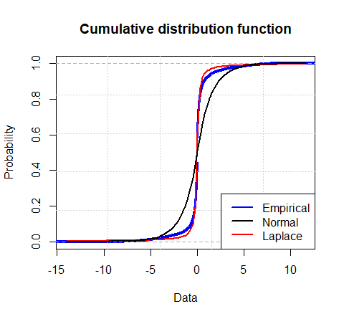

The CDF of the Cauchy generated sample overlaps over a long stretch with the CDF of empirical data. The same observation cannot be made about the Gaussian generated sample CDF.

The graphical representations reinforce our belief that the Cauchy fit is the most suitable in explaining the variation of the growth rate when compared to the others. In addition, the Gaussian fit consistently ranks as the worst from a statistical perspective. Hence, we can confidently say that the Gibrat Law does not hold on Italian firms.

* 1. – *Bootstrap confidence intervals*

For our initial unbiased sample of 50,000 observations, we can also perform a parametric bootstrap by passing to the **bootdist()** function the Cauchy fit object with the MLE estimated parameters. The function generates a thousand equally sized samples (with similar values with respect to the empirical sample values), for which the location and scale parameters are calculated using MLE. Below we show the distribution of the computed parameters and draw up 95% confidence intervals.

* *Null Hypothesis:* The estimated parameters of the empirical data are equal to the true population parameters
* *Alternative Hypothesis:* The estimated parameters of the empirical data are **not** equal to the true population parameters

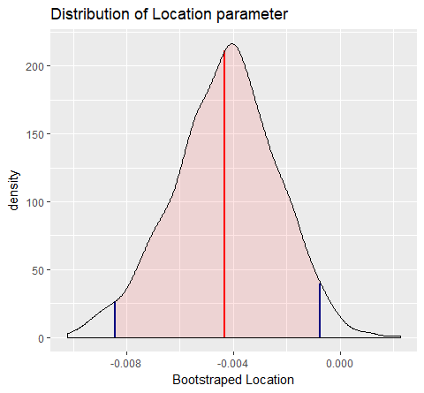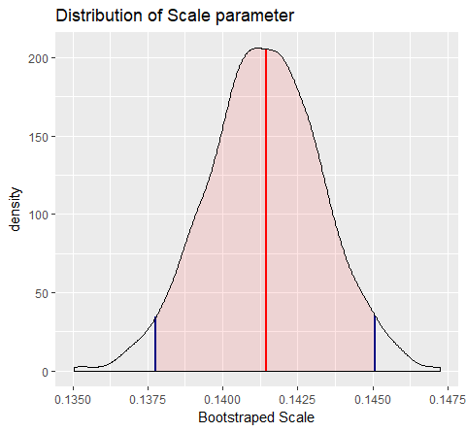

Again, the red lines represent the respective parameters of our sample, while the blue boundaries correspond to the CI limits. Clearly, the values of interest are situated between the 95% confidence intervals, so we accept the null hypothesis that the true parameters are equal to the parameters of our sample.

As mentioned earlier, we also implemented the Chi-squared test to infer the goodness of fit associated to the referenced distribution. Testing was done following the instructions of Ricci et al. 2005: Fitting distributions with R. However, we did not bother with displaying the computed p-values since they were very close to zero, even for small sample sizes. A snippet of the results is shown below:

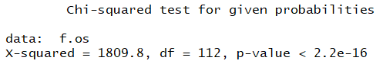

**2.1** – *Firm growth rate distribution in the Manufacturing subsector*

Distribution of growth on the manufacturing subsector exhibits some of the same characteristics as we have seen in AIDA. However, the kurtosis has a higher value (≈25), indicating heavier tails. Again, the rank of the fits is consistent, with Cauchy taking the first place as the best fit, followed by Laplace, Logistic and the Normal distribution respectively. Below we plot the histogram:

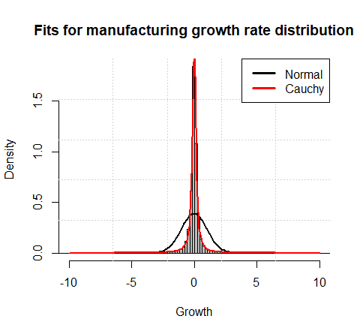

What is notable about the manufacturing subset is that, for a small enough sample size, say 1000, we get a KS-test p-value of about 0.13 for the Cauchy fit, so we accept the null hypothesis that the sample was drawn from the Cauchy distribution family. Nevertheless, with sample being so small, we decided to conduct another test in order to reaffirm the validity of the obtained fit. Using parametric bootstrap, a thousand samples of size 1000 were generated starting from the location and scale parameters of our initial sample. For every sample, the respective D-statistic was extracted. In the following graph, we plotted the density of D using a log spline fit. Log spline is similar to kernel density estimation, with the exception that it allows us to easily derive the p-value of the test because in every case, the smallest value of the x-axis will be zero. By simply subtracting from 1 the CDF value of the empirical D-stat, we get the probability of observing values that are equal to or more extreme than the max distance we already have, or in other words, the p-value:

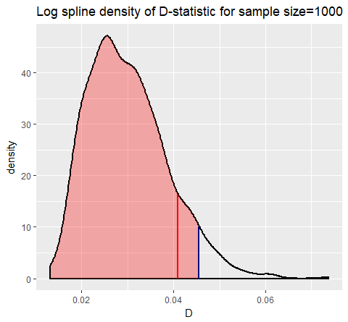

* *Null Hypothesis:* The Cauchy distribution fits the empirical data well
* *Alternative Hypothesis:* The Cauchy distribution does not fit the empirical data well

The p-value is ≈0.1, and we can see that the empirical D-stat is within the 95% confidence interval in the one-tailed test, so we accept the null hypothesis and conclude that the fit for our initial sample is a good one.

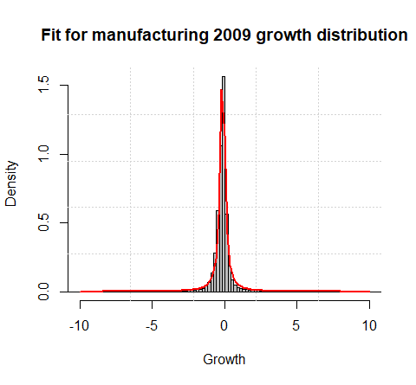Now we proceed to see if there is any significant change for the distribution of the growth throughout each year (form 2008 to 2015). We have fitted Cauchy distributions for the entire dataset in each case.

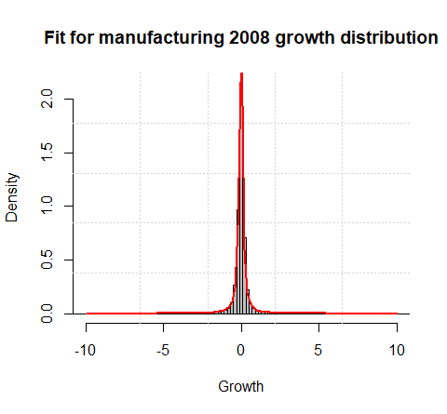

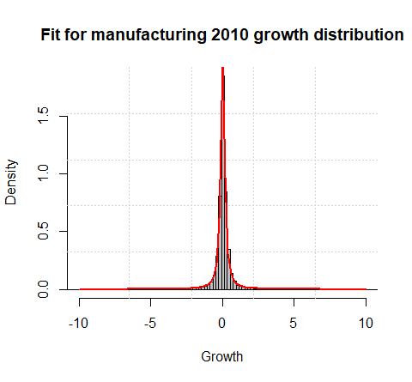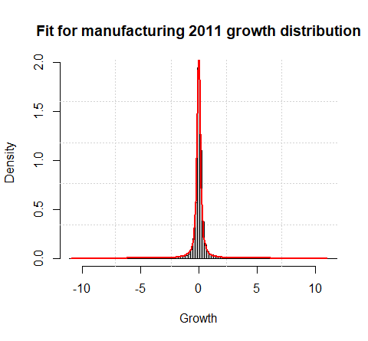

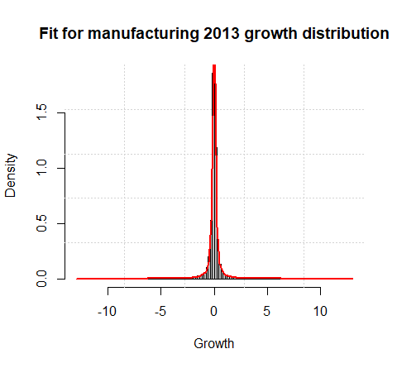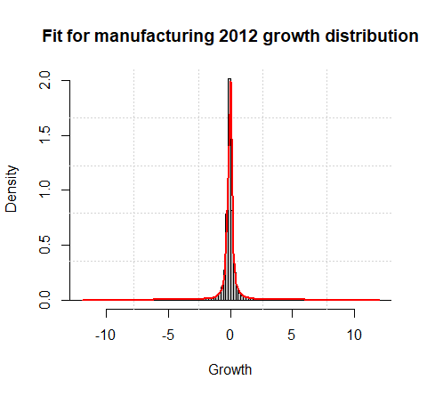

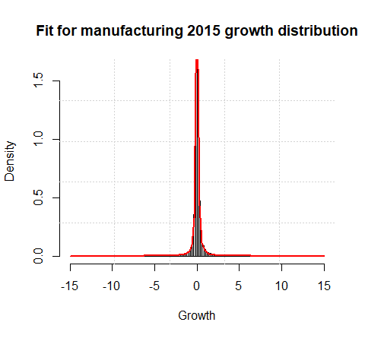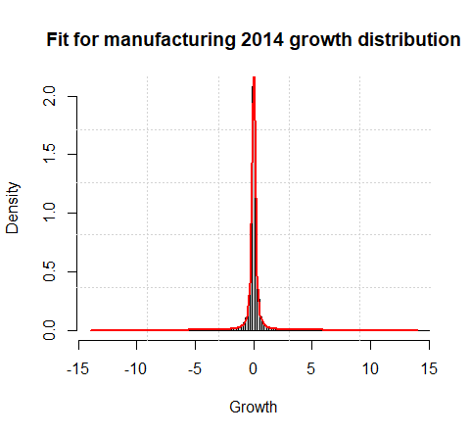

The best fit remains the same (Cauchy) across all years depicted above. At first glance, it may seem as though the distributions do not differ much among each. This is not the case, however. We conducted two sample KS-tests of the empirical data for every pair of subsequent years in order to see if there is any statistical difference between the respective distributions:

* *Null Hypothesis:* Empirical distributions are drawn from the same family of distributions
* *Alternative Hypothesis:* Empirical distributions are **not** drawn from the same family of distributions

|  |  |  |  |
| --- | --- | --- | --- |
| Years | D-statistic | p-value | Null Hypothesis |
| 2008-2009 | 0.23812 | < 2.2e-16 | Rejected |
| 2009-2010 | 0.17203 | < 2.2e-16 | Rejected |
| 2010-2011 | 0.050075 | <2.2e-16 | Rejected |
| 2011-2012 | 0.17576 | < 2.2e-16 | Rejected |
| 2012-2013 | 0.10108 | < 2.2e-16 | Rejected |
| 2013-2014 | 0.068017 | < 2.2e-16 | Rejected |
| 2014-2015 | 0.04359 | < 2.2e-16 | Rejected |

We can see that for every pair of years there is a statistically significant change in the “nature” of the distribution. If we assume that the family of distributions is Cauchy (it is in fact the best fit **relative to** the other families), then we could alternatively say that it is the parameters of the Cauchy fit that are statistically different. The change between 2008 and 2009 is notably the biggest, judging by the value of D-statistic. This may be due to the negative economic growth experienced during that period. The smallest change in distribution parameters seems to be between the years 2014 and 2015, indicating a possible stabilization of the economic growth.

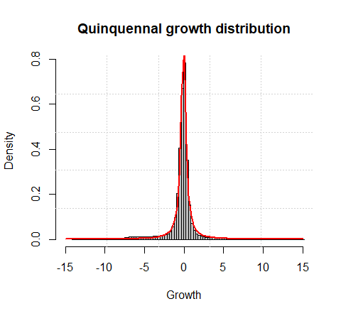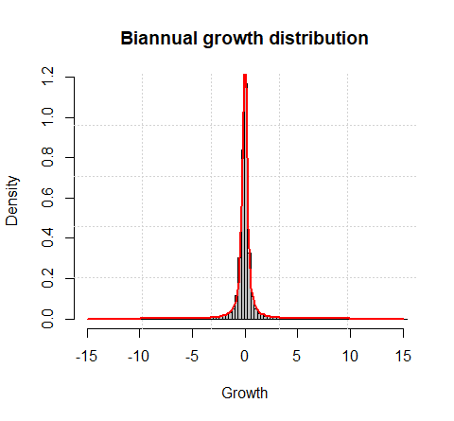Following the same line of reasoning, we check if there is any significant change in distribution for different time spans of firm growth (biannual, quinquennal and nine-year lag). The biannual growth for every firm was calculated on subsequent odd and even years while the quinquennal growth was computed for years with a difference of five units. We also estimated the growth by taking into account only the first and last years (2007 and 2015) for every firm. MLE parameters were estimated on the entire datasets, which we plot as follows.

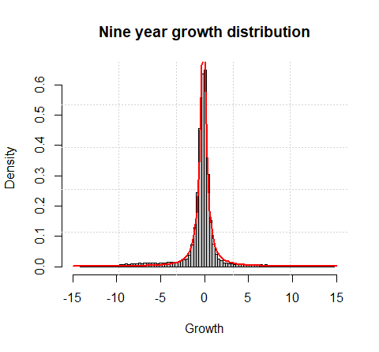

Cauchy remains the best fit. The following table summarizes some of the most relevant metrics:

|  |  |  |  |  |
| --- | --- | --- | --- | --- |
| Time span | Kurtosis | Skewness | Mean | Variance |
| Biannual | 16 | -0.29 | -0.08 | 1.85 |
| Quinquennal | 8.4 | -0.78 | -0.29 | 3.77 |
| Nine years | 7.1 | -0.83 | -0.41 | 5.1 |

The distributions are leptokurtic and negatively asymmetric (judging by the negative skewness values). The kurtosis decreases as the time span increases. Due to the fact that the number observed data decreases, the tails get thinner. The variance increases for the same reason (i.e. less, more diverse observations). We show the stats of the two-sample KS-tests among pairs of different time spans. The hypotheses are the same as for the previous two-sample KS-test:

|  |  |  |  |
| --- | --- | --- | --- |
| Time spans | D-statistic | p-value | Null Hypothesis |
| Biannual v. Quinquennal | 0.12428 | < 2.2e-16 | Rejected |
| Biannual v. Nine years | 0.18198 | < 2.2e-16 | Rejected |
| Quinquennal v. Nine years | 0.057933 | < 2.2e-16 | Rejected |

There is a statistically significant difference between the empirical distributions for every temporal span. As a result, we conclude that the empirical growth rate distribution changes across different lag intervals.

We now classify firms according to their size (small, medium, large) and follow the same procedure as previously by performing tests on the newly obtained datasets:

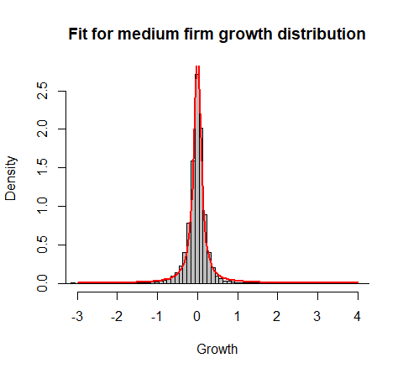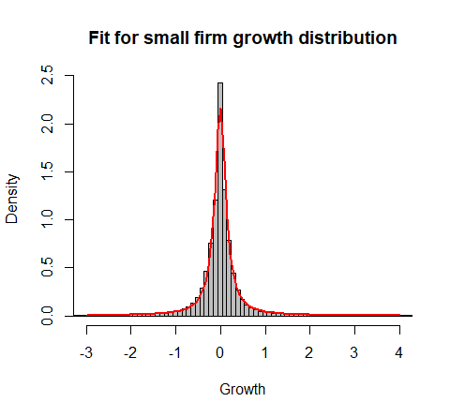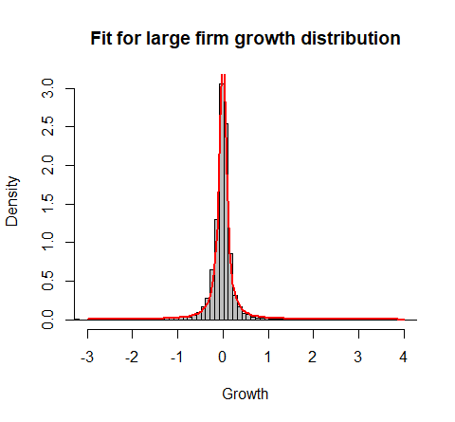

As expected, Cauchy distribution again outperforms the Laplace, Logistic and Gaussian ones.

The most important features are summarized below:

|  |  |  |  |  |
| --- | --- | --- | --- | --- |
| Firm size | Kurtosis | Skewness | Mean | Variance |
| Small | 21.5 | 0.27 | -0.014 | 1.05 |
| Medium | 172.8 | -1.78 | -0.03 | 0.22 |
| Large | 341.6 | 7.4 | -0.019 | 0.184 |

The empirical distributions are leptokurtic and positively asymmetric (i.e. skewness >0) with the exception of medium firms, which are negatively asymmetric. The kurtosis increases with increasing firm size. What this means is that the bigger the firm is, the more likely we are to see outliers or relatively large growth values in a random sample. Below we show the stats of the two sample KS-tests among pairs of different firm sizes.

|  |  |  |  |
| --- | --- | --- | --- |
| Firms | D-statistic | p-value | Null Hypothesis |
| Small v. Medium | 0.080428 | < 2.2e-16 | Rejected |
| Small v. Large | 0.11289 | < 2.2e-16 | Rejected |
| Medium v. Large | 0.045109 | 1.797e-13 | Rejected |

There seems to be a significant difference in the kind of distribution between small and large firms, while this discrepancy is smaller between medium and large sized firms.

Finally, we classify the firms also according to their region of operation, intuitively obtaining three main categories: South, Center and North. The Cauchy fit explains the variation of the empirical data the best in every case. The table below sums up the obtained stats after conduction the two-sample KS-test.

|  |  |  |  |
| --- | --- | --- | --- |
| Regions | D-statistic | p-value | Null Hypothesis |
| South v. Center | 0.080428 | < 2.2e-16 | Rejected |
| South v. North | 0.11289 | < 2.2e-16 | Rejected |
| Center v. North | 0.045109 | 1.797e-13 | Rejected |

The D-statistics suggest a considerable difference in the nature of each empirical distribution. Growth in firms located in the northern region seem to be closer (distribution wise) to the firms operating in the central region of Italy.

**2.3 –** *Symmetry test on empirical distributions*

To see if the yearly growth distribution in the manufacturing subsector is symmetric or not, we applied the two sided symmetry test by Miao, Gel, and Gastwirth (2006). Confidence intervals stand at 95%. Implementation is done by calling the **symmetry.test()** function of the *lawstat* library in R.

* *Null Hypothesis:* The distribution is symmetric
* *Alternative Hypothesis:* The distribution is asymmetric

We give a rundown of the results below.

|  |  |  |
| --- | --- | --- |
| Growth year | p-value | Null Hypothesis |
| 2008 | 0.138 | Accepted |
| 2009 | < 2.2e-16 | Rejected |
| 2010 | < 2.2e-16 | Rejected |
| 2011 | < 2.2e-16 | Rejected |
| 2012 | 0.09 | Accepted |
| 2013 | < 2.2e-16 | Rejected |
| 2014 | 0.1 | Accepted |
| 2015 | < 2.2e-16 | Rejected |

Indeed, the growth distribution belonging to the years 2008, 2012 and 2014 is symmetric according to the p-values that are greater than the significance level of 5%.

**2.3 –** *Hypothesis testing on the mean of the growth*

We want to test whether the mean of each yearly growth rate in the manufacturing subsector is statistically equal to zero. Given that we do not know the true variance of the population in each dataset, it would be logical to perform a one-sample t-test. However, the empirical distribution is not Gaussian, and as a result we cannot assume that our test statistic has a *t (n − 1)* distribution under the null hypothesis. Nevertheless, if the sample size is large enough, the distribution of the t-test statistic under the null hypothesis can also be approximated by a standard normal distribution (Dekking et. al 2005 – A modern introduction to probability and statistics). The respective sample sizes are greater than 80,000 at all times. Hence, we can perform a simple Z-test for every instance by passing as standard deviation argument the sample standard deviation.

In addition, we performed non-parametric bootstrap for the mean on each dataset, generating a thousand samples and computing the mean in each iteration in order to plot the bootstrapped distribution of the mean and extract the bootstrap confidence intervals. Parametric bootstrap was not preferred due to the large sample sizes. The Cauchy fit, being poor, would cause the obtained p-values to be unreliable. The hypotheses are listed below:

* *Null Hypothesis:* The true mean is equal to zero
* *Alternative Hypothesis:* The true mean is not equal to zero

The tests are two tailed, with 95% confidence intervals

|  |  |  |  |  |  |
| --- | --- | --- | --- | --- | --- |
| Growth year | Z-test p-value | Bootstrap p-value | Z-test CIs | Bootstrap CIs | Null Hypothesis |
| 2008 | 0.192 | 0.194 | [-0.013033297, 0.002615445] | [-0.012743726, 0.002586418] | Accepted |
| 2009 | < 2.2e-16 | 0 | [-0.1660525,  -0.1525717] | [-0.1657893,  -0.1525396] | Rejected |
| 2010 | < 2.2e-16 | 0 | [0.04368065, 0.05672658] | [0.04411189, 0.05685958] | Rejected |
| 2011 | < 2.2e-16 | 0 | [0.05367084, 0.06619221] | [0.05391392, 0.06620812] | Rejected |
| 2012 | < 2.2e-16 | 0 | [-0.06446847,  -0.05319713] | [-0.06409276,  -0.05347629] | Rejected |
| 2013 | < 2.2e-16 | 0 | [-0.06081033,  -0.04929959] | [-0.06110507,  -0.04926643] | Rejected |
| 2014 | 0.5253 | 0.51 | [-0.007808441, 0.003985842] | [-0.007673404, 0.003472902] | Accepted |
| 2015 | < 2.2e-16 | 0 | [0.04901664, 0.06028508] | [0.04967434, 0.06015972] | Rejected |

The table above summarizes the results of both the Z-test and bootstrap approach. We accept the null hypothesis for the years 2008 and 2014. The distribution of the bootstrpd mean for **2008** isplotted.

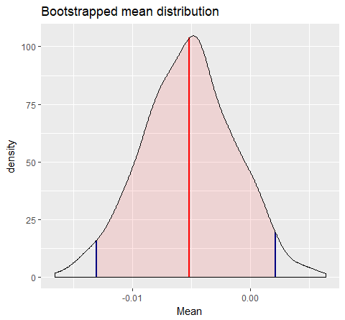

**2.4 –** *Hypothesis testing on the difference of the means for two populations*

Similarly to the previous section, we want to see if the difference of the growth means for every pair of consecutive years is equal to zero. Again, we do not know the true variances of the populations we are comparing. Therefore, we could choose to perform a two-sampled t-test. Yet again, we face the problem of a non-Normal distribution of the empirical data. However, since the sample sizes are large the distribution of the t-test statistic under the null hypothesis even in this case can be approximated by a standard normal distribution. This happens because, if we compute the difference between the same normally distributed statistic from two populations, the resulting statistic is still going to be normally distributed.

We can perform a simple Z-test by passing as standard deviation arguments the sample standard deviations of the two populations we are testing.

Non-parametric bootstrap for the mean differences was also carried out:

|  |  |  |  |  |  |
| --- | --- | --- | --- | --- | --- |
| Years | Z-test p-value | Bootstrap p-value | Z-test CIs | Bootstrap CIs | Null Hypothesis |
| 2008 v. 2009 | < 2.2e-16 | 0.194 | [0.1437759, 0.1644305] | [0.1432260 0.1645635] | Rejected |
| 2009 v. 2010 | < 2.2e-16 | 0 | [-0.2001359,  -0.2188956] | [-0.2185686,  -0.2008981] | Rejected |
| 2010 v. 2011 | 0.03496 | 0.0326 | [-0.0187692209,  -0.0006866075] | [-0.0184483352,  -0.0006070693] | Rejected |
| 2011v. 2012 | < 2.2e-16 | 0 | [0.1271879,  0.1103407] | [0.1098109, 0.1279776] | Rejected |
| 2012 v. 2013 | 0.358 | 0.325 | [-0.011832968, 0.004277281] | [-0.01135918, 0.00432352] | Accepted |
| 2013 v. 2014 | < 2.2e-16 | 0 | [-0.04490348,  -0.06138384] | [-0.06110507,  -0.04926643] | Rejected |
| 2014 v. 2015 | < 2.2e-16 | 0 | [-0.06471818  -0.04840614] | [-0.06533663,  -0.04825146] | Rejected |

The table above summarizes the results. We accept the null hypothesis only for the years 2012 v. 2013, so only for this pair, the difference of the means is statistically zero.

The graph below plots the distribution of the bootstrapped mean difference **for the years 2008-2009**. The empirical mean difference is within the 95% confidence intervals and has a value of ≈0.154.

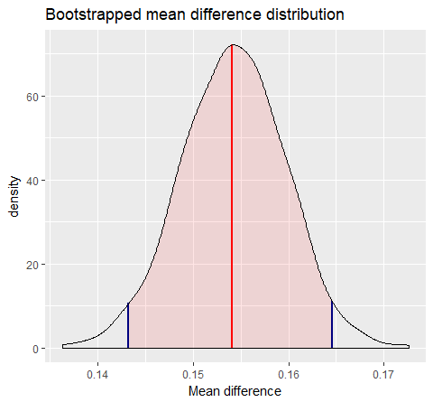

**2.5 –** *Linear regression models for the growth rate distribution of subsequent years*

In order to determine whether there is a dependence between growth in subsequent years, we can model a simple linear regression of the form “*growth_2009~ growth_2008*”, where growth_2008 is the predicting variable and growth_2009 is the target variable.

* *Null Hypothesis:* Model is not significant (i.e. β=0)
* *Alternative Hypothesis:* Model is significant (i.e. β≠0)

The default confidence interval stands at 95%.

Below we have summed up some of the more interesting stats associated with the fit of the linear regression models.

It is interesting to note that most models are significant, or in other words, the growth of the previous year adequately predicts the growth in the current year. However, it is also noteworthy that the values of the R-squared statistic (that indicates the goodness of fit) are far from ideal. R-squared can take values between 0 (very bad fit) and 1 (ideal fit). A good fit in a significant model is typically associated with an R-squared value that is greater than 0.7, but in our case, we obtained significant models with horrendous R-squared values. So what is going on here? A possible interpretation could be formulated as follows: the independent variable is correlated with the dependent variable, but it do not explain much of the variability in the dependent variable. This is likely due to the presence of heteroscedasticity around the fitted values.

|  |  |  |  |  |  |
| --- | --- | --- | --- | --- | --- |
| Years | F-statistic | Model p-value | R-squared | Slope | Null Hypothesis |
| 2009 ~ 2008 | 40.43 | 2.056e-10 | 0.0007019 | -0.024278 | Rejected |
| 2010 ~ 2009 | 112.3 | < 2.2e-16 | 0.001407 | -0.033502 | Rejected |
| 2011 ~ 2010 | 0.7307 | 0.3927 | 8.362e-06 | -0.002515 | Accepted |
| 2012 ~ 2011 | 3.196 | 0.07384 | 3.262e-05 | -0.004916 | Rejected |
| 2013 ~ 2012 | 196.3 | < 2.2e-16 | 0.001738 | 0.039106 | Accepted |
| 2014 ~ 2013 | 138.8 | < 2.2e-16 | 0.00121 | 0.03252 | Rejected |
| 2015 ~ 2014 | 84.1 | < 2.2e-16 | 0.0007577 | 0.023250 | Rejected |

Heteroscedasticity implies that there are sub populations in the dependent variable that have different variance from others. Let us take for instance the first model (**2009 ~ 2008**) and plot the fitted values.

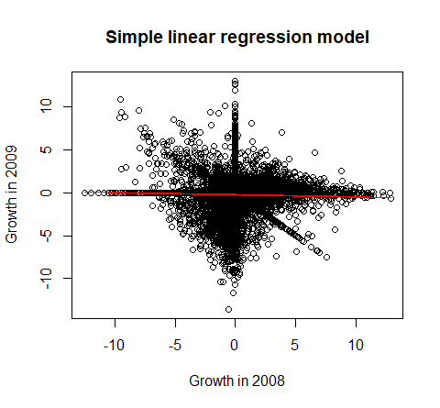

The red line across the graph represents the fitted values. Obviously, the fit is not very good, to say the least. On average, we can say that if the growth in 2008 increases with one unit, the growth of 2009 with decrease with -0.002 units, so there is a slight negative correlation between them. Still, actual values of the 2009 growth are not at all in alignment with the fitted values of the model.

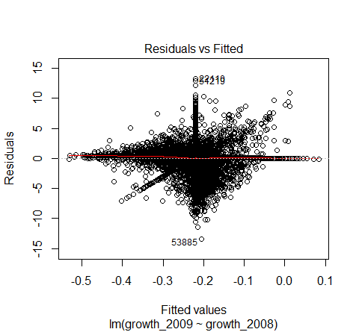The residuals (difference between actual y-values and predicted y-values) are plotted against the fitted valued in the graph below.

Residuals seemingly bounce around in a random manner. To check for the presence of heteroscedasticity, we have used the Breush-Pagan test of the *lmtest* library. The hypotheses are:

* *Null Hypothesis:* Variance of residuals is constant
* *Alternative Hypothesis:* Variance of residuals is not constant

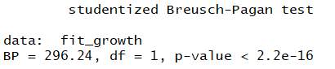We display a screenshot of the test results:

The p-value is much lower than the significance level of 5%; therefore, we reject the null hypothesis.

Overall, we can conclude that on average, there has been consistent negative growth in Italian manufacturing firms until 2011. This is reflected in the negative slopes for the preceding year growths. From 2012 and onwards, growth has been positive.