Software Requirements Specification
for
Human Resources Management Web Project
Version 2.0 approved
Myles Spillers
MSU
December 07,2022
Table of Contents
Table of Contents ii
Revision History ii
1. Introduction 1
1.1 Purpose 1
1.2 Document Conventions 1
1.3 Intended Audience and Reading Suggestions 1
1.4 Product Scope 1
1.5 References 1
2. Overall Description 1
2.1 Product Perspective 1
2.2 Product Functions 1
2.3 User Classes and Characteristics 2
2.4 Operating Environment 2
2.5 Design and Implementation Constraints 2
2.6 User Documentation 2
2.7 Assumptions and Dependencies 2
3. External Interface Requirements 2
3.1 User Interfaces 2
3.2 Hardware Interfaces 2
3.3 Software Interfaces 2
3.4 Communications Interfaces 3
4. System Features 3
4.1 User Time Reporting 3
4.2 CSV Time Reporting 3
4.3 Administration Login 4
4.4 Administration Query 4
4.5 Administration Active Pay Period 5
5. Other Nonfunctional Requirements 5
5.1 Security Requirements 5
5.2 Software Quality Attributes 5
Appendix A: Time Report-Staff-2021-2022 Original 6
Appendix B: Analysis Models 6
Appendix C: User Interfaces 9

Revision History
Name | Date | Reason For Changes | Version
Myles Spillers | 03/04/2022 | First Version of Document | 1.0
Myles Spillers | 04/29/2022 | Added Analysis Models | 1.1
Myles Spillers | 12/07/2022 | Final Prototype | 2.0

Introduction

Purpose
Time Report Web Interface v 2.0 is a standalone system with purpose specified in section 1.4

Document Conventions

Intended Audience and Reading Suggestions
HR Managers, Developers, Project Managers

Product Scope
The Time Reporting Web Interface is intended to be a standalone web form that allows MSU employees to report hours worked for compensation. The Time Reporting Interface should allow users to report actual hours worked, Military Leave, Personal Leave, Holiday Leave, Jury Duty, Overtime, and other time designations as determined in the Time-Report-Staff-2021-2022 Excel Document.

References

Overall Description

Product Perspective
The Time Reporting Web Interface is a supplement to the existing Time Reporting Tool used by MSU employees to report hours worked for compensation. It is designed to be a standalone application with a database layer and a web application layer.

Product Functions

- Allow user to enter information based upon category hours
- Calculate compensatory time based on functions determined by categorical hours
- Export compensatory time calculations for auditing purposes.

User Classes and Characteristics
- Reporting MSU Employees (High-Frequency) – This class will use this interface from a client perspective. User Class should not be concerned with the lower implementation details of the application. Thus, Class interaction with the application should be data-centric and traceable.
- HR Associates/Managers (Medium-High Frequency) – This class will provide high-level administration of the application. User Class will be concerned with some lower-level implementation of the application as this class determines the calculations for compensatory time.

Operating Environment

The software is designed to operate on a 64-bit Windows 10 version 10.0.19044 machine.

Design and Implementation Constraints
- Project inherits constraints from software and dependencies used in the implementation of the necessary functionalities

Assumptions and Dependencies
- Html 5
- CSS 3
- PHP 8.1
- PostgreSQL 12
- PHPSpreadsheet 1.25.2
- Composer 2.4.4

External Interface Requirements

User Interfaces

- See Appendix C
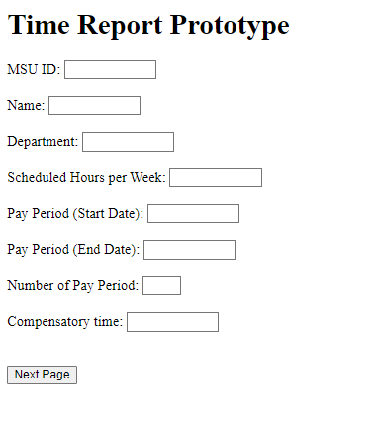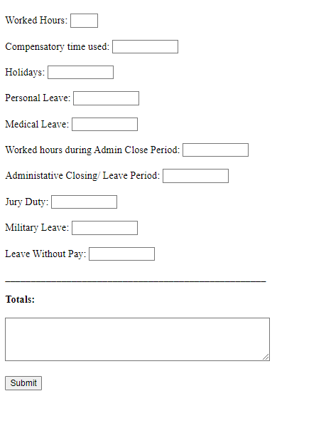

Software Interfaces

- PHP 8.1 – Server Side scripting language used to drive the form functionality
- PHPSpreadsheet – Third-Party Library to automatically export user-submitted info to Excel sheet.

Communications Interfaces
- Google Chrome/ Mozilla Firefox – cross-platform web browser(s). Users will use this browser to send HTTP requests to drive the application.

System Features

User Time Reporting
4.1.1 Description and Priority
The user should be able to navigate to the web application to enter relevant payroll reporting information which will be exported to the database.
Priority – High
4.1.2 Stimulus/Response Sequences
The user navigates to the web application.
The user enters relevant hour information.
User Submits Form.
Software should calculate correct compensatory information.
The application should send submitted time information to the database layer.

4.1.3 Functional Requirements
REQ-1: Html Forms
REQ-2: PHP
REQ-3: PostgreSQL Database Connection

CSV Time Exporting
4.2.1 Description and Priority
The user should be able to navigate to the web application to enter relevant reporting hour
Priority – High
4.2.2 Stimulus/Response Sequences
The user navigates to the web application.
The user enters relevant hour information.
User Submits Form.
The application should calculate the correct compensatory information.
The application automatically exports user CSV data.

4.2.3 Functional Requirements
REQ-1: Html Forms
REQ-2: PHP
REQ-3: PHPSpreadsheet

Administration Login
4.1.1 Description and Priority
An administrator should be able to navigate to the web application to access the Administration area.
Priority – Medium
4.1.2 Stimulus/Response Sequences
The administrator navigates to the web application
The administrator enters the relevant login information.
Administrator submits Form
The application should redirect to the administrator area if the login information is correct.
The application must deny access if the login information is incorrect.
4.1.3 Functional Requirements
REQ-1: Html Forms
REQ-2: PHP
REQ-3: PostgresSQL Database Connection

Administration Query
4.1.1 Description and Priority
An administrator should be able to navigate to the web application to query submitted pay information.
Priority – High
4.1.2 Stimulus/Response Sequences
The administrator navigates to the web application.
The administrator passes authentication.
The administrator navigates to the payroll information page.
The administrator submits query information in the correct format.
The application returns queried payroll information in a table.
4.1.3 Functional Requirements
REQ-1: Html Forms
REQ-2: PHP
REQ-3: PostgreSQL Database Connection

Administration Active Pay Period
4.1.1 Description and Priority
An administrator should be able to navigate to the web application to set the active pay period.
Priority – High
4.1.2 Stimulus/Response Sequences
The administrator navigates to the web application.
The administrator passes authentication.
The administrator navigates to the pay period information page.
The administrator submits query information in the correct format.
The application returns the new active pay period.
The application should update the payroll submission form.
4.1.3 Functional Requirements
REQ-1: Html Forms
REQ-2: PHP
REQ-3: PostgreSQL Database Connection

Other Nonfunctional Requirements

Security Requirements
- The software should be written in a way that mitigates SQL Injections, Cross Site Scripting, and other common application vulnerabilities.

Software Quality Attributes
- The product should be reliable to avoid frustration on part of the user.
- It should be built in a way that is both testable and traceable using test-driven development.
Appendix A: Time Report-Staff-2021-2022 Original
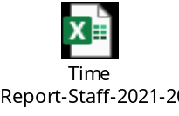
Appendix B: Analysis Models
Sequence Diagram
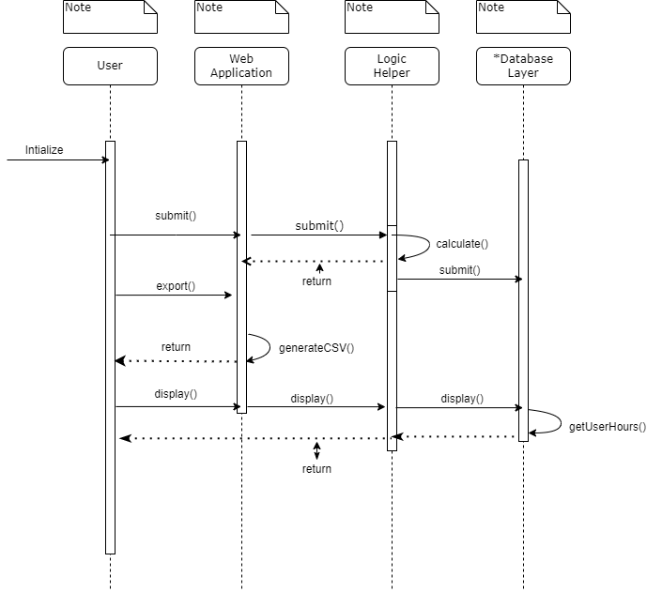

Functional Diagram
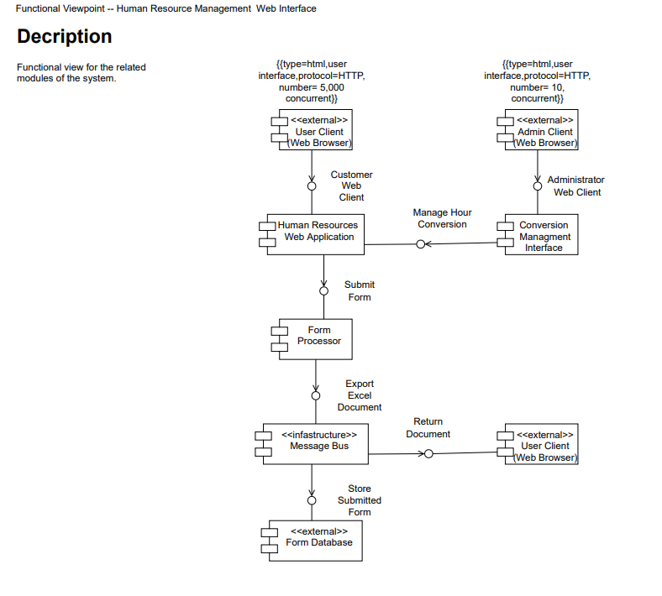

Deployment Diagram
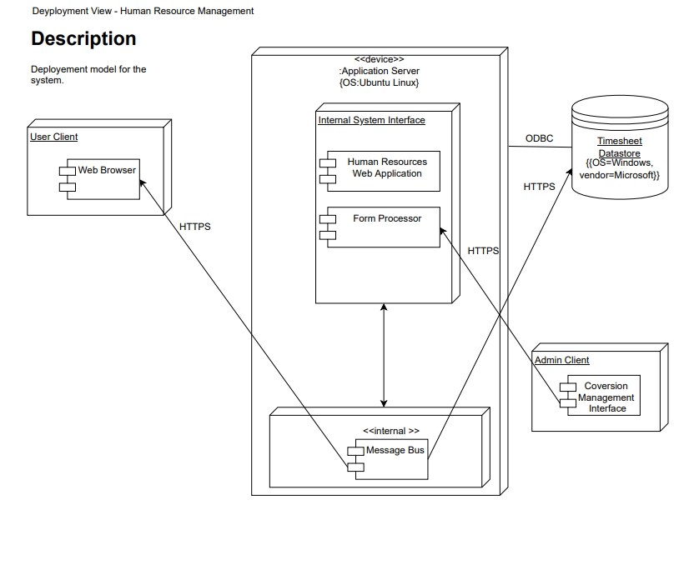

Appendix C: User Interfaces
Non-Administration
landing.html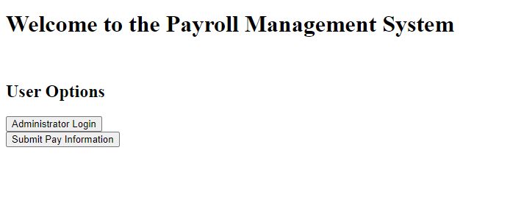
payroll.html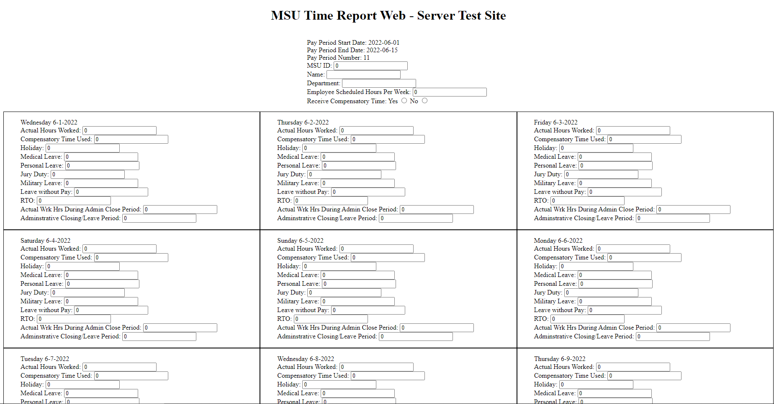

Administrative
adminlogin.html
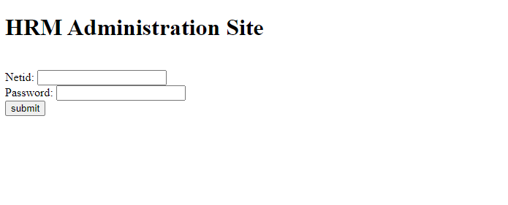
adminhomepage,html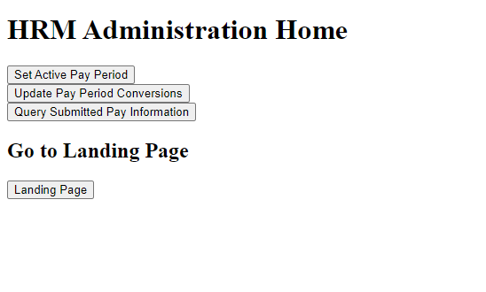
payperiod.php
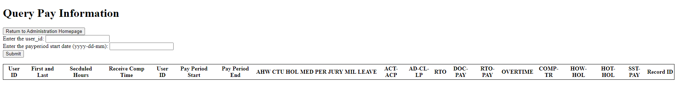
payinformation.php
