NETWORKWALKS

Mediroza General Hospital - Pentest Project Solution
Batch B082 | Week 4 | Confidential
Target: https://medirozahospital.com
Analyst Name: Mohammed Mohammed Sangari

Milestone 1 — Initial Access

Step 1. Recon
Check the robots file to find hidden folders on the target.
curl https://medirozahospital.com/robots.txt

OUTPUT
Disallow: /patient/ Disallow: /staff/ Disallow: /old/
The /patient folder is the target for this milestone. The /old folder becomes relevant in Milestone 3.
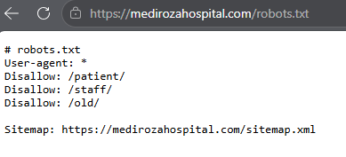

Step 2. Find the login page
The robots file told us a /patient folder exists. Opening it in the browser reveals a login page, which is a common entry point to test.
https://medirozahospital.com/patient/login.php
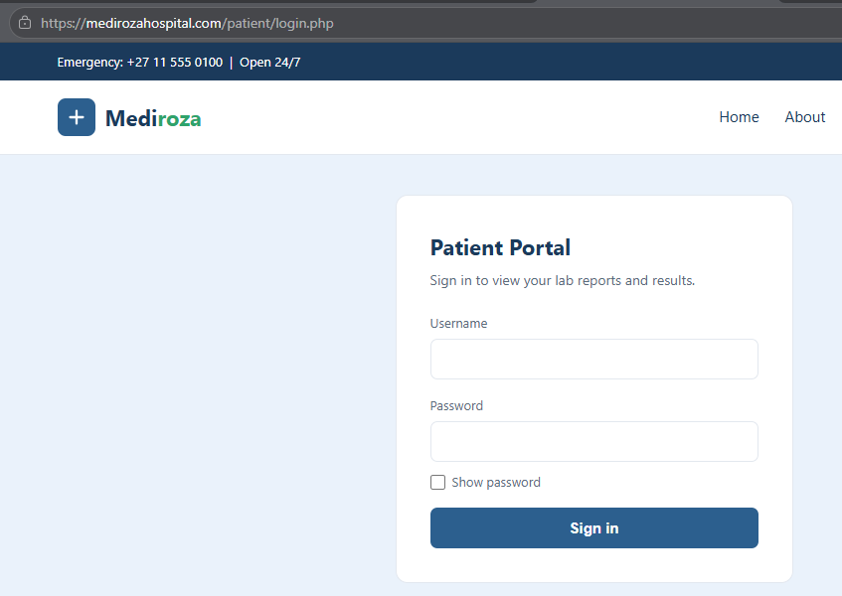

Step 3. Username enumeration
Username enumeration means the application reveals whether a username exists or not through its error messages. A secure login should always show the same message regardless of which field is wrong.
I try a fake username with any password.
username: bob password: test123

RESPONSE
Username not found
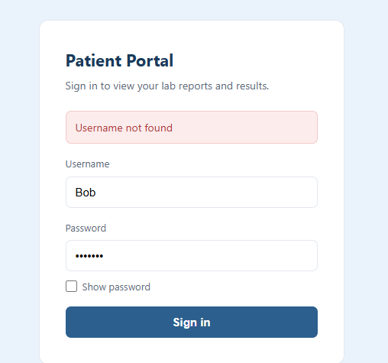

Then i try admin.
username: admin password: test123

RESPONSE
Incorrect password
The site gave two different messages. This confirms admin is a real account. This difference alone is a vulnerability.
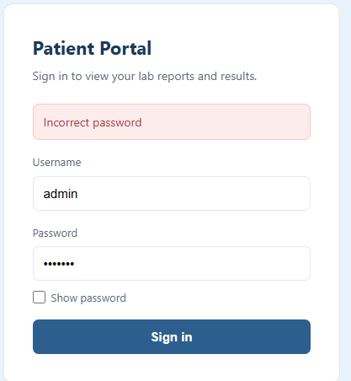

Step 4. Test for SQL injection
SQL injection is a vulnerability where the application places user input directly inside a database query. A single quote breaks the query syntax and causes the database to throw an error, which tells us the field is injectable.
I typed a single quote in the username field.
username: admin' password: test123

RESPONSE
Warning: mysqli_query(): You have an error in your SQL syntax; check the manual that corresponds to your MySQL server version for the right syntax to use near ''' at line 1
The database error confirms the login is vulnerable to SQL injection.
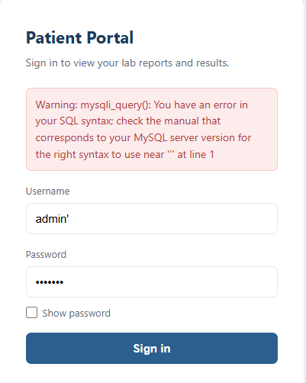

Step 5. Bypass the login
The payload admin' -- works by breaking out of the query string with a quote, then using -- to comment out everything after it, including the password check. The database then matches admin with no password condition.
username: admin' -- password: anything
RESULT
Logged in. Portal page loads with 3 reports listed.
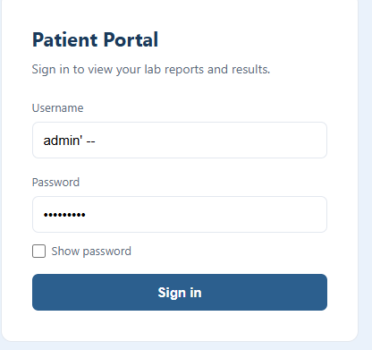

Step 6. Download the 3 reports
Download all 3 files from the portal.
patient_report_1.pdf patient_report_2.pdf patient_report_3.pdf
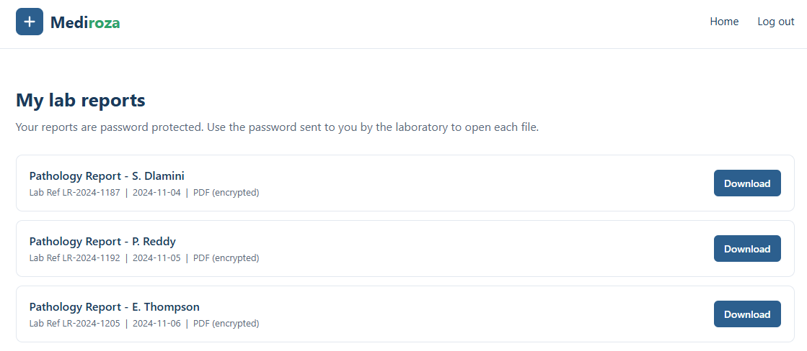

Milestone 2 — Crack the Encryption

Step 1. Get the hash of each PDF
PDF files use password-based encryption. To crack the password we first extract a hash, which is a mathematical fingerprint of the encrypted file. The cracking tool then tries passwords from a wordlist and checks each one against the hash.
I Open the Networkwalks Hash Calculator and upload each PDF one by one.
https://networkwalks.com/hash-calculator/
Copy the hash it gives me which starts with $pdf$.

Step 2. Crack reports 1 and 2
A wordlist is a text file containing common passwords. The cracker tries each word until one matches. The built-in list covers the most common 100 passwords in the world.
I Open the Networkwalks Password Cracker, paste the hash and press Start Cracking with the built-in list.
https://networkwalks.com/password-cracker/

RESULTS
patient_report_1.pdf → 123456
patient_report_2.pdf → password
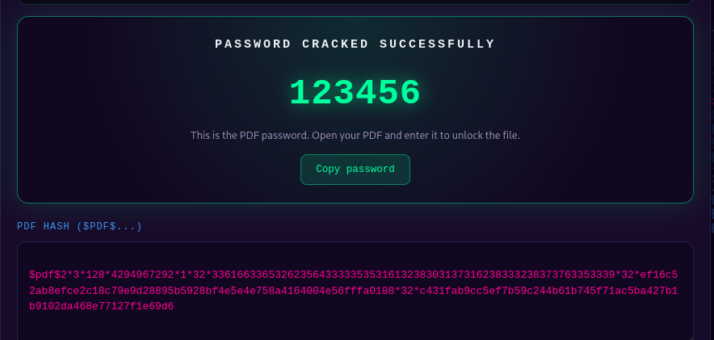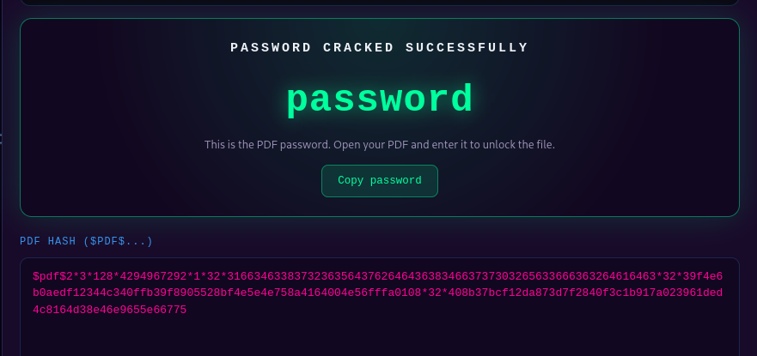

Step 3. Crack report 3
When a small wordlist fails it means the password is not among the most common ones. The solution is to try a larger wordlist that covers more possibilities.
I Run report 3 with the built-in list first.

RESULT
Exhausted wordlist. No match. ACCESS DENIED.
I Switch the wordlist to the JTR list my instructor gave me and run again.

RESULT WITH JTR LIST
patient_report_3.pdf → !@#$%^&

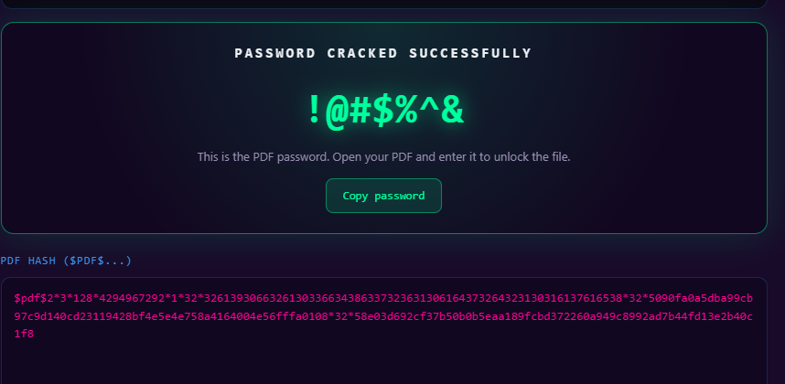
Lesson: When one wordlist fails, think about why and try a bigger one. Real attackers keep several wordlists for exactly this reason.

Step 4. Keep an unlocked copy of report 3
ℹ qpdf is a command line tool that can decrypt a password protected PDF and save a clean copy. You need an unlocked copy so that metadata analysis tools can read all the file properties in the next milestone.
qpdf --password='!@#$%^&' --decrypt patient_report_3.pdf report3_open.pdf

Milestone 3 — Deep Reconnaissance

Step 1. Read the metadata
Metadata is hidden information stored inside a file, such as who created it, when, and with what software. exiftool is a command line tool that reads and displays all metadata fields from any file type including PDFs.
Run exiftool on the unlocked report 3. A locked PDF only shows Encryption, so you must unlock it first.
exiftool report3_open.pdf

KEY FIELDS IN THE OUTPUT
Author : j.malik
Comments : DB backup moved to /old before site migration, do not delete
Someone from IT left a note inside the PDF pointing to a forgotten backup folder on the server.
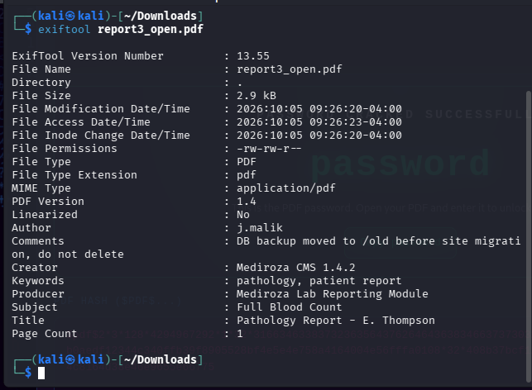

Step 2. Confirm from robots.txt
You already found /old in the robots file during recon in Step 1. This is why thorough recon matters. A clue found later in the assessment can connect back to something you spotted earlier.
Both the metadata clue and the robots file point to /old. Either path leads to the same place.

Step 3. Open the old folder
Directory listing is a misconfiguration where a web server shows the contents of a folder like a file browser when no index page exists. This exposes files that should not be publicly visible.
https://medirozahospital.com/old/
Directory listing is enabled. The backup file is visible.
mediroza_db_backup_2019.sql
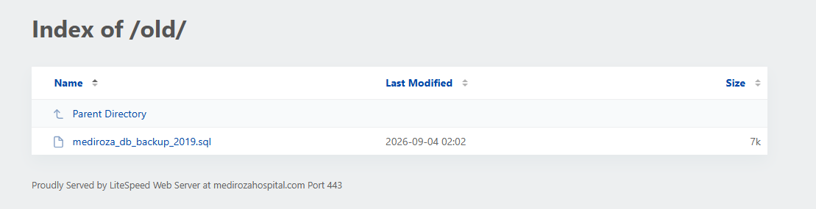
Download it.
wget https://medirozahospital.com/old/mediroza_db_backup_2019.sql

Step 4. Read the data with ChatGPT
A .sql file is a database backup in raw text format. It contains SQL commands used to recreate tables and insert data. The format is readable but dense. AI tools like ChatGPT can convert it into a clean human readable table instantly.
Open the file in a text editor. Copy the INSERT INTO `staff` rows and send to ChatGPT with this prompt.
Present this SQL data as a readable table showing name, job title, department and monthly salary.
Then copy the INSERT INTO `shareholders` rows and send with this prompt.
Present this SQL data as a readable table showing shareholder name, share percentage and share class.

Step 5. Connect the clue back to the staff table
A good pentest report does not just show findings in isolation. It traces the full chain so the client understands how one weakness led to another.
I Found Jameel Malik in the staff table. His email is j.malik, the same name that appeared as the Author field in the PDF metadata. He is the IT Systems Administrator who moved the backup and left the note inside the file.

Milestone 4 — Penetration Testing Report

Findings Summary

# | Vulnerability | Location | Risk
1 | Username enumeration on login page | patient/login.php | Medium
2 | SQL injection login bypass | patient/login.php | Critical
3 | Encrypted PDFs accessible after login bypass | patient/reports/ | High
4 | Weak PDF passwords crackable with a wordlist | patient_report_*.pdf | High
5 | Sensitive metadata left in patient PDF files | patient_report_3.pdf | Medium
6 | Forgotten backup folder with directory listing enabled | old/ | Critical
7 | Confidential staff salaries and shareholder data in plain text | old/mediroza_db_backup_2019.sql | Critical

Recommendations and Remediation
- Username enumeration: Show the same error message for a wrong username and a wrong password. Never reveal which one failed.
- SQL injection: Use parameterised queries or prepared statements. Never build SQL queries using raw user input.
- PDF access control: Store PDFs outside the web root or behind proper access controls. Use strong unique passwords per file.
- PDF metadata: Strip all metadata from patient files before distributing. Use exiftool -all= filename.pdf to clean files.
- Directory listing and backup exposure: Disable directory listing on all folders. Remove or relocate old backup files. Never store database backups in a public web folder.

