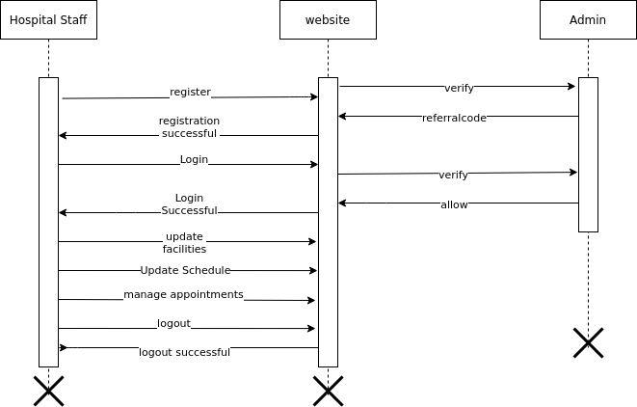

Activity diagram is used to represent the flow of execution from one activity to
another activity. Activity diagram is a type of diagram which illustrate the business and
operational step by step workflow of component within a system and shows the overflow of
control.

Activity diagram of hospital finder which shows the flow between the activity of costumer
The Hospital staff will be able to login in this account using his/her credentials. After the login, Admin
can manage all the operation like add the user details, details based on time.
User can register and login and book the appointment.

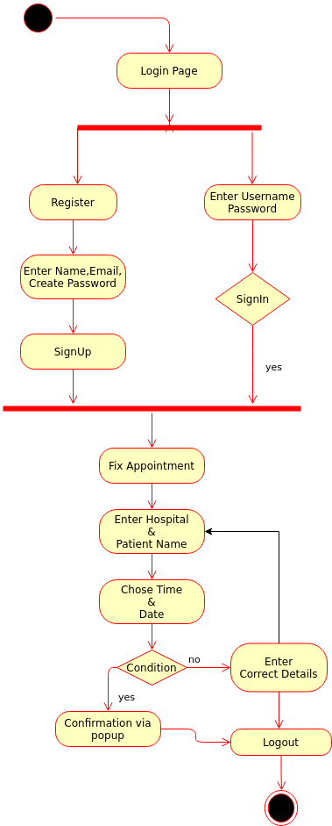

DFD : A Data Flow Data (DFD) maps out the flow of information for any process or system. It uses symbols like rectangles, circles, arrows to sow data inputs, outputs, storage points, data flows between each destination.

There are levels to draw a DFD diagram for a system. Here we drew Level-1 DFD for “Known Hospital”. The User and staff registers into the website and then Signin to proceed further . If the users forget their there is a password recovery mechanism. Admin can authenticate the user and staff credentials and manage databases. If the user wants to Fix appointment he can through the Hospital Name and patient name and proceed for the booking.

Finally this level-1 DFD depicts the pictorical data flow representation in the Known Hospital website.

