“KNOWN HOSPITAL”
Project Report
Project submitted in partial fulfillment of the degree
BACHELOR OF TECHNOLOGY
IN
COMPUTER SCIENCE AND ENGINEERING
Submitted by
M. Pranay Kumar Reddy (O161064)
M. Sreelatha (O161315)
B. Jeenath (O161615)
M. Jithendar (O161050)
G. Elumalai (O162089)
Under the supervision of
Ms M. Soumya


Department of Computer Science and Engineering ,
RGUKT – AP, ONGOLE Campus,
April – 2021.

CERTIFICATE

This is to certify that the project report entitled “Known Hospital” submitted by M. Pranay Kumar Reddy(O161064), B. Jeenath(O161615), M. Sreelatha(O161315), G. Elumalai(O162089), M. Jithendar(O161050), to the Department of Computer Science and Engineering, Rajiv Gandhi University of Knowledge Technologies , Ongole during the academic year 2019-2020 is a partial fulfillment for the award of Under graduate degree of Bachelor of Technology in Computer Science and Engineering, is a bonafide record carried out by them under my supervision. The project has fulfilled all the requirements as per as regulations of this institute and in my opinion reached the standard for submission.

Mr. P. Anantha Rao, Ms. M. Soumya,
Head of the Department, Assistant Professor,
Department of CSE, Department of CSE,
RGUKT – ONGOLE, RGUKT – ONGOLE,
Kadapa -516329. Kadapa – 516329.

Date :
Place : IIIT ONGOLE

ACKNOWLEDGEMENT

Along with the efforts of all the Team members, the section of this project report largely depends on the encouragement and guidance of the teachers. We are specially greateful to the teachers who have been in the approval of this project topic.

I would like to express my special gratitude and thanks to Head Of the Department Mr. P. Anatha Rao and our guide Ms. M. Soumya(Asst.Prof) for gving us such attention and time.

However, it could not have been possible without the kind support and help of many individuals and RGUKT. The contribution and support received from all the team members with all their abilities is vital. The Team spirit shown by all has made this project report work successful.

ABSTRACT

As the world is emerging towards the technology and ofcourse the lifestyle of a human is changing as the technology is growing. Everything is going to be door near to the people with respect to many aspects includes E-commerce, E-learning, Entertainment, science and research even in Health aspects which is going to rule the healthcare of a human.

Now a days the people from rural areas does not have much idea about the specality of the hospital. They face problem for selecting the hospital for their related health diseases. And also the people does not know whether the doctor is available in the hospital or not. There is no direct contact between hospital and patient. Our project will give the solution for the above problem by collecting theinformation from different hospitals in their locality and broadcast it to all the people everyday through a web application.

We are developing this project as a web based application which is user-friendly and is well known platform and handy to understand to the people and is going to be portable in any platforms. A login will be given to all the hospitals and the data will be updated by the hospital staff everyday.

FEATURES:

- A log in will be given to both the Users and hospital staff.

- The data related to the hospitals will be day-to-day updated by the staff of their respective hospitals.

- Searching technique is available to the users.

- Online appointment is available to the patients.

- Availability of the Doctors will be known to the patients through the site.

CONTENTS

CERTIFICATE ---------------------------------------------------- 2
ACKNOWLEDGEMENT ---------------------------------------- 3
ABSTRACT ------------------------------------------------------ 4
FEATURES ------------------------------------------------------- 5
CONTENTS ------------------------------------------------------ 6
1. INTRODUCTION -------------------------------------------- 8
1.1 MOTIVATION -------------------------------------------------------------- 8
2. SYSTEM ANALYSIS
2.1 EXISTING SYSTEM ------------------------------------------------------ 9
2.2 PROPOSED SYSTEM ---------------------------------------------------- 9
3. REQUIREMENT ANALYSIS
3.1 FUNCTIONAL REQUIREMENTS ------------------------------------ 10
3.2 HARDWARE REQUIREMENTS -------------------------------------- 10
3.3 SOFTWARE REQUIREMENTS---------------------------------------- 10
4. SYSTEM DESIGN
4.1 USECASE DIAGRAM --------------------------------------------------- 14
4.2 CLASS DIAGRAM ------------------------------------------------------ 15
4.3 SEQUENCE DIAGRAM ------------------------------------------------ 16
4.4 ACTIVITY DIAGRAM --------------------------------------------------- 17
4.5 DATAFLOW DIAGRAM ------------------------------------------------ 18
5. SOFTWARE ENVIRONMENT
5.1 XAMPP -------------------------------------------------------------------- 19
5.2 MYSQL -------------------------------------------------------------------- 23
6. IMPLEMENTATION ---------------------------------------- 24

7. SYSTEM TESTING
7.1 UNIT TESTING ------------------------------------------------------------------------ 34
7.2 PERFORMANCE TESTING -------------------------------------------------------- 35
8. SAMPLESCREENS
8.1 HOME PAGE --------------------------------------------------------------------------- 36
8.2 HOSPITAL LIST & SEARCH PAGE------------------------------------------------- 37
8.3 HOSPITAL SIGNUP PAGE --------------------------------------------------------- 38
8.4 HOSPITAL LOGIN PAGE ----------------------------------------------------------- 39
8.5 USER SIGNUP PAGE ---------------------------------------------------------------- 40
8.6 USER LOGIN PAGE ------------------------------------------------------------------ 41
8.7 APPOINTMENT BOOKING PAGE ------------------------------------------------- 42
9. CONCLUSION --------------------------------------------- 43
10. FUTURE ENHANCEMENT ------------------------------ 44
11. REFERENCES -------------------------------------------- 45
FIGURES LIST:
Figure 1: USECASE DIAGRAM ----------------------------------------- 14
Figure 2: CLASS DIAGRAM --------------------------------------------- 15
Figure 3: SEQUENCE DIAGRAM --------------------------------------- 16
Figure 4: HOME PAGE --------------------------------------------------- 34
Figure 5: HOSPITAL LIST & SEARCH PAGE------------------------- 35
Figure 6: HOSPITAL SIGNUP PAGE ----------------------------------- 36
Figure 7: HOSPITAL LOGIN PAGE ------------------------------------- 37
Figure 8: USER SIGNUP PAGE ----------------------------------------- 38 Figure 9: USER LOGIN PAGE ------------------------------------------- 39
Figure 10: APPOINTMENT BOOKING PAGE ------------------------ 40
1. INTRODUCTION

Health of a citizen is Wealth of the Nation. There are the medical services in ancient times which are having a very strong impact towards Medical system which helped to have emergences in the medical sector. We are developing our project on this basis that the medical services like Appointment booking, Availability of doctors, Speciality of hopsitals are in the door near of the people.
This “Known Hospital” enbales to develop your organization and improve its effectivenss and quality of work. Managing the key processess efficiently is critical to the success of the hospitals helps you to manage your processes.
The “Known Hospital” can be entered using a username and password. It is accessible by a Doctor, Admin, Hospital Staff. Only they can add data into the database. The data can be retrieved by the users easily. High security will be provided to the data and can be processed easily. Known Hospital is very powerful, easy to use, user-friendly, and is developed and designed to deliver the hospital services to the patients/users before moving to the treatment.
The “Known Hospital” includes registration of patients, storing of patient details into the database. Admin can authenticate the user credentials. Admin/Staff can update the hospital details such that availability of doctors, online appointments etc. This is not dedicated to a single hospital but also it refers to the availability of all the hospitals within a region.

1.1 MOTIVATION
The main motivation of “Known Hospital” is to let the users know all the details of a particular hospital before they are going to visit the hospital that they prefer related to their treatment/disease. Users are known about the hospital details, availability of doctors. The Users can appoint their OP using a website so they do not need to invest their time near hopsitals of hours and hours. They get to know the doctors availability who are specialists in a particular course of treatement. So that they do not waste their time near hopsitals for doctors for thier treatment.
2. SYSTEM ANALYSIS
Analysis is the detailed study of the various operations performed by a system and their relationships within and outside of the system. A key question is: What must be done to solve the problem? One aspect of analysis is defining the boundaries of the system and determining whether or not candidate system should consider other related systems. During analysis, data are collected on the available files, decision points, and problems handled by the present system.

2.1 Existing System
- If a patient wants to consult a doctor, he can visit there till his chance called.
- It is time consuming process.
- And we don’t have proper updates of doctor availability. Especially in rural areas there is no online appointment booking process. There are the details about a single hopsital.
- In the Existing system there is no information about doctors availability.
- It allows users to search using the Hospital name only.

2.2 Proposed System
- In proposed system, it overcomes all the negatives and difficulties in the existed system.
- “Known Hospital” will provide all the hopsital information within a region unlike a particular hopsital as in existed one.
- “Known Hospital” ows users to search for a hospital using hospital name, using a region, using a disease name, using a doctor’s name.
- The hospital staff/admin daily updates the data related to the hospital services.
- Appointements will be done using the website.
- The availability of doctor or the doctor presence information will be provided to the users through the site.
- The doctors and their speciality will also be known to the users.
3. REQUIREMENT ANALYSIS

The requirement analysis involves analyzing the design of few websites so as to make the website more user friendly. To do so, it was really important to keep the web pages in the well-ordered manner and at the same time reducing the amount of typing the user needs to do. The requirement analysis involves analysing the requirements that are needed to develop and design the project. Through the anlaysis we can specify the scope of the project and it’s lifetime.

3.1.1 Functional Requirements :
- Mysql that stores the information to be displayed to the user.

3.1.2 Hardware Requirements :
- Processor : Intel i5 core
- RAM : minimum 2GB
- Storage Space : 580 MB

3.1.3 Software Requirements :
- Operating System : Windows 7 or Ubuntu or Windows 10
- Frontend : HTML, CSS, JavaScript.
- Backend : MYSQL , PHP

- FRONTEND:

1)HTML
HTML Stands for “Hypertext Markup Language.” HTML is the language used to create webpages. “Hypertext” refers to the hyperlinks that an HTML page may contain."Markup language" refers to the way tags are used to define the page layout and elements within the page. This language is used to annotate (make notes for the computer) text so that a machine can understand it and manipulate text accordingly. Most markup languages (e.g. HTML) are human readable. Language uses tags to define what manipulation has to be done on the text.
HTML is a markup language used by the browser to manipulate text, images and other content, in order to display it in the required format. HTML was created by Tim Berners-Lee in 1991. The first ever version of HTML was HTML 1.0, but the first standard version was HTML 2.0, published in 1999.
Elements and Tags: HTML uses predefined tags and elements which tell the browser how to properly display the content. Remember to include closing tags. If omitted, the browser applies the effect of the opening tag until the endofpage.
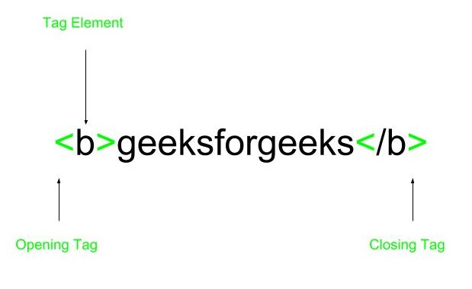
HTML page structure: The basic structure of an HTML page is laid out below. It contain the essential building-block elements (i.e. doctype declaration, html, head, title, and body elements) upon which all webpages are created.
<DOCTYPE! html>: This is the document type declaration (not technically a tag). It declares a document as HTML.
<html>: This is called the HTML root element. All other elements are contained elements in it.
<head>: The head tag contains the “behind the scenes” elements for a webpage. Elements within the head aren’t visible on the front-end of a webpage. HTML elements used inside the <head> element include:
- <style>
- <title>
- <base>
- <noscript>
- <script>
- <meta>
- <title>
- <link>
<body>: the body tag is used to enclose all of the visible content of a webpage. In other words, the body content is what the browser will show on the front-end.
An HTML document can be created using any text editor . Save the text file using .html or .htm. Once saved as an HTML document, the file can be opened as a webpage in the browser.
NOTE: Basic/built-in text editors are Notepad (Windows) and TextEdit (Macs). Basic text text editors are entirely sufficient for when you’re just getting started. As you progress, there are many feature-rich text editors available which allow for greater function and flexibility.
Features of HTML:
- It is easy to learn and easy to use.
- It is platform independent.
- Images, video and audio can be added to a web page.
- Hypertext can be added to text.
- It is a markup language.

Advantages:
- HTML is used to build websites.
- It is supported by all browsers.

2) CSS
CSS Stands for "Cascading Style Sheet." Cascading style sheets are used to format the layout of webpages. They can be used to define text styles, table sizes, and other aspects of Web pages that previously could only be defined in a page's HTML.CSS is great for creating text styles, it is helpful for formatting other aspects of Web page layout as well.

- BACKEND

1) JAVASCRIPT:
JavaScript is a programming language commonly used in web development. It was originally developed by Netscape as a means to add dynamic and interactive elements to websites. While JavaScript is influenced by Java, the syntax is more similar to C and is based on ECMAScript, a scripting language developed by Sun Microsystems.

2) PHP:
PHP is an HTML-embedded Web scripting language. This means PHP code can be inserted into the HTML of a Web page. When a PHP page is accessed, the PHP code is read or "parsed" by the server the page resides on. The output from the PHP functions on the page are typically returned as HTML code, which can be read by the browser.

4. SYSTEM DESIGN

This chapter includes the UML diagrams which represent the “Known Hospital” in pictorial representation.

4.1 Use case Diagram :

The DFD is also called as bubble chart. It is a simple graphical formalism that can be used t represent a system in terms of the input data to the system, various processing carried out on these data, and the output data is generated by the system.
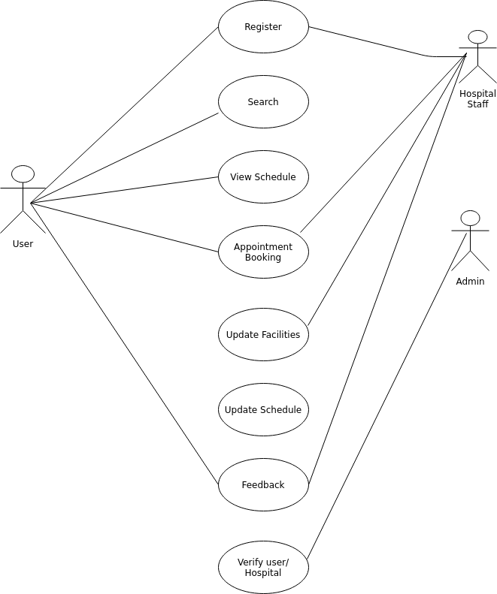

Fig: 4.1 Use Case Diagram

4.2 Class Diagram:

Class diagram is a static diagram. It represents the static view of an application.Class diagram is not only used for visualizing, describing, and documenting different aspects of a system but also for constructing executable code of the software application.Class diagrams are the only diagrams which can be directly mapped with object-oriented languages and thus widely used at the time of construction.

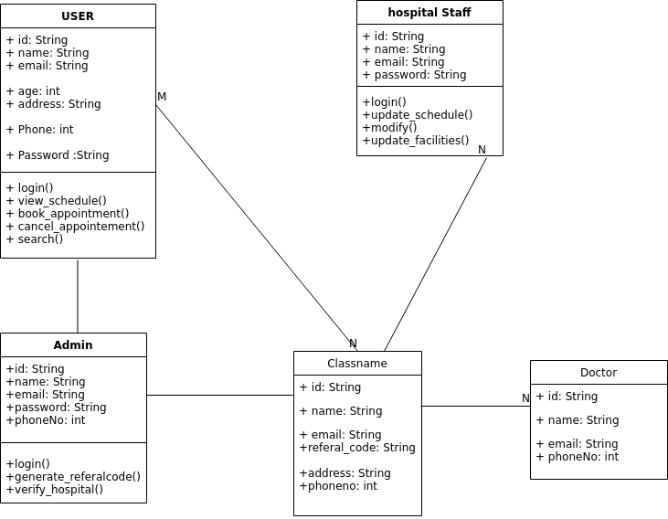
Fig: 4.2 Class Diagram

4.3 Sequence Diagram :

A sequence diagram simply depicts interaction between objects in a sequential order i.e. the order in which these interactions take place. We can also use the terms event diagrams or event scenarios to refer to a sequence diagram. Sequence diagrams describe how and in what order the objects in a system function.

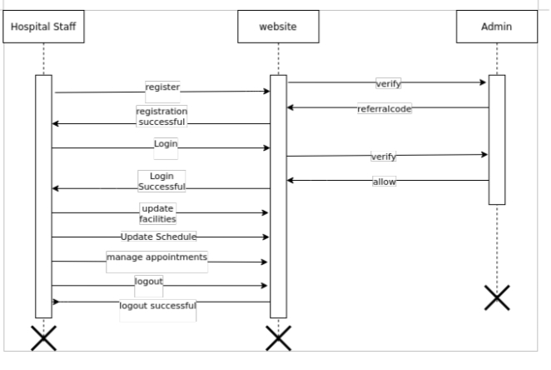
Fig: 4.3 Sequence Diagram

4.4 Activity diagram

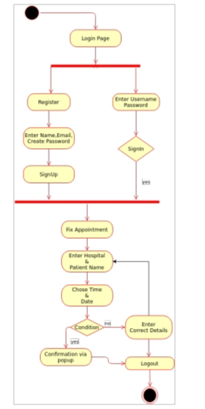
Activity diagram is used to represent the flow of execution from one activity to another activity. Activity diagram is a type of diagram which illustrate the business and operational step by step workflow of component within a system and shows the overflow of control.

Fig 4.4 Activity Diagram

4.5 Data Flow Diagram

A Data Flow Data (DFD) maps out the flow of information for any process or system. It uses symbols like rectangles, circles, arrows to sow data inputs, outputs, storage points, data flows between each destination.
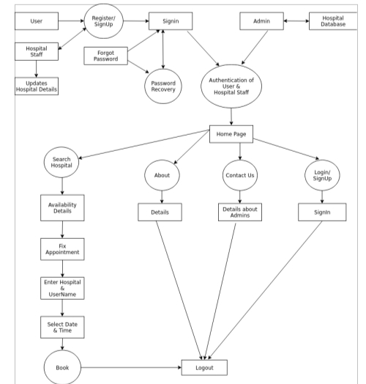

Fig 4.5 DataFlow Diagram

5.SOFTWARE ENVIRONMENT
5.1 XAMPP
XAMPP is an abbreviation where X stands for cross platform, A stands for Apache,M stands for Mysql,and the Ps stand for PHP and Perl respectively. It is an open-source package of web solutions that includes Apache distribution for many servers and command-line executables along with modules such as Apache server, MariaDB PHP, and Perl.XAMPP helps a local host or server to test its website and clients via computers and laptops before releasing it to the main server. It is a platform that furnishes a suitable environment to test and verify the working of projects based on Apache, Perl, MySQL database, and PHP through the system of the host itself. Among these technologies, Perl is a programming language used for web development, PHP is a backend scripting language, and MariaDB is the most vividly used database developed by MySQL.

- Cross-Platform: Different local systems have different configurations of operating systems installed in it. The component of cross-platform has been included to increase the utility and audience for this package of Apache distributions. It supports various platforms such as packages of Windows, Linus, and MAC OS.
- Apache: It is an HTTP a cross-platform web server. It is used worldwide for delivering web content. The server application has made free for installation and used for the community of developers under the aegis of Apache Software Foundation.
- MariaDB: Originally, MySQL DBMS was a part of XAMPP, but now it has been replaced by MariaDB. It is one of the most widely used relational DBMS, developed by MySQL. It offers online services of data storage, manipulation, retrieval, arrangement, and deletion.
- PHP: PHP allows users to create dynamic websites and applications. It can be installed on every platform and supports a variety of database management systems. It was implemented using C language. PHP stands for Hypertext Processor. It is said to be derived from Personal Home Page tools, which explains its simplicity and functionality.

- Perl: It is a combination of two high-level dynamic languages, namely Perl 5 and Perl 6. Perl can be applied for finding solutions for problems based on system administration, web development, and networking. Perl allows its users to program dynamic web applications. It is very flexible and robust.
- phpMyAdmin: It is a tool used for dealing with MariaDB. Its version 4.0.4 is currently being used in XAMPP. Administration of DBMS is its main role.
- OpenSSL: It is the open-source implementation of the Secure Socket Layer Protocol and Transport Layer Protocol. Presently version 0.9.8 is a part of XAMPP.
- XAMPP Control Panel: It is a panel that helps to operate and regulate upon other components of the XAMPP. Version 3.2.1 is the most recent update. A detailed description of the control panel will be done in the next section of the tutorial.
- Webalizer: It is a Web Analytics software solution used for User logs and provide details about the usage.
- Mercury: It is a mail transport system, and its latest version is 4.62. It is a mail server, which helps to manage the mails across the web.
- Tomcat: Version 7.0.42 is currently being used in XAMPP. It is a servlet based on JAVA to provide JAVA functionalities.
- Filezilla: It is a File Transfer Protocol Server, which supports and eases the transfer operations performed on files. Its recently updated version is 0.9.41. \

XAMPP Format Support
- XAMPP is supported in three file formats:
- .EXE- It is an extension used to denote executable files making it accessible to install because an executable file can run on a computer as any normal program.

- .7z - 7zip file- This extension is used to denote compressed files that support multiple data compression and encryption algorithms. It is morefavored by a formalist, although it requires working with more complex files.
- .ZIP- This extension supports lossless compression of files. A Zipped file may contain multiple compressed files. The Deflate algorithm is mainly used for compression of files supported by this format. The .ZIP files are quite tricky to install as compared to .EXE
- Thus .EXE is the most straightforward format to install, while the other two formats are quite complicated and complex to install.
Prequisite
- Before going through XAMPP tutorial in-depth, you must have a fundamental knowledge of web development languages like HTML, and PHP.

Audience
- Our XAMPP tutorial is designed for the aspirants who want to test their website or application on a localhost webserver. This tutorial will help those who want to build their career as a front end or web developer.
- Cascading Style Sheets, fondly referred to as CSS, is a simple design language intended to simplify the process of making web pages presentable.
- CSS handles the look and feel part of a web page. Using CSS, you can control the color of the text, the style of fonts, the spacing between paragraphs, how columns are sized and laid out, what background images or colors are used, layout designs,variations in display for different devices and screen sizes as well as a variety of other effects.

- CSS is easy to learn and understand but it provides powerful control over the presentation of an HTML document. Most commonly, CSS is combined with the markup languages HTML or XHTML.

Advantages of CSS
- CSS saves time − You can write CSS once and then reuse same sheet in multiple HTML pages. You can define a style for each HTML element and apply it to as many Web pages as you want.
- Pages load faster − If you are using CSS, you do not need to write HTML tag attributes every time. Just write one CSS rule of a tag and apply it to all the occurrences of that tag. So less code means faster download times.
- Easy maintenance − To make a global change, simply change the style, and all elements in all the web pages will be updated automatically.
- Superior styles to HTML − CSS has a much wider array of attributes than HTML, so you can give a far better look to your HTML page in comparison to HTML attributes.
- Multiple Device Compatibility − Style sheets allow content to be optimized for more than one type of device. By using the same HTML document, different versions of a website can be presented for handheld devices such as PDAs and cell phones or for printing.
- Global web standards − Now HTML attributes are being deprecated and it is being recommended to use CSS. So its a good idea to start using CSS in all the HTML pages to make them compatible to future browsers.

Css Syntax
A CSS comprises of style rules that are interpreted by the browser and then applied to the corresponding elements in your document. A style rule is made of three parts −
- Selector − A selector is an HTML tag at which a style will be applied. This could be any tag like <h1> or <table> etc.
- Property − A property is a type of attribute of HTML tag. Put simply, all the HTML attributes are converted into CSS properties. They could be color, border etc.
- Value − Values are assigned to properties. For example, color property can have value either red or #F1F1F1 etc.

5.2 MYSQL:

MySQL, pronounced either "My S-Q-L" or "My Sequel," is an open source relational database management system. It is based on the structure query language (SQL), which is used for adding, removing, and modifying information in the database. Standard SQL commands, such as ADD, DROP, INSERT, and UPDATE can be used with MySQL.

MySQL is free and open source software under the terms of the GNU General Public License, and is also available under a variety of proprietary licenses. MySQL was owned and sponsered by the Swedish company MySQL AB, which was bought by Sun MicroSystems. In 2010, when Oracle acquired Sun, Widenius forked the open- source MySQL project to create MariaDB.

6. IMPLEMENTATION

home.php
<?php
include('functions.php');
session_start();
?>
<!DOCTYPE html>
<html>
<head>
<meta charset="utf-8">
<meta http-equiv="X-UA-Compatible" content="IE=edge">
<meta name="viewport" content="width=device-width, initial-scale=1.0">
<title>Known Hospital</title>
<link rel="stylesheet" type="text/css" href="style2.css"/>
<link rel="shortcut icon" href="knownhospital.jpg"/>
</head>
<body>
<nav>
<a href="index.php" class="logo">
<img src="knownhospital.jpg"/>
<p class="name" style="margin-top:-50px;margin-left:60px;font-size: 25px;">Known Hospital</p>
</a>
<input type="checkbox" class="menu-btn" name="" id="menu-btn"/>
<label class="menu-icon" for="menu-btn">
<span class="nav-icon"></span>
</label>
<ul class="menu">
<li><a href="#">Home</a></li>

<li><a href="hos.php">Hospitals</a></li>
<li><a href="about.html">about</a></li>
<li><a href="contact.html">Contact-Us</a></li>

<li> <div class="dropdown">
<button onclick="myFunction()" class="dropbtn"> Login/Signup</button>
<div id="myDropdown" class="dropdown-content">
<a href="loginsignup.php">Patient</a>
<a href="staff.php">Hospital</a>
</div>
</div> </li>
</ul>
</div>
</nav>
<p>Hello welcone to the Know Hospital</p>
<p>please login if we are not the user of this site. Later you can take appoinment</p>
<!-------------------------->
<script type="text/javascript">
function myFunction() {
document.getElementById("myDropdown").classList.toggle("show");
}
</script>
</body></html>

Loginsignup.php
<?php
include('register.php');
?>
<!DOCTYPE html>
<html>
<head>
<title>LOG-IN</title>
<link rel="stylesheet" type="text/css" href="style.css">
<meta name="viewport" content="width=device-width,initial-scale=1.0">
</head>
<body>
<section>
<div class="container">
<div class="user signinbox">
<div class="imgbox"><img src="user.png"></div>
<div class="formbox">
<form action="" method="post" enctype="multipart/form-data">
<h2>Sign In</h2>
<input type="email" name="user_email" placeholder="Useremail">
<input type="password" name="password" placeholder="Password">
<input type="submit" name="login" value="Login">
<p class="signup">Don't have an account ?<a href="#" onclick="toggleForm();">Sign Up</a></p>
<p><a href="forgot.html">Forgot password</a></p>
<p><a href="index.html">Home</a></p>
</form>
</div> </div>

<div class="user signupbox">
<div class="formbox">

<form action="" method="post" enctype="multipart/form-data">
<h2>Create an account</h2>
<input type="email" name="user_email" placeholder="User Email">
<input type="text" name="user_name" placeholder="User Name">
<input type="password" name="password_1" placeholder="Create Password">
<input type="password" name=" " placeholder="Confirm Password">
<input type="submit" name="submit" value="Sign Up">
<p class="signup">Already have an account ?<a href="#" onclick="toggleForm();">Sign In</a></p>
<p><a href="index.html">Home</a></p>
</form>
</div>
<div class="imgbox"><img src="user1.png"></div>
</div>
</div>
</section>
<script type="text/javascript">
function toggleForm() {
var container = document.querySelector('.container');
container.classList.toggle('active')
}</script></body></html>

staff.php
<?php
include('staffregister.php');
?>
<!DOCTYPE html>
<html>
<head>
<title>LOG-IN</title>
<link rel="stylesheet" type="text/css" href="style.css">
<meta name="viewport" content="width=device-width,initial-scale=1.0">
</head>
<body>
<section>
<div class="container">
<div class="user signinbox">
<div class="imgbox"><img src="staff1.png"></div>
<div class="formbox">
<form action="" method="post" enctype="multipart/form-data">
<h2>Sign In</h2>
<input type="text" name="email" placeholder="Hospital email">
<input type="password" name="password" placeholder="Password">
<input type="submit" name="some" value="Login">
<p class="signup">Don't have an account ?<a href="#" onclick="toggleForm();">Sign Up</a></p>
<p><a href="forgot.html">Forgot password</a></p>
<p><a href="home.php">Home</a></p>
</form>
</div> </div>

<div class="user signupbox">
<div class="formbox">
<form action="" method="post" enctype="multipart/form-data">
<h2>Create an account</h2>
<input type="text" name="hospital_name" placeholder="Hospital Name">
<input type="email" name="email" placeholder=" Hospital Email">
<input type="password" name="password_1" placeholder=" Create Password">
<input type="password" name="" placeholder=" Confirm Password">
<input type="address" name="address" placeholder="enter address">
<input type="text" name="specalist_1" placeholder="specalist type">
<input type="text" name="specalist_2" placeholder="specalist type">
<input type="text" name="specalist_3" placeholder="specalist type">
<input type="submit" name="sign" value="Sign Up">
<p class="signup">Already have an account ?<a href="#" onclick="toggleForm();">Sign In</a></p>
<p><a href="index.php">Home</a></p>
</form>
</div>
<div class="imgbox"><img src="staff.png"></div>
</div>
</div>
</section>
<script type="text/javascript">
function toggleForm() {
var container = document.querySelector('.container');
container.classList.toggle('active')
}
</script>
</body>
</html>

hos.php
<?php
include('staffregister.php');
?>
<!DOCTYPE html>
<html>
<head>
<title>LOG-IN</title>
<link rel="stylesheet" type="text/css" href="style.css">
<meta name="viewport" content="width=device-width,initial-scale=1.0">
</head>
<body>
<section>
<div class="container">
<div class="user signinbox">
<div class="imgbox"><img src="staff1.png"></div>
<div class="formbox">
<form action="" method="post" enctype="multipart/form-data">
<h2>Sign In</h2>
<input type="text" name="email" placeholder="Hospital email">
<input type="password" name="password" placeholder="Password">
<input type="submit" name="some" value="Login">
<p class="signup">Don't have an account ?<a href="#" onclick="toggleForm();">Sign Up</a></p>
<p><a href="forgot.html">Forgot password</a></p>
<p><a href="home.php">Home</a></p>
</form>
</div> </div>

<div class="user signupbox">
<div class="formbox">
<form action="" method="post" enctype="multipart/form-data">
<h2>Create an account</h2>
<input type="text" name="hospital_name" placeholder="Hospital Name">
<input type="email" name="email" placeholder=" Hospital Email">
<input type="password" name="password_1" placeholder=" Create Password">
<input type="password" name="" placeholder=" Confirm Password">
<input type="address" name="address" placeholder="enter address">
<input type="text" name="specalist_1" placeholder="specalist type">
<input type="text" name="specalist_2" placeholder="specalist type">
<input type="text" name="specalist_3" placeholder="specalist type">
<input type="submit" name="sign" value="Sign Up">
<p class="signup">Already have an account ?<a href="#" onclick="toggleForm();">Sign In</a></p>
<p><a href="index.php">Home</a></p>
</form>
</div>
<div class="imgbox"><img src="staff.png"></div>
</div>
</div>
</section>
<script type="text/javascript">
function toggleForm() {
var container = document.querySelector('.container');
container.classList.toggle('active')
}
</script>
</body>
</html>

7. SYSTEM TESTING

7.1 Unit Testing:
Unit testing, a testing technique using which individual modules are tested to determine if there are any issues by the developer himself. It is concerned with functional correctness of the standalone modules. Reduces Defects in the Newly developed features or reduces bugs when changing the existing functionality. Improves design and allows better refactoring of code. Unit Tests, when integrated with build gives the quality of the build as well. Below are the test cases on the individual modules of the designed website:

Login Module:
- User enters valid credentials - opens home page of Known Hospital.
- User enters wrong credentials – it shows specific warning message.

Signin module:
- User entered his details – database account has been created successfully.

Forget password module:
- User entered new password – updation of database was done successfully.

Staff Login Module:
- Staff enters valid credentials - opens home page of Known Hospital.
- User enters wrong credentials - it shows specific warning message.

Hospital Details Module:
- User searches for hospital - database shows details of the searched hopsital

Appointment Booking Module:
- User fix his/her appointment by entering details – updation of database was done successfully.
- User enters wrong credentials - it shows specific warning message.

Search Module:
- User enters Hospital Name to search – Database shows the details.
- User enters wrong details – shows specific warning message.

7.2 Performance Testing:

Performance testing has been done to measure the responsiveness of the application to the workload such as increasing users’ requests. JMeter was used to create the users and to analyze the performance. The parameters were chosen randomly till the application performed consistently. The test has been done on a home Wi-Fi network with a speed of 5Mbps
- Speed - Determines whether the application responds quickly
- Scalability - Determines maximum user load the software application can handle.
- Stability - Determines if the application is stable under varying loads

8. SAMPLE SCREENS

This is the chapter which has the sample screens of our web based application named as “Known Hospital”

8.1 HOME PAGE

This is the Home page of “Known Hospital” when the user can see all the options of our website such as Home, Hospitals, About, Contact Us, Login/Signup.


Fig 8.1 Home Page

8.2: HOSPITAL LIST AND SEARCH PAGE

This is the Hospital list with having searching feature of “Known Hospital” where the user can search about hospitals among the hospital list and can fix his/her appointment.

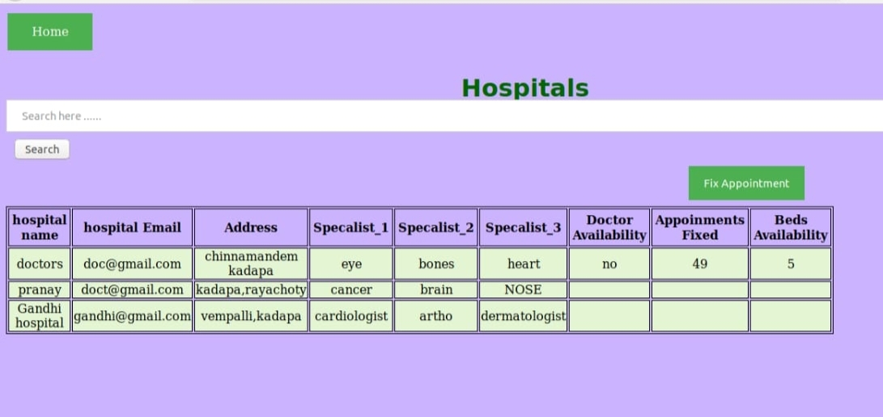
Fig 8.2. Hospital list and Search Page

8.3 HOSPITAL SIGNUP PAGE

This is the page where hospital staff can create his account in “Known Hospital”.

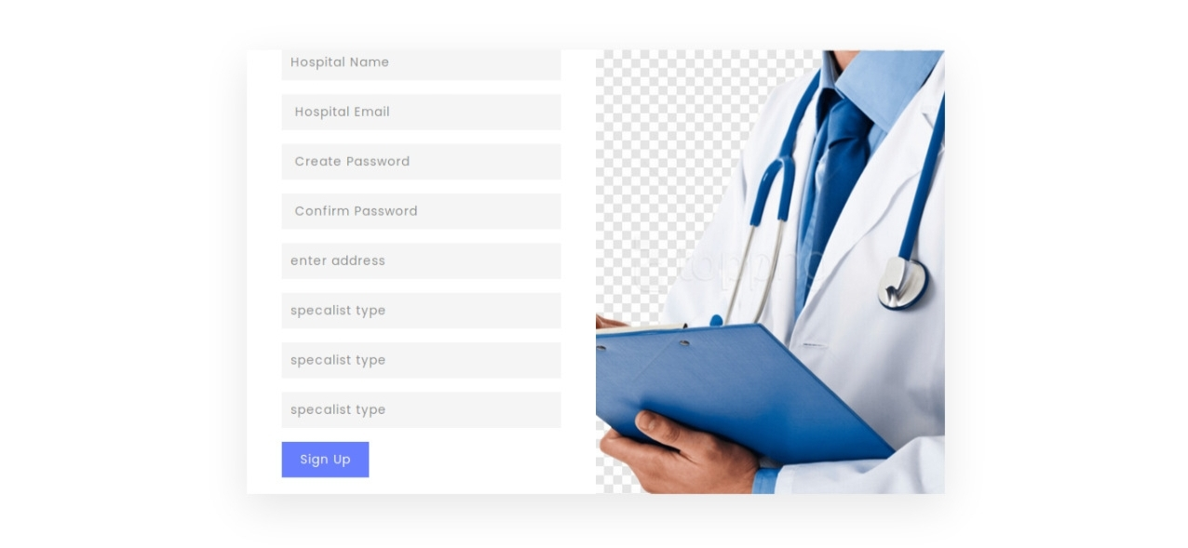
Fig 8.3. Hospital Signup page

8.4 HOSPITAL LOGIN PAGE

This is the page where hosptal staff can sign in to the account he created in “Known Hospital”.

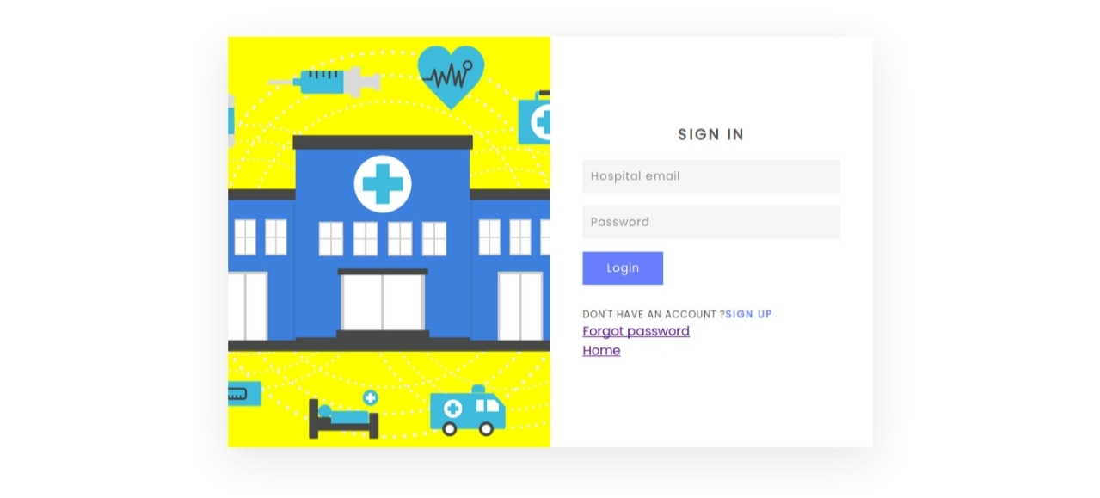

Fig 8.4. Hospital Login Page

8.5 USER SIGNUP PAGE

This is the page where user can create his account in “Known Hospital”

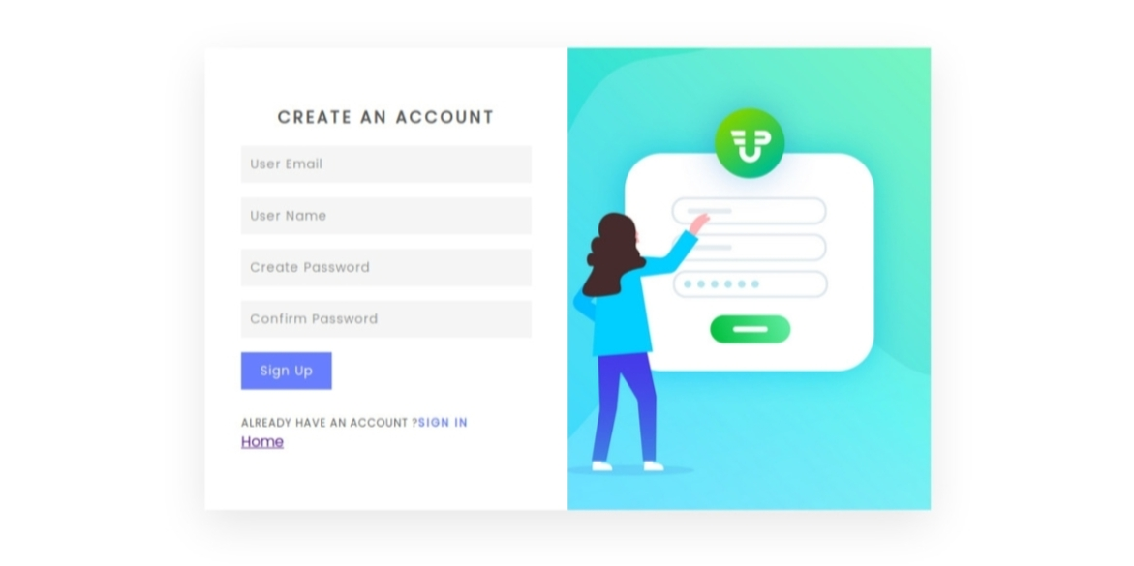
Fig: 8.5 User Signup Page

8.6 USER LOGIN PAGE

This is the page where hosptal staff can sign in to the account he created in “Known Hospital”.

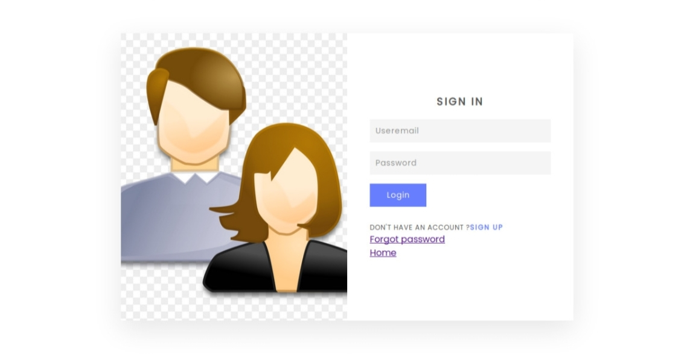
Fig: 8.6 User Login Page

8.7 APPOINTMENT BOOKING PAGE

After the user successfully signed in to the account, this is the page where he/she can book/fix his/her appointment in “Known Hospital”. It can be available without any login credentials in emergencies.

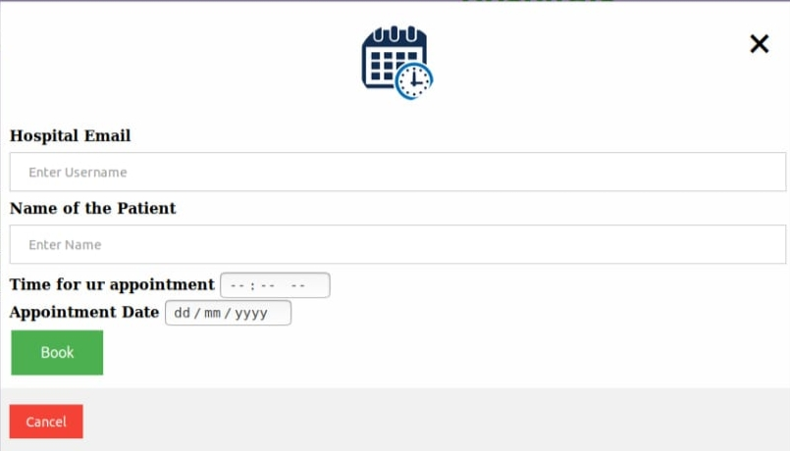
Fig 8.7 Appointment Booking Page

9. CONCLUSION

- The main motto of “Known Hospital” is that the users can get the hospital information through our website without actually visiting the hospital.

- “Known Hospital” is an innovative idea that it saves the time of a user for choosing the best hospitals for their treatement.

- The users can get the information about the hospital without stepping out. Another best feature in “Known Hospital” is that the users can even book their appointment in emergency cases without any login/signup credentials .

10. FUTURE ENHANCEMENT
Some of the future enhancements that can be done to “Known Hospital” are:
1) Based on the future security issues, security can be improved using emerging technologies.
2) Online payment module can be added.
3) Google maps will be added in order to search for the hospital location near their locality. This increases it’s scalability.
4) We allow the notification remainders to the users when they fix their appointment at particular time.
5) We allows users to order medicines on online.

11. REFERENCES

[1]
https://www.rguktong.ac.in
[2]
https://www.academia.edu/36406675/Hospital_Management_System_Project_report.
[3]
https://developer.mozilla.org/en-US/docs/Web/HTML
[4]
https://www.javatpoint.com/creating-mysql-database-with-xampp

