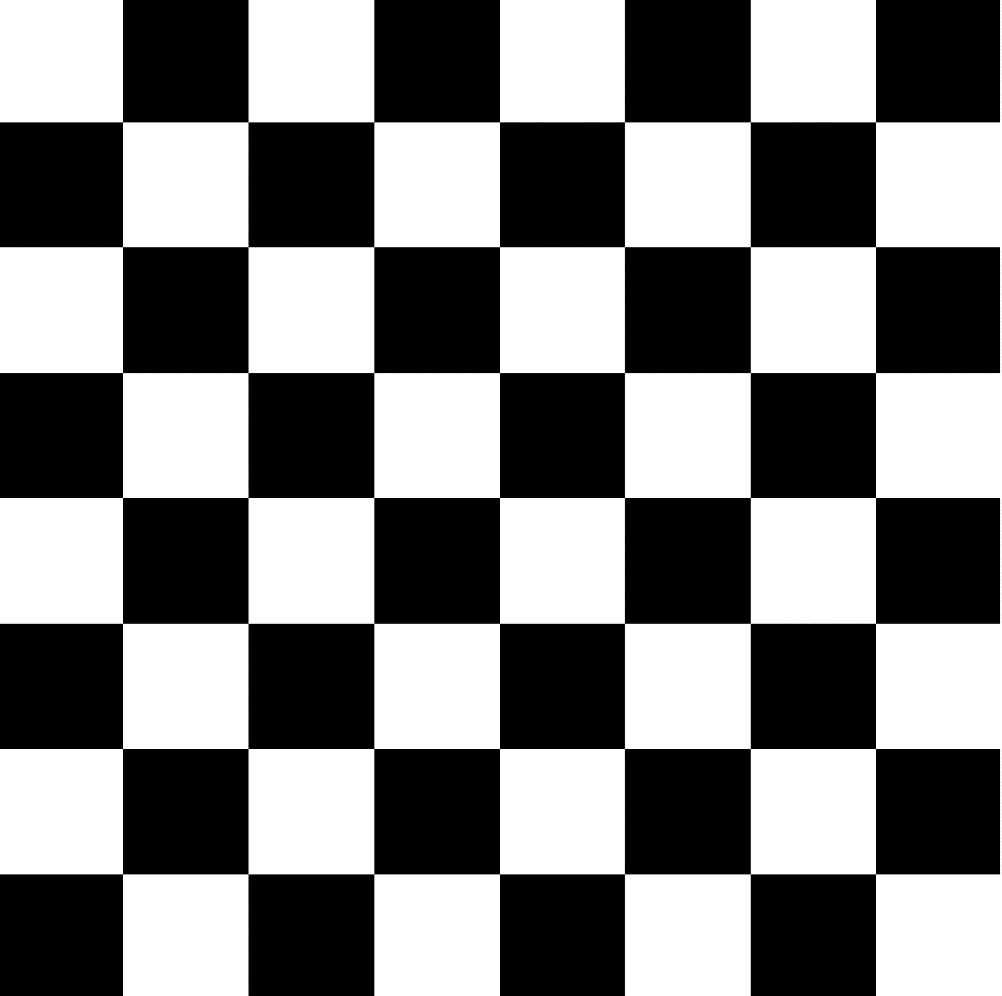

Side of a field – 2cm

In total – 16 cm