DEPARTMENT OF ARTIFICIAL INTELLIGENCE AND
MACHINE LEARNING
INTERNSHIP REPORT
ON
DATASCIENCE
SUBMITTED BY
NAME AND USN

CERTIFICATE

ACKNOWLEDGEMENT

I would like to express my sincere gratitude to my project guide [Guide Name] for their valuable guidance, continuous support, and encouragement throughout the completion of this internship report. Their suggestions and insights have been extremely helpful in successfully completing this work.
I would also like to thank the Head of the Department and all the faculty members of the Department of Artificial Intelligence and Machine Learning, Vivekananda College of Engineering and Technology, for providing the necessary facilities and support.
I extend my heartfelt thanks to Take It Smart PVT Ltd for giving me the opportunity to undertake this internship and gain practical exposure in the field of Data Science.
Finally, I would like to thank my parents, friends, and well-wishers for their constant support, motivation, and encouragement throughout this work.

ABSTRACT
The growth of e-commerce platforms and the subsequent increase in customer feedback have made it increasingly critical for businesses to effectively gauge customer sentiment. This initiative, referred to as “Ecommerce Review Sentiment Analysis,” addresses this need by streamlining the analysis of customer reviews through the application of natural language processing techniques.
The primary goal of this endeavor is to categorize e-commerce reviews into positive or negative sentiment, thereby offering expeditious insights into customer perceptions. Furthermore, the system incorporates functionality enabling users to input custom reviews, subsequently providing immediate sentiment predictions accompanied by confidence scores. This feature considerably enhances the system’s interactivity and practical utility.
The underlying data consists of e-commerce review texts, which are managed with Pandas for efficient data handling and presentation. Rather than extensive manual preprocessing, the analysis directly employs a pre-trained model. Specifically, the system integrates a DistilBERT model, sourced from the Transformers library, a component known for its contextual understanding and reliable sentiment prediction capabilities.
An intuitive and accessible web interface is constructed using Streamlit. This application encompasses functionalities including a dataset preview, individualized review analysis, batch sentiment processing for the entire dataset, and the visualization of sentiment distribution, presented via bar charts. To enhance operational efficiency, caching mechanisms are implemented, thereby mitigating the need for repetitive data and model loading.
In conclusion, this project represents a pragmatic solution for the efficient analysis of customer feedback. It assists organizations in expeditiously grasping user sentiment, identifying emergent trends, and formulating more informed, data-driven decisions, all leveraging the synergy of machine learning and web technologies.

TABLE OF CONTENT
SI.NO | CONTENT | PAGENO
1 | Cover Page | 1
2 | Certificate | 2
3 | Acknowledgement | 3
4 | Abstract | 4-5
5 | Table of Contents | 6
6 | Company Overview | 7-9
7 | INTRODUCTION TO DATA SCIENCE | 10-14
8 | TECHNOLOGIES USED | 15-26
9 | PROJECT-SENTIMENT  ANALYSIS | 27-31
10 | Results & Output Screenshots | 32-35
11 | CONCLUSION | 36-37

CHAPTER 1
COMPANY OVERVIEW
TAKE IT SMART (OPC) PVT LTD is an Indian based engineering and Software Company headquartered in Bangalore, Karnataka, India. It is both product and service-oriented software company. All offices employ an experienced team of professionals, with an outstanding track record of handling complex web & Apps development projects.
  - HISTORY
The company was legally registered in the year 2021, but it made its humble beginning in the year 2018 with a team of Two members
  - COMPANY STRATEGY
- Purpose: To be a leader in the software Industry by providing enhanced services, relationship and profitability.
- Mission: To build long term relationships with our customers and clients and provide exceptional customer services by pursuing business through innovation and advanced technology
- Vision: To provide quality services that exceeds the expectations of our esteemed customers.
- Core values:
- To incorporate good business practices in order to achieve customer satisfaction and treating the customers with respect and faith.
- To grow through creativity, invention and innovation.
- To integrate honesty, integrity and business ethics into all aspects of the business functioning.

  - COMPANY SERVICES
TAKE IT SMART (OPC) PVT LTD has its own services such as,
- Embedded Applications development
- Web design and development
- IT Service
- Android app Development
- Web Bases Software Solutions
- Web Based Ads Mobile Based Services: Mobile Web Apps a. Android Apps b. Windows Apps c. IOS Apps d. Cross Plate forms Apps
- Native Apps
- Hybrid apps Get trained for industry requirements while you pursuing degree The Different verticals that we operate in are Internship & Software Training

  - DOMAINS
TAKE IT SMART (OPC) PVT LTD has working with several domains like
- IT
- Digital marketing
1.5. DEPARTMENTS.
- Marketing: These are the main section of the market departments:
- Sales department is responsible for the sales and distribution of the products to the different regions.
- Promotion department decides on the type of promotion method for the products, arranges advertisements and the advertising media used.
- Distribution department distributes the products across the industries.
- Embedded System and Internet of Things (IOT) department.
- Machine learning and web development department.

Business Address: Take It Smart (OPC) Pvt Ltd
14,SGN Arcade, 1st Floor, 2nd stage, 1st Main Rd,
RPC Layout, Hoshalli Extension, Stage 1,
Vijayanagar, Bengaluru, Karnataka 560040
Mobile: +91-8050104212
Email: info@takeitsmart.in
Website: www.takeitsmart.in
CHAPTER-2
INTRODUCTION TO DATA SCIENCE
Data Science is a field that focuses on extracting useful insights and knowledge from data using scientific methods, algorithms, and systems. It combines statistics, mathematics, programming, and domain knowledge to analyze both structured and unstructured data.
In today’s digital world, huge amounts of data are generated every second from social media, websites, and business transactions. Data Science helps organizations convert this raw data into meaningful information for better decision-making.
The main steps in Data Science include data collection, data cleaning, data analysis, data visualization, and machine learning. Popular tools used in Data Science are Python, R, SQL, Excel, and libraries like Pandas, NumPy, and Scikit-learn.
Data Science is widely used in various fields such as healthcare (disease prediction), finance (fraud detection), e-commerce (recommendation systems), and transportation (route optimization).
In conclusion, Data Science plays a major role in modern technology by helping businesses and industries make smarter, data-driven decisions.

2.1 COMPONENTS OF DATA SCIENCE
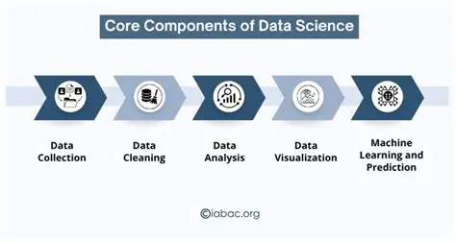
2.2 PHASES OF DATA SCIENCE
Data Collection → Gather data from databases, APIs, web scraping, sensors
Data Cleaning → Handle missing values, remove duplicates, fix errors
EDA (Exploratory Data Analysis) → Use charts & statistics to understand patterns
Feature Engineering → Select and transform important variables for better results
Data Modeling → Apply Machine Learning algorithms (Regression, Classification)
Model Evaluation → Measure performance using Accuracy, Precision, Recall, F1-score
Deployment → Deploy model into apps, websites, dashboards
Monitoring & Maintenance → Track performance and update model regularly.
2.3 IMPORTANCE OF DATA SCIENCE
Data Science has become an essential part of many industries due to its ability to provide valuable insights. Organizations use Data Science techniques to improve efficiency, reduce costs, and enhance customer experience.
Some key reasons for the importance of Data Science include:
- Helps in making data-driven decisions
- Identifies patterns and trends in data
- Improves business performance
- Supports automation and prediction
- Enhances problem-solving capabilities

2.4 APPLICATIONS OF DATA SCIENCE IN REAL WORLD
Data Science is widely used in almost every industry today to analyze data, discover patterns, and make better decisions. It helps organizations improve efficiency, reduce cost, and increase accuracy using data-driven insights.
1.Social Media
Platforms like Instagram, Facebook, and YouTube use data science to:
- Recommend posts, videos, and friends
- Analyze user behavior and engagement
- Show personalized ads
2.Entertainment (Movie Recommendation Systems)
Used by Netflix, Amazon Prime, etc. to:
- Suggest movies based on user history
- Improve user experience
- Increase watch time using recommendation algorithms
3. Banking and Finance
Banks use data science for:
- Fraud detection in transactions
- Credit score analysis
- Loan approval prediction
- Risk management
4.E-Commerce
Companies like Amazon and Flipkart use it for:
- Product recommendations
- Demand forecasting
- Customer behavior analysis
- Price optimization
5. Healthcare
Used in medical field for:
- Disease prediction
- Medical image analysis (X-rays, MRI)
- Patient risk analysis
- Drug discovery

CHAPTER-3
TECHNOLOGIES USED
3.1 PYTHON FOR DATA SCIENCE
Python is one of the most popular programming languages used in Data Science because it is simple, powerful, and easy to learn. It provides a large number of libraries that help in handling, analyzing, and visualizing data efficiently.
Python supports important Data Science tasks such as data collection, data cleaning, data analysis, data visualization, and machine learning. It is widely used to work with both structured and unstructured data.
Some important Python libraries used in Data Science are:
1.NumPy – for numerical computations
- NumPy stands for Numerical Python
- It is a powerful Python library for numerical computations
- Used for handling arrays, matrices, and mathematical operations
- Widely used in Data Science and Machine Learning
2.Pandas – for data manipulation and analysis
- Pandas is a Python library used for data analysis and manipulation
- It works with structured data like tables (rows & columns)
3.Matplotlib / Seaborn – for data visualization
- Matplotlib and Seaborn are Python libraries used for data visualization
- Help in representing data using graphs and charts
4.Scikit-learn – for machine learning
- Scikit-learn is a Python library used for Machine Learning
- Built on top of NumPy, Pandas, and Matplotlib
- Used to build and train ML models easily
5.SciPy – for scientific calculations
- SciPy is a Python library used for scientific and technical computing
- Built on top of NumPy
- Provides advanced functions for mathematics, engineering, and data science.
3.2 SQL FOR DATA SCIENCE
SQL (Structured Query Language) is used to store, manage, and retrieve data from databases. In Data Science, SQL plays an important role in extracting data from large datasets before analysis.
Data is usually stored in relational databases in the form of tables. SQL helps data scientists to filter, sort, join, and analyze data efficiently.
Some important SQL operations include:
- SELECT – retrieve data from tables
- WHERE – filter data based on conditions
- JOIN – combine data from multiple tables
- GROUP BY – group similar data
- ORDER BY – sort data
SQL is widely used in Data Science because most real-world data is stored in databases like MySQL, PostgreSQL, Oracle, etc. It works well with Python for data analysis.
In conclusion, SQL is a powerful tool for Data Science that helps in efficient data extraction and preparation for analysis and machine learning
Importance of SQL in Data Science
- Most company data is stored in databases (MySQL, PostgreSQL, etc.)
- Helps in handling large datasets efficiently
- Reduces dependency on Excel or manual processing
- Essential skill for Data Analyst and Data Scientist roles
Role of SQL in Data Science Workflow
- Data Collection → SQL extracts data
- Data Cleaning → Remove errors/nulls
- Data Analysis → Find patterns
- Feature Preparation → Used for ML models
- Reporting → Dashboards (Power BI, Tableau)
3.3 EXPLORATORY DATA ANALYSIS
Exploratory Data Analysis (EDA) is an important step in Data Science where we analyze and understand the dataset before applying machine learning models. It helps to discover patterns, detect missing values, identify outliers, and understand relationships between variables.
EDA is used to clean data, detect missing values, handle outliers, and understand data distribution. It helps data scientists to make better decisions about how to process and use the data.
Objectives of EDA
- Understand the structure of the dataset
- Identify missing or duplicate values
- Detect outliers and errors
- Find patterns and relationships between features
- Prepare data for machine learning models
Steps in EDA
1. Data Collection
Data is collected from sources like CSV files, databases, or APIs.
2. Data Cleaning
- Removing null values
- Handling missing data
- Removing duplicates
3. Data Understanding
- Using .head(), .info(), .describe() in Python
- Checking data types and statistics
4. Data Visualization
Visualization is done using:
- Matplotlib
- Seaborn
Graphs used:
- Bar chart
- Histogram
- Heatmap
- Box plot

3.4 POWER BI FOR DATASCIENCE
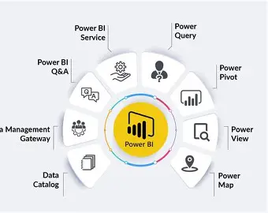
Power BI is a business intelligence tool used to visualize data and create interactive dashboards. It helps in converting raw data into meaningful insights using charts, graphs, and reports
In Data Science, Power BI is used after data analysis and machine learning to visualize insights in a clear and understandable way. It helps users to explore data through charts, graphs, and dashboards.
Objectives
- To visualize data effectively
- To create interactive dashboards
- To analyze trends and patterns
- To support decision-making
Features Used in Power BI
- Data import from Excel/SQL
- Data cleaning using Power Query
- Creating relationships between tables
- Using DAX (Data Analysis Expressions)
- Filters and slicers for interaction
Dashboard Components
- Bar charts for comparisons
- Pie charts for category distribution
- Line charts for trends
- KPI indicators for performance

3.5 MACHINE LEARNING
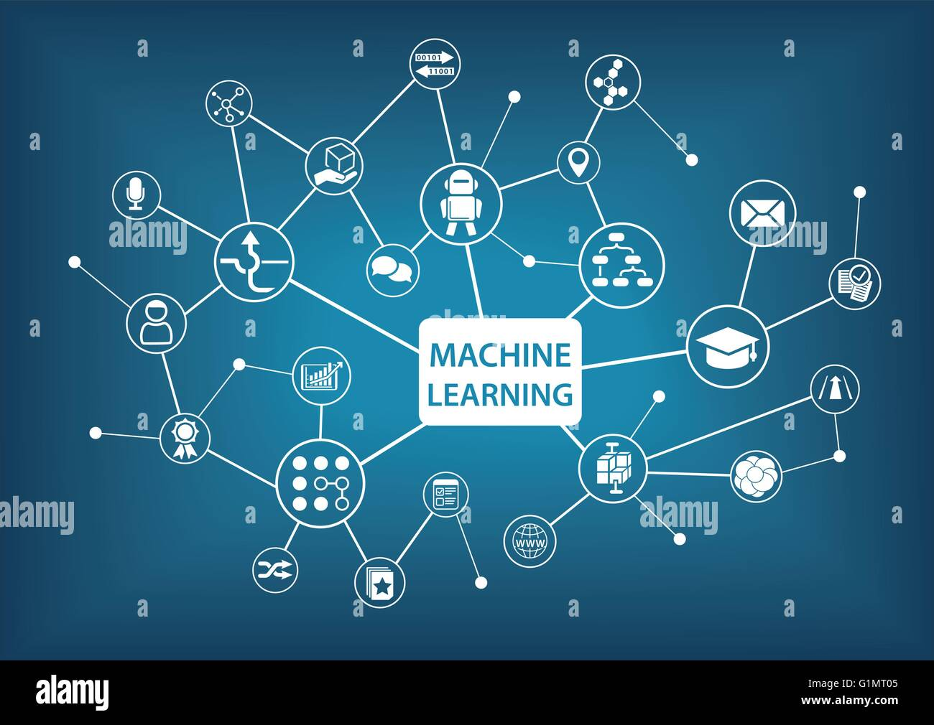
Machine Learning is a branch of Artificial Intelligence (AI) and Data Science that enables computers to learn from data and make predictions or decisions without being explicitly programmed. It identifies patterns in data and improves performance with experience.
In Data Science, Machine Learning is applied after data collection, preprocessing, and EDA to build models that can solve real-world problems.
Types of Machine Learning:
- Supervised Learning: Uses labeled data for prediction (e.g., salary prediction, spam detection)
- Unsupervised Learning: Finds patterns in unlabelled data (e.g., customer clustering)
- Reinforcement Learning: Learns through rewards and penalties
Common Algorithms:
- Linear Regression
- Logistic Regression
- Decision Tree
- Random Forest
- K-Nearest Neighbours (KNN)
Applications:
- Financial forecasting
- Fraud detection in banking
- Recommendation systems (YouTube, Netflix)
- Healthcare disease prediction

3.6 DEEP LEARNING
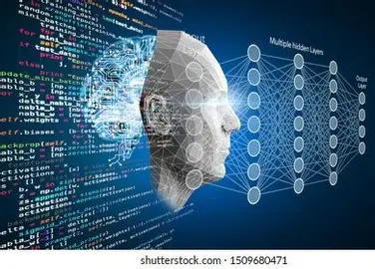

Deep Learning is a subset of Machine Learning and Artificial Intelligence (AI) that uses neural networks with multiple layers to learn complex patterns from large amounts of data. It is inspired by the working of the human brain.
Deep Learning is used for solving advanced problems like image recognition, speech processing, and natural language understanding.
Key Concepts:
- Neural Networks: Layers of interconnected nodes (neurons)
- Input Layer, Hidden Layers, Output Layer
- Training with large datasets
- Uses GPUs for faster computation
Popular Deep Learning Models:
- Artificial Neural Networks (ANN)
- Convolutional Neural Networks (CNN) – for images
- Recurrent Neural Networks (RNN) – for sequential data
Tools & Libraries:
- Python
- TensorFlow
- Keras
- PyTorch
Applications:
- Image and face recognition
- Speech recognition (Google Assistant, Alexa)
- Self-driving cars
- Medical image analysis
- Chatbots and NLP systems

Conclusion:
Deep Learning is a powerful technology that enables machines to solve complex real-world problems and is a key part of modern AI systems.

CHAPTER-4
PROJECT: ECOMMERCE - SENTIMENT ANALYSIS
4.1 INTRODUCTION
The Ecommerce Review Sentiment Analysis project is a Natural Language Processing and Machine Learning-based application designed to extract meaningful insights from customer reviews. It focuses on analyzing textual feedback using sentiment classification and visualization techniques. In today’s data-driven environment, businesses rely on tools like Python, Transformers, and Streamlit to understand customer opinions and improve decision-making.
This project aims to build a complete end-to-end system that processes ecommerce reviews, identifies sentiment patterns, and presents insights through an interactive interface.
4.2 PROBLEM STATEMENT
Businesses often face challenges in understanding customer feedback due to large volumes of unstructured textual data. Without proper analysis, it becomes difficult to identify customer satisfaction levels product issues, and overall sentiment trends.
In ecommerce platforms, analyzing reviews to determine whether customers are satisfied or dissatisfied is essential for business growth. Therefore, a structured sentiment analysis system is required to process raw text data and generate actionable insights.

4.3 OBJECTIVES
- To analyze ecommerce reviews using Natural Language Processing techniques
- To classify reviews as positive or negative using a pre-trained model
- To provide real-time sentiment analysis for user-input reviews
- To analyze sentiment distribution across the dataset
- To visualize sentiment results using charts
- To build an interactive web application using Streamlit
4.4 DATASET DESCRIPTION
The dataset used in this project contains:
- Review Text: Customer feedback in textual format (excel format)
- Sentiment (generated): Label indicating positive or negative sentiment
The data is collected from CSV files containing ecommerce reviews. The dataset is loaded and processed using Python libraries before applying sentiment analysis and visualization.
4.5 SYSTEM ARCHITECTURE
The system follows a simple pipeline:
Data Collection → Data Loading → Model Processing → Sentiment Analysis → Visualization → Insights Generation
Input: Ecommerce review dataset (text data)
Processing: Pre-trained NLP model, Python data handling, sentiment classification
Output: Sentiment predictions and visual insights
4.6 TOOLS AND TECHNOLOGIES USED
- Python
- Pandas → Data handling
- Numpy → Mathematical Calculations
- Plotly → Graph and Charts
- Transformers → Pre-trained NLP model (DistilBERT)
- Streamlit → Web application and visualization
4.7 METHODOLOGY

The project follows these steps:
- Data Collection – Ecommerce reviews dataset is collected
- Data Loading – Data is loaded using Pandas
- Model Loading – Pre-trained sentiment analysis model is initialized
- Data Processing – Reviews are passed through the model
- Sentiment Classification – Each review is classified as positive or negative
- Visualization – Results are displayed using Streamlit charts

4.8 ALGORITHM USED

The system mainly uses:
- Pre-trained Transformer-based model (DistilBERT)
- Sentiment Classification (Positive/Negative)
- Data Visualization Techniques (Bar chart)

4.9 WORKING:
- Ecommerce review data is loaded into the system
- The pre-trained model analyzes each review
- Sentiment labels and confidence scores are generated
- Users can input custom reviews for real-time analysis
- Sentiment distribution is visualized using charts

4.10 OUTPUT AND RESULTS
- The system successfully analyzes customer reviews and classifies sentiment
- Interactive interface displays predictions and confidence scores
- Provides visualization of overall sentiment distribution
- Helps understand customer opinions effectively
- User-friendly and efficient for analysis

4.11 IMPLEMENTATION

The system takes ecommerce review data as input and processes it using Python and a pre-trained NLP model. Based on sentiment predictions, it generates outputs and visualizations in Streamlit.

Example:
- Input: “Customer review text” – Excel Format
- Output: Sentiment label (Positive/Negative) with confidence score and distribution chart
4.12 ADVANTAGES
- Improves understanding of customer feedback
- Helps identify positive and negative trends
- Saves time through automated analysis
- Easy to use with an interactive interface

CONCLUSION
This project provides a complete end-to-end solution for ecommerce review sentiment analysis by integrating Python, Transformers, and Streamlit. It helps in extracting valuable insights from textual data and supports data-driven decision-making in real-world ecommerce applications.

CHAPTER 5
RESULTS AND DISCUSSION
5.1 Results
The Ecommerce Review Sentiment Analysis project was successfully developed and implemented using an ecommerce reviews dataset. The system effectively analyzes customer feedback and provides meaningful insights through sentiment classification and interactive visualization.
Key Results:
- The system accurately classifies reviews as positive or negative using a pre-trained NLP model
- Sentiment predictions include confidence scores for better interpretation
- Real-time analysis of user-input reviews is performed efficiently
- Sentiment distribution across the dataset is clearly visualized
- The Streamlit interface provides a simple and user-friendly way to interact with the system
5.2 PERFORMANCE ANALYSIS
The performance of the system is evaluated based on:
- Accuracy of sentiment predictions generated by the pre-trained model
- Efficiency of model inference and data processing
- Responsiveness of the Streamlit application
- Clarity and usefulness of sentiment visualizations
- Ability to interpret customer feedback and identify overall sentiment trends
The use of a transformer-based model ensures high-quality sentiment classification by understanding the context of text. Combined with efficient data handling using Python and an interactive Streamlit interface, the system processes large volumes of review data and presents results in a clear and understandable format.
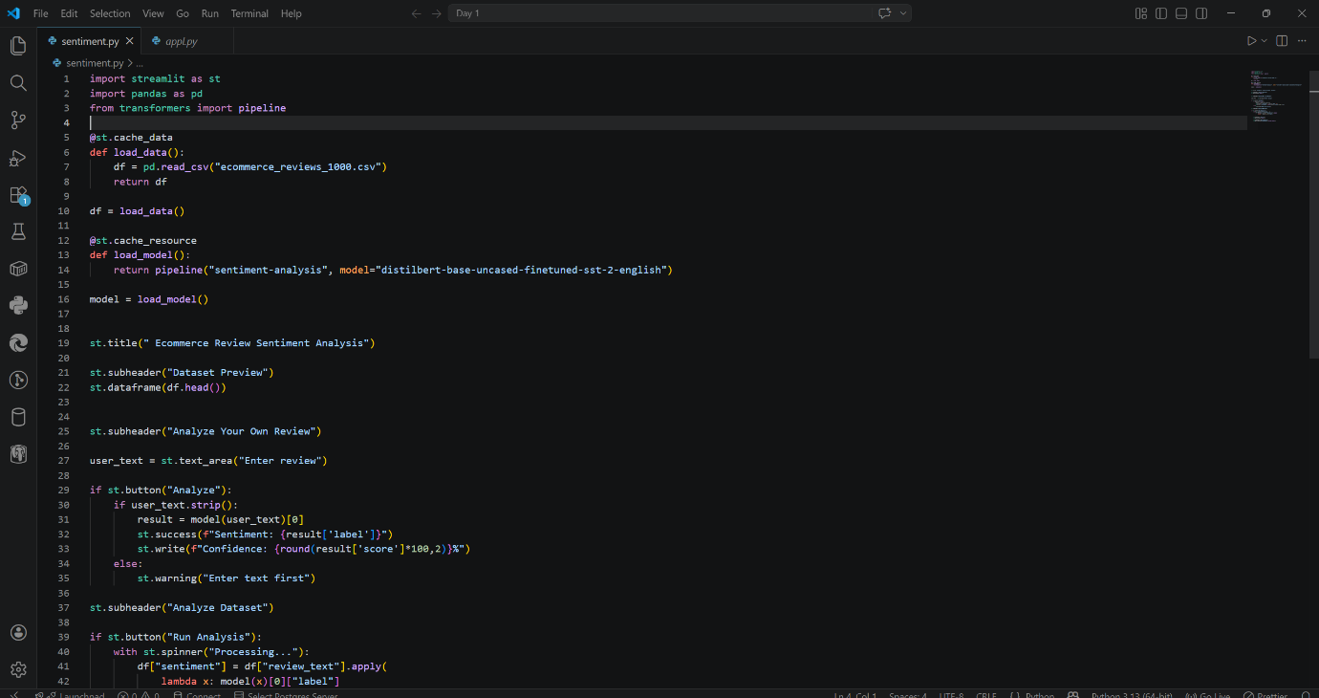
5.3 SNAPSHOTS OF PYTHON CODE
5.4 SNAPSHOTS OF STREAMLIT DASHBOARD
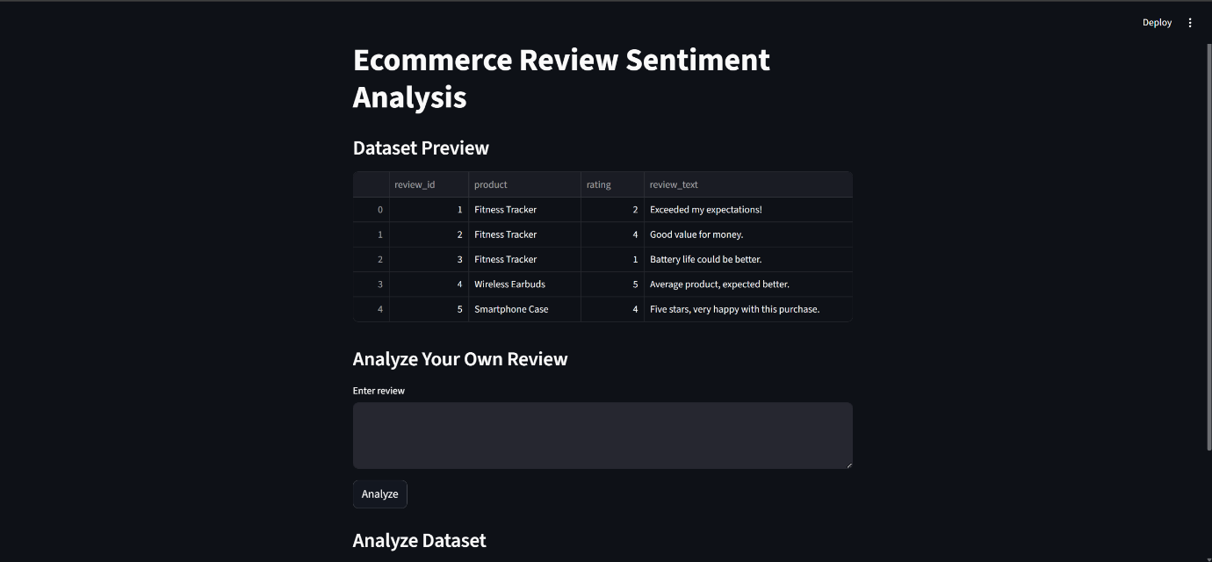
5.5 SNAPSHOTS OF POSTIVE AND NEGATIVE SENTIMENT ANALYSIS
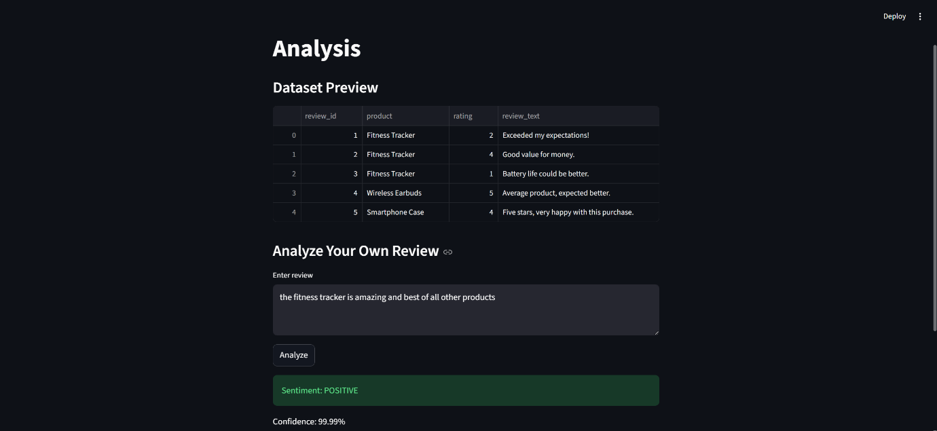

5.4.1 POSITIVE ANALYSIS
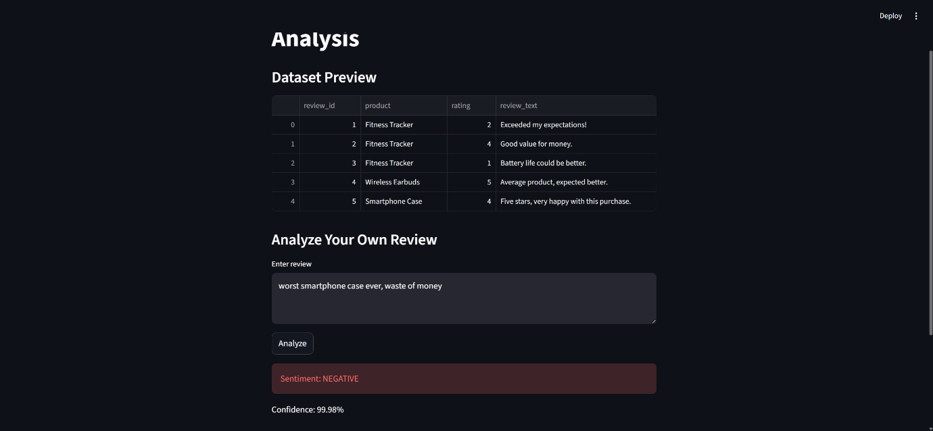

5.4.2 NEGATIVE ANALYSIS

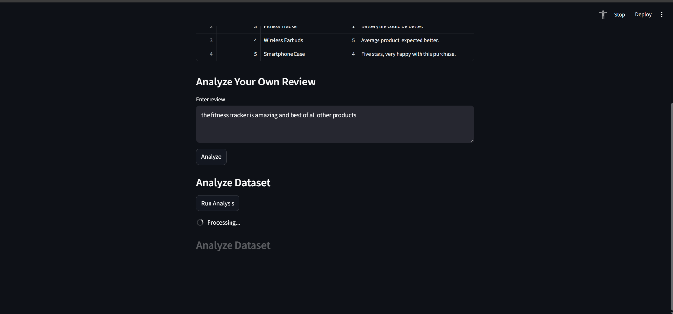
5.6 SNAPSHOTS OF DATA ANALYSIS PROCESSING,RESULTS AND GRAPH

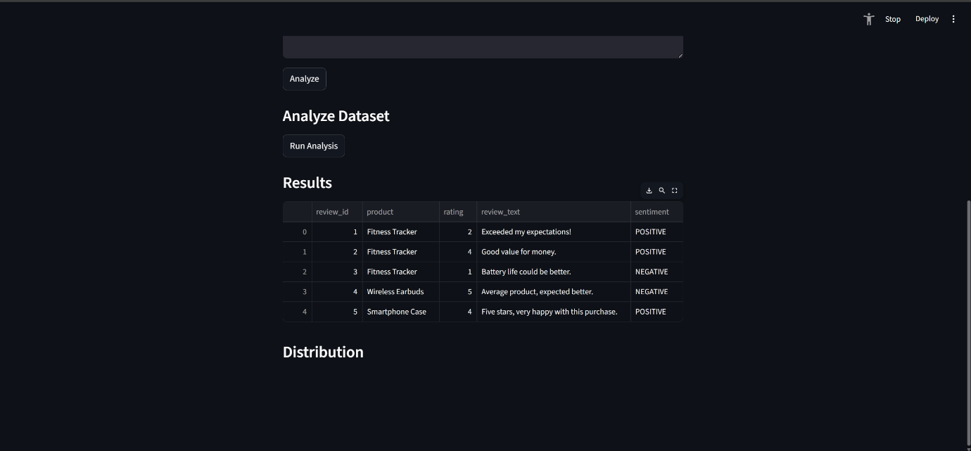

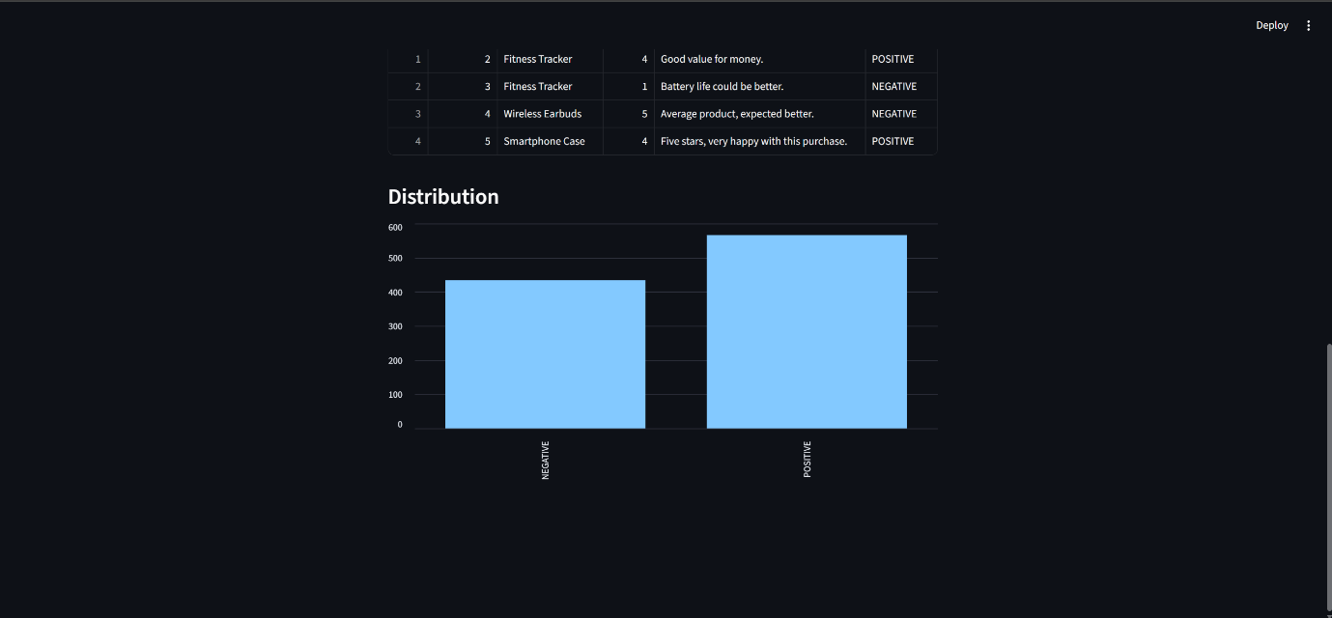

CHAPTER-6
CONCLUSION
The Ecommerce Review Sentiment Analysis project demonstrates how natural language processing and machine learning techniques can be effectively applied to analyze real-world customer feedback. The system successfully processes ecommerce review data and generates meaningful insights through sentiment classification and visualization.
By utilizing a pre-trained transformer model along with efficient data handling and visualization techniques, the project identifies overall sentiment patterns, customer opinions, and feedback trends, helping businesses better understand user satisfaction and improve decision-making.
This project provided practical experience in Python, NLP, and building interactive applications using Streamlit, while showcasing the development of a complete end-to-end sentiment analysis system.
Overall, the project is a successful implementation of ecommerce review analysis and can be further enhanced by incorporating advanced features such as multi-class sentiment classification, aspect-based sentiment analysis, or integration with real-time data sources in the future.

THANK YOU

