DEPARTMENT OF COMPUTER SCEINCE & ENGINEERING
(DATA SCIENCE)
INTERNSHIP REPORT
ON
DATASCIENCE
SUBMITTED BY
NAME
USN

CERTIFICATE

ACKNOWLEDGEMENT

I would like to express my sincere gratitude to my project guide [Guide Name] for their valuable guidance, continuous support, and encouragement throughout the completion of this internship report. Their suggestions and insights have been extremely helpful in successfully completing this work.
I would also like to thank the Head of the Department and all the faculty members of the Department of Computer Science and Engineering(Data Science), Adichunchanagiri Institute of Technology, for providing the necessary facilities and support.
I extend my heartfelt thanks to Take It Smart PVT Ltd for giving me the opportunity to undertake this internship and gain practical exposure in the field of Data Science.
Finally, I would like to thank my parents, friends, and well-wishers for their constant support, motivation, and encouragement throughout this work.

ABSTRACT

With the rapid growth of the food industry and increasing demand for data-driven decision-making, businesses need effective ways to analyze sales performance and customer preferences. This project, titled “Pizza Sales End-to-End Analysis,” aims to provide meaningful insights into pizza sales data to support better business decisions.
The main objective of this project is to analyze pizza sales by working across multiple platforms and extracting valuable insights from the data. The project focuses on understanding sales trends, customer behavior, and product performance using data analysis and visualization techniques.
In this project, pizza sales datasets containing information such as order details, pizza types, quantities, and revenue were used. The data was cleaned and preprocessed using SQL in SSMS to ensure accuracy and consistency. Further analysis was carried out in Jupyter Notebook using Python libraries to explore patterns and relationships in the data.
Python and its libraries, including Pandas and NumPy, were used for data manipulation and analysis. SQL Server Management Studio (SSMS) was used to perform queries and manage the database efficiently. Power BI was used to create interactive and visually appealing dashboards that represent key metrics such as total sales, top-selling pizzas, and revenue trends.
The developed system provides a comprehensive end-to-end solution for analyzing pizza sales data. It helps in identifying business insights, improving decision-making, and enhancing overall operational efficiency. This project demonstrates the practical application of data science, SQL, and business intelligence tools in solving real-world business problems.

TABLE OF CONTENT
SI.NO | CONTENT | PAGENO
1 | Cover Page | 1
2 | Certificate | 2
3 | Acknowledgement | 3
4 | Abstract | 4-5
5 | Table of Contents | 6
6 | Company Overview | 7-10
7 | INTRODUCTION TO DATA SCIENCE | 11-15
8 | TECHNOLOGIES USED | 16-28
9 | PROJECT-MOVIE RECOMMENDATION | 29-33
10 | Results & Output Screenshots | 34-39
11 | CONCLUSION | 38-39

CHAPTER 1
COMPANY OVERVIEW
TAKE IT SMART (OPC) PVT LTD is an Indian based engineering and Software Company headquartered in Bangalore, Karnataka, India. It is both product and service oriented software company. All offices employ an experienced team of professionals, with an outstanding track record of handling complex web & Apps development projects.
  - HISTORY
The company was legally registered in the year 2021, but it made its humble beginning in the year 2018 with a team of Two members
  - COMPANY STRATERGY
- Purpose: To be a leader in the software Industry by providing enhanced services, relationship and profitability.
- Mission: To build long term relationships with our customers and clients and provide exceptional customer services by pursuing business through innovation and advanced technology
- Vision: To provide quality services that exceeds the expectations of our esteemed customers.
- Core values:
- To incorporate good business practices in order to achieve customer satisfaction and treating the customers with respect and faith.
- To grow through creativity, invention and innovation.
- To integrate honesty, integrity and business ethics into all aspects of the business functioning.

  - COMPANY SERVICES
TAKE IT SMART (OPC) PVT LTD has its own services such as,
- Embedded Applications development
- Web design and development
- IT Service
- Android app Development
- Web Bases Software Solutions
- Web Based Ads Mobile Based Services: Mobile Web Apps a. Android Apps b. Windows Apps c. IOS Apps d. Cross Plate forms Apps
- Native Apps
- Hybrid apps Get trained for industry requirements while you pursuing degree The Different verticals that we operate in are Internship & Software Training

  - DOMAINS
TAKE IT SMART (OPC) PVT LTD has working with several domains like
- IT
- Digital marketing

1.5. DEPARTMENTS.
- Marketing: These are the main section of the market departments:
- Sales department is responsible for the sales and distribution of the products to the different regions.
- Promotion department decides on the type of promotion method for the products, arranges advertisements and the advertising media used.
- Distribution department distributes the products across the industries.
- Embedded System and Internet of Things (IOT) department.
- Machine learning and web development department.

Business Address: Take It Smart (OPC) Pvt Ltd
14,SGN Arcade, 1st Floor, 2nd stage, 1st Main Rd,
RPC Layout, Hoshalli Extension, Stage 1,
Vijayanagar, Bengaluru, Karnataka 560040
Mobile: +91-8050104212
Email: info@takeitsmart.in
Website: www.takeitsmart.in

CHAPTER-2
INTRODUCTION TO DATASCIENCE
Data Science is a field that focuses on extracting useful insights and knowledge from data using scientific methods, algorithms, and systems. It combines statistics, mathematics, programming, and domain knowledge to analyze both structured and unstructured data.
In today’s digital world, huge amounts of data are generated every second from social media, websites, and business transactions. Data Science helps organizations convert this raw data into meaningful information for better decision-making.
The main steps in Data Science include data collection, data cleaning, data analysis, data visualization, and machine learning. Popular tools used in Data Science are Python, R, SQL, Excel, and libraries like Pandas, NumPy, and Scikit-learn.
Data Science is widely used in various fields such as healthcare (disease prediction), finance (fraud detection), e-commerce (recommendation systems), and transportation (route optimization).
In conclusion, Data Science plays a major role in modern technology by helping businesses and industries make smarter, data-driven decisions.
2.1 COMPONENTS OF DATA SCIENCE

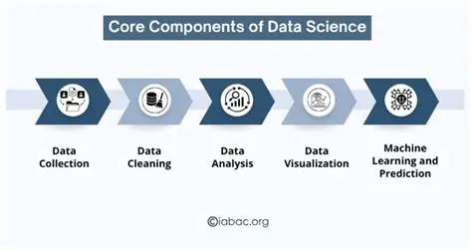
2.2 PHASES OF DATA SCIENCE
Data Collection → Gather data from databases, APIs, web scraping, sensors
Data Cleaning → Handle missing values, remove duplicates, fix errors
EDA (Exploratory Data Analysis) → Use charts & statistics to understand patterns
Feature Engineering → Select and transform important variables for better results
Data Modeling → Apply Machine Learning algorithms (Regression, Classification)
Model Evaluation → Measure performance using Accuracy, Precision, Recall, F1-score
Deployment → Deploy model into apps, websites, dashboards
Monitoring & Maintenance → Track performance and update model regularly
2.3 Importance of Data Science
Data Science has become an essential part of many industries due to its ability to provide valuable insights. Organizations use Data Science techniques to improve efficiency, reduce costs, and enhance customer experience.
Some key reasons for the importance of Data Science include:
- Helps in making data-driven decisions
- Identifies patterns and trends in data
- Improves business performance
- Supports automation and prediction
- Enhances problem-solving capabilities

2.4 Applications of Data Science in Real World
Data Science is widely used in almost every industry today to analyze data, discover patterns, and make better decisions. It helps organizations improve efficiency, reduce cost, and increase accuracy using data-driven insights.
1.Social Media
Platforms like Instagram, Facebook, and YouTube use data science to:
- Recommend posts, videos, and friends
- Analyze user behavior and engagement
- Show personalized ads
2.Entertainment (Movie Recommendation Systems)
Used by Netflix, Amazon Prime, etc. to:
- Suggest movies based on user history
- Improve user experience
- Increase watch time using recommendation algorithms
3. Banking and Finance
Banks use data science for:
- Fraud detection in transactions
- Credit score analysis
- Loan approval prediction
- Risk management
4.E-Commerce
Companies like Amazon and Flipkart use it for:
- Product recommendations
- Demand forecasting
- Customer behavior analysis
- Price optimization
5. Healthcare
Used in medical field for:
- Disease prediction
- Medical image analysis (X-rays, MRI)
- Patient risk analysis
- Drug discovery

CHAPTER-3
TECHNOLOGIES USED
3.1 PYTHON FOR DATA SCIENCE
Python is one of the most popular programming languages used in Data Science because it is simple, powerful, and easy to learn. It provides a large number of libraries that help in handling, analyzing, and visualizing data efficiently.
Python supports important Data Science tasks such as data collection, data cleaning, data analysis, data visualization, and machine learning. It is widely used to work with both structured and unstructured data.
Some important Python libraries used in Data Science are:
1.NumPy – for numerical computations
- NumPy stands for Numerical Python
- It is a powerful Python library for numerical computations
- Used for handling arrays, matrices, and mathematical operations
- Widely used in Data Science and Machine Learning
2.Pandas – for data manipulation and analysis
- Pandas is a Python library used for data analysis and manipulation
- It works with structured data like tables (rows & columns)
3.Matplotlib / Seaborn – for data visualization
- Matplotlib and Seaborn are Python libraries used for data visualization
- Help in representing data using graphs and charts
4.Scikit-learn – for machine learning
- Scikit-learn is a Python library used for Machine Learning
- Built on top of NumPy, Pandas, and Matplotlib
- Used to build and train ML models easily
5.SciPy – for scientific calculations
- SciPy is a Python library used for scientific and technical computing
- Built on top of NumPy
- Provides advanced functions for mathematics, engineering, and data science .
3.2 SQL FOR DATA SCIENCE
SQL (Structured Query Language) is used to store, manage, and retrieve data from databases. In Data Science, SQL plays an important role in extracting data from large datasets before analysis.
Data is usually stored in relational databases in the form of tables. SQL helps data scientists to filter, sort, join, and analyze data efficiently.
Some important SQL operations include:
- SELECT – retrieve data from tables
- WHERE – filter data based on conditions
- JOIN – combine data from multiple tables
- GROUP BY – group similar data
- ORDER BY – sort data
SQL is widely used in Data Science because most real-world data is stored in databases like MySQL, PostgreSQL, Oracle, etc. It works well with Python for data analysis.
In conclusion, SQL is a powerful tool for Data Science that helps in efficient data extraction and preparation for analysis and machine learning
Importance of SQL in Data Science
- Most company data is stored in databases (MySQL, PostgreSQL, etc.)
- Helps in handling large datasets efficiently
- Reduces dependency on Excel or manual processing
- Essential skill for Data Analyst and Data Scientist roles
Role of SQL in Data Science Workflow
- Data Collection → SQL extracts data
- Data Cleaning → Remove errors/nulls
- Data Analysis → Find patterns
- Feature Preparation → Used for ML models
- Reporting → Dashboards (Power BI, Tableau)

3.3 EXPLORATORY DATA ANALYSIS
Exploratory Data Analysis (EDA) is an important step in Data Science where we analyze and understand the dataset before applying machine learning models. It helps to discover patterns, detect missing values, identify outliers, and understand relationships between variables.
EDA is used to clean data, detect missing values, handle outliers, and understand data distribution. It helps data scientists to make better decisions about how to process and use the data.
Objectives of EDA
- Understand the structure of the dataset
- Identify missing or duplicate values
- Detect outliers and errors
- Find patterns and relationships between features
- Prepare data for machine learning models
Steps in EDA
1. Data Collection
Data is collected from sources like CSV files, databases, or APIs.
2. Data Cleaning
- Removing null values
- Handling missing data
- Removing duplicates
3. Data Understanding
- Using .head(), .info(), .describe() in Python
- Checking data types and statistics
4. Data Visualization
Visualization is done using:
- Matplotlib
- Seaborn
Graphs used:
- Bar chart
- Histogram
- Heatmap
- Box plot
3.4 POWER BI FOR DATASCIENCE
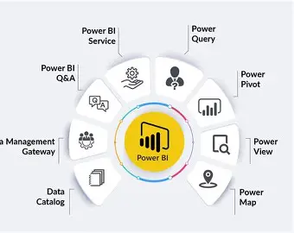
Power BI is a business intelligence tool used to visualize data and create interactive dashboards. It helps in converting raw data into meaningful insights using charts, graphs, and reports
In Data Science, Power BI is used after data analysis and machine learning to visualize insights in a clear and understandable way. It helps users to explore data through charts, graphs, and dashboards.
Objectives
- To visualize data effectively
- To create interactive dashboards
- To analyze trends and patterns
- To support decision-making
Features Used in Power BI
- Data import from Excel/SQL
- Data cleaning using Power Query
- Creating relationships between tables
- Using DAX (Data Analysis Expressions)
- Filters and slicers for interaction
Dashboard Components
- Bar charts for comparisons
- Pie charts for category distribution
- Line charts for trends
- KPI indicators for performance

3.5 MACHINE LEARNING
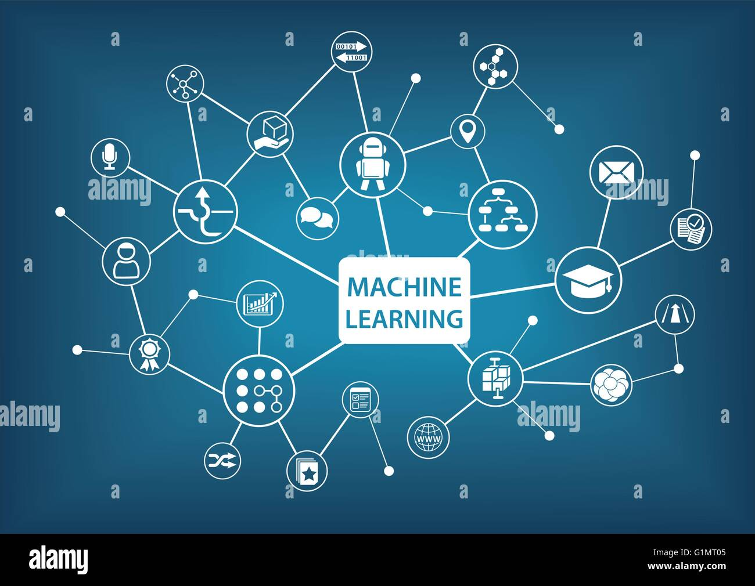
Machine Learning is a branch of Artificial Intelligence (AI) and Data Science that enables computers to learn from data and make predictions or decisions without being explicitly programmed. It identifies patterns in data and improves performance with experience.
In Data Science, Machine Learning is applied after data collection, preprocessing, and EDA to build models that can solve real-world problems.
Types of Machine Learning:
- Supervised Learning: Uses labeled data for prediction (e.g., salary prediction, spam detection)
- Unsupervised Learning: Finds patterns in unlabeled data (e.g., customer clustering)
- Reinforcement Learning: Learns through rewards and penalties
Common Algorithms:
- Linear Regression
- Logistic Regression
- Decision Tree
- Random Forest
- K-Nearest Neighbors (KNN)
Applications:
- Financial forecasting
- Fraud detection in banking
- Recommendation systems (YouTube, Netflix)
- Healthcare disease prediction
3.6 DEEP LEARNING
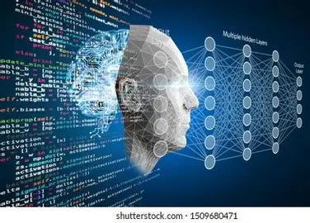

Deep Learning is a subset of Machine Learning and Artificial Intelligence (AI) that uses neural networks with multiple layers to learn complex patterns from large amounts of data. It is inspired by the working of the human brain.
Deep Learning is used for solving advanced problems like image recognition, speech processing, and natural language understanding.
Key Concepts:
- Neural Networks: Layers of interconnected nodes (neurons)
- Input Layer, Hidden Layers, Output Layer
- Training with large datasets
- Uses GPUs for faster computation
Popular Deep Learning Models:
- Artificial Neural Networks (ANN)
- Convolutional Neural Networks (CNN) – for images
- Recurrent Neural Networks (RNN) – for sequential data
Tools & Libraries:
- Python
- TensorFlow
- Keras
- PyTorch
Applications:
- Image and face recognition
- Speech recognition (Google Assistant, Alexa)
- Self-driving cars
- Medical image analysis
- Chatbots and NLP systems
Conclusion:
Deep Learning is a powerful technology that enables machines to solve complex real-world problems and is a key part of modern AI systems.

CHAPTER-4
PROJECT: PIZZA SALES ANALYIS
4.1 Introduction
The Pizza Sales Analysis project is a Data Analytics and Business Intelligence-based project designed to extract meaningful insights from pizza sales data. It focuses on analyzing business performance using key performance indicators (KPIs) and visualization techniques. In today’s data-driven environment, businesses rely on tools like Power BI, SQL, and Python to improve decision-making and operational efficiency.
This project aims to build a complete end-to-end analysis system that processes pizza sales data, identifies trends, and presents insights through interactive dashboards.
4.2 Problem Statement
Businesses often face challenges in understanding sales performance due to large volumes of transactional data. Without proper analysis, it becomes difficult to track revenue, customer preferences, and product performance.
In pizza sales, identifying key metrics such as total revenue, order trends, best-selling items, and customer buying patterns is essential for business growth. Therefore, a structured data analysis system is required to process raw data and generate actionable insights that support better decision-making.
4.3 Objectives
- To analyze pizza sales data using SQL, Python, and Data Analytics techniques
- To calculate key KPIs such as total revenue, total orders, and average order value
- To identify sales trends (daily, monthly, and hourly)
- To analyze customer preferences based on pizza category and size.
- To determine top-selling and least-selling pizzas.
- To create interactive dashboards using Power BI for clear visualization of insights
4.4 Dataset Description
The dataset used in this project contains:
- Order ID: Unique identifier for each order
- Order Date: Date on which the order was placed
- Order Time: Time of the order (used for hourly analysis)
- Pizza Name: Name of the pizza ordered
- Pizza Category: Type of pizza (e.g., Classic, Veggie, Chicken, Supreme)
- Pizza Size: Size of the pizza (Small, Medium, Large, etc.)
- Quantity: Number of pizzas ordered
- Total Price: Total cost of the orderRatings
The data is collected from sources like CSV files or online datasets. The dataset is cleaned and processed before applying python and visualized in Power BI to generate meaningful business insights.
4.5 System Architecture
The system follows a simple pipeline:
Data Collection → Data Preprocessing → Data Cleaning → Data Analysis → Visualization → Insights Generation
Input: Pizza sales dataset (order details, pizza category, size, revenue,quantity)
Processing: SQL queries, Python data analysis, KPI calculations
Output: Interactive dashboards and business insights
4.6 Tools and Technologies Used
- Python
- Pandas → Data handling
- NumPy → Numerical operations
- SQL(SSMS) → Data querying and KPI calculations
- Power BI → Visualization
4.7 Methodology

The project follows these steps:
- Data Collection – Pizza sales dataset is collected from reliable sources
- Data Cleaning – Missing values and inconsistencies are handled using SQL
- Data Processing – Data is structured and transformed for analysis
- Exploratory Data Analysis – Performed using Python (Jupyter Notebook)
- KPI Calculation – Metrics like revenue, orders, and averages are computed
- Visualization – Insights are presented using Power BI dashboards

4.8 Algorithm Used

The system mainly uses:
- Data Analysis using SQL queries
- KPI Metrics Calculation (Revenue, Orders, Averages)
- Data Visualization Techniques (Bar chart, Line chart, Pie chart, Funnel chart)

4.9 Working:
- Raw pizza sales data is processed using SQL queries
- KPIs such as total revenue, total orders, and average order value are calculated
- Trends such as daily, monthly, and hourly sales are analyzed
- Customer preferences (pizza category and size) are identified
- Power BI dashboards display insights like top-selling and least-selling pizzas

4.10 Output and Results
- The system successfully analyzes pizza sales data and generates meaningful insights
- Interactive dashboards display key performance indicators and trends

- Helps identify best-selling and underperforming products

- Provides clear visualization of customer preferences and sales patterns

- User-friendly and efficient for business analysis

4.11 IMPLEMENTATION

The system takes pizza sales data as input and processes it using SQL and Python. Based on calculated KPIs and analysis, it generates visual dashboards in Power BI.

Example:
- Input: “Pizza sales dataset”
- Output: Dashboard showing revenue trends, top pizzas, and sales distribution
4.12 Advantages
- Improves business decision-making
- Helps identify sales trends and customer preferences
- Saves time through automated analysis
- Easy to understand through visual dashboards

Conclusion
This project provides a complete end-to-end solution for pizza sales analysis by integrating SQL, Python, and Power BI. It helps in extracting valuable insights from raw data and supports data-driven decision-making in real-world business scenarios.

CHAPTER 5
RESULTS AND DISCUSSION
5.1 Results
The Pizza Sales Analysis project was successfully developed and implemented using pizza sales dataset. The system effectively analyzes sales data and provides meaningful insights through KPIs and interactive dashboards.
Key Results:
- The system calculates important KPIs such as total revenue, total orders, and average order value.
- Sales trends (daily, monthly, and hourly) are clearly identified
- Customer preferences based on pizza category and size are analyzed
- Top-selling and least-selling pizzas are identified effectively
- Interactive dashboards in Power BI provide clear and user-friendly visualization of data

5.2 Performance Analysis
The performance of the system is evaluated based on:
- Accuracy of KPI calculations
- Efficiency of SQL queries and data processing
- Clarity and effectiveness of visualizations
- Ability to identify business trends and patterns
The use of SQL queries, Python analysis, and Power BI dashboards helps in improving the quality of insights by accurately processing large volumes of sales data and presenting them in an understandable format.
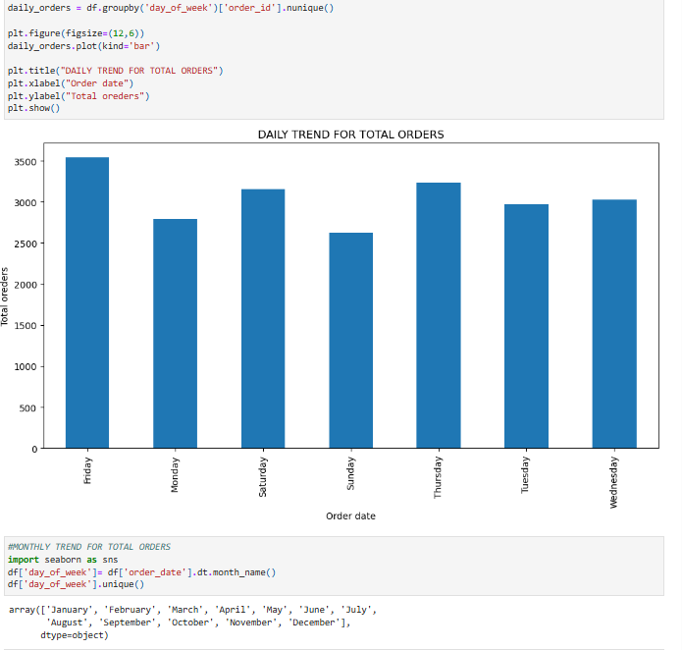
5.3 SNAPSHOTS OF PYTHON CODE
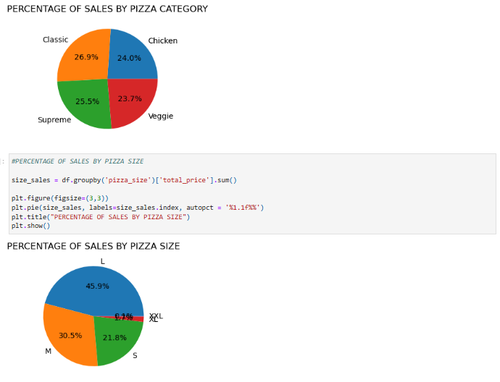
5.4 SNAPSHOTS OF SQL QUERY’S
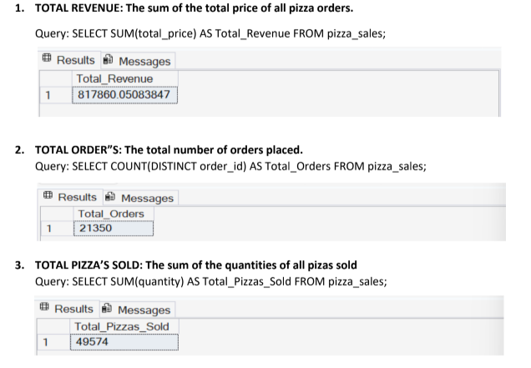

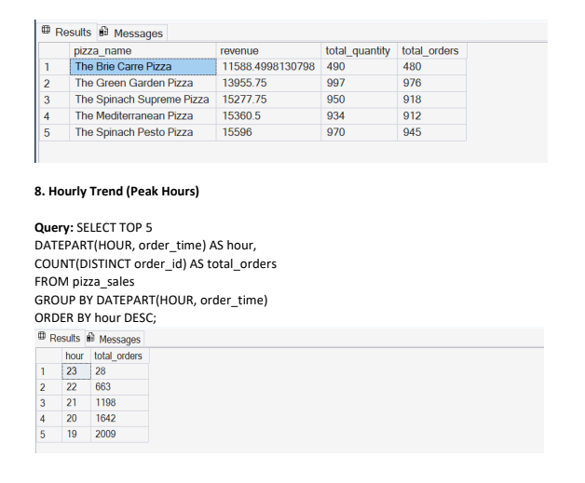
5.5 SNAPSHOT OF POWER BI DASHBOARD

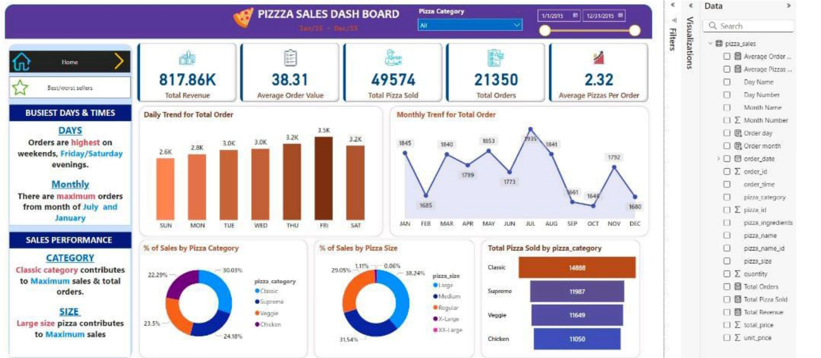
CHAPTER-6
CONCLUSION
The Pizza Sales Analysis project demonstrates how data analytics and business intelligence techniques can be effectively applied to analyze real-world business data. The system successfully processes pizza sales data and generates meaningful insights using KPIs and visual dashboards.
By applying data cleaning, SQL queries, and visualization techniques, the project identifies key trends such as revenue patterns, customer preferences, and product performance, helping in better decision-making.
This project provided practical experience in Python, SQL, and Power BI, and showcased the development of a complete end-to-end data analysis solution.
Overall, the project is a successful implementation of pizza sales analysis and can be further enhanced using advanced analytics or predictive models in the future.

THANK YOU

