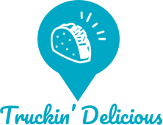

Truckin’ Delicious

The tasty way to order from your favorite food trucks

Matt Stash

MSSE 692

Regis University

# 1 Introduction

## 1.1 Overview

## Truckin' Delicious is a web and mobile application that allows you to search, order, and purchase from food trucks in their area. Users can discover new dining options hidden in their cities and view the current location of these traveling cuisines. Truckin' Delicious gives users a chance to connect with smaller locally owned food trucks, which are typically the hidden secrets of the locals in the area.

## The idea for Truckin' Delicious came from observing my local food truck scene. Every day, dozens of trucks gather the Longwarf area of New Haven, Connecticut, with little advertising other than social media and word of mouth. These trucks serve thousands of customers daily, though sales aside from lunch hours tend to be slow, as the majority of customers work in the businesses and schools surrounding the area. The idea for this application came to me specifically from a food truck that parks in my apartments parking lot on the weekends.

## Cados Egg Truck serves specialty breakfast sandwiches. While they have specific business-centered locations they park at, they serve a wide variety of customers who will drive many miles in order to get their breakfast sandwich fix of the colorfully named delicacies like the ‘Morning Bender’ and ‘Chuck Noris’. Cados recently started putting their cell phone number on their menu, telling customers they could text in their order. I tried this once, and the process was clunky. You text their number, wait for a response, confirm a few questions asked, and they tell you when to head down. When I came up with the idea for this, I asked why not use Eat24 or Beyond Menu for online orders. Owner Julia mentioned how the fees for these services, typically in the 12.5% range, were too much for a small business like theirs.

## I envision Truckin' Delicious to be a way for businesses like these to advertise and sell their products to a larger audience. While I have not thought out all the details, I would find a way for the fees to be fair both to the business and Truckin’ Delicious, so it can become a win-win for both parties.

## 1.2 Initial Designs

I got a chance to sit down and create a few mockups of what I envision the mobile version of the site looking like. I’m pretty much set on the color and font choices, along with a list of pages I will need to build within the application. I’ve also decided the stack I will be using, which is the MERN stack. Similar to MEAN, this stack uses MongoDB, Express.JS, React, and Node.js. I decided on this as I’ve become very interested in React lately and thought this would be a good way to increase my skill with the framework, as well as this stack as a whole.

## 1.2.1 Site Map

## 1.2.2 Initial Mobile Mockups

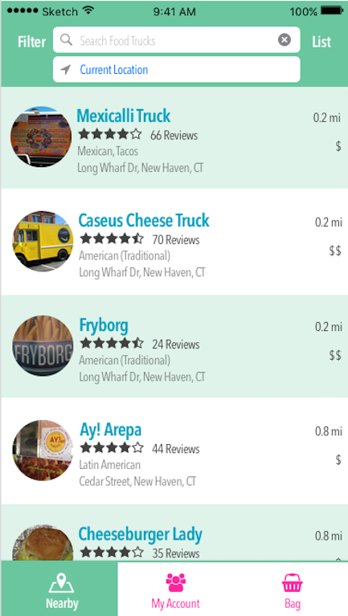

# 2 Revision History

|  |  |  |  |
| --- | --- | --- | --- |
| Date | Revision | Author | Description |
| 5/17/2018 | 1.0 | Matt Stash | Initial document created |