Michael Steven Towns
9/27/18
Lab 1

- The for loop implementation shows an increase in time based on the number of inputs
numPoints=[10^3,10^4,10^5,10^6,10^7];
time=zeros(1,numel(numPoints));
for index =1:numel(numPoints)
tic; %start timer
distance(numPoints(index)); %run calculation
time(index)=toc;
end

plot(time,numPoints,'-o');
xlabel('time (s)'); %add x and y lables
ylabel('Number of points');

function distance(points)
a=rand(points,2); %use random numbers
b=rand(points,2);
c=zeros(points,1);
for pair=1:points
c(pair)=sqrt((a(pair,1)-b(pair,1))^2+(a(pair,2)-b(pair,2))^2);
end
end
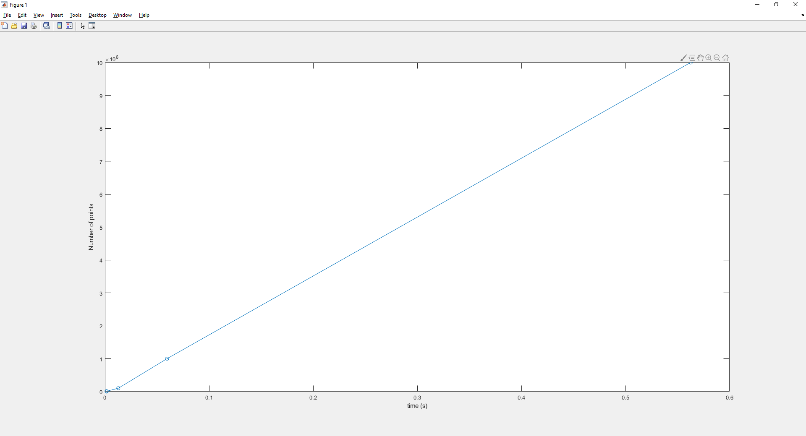

- The parfor implementation shows occasional speedup with 2 workers, but 1 and 2 workers are usually almost the same. This is likely due to my laptop only having 2 cores and the overhead of managing the thread slowing down the entire process.
delete(gcp()); %making sure i start by deleting the old pool
maxWorkers=10;

%shamlessly coppied from the internet
myCluster = parcluster('local');
myCluster.NumWorkers = maxWorkers; % 'Modified' property now TRUE
saveProfile(myCluster); % 'local' profile now updated,
% 'Modified' property now FALSE

numPoints=[10^1,10^2,10^3,10^4,10^5,10^6,10^7];
time=zeros(maxWorkers,numel(numPoints));

for workers=1:maxWorkers
delete(gcp);
parpool(workers);
parfor index =1:numel(numPoints)
tic; %start timer
distance(numPoints(index)); %run calculation
time(workers,index)=toc;
end
end

plot(time(1,:),numPoints,'-o','DisplayName','1 worker'); hold on;
plot(time(2,:),numPoints,'-+','DisplayName','2 workers');
plot(time(3,:),numPoints,'-*','DisplayName','3 workers');
plot(time(4,:),numPoints,'-x','DisplayName','4 workers');
plot(time(5,:),numPoints,'-s','DisplayName','5 workers');
plot(time(6,:),numPoints,'-d','DisplayName','6 workers');
plot(time(7,:),numPoints,'-.^','DisplayName','7 workers');
plot(time(8,:),numPoints,'-.v','DisplayName','8 workers');
plot(time(9,:),numPoints,'-.<','DisplayName','9 workers');
plot(time(10,:),numPoints,'-.>','DisplayName','10 workers'); hold off;
xlabel('time (s)'); %add x and y lables
ylabel('Number of points');

function distance(points)
a=rand(points,2); %use random numbers
b=rand(points,2);
c=zeros(points,1);
for pair=1:points
c(pair)=sqrt((a(pair,1)-b(pair,1))^2+(a(pair,2)-b(pair,2))^2);
end
end

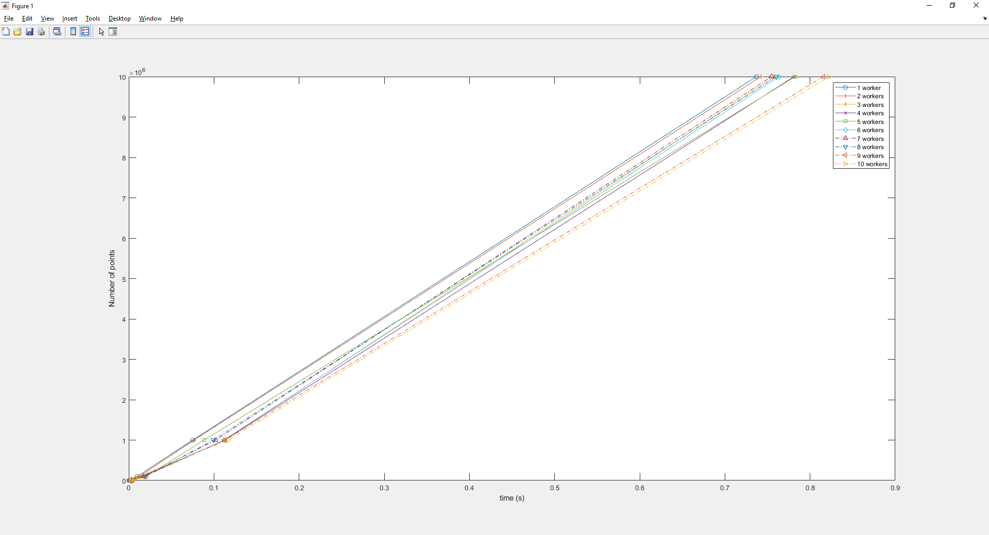
- You would expect to see a speedup using the spmd block when each thread is attempting to use and manipulate the entire array because it would reduce the number of times where one thread needs to wait for another to finish, each one could work with it’s own version of the array.

- No code

- This method produces no speedup over using only 1 worker, but this is likely due to my laptop only having 2 cores, making it inefficient when using 4. This would probably produce speedup in a device with 4 physical cores or where each of the operations was more lengthy and the communication times were a smaller portion of the computational time.
delete(gcp()); %making sure i start by deleting the old pool
maxWorkers=4;

myCluster = parcluster('local');
myCluster.NumWorkers = maxWorkers; % 'Modified' property now TRUE
saveProfile(myCluster); % 'local' profile now updated,
% 'Modified' property now FALSE

parpool(4)
numPoints=[10^1,10^2,10^3,10^4,10^5,10^6,10^7];
time=zeros(numel(numPoints));

for index =1:numel(numPoints)
tic; %start timer
distance(numPoints(index)); %run calculation
time(index)=toc;
end

function distance(points)
a=rand(points,2); %use random numbers
b=rand(points,2);
c=zeros(points,1);
sum=0;
spmd
switch labindex
case 1
for pair=1:points
dif=a(pair)-b(pair);
labSend(dif,2);
end
case 2
sqr=labRecieve(1)^2;
labSend(sqr,3);
case 3
sum=sum+labRecieve(2);
labSend(sum,4);
case 4
root=sqrt(labRecieve(3));
labSend(root,1);
end
end
end


- Registered, waiting for confirmation email, here is account email as semi-proof.

